
Old Dominion Chapter
SKYLINES
October 2021

Chair: Mary McCutcheon
Vice-Chair: Laura Savino
Secretary: Judy Shaw
Treasurer: Barbara Wilper
Amelia Earhart Scholarship: Sue Passmore

Aerospace Education: Debbie Gallaway
Membership: Barb Wilper
Air Marking: vacant
Newsletter: Mary McCutcheon
Webmaster: Rose Brown

Next Meeting
Thursday October 7 at 7:00 PM. This will be another zoom meeting:

The meeting zoom information is:
Join Zoom Meeting
https://gmu.zoom.us/j/97610257773?pwd=OFZhdXZpR3luemVEZGs1UXRpWDBBUT09
Meeting ID: 976 1025 7773
Passcode: 949639

Upcoming Section Meeting

I don’t think it is too late to sign up for the section meeting. It will be at or near the Martin State Airport north of Baltimore. The dates are October 15 and 16^{th.} For more information and to register, check out this web page:
https://meeting.maryland99s.org/

Friday Night
visit the museum at Martin State. Have some pizza and meet your fellow Ninety-Nines! 18:00 - 20:00 $10 per person

Saturday

8:00 - 12 Chapter Chairs and section meeting

12 Lunch followed by a speaker

15:00 A-10 tour or Guinness Brewery tour

18:30 – 21:00 Dinner with separate checks.
Get your tickets

Ocracoke Fly-in

The Ocracoke Fly-in on September 10-12 was a huge success.
Here are some pictures:

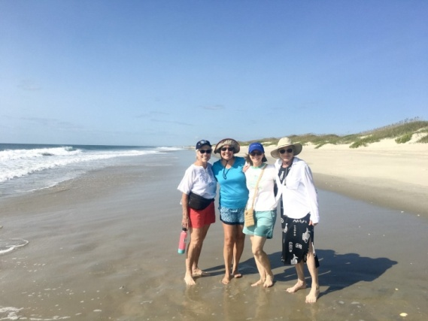
Peggy Doyle, Morgen Reeb, Laura Savino and Debbie Gallaway

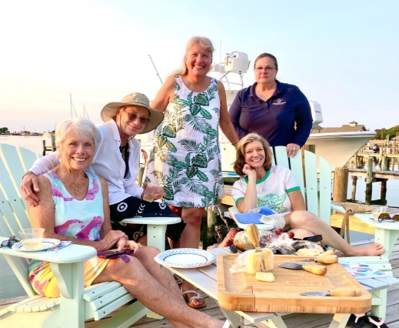
Standing: Morgen Reeb and Rose Brown
Seated: Peggy Doyle, Debbie Gallaway and Laura Savino

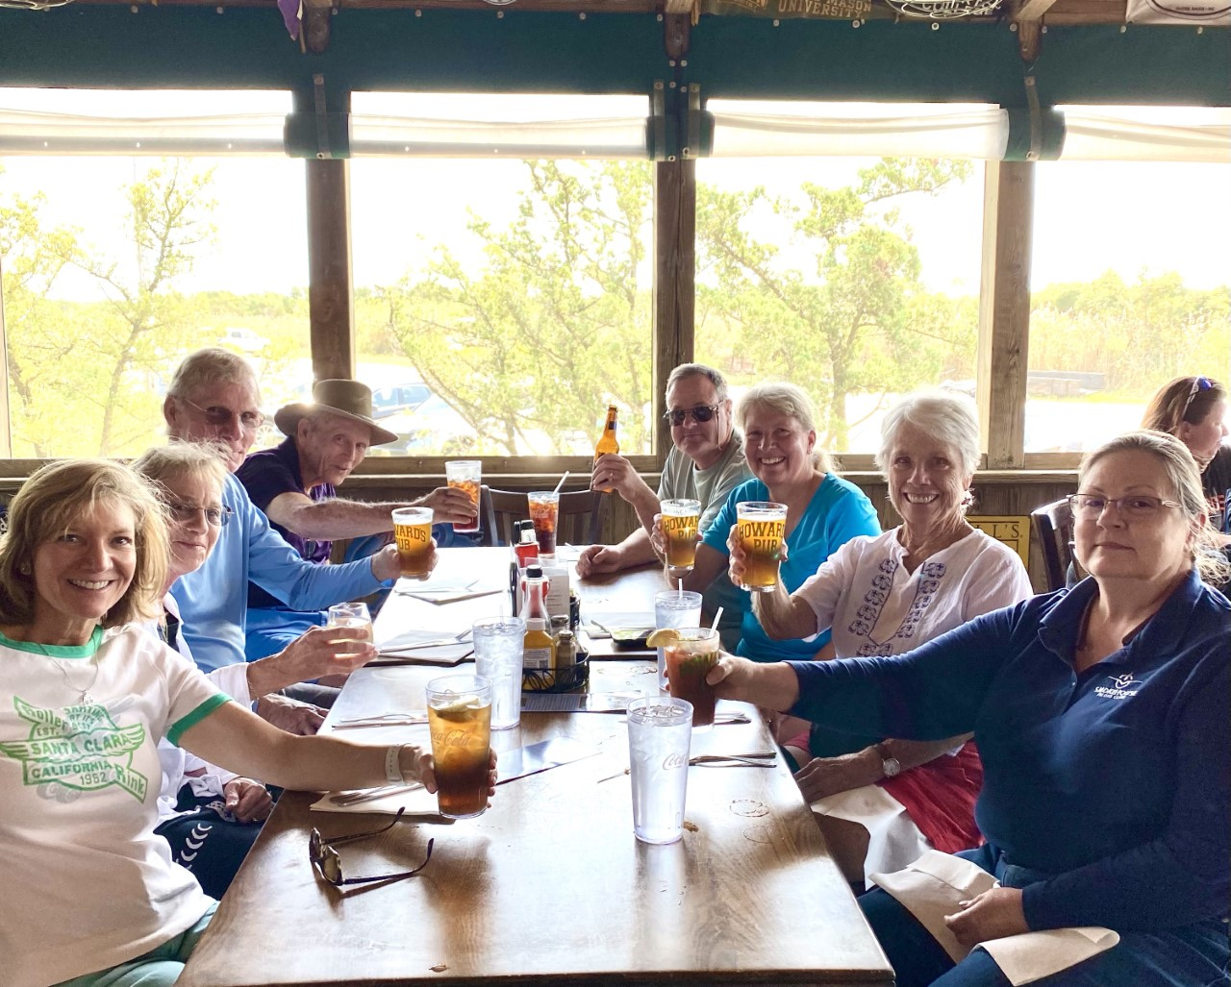

Accomplishments and activities of our members

Sue Passmore
Sue and Dave Passmore just got back from their big two-week trip to the Dakotas. They went with friends from Northern Virginia in a total of 7 planes to three different airports. First they met in Dickinson, North Dakota and saw Teddy Roosevelt National Park. Then they went to West Yellowstone to see the Grand Tetons and Yellowstone, After that they went to Rapid City, SD to see the Crazy Horse Monument, Mt. Rushmore, the South Dakota badlands and the mountains and waterfalls around Spearfish, South Dakota. The weather was mostly good, the planes mostly stood the test, and everyone stayed healthy as far as I know.
Here are some pictures lifted from Sue’s facebook page:

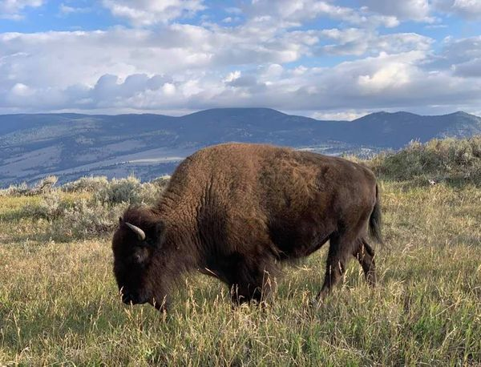

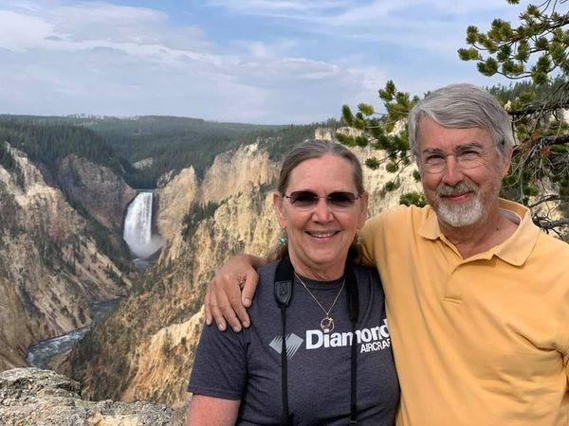

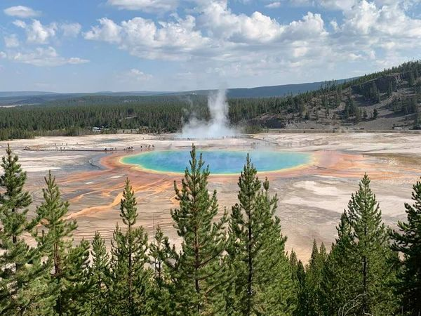

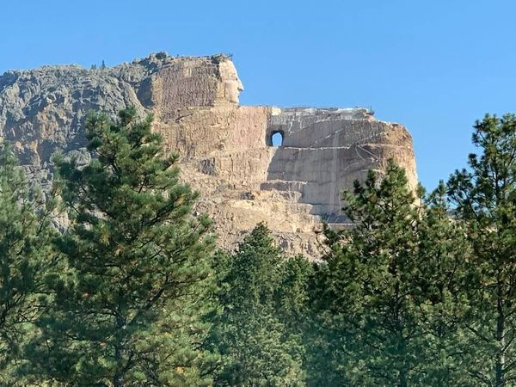



Peggy Doyle inducted into Forest of Friendship

During the virtual meeting of the International Forest of Friendship held on September 16 and 17th, Peggy Doyle was recognized and inducted as an honoree. Look at the video of the proceedings and note Peggy’s moment at milepost (?) 1:10:45.
The rest of the video is wonderful too.
https://ifof.org/2021-virtual-ceremony

Laura Savino

Laura Savino’s autobiographical book is has been accepted by Freedom Forge Press and is, we hope, going to be released before Christmas.

Colleen Whitehouse
Colleen Whitehouse used to be at Flight Safety Academy and is now at Sky Warrior as a flight instructor in the NIFE program. NIFE stands for “Navy Introductory Flight Evaluation” located in Pensacola.

Things to Do This Fall

1. October 9 (Raindate October 10) Culpeper air show.

2. October 9-10 Help paint a compass rose

The DC99s Chapter is planning to paint a compass rose on the tarmac in Potomac this weekend (Oct 9-10) and we are looking for more painters to assist with the project! If you are interested or know anyone in the DC area who might be interested please reach out to let us know! For more event info please see the events section of our page
(https://www.dc99s.com/ ),

3. October 15 and 16th. MidAtlantic Section meeting.
Save Friday October 15th and Saturday October 16th. Fly into Martin State KMTN, Drive to the Residence Inn near the airport OR attend virtually.
Questions? Contact Jane Toskes, planejane49@gmail.com or (443) 756-7890, or check out full weekend schedule at meeting.maryland99s.org.

4. October 29. ProJet Expo at Leesburg.
The Projet committee has confirmed that we are scheduled for table at their Expo. So far we have several volunteers.
If you want to volunteer, let me know:
703-217-8850 or mmccutch@gmu.edu

Aviatrix Book Club October choice


