
Old Dominion Chapter
SKYLINES
November 2021

Chair: Mary McCutcheon
Vice-Chair: Laura Savino
Secretary: Judy Shaw
Treasurer: Barbara Wilper
Amelia Earhart Scholarship: Sue Passmore

Aerospace Education: Debbie Gallaway
Membership: Barb Wilper
Air Marking: vacant
Newsletter: Mary McCutcheon
Webmaster: Rose Brown

Next Meeting
Thursday November 11 at 8 PM.
This will be another zoom meeting:

Topic: Old Dominion ninety-nines
Time: Nov 11, 2021 8 PM Eastern Time (US and Canada)
Join Zoom Meeting
https://gmu.zoom.us/j/95684531508?pwd=dnB4LzkybTBBNmwxbXA0Uy9rOUtHUT09
Meeting ID: 956 8453 1508
Passcode: 481190

Report on the Section Meeting

The Maryland Chapter hosted the Section meeting at and near the Martin State Airport north of Baltimore. There was a social event on Friday evening at the Glenn L. Martin Aviation Museum and the following morning the business meetings took place at the hotel. There were activities in the afternoon
The keynote speaker was the woman who is featured in the column “Touch and Go” in this month’s Ninety-nines magazine. Her name is Raliene Banks and she combines being Mrs. Regency International with a career in the Air Force. Her talk focused on motivating and empowering women in aviation.

New Member

Stephanie Kenyon has joined our chapter. She lives in Waterford.

Stephanie Kenyon is the Chief Growth Officer for Women in Aviation. She has also led other nonprofits with a special focus on aviation notably: developing the successful AOPA High School Aviation Program for AOPA, launching Embry-Riddle Aeronautical University’s initiative to support female students, and supporting AirServ International’s humanitarian aid flights on the African continent.
Stephanie first launched her career in aviation as a flight attendant. She is a member of WAI, the 99s, IAWA, and holds a Private Pilots License (SEL). Stephanie and her family live in Northern Virginia where she is involved with a number of conservation and historic preservation groups.

Report on ProJet’s Aviation Expo

The miserable weather didn’t keep either us or the thousands of high school students away from the event at Leesburg airport. We talked to lots of the girls about their future in aviation and also talked to some of the teachers. It got us to thinking about how we could do some outreach to schools with aviation programs. I’ll be contacting some of these teachers to see what we can do for them.

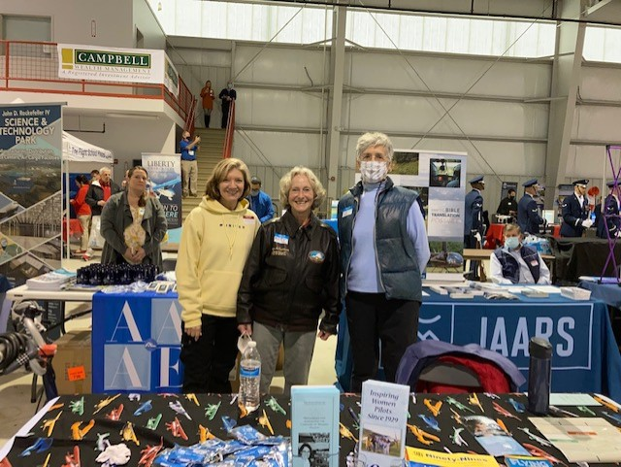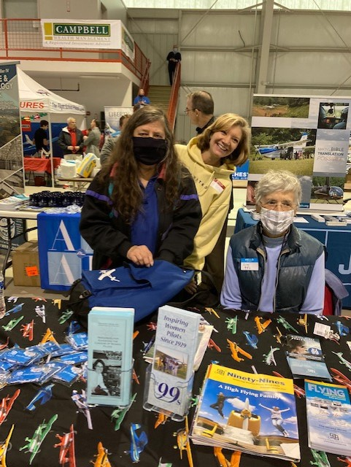

Laura Savino, Mary McCutcheon and Judy Shaw Barb Wilper, Laura Savino and Judy Shaw
Two ideas for outings this fall:

1. Xelevate The table behind ours at the Expo was for an organization called Xelevate. They launch drones from their “pad” in Waterford. This sounded neat to us, so we have reached out to them to see if we could come for a tour. They are happy to have us visit any day of the week. So please think of a day when you would be free and excited to go.

2. The Wright Experience. I have tried several times to reach people at the place where historic aircraft are rebuilt in Warrenton, but have not succeeded. Still want to work on this though.

Ninety-nines International Awards for 2022

Nominations for the 2022 International Awards, to be presented next July at the International Conference in Charleston, South Carolina, are now being accepted. Consider the many members who deserve special recognition - and submit your nominations via email to the Awards Committee at award@ninety-nines.org. 2021 Awards winners and 2022 criteria and submission information are provided in the September/October issue of the Ninety-Nines magazine. The deadline for nominations for the awards is January 31, 2022. The five Awards are: Award of Achievement for Contributions to The Ninety-Nines Award of Achievement for Contributions to Aviation Award of Achievement for Humanitarian Efforts Award of Merit George Palmer Putnam Award

Charlie Kulp’s Death


We are all deeply saddened that Charlie Kulp (AKA the Flying Farmer) died last month. He was a friend of ours and more than that, a devoted companion to Evelyn Marshall. His grandchildren want us to remember him by sending a donation to Virginia Aeronautical Historical Society (VAHS). VAHS Mailing Address: Shannon Airport KEZF Campus, PO Box 7795, Fredericksburg, VA 22404.

Charles Allen Kulp Sr. Obituary – Virginia Aeronautical Historical Society (VAHS) (vahsonline.com)

So far individual ninety-nines have sent donations, but our chapter has not. If we send something, it will be limited to $50 and should be approved by the general membership.

SCHOLARSHIPS

The 2022 AEMSF Scholarship applications are now available on the International website at www.ninety-nines.org/scholarships.htm. Applications must be submitted to the Chapter AEMSF Chairman by January 1, 2022. If you have any questions about the applications, you may send them to aechair@ninety-nines.org

Things to do this winter

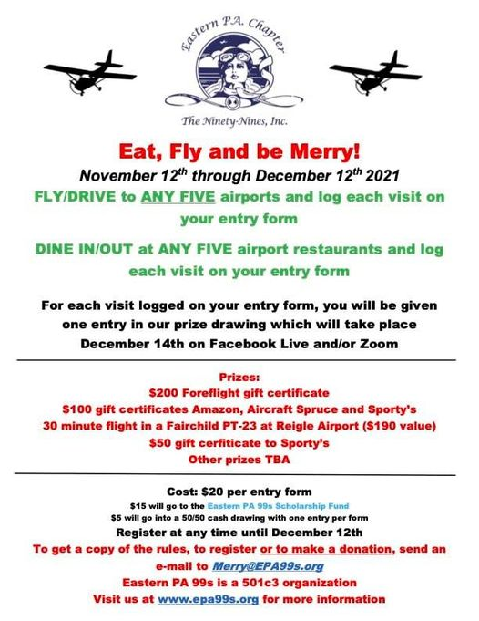
Things to watch and read

1. Beyond Haiku: Women Pilots Write Poetry Edited by Linda Pauwels
Beyond Haiku peeks through the cockpit door to reveal the poetic heart of airline pilots. Captain Linda Pauwels, instructor pilot on the Boeing 787 and aviation writer, presents a selection of haiku and short poems by men and women who fly airplanes for a living. The humor is characteristically wry, befitting the pilot persona. Beautiful illustrations, by children of pilots aged 6 to 17, bring this flight of fancy in for a smooth landing. Proceeds from Beyond Haiku will go to the Allied Pilots Association Emergency Relief and Scholarship Fund, to provide support for pilots impacted by industry effects of COVID-19.
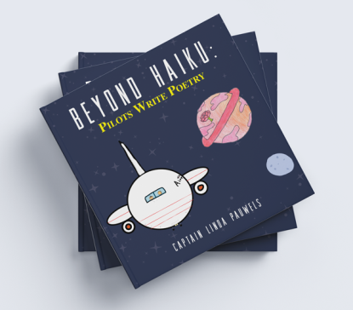

Amelia Earhart's poems reveal her inner thoughts - The Washington Post

2. November Aviatrix Book Club Choice
A Spitfire Girl by Mary Ellis


3. The Webinar about Bev Weintraub November 11 7PM
American Democracy Live Event | Wings of Gold: The Story of the First Women Naval Aviators — The War Memorial

