
Old Dominion Chapter
SKYLINES
December 2021

Chair: Mary McCutcheon
Vice-Chair: Laura Savino
Secretary: Judy Shaw
Treasurer: Barbara Wilper
Amelia Earhart Scholarship: Sue Passmore

Aerospace Education: Debbie Gallaway
Membership: Barb Wilper
Air Marking: vacant
Newsletter: Mary McCutcheon
Webmaster: Rose Brown

Next Meeting
Thursday December 2 at 7 PM.
This will be another zoom meeting:

The meeting zoom information is:

Mary McCutcheon is inviting you to a scheduled Zoom meeting.

Topic: Old Dominion 99s monthly meeting
Time: Dec 2, 2021 06:30 PM Eastern Time (US and Canada)

Join Zoom Meeting

https://gmu.zoom.us/j/98451730296?pwd=NTBDdnNydlQrZVVobW5VYzJPcTdlQT09

Meeting ID: 984 5173 0296
Passcode: 595939

Ninety-nines International Awards for 2022

Nominations for the 2022 International Awards, to be presented next July at the International Conference in Charleston, South Carolina, are now being accepted. Consider the many members who deserve special recognition - and submit your nominations via email to the Awards Committee at award@ninety-nines.org. Nominations from previous years may be re-submitted. 2021 Awards winners and 2022 criteria and submission information are provided in the September/October issue of the Ninety-Nines magazine. The deadline for nominations for the awards is January 31, 2022, but don't delay! The five Awards are: Award of Achievement for Contributions to The Ninety-Nines Award of Achievement for Contributions to Aviation Award of Achievement for Humanitarian Efforts Award of Merit George Palmer Putnam Award

The New Mountain Air Chapter of the Ninety-nines

Cindy Gresham is a founding member of the new chapter of the Ninety-nines for the region around Martinsburg. The membership will come from Eastern West Virginia, Western Maryland and Northern Virginia. So far there are nine charter members and it looks as if this chapter will cruise through the steps: Section approval as well as International approval. Sorry to lose Cindy from our chapter, but we’re happy for this expansion.

GENDER NEUTRAL LANGUAGE FOR AIRPERSONS

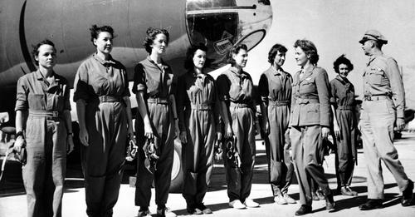

WASHINGTONPOST.COM
Perspective | Why aviation might finally ditch gendered language

FAA committee recommends gender-neutral language usage - The Washington Post

A Visit to Evelyn Marshall

At our November meeting we decided to make a donation of $50 in memory of Charlie Kulp to the Virginia Aeronautical Historical Society located at Shannon Airport.

We also decided to get Evelyn Marshall a bouquet of flowers for Thanksgiving, but when she was asked what she might like, she answered that she would prefer a potted plant – “something I can’t kill.” So Mary McCutcheon got her a Norfolk Island Pine and put two biplane ornaments on it so it could become a living Christmas Tree . She and Peggy Doyle went to deliver this plant to Evelyn and learned that Charlie’s daughter had taken the very potted plant that he and Evelyn used to decorate for Christmas, so our tree fit perfectly into that empty space by a window.

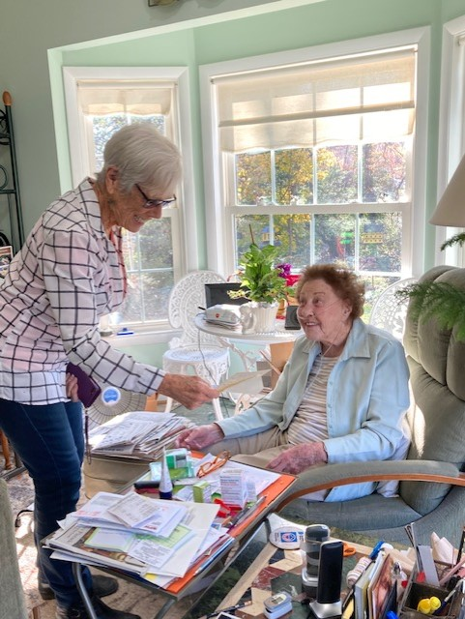

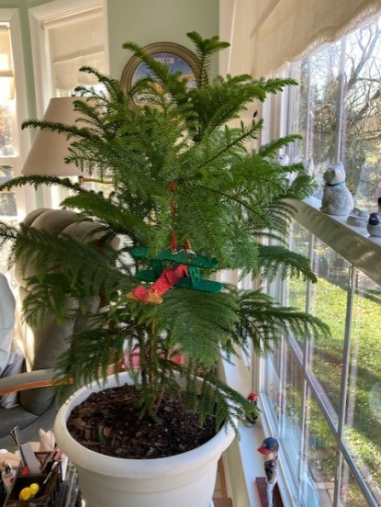
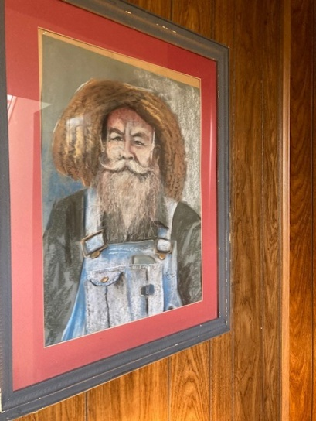

WOMEN CAN FLY

Barb Wilper, the Women Can Fly Coordination Chair, reports that there are tentative plans to hold Women Can Fly on various dates in june 2022. There is some interest in hosting this event at Hampton Roads, Warrenton, military aviation museum in Virginia Beach, and Shannon.

SCHOLARSHIPS
I. Mid-Atlantic Scholarship
Name of Scholarship: Mid Atlantic Section Scholarship
Amount of Scholarship: Up to $5,000.00
Application Receipt Deadline: February 28, 2022
Description:Mid Atlantic Section of the 99s is committed to supporting and promoting pilots who are female in the continued pursuit of aeronautical skills, both professionally and recreationally.
Open to: Any Mid Atlantic Ninety-Nine member seeking to regain currency, increase proficiency or add an additional rating, certificate or endorsement by participating in a defined training activity, e.g. instrument training, multi-engine training, CFI, CFII, seaplane, tailwheel, aerobatics, etc.
Note: This scholarship is NOT available to student pilots for initial flight training in obtaining their private pilot certificate.

APPLICATION
Please submit the following in a PDF and attachments (include your name on each document title):

An essay limited to 1000 words describing the applicant’s:
- Objectives in obtaining the scholarship – career and/or personal aviation goals.
- How the scholarship will be used to advance those goals. What challenges do you face without this scholarship?
- Any special qualifications/experiences you may have to pursue these goals.
- Aviation related activities in which you have participated (including employment), and what it means to you.
- Any obstacles you have had to overcome to start or continue flying.
- How you would contribute to the Ninety-Nines and to the aviation community in general. Please emphasize what this training would mean to you and how you plan to “pay it forward” by returning value to the aviation community.
Optional Attachments:
Any supporting documentation you deem important, such as:
- Evidence of passing written or practical test, if applicable.
- Current flight medical/BFR or other pertinent training
- Last page or more of logbook
- Reference letter from flight instructor/other.

Required Documents:
- TOTAL cost of flight training requested and how you will pay for the additional cost of training not covered by the scholarship (make it clear that there are sufficient funds from other sources to complete the training or course of study within one year). Financial need is not a requirement, but is an evaluation factor (tie-breaker).
- Letter of recommendation from applicant’s chapter chair to verify member's activity level and participation in chapter activities.

Scholarship Limitations:
- Applicant must be a member of the Mid Atlantic Section of The Ninety-Nines.
- Applicant must be a current member (in good standing) of The Ninety-Nines, Inc.
- Scholarship must be used for training within one year.

Other Information:
- Scholarship will be awarded based on qualifications of applicant.
- Scholarship funds will be disbursed directly to the appropriate training FBO or training organization.
- Invoices shall be submitted to the Treasurer of the Mid Atlantic Scholarship of The Ninety-Nines.
- The Mid Atlantic Section of The Ninety-Nines Scholarship Committee may request additional information or documentation.

Contact Information - Name & Position: Laura Savino, Mid Atlantic Scholarship Committee Chairman
Cell: 703-625-6164

Please send application as PDF document with attachments to Laura Savino at: BigPlanet747@gmail.com

2. AE Scholarships

Scholarships | AE Memorial Scholarships (The Ninety-Nines, Inc.)
AE Scholarship Application Deadline is January 1, 2022
Each year Amelia Earhart Memorial Scholarships are awarded to qualified members for five different scholarship types, including two specialized scholarships: an Emergency Maneuver Training Scholarship established in memory of 99 member Vicki Cruse and an International Scholarship, in memory of Kitty Houghton, for pilots in developing countries. In addition, the AEMSF provides Research Scholarship Grants and also First Wings Awards for Student Pilot members of the organization. 99s members and other individuals have donated to the Fund through their estate bequests and the Perpetual Scholarship program. Since 1941, the AEMSF has awarded over 800 scholarships plus more than 300 awards to student pilots earning their first certificate. The amount awarded for these scholarships, including Research Scholar Grants and Fly Now/First Wings Awards exceeds $12 Million. The AEMSF's investment account is currently valued at over $6 Million.
Questions: Contact Jacque Boyd or Peggy Doyle, AEMSF Chairman and Vice Chairman

Things to do this winter

Eat, Fly and be Merry
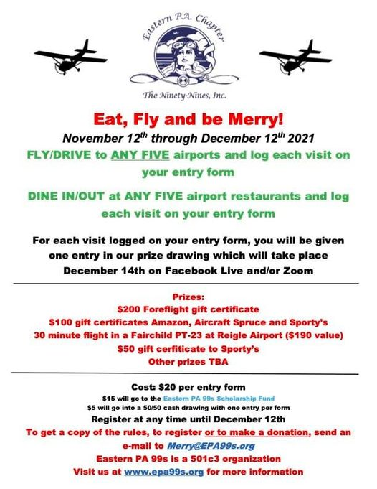

An outing in January

1. Xelevate At our November meeting we decided to schedule our Zelevate outing for January 15. We are now confirmed. So we’ll meet there or carpool there for our tour and demonstration. Let me (Mary McCutcheon) know as the date approaches whether you can go or not. (mmccutch@gmu.edu) Right at this moment, I don’t know the exact time, but I’m guessing it’ll be late morning.

Another outing idea for February?
.

Patuxent River Naval Air Museum’s
newest exhibit "Women in Aviation: Exploring Their Diverse Contributions to NAS Patuxent River and Beyond."

Plan Your Visit - Patuxent River Naval Air Museum (paxmuseum.com)

Things to watch and read

1. LAURA SAVINO’s BOOK
Laura Savino’s book is out. She says she’s “excited to let my friends know that my book is now available. Offering an insider look at what really goes on behind the cockpit door - and an encouraging push to empower women everywhere”

AMAZON.COM
Jet Boss: A Female Pilot on Taking Risks and Flying High

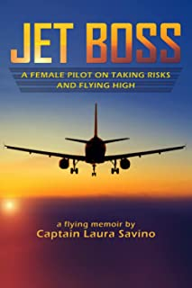
2. December Aviatrix Book Club Choice
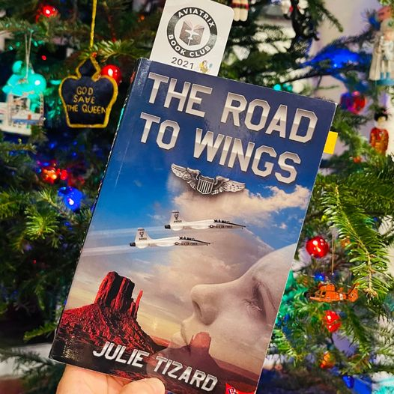

What does it take to earn Air Force wings? Your heart, your soul, even your very life? Lieutenant Casey Tompkins is starting the most difficult flight training program in the world. She has to face thunderstorms, the death of friends, and male instructors who want to wash her out.
Captain Kathryn Hardesty is the toughest and best instructor pilot on the base and the chief of flight safety. She’s demanding because she knows the price of failure is tragedy and a smoking hole. She looks out for all the students, especially the female ones.
Casey has to learn to fly a supersonic jet, not get killed in the process, and face a growing forbidden attraction. Can she muster the intelligence, courage, and unbreakable determination to become an air force pilot? Does she have what it takes to earn wings, find love, and not crash and burn?

3. December 9 at 8 PM Wednesday Webinar
WEDNESDAY WEBINAR - "Wings of Gold: The Story of the First Women Naval Aviators"
11/27/2021 - Wednesday, December 8:00–7:00 pm Central (01:00 UTC, Thursday, December 9)

4. Aviatrix Book Club Ice Breakers
Elizabeth Booker will be hosting three Ice Breakers in the next week - two on Sunday December 5th 9AM EST & 6PM EST, and one on Tuesday December 7th at 9PM EST. No pressure to read or discuss a book--just an opportunity to meet other members and maybe identify a day/time that works for you to discuss our books in the new year. RSVP by going to the Facebook Page (Aviatrix Book Club).
The books have served as a conduit for us to connect and get to know one another--and make new friends! The great thing about this experience is that you can pop in for one book that you want to read, read and discuss all of them, or just make your TBR list for the future when you have time.

5. Laura Savino’s podcast on Departure Lounge.
Stream it at your convenience

THE DEPARTURE LOUNGE PODCAST! EPISODE #37 WITH LAURA SAVINO! - YouTube

6. The 2022 choices for Aviatrix Book Club

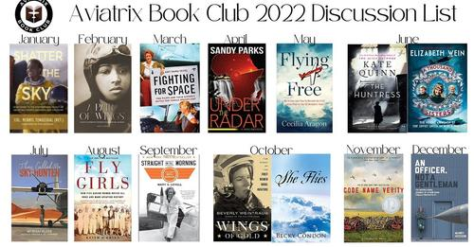

News from our members.

1. Colleen Whitehouse’s new job

Here is an email from Colleen Whitehouse:
Hi Mary!
I have decided to commit to SkyWest! I got the job offer at PSA as well but decided that my quality of life would be higher at SkyWest. I’m very excited!
I am going to training in March in Denver, Colorado. First I will take my ATP/CPT ground school, simulator, and written test. Then start indoc in Denver as well. I will be flying the Embraer 175 and it’s a gorgeous aircraft! SkyWest has ordered about 40 of these planes so I hope to get on the line soon!
In the meantime I am volunteering and mentoring a JROTC class in Callahan, FL. They have a really awesome program at the high school that’s basically a ground school and the students will even take their private written at the end of the year. Embrey Riddle donated a RedBird TD to the high school and I have been teaching them to fly in that and eventually we will get to go up in a DA20 Katana. Not all the students have the goal of being pilots when they grow up but giving them the tools to prove to themselves they can do anything they put their minds to, even really difficult things like flying, gives them confidence to peruse any dreams they have. I was so surprised that about half the class is female too! Girl power! It’s been really cool and rewarding. They are the youngest students I have ever had and I can’t wait to see what they do after high school!
Anyways, that’s what I have been up to. Just waiting for my class date. I’m hoping in the future at SkyWest I can also go into a recruiter role to continue to meet pilots in training and be able to help them reach their airline career goals. But I need to get through training first, I heard it’s very hard. But like I said, I’m still so excited!

Colleen Whitehouse

2. Elise Wheelock. Sue Passmore reports that Elise is now in Boise selling Pipers from the branch distributor there. Hope she sticks with our chapter and does well.

3. Carolyn hunker has her CFII and is still instructing at the Manassas campus of Aviation Adventures

