
SKYLINES
Newsletter February 2021

Chair: Mary McCutcheon
Vice-Chair: Melissa Plumer
Secretary: Judy Shaw
Treasurer: Barbara Wilper
Amelia Earhart Scholarship: Sue Passmore
Aerospace Education: Debbie Gallaway
Membership: Frida Norberg
Air Marking: vacant
Newsletter: Mary McCutcheon
Webmaster: Rose Brown

Laugh of the day

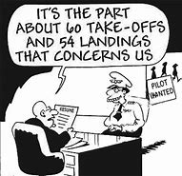

Next Meeting February 2, 2020.

Mary McCutcheon is inviting you to a scheduled Zoom meeting.
Topic: My Meeting
Time: Feb 2, 2021 06:30 PM Eastern Time (US and Canada)
Join Zoom Meeting
https://gmu.zoom.us/j/94687358126?pwd=Vy9XU1pjcHdJazJLQi9YVWE5Vml4Zz09

Meeting ID: 946 8735 8126
Passcode: 247401
One tap mobile
The Treasure Trove of Section Archives

R.J. McGlasson found a box of Section Archives in her attic and gave them to me (Mary McCutcheon). Up till the 1980s, the section was called the “Middle East Section” and has now become the “Mid-Atlantic Section”. There is a book-length manuscript of the section history, several papers detailing the earliest days of the Ninety-Nines (could these be originals??) and two carousels full of slides on the history of women in aviation with an entire script to accompany them. Now what? I will show some of the slides on Tuesday evening just for a taste and then I think I should send the whole box to Oklahoma City.

Upcoming Events

1. Ninety-Nines FIRST WEDNESDAY WEBINAR –
"Chapter Lifelines: Building and Reinforcing Our Foundation"
Wed Feb 3 - 7:00 pm Central. 8PM EST (01:00 UTC, Thu Feb 4)
Please join us for this webinar - register today!
https://attendee.gotowebinar.com/regi.../1960196548455949582
What's going on in your Chapter? How do your Chapter and your Section interact, and how do you engage with them?

2. Second Webinar: “How to Be A Chick in the Cockpit”
When: Tuesday, February 16, 2021, 7:00-9:00 pm Central (8-10 EST)
How: GoToWebinar - click here to register
Presenter: Erika Armstrong, Commercial Airline Captain, Author of A Chick in the Cockpit. In the high stakes, ego-driven world of aviation, this is an extraordinary best-selling true story of how a level-headed, self-deprecating woman with an aviation addiction finds herself in jail, her baby ripped from her arms, her piloting career taken away, and every feasible exit leading to a very dark place.

3. The Life and Death of Amy Johnson –Zoom Lecture
Wednesday 10th February 2021, 1900 ZULU = 2 PM here)

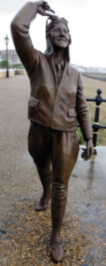
Amy Johnson was an international celebrity in the 1930s. This special lecture will be given by Jane Priston of the Amy Johnson Project for the 80th anniversary of Amy’s unexplained death when she parachuted from the plane she was delivering for ATA and landed in the freezing waters of the Thames Estuary.

If you haven't yet bought a ticket and are interested in doing so, they are available to buy from our online shop. Zoom details will follow.

3. Mercury 13 commemoration February 27 12-2 EST

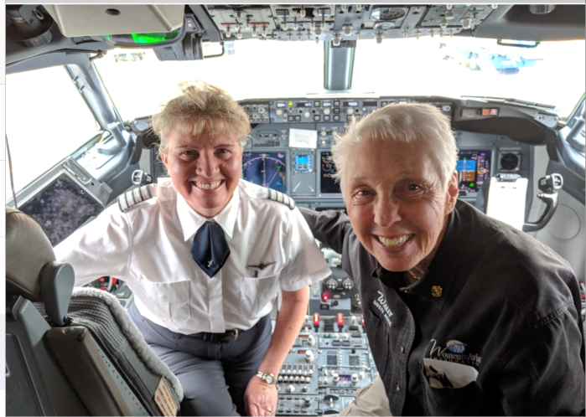

Here is Morgen Reeb with Wally Funk in 2019
Morgen says: “I’ve known Wally Funk for around 30 years. I had Wally on my flight from Albuquerque to Dallas/Ft. Worth on May 10, 2019 and we took this picture together.”

The 99s Museum of Women Pilots (MWP) is commemorating the 60th Anniversary of the culmination of the Mercury 13 program with a virtual celebration on Saturday, February 27, 2021, from 11 a.m.-1 p.m. CST. Tickets will be available through Eventbrite.com. Admission is $25 for adults. "First Lady Astronaut Trainees" Gene Nora Jessen and Wally Funk will participate in the live event hosted on Go-To-Webinar. Other participants include keynote speaker Col. Eileen Collins and Alyssa Carson, the 19-year-old who has worked endlessly towards being an astronaut since the age of three. Emcee for the event will be Janet Ivey. For more information, email to 99sMuseum@gmail.com. (But they never answered my email….)

4. Women in Aviation International
Virtual Meeting

Online Registration
WAI2021 Sponsorship Opportunities
March 17-19, 2022
Gaylord Opryland Resort
Nashville, Tennessee

5. Mid-Atlantic Section Spring Meeting

Where: online
When: Saturday, April 24, 2021
Mid-Atlantic Section
Contact: Debi Dreyfuss

6. Ninety-nines international 2021 Conference
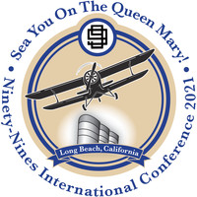
2021 International Conference and Career Expo
The business meeting will be held virtually on July 10, but the rest of the conference has been canceled
The 2022 International Conference will be held in Charleston, South Carolina, July 6-11, 2022, at the beautiful and historic Francis Marion Hotel on King Street.

7. A day trip to Fredericksburg
Why don’t we go down to the Shannon airport (Fredericksburg, EZF) and check out the Shannon Air Museum and Robin’s Nest Café? Let’s set a date in spring sometime.
This museum recently got some publicity when it acquired a vintage 1940 DC -3. When the plane was retired from service, Ron Alexander, a restorer of old aircraft, bought it and named it “Stars and Stripes”. He tragically was killed in another one of his historic planes, a Curtiss JN-4 “Jenny” in 2016. For the last four years, the plane has been in Georgia.
Founded back in 1950 by Sydney Shannon, the small airport near Fredericksburg was the home for a collection of historic airplanes. When Shannon died in 1981 the airplane collection went down to Richmond and formed a major part of the Virginia Aviation Museum.
Luke Curtas was a young man passionate about airplanes who began taking flying lessons at Shannon airport in 2004. Seeing that the airport had fallen into disrepair, he and his wife made up their minds to buy it and to fix it up. They began their restoration in 2014.
While clearing out the offices and hangars, they found a lot photos and small artifacts relating to the history of aviation and they then decided to get the airplanes back from Richmond. This was the rebirth of the Shannon Air Museum. When they learned about the “Stars and Stripes” down in Florida, they decided to buy it and fly it up to Shannon. The Curtas family intends for their collection to continue to grow.
The Shannon Air Museum is located just inside the airport entrance at 3380 Shannon Airport Circle. It is open daily by appointment only. Visit shannonairmuseum.com or call 540/642-4387 for more information. And the Robin’s Nest Café is in the restored hangar where Mr. Shannon kept his Curtiss Robin.
THINGS TO NOTICE, READ, LISTEN TO or WATCH

1. Don’t miss the cover story of the 99 News this latest issue (November-December 2020) that features Elise Wheelock.

2. A YOUTUBE TO WATCH:



YOUTUBE.COM
What are your fake arms? | Jessica Cox |

3. Read Happy Bottom Riding Club: The Life and Times of Pancho Barnes

February book for the Aviatrix Book Club. See their facebook page and sign up for one of the discussion groups

4. A PANDORA MUSIC CHANNEL JUST FOR US

The AOPA Top 100 Flying Songs is now available as a Pandora playlist, and you can register for this service at no charge to enjoy these and thousands of other great songs!

FUNDING SOURCES

1. AOPA SCHOLARSHIPS

The deadline is February 14 to apply for an AOPA scholarship. You must be a member of AOPA to qualify:

A. AOPA High School flight Training scholarship
B. AOPA Teacher Flight Training Scholarship
C. AOPA Primaryi Flight Training Scholarship
D. AOPA Advanced Rating Scholarhips
E. Aviation Industry Scholarships

Flight Training Scholarships - AOPA

2. You Fly Gal 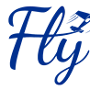

Each “You Fly Gal” Scholarship recipient will receive:

First year Student Pilot Membership in The 99s.

Donation to their local 99s Chapter.

Each year, a total of 20 scholarships will be awarded.

Ten in May – Closing date for nominations is April 15th.

Ten in November – Closing date is October 15th.

The requirements are:

1) Be a woman or girl* with a valid FAA Student Pilot Certificate

2) Have a current FAA medical certificate

3) Be NOMINATED by your primary CFI, a current member of The 99s or your Aviation Advisor / Mentor

Go to the web site www.youflygal.org

Maria Harrison set up this award program to encourage women of all ages to pursue their dream of flying by getting them involved in the 99s. She won a Fly Now scholarship and wanted to give back. She used to live down here in Virginia but is now in Maine. Next time she comes through town, she promises to visit us.

3. Private Pilot Leadership Initiative PPLI SCHOLARSHIPS

This program encourages leadership and mentoring for career oriented women who already have commercial certificates.

It is too late to apply for the winter cycle,

but not too late to meet the July 31 deadline.
These links will get you directly to the Fact Sheet and
participant application form:
- Brochure
- Fact Sheet
- Participant Application form

