
SKYLINES
Newsletter March 2021

Chair: Mary McCutcheon
Vice-Chair: Melissa Plumer
Secretary: Judy Shaw
Treasurer: Barbara Wilper
Amelia Earhart Scholarship: Sue Passmore
Aerospace Education: Debbie Gallaway
Membership: Frida Norberg
Air Marking: vacant
Newsletter: Mary McCutcheon
Webmaster: Rose Brown

Next Meeting March 3, 2021.

Mary McCutcheon is inviting you to a scheduled Zoom meeting.

Topic: Old Dominion Ninety-nines
Time: Mar 3, 2021 06:30 PM Eastern Time (US and Canada)

Join Zoom Meeting
https://gmu.zoom.us/j/96551153551?pwd=YUo3VlBzLzVoSzRnWFc2UzJzanhHUT09

Have you paid your Chapter dues?
If not, please send your $25 to
Barb Wilper
6724 Swarthmore Drive
Alexandria, VA 22307-166

I found in the documents that RJ found in her attic, the way the dues ($2) were requested from the first crop of members in 1930:

“It would be awfully nice if you would sit down right now and mail your check or the money to the treasurer, Blanche Noyes… And let’s not holler about the price.” The secretary who wrote this was Louise Thaden
The Treasure Trove of Section Archives

Speaking of the files in RJ’s attic, I did propose to give both the originals and the digital copies of the 99s 50’th anniversary slide show to Laura Ohrenberg. She is delighted and wants us to send everything we are willing to part with to the museum. But first I will be getting this material digitized. Does anyone have some equipment to copy a cassette recording and about 160 slides? If not, I will work with my friend, whose mother was a WASP, to buy some equipment which we will share.

Upcoming Events

1. Ninety-Nines FIRST WEDNESDAY WEBINAR –
FIRST WEDNESDAY WEBINAR - "2021 ARC Air Derby - A Twist on Tradition"
Wednesday March 3 - 7:00 pm Central (01:00 UTC, Thursday, March 4)

Note that this webinar is just following our monthly meeting. We should be able to slide easily from one zoom to the webinar and not miss much.
Air Race Classic will host the first ever ARC Air Derby in June 2021. The 2021 traditional Air Race Classic was cancelled due to the ongoing situation with COVID-19. The ARC Air Derby is open to a wider range of aircraft and can be flown across the U.S. as well as in other countries. This is your opportunity to create your own personal cross-country route. Challenge yourself. Make this a learning opportunity to sharpen and expand your aviation skills. Join us for this webinar to learn more!
Visit the Air Race Classic Event Details page for the Air Derby Rules and Procedures - https://www.airraceclassic.org/event-details.htm.
Panelists: Lin Caywood (ARC Safety Officer); Donna Harris (ARC Vice President); Theresa White (ARC Secretary)
Please join us for this webinar - register today!
https://attendee.gotowebinar.com/register/5640650094776071181
Please join us for this webinar - register today!
https://attendee.gotowebinar.com/register/5640650094776071181

2. FAA Safety Seminars. There are dozens of safety seminars. These can be applied to WINGS credits and are certainly worth taking. Just as an example, here is the announcement for one that is on Thursday March 4:

Moody Aviation - Two Days Of Safety Presentations
This Years Theme: The Human In Human Factors
:
Thursday, March 4, 2021 12:00 EST, 07:00 HST, 08:00 AKST,
https://zoom.us/webinar/register/WN_6mih9K24RoqqlLHo-Goh6Q
Here is a way to find out about all the others:
https://www.faasafety.gov/SPANS/events/EventList.aspx

3. Women in Aviation International Virtual Meeting

Online Registration
WAI2021 Sponsorship Opportunities
March 17-19, 2022

5. Mid-Atlantic Section Spring Meeting
Where: online To be announced later
When: Saturday, April 24, 2021
Contact: Debi Dreyfuss

6. Ninety-nines international 2021 Conference
2021 International Conference and Career Expo
The business meeting will be held virtually on July 10, but the rest of the conference has been canceled
The 2022 International Conference will be held in Charleston, South Carolina, July 6-11, 2022, at the beautiful and historic Francis Marion Hotel on King Street.
The website survey

Robin Hadfield, a ninety-nines director, wants to find out how effective the web page is. If you haven’t already done so, please give a hard and critical look at the webpage: https://www.ninety-nines.org/members/ And fill in the questionnaire
Begin Survey

THINGS TO TAKE IN

1 WATCH
The intro video about the ninety-nines museum:

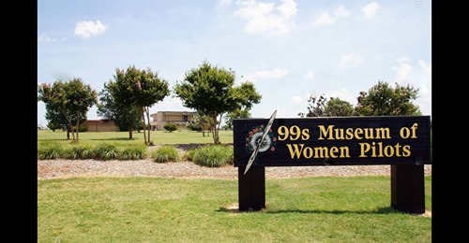

https://www.youtube.com/watch?fbclid=IwAR2CXBSZhgs6xihCse2ltRn5twOrGhPpVHxkAgdYzMEkboG-jRFbhzpKWBU&v=GT2TQSUyTmI&feature=youtu.be

2. Read
A. March selection for the Aviatrix Book Club:

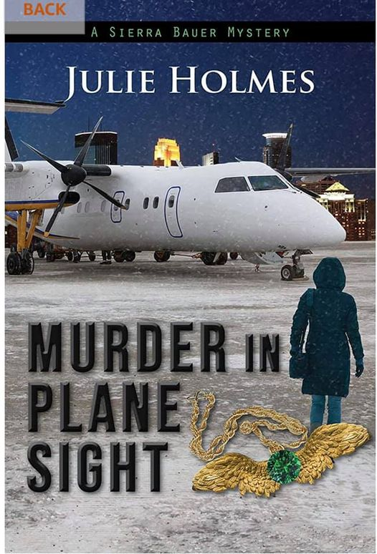
This is a thriller about an airplane mechanic who finds a body in the plane she’s working on

B. Skies Magazine series on Women at the Controls:

https://skiesmag.com/news/women-aviation-notes-female-pilots/?fbclid=IwAR1-gAX-JWKeu6Ro3Iua_C6c-DI4sCnASq1KV4_2jr1Mol2nefbBTCyClws

3. Follow facebook pages:
a. FlyGirl Kelley. Lots of aviation information.
https://www.facebook.com/flyGIRLKelley
b. Check out the resources through AOPA
https://www.aopa.org/training-and-safety/online-learning
4. Listen to good Podcasts: There are lots of episodes that encourage women in aviation from the FlyGirlKelley page.

https://flygirlllc.com/the-podcast/
FUNDING SOURCES

1. FIRST WINGS AWARD
Now is the time to think about applying for a First Wings Award.
This used to be called “Fly Now” except there were too many other programs with similar names. It is provided through the Ninety-nines and the application deadline is April 1.
The First Wings Awards are semiannual awards of up to $6,000 based on completion of specific training milestones. They are available to Student Pilot Members of The 99s who meet eligibility requirements. To be eligible, applicants must hold a student pilot certificate (or provide evidence that they meet their country's flight training requirement), have been an official Student Pilot Member three months prior to the application deadline, have logged 5 hours in the six months prior to the application deadline and show financial need.
Scholarships | AE Memorial Scholarships | First Wings Award (The Ninety-Nines, Inc.) (ninety-nines.org)
2. Private Pilot Leadership Initiative PPLI SCHOLARSHIPS

This program encourages career oriented women who

already have commercial certificates.

It is too late to apply for the winter cycle,

but not too late to meet the July 31 deadline.
These links will get you directly to the Fact Sheet and
participant application form:
- Brochure
- Fact Sheet
- Participant Application form

Accomplishments of members.
Eleanor Brunsman got her Instrument Rating at Embry Riddle
.

