
SKYLINES
April 2021

Chair: Mary McCutcheon
Vice-Chair: Melissa Plumer
Secretary: Judy Shaw
Treasurer: Barbara Wilper
Amelia Earhart Scholarship: Sue Passmore

Aerospace Education: Debbie Gallaway
Membership: Frida Norberg
Air Marking: vacant
Newsletter: Mary McCutcheon
Webmaster: Rose Brown

Next meeting will be Wednesday, April 7 at 7 PM. Sign in at 6:30 for happy half hour.

Mary McCutcheon is inviting you to a scheduled Zoom meeting.

Topic: Old Dominion 99s
Time: Apr 7, 2021 06:30 PM Eastern Time (US and Canada)

Join Zoom Meeting
https://gmu.zoom.us/j/92072272142?pwd=cEJ1WTJQU3YrdW9yZ2FKd013dE1CZz09

Meeting ID: 920 7227 2142
Passcode: 380777

Thoughts about future meetings.

Our zoom meetings are remarkably well attended and we cover the business pretty efficiently, but we are all probably impatient to meet face to face now that the weather is getting nice again.

I propose that we do our Fredericksburg field trip pretty soon.
And I propose that we have our Christmas gift exchange with a potluck also pretty soon and do it outdoors.

Our Chapter Election

We will hold our chapter election this month and we need a slate of candidates ASAP. Please consider volunteering for one of the positions that come up for election: Chairman, Vice Chairman, Secretary, and Treasurer. Do you have talents that you can put to use? We need you.

Ninety-nines International Elections

All ballots must be submitted or received by May 1, 2021 in order to be counted. Candidate information can be found in the Members Area of the website
Upcoming things to do

I. First Wednesday Webinar. Right after our meeting April 7 8 PM
Dr. Katherine Sharp Landdeck is the author of the bestseller "The Women With Silver Wings: The Inspiring True Story of the Women Airforce Service Pilots of World War II." She is an associate professor of history at Texas Woman's University, the home of the WASP archives. Landdeck is a Guggenheim Fellow at the Smithsonian National Air & Space Museum, a Normandy Scholar, and a graduate of the University of Tennessee, where she earned her PhD. She has received numerous awards for her more than two decades of work on the WASP and has appeared as an expert on NPR's "Morning Edition" and "Think," PBS, and the History Channel. Her work has been published in The Washington Post, The Atlantic, and Time, as well as in numerous academic and aviation publications. More than an aviation historian, Landdeck is also a licensed pilot who flies whenever she can. Please join us for this webinar - register today!
Register here to attend this event

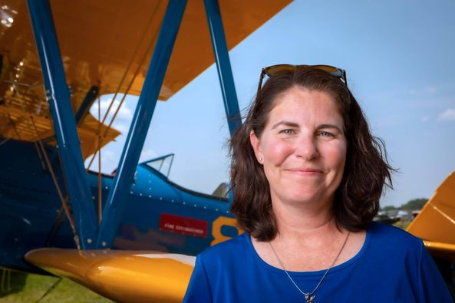

II. Captain Kelly Lepley: Turbulence to Triumph webinar
Thursday, April 15 from 8 to 9 PM EDT.
This is the fourth webinar the series about women’s empowerment in the world of aviation. Kelly Lepley had a career flying for the world’s largest package delivery company. She was at the top of her career when, in 2009, her life imploded and she lost her marriage, her home and her church community. She has risen above all of these hardships and is now a spokeswoman for becoming your authentic self. Register here
III. Learn about the By-Laws Amendments through webinars

Mark your calendar for these upcoming webinars on proposed bylaws amendments.
Proposed Amendments 1 to 12: April 16, 1:00 p.m. EDT / 7:00 pm CET April 20, 8:00 p.m. EDT / 11:00 am NZT.
Proposed Amendment 13 One Member One Vote: May 21, 1:00 p.m. EDT / 7:00 pm CET May 25, 8:00 p.m., EDT / 11:00 am NZT

I do not know how to sign up for these webinars yet.

IV. Mid Atlantic Section meeting April 24 at 10 AM

Mary McCutcheon is inviting you to a scheduled Zoom meeting.

Topic: Mid Atlantic Section Meeting of the Ninety-Nines
Time: Apr 24, 2021 10:00 AM Eastern Time (US and Canada)

Join Zoom Meeting
https://gmu.zoom.us/j/95347920896?pwd=REM1RVhmVkNMSHlSblQ3TzlrVlFVUT09

Meeting ID: 953 4792 0896
Passcode: 708056

V. Ninety-nines International meeting -- July 10

Check Straight and Level for information on attending this on-line meeting

VI. 99s Annual Fly-In September 24-26

Our re-scheduled 2021 fly-in at McKeller-Sipes Airport, Jackson, Tennessee (KMKL) is a go! Save the date: September 24-26, 2021. The event is FREE for the weekend. Register here.

VII. Projet Aviation Education and Career Expo October 29

t


Scholarships

I. FIRST WINGS AWARDS
The First Wings Awards are semiannual awards of up to $6,000 based on completion of specific training milestones. To be eligible, applicants must hold a student pilot certificate (or provide evidence that they meet their country's flight training requirement), have been an official Student Pilot Member three months prior to the application deadline, have logged 5 hours in the six months prior to the application deadline and show financial need.
The Fall First Wings Award Application deadline is October 1 each year. Membership join date must be no later than July 1 of that year.
Click here to view the Award Description and Instructions
Click here for Application1

II. Search the Ninety-nine’s web page for other scholarships:

Scholarships | Scholarship Registry (The Ninety-Nines, Inc.) (ninety-nines.org)
Note that deadlines may be April 15.

III. Ray Aviation Scholarship through the EAA Chapter 186

Only people from age 16 to 19 are eligible.
EAA 186 Ray Aviation Scholarship 2021 - https://mailchi.mp/3ea7ccfe0a6f/holidayparty-4910710

Our members activities

I. Morgen Reeb

Frank and I were in Kitty Hawk the end of February and went to visit the Aviation Mecca where it all got started. While we were there, we reminisced about the 100th Anniversary visit when a group of us from the chapter went.
Here are a few pictures from our recent visit.

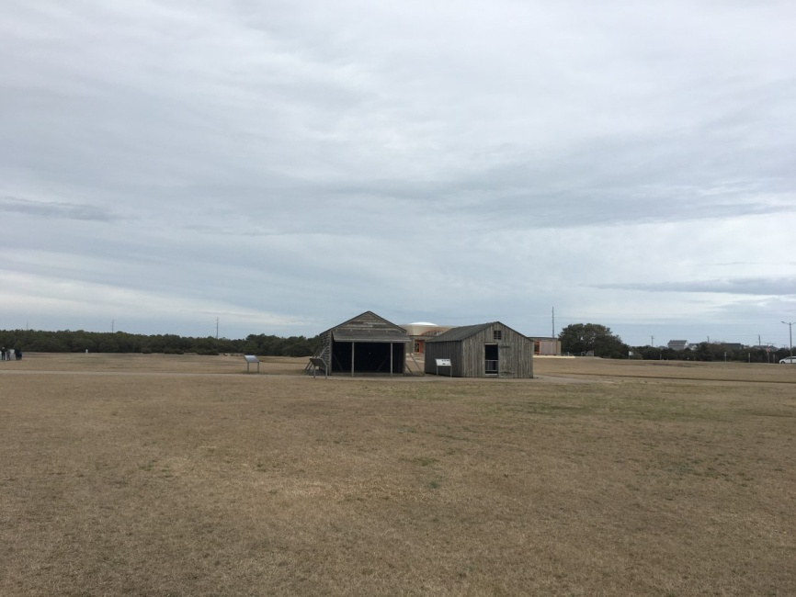

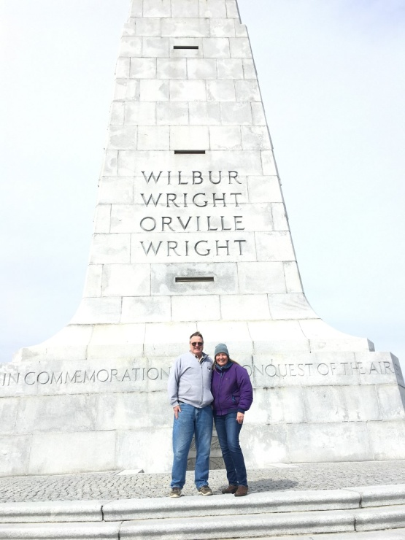

II. Laura Savino

I’m so excited to have my story of how I became a pilot published in the upcoming book
Chicken Soup for the Soul: Be You, 101 Stories of Affirmation, Determination and Female Empowerment

The title of the chapter is “My Flying Tribe”
And it is the Lead story for the chapter 2: Breaking new ground.

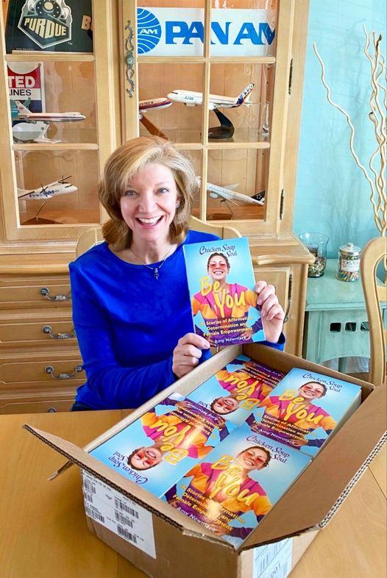

Things to Read, watch and listen to

I. Women and Flight – Evie Washington chapter

In our March meeting we talked about the book that has a chapter featuring Evie Washington. Althought it is out of print, there are copies available through some of the used book dealers. I got one through Thriftbooks and there were a few additional copies.

.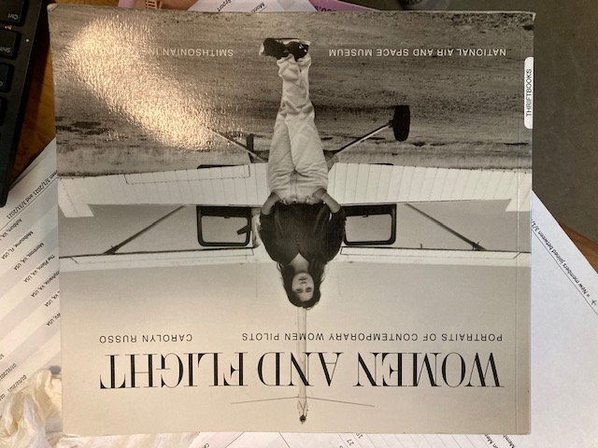

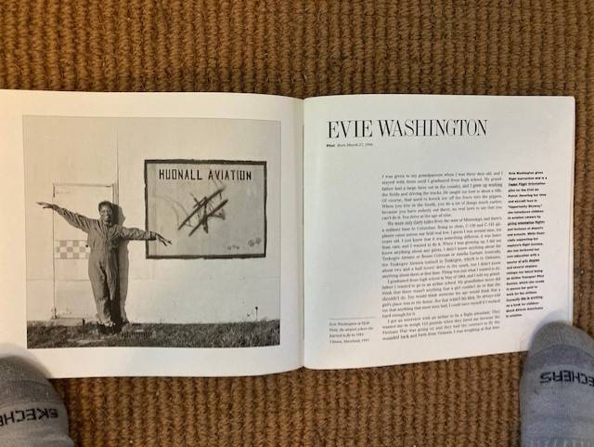

II. Aviatrix Book Club April reading:
Australian Women Pilots - Kathy Mexted.

This is an anthology of stories of ten different pilots from a very early pioneer to present day, with all different stories, adventures, and types of flying jobs. Trials and tribulations abound, but the triumphs made you want to cheer.
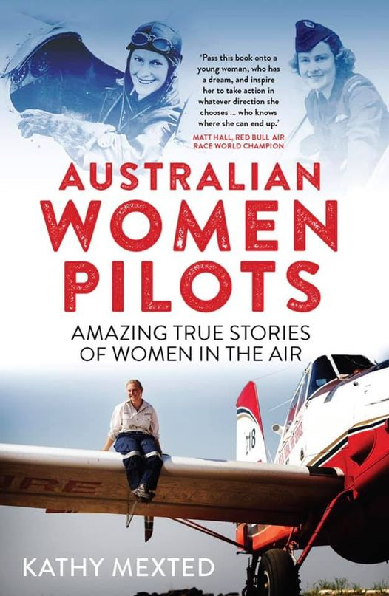

III. Ninety-nines YouTube Channel

Be sure to take a look and consider submitting your video too
How can you help? If you have any event, flight, or training videos, we would love to add them to our channel. Ballooning, gliders, aerobatics, air racing, waterbombers, flying to exotic locations... all videos will be considered for our channel. Do you have any video editing skills and are interested in helping edit video? Do you have experience live streaming on YouTube? We could use your help with editing videos and creating a regular live-stream discussion series. Questions & Video Content: contact Robin Hadfield, directorhadfield@ninety-nines.org

IV. Watch Joni Mitchell singing a song about Amelia Earhart
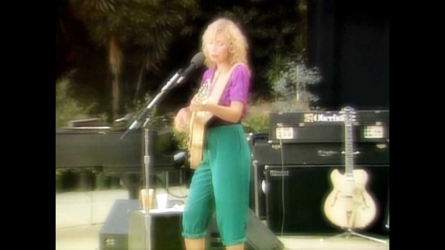 | Joni Mitchell - Amelia (Live 1979)  written & produced by Joni Mitchell | from the album Hejira (1976) | live version from Shadows & Light (1979) | guitar solo by Pat Metheny  youtu.be

