
Old Dominion Chapter
SKYLINES
May 2021

Chair: Mary McCutcheon
Vice-Chair: Melissa Plumer
Secretary: Judy Shaw
Treasurer: Barbara Wilper
Amelia Earhart Scholarship: Sue Passmore

Aerospace Education: Debbie Gallaway
Membership: Frida Norberg
Air Marking: vacant
Newsletter: Mary McCutcheon
Webmaster: Rose Brown

Next Meeting

Topic: Old Dominion 99s monthly meeting
Time: May 6, 2021 06:30 PM Eastern Time (US and Canada)

Join Zoom Meeting
https://gmu.zoom.us/j/99554957533?pwd=cjFER3E4VjFYU2Z0UWxmWVJQcnhYQT09

Meeting ID: 995 5495 7533
Passcode: 024829

Plea for payment of dues (From Barb Wilper)

CHAPTER DUES: The Chapters of the 99s are completely self-supporting. They do not receive any part of the dues you pay to International. The Chapter, however, does have financial needs which include web site fees, administrative expenses, and materials and logistics to support air aviation events. These events have included: Women Can Fly, ProJet Aviation Expo, Women's Day at Udvar-Hazy, Safety Seminars, and Air Markings. To this purpose, we request annual payment of Chapter dues in the amount of $25.00.

The upcoming fiscal year of the Old Dominion Chapter is June 1, 2021 to May 31, 2022. Please send Chapter dues for the 2021-2022 fiscal year, payable to Old Dominion 99s, to (treasurer) Barbara Wilper, 6724 Swarthmore Dr., Alexandria, VA 22307.

Election results

Our chapter elections were held in April and with only ten people casting ballots, we elected Mary McCutcheon as chair, Laura Savino as vice-chair, Barb Wilper as treasurer, and Judy Shaw as secretary. Thanks go to Jeannine Bouvier for keeping the tally. If you can offer feedback about the election process so that we get a bigger turnout in the future, please notify either Judy Shaw jashaw@cox.net or Jeannine Bouvier jbouvier@bleuwavesolutions.com and make any recommendations you have.

Things to do this summer and fall

1. June 5 Field Trip to Fredericksburg. We scheduled a tour of the museum in Fredericksburg (Shannon Airport) for Saturday, June 5. Each of us gets there however we want and aim to arrive at 11. We’ll have lunch at the Robin’s Nest Café. There are COVID protocols in place, so we have to stay in small groups, socially distant, and masked. Many of us are vaccinated, so we might feel safe no matter what.

2. July 10 Ninety-nines International meeting

The meeting will be online again this year.

Information on registering will be announced

3. July 26 through August 1 EAA AirVenture Oshkosh
EAA AirVenture - Whittman Regional Airport (OSH)
The Ninety-Nines will have a booth in the exhibit area.
4. September 10-12 Old Dominion Chapter Fly-in to Ocracoke.

5. September 17-18 International Forest of Friendship Celebration, Atchison, Kansas

6. September 24-26. Ninety-nines annual fly-in.
McKeller-Sipes Airport, Jackson, Tennessee (KMKL).
The event is FREE for the weekend. Register here.

7. September 25 Leesburg air show.

8. October 9 (Raindate October 10) Culpeper air show.

9. October 29. ProJet Expo at Leesburg. We have a table and will arrange to have it staffed with volunteers. And if you know young students who can benefit from some of the career opportunities,
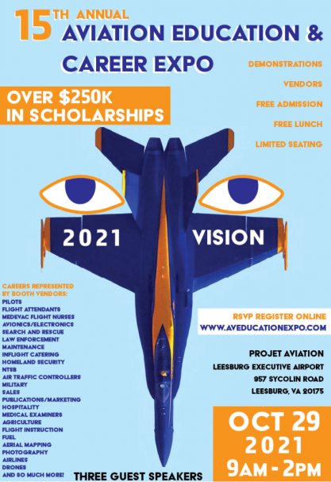

News from our members
1. Oldest member, Elizabeth Fisher. I called up Elizabeth Fisher at Greensprings Retirement community and had a great conversation with her. She was born in 1923 and started flying at age 18. Her earliest memory of the thrill of aviation was when she was a little girl in Bethlehem, Pennsylvania picking up paper promotional leaflets being dropped from planes. Then when she graduated from high school in around 1941, her father asked her what she wanted. She replied “flying lessons”. She graduated from Smith College – a school with a track record of encouraging women in aviation: the founder of the Nancy Love (founder of the WAFS), Gloria Whitten Heath (a WASP), and a flight instructor were all there at more or less the same time in the early 1940’s. After college, she continued flying for fun, but had a really serious job with the CIA.

2. Newest member, Kenya Carr. Welcome to the Old Dominion Chapter, Kenya Carr. She lives in Centreville and is taking lessons at Gaithersburg.

3. Jenny Reeb earned her Commercial Single-engine rating! Now she starts attending the CFI academy at Florida Tech and taking summer school courses.

4. Morgen and Jenny Reeb at Sun n Fun
By Morgen Reeb
I had the pleasure of taking my daughter Jenny to her first Sun-n-Fun and first large aviation event. It was a lot of fun seeing her enjoy the newness and amazement of so many airplanes in one place. I had Jenny pick out the pictures for the newsletter. She picked out some of her favorites.
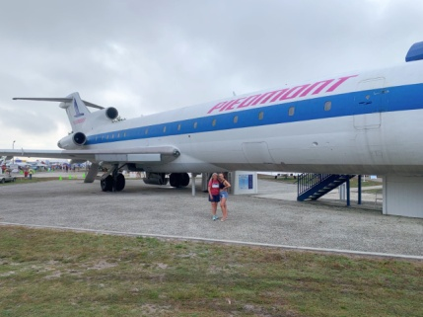
The Boeing 727 was the first airplane that I flew for American Airlines. We had a lot of fun looking at all the warbirds, homebuilts, antiques and classic airplanes.
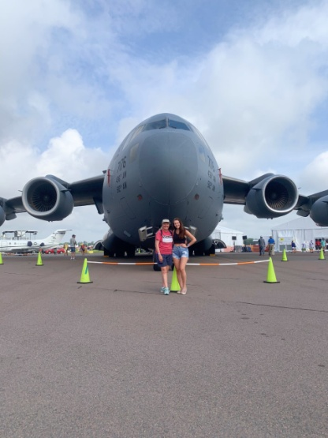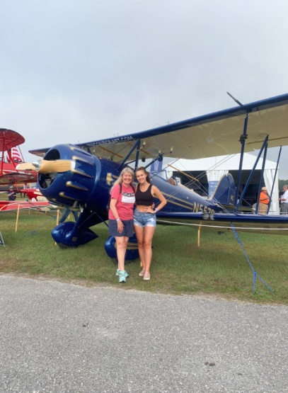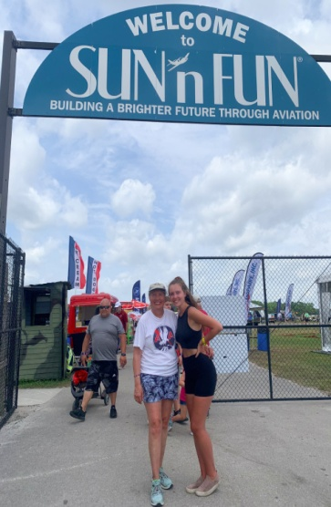
We met and talked with several women military pilots representing their units. The Ninety-nines house was a great place to hang out and watch the airshows. That’s where we ran into Mary Wunder.
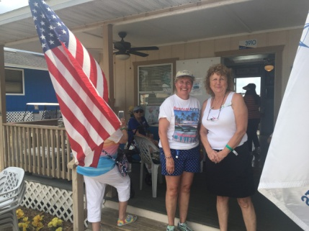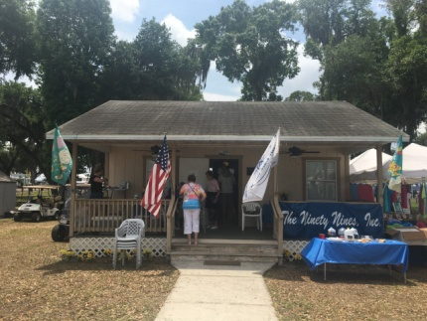
The airshows were spectacular. The Blue Angles performed in their new F18A’s. Every day there was a demo flight with the F22 Raptor, an amazing airplane that uses the new thrust vector design to make it unbelievably maneuverable. The MXSRH, flown by Rob Holland, also uses the thrust vector design. I saw aerobatic maneuvers I’ve never seen before. They also had performers flying Pitts, Christen Eagles, Extra 300, F4U, P51, P40, C17, T6, and even a Bonanza.
Jenny and I had never seen a night airshow before, so for us it was one of the highlights. The Aeroshell team comprised four T6’s with lots of lights. As the team performed aerobatics in tight formation it looked like one large airplane and then they all split up. Manfred Radius performed in a sailplane with glittery smoke out the back. His performance was like ballet in the air. The newest technology was about 100 drones flying around forming different pictures in the air. Here is their aerial flag:
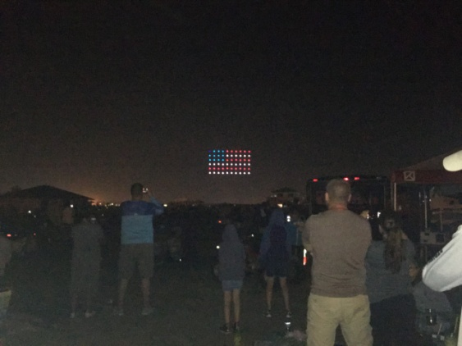
Sun-n-Fun 2021 was very successful and a great one for our memory books.
5. Frank Reeb’s retirement

By Morgen Reeb

Frank, my 49 ½ retired from American Airlines after a retirement flight on Sunday April 25th from Dallas/Ft. Worth to Washington National Airport. His first officer was Mike Swift. He received a water cannon salute, one fire truck on each side of the airplane.
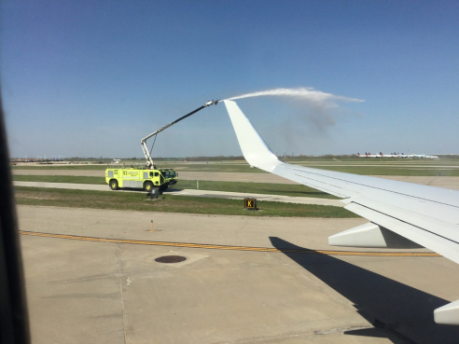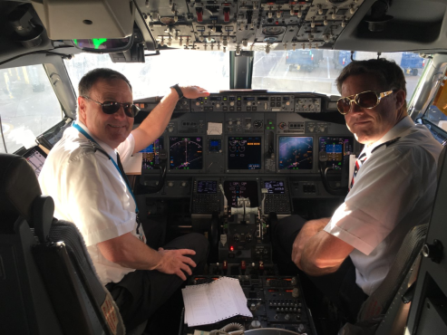
I was able to accompany him on his last AA trip and we had a nice overnight in Kansas City. I got him an “Official American Airlines Retiree” T-shirt and at the bottom it says “Now I’m living the Dream”. So now it is official, Frank is retired from American Airlines and he has the T-shirt!

6. Meaghan Cohen (Maryland Chapter) won the Mid Atlantic Section scholarship. Too bad she’s not from our chapter.
Things to read, watch, listen to, and be aware of

1. Laura Savino

Chicken Soup for the Soul: Be You. 101 Stories of Affirmation, Determination and Female Empowerment

Is now available for purchase. Lauras chapter, My Flying Tribe is the lead story for chapter 2, and has also been singled out in publicity as the highlight of the book.
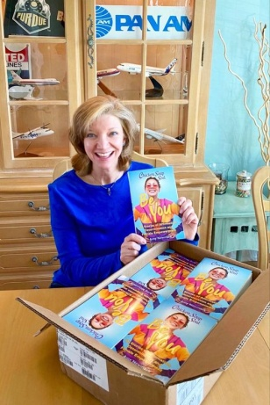

2. May book of the month for Aviatrix Book Club:
The Women Who Flew for Hitler by Clare Mulley
Becky Condon writes:
·
This is the 5th book for the Aviatrix Book Club and it is a five star WOW!... ·
This was a wildly fascinating history of two incredible women, each with amazing stories. It was also a detailed snapshot of a time and place from a very different angle than the WWII story is normally told. Interesting and well worth reading.

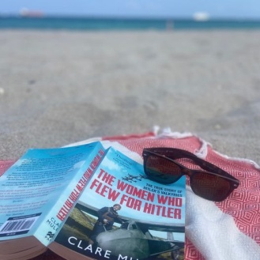

3. Get familiar with the bylaws amendments , including:

Proposed Amendment 13 One Member One Vote
Two webinars are coming up in May to satisfy your curiosity and answer your questions. You may be wondering, what is this proposed amendment about? Currently, not everyone attending an annual meeting of The Ninety-Nines has a vote. Instead, delegates cast votes on behalf of members. The process of selecting delegates to represent the wishes of chapter members and then registering delegates prior to voting is complicated. At recent annual meetings, only a portion of the members were actually represented by delegates. With recent improvements in technology and software, holding meetings online allows members to attend who cannot do so in person. At the annual meeting, held online July 11, 2020, attendance was more than double that of the 2019 meeting. Voting can also be done online which simplifies counting.
The full set of proposed amendments can be accessed through the Bylaws and Standing Rules Information page in the Member Area of the Ninety-nines website. To learn more about this proposed amendment join the International Bylaws and Standing Rules Committee for a Zoom meeting on May 21, 1:00 pm EDT / 7:00 pm CET or May 25, 8:00 pm EDT / 11:00 am NZT For those who have not yet registered for one of these webinars, information on how to register will be coming in a separate email announcement from International.

4. Other Ninety-nines webinars

a) Turbulence to Triumph: Navigating Experiences to Empowerment Where: online When: Tuesday, May 18, 2021, 8:00 t 10:00 pm (EDT) Register: Registration For more information: contact Monica Randolph-Graham

b) WEBINAR - BIG PICTURE WEATHER FLIGHT PLANNING
Sponsored by The Ninety-Nines and SiriusXM
June 30, 2021 8:00 PM, EDT
Planning for a flight starts days in advance of the flight with the big weather picture. Join CFI, former NWS research meteorologist, and founder of EZWxBrief, Dr. Scott Dennstaedt, as he shares his expertise on how to monitor and plan for the weather in the days leading up to your summertime flight. Additional Topics will include · Forecasting the potential for deep, moist convection · Maximizing the use of prog charts . Think convection, not thunderstorms Accepted for FAA Wings. Registration information to come soon.

Scholarships and other support

PPLI Deadline - Autumn

Autumn Session
When: Saturday, July 31, 2021
How to apply
If you are a 99s member with at least a commercial certificate (and be actively flying) pursuing a professional pilot career, or you are an established professional who wants to take your career to the next level, this program is designed for you. These links will get you directly to the Fact Sheet and participant application form:
- Brochure
- Fact Sheet
- Participant Application form

For more information, go to www.ninety-nines. org/resources.htm
or email mentoring@ninety-nines. org

