
Old Dominion Chapter
SKYLINES
June 2021

Chair: Mary McCutcheon
Vice-Chair: Melissa Plumer
Vice-Chair Elect: Laura Savino
Secretary: Judy Shaw
Treasurer: Barbara Wilper
Amelia Earhart Scholarship: Sue Passmore

Aerospace Education: Debbie Gallaway
Membership: Frida Norberg
Air Marking: vacant
Newsletter: Mary McCutcheon
Webmaster: Rose Brown

Next Meeting

Time: Jun 3, 2021 06:30 PM Eastern Time (US and Canada)

Join Zoom Meeting
https://gmu.zoom.us/j/92602394415?pwd=a2xpbkV4TzFrSUVCbXJIczJzWUd4UT09

Meeting ID: 926 0239 4415
Passcode: 255101

Laugh (or cry) of the Day

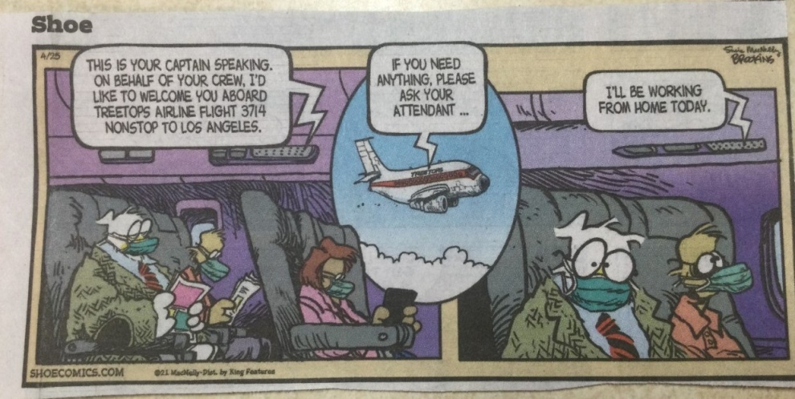
Plea for payment of dues (From Barb Wilper)

CHAPTER DUES: The Chapters of the 99s are completely self-supporting. They do not receive any part of the dues you pay to International. The Chapter, however, does have financial needs which include web site fees, administrative expenses, and materials and logistics to support air aviation events. These events have included: Women Can Fly, ProJet Aviation Expo, Women's Day at Udvar-Hazy, Safety Seminars, and Air Markings. To this purpose, we request annual payment of Chapter dues in the amount of $25.00.

The upcoming fiscal year of the Old Dominion Chapter is June 1, 2021 to May 31, 2022. Please send Chapter dues for the 2021-2022 fiscal year, payable to Old Dominion 99s, to (treasurer) Barbara Wilper, 6724 Swarthmore Dr., Alexandria, VA 22307.

Understand the by-laws changes
And make sure our delegates to the International Meeting hear your thoughts

There are 13 amendments to the bylaws being proposed.
The most significant one is Number 13, -- One Member – One Vote
Currently, not everyone attending an annual meeting of The Ninety-Nines has a vote. Instead, delegates cast votes on behalf of members. The process of selecting delegates to represent the wishes of chapter members and then registering delegates prior to voting is complicated. At recent annual meetings, only a portion of the members were actually represented by delegates. With recent improvements in technology and software, holding meetings online allows members to attend who cannot do so in person. At the annual meeting, held online July 11, 2020, attendance was more than double that of the 2019 meeting. Voting can also be done online which simplifies counting. The full set of proposed amendments can be accessed through the Bylaws and Standing Rules Information page in the Member Area of the website. Here is a link that includes a 30 minute webinar:

Bylaws and Standing Rules Information (The Ninety-Nines, Inc.)

Nominations for Forest of Friendship

We have an opportunity to nominate someone for the Forest of Friendship.
What IS the Forest of Friendship and who does it celebrate? It is in Atchison, Kansas and was founded in 1976 to honor pioneer aviators and those who contributed substantially to aviation and to space exploration. It was established in part by the Ninety-nines but celebrates both men and women. Should we nominate someone?

Let me know what you think. mmccutch@gmu.edu.

WASP NEWS

1. Note what’s happening at the AirPower Museum up in Farmingdale, NY.
This is worth a trip – maybe a Fly-in someday

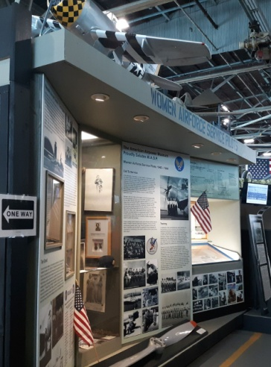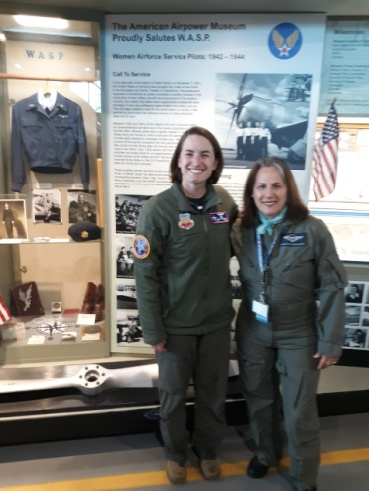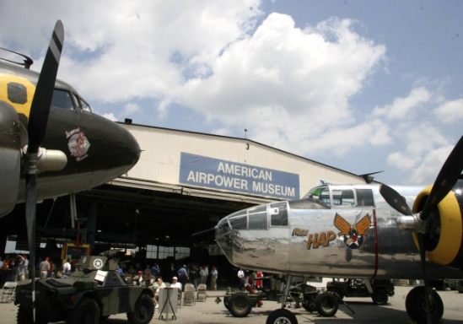

This comes from Julia Blum who has curated this collection as well as the archives at the Cradle of Aviation nearby.
“ On June 13, 2021 the WASP exhibit at American Airpower Museum will celebrate its 20th anniversary at the American Airpower Museum in Farmingdale, NY (the former site of Republic Aviation). This exhibit was dedicated by, then, NY Gov. George Pataki in the presence of eight WASP who were each given the NYS Conspicuous Service Medal. Teresa James, who flew ‘Ten Grand’ (the 10,000th P-47 Thunderbolt built) attended the ceremony and we spent a wonderful week together at my home following the dedication. The museum itself is housed within one of the remaining historic hangars where the P-47s were manufactured and finished by the Republic Aviation Corp. From there, a group of WASP on TDY ferried the completed P-47s to the docks at Newark, NJ for shipment overseas in 1944.
Due to a great deal of media attention at and following the opening of the exhibit and the many special flight operations involving the WASP, their history and legacy received a great deal of exposure. Hence, the American Airpower Museum is one of the educational institutions listed on the resolution to award the WASP the Congressional Gold Medal. Preceding the CGM, the names of the 38 WASP who died in the service were read into the Congressional Record in 2003 by Congressman, Steven Israel.
Attached are a few photos of today's event at Airpower. The B-25 in the foreground of the exterior photo of the Museum is the oldest flying B-25 and was once Gen. Hap Arnold's transport plane, now named 'Miss Hap'
I welcome all to visit the museum if/and or when you find yourself in the NY metropolitan area! Drop me a heads up email and I will give you a personal tour. Because of the museum's strong relevance to the WASP who ferried aircraft from its site, here is the link to an article written for the publication Metropolitan Airport News, May 2021
https://metroairportnews.com/the-american-airpower-museum-at-republic-airport/
Regards,
Julia Lauria-Blum
Curator, WASP WWII Exhibit
American Airpower Museum at Republic, Farmingdale, NY
Email: juleblu@gmail.com
2. Unveiling of the WASP memorial plaque at Conroe, Texas.

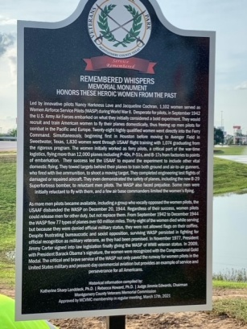

3. WASP Homecoming was May 15 in Sweetwater, TX
See what happened
https://waspmuseum.org/events/homecoming-virtual.html
https://www.facebook.com/nationalwaspww2museum/videos/206695264428797

Things to do this summer and fall

1. June 5 Field Trip to Fredericksburg.

We scheduled a tour of the museum in Fredericksburg (Shannon Airport) for Saturday, June 5. Each of us gets there however we want and aim to arrive at 11. We’ll get a tour of the museum as well as lunch at the Robin’s Nest Café. There are COVID protocols in place, so we have to stay in small groups, socially distant, and masked. Many of us are vaccinated, so we might feel safe no matter what, but as a matter of courtesy, let’s stay masked whenever it seems proper.
2. Wednesday, June 9 – 8:00 pm
Ninety-nines Wednesday webinar is now known as the
“SECOND WEDNESDAY WEBINAR” - "Stabilized Approaches and Landings"
This webinar is a FAASTeam offering that is part of a joint FAA/industry public education campaign emphasizing the need for training and currency of stabilized approaches, which are key to safe approaches and landings. The stabilized approach concept is characterized by maintaining a stable approach speed, descent rate, vertical flightpath, and configuration to the landing touchdown point.
This presentation acquaints the audience with the hazards of flying unstabilized approaches and landings and offers suggestions for avoiding accidents. It is eligible for WINGS credit.
Speakers: Minnetta Gardinier (Iowa FAASTeam Representative.); Deb Henneberry, Ed.D. (Assisant. Prof. of Aeronautics, Vaughn College; CFI/CFII/MEI)
Registration
3. June 30 8:00 PM EDT
Big Picture Weather Flight Planning Webinar

Sponsored by Sirius XM Aviation and the Ninety-Nines, this webinar is designed to prepare you for summertime flying. Planning for a flight starts days in acvance with the big weather picture. Join CFI, former NWS research ;meteorologist, and founder of EZWxBrief, Dr. Scott Dennstaedt, as he shares his expertise on monitoring and planning for weather. You will Learn:
Forecasting the potential for deep, moist convection
Maximizing the use of prog charts
Think convection, not thunderstorms
Accepted for FAA Wings Credit
Link to register: https://siriusxmcommunications.com/aviationwebinars

4. July 10 Ninety-nines International meeting

The meeting will be online again this year.

Information on registering will be announced
Because the one vote for every member has not been changed yet, we still have to select delegates to cast our votes. I should learn soon what this entails. If you have a strong desire to be a delegate, let me know: mmccutch@gmu.edu

5. July 26 through August 1 EAA AirVenture Oshkosh
EAA AirVenture - Wittman Regional Airport (OSH)
The Ninety-Nines will have a booth in the exhibit area.
6. September 10-12 Old Dominion Chapter Fly-in to Ocracoke.

7. September 17-18 International Forest of Friendship Celebration, Atchison, Kansas

8. September 24-26. Ninety-nines annual fly-in.
McKeller-Sipes Airport, Jackson, Tennessee (KMKL).
The event is FREE for the weekend. Register here.

9. September 25 Leesburg air show.

10. October 9 (Raindate October 10) Culpeper air show.

11. October 15 and 16th. MidAtlantic Section meeting.

The Maryland Chapter is excited to announce dates for the Fall 2021 Section Meeting. Save Friday October 15th and Saturday October 16th. Fly into Martin State KMTN. Hoping to do a hybrid Zoom Saturday morning for those who cannot attend in person. Details and registration coming soon.

12. October 29. ProJet Expo at Leesburg. We have a table and will arrange to have it staffed with volunteers. And if you know young students who can benefit from some of the career opportunities,

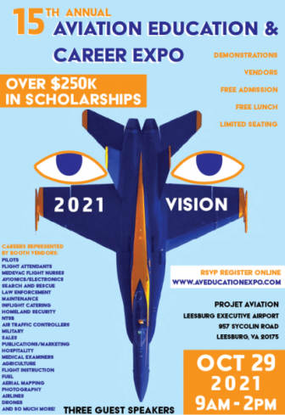

Accomplishments or our Members

Piper Aircraft is proud to sponsor a team in this year’s Air Race Classic Derby! Our very own Elise Wheelock will race alongside aviation legends Olga Custodio and Tammie Jo Shults in a brand new Pilot 100i. Stay tuned for updates to come as the derby approaches.


Things to read, watch, listen to, and be aware of

1. June selection for Aviatrix book club:

June 2021 - FLYGIRL by R.D. Kardon

2. See the film RISE ABOVE WASP

“Rise Above: WASP” is a finalist at the New York International Women Festival. Festival results will be announced later next month. https://www.hemlockfilms.com/riseabovewasp
Training opportunities

1. On-line Ground School
Dan George CFI at College Park
Has produced an On line Ground school
Ground School | FlightInsight | Flight Training (flight-insight.com)

Scholarships and other support

PPLI Deadline - Autumn

Autumn Session
When: Saturday, July 31, 2021
How to apply
If you are a 99s member with at least a commercial certificate (and be actively flying) pursuing a professional pilot career, or you are an established professional who wants to take your career to the next level, this program is designed for you. These links will get you directly to the Fact Sheet and participant application form:
- Brochure
- Fact Sheet
- Participant Application form

For more information, go to www.ninety-nines. org/resources.htm
or email mentoring@ninety-nines. org

