
Old Dominion Chapter
SKYLINES
July 2021

Chair: Mary McCutcheon
Vice-Chair: Laura Savino
Secretary: Judy Shaw
Treasurer: Barbara Wilper
Amelia Earhart Scholarship: Sue Passmore

Aerospace Education: Debbie Gallaway
Membership: Barb Wilper
Air Marking: vacant
Newsletter: Mary McCutcheon
Webmaster: Rose Brown

Next Meeting

Time: Thursday, July 8, 2021 06:00 PM Eastern Time (US and Canada)

Mary McCutcheon is inviting you to a scheduled Zoom meeting.

Topic: Monthly meeting
Time: Jul 8, 2021 06:00 PM Eastern Time (US and Canada)

Join Zoom Meeting
https://gmu.zoom.us/j/98093085586?pwd=Z3pmNDVVbHlmNGgzczY2ekxxUjZ3QT09

Meeting ID: 980 9308 5586
Passcode: 454370

Ninety-nines International meeting

will be this Saturday (July 10) by ZOOM. Our delegates, Mary McCutcheon, Judy Shaw and Barb Wilper will be casting votes for or against the 13 by-laws changes. Please let one of us know if you have a position. At the meeting Thursday July 8, we will take a poll among the attendees, but if you can’t make the meeting let one of us know BEFORE SATURDAY. Mary McCutcheon (mmccutch@gmu.edu), Judy Shaw (jashaw@cox.net) Barb Wilper (bwilper@verizon.net).

Our hugely successful field trip to Shannon (Fredericksburg)

On June 5, a bunch of us met at Shannon airport after a grueling drive down there. It took us about 2 ½ hours to go from Alexandria to Fredericksburg. But once we got there we had a wonderful lunch in the retro Robin’s Egg Café and then had a guided tour of the museum to see airplanes from almost every era of aviation and aircraft featured in Hollywood films. The drive home again was relatively painless.

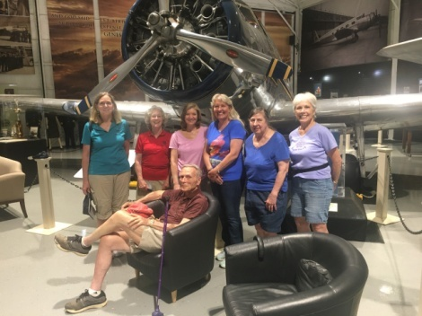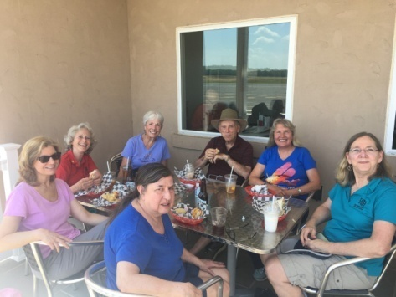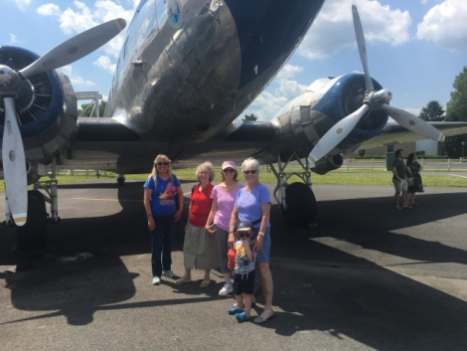

NEWS ABOUT WALLY FUNK



Wally Funk was the youngest person on the Mercury 13 team and now will be the oldest person to go into space. The launch is scheduled for July 20. Stay tuned. She has been a 99 since 1958.

Trailblazing Female Pilot to Join Jeff Bezos on Spaceflight - The New York Times (nytimes.com)

ARC AIR DERBY REPLACES AIR RACE CLASSIC FOR 2021

The original race was cancelled because of the pandemic, but 54 teams completed the air derby and our own Elise Wheelock was among them.

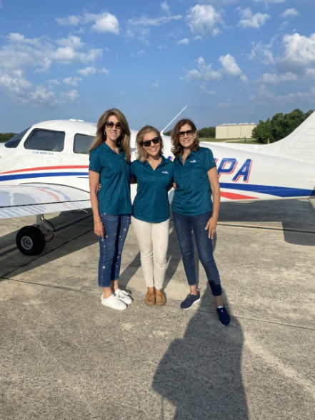

Here is Elise’s story:

This year I had the opportunity to participate in the Air Race Classic Derby. I have been hoping to participate in the Air Race Classic since I was a student pilot, when I volunteered at one of the airport stops of the 2015 race. Because of the uncertainty of the past year, the traditional 2,500nm race was modified to be a one-day, five leg race with each leg being a minimum of 65nm in length. Each team had the opportunity to select their own route, and to fly it any one day out of a two-week window.
My team was about as high-powered as it gets: Tammie Jo Shults and Olga Custodio, both women who have made amazing contributions to female aviators and aviation in general. Tammie Jo is a former Naval aviator and retired captain at Southwest Airlines. Olga is a former Air Force aviator and captain at retired American airlines. Both women are active in promoting and encouraging up-and-coming young pilots. I had worked with Olga in the past on a Girls in Aviation Day, and so when she called and asked me to be part of her team I was thrilled! Piper Aircraft - my employer - even agreed to sponsor us and provide an airplane, which they decorated with vinyls of our team name, Tres Aviadoras, and each pilot name under her respective window.
We planned our race in the San Antonio area. We spent several days planning, figuring out our coordinates in decimal degrees to the third decimal place, and planning the times for our legs. Finding a time in the two-week window where we all had enough time to meet up, prepare, and fly the race turned out to be much more difficult than I had initially expected.
Race day dawned beautiful, but incredibly hot. The first leg got us off to a great start – we were less than one second off! The second leg went similarly well. I was flying, Olga was navigating, and Tammie Jo was keeping us on time. The third leg went perfectly well until we realized that we had not added enough time for the traffic pattern. I executed a power-off 180, saving us precious seconds, I thought. Unfortunately – the judges found the power-off 180 to be a nonstandard traffic pattern, and that leg was disqualified. The last two legs were an epic recovery from another small miscalculation. On the last leg, we ended up only in 12th place, but we had to add in a whole 10 minutes! We flew at slow flight for almost an hour, and successfully corrected for the miscalculation.
Even though we didn’t place in the final race, the learning experience and the team that I got to work with more than made the experience amazing. A lot of the challenges we faced could have been prevented with a little more time and planning, but now we know what to watch out for next year!

Things to Do July through October

1. July 10 Ninety-nines International meeting

The meeting will be online again this year.

Information on registering will be announced
Because the one vote for every member has not been changed yet, we still have to select delegates to cast our votes. I should learn soon what this entails. If you have a strong desire to be a delegate, let me know: mmccutch@gmu.edu

2. July 18 Ninety-nines Day at the Flying Circus.

Gates open at 11:00 AM
Pre-Show starts at 2:00
Airshow starts promptly at 2:30 PM
Airshow ends at approximately 4:00 PM

The Flying Circus Aerodrome is located 14 miles SE of Warrenton, VA and 22 miles NW of Fredericksburg, VA.
We are just off Route 17, at 5114 Ritchie Road (Route 644) in Bealeton, VA.
Just look for the Flying Circus Airport Sign
Tickets are $16.00 per adult

3. July 26 through August 1 EAA AirVenture Oshkosh
EAA AirVenture - Wittman Regional Airport (OSH)
The Ninety-Nines will have a booth in the exhibit area.
4. August 21 Innovations in Flight at Udvar-Hazy
If any of you are interested in participating. The National Air and Space Museum is holding our Innovations in Flight Day on August 21, 2021. Sign up to fly in here. This will be an outdoor event focusing on airplanes on the ramp.

5. September 10-12 Old Dominion Chapter Fly-in to Ocracoke.

6. September 17-18 International Forest of Friendship Celebration

International Forest of Friendship Celebration (45th Year)
Atchison, Kansas - September 17 - 18, 2021
Weekend Schedule
Friday, September 17:
1:00 to 3:30 p.m. - Registration at Atchison Chamber of Commerce, 200 Tenth Street. You can also check in with us later at the Cocktail Party.
5:00 p.m.- Friday Evening Cocktail Party at the Amelia Earhart Birthplace Museum, 223 N. Terrace St, Atchison KS 66002. Two tickets for the bar are included with each registration. Pick-up from hotels at 5:00 p.m., return trolley at 8:00 p.m.

Saturday, September 18
9:15 a.m.- Bus transportation from the hotels to the International Forest of Friendship for the Induction Celebration.
10:00 a.m. - Induction ceremonies at the Forest. Bus transport to Luncheon afterwards.
1:30 p.m. - Luncheon at Benedictine College, McCallister Board Room, 1020 N 2nd St., Atchison, KS 66002, with keynote speaker (Cash Bar will be provided)
4:00 p.m - Bus transportation to hotels
Afternoon trolley and visits to Atchison landmarks
6:00 p.m. - Dinner and hangar dance at AE airport. (This is not included in your registration fee, there is an additional $10.00 fee if you wish to attend.

7. September 24-26. Ninety-nines annual fly-in.

McKeller-Sipes Airport, Jackson, Tennessee (KMKL).
The event is FREE for the weekend. Register here.

8. September 25 Leesburg air show.

9. October 9 (Raindate October 10) Culpeper air show.

10. October 15 and 16th. MidAtlantic Section meeting.

Save Friday October 15th and Saturday October 16th. Fly into Martin State KMTN. Hoping to do a hybrid Zoom Saturday morning for those who cannot attend in person. Details and registration coming soon.

11. October 16 (October 30 rain date) Poker Run

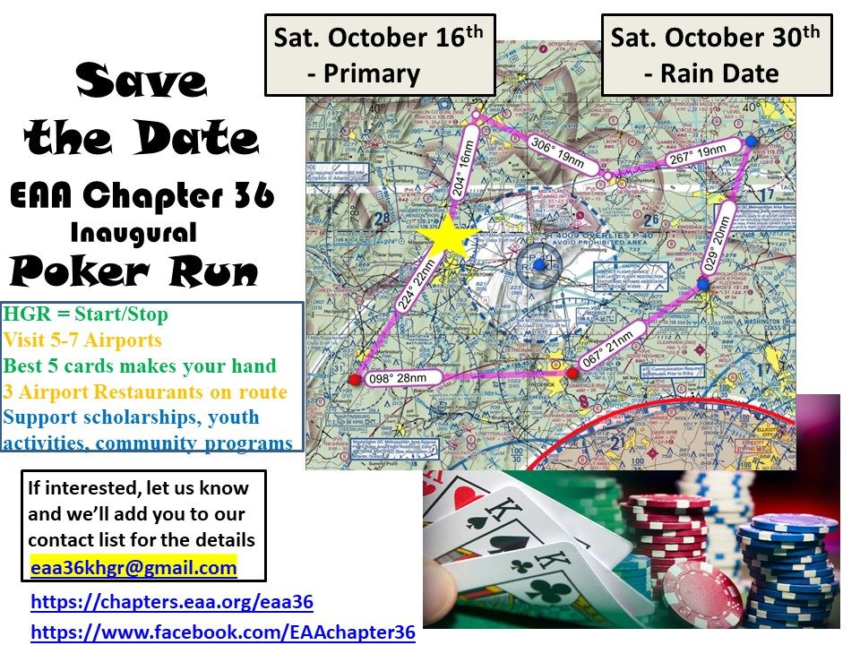

12. October 29. ProJet Expo at Leesburg. We have a table and will arrange to have it staffed with volunteers. And if you know young students who can benefit from some of the career opportunities,

Things to Read, watch and Listen to

1. Rise Above: Wasp film

The Commemorative AirForce has produced a film which is making its tour. The film is being shown this month in Fargo and at Oshkosh.
Here is a link to various trailers:

https://www.hemlockfilms.com/copy-of-rise-above-wasp-photos

And the CAF also has a fabulous resource for the WASP.

https://cafriseabove.org/wasp/

2. July selection for Aviatrix Book Club
Amber Smith: Danger Close



Scholarships and other support

PPLI Deadline - Autumn Session
When: Saturday, July 31, 2021
If you are a 99s member with at least a commercial certificate (and be actively flying) pursuing a professional pilot career, or you are an established professional who wants to take your career to the next level, this program is designed for you.
For more information, go to www.ninety-nines. org/resources.htm
or email mentoring@ninety-nines. org
Accomplishments or our Members

1. Jessica Citrin gets her Private Pilots license
Here she is flying on the Fourth of July.

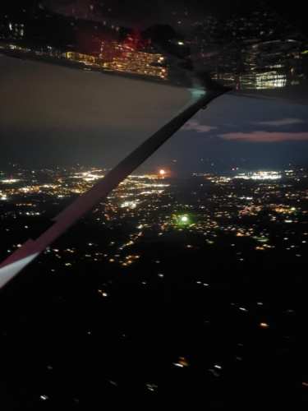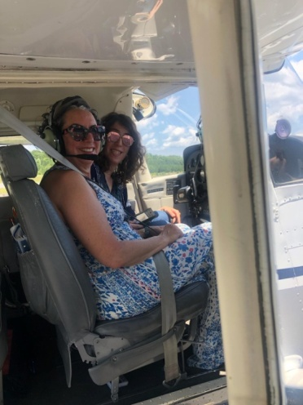

Mia Anderson soloed in a glider

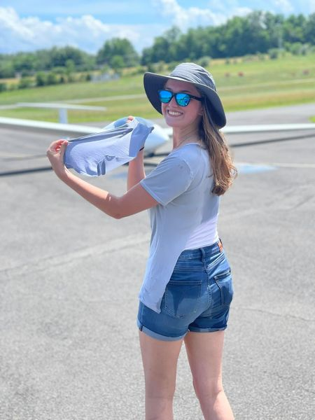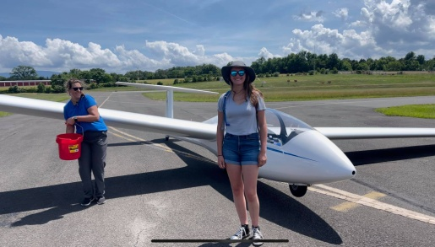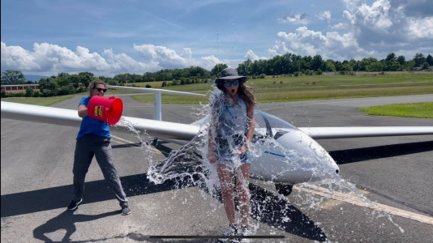

Here is her glide path: 