
Old Dominion Chapter
SKYLINES
August 2021

Chair: Mary McCutcheon
Vice-Chair: Laura Savino
Secretary: Judy Shaw
Treasurer: Barbara Wilper
Amelia Earhart Scholarship: Sue Passmore

Aerospace Education: Debbie Gallaway
Membership: Barb Wilper
Air Marking: vacant
Newsletter: Mary McCutcheon
Webmaster: Rose Brown

Next Meeting

Next meeting will be a composite pool Party at Judy Shaw’s house plus a business meeting afterwards.
If you plan to come, bring a swim suit and some finger food to share.

The choice is yours: In person or ZOOM

For those who plan to come: the party starts at 3 PM
but don’t worry about being punctual since the meeting won’t start till 5 PM.

Judy Shaw’s address is
1402 Langley Place
McLean, VA 22101
Phone number in case you need to get directions: (571) 243-4553

The meeting zoom information is:
Topic: Old Dominion 99s monthly meeting
Time: Aug 14, 2021 05:00 PM Eastern Time (US and Canada)

Join Zoom Meeting
https://gmu.zoom.us/j/93081946207?pwd=NmJQNVB3dUNDaHk4dnp3dklpZHZRZz09

Meeting ID: 930 8194 6207
Passcode: 630984

GRACE BORAS’S AMAZING EMERGENCY LANDING
Or “Why it is a good idea to practice power-out landings”

By Grace Boras

I was flying a Cessna 150 on my way to get some stamps for my Virginia Aviation Ambassador Passport. I took off from KJYO and flew to KHWY with no issues, got my stamp and went on my way.
Then I was on my way to KCJR and I was going to enter the pattern on the downwind and pulled the carb heat and noticed the RPM was dropping fast. Then the engine cut out and I tried to restart twice with no luck.
At this point I was like “Well, I guess this is happening. I’ll have to land now.” I was losing altitude and looked around and decided not to go for the airport because it was surrounded by trees. I turned and went for the open field and landed there.
I rolled into a corn field after landing and about 5 minutes later a farmer came by to check on me. I was fine and from what we could tell there was no damage to the plane.
The fire department, police, and my parents came to check on me and wait until the FAA got there. The FAA investigated the incident and think I had carb ice.
A couple days later an airworthiness inspector came out and checked out the plane. He didn’t find any damage and they were able to fly the plane off the road back to KCJR.

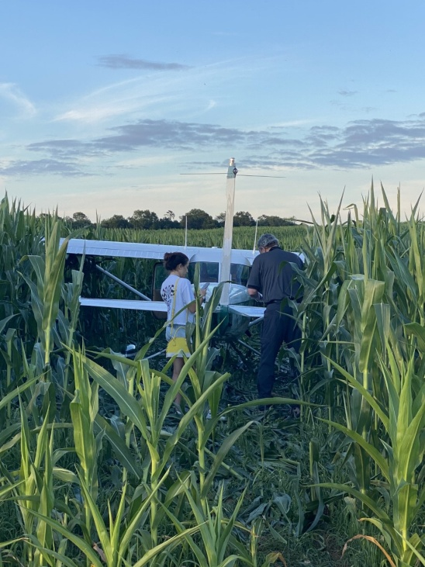
Can I get an ear while I’m at it?

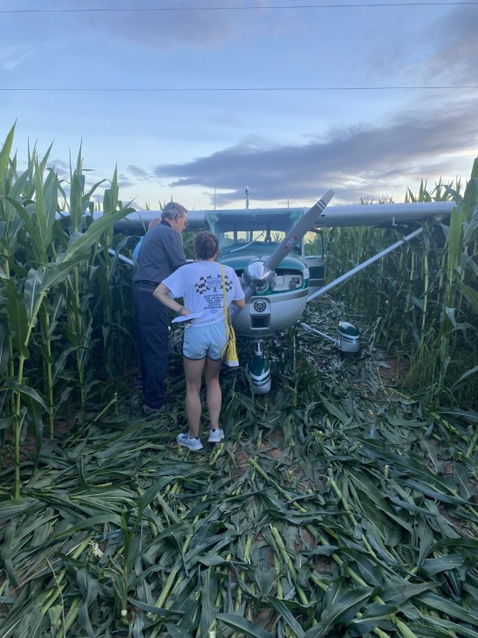
Getting ready to roll the plane out

The big question we all have is: “Well, did you finally get that stamp? And could you get an extra one for the corn field?”

Ninety-nines International meeting

The highlight of the meeting was the passage of all 13 amendments to the standing rules and the by-laws. The most controversial one was the 13th: to give one vote to each member and to eliminate the delegate system. The take-away was that many board members prefer eventually to have all substantive votes take place at the same time and using the same ballots as the board member elections. One member/one vote during the annual meeting is an interim step.

For an abbreviated meeting report, check the Straight and Level

Straight & Level (The Ninety-Nines, Inc.)

Fun times at the flying circus
Here are some pictures of us at the Flying Circus:

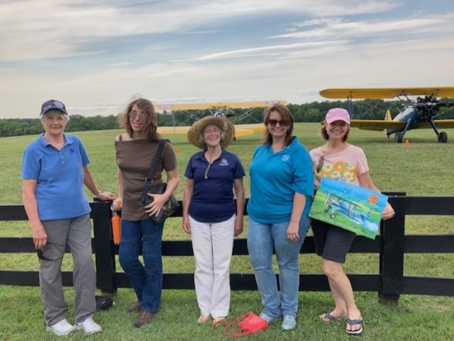
Judy Shaw, Jessica Citrin, Mary McCutcheon, Michele Bell, and Laura Savino

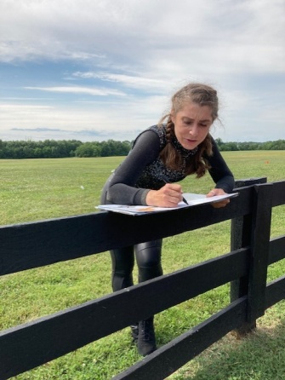
Our new best friend, the fabulous wing walker Beth Sommer.
She is a private pilot and also a flight attendant for American

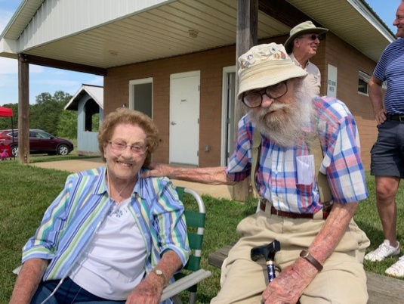

Evelyn Marshall and Charlie Culp were VIPs in the audience

Did you miss our field trip to Shannon (Fredericksburg)?
The Hampton Roads Chapter is inviting us to join them on August 28. Even if you didn’t miss the field trip, why not go again?

If you plan to go Please email Linda Bangert (lsbangert@cox.net)

News from Air Venture/ Oshkosh

Sue Passmore was (as far as we know) the only chapter member to get to Oshkosh this year.
She was fortunate to have a golf cart to get around, and was able to get around to see the 99s booth, a bunch of friends, and interesting aircraft.
What marred the trip was the weather: too hot at times and the risk of hail and tornado damage. It was the ominous forecast of severe weather on the 28th that convinced them to leave early.

SPUNKY WALLY FUNK

Our fellow ninety-nine, Wally Funk spent 10 minutes in space and realized her life-long dream. This generated a new expression: “May the Funk Be With You”

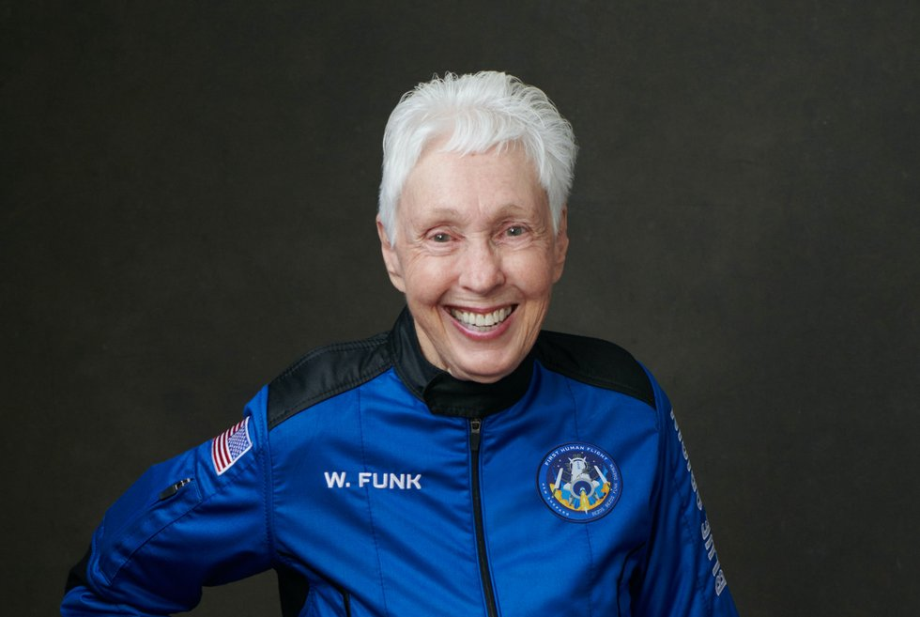

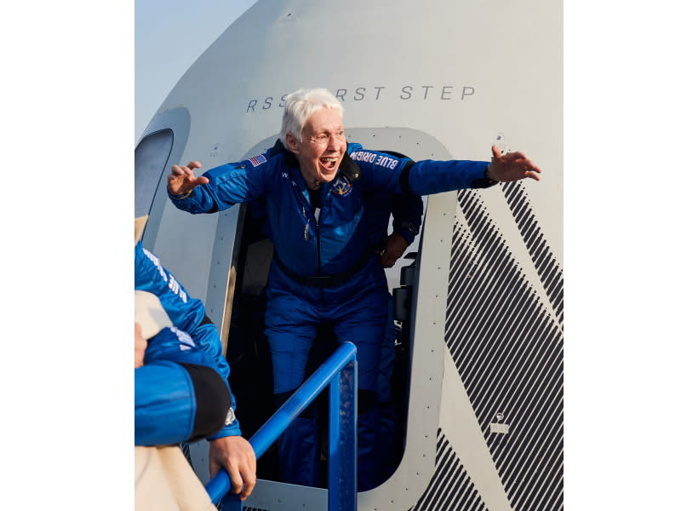

Things to Do August through October
1. August 21 Innovations in Flight at Udvar-HazyIf any of you are interested in participating. The National Air and Space Museum is holding our Innovations in Flight Day on August 21, 2021. Sign up to fly in here. This will be an outdoor event focusing on airplanes on the ramp.

2. Friday, August 27. AOPA Fly-in at Manassas.

3. Saturday August 28. Join the Hampton Roads Chapter for a visit to Shannon Airport, Fredericksburg. Notify Linda Bangert (lsbangert@cox.net) By August 18

4. September 10-12 Old Dominion Chapter Fly-in to Ocracoke.
5. September 17-18 International Forest of Friendship Celebration

6. September 24-26. Ninety-nines annual fly-in.
McKeller-Sipes Airport, Jackson, Tennessee (KMKL).
The event is FREE for the weekend. Get schedule and Register here.
You can stay at the Fairfield by Marriott Jackson
At a special rate of $109 for a 2 queen room
Use Group Name: Ninety-Nine Fly-in
Check-in: 9/24/2021
Check-out: 9/26/2020
Phone Number: 731-736-4550
CUT-OFF FOR RESERVATIONS: 8/24/2021
Or you might want to camp out
Bring your own tent or camper and set up camp right on the airport grounds. we have a LIMITED number of tents available for those who need a tent - these are available on a first come first serve basis so please reserve a tent early if you need one.

7. September 25 Leesburg air show.
8. October 9 (Raindate October 10) Culpeper air show.
9. October 15 and 16th. MidAtlantic Section meeting.
Save Friday October 15th and Saturday October 16th. Fly into Martin State KMTN. Hoping to do a hybrid Zoom Saturday morning for those who cannot attend in person. Details and registration coming soon.

10. October 29. ProJet Expo at Leesburg. We have a table and will arrange to have it staffed with volunteers. And if you know young students who can benefit from some of the career opportunities,

Things to Read, watch and Listen to

1. NEW PODCAST HIGHLIGHTS WOMEN IN AVIATION
August 3, 2021By Alyssa J. Cobb
Shaesta Waiz, the youngest woman to fly solo around the world in a launched a new podcast AVIATE WITH SHAESTA, to showcase women in aviation. Check it out: AVIATE with Shaesta
2. August selection for Aviatrix Book Club

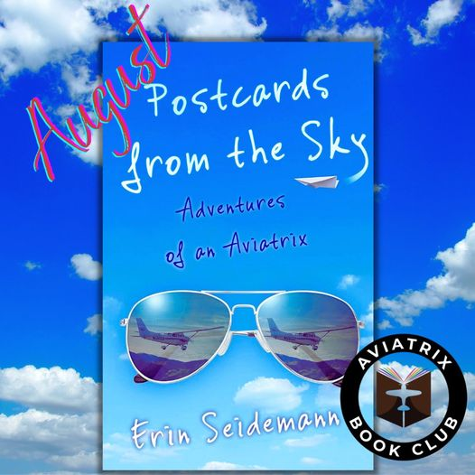
Scholarships
1. Amelia Earhart Scholarship
2022 AE applications will be available by September 1, 2021
General Requirements and Instructions
Scholarship Descriptions
First Wings Award for Student Pilot Members
Research Scholar Grants
2. FIRST WINGS AWARDS
The First Wings Awards are semiannual awards of up to $6,000 based on completion of specific training milestones. They are available to Student Pilot Members of The 99s who meet eligibility requirements. To be eligible, applicants must hold a student pilot certificate (or provide evidence that they meet their country's flight training requirement), have been an official Student Pilot Member three months prior to the application deadline, have logged five hours in the six months prior to the application deadline and show financial need.
The Fall First Wings Award Application deadline is October 1 each year. Membership join date must be no later than July 1 of that year.
Click here to view the Award Description and Instructions
Ready to apply? Application1

