
Old Dominion Chapter
SKYLINES
September 2021

Chair: Mary McCutcheon
Vice-Chair: Laura Savino
Secretary: Judy Shaw
Treasurer: Barbara Wilper
Amelia Earhart Scholarship: Sue Passmore

Aerospace Education: Debbie Gallaway
Membership: Barb Wilper
Air Marking: vacant
Newsletter: Mary McCutcheon
Webmaster: Rose Brown

Next Meeting

Thursday September 9 7:00 PM. This will be another zoom meeting:

The meeting zoom information is:
Mary McCutcheon is inviting you to a scheduled Zoom meeting.

Topic: Old Dominion 99s monthly meeting
Time: Sep 9, 2021 06:30 PM Eastern Time (US and Canada)

Join Zoom Meeting
https://gmu.zoom.us/j/96013946478?pwd=ZGc3M1FSQ3lOS21JSXAyS0xYYnRYZz09

Meeting ID: 960 1394 6478
Passcode: 537172

Last Meeting
In August we met at Judy Shaw’s pool and had a nice swim and a potluck dinner. There was also a zoom opportunity though no one zoomed in. We didn’t cover much business, but had a good time. Here are Jessica Citrin, Mary McCutcheon and Laura Savino
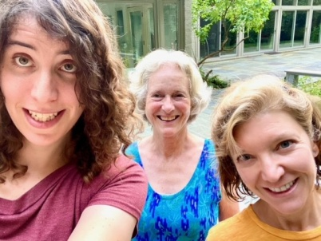

Another great trip to Shannon

The Hampton Roads Chapter proposed a joint field trip to Shannon. We went down on August 21 and had a great time. Because of low overcast over Southern Virginia, only two members of Hampton Roads came by car. It was a lot of fun.

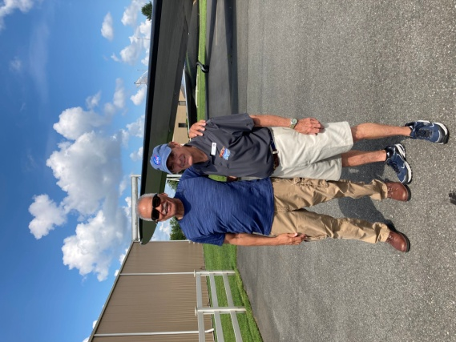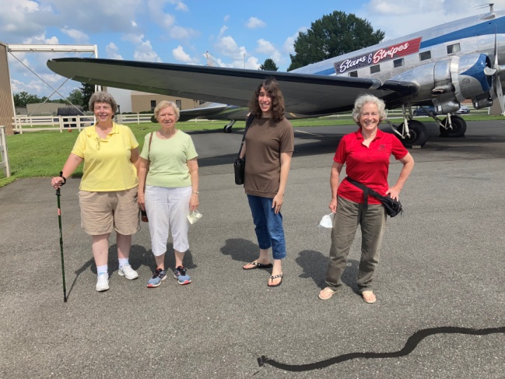
Our guides Woody and Charlie Linda Bangert, Linda Mathias, Jessica Citrin and Mary McCutcheon

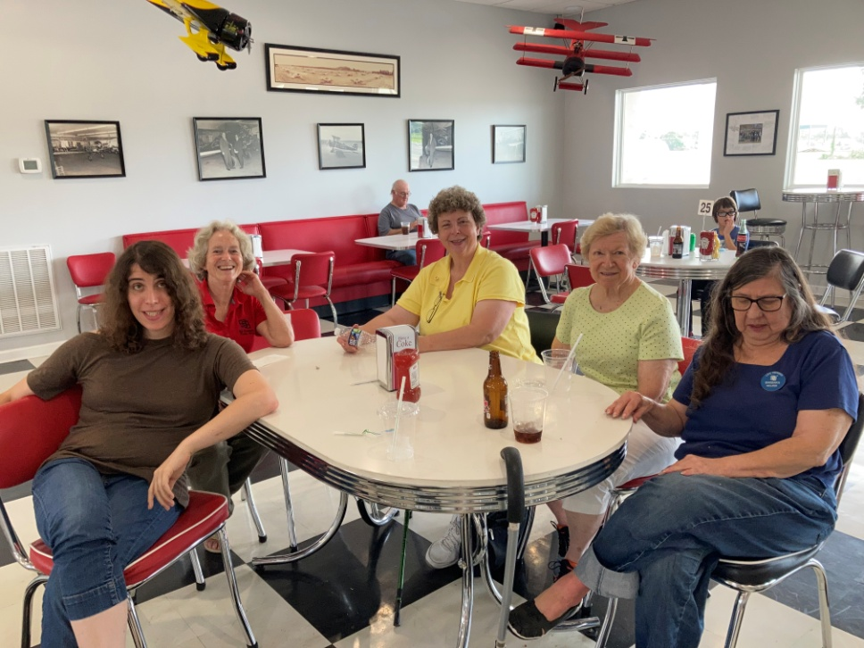

Jessica Citrin, Mary McCutcheon, Linda Bangert, Linda Mathias and Barb Willper in the Robin’s Nest Café

The fly-in to Ocracoke is ON.
A fair crowd is going down by car or by plane.
Morgen Reeb is setting up a day-fishing outing.
“For those going on the Ocracoke trip, I wanted to see if anyone would be interested in a half day off shore fishing charter trip. Depending on who we go with and how many people go, the price runs from $125 to $135 per person plus tip if 6 people go. If there is an interest, it probably needs to be set up ahead of time. If anyone is interested, please email, txt or call me. reebma@comcast.net or (804) 761-6270.”

New chapter in Martinsburg
Cindy Gresham is a charter member of a new chapter out of Martinsburg. Mountaineer Ninety nine chapter is their chosen new name. They are already having barbecues and gearing up for further activities. I guess they will be part of the MidAtlantic Section.

Automatic renewal of membership

If you count on Ninety-nines International to renew your membership automatically, make sure you check to see that this is done. Some people are noticing that their membership is suspended when they thought they were automatically renewed.

Forest of Friendship gathering cancelled. Peggy Doyle still nominated

Things to Do This Fall

1. September 10-12 Old Dominion Chapter Fly-in to Ocracoke.

2. September 24-26. Ninety-nines annual fly-in.
McKeller-Sipes Airport, Jackson, Tennessee (KMKL).
The event is FREE for the weekend. Get schedule and Register here.
You can stay at the Fairfield by Marriott Jackson
At a special rate of $109 for a 2 queen room
Use Group Name: Ninety-Nine Fly-in
Check-in: 9/24/2021
Check-out: 9/26/2020
Phone Number: 731-736-4550
CUT-OFF FOR RESERVATIONS: 8/24/2021
Or you might want to camp out
Bring your own tent or camper and set up camp right on the airport grounds. we have a LIMITED number of tents available for those who need a tent - these are available on a first come first serve basis so please reserve a tent early if you need one.

3. September 25 Leesburg air show. Starts at 11 and lasts till 4.
Join us for the 2021 Leesburg Airshow
4. September 25 Virginia Aviation Council meeting
On Saturday September 25th, from 9:30 AM – 3:30 PM, the Virginia Aviation Council will sponsor a face-to-face summit of all interested parties. If you are passionate about the future of aviation in Virginia, then you will want to attend this one-day event. Those present will serve as state-wide decision-makers regarding our future. The meeting will be hosted at the new Richmond Executive Aviation FBO facility at the Chesterfield County Airport (KFCI). There is plenty of parking for aircraft and cars. The Council will provide refreshments and lunch for all in attendance.

5. October 9 (Raindate October 10) Culpeper air show.

6. October 15 and 16th. MidAtlantic Section meeting.
Save Friday October 15th and Saturday October 16th. Fly into Martin State KMTN.
Questions? Contact Jane Toskes, planejane49@gmail.com or (443) 756-7890, or check out Full weekend schedule at
meeting.maryland99s.org.

7. October 29. ProJet Expo at Leesburg. The Projet committee has confirmed that we are scheduled for table at their Expo. So far we have several volunteers.
If you want to volunteer, let me know:
703-217-8850 or mmccutch@gmu.edu

Volunteer opportunities
These are just the volunteer organizations I used to fly for. Do you have any more suggestions? Volunteer flying is the most gratifying thing you can do.

Southwings Be a SouthWings Volunteer Pilot

Pilots N Paws Pilots N PawsPilots - Pilots N Paws

AngelFlight Mid Atlantic Volunteer Pilots | Air Transportation | Angel Flight Mid-Atlantic (angelflightmidatlantic.org)

Accomplishments of our members:

Eleanor Brunsman has her Commercial license and tail dragger endorsement. She will graduate from Embry Riddle in May and is hoping to get a job in California after that.

Carolyn Hunker has her CFI and is a flight instructor at Aviation Adventures now.

Jenny Reeb got her Commercial and her CFI and already has a job as a flight instructor.

Things to Read, watch and Listen to

1. September selection for Aviatrix Book Club
“Flygirl” by Sherrie L. Smith. This is the 9th book in the Aviatrix Book Club for September.
This is a work of fiction portraying the Women’s Airforce Service Pilots or WASP.



2. Check out FlyGirl Kelley
On facebook: https://www.facebook.com/flyGIRLKelley/
On their web page:
http://www.flygirlllc.com/

Scholarships
1. Amelia Earhart Scholarship
2022 AE applications are available .
General Requirements and Instructions
Scholarship Descriptions
First Wings Award for Student Pilot Members
Research Scholar Grants
2. FIRST WINGS AWARDS
The First Wings Awards are semiannual awards of up to $6,000 based on completion of specific training milestones. They are available to Student Pilot Members of The 99s. To be eligible, applicants must hold a student pilot, have been an official Student Pilot Member three months prior to the application deadline, have logged five hours in the six months prior to the application deadline and show financial need.
The Fall First Wings Award Application deadline is October 1 each year. Membership join date must be no later than July 1 of that year.
Click here to view the Award Description and Instructions
Ready to apply? Application1

