
Old Dominion Chapter
SKYLINES
Newsletter October 2020

Officers and significant volunteers:

Chair: Mary McCutcheon
Vice-Chair: Melissa Plumer
Secretary: Judy Shaw
Treasurer: Barbara Wilper
Amelia Earhart Scholarship: Sue Passmore
Aerospace Education: Debbie Gallaway
Membership: Marge Shaffer
Air Marking: Stephanie Johnson
Newsletter: Mary McCutcheon

Next meeting: Tuesday October 6 at 7 PM

Due the pandemic, we will meet on zoom again.
Mary McCutcheon will host this meeting with hopes that the new computer she has will work better than the old cheesy laptop. Here is the information:
Join Zoom Meeting: https://gmu.zoom.us/j/96531152614 Meeting ID: 965 3115 2614
LAUGH OF THE DAY
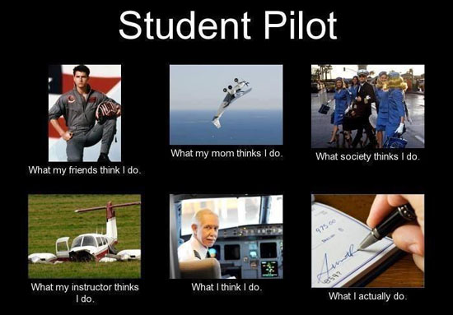

CHAPTER DUES REMINDER

Please remember to pay your chapter dues.
Your $25 pays for our website, our air educational expenses (such as the projector we bought), our election expenses, and contributions to the section programs. We get no support from International.
Make checks payable to Old Dominion Chapter 99s and send to
Barbara Wilper
6724 SWARTHMORE DR
ALEXANDRIA, VA 22307

BIG NEWS ITEMS

I Congratulations to Eleanor Brunsman new private pilot.

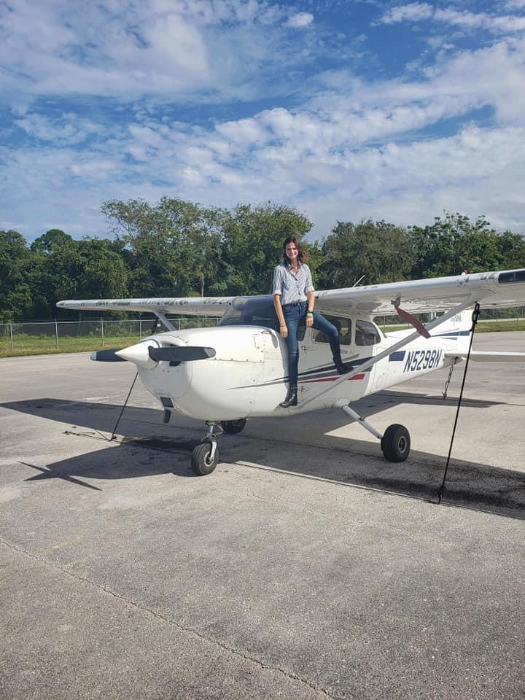

II. Congratulations to Jenny Reeb for getting through the multi-engine simulator ground training. Here is what Morgen Reeb says:

"Also an update on Jenny’s flying. She has completed all of her multi-engine simulator lessons. Everything is in the airplane now. She was weathered out this past week, but she has three days she can fly next week. Some of the flights she has to do now are maneuvers, so they need pretty good weather."

III. The credit stencil was added to our fabulous Compass Rose at Culpeper. Thanks to Stephanie Johnson and Judy Shaw:

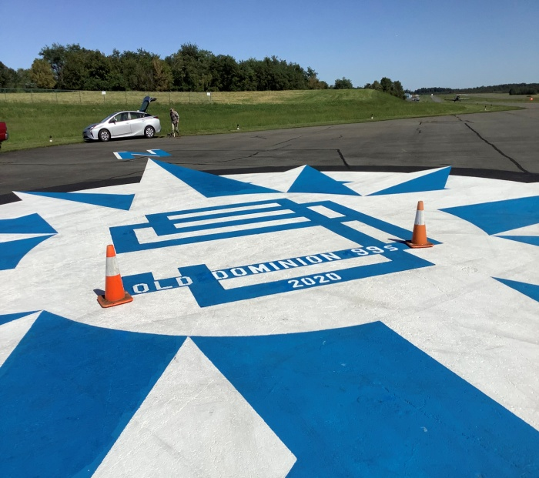

IV. The Ocracoke Fly-in was a huge success.

Around nine people joined RJ in Ocracoke for the fly-in although only Debbie Gallaway and her 49 ½ actually few in! Here's what she has to say:

"We were the only plane to fly into our annual get together which was unusual. When we reached the sound there were thunder storms to the SW which we had a good eye on and a clear picture of through Nexrad. There were heavy showers NE of Ocracoke, but fortunately the field was in the clear if we landed to the NE. There was very little wind which was a surprise; it's always very windy there. We were lucky."

V. The Fall Mid-Atlantic Section meeting was held on October 3. It was a zoom meeting with about 27 people attending. It lasted FOUR hours during which there was a lot of discussion about such issues as the funding of the NIFA awards. We voted that each chapter will contribute $50 or $100 toward this competition.
THINGS TO DO

I. Run for office in some of 99 International programs:

By Susan Larson, Chairman International Nominating Committee
The Nominating Committee is looking for a few more good women to run for elective positions on our Board and Trusts. At the 2021 annual meeting in Long Beach, California, the delegates to the meeting will elect two Directors to the International Board and will elect individuals to all four Trusts: Amelia Earhart Birthplace Museum (Atchison, Kansas), Museum of Women Pilots (Oklahoma City, Oklahoma), Endowment Fund and Amelia Earhart Memorial Scholarship Fund. An 'Intent to Seek Election' form must be completed along with a resume and submitted to the Nominating Committee per instructions. Deadline for receipt by the Nominating Committee is October 31, 2020. The term of office will begin immediately after the annual meeting.

II. Attend, virtually, the 99 Webinars
A. FIRST WEDNESDAY WEBINAR - "Pathway to Wings Career Brief"
Wednesday, October 7; 6:00 pm Central Daylight Time (23:00 UTC)
NOTE: this webinar is one hour EARLIER than our usual time!
Are you interested in U.S. Air Force Aviation careers? Do you want to speak to Air Force aviators and ask your questions? Do you want to learn to fly for free? Check out the U.S. Air Force Pathway to Wings Career Brief. Air Force Recruiting Service Detachment 1 will discuss everything you need to know to start on your pathway to wings.
Also, if you are looking to find flight opportunities, this month we will focus on flight academies, scholarships, and other opportunities. We will talk to experts from the USAF AIM HIGH Flight Academy, Civil Air Patrol Flight Academy, Junior Reserve Officer Training Corps Flight Academy, and the Reserve Officer Training Corps You Can Fly program. Our civilian partner organization The 99s will also be there to talk about scholarship opportunities.
Flyer for Webinar
Sign up at: http://bit.ly/pathwaytowingsOct2020
B. October 20 - Navigating NEXRAD
Of all of the weather products relied upon by pilots, NEXRAD is by far the most familiar. When making a go or stay decision or to safely navigate through challenging weather, it is extremely important to know its inherent limitations. Join Scott Dennstaedt, Weather Systems Engineer, CFI & former NWS research meteorologist, for our next 99s/SiriusXM webinar: "Navigating Nexrad," October 20, 2020 8:00 PM Eastern to learn the ins and outs of how to safely use NEXRAD guidance before and during your next flight.
Registration
III. Enter the 99s art competition:
The 99s FLYtionary Contest
If you love to fly, and want to fly with a purpose while maintaining social distancing, start your engines and get ready for another fun flying activity!
Between October 1 and December 31, use a flight tracker (such as the "breadcrumbs" on Foreflight®) to fly the most creative shape you can imagine, then email a screenshot of your flightpath to the Paradise Coast Chapter at ParadiseCoast99s@gmail.com. All 99s and Friends of The 99s can join the fun and may submit multiple entries. The screenshots will be posted on our Facebook page for voting between January 7-21, 2021 and the flightpath with the most "likes" will be awarded a prize as the first winner in FLYtionary, earning bragging rights as our most creative pilot!

IV. Listen to the Traffic Pattern podcast Featuring Laura Savino
Laura is brilliant and entertaining in this wonderful podcast. Don't miss the part about the pencil skirt!! The host is a charming Air Traffic Controller who brings out the best, Derek Vento. Click on one of the following to get it:
https://player.fm/series/the-traffic-pattern/laura-savino-this-is-your-captain-speaking
https://podcasts.apple.com/us/podcast/laura-savino-this-is-your-captain-speaking/id1440722596?i=1000486413415

V. Donate to the many programs in the 99s
Check out the web page of the organization and go to the Donate page:
https://www.ninety-nines.org/

SOURCES OF FUNDING AND OTHER COMPETITIONS
I The Mid-Atlantic Section Scholarship
In response to the COVID-19 virus precautions, the scholarship committee has made a decision to delay the scholarship applications until October, with selection of the winner in January 2021. The Mid-Atlantic scholarship committee will award one scholarship in January for up to $5,000. The M-A website is being worked on, so give it a few days and you can access it.
II. Amelia Earhart Scholarship
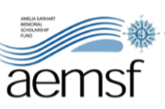The 2021 AEMSF Scholarship applications are now available on the International website at www.ninety-nines.org/scholarships.htm. Applications must be submitted to the Chapter AEMSF Chairman by January 1, 2021.
If you have any questions about the applications, see aechair@ninety-nines.org.

III. National Intercollegiate Flying Association competition

NIFA NEEDS YOU!

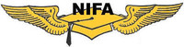The National Intercollegiate Flying Association (NIFA) exists today as a forum for collegiate aviators to expand their studies and further their careers by participating in competitive and non-competitive events, networking with industry and contemporaries, and applying themselves to go above-and-beyond their ordinary curriculum. But, its history began almost a century ago (nifa.aero/nifa/history).
Learn more about NIFA and our shared history. Be inspired by these young aviators and their dreams to "slip the surly bonds of Earth". Sign up to be a judge! No aviation experience needed so your 49½ can join in on the fun too! Judge in your Region or at Nationals in 2021 at Oshkosh, Wisconsin. Like Uncle Sam said years ago: WE need you! Nifa.aero/judges/judge-register.

