
Old Dominion Chapter
SKYLINES
Newsletter November 2020

Officers and significant volunteers:

Chair: Mary McCutcheon
Vice-Chair: Melissa Plumer
Secretary: Judy Shaw
Treasurer: Barbara Wilper
Amelia Earhart Scholarship: Sue Passmore
Aerospace Education: Debbie Gallaway
Membership: Marge Shaffer
Air Marking: Stephanie Johnson
Newsletter: Mary McCutcheon
Webmaster: Rose Brown

Next meeting: Tuesday November 10 at 7 PM

Due the pandemic, we will meet on zoom again.
Mary McCutcheon will host this meeting
Here are the details:
Mary McCutcheon is inviting you to a scheduled Zoom meeting.
Topic: Old Dominion 99s monthly meeting
Time: Nov 10, 2020 07:00 PM Eastern Time (US and Canada)

Join Zoom Meeting
https://gmu.zoom.us/j/93172808160?pwd=OXpkbE9pRSs2WHVCRGV3ajZpUkZJUT09

Meeting ID: 931 7280 8160
Passcode: 642366
One tap mobile
+12678310333,,93172808160#,,,,,,0#,,642366# US (Philadelphia)
+13017158592,,93172808160#,,,,,,0#,,642366# US (Washington D.C)

Dial by your location
+1 267 831 0333 US (Philadelphia)
+1 301 715 8592 US (Washington D.C)
Meeting ID: 931 7280 8160
Passcode: 642366
MAJOR MILESTONES FOR THE OLD DOMINION 99s

I. Carolyn Hunker passed her commercial checkride on October 20. During the check ride she also passed the 300 hour mark. It turned out that a new chief examiner, Kim Webster, was completing training Bob Hepp, the old chief examiner. Kim Webster was naturally trying to show how rigorous he was. Nevertheless, all went well. Here she is with Kim Webster. We guess they are both smiling, but who knows? Congratulations, Carolyn.

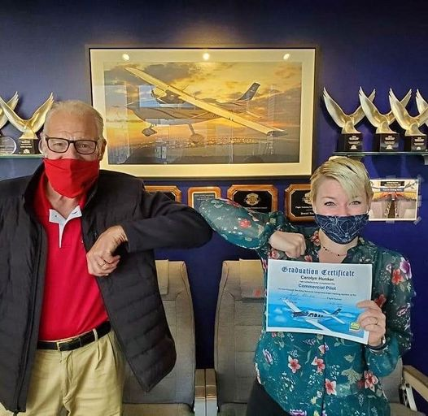

II. Grace Boras passed her Private Pilot’s checkride down in Siler City, North Carolina on October 22. She is staying in the Outer Banks but had to fly to the nearest examiner in the center of the state. Good practice round trip. She flew in a Cessna 150. Here she is looking pretty happy. After Thanksgiving she should be coming back up here again and will be flying out of Leesburg.

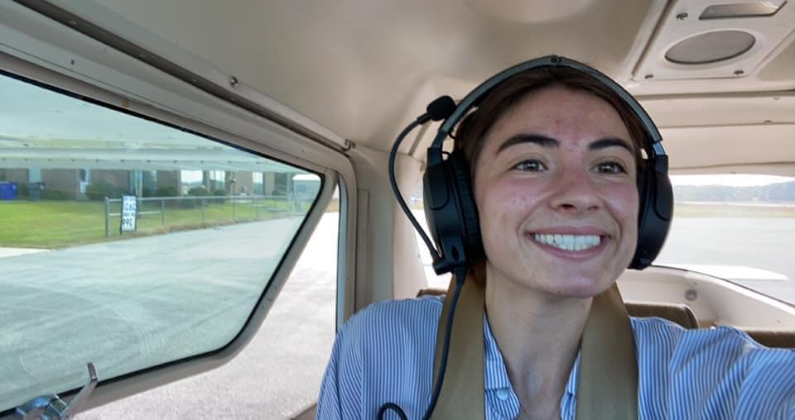

III. Mia Anderson has been awarded the Skyline Soaring Educational Foundation Glider Scholarship and posted a fabulous youtube video that was taken on October 17. This’ll make you want to learn gliding too.

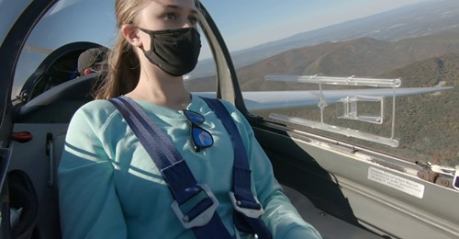

YOUTUBE.COM
https://www.youtube.com/watch?v=5A8xUySOmx4&feature=youtu.be&fbclid=IwAR1NFyCh3ILezLEeXXl7x1q4DqP8NP4_Gipz2fVNv7egp5ou938GbALUbzI
Amelia Glider Lesson 10/17/2020

IV. Elise Wheelock spent last year flying all over the country showing off the new Piper Pilot 100 series aircraft. Now she’s delivering Piper aircraft from Vero Beach, Florida to the buyers wherever they may be. Mostly these are 500s (Archers) but she is delivering the newest M600 series, too. What a totally fun job to have. Don’t miss the podcast in which she talks about her first exposure to flight through Women Can Fly and her affiliation with the 99s. http://www.airplanegeeks.com/2019/09/03/558-bits-pieces-xxv/ fast forward to 39 minutes.

MORE ON THE OCRACOKE FLY-IN

Last month I did a grave injustice to the Ocracoke Fly-in. Here are more pictures and more from Debbie Gallaway:

For some of us, it was the first time we had ventured out since the
COVID-19 lock down and we were all excited about getting together and
catching up with one another in person. The nine folks who were able
to travel to the island were RJ and Dan Mcglasson, Peggy Doyle and Rick
Koehnke, Morgen and Frank Reeb, Rose Brown, myself and my husband Chuck
Gallaway. It turned out to be a very safe and fun weekend. Mostly, we
met on the dock of the Ocracoke Harbor Inn, socially distanced of
course, where we enjoyed refreshments, told stories, and had lots of
laughs. We only got together as a group for dinner once on the back
porch of Howard's Pub where caught up for hours. We explored the island
on bikes, golf carts, or by car. It was so wonderful to see everyone!
Fortunately, the weather turned out to be fine the whole weekend.
RJ deserves a special shout out; as usual, she made all of the arrangements at the Inn for us and coordinated all the details leading up to the trip.

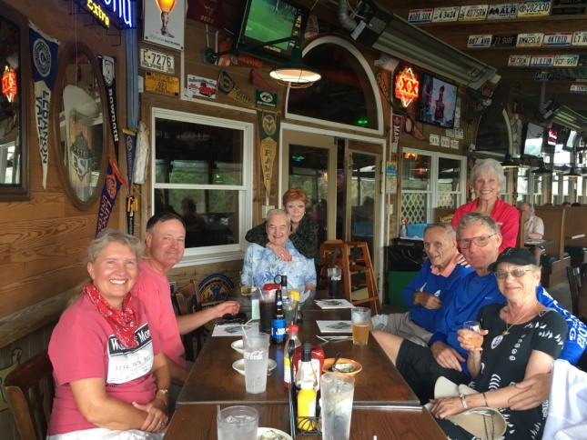

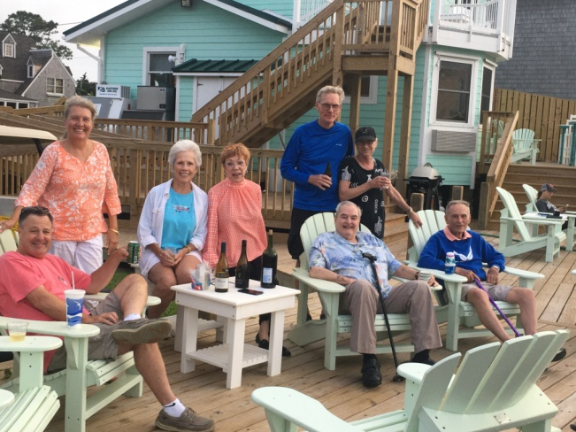

SCHOLARSHIPS
I. Amelia Earhart Scholarship
There is a generous scholarship fund in five categories of aviation training. If you need support along the path toward your goals, check out the following link and note the deadline is January 1.
The 2021 AEMSF Scholarship applications are now available on the International website at www.ninety-nines.org/scholarships.htm. Applications must be submitted to the Chapter AEMSF Chairman by January 1, 2021.
If you have any questions about the applications, see aechair@ninety-nines.org.

If you want tips for your application, check the 99s web page and you should (soon) find a link to the webinar that was given on November 4. As of this writing, it hasn’t been put up, but maybe in the next week or two it will be. Keep checking.
https://www.ninety-nines.org/webinars.htm

But the substance of this webinar is on the powerpoint show: www.tinyurl.com/aemsftips
and on Dottie Norkus “tips” page - http://www.flightscholarship.info/application--tips.html

II. LADIES IN FLIGHT TRAINING (L.I.F.T.)
C.F.I. SCHOLARSHIP

L.I.F.T. is primarily a facebook group formed by Krista Morisen. It is now a 501 (c)3 nonprofit organization that provides scholarship money for women in aviation.

The deadline for the C.F.I. scholarship is November 30 so here is the announcement for it.
There is $1500 available for some woman who wants to be a flight instructor.

To learn more, check out the web page:
https://www.flylift.org/

III. Aviation Adventures Flight Scholarship
Aviation Adventures will award two $3,000 scholarships to applicants pursuing their dream in the world of aviation. Candidates must be a current student at Aviation Adventures. Funds will be paid directly to Aviation Adventures and must be used within one year of the award. Recipients will be chosen on the basis of merit, financial need, career/personal aspirations, and dedication to the aviation community.
Scholarship applications must be submitted in the form of
1) a typed thank you note to the anonymous donors of this scholarship. This letter must explain how the scholarship will enable you to achieve your aviation goals and must tell the recipient how committed you are to become an aviation professional. NO LONGER THAN 500 WORDS.
2) A professional résumé (no more than two pages).
3) Deadline is November 30, 2020. Submit to Abby Welch by email (AbigailLeeWelch@gmail.com).

MERCHANDISE AND OUR TRADEMARKED LOGO

It turns out we have a legally trademarked LOGO. It is a biplane superimposed on the map of Virginia nested in a burst of radiating blue. It is the LOGO Rose Brown uses on our web page.
(https://olddominion99s.com/)

The International 99s keeps a list of logos that the sections and chapters use and needs to know if we are going to marketing any clothing or jewelry or other promotional items using it or any other authorized 99 logo.

What do you think?

THINGS TO DO

1. On Sunday, November 15 Attend the virtual interview with Wally Funk sponsored by the Sugarloaf chapter. Register and get ZOOM information by contacting Melinda@viteri.net.



2. From November 14 to December 14 visit nearby airports and eat at airport restaurants for a possible prize.

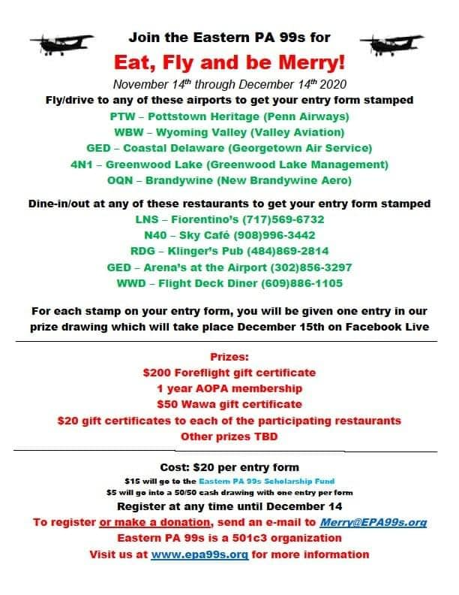
3. First Wednesday Webinar for the 99s International

On December 2 at 7 PM there will be a talk on a subject yet to be arranged

THINGS TO WATCH

1. Fly Like a Girl
This is a feature length film that is rentable through Amazon Prime and other services.



2. Cecile Hatfield’s story.

https://www.youtube.com/watch?v=DvCcFr8HV9Y&feature=youtu.be&fbclid=IwAR0yBCiSBNGrNKJSyNQupzLQ0xuTXyBYri0pWErKb_jwRZ2fvHHjqzZVZ7o

3. How Gene Nora Jessen’s plane ended up in Culpeper

https://www.youtube.com/watch?fbclid=IwAR3xrusCRD4pOnYxSItcTte5qNrHd_dpmuKM22NOTd1shGA7JC-zp5vVVJ8&feature=youtu.be&v=C_iGYTGCleY&app=desktop

THINGS TO READ

1. Wally Funk’s autobiography: Higher Faster Longer

Higher, Faster, Longer: My Life in Aviation and My Quest for Spaceflight is the memoir of one of Mercury 13's accomplished female pilots who passed the same physical qualification tests in 1961 as NASA’s first astronauts, the Mercury 7. Wally Funk was the youngest of these women and the only one who has actively continued to pursue spaceflight through nearly six decades since those tests were administered.

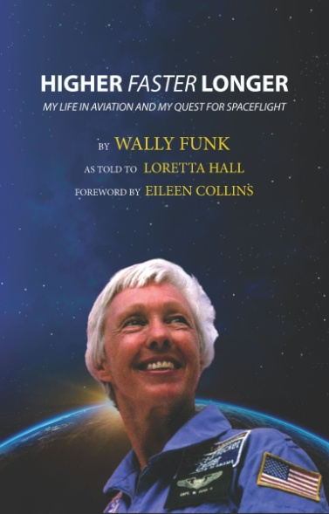

2. Join a book club

From Elizabeth Booker,
I’m excited to share that I recently launched the Aviatrix Book Club FaceBook Group!
Below is our 2021 reading list. I have several of the authors lined up to do virtual author discussions via Zoom, which I will also record and post.
If you’re interested, please join us . . . https://www.facebook.com/groups/963231860835690.

Here are the choices for 2021. Sounds fun to me.
JANUARY
A Chick in the Cockpit by Erika Armstrong
Erika’s aviation and personal journey, “from the desk of a busy FBO, to the captain’s seat of a commercial airliner.” Non-fiction, Autobiography, General Aviation, Airlines.
FEBRUARY
The Happy Bottom Riding Club: The Life and Times of Pancho Barnes
by Lauren Kessler
Biography of Pancho Barnes, one of aviation’s most colorful historical characters
MARCH
Home Front by Kristin Hannah
Warrant Officer Jolene Zarkedes, an Army National Guard Black Hawk helicopter pilot, is deployed to Iraq, leaving a failing marriage and her children at home.
APRIL
Australian Women Pilots: Amazing True Stories of Women in the Air by Katy Mexted
10 biographies of pioneer Australian Aviatrices, from the 1930s to present day, in every aspect of aviation..
MAY
The Women Who Flew for Hitler: A True Story of Soaring Ambition and Searing Rivalry
by Clare Mulley
“The extraordinary story of two women at the heart of Nazi Germany, whose choices and actions put them on opposite sides of history.”
JUNE
Flygirl
by Nancy Kardon
“1997. International corporate aviation. Pilot Tris Miles tries to crack the blue ceiling and become a captain as she confronts harassment, hidden agendas, and her own haunting loss while integrating in an all-male corporate flight department.”.
JULY
Danger Close: My Epic Journey as a Combat Helicopter Pilot in Iraq and Afghanistan
by Amber Smith
Amber’s experiences as a Kiowa Warrior armed reconnaissance pilot. “The captivating story of one woman’s fight to serve her country in the direct line of danger.”.
AUGUST
Postcards from the Sky: Adventures of an Aviatrix by Erin Seidemann
Erin, a financial analyst by trade, shares her journey to becoming a commercially rated pilot and owning her own plane. Check out her FaceBook page: https://www.facebook.com/ErinSeidemann.. . .
SEPTEMBER
Flygirl by Sherri L. Smith
Ida Mae Jones is a young Black woman in 1940’s Louisiana whose fair skin allows her to pass as White to join the WASPs. OCTOBER
Open Skies: My Life as Afghanistan’s First Female Pilot by Niloofar Rahmani and R.D. Sykes
“Against the odds, Niloofar performed the first solo flight of her class—ahead of all her male classmates—and in 2013 became Afghanistan's first female fixed-wing air force pilot. Yet some Afghan soldiers refused to fly with her, while others disparaged and harassed herNOVEMBER
A Spitfire Girl: One of the World’s Greatest ATA Pilots Tells Her Story by Mary Ellis
Ferry pilot with the British Air Transport Auxiliary tells her story of being an RAF pilot during WWII. Military, ATA, WWII.
DECEMBER
The Road to Wings by Julie Tizard
A love story set in Air Force Flight training between Lieutenant Casey Tompkins and her demanding flight instructor, Captain Kathryn Hardesty

