
Old Dominion Chapter
SKYLINES
Newsletter December 2020

Officers and significant volunteers:

Chair: Mary McCutcheon
Vice-Chair: Melissa Plumer
Secretary: Judy Shaw
Treasurer: Barbara Wilper
Amelia Earhart Scholarship: Sue Passmore
Aerospace Education: Debbie Gallaway
Membership: Frida Norberg
Air Marking: vacant
Newsletter: Mary McCutcheon
Webmaster: Rose Brown
Laugh of the Day



Next meeting: Tuesday December 8 at 7 PM

Mary McCutcheon is inviting you to a scheduled Zoom meeting.

Topic: Old Dominion 99s monthly meeting
Time: Dec 8, 2020 06:30 PM Eastern Time (US and Canada)

Join Zoom Meeting
https://gmu.zoom.us/j/95187725649?pwd=Z09yMVFpVEdFN1U1dkZaZVMzWnlrUT09
Meeting ID: 951 8772 5649
Passcode: 942087
One tap mobile
+13017158592,,95187725649#,,,,,,0#,,942087# US (Washington D.C)

UPCOMING EVENTS

I. ProJet Aviation’s “Vision 2021” Expo. October 29, 2021

We have applied to get a table at the expo. The people likely to come to visit our table will be pilots, students, and aviation enthusiasts. The purpose is to expose these people to educational and career opportunities. .

II Women Can Fly

Women Can Fly has not been scheduled yet, but if it isn’t canceled, it’ll be in May and June of next year. No one knows yet.

III. 99s International Conference and Career Expo
July 7-11, 2021 Long Beach, California
To register and for more information, go to www.99sconference.org

IV. December 14 visit nearby airports and eat at airport restaurants for a possible prize. See last month’s newsletter for the particulars.

COMINGS AND GOINGS FOR OLD DOMINION 99s

I. NEW MEMBERS

Rebecca Johnson

Rebecca is Executive Administrator for Checkride Prep where she helps run and coordinate all the ground school classes. She helped to put together the online youth aviation course for Middle School and High School Students and right now she is in the process of coordinating and scheduling an online live CFI Course. Plus she is a single parent with 6 kids who are all distance learning from her office. Makes life a challenge!!

Cynthia Gresham

Cindy is going to be living in Hedgesville, West Virginia permanently now that she is moving away from Florida. Her husband gave her a discovery flight about 10 years ago and she was hooked. She has a Cessna 172 and a private pilot’s license. She is about to start instrument training at Martinsburg, where her plane is tied down.

II. DEPARTURES

Marge Shaffer.

Marge moved to Tybee Island right near Savannah, Georgia. She is trying to sell the boat club business that she and her husband ran. She misses us all and would welcome any visits. She is close enough to the Savannah airport to pick us up. Now that she is there she will no longer serve as membership coordinator, a job that has fallen to Frida Norberg.

Stephanie Johnson

Stephanie Moved to New Hamphire along with a household composed of lots of hens (but alas she had to leave the rooster or roosters behind). She managed to transport the whole household and buy a house in New Hampshire and sell a house in Stafford in a very short space of time. She will not be able to do our airmarking any more and we will sorely miss her.

THINGS TO WATCH, LISTEN TO OR READ

A. Listen to the Interview with Kate Landeck, author of the recent book, The Women with Silver Wings about the WASP.

There is also an embedded link to WASP documentaries.
The link to Kate's WASP interview is:
https://www.texasstandard.org/stories/women-who-flew-the-silver-winged-wasps-of-world-war-ii/?fbclid=IwAR3td-vFNbpBgr2XJ3VJ2Ko55Fz_YIFc936nxM0jHa8tnpxrbZu7llqR0aE

B. The Aviatrix Book Club has an evolving list of books. Join up and start reading. To join, go to the facebook page: Aviatrix Book Club. There are currently over 800 members so the idea of an intimate discussion got abandoned in favor of zoom “ice breakers”. The first one is unfortunately happening at the same time as our meeting on Tuesday December 8. The founder is a 99 also. Her name is Elizabeth Booker. Listen to her ideas:
https://www.facebook.com/elizabeth.booker.73/videos/10157900627588635

C. Listen to another interview with Laura Savino.
Laura tells us about her experiences in aviation. Inspiring and fun.
https://www.youtube.com/watch?v=D5o6blKUfCQ&fbclid=IwAR0sEo56RVPFnVISPXOHiy8jlmBnCqkpWOPm3D2dhdkTKpJvCEX5yv_kKgA

D. Learn about astronaut Shannon Walker:
https://www.facebook.com/elizabeth.booker.73/videos/10157900627588635

PROGRESS ON THE PLAYGROUND AT STAFFORD.

Here is Stephanie Johnson laying bricks
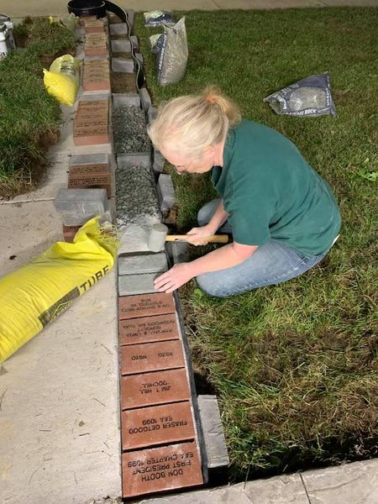

the brick in the center is from the Old Dominion 99s
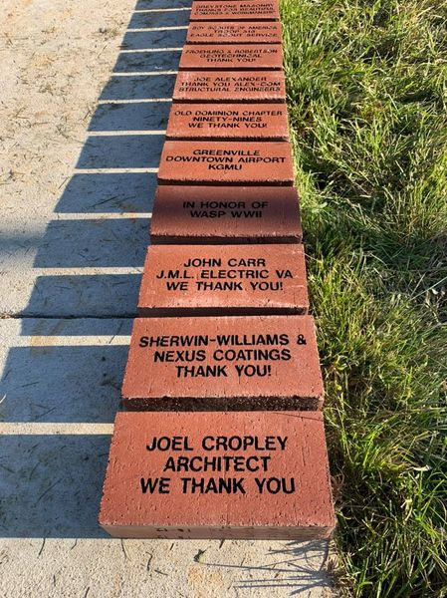

MERCHANDISE

We renewed our rights to use the 99 trademark to make shirts and jackets. Here is what we might have available and here is our new Authorization!
I’ll post a notice when these shirts will be available and how you can get them. There will be no middleman (or middlewoman); you will purchase directly from the manufacturer.

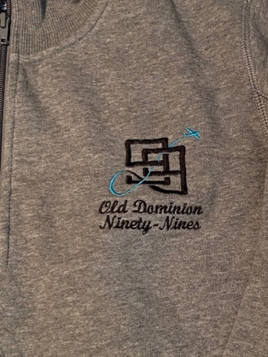

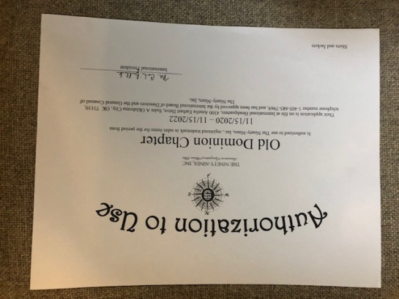

SCHOLARSHIPS

I. Applications for AOPA’s You Can Fly program 2021 scholarships opened on December 1. The 2020 program awarded 124 scholarships totaling more than $1 million, and with the help of generous donations to the AOPA Foundation, AOPA has awarded nearly $2.5 million in scholarship funding to 345 aspiring and enduring pilots in the past two years.

These programs fund high school students, teachers, primary flight training, and advanced ratings. Must be a member of AOPA to qualify.
II. Amelia Earhart Scholarship
There is a generous scholarship fund in five categories of aviation training. If you need support along the path toward your goals, check out the following link and note the deadline is January 1.
Go to the International website at www.ninety-nines.org/scholarships.htm for application material and information

If you want tips for your application, check the powerpoint show: www.tinyurl.com/aemsftips
and on Dottie Norkus “tips” page - http://www.flightscholarship.info/application--tips.html

