
SKYLINES
Newsletter January 2021

Officers and significant volunteers:

Chair: Mary McCutcheon
Vice-Chair: Melissa Plumer
Secretary: Judy Shaw
Treasurer: Barbara Wilper
Amelia Earhart Scholarship: Sue Passmore

Aerospace Education: Debbie Gallaway
Membership: Frida Norberg
Air Marking: vacant
Newsletter: Mary McCutcheon
Webmaster: Rose Brown

Laugh of the Day

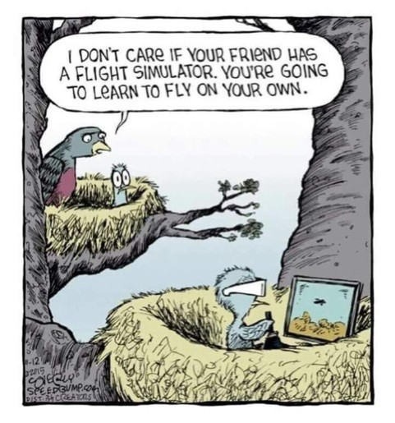
Achievements of our members

1. Jenny Reeb

From Morgen Reeb: We have another woman Commercial Multi-engine pilot among us! This year Jenny was singing “All I want for Christmas is my Commercial Multi-engine license”. And she earned it on December 17, the 117th anniversary of the Wright Brothers First Flight. That whole morning the weather was too windy and IMC, but lat in the day the weather finally cleared up. The sun sets really early in mid December, so she ended up doing some steep turns and over-ocean practice at night. On her single engine instrument approach, the examiner failed the gear and she had to also do the emergency gear extension procedure. Jenny really earned her Commercial Multi-engine license!
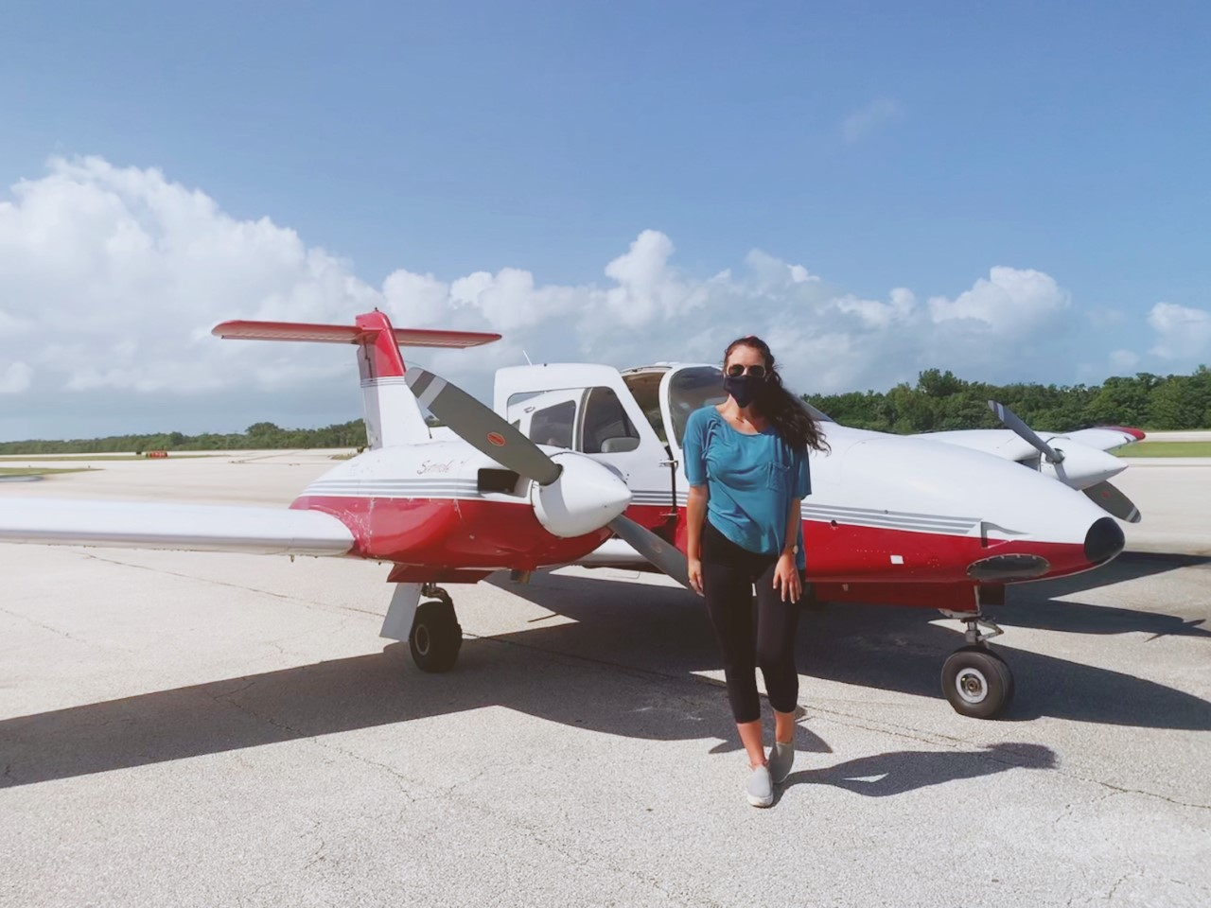

2. Eleanor Brunsman

Eleanor is a newly licensed pilot and a student at Embry Riddle. Her friend, Joseph, bought a tail dragging Cessna 150 in California and asked Eleanor to fly it cross country to Florida. She jumped at the chance and wrote a gripping narrative of the trip. They battled dust, ice, snow, low ceilings and brutal cross winds. They flew over the grand canyon and into Marble Canyon to learn how tricky it is to climb with full fuel from a high elevation field surrounded by canyon walls. They landed on runways that aren’t even on the charts and met a fair number of colorful characters along the way. Her story is gripping and will make any of us who have done similar trips smile with recognition and a few white knuckles. Let her know if you would like to read the full narrative: eleanorbrunsman@gmail.com.

Here are a couple of photos and a route map:

Eleanor at Goler Heights, California (left), N7303X in Marble Canyon (right)

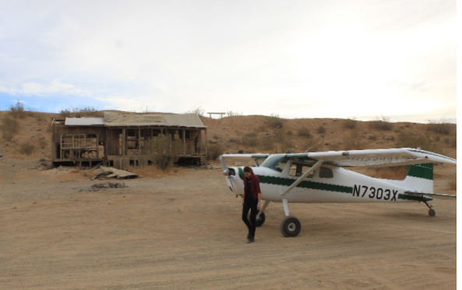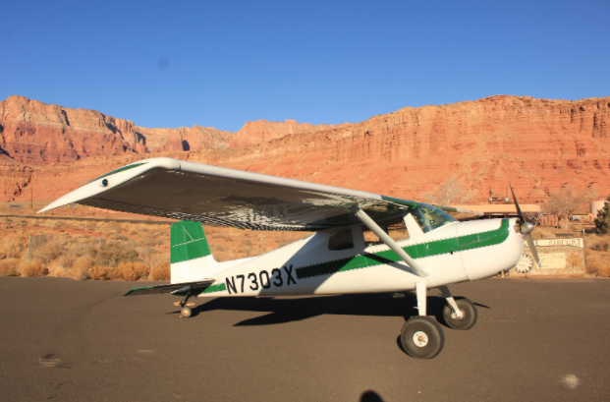

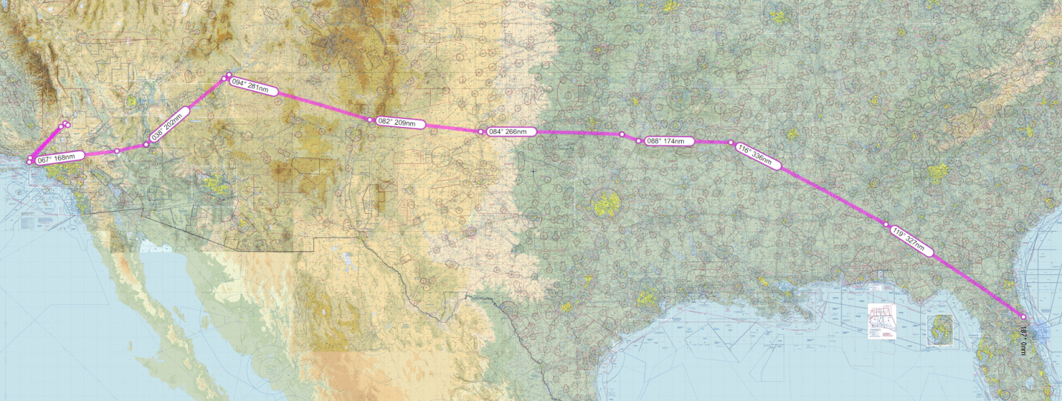

Awards Nominations

Do you know of a 99, a Friend of The 99s, or an organization that deserves to be recognized for their aviation contributions? Please submit your chapter, section, or trust nominations to our International Awards Committee at
awards@ninety-nines.org.

The deadline for nominations for the awards is January 31, 2021. Information about the awards can be found in the Ninety-Nines magazine. The five Awards are: Award of Achievement for Contributions to The Ninety-Nines, Award of Achievement for Contributions to Aviation, Award of Achievement for Humanitarian Efforts, Award of Merit, and the George Palmer Putnam Award.

Upcoming events

Maidenhead Heritage Center

This English museum and research center has a special focus on women in aviation

Their next online lecture 'The Life and Death of Amy Johnson' by Jane Priston was scheduled for Wednesday January 6 which was the anniversary of her death, but it has been postponed to a date to be determined

Let me know if you want me (Mary McCutcheon) to notify you about this new date (703-217-8850). You will need to buy a ticket for whatever 15 pounds is these days https://maidenheadheritage.org.uk/shop/.

First Wednesday webinar:

Wednesday, January 6 - 8:00 pm Eastern. Learn more about the 99s Professional Pilot Leadership Initiative (PPLI) that could support your aviation career goasl. Applications for the next PPLI class are due January 31. The PPLI leverages the "power of a pack" to help women across the globe achieve professional and personal success. We'll talk about what constitutes a "pack", how you find one, and why it is so important that everyone has her own pack.
PPLI is a unique 18-24 month structured, formal leadership and mentoring program.
Panelists include Lynzie Hudson, Lorena Knapp, McKenzie, Auste Rayome, Melissa Shantz, - register today!

https://attendee.gotowebinar.com/register/3188732566508858896

Harassment in Aviation

Jenny Beatty, a pilot for a major airline, will present an online educational seminar on the subject of "Harassment in Aviation" on January 12 at 8 PM Eastern time.

The Host will be Dr. Monica Randolph-Graham, 99s International Director, 99s Member Council Leader

Captain Jenny Beatty discusses Harassment in Aviation, including how sexual harassment and other types of harassment may look in different scenarios at the airport, in training, in flight, and in hiring; how it can affect safety of flight; how it impacts student pilots and those aiming for professional pilot careers; what you can do to prepare yourself and address harassment if it occurs; being an ally and advocate for others; and much more. Do you have specific questions that you want Captain Beatty to address? Please send them to: Monica.Director.99s@gmail.com.

To register, go to https://register.gotowebinar.com/register/901554866753819407

Amelia Earhart Birthplace Museum Fundraiser

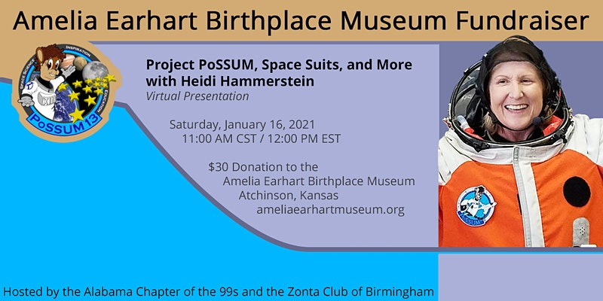

January 16, 2021 12 PM EST
Purchase tickets at https://2021_aebm.eventbrite.com for $30

Mercury 13 commemoration

Our 99s Museum of Women Pilots (MWP) is commemorating the 60th Anniversary of the culmination of the Mercury 13 program with a virtual celebration on Saturday, February 27, 2021, from 11 a.m.-1 p.m. CST. Tickets will be available through Eventbrite.com. Admission is $25 for adults and $15 for students through 12th grade. "First Lady Astronaut Trainees" Gene Nora Jessen and Wally Funk will participate in the live event hosted on Go-To-Webinar. Other participants include keynote speaker Col. Eileen Collins, USAF ret, the first woman to command the NASA Space Shuttle and Alyssa Carson, the 19-year-old who has worked endlessly towards being an astronaut since the age of three. Emcee for the event will be Janet Ivey of the Emmy Award-winning PBS series "Janet's Planet." Look for final details on 99s websites and social media, and other aviation sites. For more information, email to 99sMuseum@gmail.com. Please help promote this event for the MWP.

Women in Aviation International

Virtual conference March 11 and 12

I don’t know yet how to register, but you can go to www.wai.org and check as time goes on.

SUN 'n FUN Aerospace Expo
April 13 – April 18, 2021
At the Lakeland Linder Regional Airport (LAL) in Lakeland, Florida

Tickets are already on sale.
Go to http://flysnf.org

The promotional code for The Ninety-Nines, Inc. is: NNI506

Ninety-nines international 2021 Conference
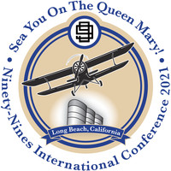

2021 International Conference and Career Expo
July 7-11, 2021
Long Beach, California
To register and for more information, go to www.99sconference.org
EAA AirVenture July 26 to August 1
AKA “OSHKOSH”
Tickets are already available. Go to https://www.eaa.org/en/airventure

Women Can Fly
No further news about Women can fly

99s Fly-in:

SEP 24 AT 1 PM EDT – SEP 26 AT 1 PM EDT

A jam-packed weekend of flying, friends and fun!
McKeller-Sipes Airport (KMKL), Jackson, Tennessee

ProJet Aviation and Career Expo
October 29
I think we have a table there.

Things to watch

Arsenal of Democracy documentary done by AOPA

YOUTUBE.COM
The massive flyover of Washington, D.C. that nobody saw - Arsenal of Democracy 2020 | AOPA Live This
This is about 45 minutes long but worth everything. Note the footage of the riveter as well as the brief moment at 24 minutes 27 seconds where our compass rose at Culpeper is clearly visible.
Sources of Support:
scholarships and learning resources

Professional Pilot Leadership Initiative (PPLI)
The Professional Pilot Leadership Initiative (PPLI) is a mentoring program which will connect you with other supportive fellow Ninety-Nines.
It will help you to develop and enhance your leadership talents and qualities. And it will assist you to strengthen and advance your career progress.
View the promotional video
And watch the webinar on Wednesday January 7
Application deadline January 31

