
Old Dominion Chapter
SKYLINES
November 2022

Chair: Laura Savino
Vice-Chair: Mary McCutcheon
Secretary: Jessica Citrin
Treasurer: Barbara Wilper
Amelia Earhart Scholarship: Sue Passmore
Aerospace Education: Debbie Gallaway
Membership: Barb Wilper
Air Marking: vacant
Newsletter: Mary McCutcheon
Webmaster: Rose Brown

Next Meeting Monday December 5

Our November meeting has been canceled but there was not too much business anyhow. So make a note of December’s meeting

Laura Savino & Mary McCutcheon are inviting you to a scheduled Zoom meeting

Mary McCutcheon is inviting you to a scheduled Zoom meeting.
Topic: My Meeting
Time: Dec 5, 2022 06:30 PM Eastern Time (US and Canada)

Join Zoom Meeting
https://gmu.zoom.us/j/95306220218?pwd=ZnNROTJUckVJN1VQZjIxMEg3VE9Xdz09

Meeting ID: 953 0622 0218
Passcode: 739007

Past Events

Mid Atlantic Section meeting
Laura Savino and Peggy Doyle were there for the Saturday morning business meeting in Liditz, PA on October 29.

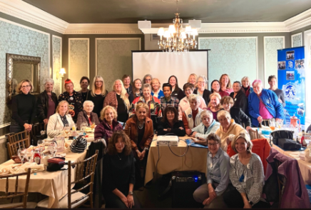

ProJet Aviation Expo

Our chapter made a good showing on November 4 at Leesburg airport. The place was swarming with people interested in aerospace careers. I think we managed to recruit one or two new members too as well as young women who may be members some day in the future.

Laura Savino, Mary McCutcheon, Melissa Plumer, Stephanie Kight, Mia Anderson, and Hannah Rust were all there.

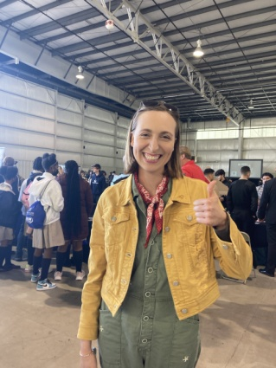
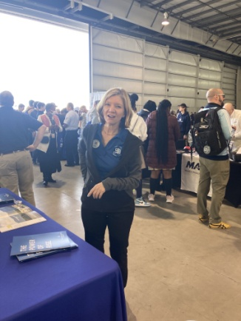

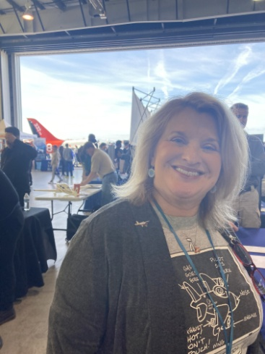
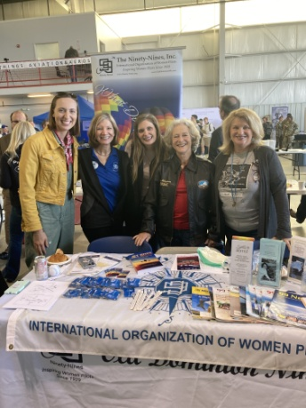

Goodbye party for Debbie Galloway

A good crowd of 99s and 491/2s came to Debbie and Chuck Galloway’s goodbye party. They are off to a retirement community where, no coincidence, Marti Tidmore also lives.

Rose Brown, John Brown, Peggy Doyle and Rick Koehnke, Jessica Citrin, Mary McCutcheon, Laura Savino, R.J. McGlasson, Judy Shaw, Melissa Plumer and Eric, came to Guapo’s Mexican restaurant and ate al fresco on a gorgeous warm autumn night.

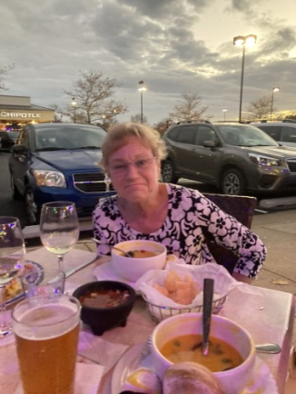

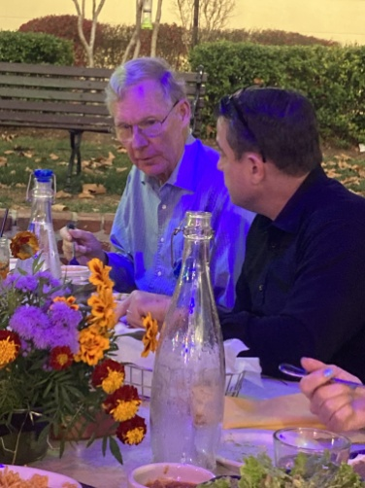

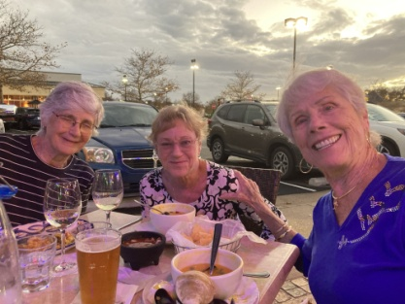

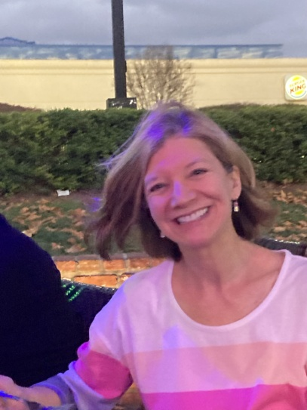



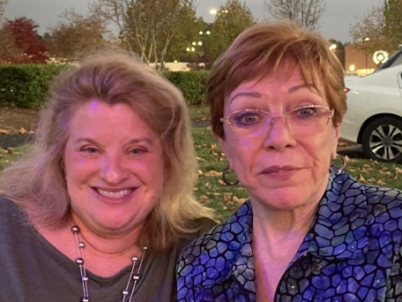

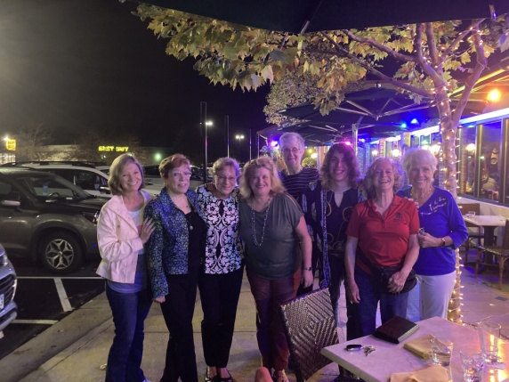
Future Events

College Park November 13
Nothing to report at this time since the newsletter is getting finished too early but my the time you read it, this will be a past event. Stay tuned for a report.

An idea for a gathering: NASA Museum at Greenbelt, MD
The folks at this museum right on the Goddard campus are anxious for us to come for a tour. Let’s figure out a good day. They have a lot on planetary science and exploration as well as a small exhibit on the main characters in the movie, Hidden Figures.

Ocracoke Fly-in May 18-22 2023

2023 International 99s Conference:
October 30-November 3, 2023 in Jordan

Fall 2023 Old Dominion hosts Mid-Atlantic Section meeting
We should start to think about locations and plans soon

NEWS STORIES

Jenny Reeb’s custody of Foxy

As you read last month, Jenny Reeb will be keeping the Cessna 152 down in Florida so she can build hours in it. Now that it’s there, Jenny and some of her friends have affectionately renamed it “Foxy”, a name that Morgen pledges to keep. Last month was the first in the saga of keeping that plane safe from hurricanes. Here is what Morgen says: “Unfortunately another hurricane named Nicole popped up so quickly we scrambled to figure out what to do with Foxy. Luckily this time there weren’t as many airplanes in the large maintenance hangar at Melbourne airport. The director at FIT Aviation where Jenny works said that they could fit the 152 in. So Foxy rode out hurricane Nicole in the maintenance hangar at FIT Aviation. Jenny sent a picture of Foxy in the maintenance hangar and a picture of the FIT airplanes in the large hangar at Melbourne Airport.”

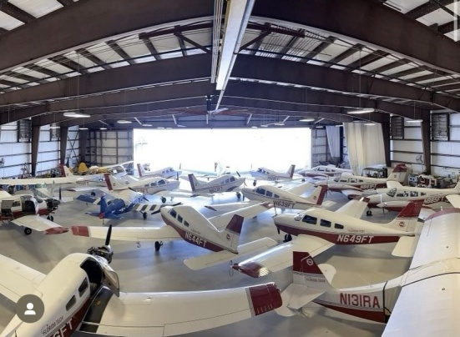
Can you find Foxy?
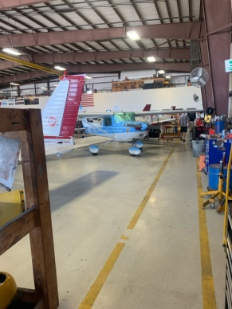
Oh there she is!
Members Accomplishments

Peggy Doyle
Here is a picture of Peggy next to Bench at the Forest of Friendship that honors the scholarship fund that Peggy has worked on for years. You’ll notice that none of these women plans to use the bench to lounge around.

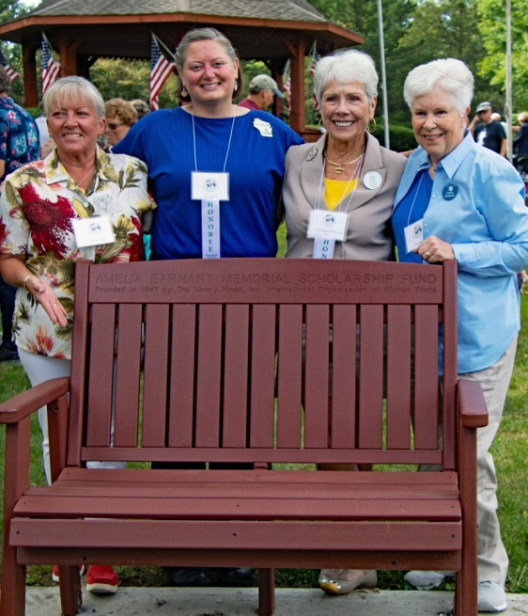

Peggy has also renewed her CFII

Mia Anderson has decided to learn how to fly machines that have engines! Good for her. Here she is after her solo losing her shirt tails.

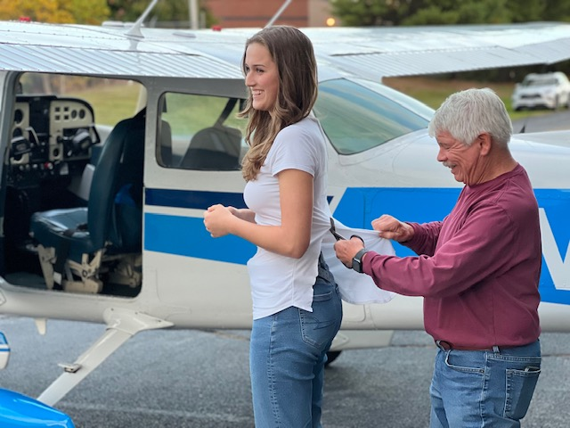

Grace Boras has earned her Tail Wheel endorsement

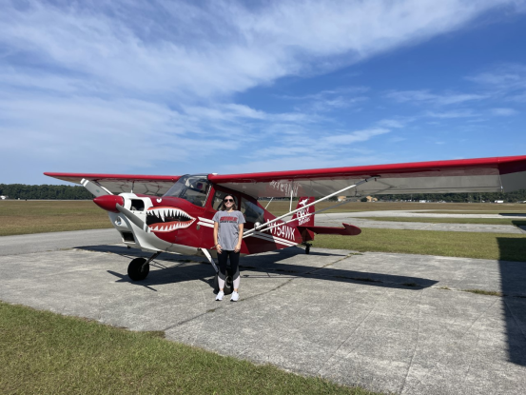
Here she is with the Citabria she checked out in

Robert Emery (kat’s 49½) got his Private Pilot’s license on October 5. Kat was his CFI! (with Aero Elite Flight Training). Here they are:

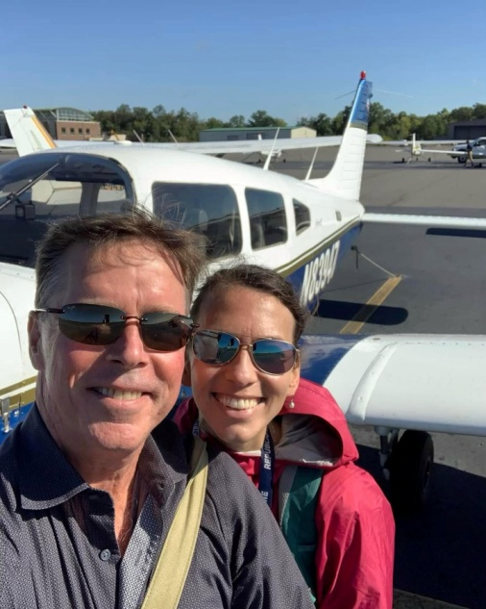

November selection Aviatrix Book Club



