
Old Dominion Chapter
SKYLINES
March 2022

Chair: Mary McCutcheon
Vice-Chair: Laura Savino
Secretary (acting): Jessica Citrin
Treasurer: Barbara Wilper
Amelia Earhart Scholarship: Sue Passmore

Aerospace Education: Debbie Gallaway
Membership: Barb Wilper
Air Marking: vacant
Newsletter: Mary McCutcheon
Webmaster: Rose Brown
Next Meeting

Topic: Old Dominion Ninety-nines
Time: Mar 3, 2022 06:30 PM Eastern Time (US and Canada)

Join Zoom Meeting
https://gmu.zoom.us/j/91462032231?pwd=cUxjODJnaS8xSHd1V2h5aEdZR1BjQT09

Meeting ID: 914 6203 2231
Passcode: 069483

A Ninety-nine in Kyiv

I sent her an email which I had translated into Ukrainian by Google Translate. I hope she answers. She is a student pilot, but maybe she can fly away or drop something.

Moskalenko, Marina
Ihor Branovytsky Street, H8, Apt 69
Kyiv, Kyiv 01042
Ukraine

Cell: +38 096 873 6209
marynamoskalenko31@gmail.com

UPCOMING ELECTIONS

CHAPTER
Our present officers are rotating out this summer, so we need to get some candidates pretty soon. If we have our election in April, there will be some transition time before the officers take their positions on the First of June.

There are not enough volunteers stepping up. Barb Wilper is willing to serve again as Treasurer. Please think about taking a position.

SECTION

Governor: Lin Caywood
Vice Governor: Maria Esparraguerra and Mary Wunder
Secretary: ??
Treasurer: Barb Gruber (current and continuing)
Director (2): Joy Halcott and Lauren Brenneman

Two willing to run for whatever we need: Katrina Emery and Carley Walker

INTERNATIONAL

There is a full slate of candidates for our 2022 election and ballots will be disseminated on March 15 to all members who are eligible to vote. This Spring, we will be electing a President, Vice-President, Secretary, Treasurer, two Directors, the Nominating Committee, and Trustees for our four Trusts. See the list of candidates below.

For the first time, there will be a "Meet the Candidates" online event, to be held on March 2 and March 9. These sessions will feature a question-and-answer segment and give the candidates an opportunity to address our members.
Ninety-Nines Election 2022
Voting will be held by secret ballot. Members will receive an invitation to vote electronically or paper ballot depending on the selection made prior to the deadline. Ballots will be sent on or before March 1, 2022. New officers will be announced prior to the Annual Conference and will be inducted at the Annual Business Meeting.

PRESIDENT (ONE POSITION)

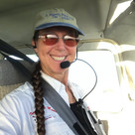 | TERRY CARBONELL  Paradise Coast Chapter  Southeast Section  Position Statement  Intent  Resume
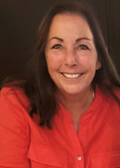 | ROBIN HADFIELD  First Canadian Chapter  East Canada Section  Position Statement  Intent  Resume

VICE-PRESIDENT (ONE POSITION)

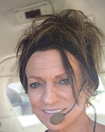 | MONICA RANDOLPH-GRAHAM  Fort Worth Chapter  South Central Section  Position Statement  Intent  Resume
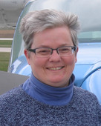 | MINNETTA GARDINIER  Iowa Chapter  North Central Section  Position Statement  Intent  Resume

SECRETARY
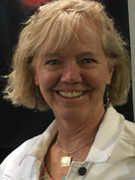 | GLENNA BLACKWELL  Connecticut Chapter  New England Section  Position Statement

TREASURER (ONE POSITION)

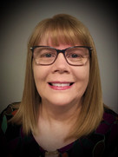 | AILEEN COVERDELL  Mid-Columbia Chapter  Northwest Section  Position Statement  Intent  Resume
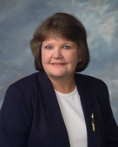 | MARIA LAMIA  Wisconsin Chapter  North Central Section  Position Statement  Intent  Resume

DIRECTOR (TWO POSITIONS)

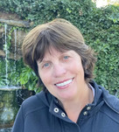 | PAT PRENTISS  Orange County Chapter  Southwest Section  Position Statement  Intent  Resume
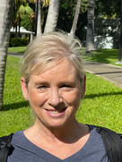 | SHANNON OSBORNE  Greater New York Chapter  New York-New Jersey Section  Position Statement  Intent  Resume
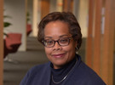 | LESLIE PRELLWITZ  Chicago Area Chapter  North Central Section  Position Statement  Intent  Resume

NOMINATING COMMITTEE (FIVE POSITIONS)

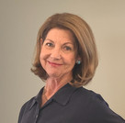 | MAE MARQUET  NOLA Chapter  Southeast Section  Position Statement  Intent  Resume
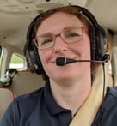 | VIRGINIE ROLLIN  San Joaquin Valley Chapter  Southwest Section  Position Statement  Intent  Resume
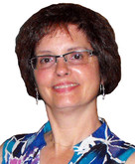 | ROSEANNE ISOM  New Jersey Chapter  New York-New Jersey Section  Position Statement  Intent  Resume
 | MARGARET WINT  Indiana DunesChapter  North Central Section  Position Statement  Intent  Resume
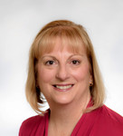 | LIN CAYWOOD  Sugardloaf Chapter  Mid-Atlantic Section  Position Statement  Intent  Resume

99s MUSEUM OF WOMEN PILOTS (TWO POSITIONS)

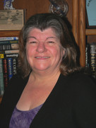 | JEANNE BURKLUND  Florida Suncoast Chapter  Southeast Section  Position Statement
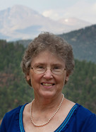 | SARAH RICKMAN  Pikes Peak Chapter  South Central Section  Position Statement  Intent  Resume

AMELIA EARHART MEMORIAL SCHOLARSHIP FUND (ONE POSITION)
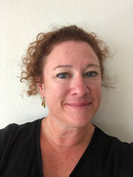 | LAURA ABRAHAM  Colorado Chapter  South Central Section  Position Statement  Intent  Resume

AEBM (TWO POSITIONS)
 | ROBIN LAWS  Ambassador Chapter  South Central Section  Position Statement  Intent  Resume

NINETY-NINES ENDOWMENT FUND (ONE POSITION)

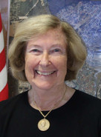 | PAT OHLSSON  Long Island Chapter  New York-New Jersey Section  Position Statement  Intent  Resume
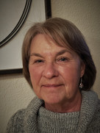 | JEANNE PIERCE  Reno Area Chapter  Southwest Section  Position Statement  Intent  Resume

UPCOMING EVENTS

Spring International Board of Directors Meeting

The Spring International Board of Directors (IBOD) meeting will be held on March 4-5 and all non-board members are invited to attend virtually. No travel, hotel, or meal expenses; no time off from work; show up in your pajamas or whatever attire you choose. Details will be provided in the March Straight & Level.

March 17-19 - Women in Aviation, Nashville!

Homepage | Women in Aviation International (wai.org)

Trip to Patuxent Naval Air Museum.

April 2 noon
The featured exhibit is called "Women in Aviation: Exploring Their Diverse Contributions to NAS Patuxent River and Beyond." At our February meeting we selected March 26 as our first choice date, but this is not possible; there will be 500 other people at the museum that day for a huge art auction. So we agreed that April 2 would work best. We can negotiate a time, but, considering the long drive, it might be best not to aim for anything before noon. They are ready to give us a guided tour, but we can go anytime between 10 and 5 if we want to take care of ourselves. So let’s talk about transportation. St. Mary’s County Airport is not too far for those who fly and those who drive can provide ground transport.

Sun n Fun Aerospace expo. April 5- 10 Lakeland, Florida

SUN 'n FUN Aerospace Expo - Largest Air Show in the Southern US (flysnf.org)

Mid-Atlantic Section Meeting
The date has not been set yet but the Delaware chapter is hosting

Women can Fly June 4

Note from Sarah Patten:
I hope you've all been well, and that you've stayed safe and healthy through the holiday season! After a two year break, we're excited to be bringing the Women Can Fly event back to HWY again. This year's event will be held on Saturday, June 4th, from 9am to 4pm. Your hard work and efforts have been the key to success with our past events, and we'd love to have you back for any amount of time you might be available!
We have some big changes coming for this year, most notably that we'll be moving the entire event down to the new FBO. While we're planning to keep the same basic event structure (exhibitors, static display, preflight briefing, flights, Women Can Build), we will be making some changes to the layout and flow of the event to fit into the new space. We could especially use some extra ground volunteers to make sure that everything runs smoothly, so if you know of anyone that might be interested, please feel free to pass along my contact information.
We're still in the process of updating the website to reflect this year's event, and I'm still waiting to hear which of the other locations are also planning to hold their events this year. I'll send out more information to everyone as planning progresses; in the meantime, if you have any questions, suggestions, thoughts, or know that you'd like to help again this year, just let me know!

Thanks, and hope to see you again soon!
Sarah Patten Women Can Fly at HWY Event Coordinator

Summer International Meeting

"Do the Charleston" This Summer!
Registration is open for the 2022 International Conference in Charleston, SC July 6-10.
The full registration fee is reduced to $319 USD until March 31; after March 31 the fee for a full registration is $349 until May 31. There are also options for one-day and guest registrations.
Speakers include Captain Brian Schiff, Mary Build, Dr. Susan Ying, Kathy Yodice, Heidi Hammerstein and Judy Phelps.
REGISTER HERE

Air Race Classic June 21-24, 2022
Thinking of racing? Check out the web page: www.airraceclassic.org
March 31, 23:59EDT - Racer Registration Deadline
98 racers have registered so far! Will you be #100? You’ll need copies of your pilot certificate, medical certificate or BasicMed documents, and a government-issued photo ID. Have you registered as a racer but haven’t finished your team registration? Don’t forget to upload a photo showing the pilot on the left side and the copilot on the right, with a separate photo for teammates. For best results, the photo should be 300 pixels by 300 pixels and not smaller than 200 megabytes. The fee paid at registration includes the entry fee, as well as the Start and Terminus fees. Questions? Email entryadmin@airraceclassic.org.

EAA AirVenture Oshkosh July 25 to July 31

AirVenture (eaa.org)

ProJet Aviation Expo November 4.

We are likely to participate again this year but we will need to vote on it. Our attorney has advised us not to initial the spots on the application that indemnify ProJet or that require taking out extra insurance

Compass roses

1. at Front Royal
2. at Manassas?

AE Scholarships: First Wings
The Amelia Earhart Memorial Scholarship Fund First Wings Awards are semiannual awards of up to $6,000 based on completion of specific training milestones. They are available to Student Pilot Members of The 99s who meet eligibility requirements. To be eligible, applicants must hold a student pilot certificate (or provide evidence that they meet their country's flight training requirement), have been an official Student Pilot Member three months prior to the application deadline, have logged 5 hours in the six months prior to the application deadline and show financial need.
The Fall 2021 First Wings deadline is October 1. The instructions and application are available on The 99s.
Win a year’s membership in the 99s

The Ninety-Nines, Inc. Attn: SiriusXM Offer Processing PO Box 950374 Oklahoma City, OK 73195-0374 Receiver Purchase Requirements 1. Purchase any new eligible SiriusXM Aviation receiver: Garmin GDL 69/69A SXM, GDL 51/52, GDL 51R/52R, GXM 42, G3X Touch, GDU 455/465 2. Mail in fully completed form Subscription Activation Requirements 1. Subscribe to a SiriusXM Aviation weather package 2. Mail in fully completed form, including a copy of your SiriusXM Aviation subscription receipt

A High School aeronautics program outreach

At the ProJet Expo, we met an aeronautics teacher from a high school in Ashburn and we proposed that the Old Dominion Ninety-nines could make some presentations to her classes. She said she was interested. We have had a couple of back and forth emails and hope an in-class event might happen this spring semester. As the plans solidify, I’ll let you know.

Things to read and watch

1. March selection Aviatrix Book Club


2. NPR’s show on Morning Edition

This was a show about United Airlines plans to train its own pilots with the larger goal of diversifying its pilots. Good show. Listen if you have a few minutes.
https://www.npr.org/2022/03/01/1083664582

