
Old Dominion Chapter
SKYLINES
April 2022

Chair: Mary McCutcheon
Vice-Chair: Laura Savino
Secretary (acting): Jessica Citrin
Treasurer: Barbara Wilper
Amelia Earhart Scholarship: Sue Passmore

Aerospace Education: Debbie Gallaway
Membership: Barb Wilper
Air Marking: vacant
Newsletter: Mary McCutcheon
Webmaster: Rose Brown
Next Meeting Thursday April 7

Mary McCutcheon is inviting you to a scheduled Zoom meeting.
Come for the Happy Half Hour at 6:30 if you want the lowdown on the International Candidates

Topic: Old Dominion ninety-nines
Time: Apr 7, 2022 06:30 PM Eastern Time (US and Canada)

Join Zoom Meeting
https://gmu.zoom.us/j/92128316059?pwd=eDcyeE0wdUlFUjU2STVBTVFQTTZOQT09

Meeting ID: 921 2831 6059
Passcode: 528564

Chapter Officers -- Plea for Candidates

There is an urgent need for people to run for chapter offices: Chair, Vice Chair, Secretary, and Treasurer. Barb Wilper is happy to serve as treasurer again and Jessica will continue as secretary, our by-laws state that the vicechair position can be held for two terms so Laura could continue. The critical position is CHAIR. Mary may not continue to serve after her two terms. PLEASE step up. Mary is happy to do a lot of work as are many of the other past chairs, so the load may not be too onerous.

RECENT HAPPENINGS

Anniversary of the founding of the Old Dominion Chapter -- April 1

Thanks to Sue Passmore we discovered that our chapter was founded on April 1, 1992, making this last week our thirtieth anniversary. The founding members were: R.J. McGlasson, Marti Tidmore Constantinos, Marge Shaffer, Peggy Doyle, Betty Fisher, Linda Cain, and Maureen Long. These members came from the D.C. Chapter. Very soon after our founding, other women joined: Evie Washington and Judy Bergman have also been with the group nearly since the beginning. These are the people who are currently members, but other women have left or died. I would like to get a better idea of the history of our membership. Does anyone want to help?

So to celebrate this auspicious event, Melissa Plumer arranged for us to go to a wine tasting place in Haymarket for a happy reunion. Of the founding members, R.J., Peggy, and Marti were able to make it. Here are some photos.

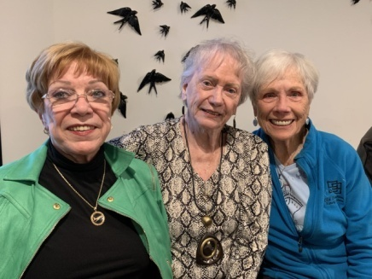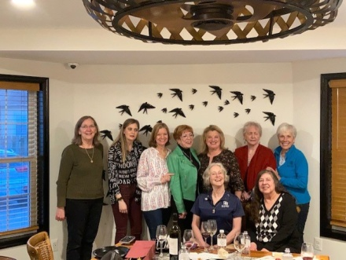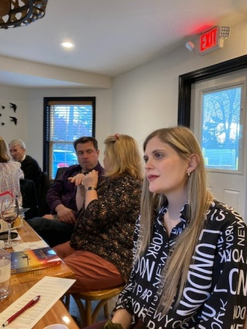
RJ, Marti, and Peggy All the ladies Our new member, Stephanie Kight

Trip to Patuxent Naval Air Museum.

April 2
Barb Wilper and Mary McCutcheon drove down to Patuxent River Naval Air Station and were met by our tour guide, Brian Koenig. The exhibit about women, “Women in Aviation: Exploring Their Diverse Contributions to NAS Patuxent River and Beyond”, was simply some silkscreened hanging flags each one depicting the picture and background of some women navy pilots. It was a nice gesture, but not particularly memorable. The trip was fun because Barb had so many personal experiences with the human factors aspects of the aircraft and weapons having worked for McDonnell Douglas/Boeing, and the Navy for over 30 years. Then we had a seafood lunch in Solomon’s Island.
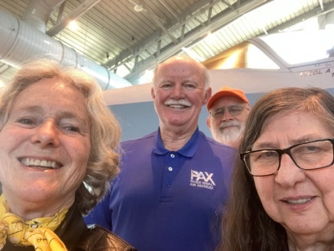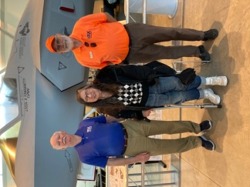

S.H.E. CAN Aviation STEAM Camp

Barb Gruber and Julia Orr have been running a program at National Air and Space Museum to attract girls to aviation and other technical fields. Laura Savino has gone twice to this camp to speak: first to give the graduation talk (pictured below) and recently to give the orientation/ initiation talk to the newest crop of girls. This program is fabulous. It’s called SHECAN Aviation Steam Camp. Check out the YouTube for a feel-good experience:

https://www.youtube.com/watch?v=avZ1ktQsB0o

https://www.youtube.com/watch?v=NRHbkmkZONo

And here are some pictures of Laura speaking to the graduating class

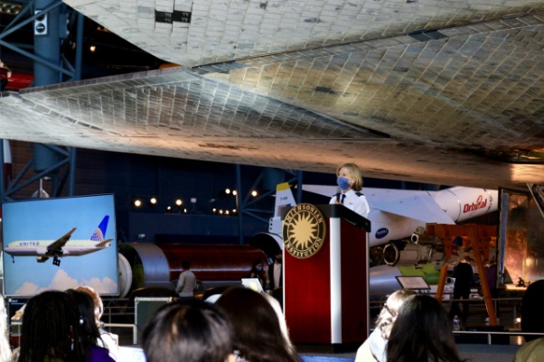

UPCOMING EVENTS

Air Drop for Ukraine

On Sunday April 10 beginning at 9 and ending at 6 PM, at Warrenton Airport, there will be a fundraiser for World Central Kitchen’s work for the Ukrainian refugees in Poland. Many volunteer pilots will take passengers up in Cessnas and Stearmans so the passenger can drop a beanbag onto a target. Chance to win gift certificates from local businesses or a grand prize of $1000 for the first bullseye.

Speakers in schools

Carolyn Hunker and Laura Savino are inaugurating a program we hope will be the beginning of something good. They are speaking to two classes of aerospace students on April 25 at Stone Bridge High School in Ashburn. Carolyn will explain how to get a pilot’s license and Laura will tell them what kinds of things they can do, flying and non-flying, in aerospace.

Mid Atlantic Meeting is scheduled on May 14 as a zoom

We invite you to join us online for our spring section meeting hosted by the Delaware Chapter. Due to the weekly Presidential TFR in the DE area it was decided that an online meeting would be best at this time.

All Women’s air show in Oregon

All female air show May 20 - 22, 2022 Hillsboro Airport Hillsboro, Oregon https://oregonairshow.com/hillsboroevent-2022/ The Oregon International Air Show is returning to Hillsboro after a three-year hiatus at the Hillsboro Airport. The air show returns in May following a year of cancellations due to the COVID19 pandemic and two years of reconfiguring the show into a two-location format. As was planned for the 2021 event that was postponed, this year will feature an all-female air show, with all the pilots, performers and announcers being women.

Oregon Hosts All-Female Air Show - AVweb
Pamplin Media Group - 2022 Oregon International Air Show returns to Hillsboro in May

Ocracoke Trip May 20-May 23

The Weekend of May 20 is the annual Ocracoke trip. Fly in or Drive in. It is too late to reserve a hotel room where the group is staying, but perhaps possible to get a place to stay somewhere else.

Women can Fly June 4. Warrenton

Sign up available for volunteer pilots and desk staff.
Womencanfly.com.

Air Race Classic June 21-24, 2022
Check out the web page: www.airraceclassic.org
Too late to register to race, but follow the racers

Summer International Meeting

"Do the Charleston" This Summer!
Registration is open for the 2022 International Conference in Charleston, SC July 6-10.
The fee for a full registration is $349 until May 31. There are also options for one-day and guest registrations.
Speakers include Captain Brian Schiff, Mary Build, Dr. Susan Ying, Kathy Yodice, Heidi Hammerstein and Judy Phelps.
REGISTER HERE
Laura Savino will be sitting at a “meet the author” table.

EAA AirVenture Oshkosh July 25 to July 31

AirVenture (eaa.org)

ProJet Aviation Expo November 4.

We are participating again this year. All the paperwork is in. Hoping that a good number of ninety-nines come to help staff our table.

Elections
Vote on line Section and International
For the first time, there was a "Meet the Candidates" online event, held on March 2 and March 9. These sessions featured a candidates statement and question-and-answer segment. You can stream this event by going to the members only page of the Ninety-nines web page and look for it.

Peg Doyle offers endorsements for the international elections:
Robin Hadfield for President
Minnetta Gardinier for Vice President
Glenna Blackwell for Secretary
Leslie Prellwitz for Governor

Scholarships

The MidAtlantic Scholarship

deadline has passed and the committee is going to make its announcement on the 15th. Laura Savino reports that there were 5 applicants so the competition was stiff.

Female Aviators Sticking Together (FAST)
Home page - Female Aviators Sticking Together (fastpilots.com)
This group is new to me. But I checked out both the Facebook page and the Web page. It is full of scholarship information.

Blonds In Aviation
Aviation Scholarship Calendar - Blonds In Aviation

AE Scholarships: First Wings
The Amelia Earhart Memorial Scholarship Fund First Wings Awards are semiannual awards of up to $6,000 based on completion of specific training milestones. They are available to Student Pilot Members of The 99s who meet eligibility requirements. To be eligible, applicants must hold a student pilot certificate (or provide evidence that they meet their country's flight training requirement), have been an official Student Pilot Member three months prior to the application deadline, have logged 5 hours in the six months prior to the application deadline and show financial need.
The Fall First Wings Award Application deadline is October 1. Membership join date must be no later than July 1 of that year.
Click here to view the Award Description and Instructions
Ready to apply? Application1
WASP NEWS

1. Renée Zellweger will direct and star in a movie about the WASP
https://www.military.com/off-duty/television/2022/03/08/renee-zellweger-star-tv-drama-about-world-war-iis-wasps.html

2. Nicole Malachowski on Social Flight April 12
SocialFlight Live - Honoring the WASPS, Fmr Thunderbirds Pilot Nicole Malachowski

https://www.socialflight.com/event-details.php?eventId=1231964

3. WASP Reunion and Fly-In April 28-30
Sweetwater Texas
https://www.waspmuseum.org/upcoming-events/

4. Good short film on Youtube. https://www.youtube.com/watch?v=FyKcQhN4A8c

5. Where did the WASP logo Fifinella come from?
https://www.flyingmag.com/disney-animations-art-brought-color-to-world-war-ii/

6. A documentary about Betty Wall: Girls Don’t Fly
https://www.youtube.com/watch?v=K7KDubhzmYo

7. Another documentary When We Were WASP
https://www.youtube.com/watch?v=a2DN_7g0UVg

Accomplishments of our members
Colleen Whitehouse got her ATP and is currently in training for Sky West in Denver. Peg Doyle says she is “Living the dream”.

Things to look at

Girls love to Fly
https://www.facebook.com/groups/girlslovetofly
https://girlslovetofly.com/

Female Aviators Sticking Together (FAST)
Home page - Female Aviators Sticking Together (fastpilots.com)

Article in Fauquier County paper re: Women Can Fly

I don’t remember the name of the newspaper or the writer. But one of these days, Women Can Fly will get some publicity.

Blonds in Aviation
https://www.blondsinaviation.com

AVIATION PODCASTS
AviatorCast
The Finer Points
Aviation Careers Podcast
Stuck Mic AvCast
Pilot to Pilot
Airplane Owner Maintenance
AOPA
MzeroA

April selection Aviatrix Book Club

