
Old Dominion Chapter
SKYLINES
May 2022

Chair: Mary McCutcheon
Vice-Chair: Laura Savino
Secretary (acting): Jessica Citrin
Treasurer: Barbara Wilper
Amelia Earhart Scholarship: Sue Passmore
Aerospace Education: Debbie Gallaway
Membership: Barb Wilper
Air Marking: vacant
Newsletter: Mary McCutcheon
Webmaster: Rose Brown

Next Meeting Thursday May 5

Topic: Old Dominion ninety-nines monthly meeting
Time: May 5, 2022 06:30 PM Eastern Time (US and Canada)

Join Zoom Meeting
https://gmu.zoom.us/j/99629846416?pwd=cHdSY3NoTE9POWpMTnZydEtVaG93QT09

Meeting ID: 996 2984 6416
Passcode: 564221

Old Dominion Chapter Election

We thought we had our election, but only a handful of people voted
It turns out that our experiment with GoogleGroups as a means of communication didn’t work for a large percentage of our membership.

There were no contested positions, so the election might have been largely a formality, BUT this should not be the way we conduct an election. At our meeting on Thursday the 5th, we will have to discuss the legitimacy of such an election and perhaps resend the ballots using our old-fashioned method as well as snail mail ballots for the three people who get their newsletters that way. If this is what we decide to do, our deadline will obviously be extended.

The candidates are:

Laura Savino, chair
Mary McCutcheon, vice-chair
Barbara Wilper, continuing as treasurer
Jessica Citrin, secretary

Other election results

International
No news yet on the International elections. Ballots were due on May 1.

Mid Atlantic Section
No results yet, but there will be within the next week

Women can fly/ women can build on June 4

Women and fly and women can build will take place at various Virginia airports in June. Our chapter is involved in the women can fly event at Warrenton on June 4. Please volunteer to attend in some capacity. Our chapter has a table but I think it will be necessary for you as individuals to fill out a volunteer form even if you plan to sit at our table or just hang around. There are various other jobs to do at this event including flying some children, working with kids to build things, telling attendees about the great things that can be done with airplanes, helicopters, drones and other flying objects.

There is a rumor going around that Miss United States 2021 may make an appearance with, perhaps, a few other beauty pageant winners. Miss United States (not to be confused with either Miss America OR Miss U.S.A. is Samantha Keene Anderson. She is working toward her private pilot’s license.

Warrenton Volunteer | Women Can Fly

Our chapter is determining how else to support this event. Should we contribute some money toward one of the activities? This will be discussed at our May meeting

RECENT HAPPENINGS
Air Drop for Ukraine

It was cold and blustery on April 10, but the Air Drop for Ukraine took place at Warrenton as planned. Our Chapter volunteers took donations at the table for people who wanted to pay for beanbags whether or not they had their own airplanes. We also collected money from anyone who just wanted to donate.

I think we collected close to $13,000 that day, money that could feed a thousand or more refugees from Ukraine.

Here are some pictures of us

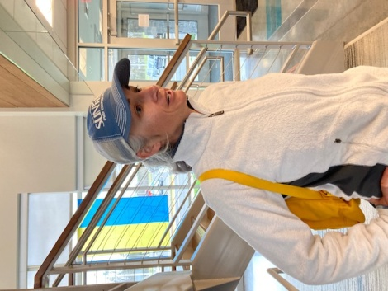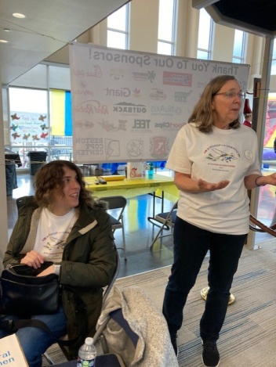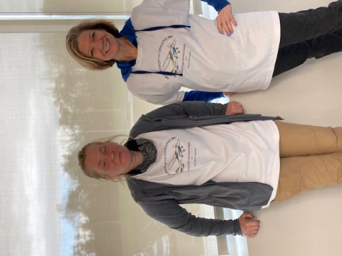

Sarah Patten Jessica Citrin & Sue Passmore Elena Shakula & Laura Savino

Stone Bridge High School Outreach

Carolyn Hunker and Laura Savino went together to Stone Bridge High School in Ashburn at the High School one day in April. They met the teacher of the engineering and aerospace classes, Terry Lucas-Fields. She teaches two back-to-back 90 minute classes so Carolyn and Laura were able to give the same talks twice. Carolyn told the students about the process of getting trained to fly and Laura talked about career possibilities. Both of them had power point shows and the students had lots of questions and showed lots of interest. Let’s hope this expands to include more schools and more of us to participate.

UPCOMING EVENTS

Mid Atlantic Meeting is scheduled on May 14 as a zoom

We invite you to join us online for our spring section meeting hosted by the Delaware Chapter. Due to the weekly Presidential TFR in the DE area it was decided that an online meeting would be best at this time.

Mid-Atlantic Section Meeting Saturday, May 14, 2022 09:00 – 10:00
The Chapter Chair meeting 10:00 – 12:00
Join Zoom Meeting
https://us02web.zoom.us/j/82304671077? pwd=Sjg4U2hmVkd2QW93bXVvWlNuZn VkZz09
Meeting ID: 823 0467 1077
Passcode: 222795

“Amelia Earhart: Pioneering Feminist”
May 16 8 to 9 PM online or in person, but you MUST register
https://airandspace.si.edu/events/amelia-earhart-pioneering-feminist

Ocracoke Trip May 20-May 23

The Weekend of May 20 is the annual Ocracoke trip. Fly in or Drive in. It is too late to reserve a hotel room where the group is staying, but perhaps possible to get a place to stay somewhere else.

Laura Savino’s Barnes and Noble Book Signing
May 28 1-4 PM
Barnes and Noble book store One Loudoun Center
20427 Exchange St
Ashburn, VA 20147
There is food and coffee and lots of books

Innovations in Flight
June 18 10 to 3
National Air and Space Museum, Udvar-Hazy

Innovations in Flight | National Air and Space Museum

Air Race Classic June 21-24, 2022
Check out the web page: www.airraceclassic.org
Too late to register to race, but follow the racers

Summer International Meeting

"Do the Charleston" This Summer!
Registration is open for the 2022 International Conference in Charleston, SC July 6-10.
The fee for a full registration is $349 until May 31. There are also options for one-day and guest registrations.
Speakers include Captain Brian Schiff, Mary Build, Dr. Susan Ying, Kathy Yodice, Heidi Hammerstein and Judy Phelps.
REGISTER HERE
Laura Savino will be sitting at a “meet the author” table.

EAA AirVenture Oshkosh July 25 to July 31

AirVenture (eaa.org)

ProJet Aviation Expo November 4.

We are participating again this year. All the paperwork is in. Hoping that a good number of ninety-nines come to help staff our table.

Scholarships

The MidAtlantic Scholarship

The winner of the Mid Atlantic Scholarship has been announced and it is:
Leah Murphy of the Maryland chapter –
the 2022 winner of the Mid-Atlantic Section Scholarship!

Female Aviators Sticking Together (FAST)
Home page - Female Aviators Sticking Together (fastpilots.com)
This group is new to me. But I checked out both the Facebook page and the Web page. It is full of scholarship information.

Blonds In Aviation
Aviation Scholarship Calendar - Blonds In Aviation

AE Scholarships: First Wings
The Amelia Earhart Memorial Scholarship Fund First Wings Awards are semiannual awards of up to $6,000 based on completion of specific training milestones. They are available to Student Pilot Members of The 99s who meet eligibility requirements. To be eligible, applicants must hold a student pilot certificate (or provide evidence that they meet their country's flight training requirement), have been an official Student Pilot Member three months prior to the application deadline, have logged 5 hours in the six months prior to the application deadline and show financial need.
The Fall First Wings Award Application deadline is October 1. Membership join date must be no later than July 1 of that year.
Click here to view the Award Description and Instructions
Ready to apply? Application1

May selection Aviatrix Book Club

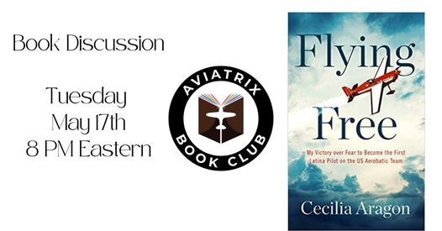

Accomplishments of our members

Mia Anderson has been selected as Miss Teen Shenandoah Valley.

