
Old Dominion Chapter
SKYLINES
June 2022

Chair: Mary McCutcheon
Vice-Chair: Laura Savino
Secretary (acting): Jessica Citrin
Treasurer: Barbara Wilper
Amelia Earhart Scholarship: Sue Passmore
Aerospace Education: Debbie Gallaway
Membership: Barb Wilper
Air Marking: vacant
Newsletter: Mary McCutcheon
Webmaster: Rose Brown

Next Meeting Thursday June 2

Laura Savino and Mary McCutchion are inviting you to a scheduled Zoom meeting.

Topic: Old Dominion Monthly meeting
Time: Jun 2, 2022 06:30 PM Eastern Time (US and Canada)

Join Zoom Meeting
https://gmu.zoom.us/j/95191663713?pwd=dTczNUJHNkxMVnc3UWFEWkNVWk9qdz09

Meeting ID: 951 9166 3713
Passcode: 325997

TIME TO PAY CHAPTER DUES for 2022-2023

CHAPTER DUES The fiscal year for the 99s, and for the Old Dominion Chapter, is from 1 June 2022 to May 31, 2023. The Chapter receives no support from International or the Section. All monies of the Chapter are generated from dues and fund raising activities, if any. Chapter expenses include Web Site fees, Air Education expenses, Donations when specified, and other administrative expenses. The Chapter requests that you forward dues in the Amount of $25.00 for the fiscal year 2022-2023 to: Payable to Old Dominion Chapter 99s to Barbara Wilper, 6724 Swarthmore Dr., Alexandria, VA 22307.

RECENT HAPPENINGS

Trip to Ocracoke

Those who went to Ocracoke from May 20 to May 22 were relieved to be spared the steaming hot weather up here in Northern Virginia. They report having a fabulous time.

R.J. McGlasson
Marti Constantinos
Peggy Doyle and Rick Köehnke
Judy Shaw
Sue and Dave Passmore
Rose Brown
Laura Savino
Debbie and Chuck Gallaway

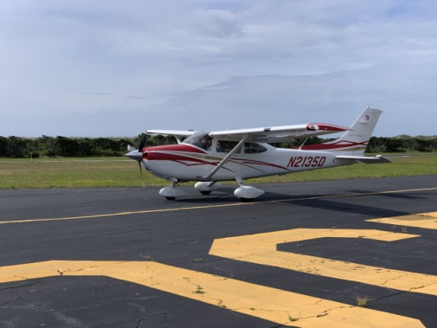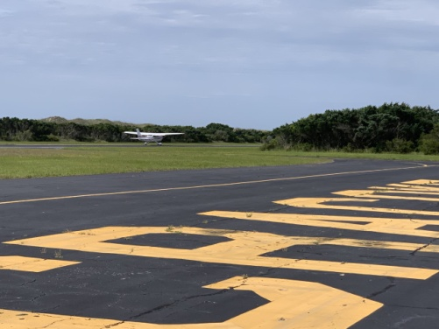
Judy and Rose on the way home The Ocracoke sign at the airport
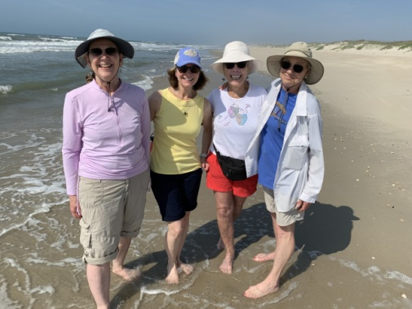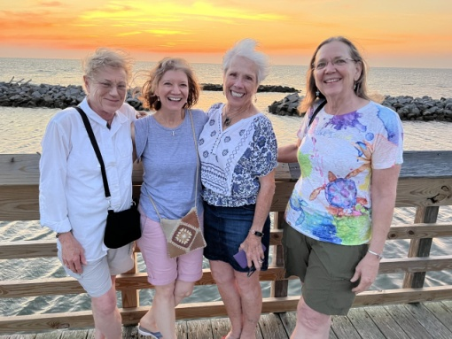
Sue, Laura, Peggy, Debbie Debbie, Laura, Peggy, Sue
Laura Savino’s book signing May 28

Several of us showed up at the Barnes and Noble book store in Ashburn to see Laura sitting at a table with pen in hand signing books. She was never alone!!!

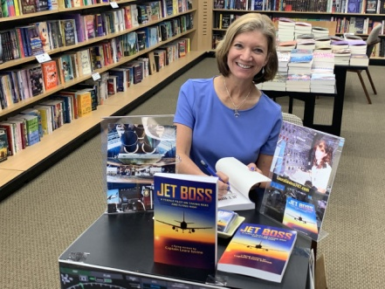

And then we hung around the book store where there is a coffee shop. A friendly neighboring person took a picture of us crowning Laura and then his girlfriend took a picture of him joining us for the coronation with a cappuccino lid. Stephanie Kight’s 49½, Kyle Goins, joined us. We expressed our resounding approval and hope to see more of him.

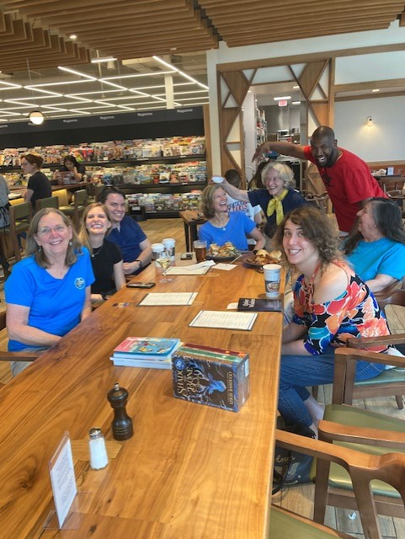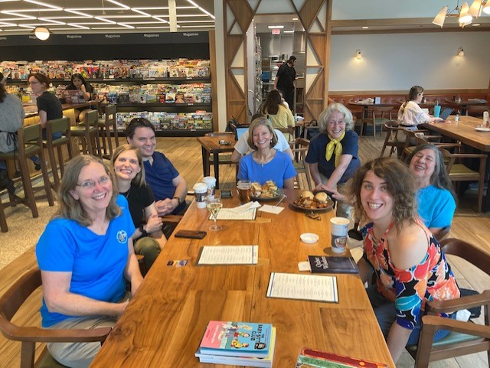
Sue, Stephanie, Kyle, Laura, Mary, Jessica, table neighbor, Barb

UPCOMING EVENTS

Women can fly/ women can build on June 4

The weather is forecast to be ideal for Women Can Fly on Saturday. We anticipate having a crowd of participants as well as a crowd of volunteers. And lunch will be available for those who are present at 11:30! Thanks to Bealeton’s Subway for making all kinds of accommodations for us.

Warrenton Volunteer | Women Can Fly

Innovations in Flight

June 18 10 to 3
National Air and Space Museum, Udvar-Hazy

Innovations in Flight | National Air and Space Museum

Air Race Classic
June 21-24, 2022
Check out the web page: www.airraceclassic.org
Too late to register to race, but follow the racers

Summer International Meeting

"Do the Charleston" This Summer!
Registration is over for the meeting. Those of us who plan to go should go see
Laura Savino will be sitting at a “meet the author” table.

There are several by-laws changes you may want to vote for or against. If so, become credentialed. Credentialing will begin on June 15. You should get an email instructing you how.

“The 2022 Annual meeting is employing a hybrid approach; therefore in order for a Ninety-Nine Member to attend and VOTE, either in person or virtually via Zoom, every member must complete the Credentials process. Good news, the Credentials process is done ALL ONLINE using the same platform we employed in 2021. The software application, 1) confirms you are a member of The 99s Inc. using the email address on file at International Headquarters; 2) once confirmed that your email address matches the Headquarters database, the application will assign you an Election Buddy password. Your email address and application- issued password will be forwarded to the Head Teller for setup in Election Buddy.”

EAA AirVenture Oshkosh July 25 to July 31

AirVenture (eaa.org)

ProJet Aviation Expo November 4.

We are participating again this year. All the paperwork is in. Hoping that a good number of ninety-nines come to help staff our table.

Scholarships

Female Aviators Sticking Together (FAST)
Home page - Female Aviators Sticking Together (fastpilots.com)
This group is new to me. But I checked out both the Facebook page and the Web page. It is full of scholarship information.

Blonds In Aviation
Aviation Scholarship Calendar - Blonds In Aviation

AE Scholarships: First Wings
The Amelia Earhart Memorial Scholarship Fund First Wings Awards are semiannual awards of up to $6,000 based on completion of specific training milestones. They are available to Student Pilot Members of The 99s who meet eligibility requirements. To be eligible, applicants must hold a student pilot certificate (or provide evidence that they meet their country's flight training requirement), have been an official Student Pilot Member three months prior to the application deadline, have logged 5 hours in the six months prior to the application deadline and show financial need.
The Fall First Wings Award Application deadline is October 1. Membership join date must be no later than July 1 of that year.
Click here to view the Award Description and Instructions
Ready to apply? Application1

June selection Aviatrix Book Club

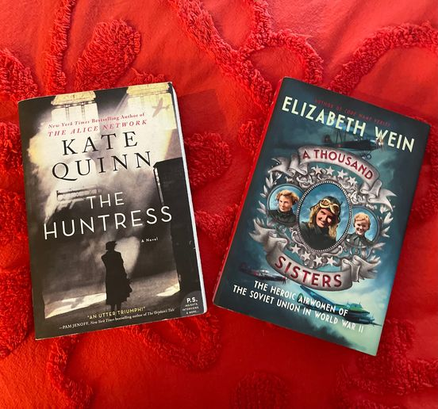

Both books are about the Soviet Night Witches who flew in World War II.
Several zoom discussions are open throughout the month. Check the facebook page for Aviatrix Book Club
(20+) Aviatrix Book Club | Groups | Facebook

Accomplishments of our members

Mia Anderson has been selected as Miss Skyline Drive Outstanding Teen. (Note this corrects the misinformation from last month)
The next level of pageant will be on June 25, 2022 for Miss Virginia Outstanding Teen

 | SKYLINE DRIVE  Amelia Anderson  Social Impact Initiative:  A View From Above: Soaring to Your Dreams  Type of Talent:  Musical Theatre Vocal

