
Old Dominion Chapter
SKYLINES
August 2022

Chair: Laura Savino
Vice-Chair: Mary McCutcheon
Secretary: Jessica Citrin
Treasurer: Barbara Wilper
Amelia Earhart Scholarship: Sue Passmore
Aerospace Education: Debbie Gallaway
Membership: Barb Wilper
Air Marking: vacant
Newsletter: Mary McCutcheon
Webmaster: Rose Brown

Next Meeting
Wednesday August 3

Laura Savino and Mary McCutcheon are inviting you to a scheduled Zoom meeting.

Topic: Old Dominion Ninety-nines August meeting
Time: Aug 3, 2022 06:30 PM Eastern Time (US and Canada)

Join Zoom Meeting
https://gmu.zoom.us/j/92653819320?pwd=ZUZJZE9CekpSSlNZQnNiSnN1UXVWUT09
Meeting ID: 926 5381 9320
Passcode: 298389

Conflict with our meeting.
Also happening at 7 PM on Wednesday the 3rd is a book promotion for “High Flyers: 15 Inspiring Women Aviators and Astronauts” by Ann McCallum Staats. This will be held at Scrawl Books, 11911 Freedom Drive in Reston.

Woman Navy Pilot selected for Blue Angels
Amanda Lee
First female demo pilot for the Blue Angels - YouTube

Statue of Amelia Earhart in the Capitol

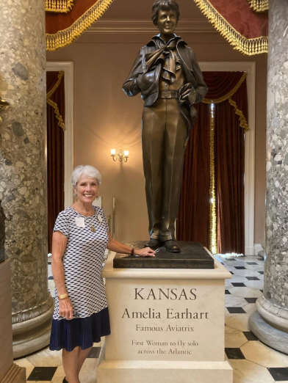

Amelia Earhart statue in U.S. Capitol's National Statuary Hall is unveiled : NPR

A statue of Amelia Earhart was unveiled at the National Statuary Hall inside the U.S. Capitol on Wednesday July 27. Peggy Doyle was there to witness it.
Past events

Summer International Meeting in Charleston was a success. Peggy and Laura were both there. The new one person/one vote policy was implemented.

EAA AirVenture Oshkosh July 25 to July 31

Sue Passmore, Carolyn Hunker and Laura Savino made appearances at Oshkosh last week.
Laura and Mia Anderson’s mother flew “first class” with Dave and Sue Passmore in their new EPIC 1000GX.

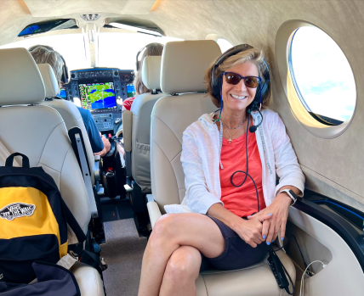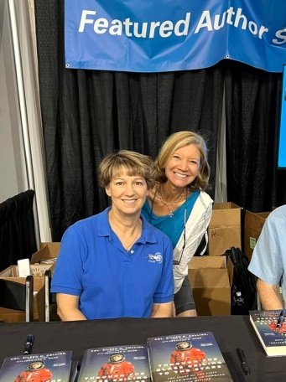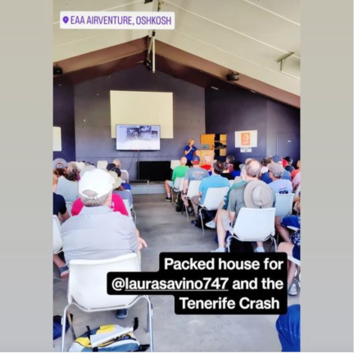

Laura traveling first class with Dave and Sue Laura talking about Tenerife Crash
Laura with Eileen Collins

Future Events

August 13. Sugarloaf Ninety-nines

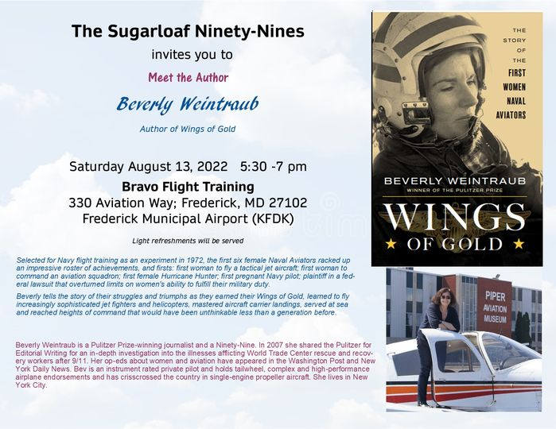

Mid-Atlantic Section meeting– October 28-29, Lancaster, Pennsylvania
Contact: Lin Caywood

ProJet Aviation Expo November 4.

We are participating again this year. All the paperwork is in. Hoping that a good number of ninety-nines come to help staff our table.

Ocracoke Fly-in May 18-22 2023

2023 International 99s Conference:
October 30-November 3, 2023 in Jordan

AE Scholarships: First Wings
The Amelia Earhart Memorial Scholarship Fund First Wings Awards are semiannual awards of up to $6,000 based on completion of specific training milestones. They are available to Student Pilot Members of The 99s who meet eligibility requirements. To be eligible, applicants must hold a student pilot certificate, have been an official Student Pilot Member three months prior to the application deadline, have logged 5 hours in the six months prior to the application deadline and show financial need.
The Fall First Wings Award Application deadline is October 1. Membership join date must be no later than July 1 of that year.
Click here to view the Award Description and Instructions
Ready to apply? Application1
News from our Members

Sue and Dave Passmore bought a brand new EPIC turboprop plane from the factory in Bend Oregon. Sue says: “We took delivery of this EPIC E1000 GX in the middle of June in Bend, OR. We did the factory training and Dave got the 50 hours of flying with a mentor pilot for insurance. So we were in Bend for almost a month! Bend is wonderful and we had fabulous weather with weekends for exploring areas like Crater Lake.”

Here they are with the new plane:

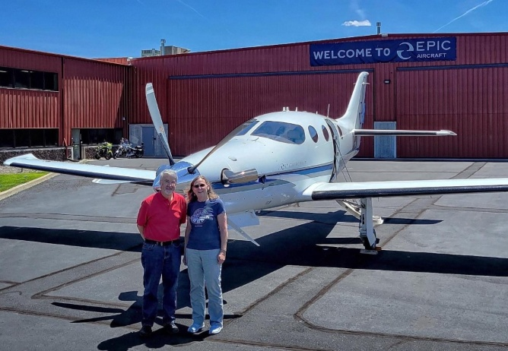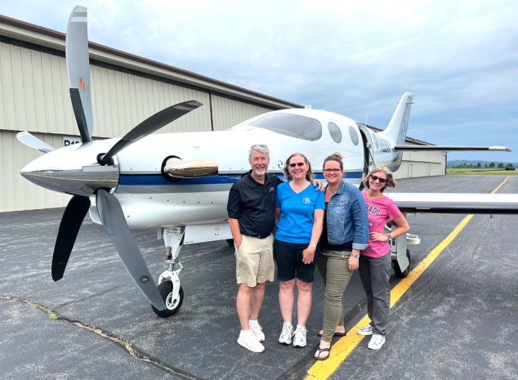

Dave and Sue in Bend Dave and Sue and Kari Anderson and Laura Savino
In GreenBay for AirVenture/Oshkosh

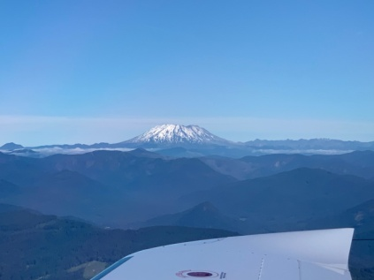
Volcanoes and more volcanoes


Dave and Sue at Crater Lake

Morgen Reeb has been doing a lot of transatlantic flights in the Boeing 777.
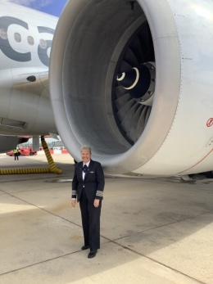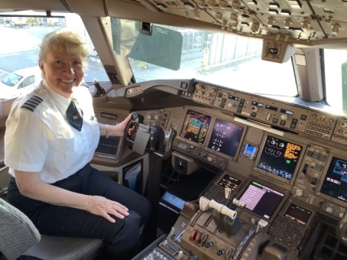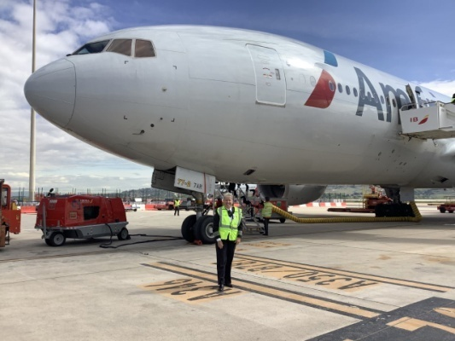

August selection Aviatrix Book Club

August Aviatrix Book Club discussion book! Please join us Wed Aug 17th at 6PM Eastern or Sun Aug 28th at 1PM Eastern. www.facebook.com/groups/aviatrixbookclub
Between the world wars, no sport was more popular, or more dangerous, than airplane racing. While male pilots were lauded as heroes, the few women who dared to fly were more often ridiculed—until a cadre of women pilots banded together to break through the entrenched prejudice.
Fly Girls weaves together the stories of five remarkable women: Florence Klingensmith, a high school dropout from Fargo, North Dakota; Ruth Elder, an Alabama divorcée; Amelia Earhart, the most famous, but not necessarily the most skilled; Ruth Nichols, who chafed at her blue blood family’s expectations; and Louise Thaden, the young mother of two who got her start selling coal in Wichita. Together, they fought for the chance to fly and race airplanes—and in 1936, one of them would triumph, beating the men in the toughest air race of them all.

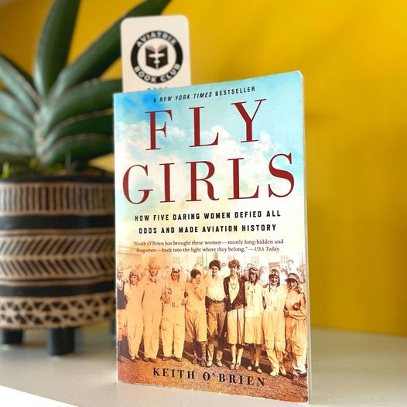

(20+) Aviatrix Book Club | Groups | Facebook

