
Old Dominion Chapter
SKYLINES
September 2022

Chair: Laura Savino
Vice-Chair: Mary McCutcheon
Secretary: Jessica Citrin
Treasurer: Barbara Wilper
Amelia Earhart Scholarship: Sue Passmore
Aerospace Education: Debbie Gallaway
Membership: Barb Wilper
Air Marking: vacant
Newsletter: Mary McCutcheon
Webmaster: Rose Brown

Next Meeting
Thursday September 1

Laura Savino & Mary McCutcheon are inviting you to a scheduled Zoom meeting.

Topic: Old Dominion 99s monthly meeting
Time: Sep 1, 2022 06:30 PM Eastern Time (US and Canada)

Join Zoom Meeting
https://gmu.zoom.us/j/93701582365?pwd=VjRlejFBV20xSENGU0JNR0wxMXhmUT09

Meeting ID: 937 0158 2365
Passcode: 637450

Past Events
August 20 FAPA Pilot fair
The Future and Active Pilot Advisors had meeting to promote careers in aviation in Crystal City on August 20. The morning part of the meeting was devoted to airline recruitment so we didn’t go. We did, however, make an appearance for the free lunch to help keep food waste down to a minimum. Then we set up our 99s table for the afternoon portion for people in the course of their flight training. Kat Emery was there checking out jobs. Laura Savino, Mary McCutcheon, Jessica Citrin and our new member, Leila Burns, and well as our even newer member whom we recruited at the fair, Samantha Stahl.

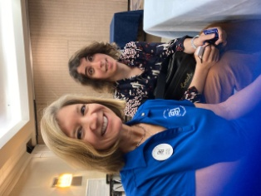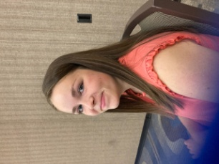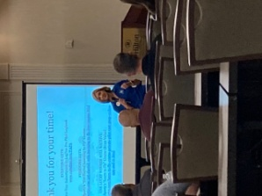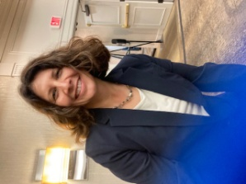

Laura Savino and Jessica Citrin Leila Burns Laura speaking Kat Emery

Mia Anderson’s glider celebration. August 28
A good crowd of 99s and friends of Mia’s family showed up for the cake baked by Sue Passmore AS WELL AS the celebration of Mia’s glider certificate. Here are some pictures:

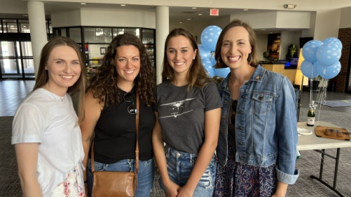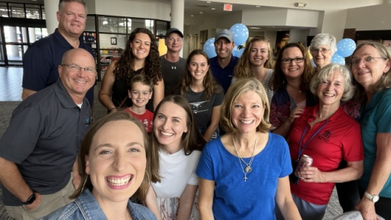
Becca Rust, Allison Diaz, Mia Anderson, Hannah Rust Most of the people who attended (photo taken by Kari)

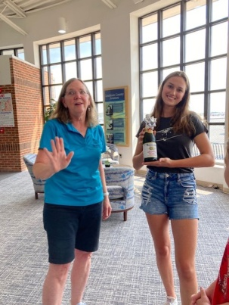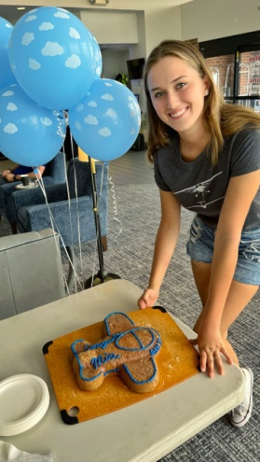
Sue Passmore and Mia Mia and the cake Sue baked

Future Events

September 17. Flying Circus Memorial for Charlie Kulp

CHARLES “CHARLIE” ALLEN KULP, SR.
THE FLYING FARMER
“I just feel I’ve always wanted to fly.”

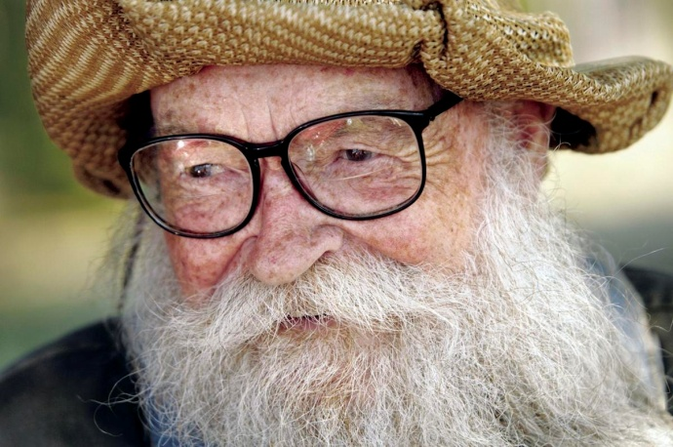

Life began for Charlie Kulp in Stafford, VA on September 20, 1925. It didn’t take long for him to follow his dream in the field of aviation. In 1942, at age 16, he became an apprentice mechanic at V.P.I. Airport in Blacksburg, VA and began flight lessons at Woodrum field in Roanoke, VA. He entered the Navy as an Aircraft Mechanic, got his private pilot’s license in San Diego in 1946. After his Navy career, he spent the next 25 years or so working at, and managing, various airports and continuing his Aircraft Mechanic education. In 1952 he became a Private Pilot Examiner. There is no telling exactly how many pilots he inspired and trained to fly in his career.
He and his first wife, Joan, became instrumental in joining others to help found the Flying Circus Aerodrome in the early 70’s. In 1973 he began his famous Flying Farmer airshow routine, which took him all over the world, including his return to England to perform three times for Royalty in the late 80’s and early 90’s. As of 2004 he had flown over 800 performances, in NY, NJ, PA, WV, OH, MO, MD, VA, NC, SC, IL, OK, TX, GA, FL, LA, Canada and England. He retired the “Farmer” in October, 2007 at the age of 82.
It is only fitting that we say our “see you later” at the Flying Circus in Bealeton, VA, where he flew his last plane on his 96th birthday. Join his daughter Joanna and Evelyn Marshall and family in sharing stories about the man and his impact on aviation and countless lives on September 17, 2022 at the picnic pavilion from 11:00a.m.until about 4:00p.m. The stories could run on longer, so we have some flexibility on the end time. Bring a picnic lunch and a chair. Spread the word to those who might be interested.
An RSVP would be nice, but not required, sent to flyingfarmer1022@gmail.com just to get an idea of the number to expect.
Thanks, Joanna Kulp

September 17 and 18. Joint Base Andrews Air Show and Good fun

Joint Base Andrews > Air & Space Expo 2022 (af.mil)
Air shows and static displays

September 24.
Women in Aviation Day at College Park Aviation Museum.
We have been invited to participate at this event. It sounds like something up our alley for sure. General public should go here to register https://GIADCPAM.eventbrite.com

Sepember 23 to October 1. ARC Air Derby

2022 EDITION!

WELCOME TO THE ARC AIR DERBY!
“Once again this year, we are offering a one-day test, the ARC Air Derby! It is your opportunity to create your own personal cross-country route. Challenge yourself. Make this a learning opportunity to sharpen and expand your aviation skills. Teams can devise their own routes that conform to the ARC Air Derby Rules, estimate the time it will take them to fly that route, and then fly it as close to their estimated time as possible.
You choose the route. You choose the day to fly from September 23 - October 1. You fly your route in one day under day VFR conditions. Hone your flight planning and precision flying skills as you fly your Derby route. For more details, explore the ARC web site and review the 2022 ARC Air Derby Rules and Procedures E-01b Derby rules .
ARC Air Derby - A Twist on tradition (Air Race Classic, Inc.)

October 28-29 Mid-Atlantic Section meeting
Hosted by the Eastern Pennsylvania Chapter in Lancaster, Pennsylvania
From Amy Urbine: “I am happy to announce the fall section meeting hosted by the Eastern PA 99s in Lititz, PA on October 28-29. Fly into Lancaster Airport (KLNS) or drive and meet us at Fiorentino's restaurant for appetizers, drinks, and door prizes. Stay at The Wilbur Hotel, which used to be the original Wilbur Chocolate factory. Our meeting and lunch will be at the Lititz Springs Inn and Spa in a private meeting room. The adjoining pub is a proper English pub that is filled with aviation photos and memorabilia. We are offering 3 choices for tours to accommodate all tastes. I am excited to see all of you and enjoy the beautiful fall in this quaint town. Please pass this on to your chapters.

P.S. There is chocolate!
P.S.S .Thank you to all the ladies who helped me with questions and suggestions. Unfortunately, Sensenich propeller factory is not open on Saturdays. “

2022 Mid-Atlantic 99s Fall Section Meeting Tickets, Fri, Oct 28, 2022 at 5:00 PM | Eventbrite

ProJet Aviation Expo November 4.

We are participating again this year. All the paperwork is in. Hoping that a good number of ninety-nines come to help staff our table.

Ocracoke Fly-in May 18-22 2023

2023 International 99s Conference:
October 30-November 3, 2023 in Jordan

NEW MEMBERS

Leila Burns

Leila got her Private Pilots License and joined our chapter while she was at Oshkosh

Thank you! I hope I can be at the next meeting. I was also wondering if the meetings are always on zoom or if they are ever in-person. Here is some biographical information: I have been training out of the Manassas Airport with American Aviation since April of 2021. I will turn 18 in November and I will be senior in high school next year at Trinity Christian School. I live in Fairfax. My great grandfather was a pilot, but no one in my family has been a pilot since the 1960s.

Samantha Stahl
Samantha just joined us a week ago and here’s what she has to say:

“Aviation is in my genes. My grandfather and father were both pilots in the Air Force, and my brother and father are both CFIs. So aviation is something that has always been a part of my life.
As soon as I realized what the General Aviation side of flying was like, I became interested in getting my first certification. Because how cool is it to fly to another state, grab a burger at sunset, and fly home?
I am currently a student pilot, and made the big jump into aviation after selling my truck and buying a Cessna 150. I am part of a flight club that was started by a retired Air Force fighter pilot, his son, my father, and myself. It’s been a great experience, and I am excited to keep growing as an aviator.
I hope to fly for a cargo airlines and get sent around the world. I am also looking to expand my flying experience in different types of aircraft, but that part is mostly just for fun. Whatever happens, it’ll be an adventure! “

Members Accomplishments

Leila Burns got her Private Pilots License right before she joined.

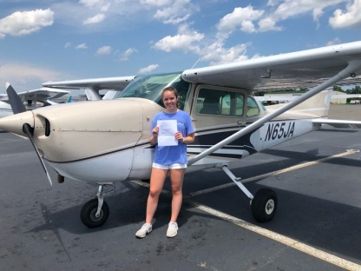

Mia Anderson got her certificate to fly gliders with Allison Diaz as her valiant instructor. She is going into her senior year in high school and is already starting here single engine training
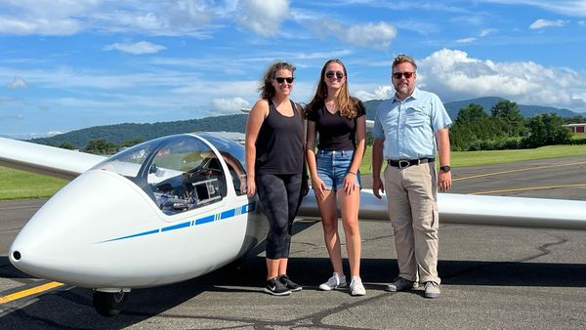


September selection Aviatrix Book Club

A biography of Beryl Markham is the September Aviatrix Book Club choice
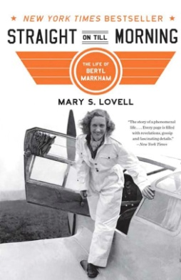

Becky Condon says: ‘“Straight On Till Morning” by Mary S. Lovell is a very complete life story of Beryl Markham who is a very interesting and complex character. It fills in a lot of holes and questions I had from her memoir. Mary S. Lovell obviously went to a great deal of work researching Beryl Markham’s life, including visiting the lady in her later years, and patiently working with her to get the most accurate story possible.
Beryl Markham was more technically Beryl Clutterbuck Purves Markham Schumacher (and a spicy relationship with a Prince of England on the side). She had one son, but was not close to him. She maintained her married name Markham to share the name with her son. Beryl was a very famous aviatrix, but after this reading, it is evident that her accomplishments there were just a small piece of her life.’

