
Old Dominion Chapter
SKYLINES
January 2023

Chair: Laura Savino
Vice-Chair: Mary McCutcheon
Secretary: Jessica Citrin
Treasurer: Barbara Wilper
Amelia Earhart Scholarship: Sue Passmore
Aerospace Education: Debbie Gallaway
Membership: Barb Wilper
Air Marking: vacant
Newsletter: Mary McCutcheon
Webmaster: Rose Brown

Next Meeting

Monday January 2 6:30 happy half hour. 7:00 meeting

Topic: Old Dominion 99s monthly meeting
Time: Jan 2, 2023 06:30 PM Eastern Time (US and Canada)

Join Zoom Meeting
https://gmu.zoom.us/j/91623740824?pwd=NVZqZ0JZYUZJd3U0RjVGdktnOHpldz09

Meeting ID: 916 2374 0824
Passcode: 862564

Announcements about upcoming deadlines

International Ninety-nines candidate search
The International Nominating Committee is seeking candidates for the following positions to serve the term of 2023-2025: Directors (two positions), Nominating Committee (two positions). Our trusts are also looking for candidates for their 2023-2026 term. Please contact the trust chairmen for more information.
The Intent to Seek Election Packet is available in the Library in the Members' Area of the website. For questions or more information, contact one of the Nominating Committee members:
The deadline to submit your packet to the committee is December 31, 2022
.
Ninety-nines Contribution Awards
It's that time of year again to consider your nominations for the five awards given at the annual conference. Deadline is January 31
I. AWARD OF ACHIEVEMENT (for Ninety-Nines) Three Awards of Achievement may be presented for: •
A. Contributions to The Ninety-Nines
B. Contributions to Aviation
C. Humanitarian Efforts
Who May be Nominated? An individual member of The Ninety-Nines (living or deceased); a group of Ninety-Nines; or an organization within The Ninety-Nines, such as a Chapter, Section, Committee, or Trust. An individual recipient must be a current member, or have been a current member at the time of her death.

II. AWARD OF MERIT (for non-Ninety-Nines) Recognizes a significant contribution to any facet of aviation, such as aviation or aerospace education, aviation science, aviation history, aviation commerce, aviation legislation, etc.
Who May be Nominated? An individual (male or female, living or deceased) or an organization. The recipient may not be a current or former member of The Ninety-Nines or of a group within The Ninety-Nines.

III GEORGE PALMER PUTNAM AWARD (for non-Ninety-Nines) Recognizes support provided to The Ninety-Nines by an individual (male or female, living or deceased) or an organization. The contribution may have occurred in the past or present, as a single action or a series of events.
Who May be Nominated? An individual (male or female, living or deceased), or an organization. The recipient may not be a current or former member of The Ninety-Nines or of a group within The Ninety-Nines.

Who may submit nominations? A Ninety-Nines Chapter, Section, or Trust. How to nominate: Submit a one-page letter, signed by two officers or trustees (as appropriate). The nomination must include the name, address, and telephone number of the nominee, or the nominee’s next-of-kin if the nominee is deceased. Up to three additional pages of substantiating material may be attached to the letter. Email your nomination to Awards@ninety-nines.

Mid-Atlantic Section scholarship

Amount of Scholarship: Up to $5,000.00
Application Receipt Deadline: February 28, 2023
Announcement Date: April 15, 2023

Description: Mid Atlantic Section of the 99s is committed to supporting and promoting female pilots in the continued pursuit of aeronautical skills, both professionally and recreationally.
Open to: Any Mid Atlantic Ninety-Nine member seeking to regain currency, increase proficiency or add an additional rating, certificate or endorsement by participating in a defined training activity, e.g. instrument training, multi-engine training, CFI, CFII, seaplane, tailwheel, aerobatics, etc.
Note: This scholarship is NOT available to student pilots for initial flight training for their private pilot certificate.
APPLICATION
Please submit the following in a PDF and attachments (include your name on each document title):

An essay limited to 1000 words describing the applicant’s:
1. Objectives in obtaining the scholarship – career and/or personal aviation goals.
2. How the scholarship will be used to advance those goals. What challenges do you face without this scholarship?
3. Any special qualifications/experiences you may have to pursue these goals.
4. Aviation related activities in which you have participated (including employment), and what it means to you.
5. Any obstacles you have had to overcome to start or continue flying.
6. How you would contribute to the Ninety-Nines and to the aviation community in general. Please emphasize what this training would mean to you and how you plan to “pay it forward” by returning value to the aviation community.
Optional Attachments:
Any supporting documentation you deem important, such as:
- Evidence of passing written or practical test, if applicable.
- Current flight medical/BFR or other pertinent training
- Last page or more of logbook
- Reference letter from flight instructor/other.

Required Documents:
- TOTAL cost of flight training requested and how you will pay for the additional cost of training not covered by the scholarship (make it clear that there are sufficient funds from other sources to complete the training or course of study within one year). Financial need is not a requirement, but is an evaluation factor (tie-breaker).
- Letter of recommendation from applicant’s chapter chair to verify member's activity level and participation in chapter activities.
Scholarship Limitations:
- Applicant must be a member of the Mid Atlantic Section of The Ninety-Nines.
- Applicant must be a current member (in good standing) of The Ninety-Nines, Inc.
- Scholarship must be used for training within one year.
Other Information:
- Scholarship will be awarded based on qualifications of applicant.
- Scholarship funds will be disbursed directly to the appropriate training FBO or training organization.
- Invoices shall be submitted to the Treasurer of the Mid Atlantic Scholarship of The Ninety-Nines.

- The Mid Atlantic Section of The Ninety-Nines Scholarship Committee may request additional information or documentation.

Name of Group Offering Scholarship: Mid Atlantic Section of The Ninety-Nines
Contact Information - Laura Savino, Mid Atlantic Scholarship Committee Chairman Cell: 703-625-6164.
Please send application as PDF document with attachments to Laura Savino at: BigPlanet747@gmail.com

Past Events

Holiday Party at Sue Passmore’s
Sue and Dave Passmore hosted our fabulous holiday party this year on December 11. The potluck food was delicious and the crowd was happy. We were especially happy that three of our new members, Cynthia Axell, Samantha Stahl, and Leila Burns were there. Sue had baked a PPL cake for Leila. Several 49 ½s and a friend of Jessica’s, Bobby Thierry were there too.

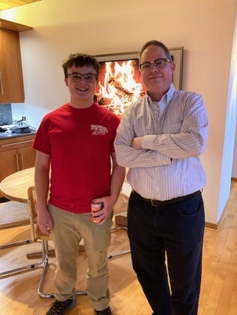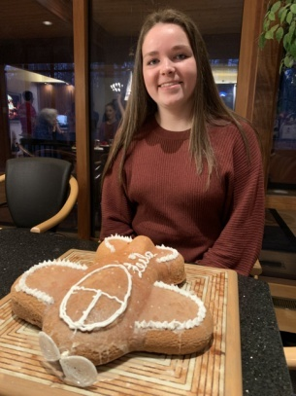
Bobby Thierry and John Brown Cynthia Axell Dave Passmore Leila and her cake

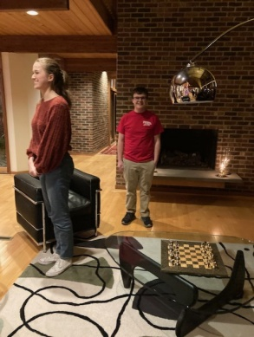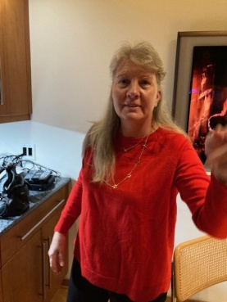
Robert and Kat Emery and Laura Mia and Bobby Thierry Morgen Reeb Samantha Stahl

Outing to College Park Airport
Although a small group took the College Park Airport tour on November 13, they report that it was excellent.


(guide), Jessica, Laura, Stephanie, and Moranda Reilly

ACCOMPLISHMENTS OF OUR MEMBERS AND OTHER NEWS
Stephanie Kight. From Aero Elite:
“Big congratulations to Stephanie Kight for passing your CFI checkride! We are thrilled to welcome you to the Aero Elite team!”

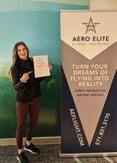

Samantha Stahl earned her Private Pilot License on December 20 at Shenandoah.
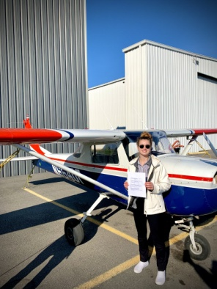

Stephanie Johnson recently retired from River Restoration and is up in New Hampshire with her husband and their airplane. They are planning to fly out of Hampton airfield (7B3) which advertises that it is “more than just an airfield; we are a community” I looked at the aerial photo of this field and see that there is, shamefully, NO COMPASS ROSE. Get to work, Stephanie.

Future Events

Ocracoke Fly-in May 18-22 2023

2023 International 99s Conference:
October 30-November 3, 2023 in Jordan

Fall 2023 Old Dominion hosts Mid-Atlantic Section meeting
We should start to think about locations and plans soon

THINGS TO READ and ATTEND
It goes without saying that we should all be reading Laura Savino’s memoir, Jet Boss. It has been chosen by THREE book clubs as the January selection. One of these is Aviatrix Book Club. Her zoom webinar discussion will be:
Jan. 22 at 6pm, for Liz Booker as host
Jan. 29 at 1pm, for the LA 99s book club discussion
I think we can attend by going to the facebook page for Aviatrix Book Club and signing in. I’m not quite sure though.



