
Old Dominion Chapter
SKYLINES
October 2023

Chair: Laura Savino
Vice-Chair: Mary McCutcheon
Secretary: Jessica Citrin
Treasurer: Barbara Gruber
Amelia Earhart Scholarship: Cynthia Axell
Aerospace Education: Debbie Gallaway
Membership: Barb Wilper
Newsletter: Mary McCutcheon
Webmasters: Jessica Citrin and
Stephanie Kight

Next Meeting

Our next meeting will be November 6.
Location will be announced later.

The Section Meeting we hosted

From October 6 through the 8th, our chapter hosted the Mid-Atlantic Section meeting. It was attended by something like 38 or 39 members plus a handful of 49 1/2s and children. It was a perfect meeting in spite of last minute frantic worries about whether the federal government would close and leave us high and dry when we had plans to visit the TRACON facility. We also had to make last minute plans to replace the brewery place we had chosen for Saturday night with Kalypso restaurant in Reston

Here are the people from our chapter who made it such a success:

Barb Gruber made it possible for us to meet at Udvar-Hazy and also found swag to put in souvenir bags. She also arranged for the delicious Panera lunch. Thanks for all the logistic work that this took. As treasurer, she also took charge of the registration fees and expenses for the meeting.

Frankie Velasquez designed the information flier. Then she got us delicious breakfast snacks for Saturday morning. And Sue Passmore baked a delicious banana bread to contribute. YAY Frankie and Sue.

Hannah Rust was the designated driver for our guest of honor/ international representative, Robin Hadfield. She was gracious and cheerful and showed Robin that safe drivers make safe pilots.

Jessica Citrin designed and publicized the google form that allowed people to register. She kept track of the RSVPs too. Then she found our substitute restaurant in Reston for Saturday night and made all the arrangements for them to feed a crowd..

Jessica and Samantha Stahl checked in the meeting attendees.

Lin Caywood conducted the meeting efficiently with excellent AV facilities at Udvar-Hazy. I want to make a sad note, though. The recipient of the Forest of Friendship induction for 2024, suddenly died in August. This is Eileen Kay, a member of the D.C. chapter.

Robin Hadfield came from Canada.

Girls and boys from the STEAM camp arrived to hear the talk and to have lunch.

Jana Leigh Scheaffer gave an inspirational talk describing her career as a wing walker.and encouraging us all to believe in ourselves.

Doug Scheaffer handled all the AV for Jane Leigh’s talk

Thankfully, the federal government did NOT shut down, and our tour of TRACON went smoothly.

Sarah Patten organized our visit there and gave an introduction and orientation to air traffic control.

And finally Laura Savino took care of every detail, set up our dinner arrangements for Friday night, welcomed the attendees, arranged for Jana Leigh Scheaffer to speak, and generally coordinated all the activities, driving, food, and logistics. She did a heroic job.

The only disappointment during the whole weekend was the cancelation of the Flying Circus show on Sunday. A few of us met at the Flying Circus before we found out that the cross winds were too strong for the show. Jana Leigh was there with her husband Doug and we gobbled up some of the leftover Panera sandwiches and gulped down the drinks that Sue Passmore brought.

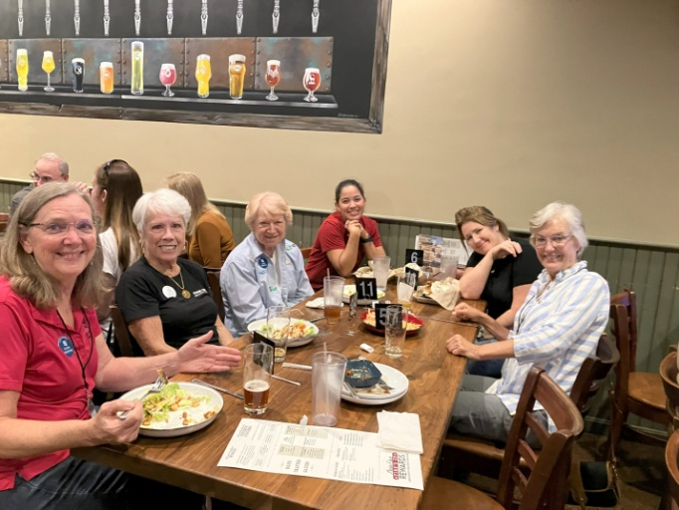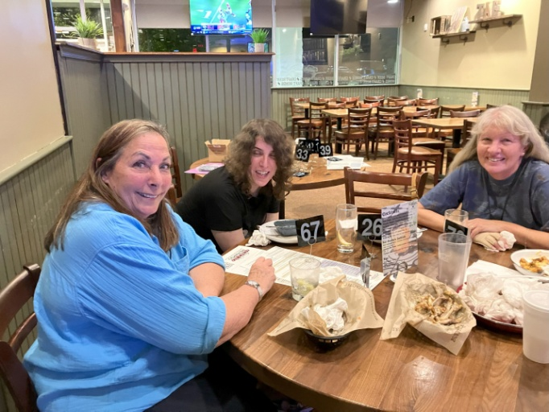

Friday night dinner at Buffalo Wing Factory Robin Hadfield, Jessica Citrin and Morgen Reeb

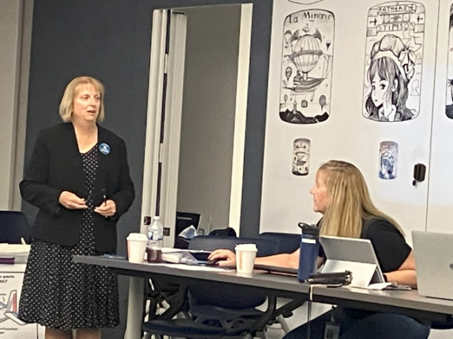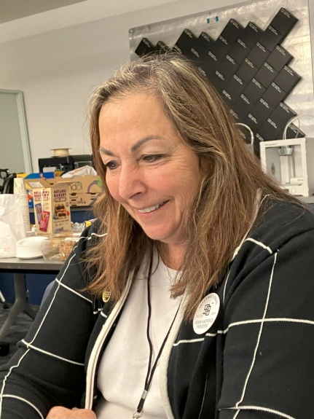

Lin Caywood and Barb Gruber International Representative and
President of the 99s, Robin Hadfield

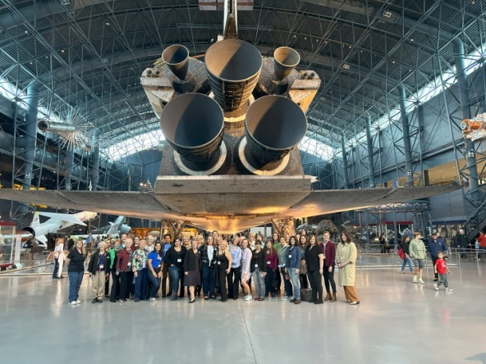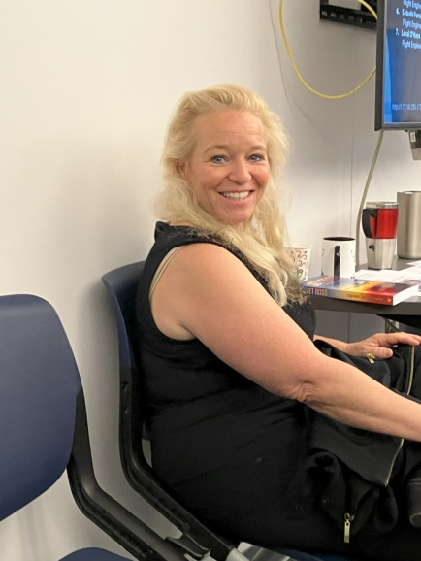
The section membership behind the space shuttle Jana Leigh Scheaffer, the wing walker and
Motivational speaker

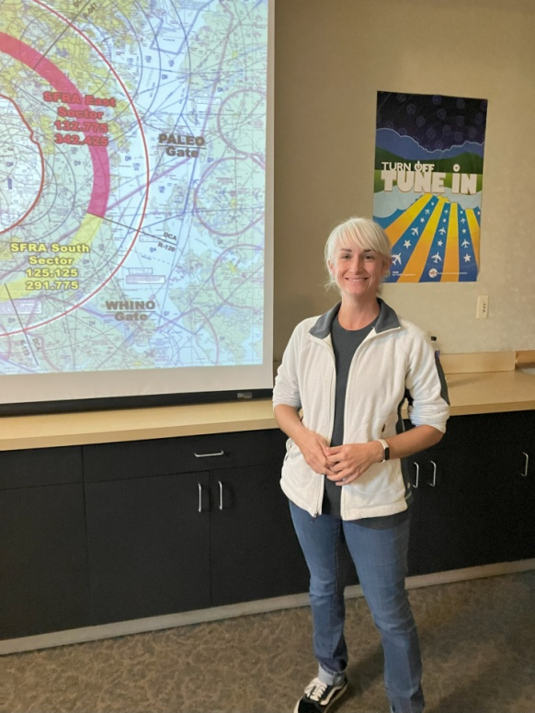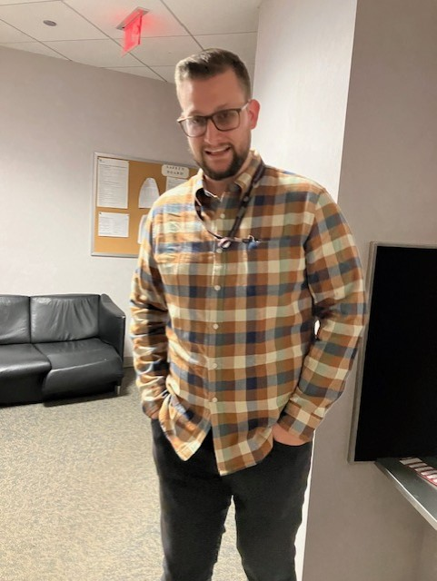

Sarah Patten at TRACON Griffin Hill, a tour guide at TRACON

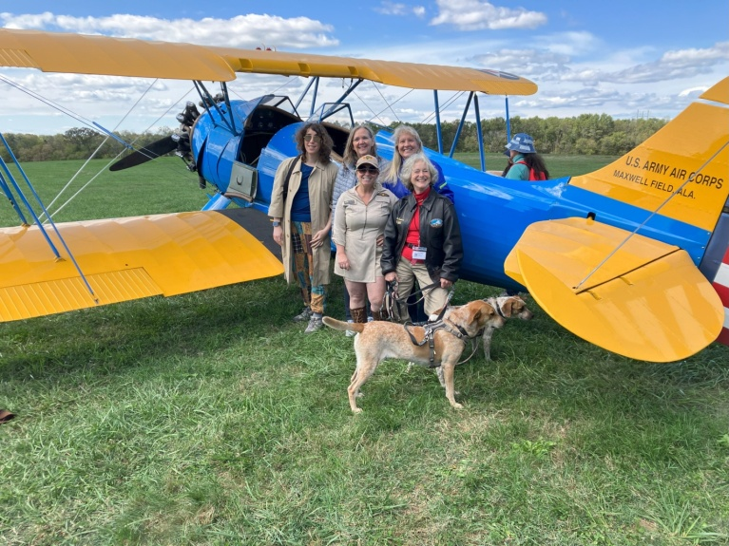

Jessica Citrin, Sue Passmore, Jana Leigh Scheaffer,
Morgen Reeb, Mary McCutcheon, Bonanza and Presto Doggo.


Dave Conn, a performing pilot and our photographer

International meeting in Jordan

Jennifer Zinn is going. We hope she has a great time and gives us a full report when she comes back.

ProJet Aviation Expo November 3.

The ProJet hangar at Leesburg turns into a big convention center on November 3. Please consider signing up to help us at our table. November 3 is a Friday. Let Laura know if you can come, bigplanet747@gmail.com.

We are there all morning and until shortly after lunch. Mary and Laura will get there around 8 and the crowds will begin to arrive at 9. It winds down around lunchtime, but many people stay for the free lunch and to pack up. It is really fun.

WASP NEWS

From Marge Shaffer
I toured the 3rd Infantry Division museum today at Fort Stewart Georgia. It is a huge installation! 800,000 acres.

I came across a tiny closet-size area where a WASP by the name of Helen Snap was featured along with her uniform. Among her many accomplishments is that she is a Ninety-nine!!!!

Ft Stewart is about one hour southwest of my home in Savannah.

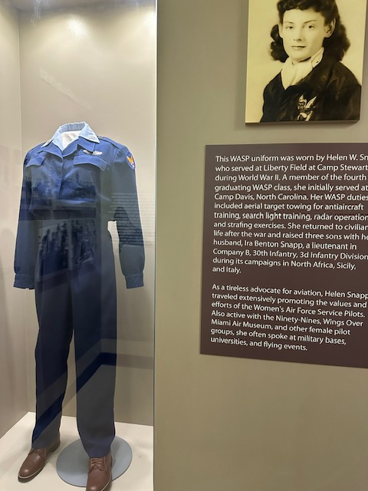

Obituary for Robert Comunale
Many of us used Dr. Comunale for our flight physicals. It is with sadness that I report his death on September 29. He practiced out of his own home in McLean until he got COVID in 2020. It was always an adventure to go to his office where a flight physical cost $90 and took little more than 90 seconds—a dollar a second. He and his office staff fed the squirrels outside and admonished the patients to “shut the door fast so the squirrels don’t come in”. But indoors they kept multiple cats whose cat climbing furniture was all over the place. He wrote novels which he sold out of his waiting room, and his secondary practice was treating erectile disfunction with an inventory of cialis and Viagra in the bathtubs.

Compass Rose at Manassas
The Manassas Airport Authority would like to have a repainted compass rose as part of their taxiway renovation. The last compass rose we painted was on the runup area at 34W. The new one will be at 34 E (I think).
NIFA
Suzanne Collins (from Hampton Roads Chapter) promotes this competition for college students. Each region within the US hosts a competition, and the winners go to compete at the national level. Here is a brief documentary describing the program: https://www.youtube.com/watch?v=PEv_CHp8qtc.
NIFA is the National Intercollegiate Flying Association. It maintains a nationwide roster of 78 or so schools/colleges/universities with an aviation program, broken down by regions (1 thru 12). NIFA organizes flying and ground competitions and ensures that volunteer judges are in place for grading. Additionally, NIFA maintains the rulebook governing each flying season, and writes the ground event tests. The 'rules' page https://nifa.aero/schools/rules describes all the activities one might expect at a typical event.
Any University student in our chapter should consider competing. If your school is among the ones who participate, you will qualify for the 2024 cycle with the final competition in 2025.
The competition was just held October 18 to 21 in Danville for our region (Region X). I don’t know who won at this time.
Ninety-nines awards
2024 INTERNATIONAL AWARDS
The International Awards Committee is soliciting nominations for three prestigious awards to be presented by The Ninety-Nines, Inc. at the 2024 International Conference in Vancouver, BC. The deadline for submitting nominations is January 31, 2024.
AWARD OF ACHIEVEMENT (for Ninety-Nines)
Three Awards of Achievement may be presented for:
- Contributions to The Ninety-Nines
- Contributions to Aviation
- Humanitarian Efforts
Who May be Nominated? An individual member of The Ninety-Nines (living or deceased); a group of Ninety-Nines; or an organization within The Ninety-Nines, such as a Chapter, Section, Committee, or Trust
AWARD OF MERIT (For non-Ninety-Nines)
Recognizes a significant contribution to any facet of aviation
Who May be Nominated? An individual (male or female, living or deceased) or an organization. ***The recipient may not be a current or former member of The Ninety-Nines or of a group within The Ninety-Nines.
GEORGE PALMER PUTNAM AWARD (For non-Ninety-Nines)
Recognizes support provided to The Ninety-Nines by an individual (male or female, living or deceased) or an organization.
Who May be Nominated? An individual (male or female, living or deceased), or an organization. The recipient may not be a current or former member of The Ninety-Nines or of a group within The Ninety-Nines.

Who may submit nominations? A Ninety-Nines Chapter, Section, or Trust.
How to nominate: Submit a one-page letter, signed by two officers or trustees (as appropriate). The nomination must include the name, address, and telephone number of the nominee, or the nominee's next-of-kin if the nominee is deceased. Up to three additional pages of substantiating material may be attached to the letter.
Email your nomination to Awards@ninety-nines.org. Nominations should be received by the deadline, January 31, 2024.
Questions? Email Awards@ninety-nines.org

Accomplishments of our members

Kat Emery
From Kat Emery: “I got my ATP and type rating on the E175/190 on September 11´

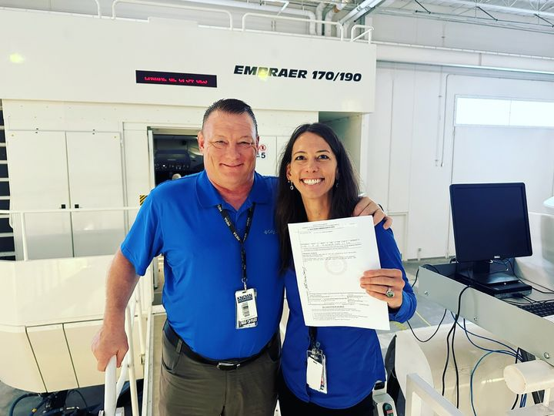

Laila Burns

is currently at Florida Tech majoring in Aeronautical Science/ Flight. She is working toward her Commercial (stage 1) then she will get her Instrument and then complete commercial training (stage 2).

Mia Anderson

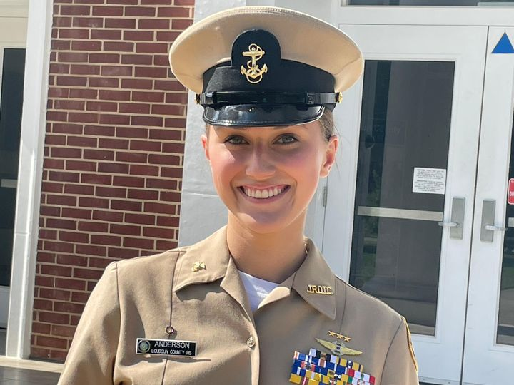

Mia in her JROTC uniform

Mia got the AOPA scholarship and here is her youtube describing her flight history.

Young Aviator's Dream: AOPA Flight Training Scholarship Success Story - YouTube

Meet Loudoun County High School senior Mia Anderson, a young pilot and Miss Virginia Teen Volunteer 2023! Anderson started a non-profit, Air Ambition, whose mission is to inspire, educate and mentor the next generation of aviators. Read more about Anderson’s amazing accomplishments:

Anderson Takes Flight as Miss Virginia Teen Volunteer (lcps.org)

Things to read and watch:

Kennedy Center opera opening

Grounded | Kennedy Center (kennedy-center.org)

Jess is an accomplished F-16 fighter pilot—until pregnancy grounds her to the “chair force” to target enemies via drones from a trailer in Las Vegas. This new arrangement seems ideal at first: by day, Jess uses her elite training to protect and serve America, and by night, she returns to her family. Ultimately, we see that protecting Jess from physical danger does little to shield her from the psychological trauma of war-by-proxy.

Fun movie on Netflix

Love Is in the Air (2023 film) Netflix

This film is totally formulaic and light. If you’re looking for romance and quite stunning pictures of seaplane flying and coastal Queensland, you’ll like this film. It’s on Netflix.



Aviatrix Book Club recommendations:

October

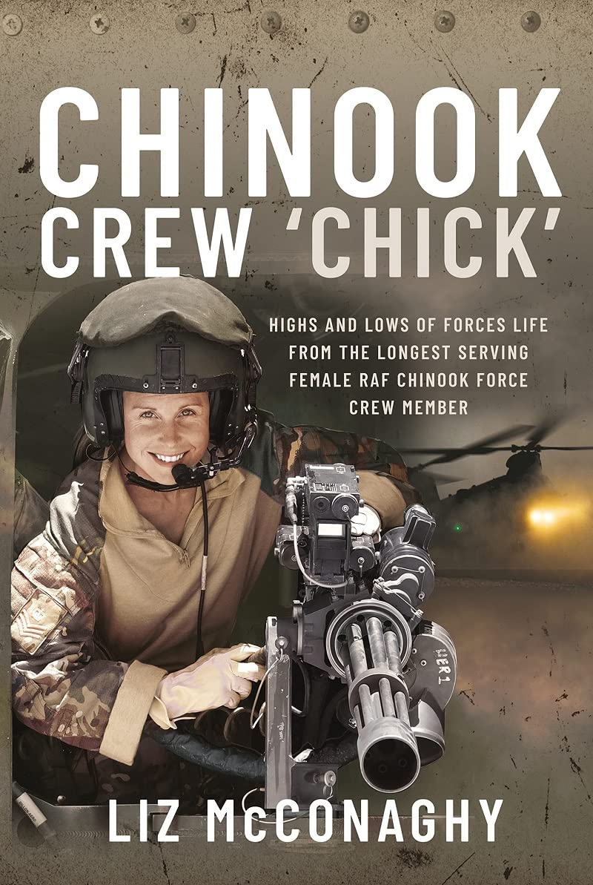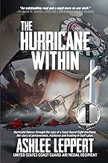

November

