

Old Dominion Chapter
SKYLINES
December 2023

Chair: Laura Savino
Vice-Chair: Mary McCutcheon
Secretary: Jessica Citrin
Treasurer: Barbara Gruber
Amelia Earhart Scholarship: Cynthia Axell
Aerospace Education: Debbie Gallaway
Membership: Sue Passmore
Newsletter: Mary McCutcheon
Webmasters: Jessica Citrin and
Stephanie Kight

Next Meeting

Holiday Party will be on Saturday December 16 at 6 PM
Peggy Doyle’s House
80 Menlough Drive/ Warrenton, VA

If you haven’t already, Please email Peggy (pegdoyle17@gmail.com) to tell her if you are coming and what food you will bring. She and Rick are providing ham and rolls, so desserts, appetizers, salads, beverages and sides are welcome.

Also there will be our traditional gift exchange. All 99s should bring something for a woman and all 49½ s should bring something for a man.

Past Events.

October 29 The last flying circus of the season

Laura Savino and I went to the flying circus to see Jana Leigh wing walk. That didn’t happen, though, because Jana Leigh was sidelined by a different wing walker. Still it was a great show, and we got to sit in on the pre-show “green room” briefing.

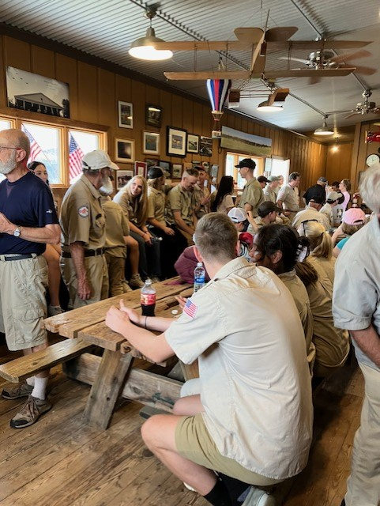
November 3 ProJet was a big success with lots of students coming for information.

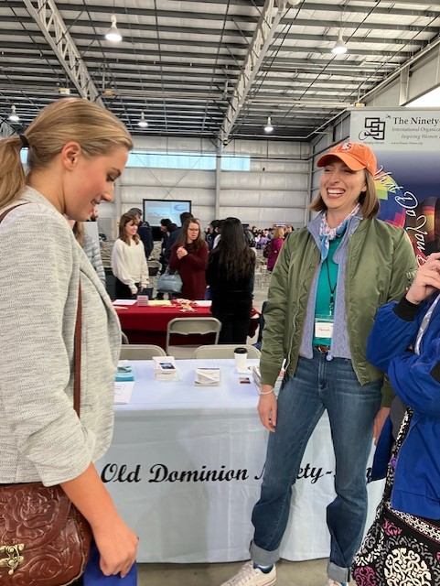
Mia Anderson and Hannah Rust

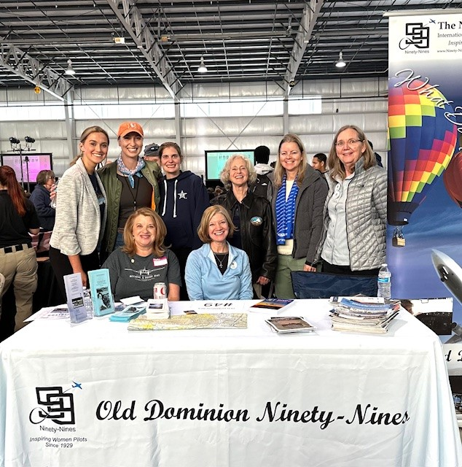

Mia Anderson, Hannah Rust, Stephanie Kight, Mary McCutcheon, Erin Miller, Sue Passmore, Melissa Plumer, Laura Savino
November 3 Grounded

Mia and Kari Anderson, Mary McCutcheon, Sue Passmore and Laura Savino went to the opera, Grounded, at the Kennedy Center. The story was about a woman who was an ace military pilot in Iraq. While on R&R, she got knocked up by a cowboy and had to be reassigned to conduct missions using drones (the “Reaper”). The work is stressful and she is also raising her daughter and staying married to the cowboy. Finally she has a mental breakdown and forces the Reaper to crash. She is sent to a military prison.

We were lucky to catch most of the pre-show talk by Francesca Zambello (who was a classmate of Sue Passmore’s at Colgate) in which she told us that her wife is a pilot. They live up in New York State, though so if she’s in a chapter of the 99s, it isn’t ours. Graciela Tiscareño-Sato, active in Latinas in Aviation and author of several children’s books promoting military aviation for girls, talked to us both before and after the performance. Good contacts!


November 9 Job fair at Manassas

Manassas hosted a career fair for middle and high school students mostly from Prince William County and Manassas. Melissa Plumer and I set up our table and talked to hundreds of students, both boys and girls. Then, across the crowded room, came another member of our chapter, Janet Davidson, who was at the Chantilly Air Charter service.

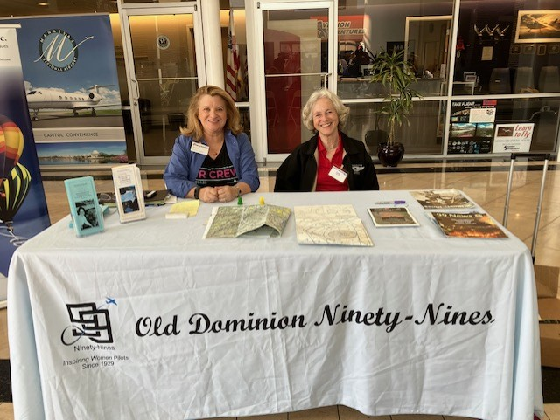
Melissa Plumer and Mary McCutcheon

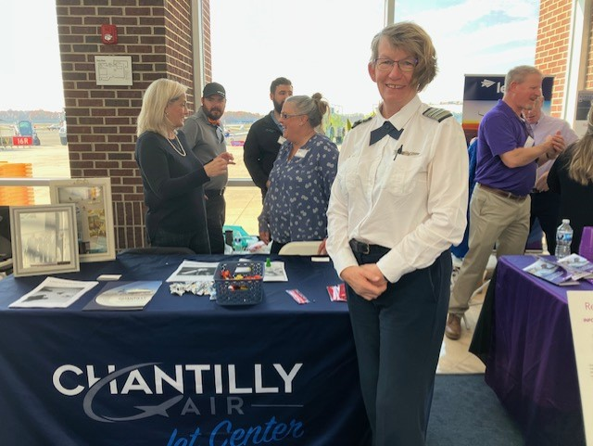
Janet Davidson

Things to plan for in the future:

Volunteering for ARC

I have volunteered for the ARC three times at five different posts. It was almost as much fun as flying the race and even more fun if you aren’t the competitive type.

Welcome to The Air Race Classic (Air Race Classic, Inc.)

If this interests you check out the The video link is available now:
Video: https://www.youtube.com/watch?v=bhgsazyX9Ds
Slides only: https://www.airraceclassic.org/volunteer-training.htm

The info in the attached document and the links above are also available on the Volunteer pages of the ARC website, but you must have an account. If you've created an account but didn't fill out the Volunteer form on this page: https://www.airraceclassic.org/how-to-volunteer.htm,

I am planning to volunteer at Newark, Ohio and would LOVE to have some chapter company.

Compass Rose at Manassas

I saw Richard Allapaugh at the Manassas career expo and he reminded me that he expects us to paint a new compass rose at Manassas once the taxiway renovation is complete.. The last compass rose we painted was on the runup area at 34L. The new one will be at 16R (I think). Both on the West side of the field.

Awards and Scholarships
2024 INTERNATIONAL AWARDS
The International Awards Committee is soliciting nominations for three prestigious awards to be presented by The Ninety-Nines, Inc. at the 2024 International Conference in Vancouver, BC. The deadline for submitting nominations is January 31, 2024.
AWARD OF ACHIEVEMENT (for Ninety-Nines)
Three Awards of Achievement may be presented for:
- Contributions to The Ninety-Nines
- Contributions to Aviation
- Humanitarian Efforts
Who May be Nominated? An individual member of The Ninety-Nines (living or deceased); a group of Ninety-Nines; or an organization within The Ninety-Nines, such as a Chapter, Section, Committee, or Trust
AWARD OF MERIT (For non-Ninety-Nines)
Recognizes a significant contribution to any facet of aviation
Who May be Nominated? An individual (male or female, living or deceased) or an organization. ***The recipient may not be a current or former member of The Ninety-Nines or of a group within The Ninety-Nines.
GEORGE PALMER PUTNAM AWARD (For non-Ninety-Nines)
Recognizes support provided to The Ninety-Nines by an individual (male or female, living or deceased) or an organization.
Who May be Nominated? An individual (male or female, living or deceased), or an organization. The recipient may not be a current or former member of The Ninety-Nines or of a group within The Ninety-Nines.

Who may submit nominations? A Ninety-Nines Chapter, Section, or Trust.
How to nominate: Submit a one-page letter, signed by two officers or trustees (as appropriate). The nomination must include the name, address, and telephone number of the nominee, or the nominee's next-of-kin if the nominee is deceased. Up to three additional pages of substantiating material may be attached to the letter.
Email your nomination to Awards@ninety-nines.org. Nominations should be received by the deadline, January 31, 2024.
Questions? Email Awards@ninety-nines.org

Mid-Atlantic Scholarship

Applications for this scholarship will be accepted between January 1 and January 31. The application will not be significantly different from last year, but stay tuned for more information as this year comes to a close.

Things to read and watch:

Laura Savino’s YouTube Channel is full of cool things

In the Kaneohe overshoot accident on November 20 the flight crew was all-female. Was this a factor? Laura reviews the data and goes through other bad approach accidents.

https://www.youtube.com/@JetBossLauraSavino

Aviatrix Book Club choice for December 2023

Death on the D’Urville: A Claire Hardcastle Mystery

By Penelope Haines

Meet commercial pilot Claire Hardcastle – fiery, clever, daring and trying to prove herself in a man’s world.
When Claire’s routine flight to pick up regular passenger, Jorge, from a remote island turns into a homicide investigation, she is excited to discover she may hold a clue to the crime!
A growing attraction to investigator Detective Sergeant Jack Body, and a desire to help solve the murder, leads Claire into a world of disputed Maori history, artefact smuggling and child abuse.
Death on D’Urville is the first novel in the Claire Hardcastle Mystery series set in New Zealand, following Claire’s adventures as a commercial pilot, flying instructor and accidental detective.

