
Old Dominion Chapter
SKYLINES
March 2023

Chair: Laura Savino
Vice-Chair: Mary McCutcheon
Secretary: Jessica Citrin
Treasurer: Barbara Wilper
Amelia Earhart Scholarship: Sue Passmore
Aerospace Education: Debbie Gallaway
Membership: Barb Wilper
Air Marking: vacant
Newsletter: Mary McCutcheon
Webmasters: Jessica Citrin and
Stephanie Kight

Next Meeting

March 6. Gregorio’s Trattoria in Reston
1428 N. Point Village Center
Reston, VA
6 PM for dinner. 7 PM for meeting

Our new webpage

Thanks to Jessica Citrin and Stephanie Kight for updating our webpage. Here is the link to it. If you want to get into the “members” page, you’ll have to contact Jessica (jessicacitrin@outlook.com) or Stephanie (skight2714@gmail.com) for the secret password.
https://olddominion99s.com/

Plans for hosting the Fall Mid-Atlantic Section Meeting

We have settled on the dates October 6-8 for the Mid-Atlantic Section meeting that our chapter is hosting. The planning committee is working on the details but the Hampton Inn in Warrenton looks like the place where people will stay, a TRACON tour at Vint Hill may be shaping up, a Sunday Flying Circus outing may tempt people to stay another day, and a tour of the Wright Experience in Warrenton are ideas for Saturday. If you have suggestions for activities or a Saturday evening lecture, please let one of us know: Mary McCutcheon (mmccutch@gmu.edu), Laura Savino (bigplanet747@gmail.com) or Peggy Doyle (pegdoyle17@gmail.com)

Past Events
Meeting on February 6 in Leesburg
Our first true meeting in person in the last three years was held at Leesburg Public House in the private meeting room. It was well attended. Here are some pictures:

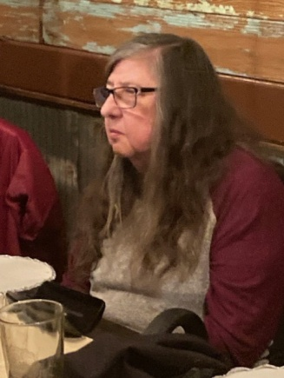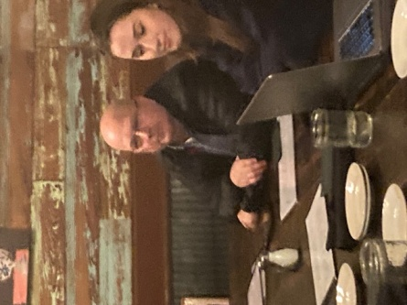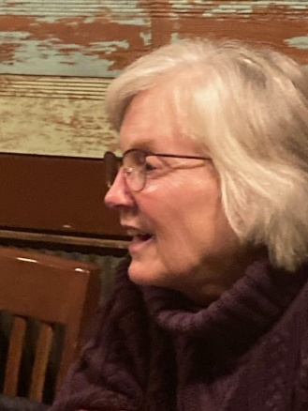
Barb Wilper Brent and Mia Anderson Cynthia Axell

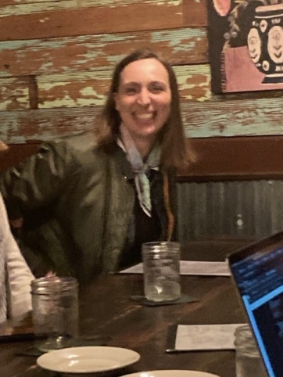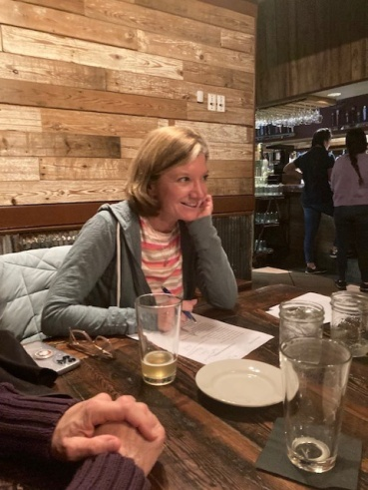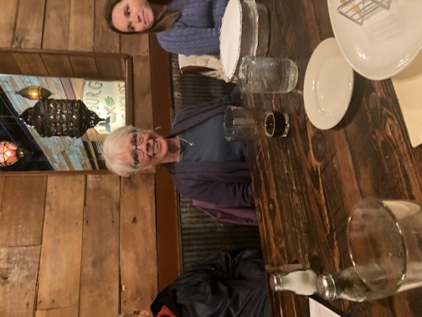
Hannah Rust Laura Savino Peggy Doyle and Leila Burns

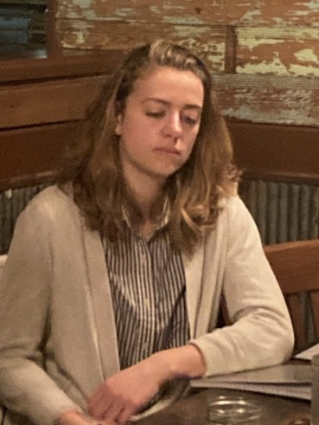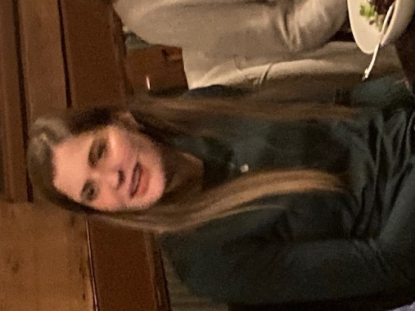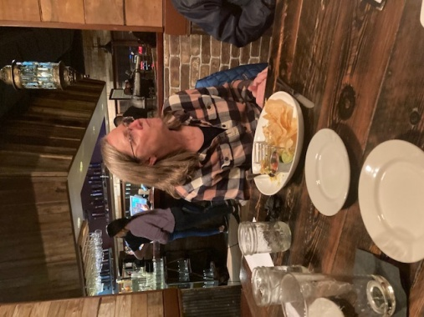
Samantha Stahl Stephanie Kight Sue Passmore

Smokehouse fly-in to Georgetown, Delaware

From Sue Passmore:

Jessica and I flew to Delaware Coastal airport (KGED) in a Diamond DA40 NG (along with the Smokehouse pilots… 76 people and 44 airplanes!). We ate lunch on the field and then toured the Delaware Aviation Museum. The B-25 was the biggest thing in the hangar, though not the only classic airplane. I had a hard time getting Jessica OUT of the B-25!

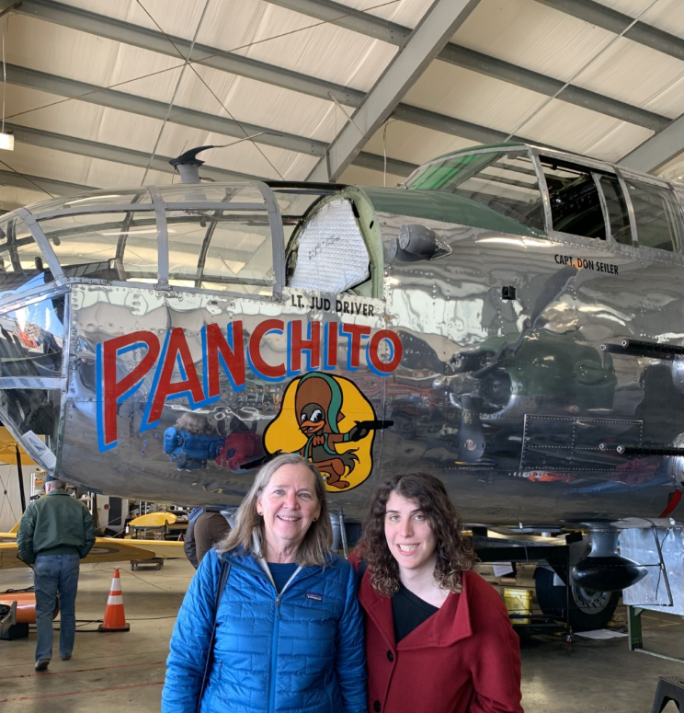

Women in Aviation International Meeting

Laura Savino and Mia Anderson went to Long Beach, California for the meeting of Women in Aviation International and Girls in Aviation. They both said it was fabulous

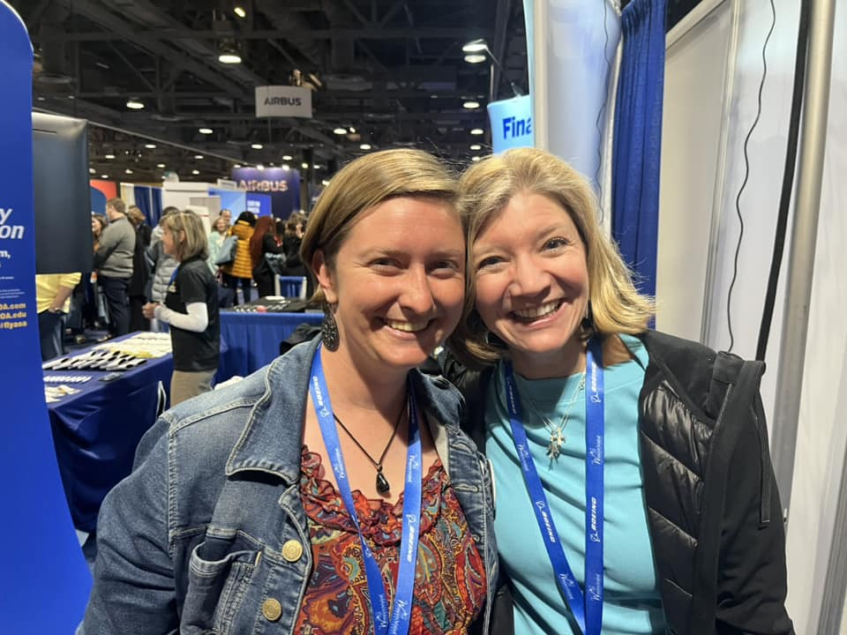
Robin Laws and Laura Savino

From Mia:

I had SO SO SO much fun at Girls in Aviation day! Girls of all ages had the chance to learn about various career paths in the aviation industry on Girls in Aviation Day in Long Beach, California. I loved working the simulator table, where the girls were naturals!

Various pictures of Mia and her future pilots:

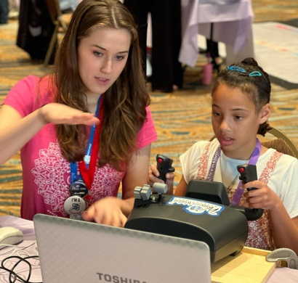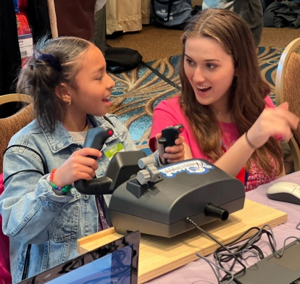

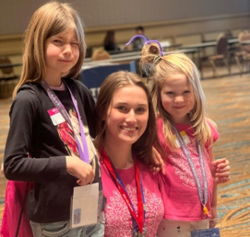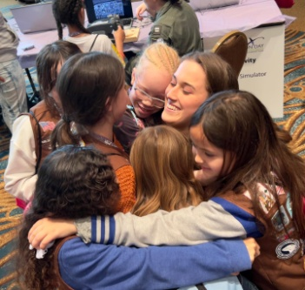
Other News.

Lovettsville Vintage Aerodrome Rises Again
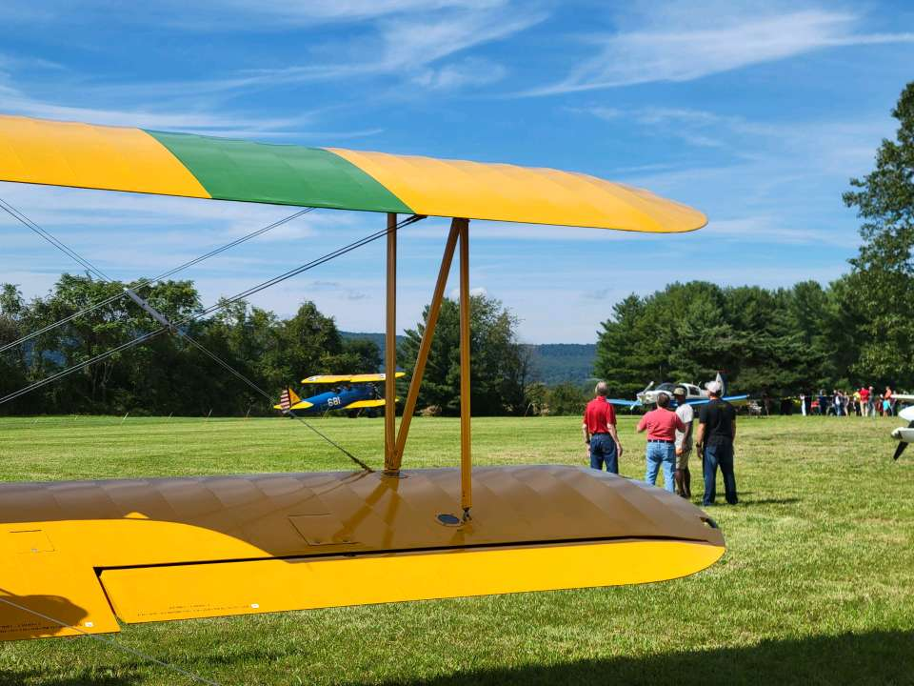

The private airport in Virginia carries on the grass strip’s history as a gathering spot for classic and historic aircraft.
https://www.flyingmag.com/lovettsville-vintage-aerodrome-rises-again/

Future Events:

SUN N FUN Luncheon

From the Straight and Level (I think)
Every year at Sun ‘n Fun, the Ninety-Nines host a WASP Luncheon. As we lose these amazing women or the few left have difficulty travelling, we wanted to continue the traditional luncheon with interesting speakers.
As pilots we are used to having alternatives and making changes to our flight plans, so we thought about alternatives for the luncheon and our new flight plan is the 99s Trailblazers in Aviation Luncheon.
Join us at the 99s Trailblazers in Aviation Luncheon at SUN 'n FUN. The speakers will be John and Martha King.
Tickets are available for purchase at
(https://2023_99s_trailblazers_aviation_luncheon.eventbrit...)

Ocracoke fly in will be May 18 – 22, 2023

International meeting in Jordan
will be October 27 to October 29 with optional tours through November 2. See Ninety-Nine News for agenda and making travel plans. See the Ninety-nine News for the full agenda

Women Can Fly
at Shannon on April 29
And at Warrenton on June 24

Scholarships

The Amelia Earhart Memorial Scholarship Fund First Wings Awards are semiannual awards of up to $6,000 based on completion of specific training milestones. They are available to Student Pilot Members of The 99s who meet eligibility requirements. To be eligible, applicants must hold a student pilot certificate (or provide evidence that they meet their country's flight training requirement), have been an official Student Pilot member three months prior to the application deadline, have logged five hours in the six months prior to the application deadline and show financial need. The Spring 2023 First Wings deadline is April 1. The instructions and application are available on The 99s website.

Soaring
Youth Members (Juniors) ages 13-25 are encouraged to apply for an SSA Youth Flight Training Scholarship ($2,000 each). Funding for these scholarships have been provided through donations from multiple sources, including but not limited to Pat Costello, the estate of Dennis Purduski and the Community Foundation for Mississippi, John Stoffel, the Estate of Bill Ivans, George Moffat and others.
At least two (2) Bultman Awards ($1,000), and possibly one (1) Junior CFIG Scholarship ($2,000) will be awarded too.
Youth Scholarship Applicants should go to the following website and fill out the unified scholarship application: https://www.ssa.org/ssa-flight-training-scholarships/ Scholarship Application Deadline: March 31, 2023
Our Newest Members

Jennifer Zinn. Jennifer learned to fly at Leesburg has had a private pilot’s license since 2017. Before that she served in the AirForce. She owns a Mooney. Now she wants to go on and get her instrument rating.

Frances Velazquez. Frances (or Frankie) Lives in Leesburg. She began her lessons in October 2022 with Aviation Adventures. She currently has 30 hours and expects to solo pretty soon. She works for the FAA and is an authority of weather and aviation. She studied meteorology at Embry Riddle. She wants to promote aviation safety in the context of weather conditions One of many reasons she joined the ninety-nines was her meeting Laura Savino at the Latinas in Aviation event at College Park. That was where the new book, Latinas in Aviation: Maryland Edition made its debut. Frances is featured in Chapter ONE.

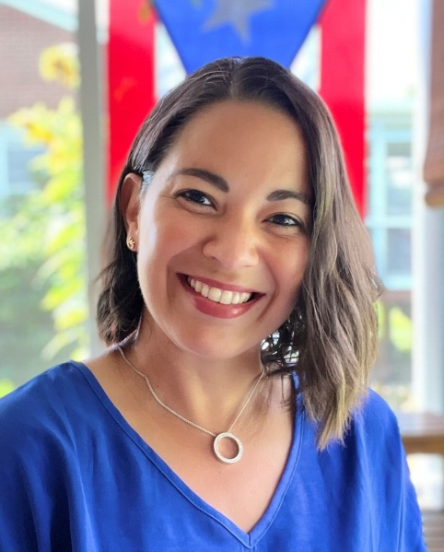

Member Accomplishments

Michele Bell

Michele Bell gets Ambassador Jacket
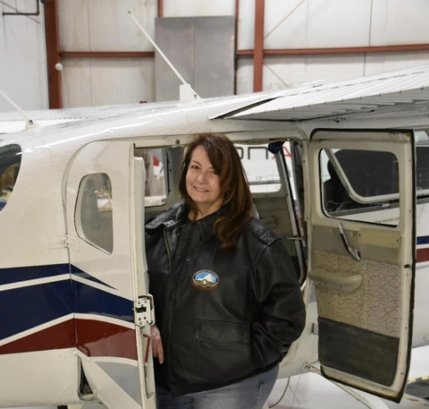

Jenny Reeb

From Morgen:,
The good news you’ve been waiting for. Jenny passed her ATP written! She has been hired by Commute Air! They are a United Airlines commuter. Jenny is in school right now learning to fly the Embraer 145.

THINGS TO READ

This Is the Aviatrix Book Club book for March:



