
Old Dominion Chapter
SKYLINES
April 2023

Chair: Laura Savino
Vice-Chair: Mary McCutcheon
Secretary: Jessica Citrin
Treasurer: Barbara Wilper
Amelia Earhart Scholarship: Sue Passmore
Aerospace Education: Debbie Gallaway
Membership: Barb Wilper
Air Marking: vacant
Newsletter: Mary McCutcheon
Webmasters: Jessica Citrin and
Stephanie Kight

Next Meeting

We'll be holding the April Business Meeting at Firebirds Wood Fired Grill in Leesburg, VA on April 10th. The happy hour/dinner starts at 6PM, and otherwise the business meeting will start sometime after 7PM.

1607 Village Market Blvd
Leesburg, VA 20175
(703) 840-0443
Elections:

International Voting deadline is May 2
Voting will be held by secret ballot. Members will receive an invitation to vote electronically or paper ballot depending on the selection made prior to the deadline. To see the list of candidates and learn more about each,
go to https://www.ninety-nines.org/election-page.htm.

See your email and go to
secure.electionbuddy.com/QWV6-8MC-SVJ7-MN8K.

Chapter
Electronic ballots were sent out and you should have received one or you should have received one in the mail for paper voting. They will go to Cynthia Axell. In order to do the voting by email, you will need a Google account. Mail your paper ballot to Cynthia at:

Cynthia Axell
3903 Lincolnshire Street
Annandale, VA 22003

Plans for hosting the Fall Mid-Atlantic Section Meeting

We have settled on the dates October 6-8 for the Mid-Atlantic Section meeting that our chapter is hosting. We will not concern ourselves with any lodging arrangements since there are no hotels right nearby and people coming can simply make their own arrangements. A TRACON and Command Center tour at Vint Hill is now a certainty. Thanks to Laura and Sue for talking to Gary Shiflett at Sun N Fun. A Sunday Flying Circus outing may tempt people to stay another day, and a tour of the Wright Experience in Warrenton are ideas for Saturday.

Janet Davidson (our member who lives near Warrenton in Amissville) writes “Our neighbours here at the farm are the Narmada winery, award-winning, great wine, great location. I’m sure they’d be happy to do a group event. Also further west is little Washington, and then the fun little town of Sperryville, with yet more wineries and cideries and breweries. I’m making it sound like the ultimate pub crawl”

If you have suggestions for activities or a Saturday evening lecture, please let one of us know: Mary McCutcheon (mmccutch@gmu.edu), Laura Savino (bigplanet747@gmail.com) or Peggy Doyle (pegdoyle17@gmail.com)

Past Events

Meeting in Reston on March 6 at Gregorio’s Trattoria.
We had a wonderful meeting in Reston attended by twelve. I totally forgot to take pictures. Be sure to read the minutes

SUN N FUN Luncheon

Every year at Sun ‘n Fun, the Ninety-Nines have a luncheon.
Sue Passmore reports from the talk by John and Martha King who are promoting their new book.

The 99s held a lunch at Sun n Fun with the theme of Trailblazers in Aviation. John and Martha King are indeed trailblazers. They entertained the audience with their story. I had no idea that they once went bankrupt; they said it was because they didn’t have a passion for the company they started. They wanted to be 50-50 partners in everything.

They started flying to small cities to offer ground school over a weekend. John would teach in one room and Martha would teach in another room. They attracted ranchers, who would otherwise have to travel hours to get to a ground school. They recorded sections of the class to make it easier for themselves. Then, they started to sell the tapes to other CFIs for $500 each to make it easier for other CFIs to teach classes. They found that pilots wanted to purchase the tapes even though they were ridiculously expensive. Now, it’s internet training that they are known for.

They talked about all the planes they’ve owned. Basically they said you usually own a plane that you can’t really afford. They joked about their first jet, the Citation known as “Slow-tation” , which was purchased with the idea of going faster. Ha Ha.

Their topic was PLAY builds habits that lead to success (with a funny nemonic about playing Scrabble).
P is for Passion. Without passion, it’s hard to be successful.
L is for Lots of interests. Have interests that build skills that you do better than others OR for others . Add interests together. Different from Scrabble, you get to choose these.
A is for Always learning.
Y is for Yet again. As in start with P again and re-do.

All while having Fun.

John and Martha have released their book, LIFT, to share how they started their business of teaching pilots.

“Flying changes who you are and how you feel about yourself.” - John and Martha King

.
Funeral for Evelyn Marshall.

Many of us knew Evelyn Marshall from Dulles Aviation Center or from her affiliation with the Flying Circus and with their Flying Farmer, Charlie Kulp. Evelyn died at the end of March and her funeral was held on Wednesday, April 5. Morgen Reeb and Mary McCutcheon went and here is a picture of them just after the Stearman missing man fly-over. here is part of the program.

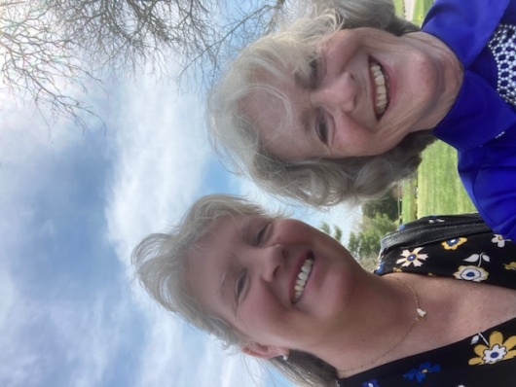

Here are select parts of the funeral program:

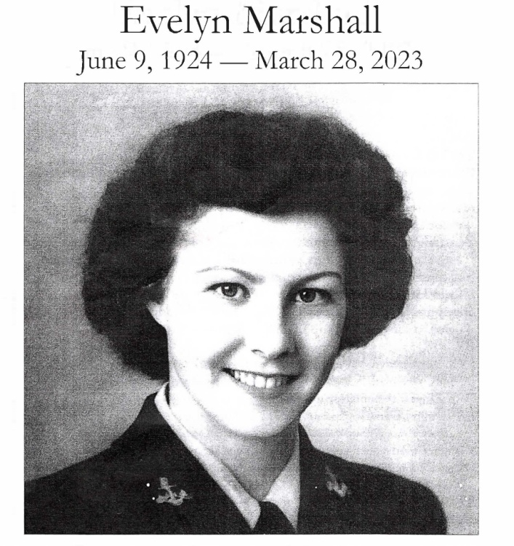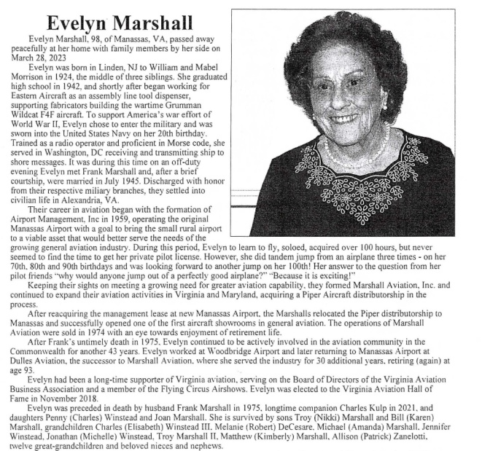

Future Events:

Women Can Fly -- Shannon
Shannon on April 29. We will need volunteers to staff a booth staff by our. She has fliers but may need more flyers. Sign up through the women can fly web site. Hours are 10 to 2. Women Can Fly

Air and Space program Merryl Tengesdal U-W Pilot
May 3 8 – 9 PM Downtown NASM

https://airandspace.si.edu/whats-on/events/taking-challenges-intention-making-history-lockheed-u-2

Spring Section Meeting: May 5th and 6th
Where to go Poquoson Women’s Club, 9 Cedar Road, Poquoson,Va
When to Get there May 5 6 PM for the welcome reception
May 6 9 AM for the business meeting
Noon for the taco bar lunch
What to pay and how to pay it: $35 for all activities both days (food)
$25 for just the business meeting and lunch
Use venmo https://www.venmo.com/u/Linda-Mathias-8
Or pay by check to Hampton Roads Chapter 99s
c/o Linda Mathias
1 Colley Avenue Apt 614
Norfolk, VA 23510
Where to stay Courtyard by Marriott, Yorktown, VA (http://tiny.cc/Marriott-NNY
Extended Stay America (http://tiny.cc/ExtendedStay-NNY
How to get there Fly into PHF (Newport News/Williamsburg Int
Or drive
What else Airshow on Saturday afternoon

https://www.facebook.com/warbirdthunderairshows

Jackie Cochrane Lecture. May10 8-9 PM Udvar-Hazy

Jacqueline Cochran: Pilot, Leader, Myth | National Air and Space Museum (si.edu)

Ocracoke fly in will be May 18 – 22, 2023

Women Can Fly – Warrenton
We need volunteers to sign up and also people to do the flying. Women Can Fly

Girl Scout Aviation Day will be May 20 at the Flying Circus in Bealeton

Calling Girl Scouts, American Heritage Troops, Girls in STEM, Aviation Clubs! GRADES 4-12!
Mia Anderson is hosting, through her non-profit Air Ambition,
The lineup is growing and will be EPIC!
UVA mobile Planetarium!
Air Traffic Controllers
Udvar Hazy Air and Space Museum will be there with “touch artifacts”
A Med Flight Nurse!
Vintage aircraft displays
Pilots and Flight attendants!
a Fly-Over and Surprises by the Glory Hounds
Awesome SWAG bags!
Email girlscoutaviationday23@gmail.com
The event is limited to 150 participants. Register today!
Girl Scout Troops will earn their Aviation Fun Badge.

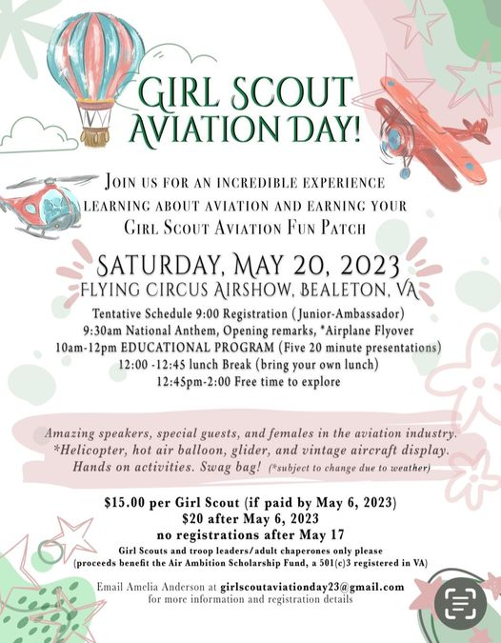

EAA Air Venture (Oshkosh) July 23-26.
If you plan to go to Oshkosh, you might consider being a mentor for girls and women who want to fly.

https://www.eaa.org/eaa/youth/eaa-aviation-and-flight-summer-camps/girlventure?utm_source=girlventure_mentors_230320&utm_medium=email&utm_campaign=edu_girlventure_2023&utm_content=cta&mkt_tok=OTEwLVNFVS0wNzMAAAGKpLrz1Hx504ov82AwR8R93hhhKyGcYblTEZz-3a1vlscGJrO_K5O6aKEa0qYxdlcWWZ2NxtmZ7cUgTZ-NH3f8CgYiBlTWUgIZ13OW0w7VpEw&fbclid=IwAR3j4EhOICcD6mtAdj5ZGVbGmfaZSLk7_xJJZE0v7Ijq4SqxKjtFSoqRAYM#mentor

International meeting in Jordan
will be October 27 to October 29 with optional tours through November 2. See Ninety-Nine News for agenda and making travel plans.

Our Newest Members

Jennifer Diffenderfer She has a Bonanza at Leesburg

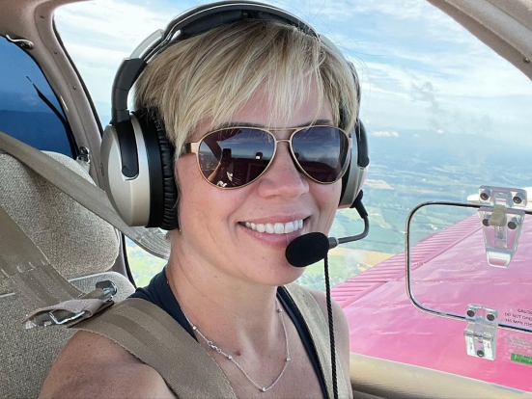

Jennifer Zinn (not new, but her picture is here this time)
It looks as if the dog is the featured part of the picture and
maybe we’ll see the left side of her face one of these days

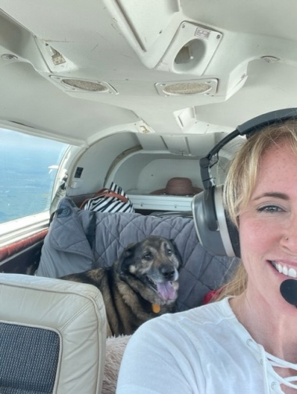

Things to watch, read or listen to

Ninety-nines Wednesday Webinar
Wednesday, April 12, 8:00 pm Eastern
Flying for Humanity
Presented by Celeste Pearce Connecticut Chapter 99s member and American Airlines 777 Pilot
Don't miss our guest speaker as she recounts her missions piloting evacuation flights carrying at-risk Afghan civilians and American troops to the United States as part of the Civilian Reserve Air Fleet in August 2021.
WEDNESDAY WEBINAR - Flying for Humanity | Press Releases - The Ninety-Nines, Inc.

Aviatrix Book Club choice for April

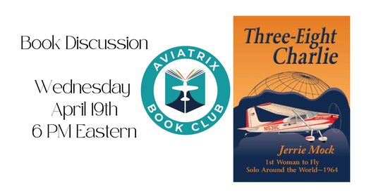
(18) Liz Booker's Three-Eight Charlie Discussion | Facebook

Member Accomplishments

Stephanie Kight. Completed the PPLI Program in January

Frankie Velasquez was at Sun N Fun giving weather briefings

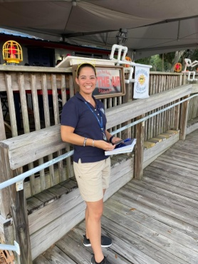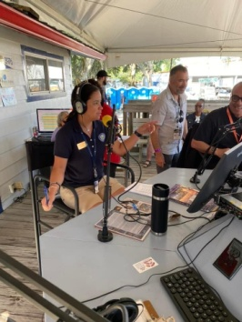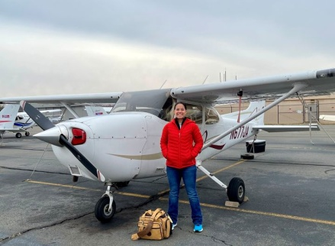

She did a first solo and first solo cross country

Carolyn Hunker
Earned her Embraer E-170 type rating
Airline Transport Pilot - ATP
March 17, 2023

Carolyn is now a First Officer for Mesa Airlines.
‘

Michele Bell visited every airport in Virginia and got her ambassador jacket

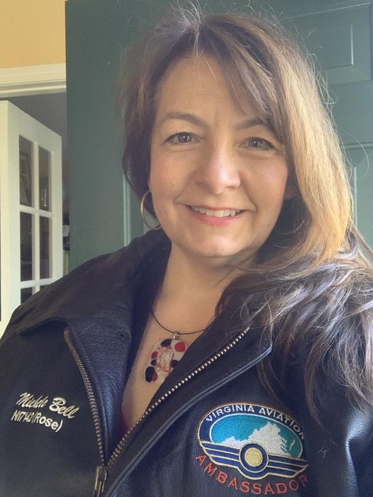

Jenny Reeb passed her ATP written and was hired by Commute Air and is now training to fly an Embraer 145

Katrina Emery passed her ATP written.

Morgen Reeb earned her 35 year pin In March
though her official 35th anniversary was April 5!
She also documented her all woman flight deck.

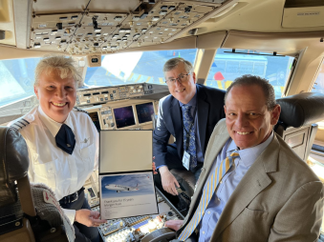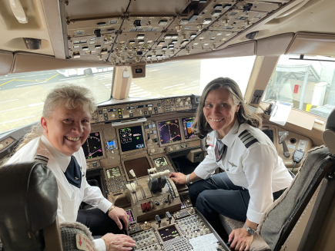

Mia Anderson Glides upside down

