
Old Dominion Chapter
SKYLINES
June 2023

Chair: Laura Savino
Vice-Chair: Mary McCutcheon
Secretary: Jessica Citrin
Treasurer: Barbara Gruber
Amelia Earhart Scholarship: Sue Passmore
Aerospace Education: Debbie Gallaway
Membership: Barb Wilper
Newsletter: Mary McCutcheon
Webmasters: Jessica Citrin and
Stephanie Kight

Next Meeting
Our June meeting will be Piggybacking on the Smokehouse Pilot’s meeting Wednesday, June 7. This will be at Buffalo Wing Factory at 43761 Parkhurst Plaza #100, Ashburn, VA 20147. Our meeting will begin at 5:30 so that we’ll be able to listen to the speaker at 6:00. Come earlier than that if you want to have dinner too.

Barb Wilper’s service as Treasurer
From 2008 until now Barb Wilper has served as treasurer and, recently also as Membership coordinator. In her role as treasurer she has kept us in the black and gently leaned on us to pay our dues. Thanks to Barb for keeping us on track.
Beginning last week, Barb Gruber has been the treasurer and she will tell us how we should pay our dues in the future. We may be expanding options to include Venmo and Zelle and other electronic payment methods.
Barb Wilper will continue to serve as membership coordinator until she moves or until someone else steps into the position.

The International Election results have been announced
Directors Janet Patton, Ambassador Chapter, South Central Section
Nivedita Bhasin, India Section
Nominating Committee Mae Marquet, NOLA Chapter, Southeast Section
Karissa Davan, Katahdin Wings, New England Section
Amelia Earhart Memorial Scholarship Fund
Helen Consolino, Phoenix Chapter, Southwest Section
Ninety-Nines Endowment Fund
Brenda Thibodeau, Katahdin Wings, New England Section
Ninety-Nines Museum of Women Pilots
Tweet Coleman, Daytona Chapter, Southeast Section
Diane Earhart, Greater St. Louis Chapter, North Central Section Amelia Earhart Birthplace Museum
Emmy Dillon, San Diego Chapter, Southwest Section
Lindsey Dreiling, Air Capital Chapter, South Central Section

Plans for hosting the Fall Mid-Atlantic Section Meeting
Friday - Welcome activity (food/drinks - need to schedule)
Saturday - At Udvar-Hazy, meeting to begin 8am,
tour museum, lunch,
road trip to Potomac TRACON,
casual dinner with Jana Leigh as our speaker.
Sunday - road trip to Flying Circus

Past Events

The Mid-Atlantic Section Meeting May 5-6
The Section meeting was held near Newport News, VA. From our chapter, Barb Gruber, Barb Wilper, Peggy Doyle, Morgen Reeb and Mary McCutcheon attended. There was an informal gathering on Friday night, a formal meeting on Saturday morning and an outing to see the airshow at Langley AirForce Base that afternoon. For our purposes, the biggest take-away was the new policy on participants representing the Ninety-nines headquarters. These women must make their own hotel arrangements and will be reimbursed from the section up to $300. The registration fees will then reimburse the section.

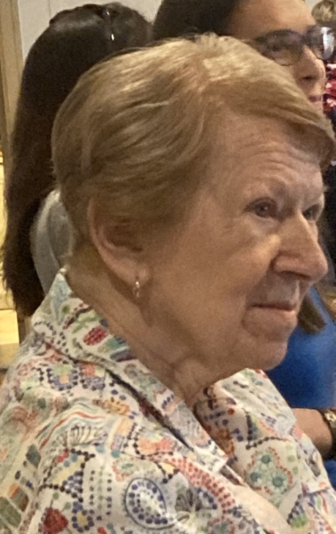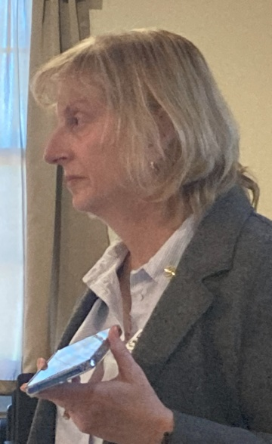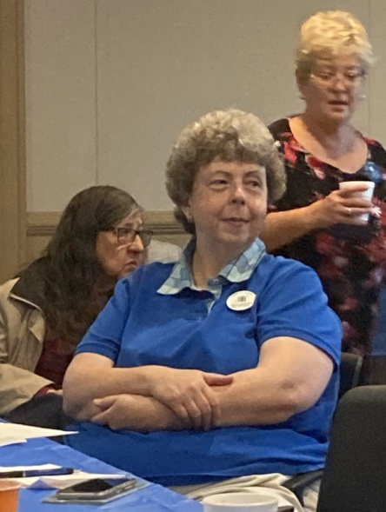

Linda Mathias Lin Caywood Barb Wilper, Linda Bangert Connie Jones

Ocracoke Weekend
How long has this been going on??? RJ thinks that the chapter has been going to Ocracoke for 30 years. The Ocracoke Inn celebrated its 25th anniversary and bragged that our group has been reserving rooms at the end since they began.

This year was another great weekend although no one was able to fly down because of weather.

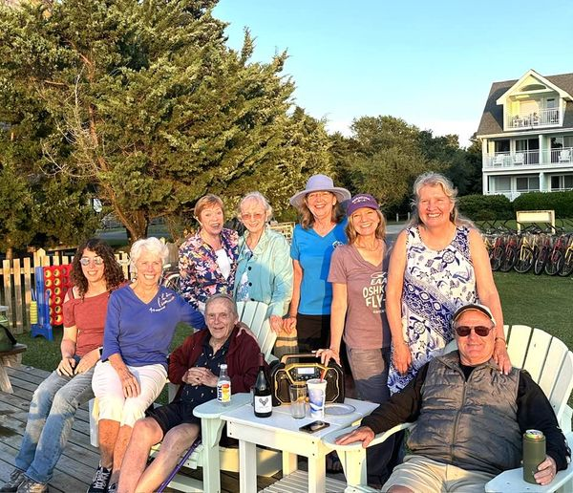
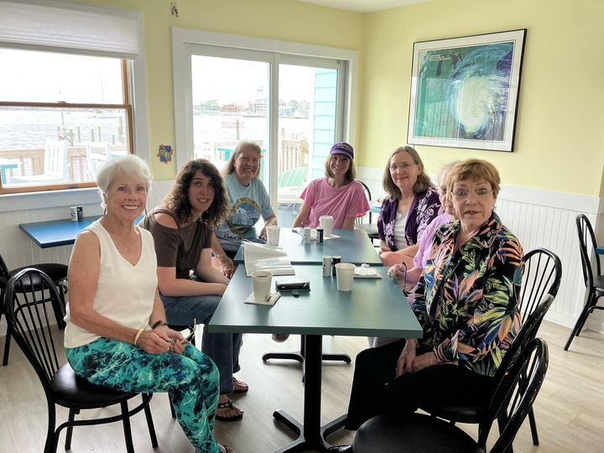

Jessica Citrin, Peggy Doyle, Rick Koehnke,
RJ McGlasson, Marti Constantinos, Sue Passmore
Laura Savino, Morgen and Frank Reeb
Peggy Doyle, Jessica Citrin, Morgen Reeb, Laura Savino, Sue Passmore, Marti Constantinos, RJ McGlasson

Mia Anderson’s Girl Scout Event
On May 20 a large number of girl scouts and their families came to the Flying Circus Aerodrome to learn about many aspects of aviation including, space exploration, principles of flight, navigation, gliding, ballooning, and air traffic control. It was a fabulous day and everyone had a great time. Old Dominion members there were Hannah Rust, Mia, Allison Diaz, Barb Gruber, and Mary McCutcheon. The girls earned an aviation patch for participating.

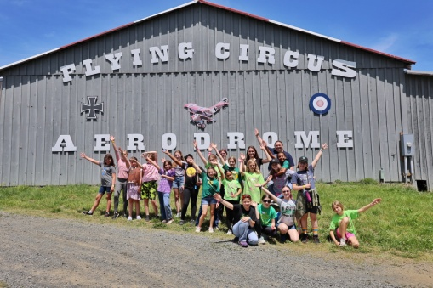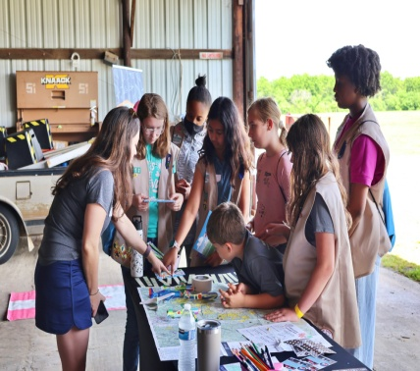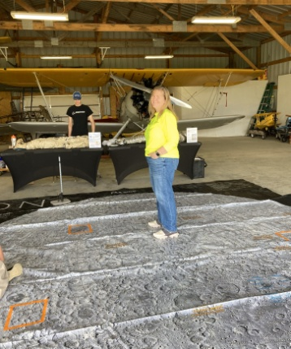
A bunch of kids Barb Gruber on the moon kids learning

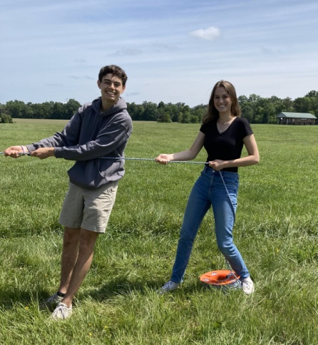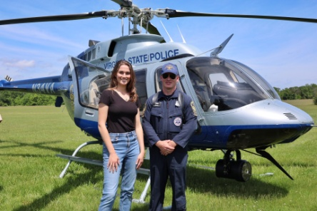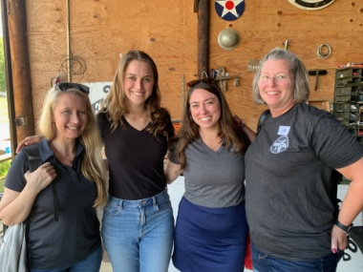
Mia and friend with balloon rope Mia and the ATC crew
Mia and the police helicopter

Future Events:

Women Can Fly – Warrenton

Women Can Fly is planned for HWY on 24 June. It is the SINGLE LARGEST PUBLIC EVENT at HWY every year. Sarah Patten has already received hundreds of registrations, and is actively seeking your assistance. There are numerous ways to contribute to this busiest of days on our ramp, from volunteer pilots to ramp-escorts to the construction table to simply providing economic contributions. If you can influence the weather, please order a light breeze from the north, low humidity, plenty of sunshine and very high clouds. Sarah is seeking financial sponsors for new WCF Shirts, fuel donations and volunteer lunches. Contact Sarah www.womencanfly.com

EAA Air Venture (Oshkosh) July 23-26.
If you plan to go to Oshkosh, you might consider being a mentor for girls and women who want to fly.

International meeting in Jordan
will be October 27 to October 29. It’s probably too late for early registration and probably too late to sign up for special tours.

ProJet Aviation Expo November 3.

Thanks to Sue for signing us up for another year at ProJet Aviation Expo. Please consider signing up to volunteer there. It is always fun and gives you a chance to meet other aviators.

Accomplishments of our members

Kat Emery’s story is being publicized by Piper Aircraft, Inc.

(20+) Facebook

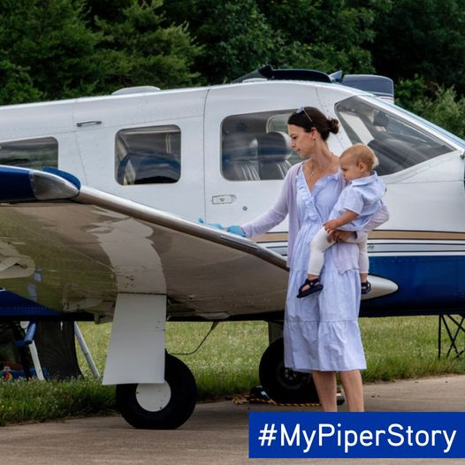

Katrina Emery’s #MyPiperStory began in 2012 when she took a discovery flight in a Piper PA-38 Tomahawk. She was hooked. She completed her private pilot certificate in that very same Tomahawk and then went on to fly Warriors, Archers, and Arrows, eventually earning her CFII.
Katrina’s first airplane was an Archer, which she instructed in and leased back to her flight school. After growing her flying family, Katrina and her husband decided it was time for a larger aircraft. She found a PA-32 Saratoga turbocharged with factory TKS, air conditioning, oxygen, a glass panel, and more! They now use the Saratoga to travel to and from their vacation home, visit family in the northeast, and to participate in Pilots and Paws missions.

Frankie Velasquez Mercado wins First Wings
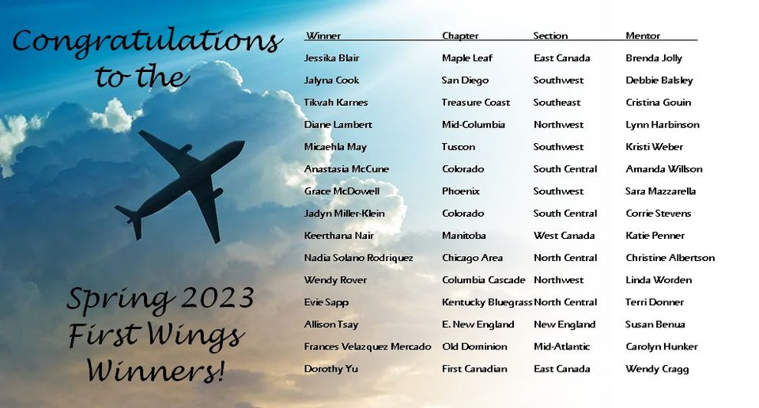
Morgen and Jenny are featured in the latest issue of Ninety-nine News.

20230506.pdf (ninety-nines.org)

the Adventure Sharing Multi-Generation Families in The 99s - Issuu

Other News

The fiftieth Anniversary of the Flying Circus

Here is a wonderful film with Ken Hyde and Charlie Kulp talking about the Flying Circus

50th Anniversary Flying Circus - YouTube

Things to watch, read or listen to

Aviatrix Book Club choices for June


Skybound: One Woman's Journey in Flight, by Rebecca Loncraine:
The day she flew in a glider for the first time, Rebecca Loncraine fell in love. Months of gruelling treatment for cancer meant she had lost touch with the world around her, but in that engineless plane, soaring 3,000 feet over the landscape of her childhood, with only the rising thermals to take her higher and the birds to lead the way, she felt ready to face life again.
And so Rebecca flew, travelling from her home in the Black Mountains of Wales to New Zealand’s Southern Alps and the Nepalese Himalayas as she chased her new-found passion: her need to soar with the birds. She would push herself to the boundary of her own fear, and learn to live with joy and hope once more.
Crosswind: A Novel, by Patricia Valdata:
Ellen Horvath, whose college education is interrupted by personal tragedy, finds herself in the cycle of Life's realities, at a time and place chosen by Fate. Crosswind is her story, as she sorts through barriers and obstacles, until she finally discovers a world so appealing her life is changed again. This book is about a segment of Ellen's life, but the characters and personal interactions, and the outside influences on her life, can't help but make each reader think of his/her own life, and the combination of choices and circumstances that puts us where we are.
Join the discussions on Wednesday June 21st at 7PM Eastern, and June 25th at 1PM eastern, and stay up to day on all of the Aviatrix Book News with the Literary Aviatrix Monthly Newsletter. https://linktr.ee/literaryaviatrix

Our Newest Member:

We welcome Anna Green into our chapter. She joined in late May.
.

