
Old Dominion Chapter
SKYLINES
July 2023

Chair: Laura Savino
Vice-Chair: Mary McCutcheon
Secretary: Jessica Citrin
Treasurer: Barbara Gruber
Amelia Earhart Scholarship: Sue Passmore
Aerospace Education: Debbie Gallaway
Membership: Barb Wilper
Newsletter: Mary McCutcheon
Webmasters: Jessica Citrin and
Stephanie Kight

Next Meeting

Saturday August 12 from 1 to 3 at Peggy Doyle’s house

80 Menlough Dr
Warrenton Va 20186
540-229-7713

Bring something for lunch and RSVP to Peg pegdoyle17@gmail.com


Plans for hosting the Fall Mid-Atlantic Section Meeting

Friday - Welcome activity (food/drinks probably at Buffalo Wing Factory in Ashburn
Saturday - At Udvar-Hazy, meeting to begin 8am,
tour museum, lunch,
road trip to Potomac TRACON,
casual dinner with Jana Leigh as our speaker.
Sunday - road trip to Flying Circus with behind-the-scenes tour before the show.

ANNOUNCEMENT
Request from Sue Passmore
for a volunteer to serve as chapter AEMSF rep

As you recall, I was part of The 99s election process for a Trustee for the AEMSF. Though I did not win, the Trustees are executing a resolution to expand the number of trustees. That means both Judy Shaw and I are added by appointment to the scholarship trustees! Because we went through the election process and were approved by the IBOD for that, we are good to go!

That means that I have to resign my position as the chapter AEMSF representative. And I cannot hold any elected positions in the chapter going forward (for my term of 3 years… I must remain neutral in any selection process).

I can help any new person willing to step into this role. Action starts in September for the First Wings scholarship. I’ve attached a SOP to help any new person understand what needs to be done throughout the year.

Please let the chapter know ASAP that you need another volunteer (because if there isn’t one, it falls to the chapter chair!)

We also have to submit a new report to HQ that puts a new person as the AEMSF chapter contact (or takes me off).

Past Events

June Meeting

The call to order occurred around 5:33. This meeting was in-person at Buffalo Wing Factory in Ashburn, VA..

This was the first meeting that Jen Diffenderfer was able to attend, so we took the time to introduce ourselves to her.

Dave Linton presentation about Angel Flight (Mercy Medical Angels) at the Smokehouse pilot’s meeting which we joined after our business meeting.

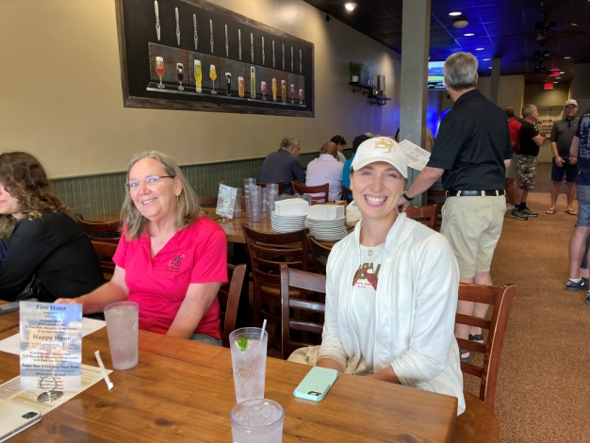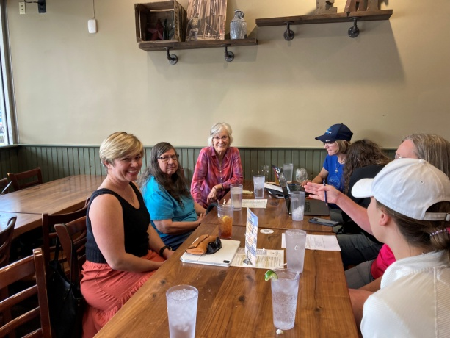
Sue Passmore and Hannah Rust Jenn Diffenderfer, Barb Wilper, Cynthia Axell
Laura Savino, Hannah Rust

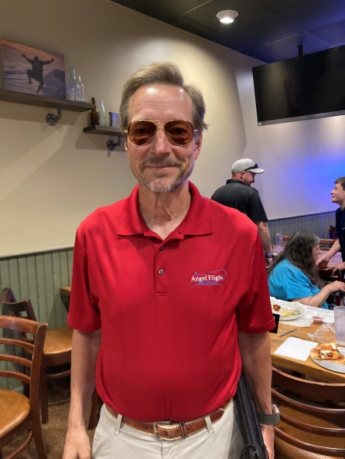
Dave Linton

Women Can Fly – Warrenton

Women Can Fly on June 24 was a big success. Hundreds of people got flights, a lot of people made things at Women can Build, Tables for various organizations were well attended including our 99s table.

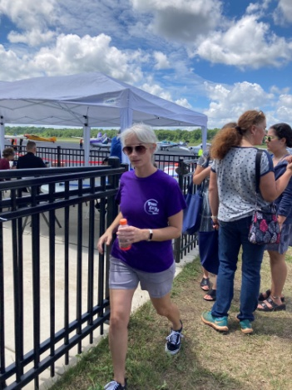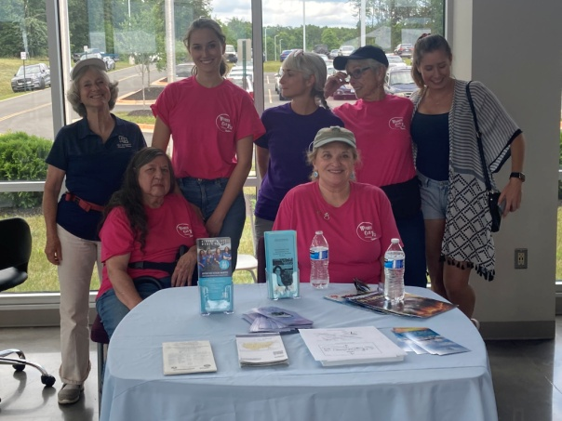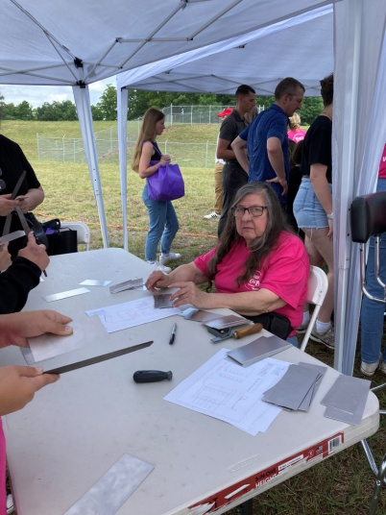

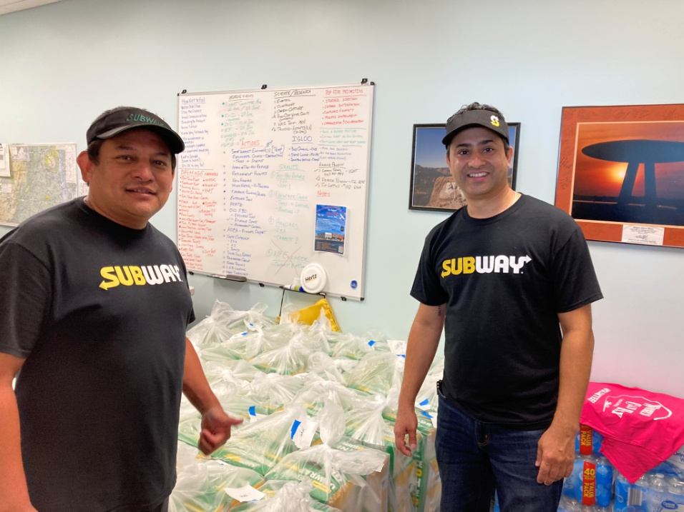

One of the Subway delivery men came back with his whole family who all got to fly.

EAA Air Venture (Oshkosh) July 23-26.

Several of our members went to Oshkosh.

Laura Savino had some book signings and gave her wildly popular talk on the Tenerife crash in the Canary Islands in 1977

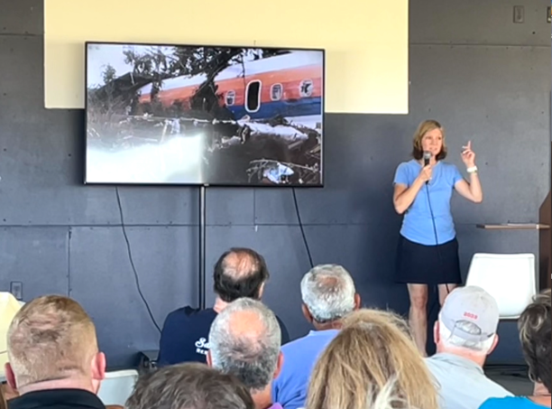

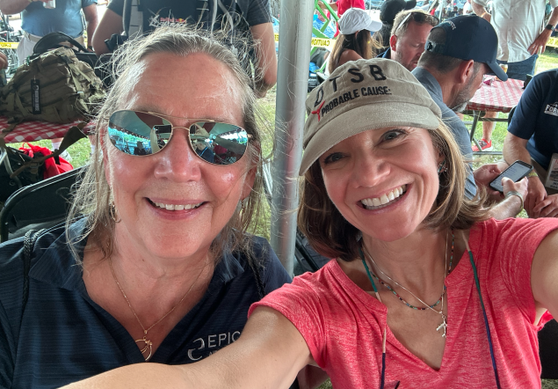

Sue Passmore and Laura Savino

Future Events:

Air Derby

Co-ed Race! Check it out!!
The ARC Air Derby is a VFR flight flown during daylight hours on a single day this Fall. The objectives are for each team to design a route that conforms to the ARC Air Derby Rules, estimate the time it will take them to fly that route, and then fly it as close to their estimated time as possible. The ARC Air Derby will conclude with a virtual Awards Banquet where prizes will be awarded for the closest time estimates for each leg and the entire route. The 2023 ARC Air Derby is open to all light aircraft that can compete within these rules. Routes may be designed and flown in the U.S. as well as other countries. Registration is limited to 99 Teams.
Registration for the 2023 ARC Air Derby opens Saturday, July 15, 2023, and closes Tuesday September 26, 2023. The Derby event must be completed on any day between Friday, September 29, 2023, and Monday, October 9, 2023. For more information and rules, visit https://derby.airraceclassic.org/.

International meeting in Jordan

will be October 27 to October 29. It’s too late for early registration and probably too late to sign up for special tours. But if any of you are going, please make sure to go as an Old Dominion representative and take a nice tax deduction.

ProJet Aviation Expo November 3.

Thanks to Sue for signing us up for another year at ProJet Aviation Expo. Please consider signing up to volunteer there. It is always fun and gives you a chance to meet other aviators.

Accomplishments of our members

Eleanor Brunsman

Eleanor Brunsman is now type rated in the Hawker 900XP! Congratulations Eleanor!

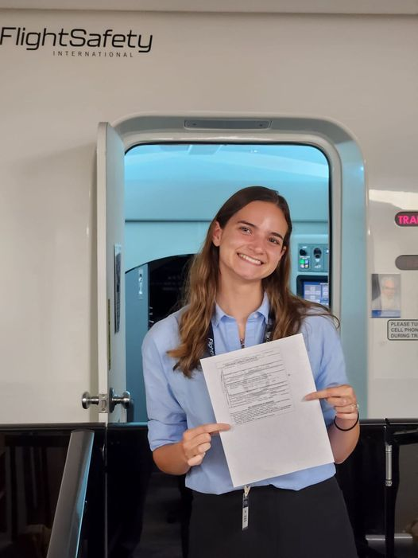

Mia Anderson earned her powered pilot’s license

And with an EAA Ray Aviation Foundation scholarship and an AOPA You Can Fly High School scholarship, Mia is now going to pursue additional ratings.

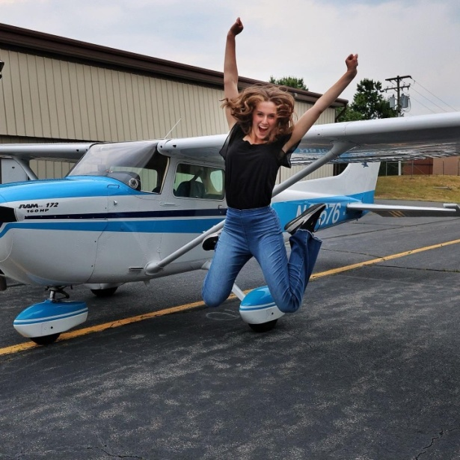

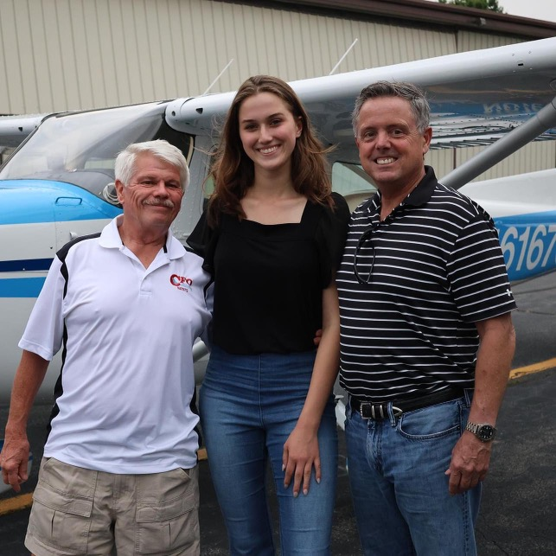

Mia is also starting float plane training. Here she is at Coeur d’Alene, Idaho

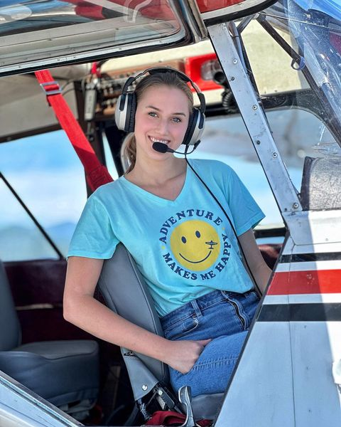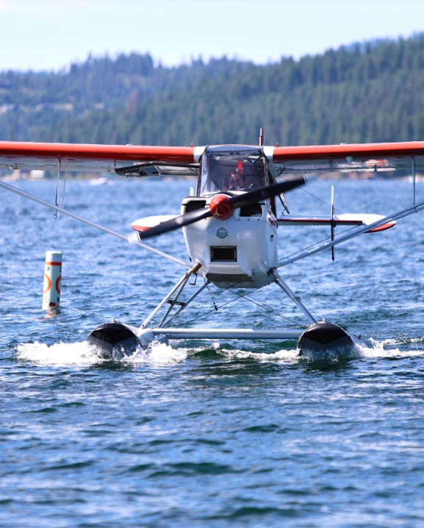

Mia was a speaker at the Air and Space Museum SHE- STEM program

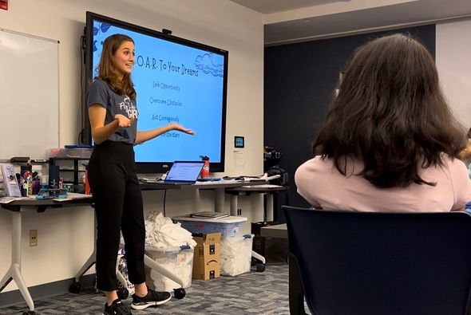

And Mia was featured at Camp Summer Magic

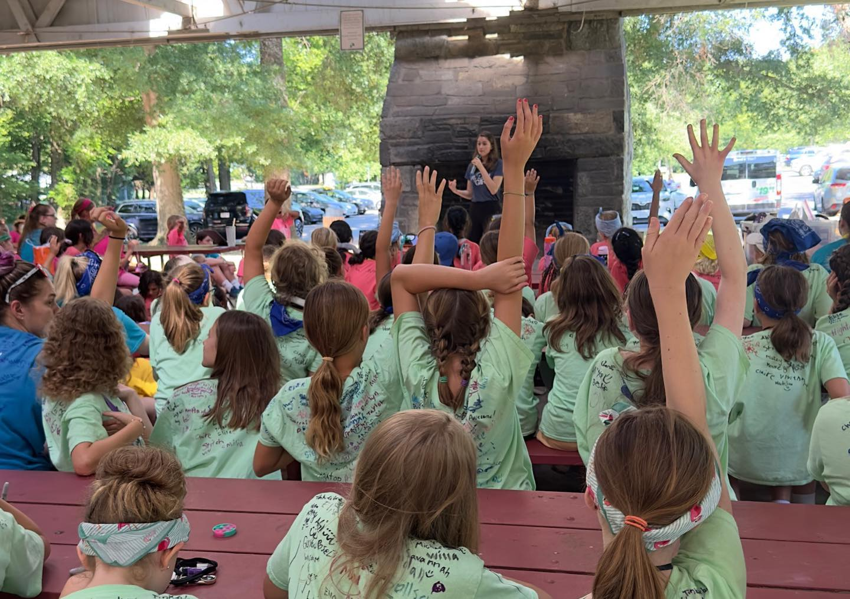

Samantha Stahl

“I have been working on my instrument rating in San Antonio, TX, and have just completed it. I wanted to update the 99s that I passed on 6/14 at KFWS and I used a Diamond Star DA40. Attached is a photo at KSSF where I trained.

I look forward to returning to VA and seeing everyone!”

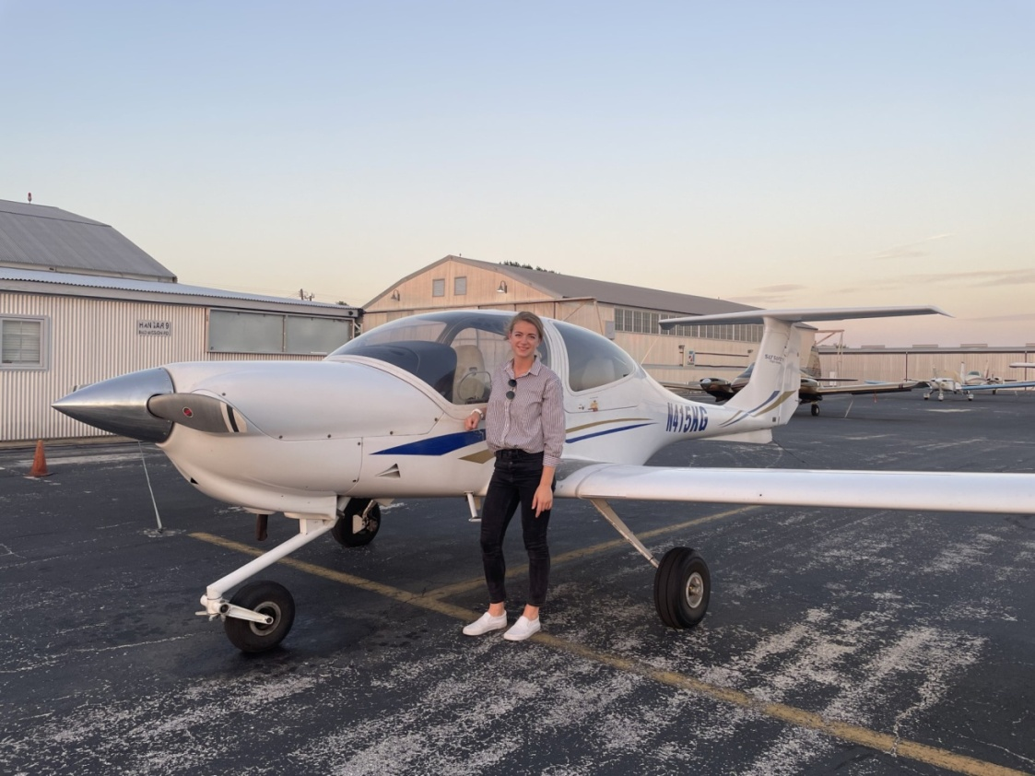

Morgen Reeb and all–women’s flight deck

From Morgen: “I had my first Boeing 777 trip with 2 lady First Officers. It was on July 5th from JFK to Athens, Greece and we returned to JFK on July 7th. Jodie Gooby is in the First Officer seat and Ashley Lagrou is on the jump seat. Ashley is considered the FB, since she is the extra First Officer.”

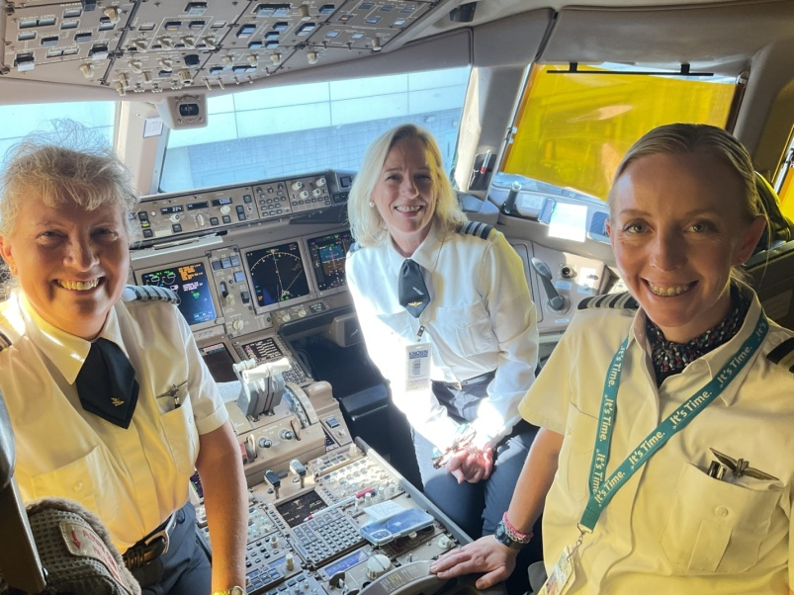

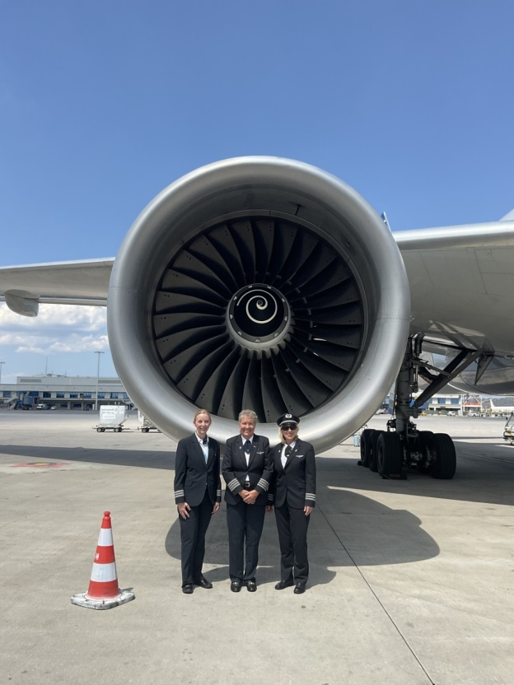

Frankie Velasquez Mercado earns private pilot license

Sue Passmore writes: “Congrats to First Wings winner Frances Velazquez Mercado of Old Dominion Chapter who completed her written, cross-country and checkride! That earns her $3,500 in milestone payments. She says “I remember the first time my college friends took me on a flight. It was all so exciting. But the radios came on and all voices immediately convinced me I would never be able to be a pilot. It was just too much to handle. That was over twenty years ago and look at me today. I’m so grateful for the support I have received from the moment I joined The Ninety-Nines.”

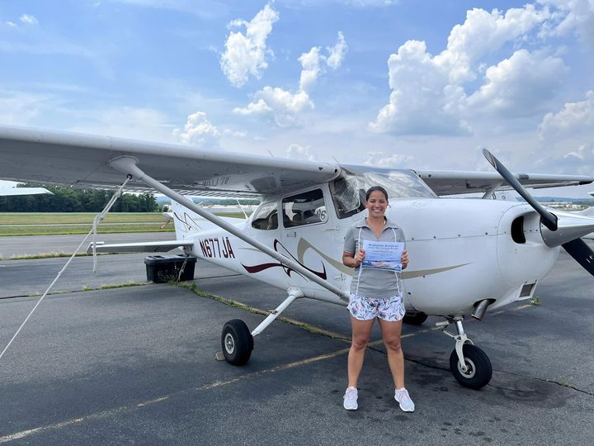

Stephanie Kenyon

Women in Aviation International Announces the Appointment of Stephanie Kenyon as Interim CEO

Stephanie has served as WAI’s Chief Growth Officer since 2021, where she led the strategic direction and financial growth of the organization. She most recently assumed management of the organization’s successful scholarship program, including its new international university scholarships, and she launched Harvard University/WAI Emerging Leaders professional education program designed to give women the leadership skills needed to assume executive positions within their organizations and the aviation/aerospace industry.

Stephanie comes to the position with more than two decades of leadership experience in nonprofits and the aviation industry. As vice president of the AOPA Foundation, she designed and launched the popular AOPA High School Aviation Initiative, now a nationwide program that introduces teachers and students to aviation..

Things to watch, read or listen to

Laura Savino has a YouTube channel on Aviation Safety.
https://www.youtube.com/@JetBossLauraSavino

Aviatrix Book Club choices for July
^{Fly Girls Revolt}


This is the story of women military aviators breaking through the barriers preventing them from combat flying. When a flying officer can’t do it “all,” her career options are seriously limited to non-existent. Eileen starts with the earliest “military” aviatrices, the WASP and traces the progress of women in military aviation up to the present.

Aviatrix Book Club choice for August.
^{The Elimination Game}


In this work of fiction, all-female Army helicopter flight crew are repeatedly sabotaged

Our Newest Members:

ANNA GREEN

We welcome Anna Green into our chapter. She joined in late May. She will probably transfer her chapter affiliation to the Virginia chapter though because she lives in Chesterfield and that’s a little out of our bounds.

Samantha Lawrence

Next month we will learn more about this aviatrix from Reston who just joined last week.

.

