
Old Dominion Chapter
SKYLINES
September 2023

Chair: Laura Savino
Vice-Chair: Mary McCutcheon
Secretary: Jessica Citrin
Treasurer: Barbara Gruber
Amelia Earhart Scholarship: Cynthia Axell
Aerospace Education: Debbie Gallaway
Membership: Barb Wilper
Newsletter: Mary McCutcheon
Webmasters: Jessica Citrin and
Stephanie Kight

Next Meeting

September 18. 6 PM for dinner and 7 PM for the meeting
Buffalo Wing Factory

43761 Parkhurst Plaza #100/ Ashburn

Buffalo Wing Factory Ashburn, VA | Craft Wings. Craft Beer.

International Is Soliciting candidates for election

By Virginie Rollin, Chairman International Nominating Committee

The International Nominating Committee is seeking candidates for the following positions to serve for the 2024-2026 term: President, Vice President, Secretary, Treasurer, Directors (two positions), Nominating Committee (three positions). All our trusts (Amelia Earhart Birthplace Museum, Amelia Earhart Memorial Scholarship Fund, Endowment Fund and Museum of Women Pilots) are also looking for candidates for their 2024-2027 term. Please contact the trust chairmen for more information. The Intent to Seek Election Form is available in the Library in the Members Area of the website. For questions or more information, contact one of the Nominating Committee members: Virginie Rollin, Chairman Lin Caywood Karissa Davan Mae Marquet Margaret Wint The deadline to submit your packet to the committee is December 31, 2023

Past Events

August Meeting
We had a good attendance at our August meeting (see minutes for the list) and had a delicious pot luck dinner at Peggy Doyle’s house in Warrenton. Almost the entire meeting was devoted to hammering out details for the October section meeting which we are hosting. One of our new members, Kayleigh Isaacs, was there. Here are some pictures showing Frankie, Hayleigh, Barb Gruber, Barb Wilper, Sue Passmore, Peggy Doyle, Laura Savino, .

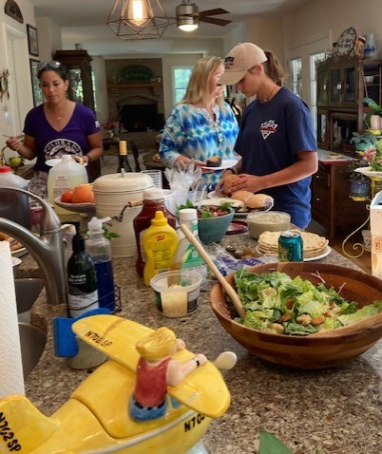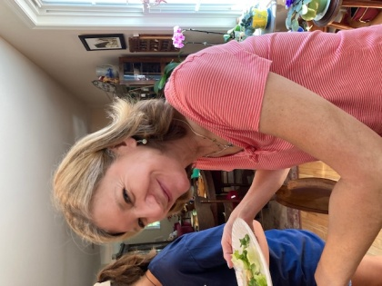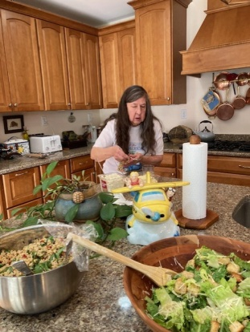

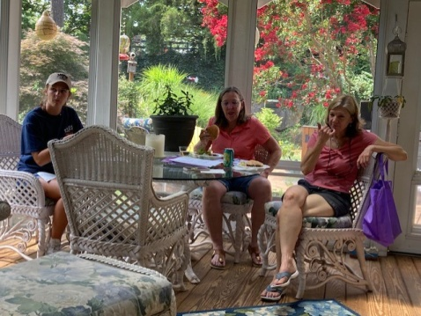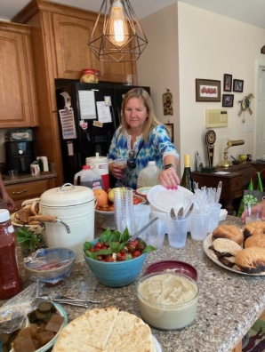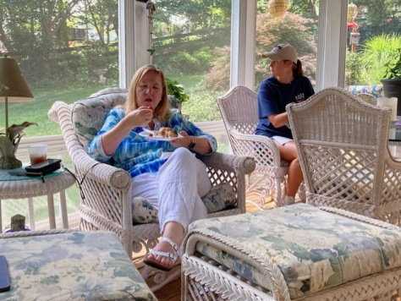

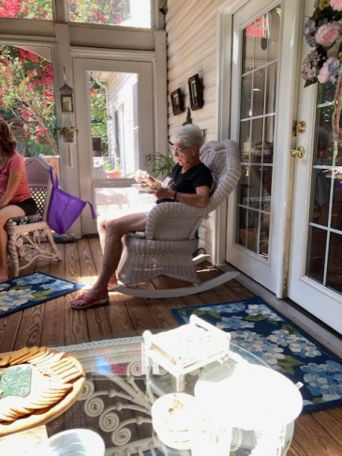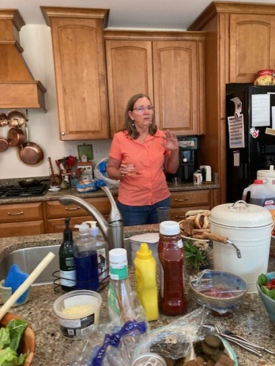

IBOD Meeting in Oklahoma City.

From Sue Passmore:

While we attended the International Board Of Directors meeting in OKC, Janet Patton ( a Director) attempted to tether her balloon on the grounds of The 99s building. It was a bit too windy. I was supposed to be ballast( an extra person to hold it down). But, we never got the balloon to vertical. Here are some photos of Janet, Judy Shaw, and Peggy. Judy was working hard to fill the balloon with cold air.

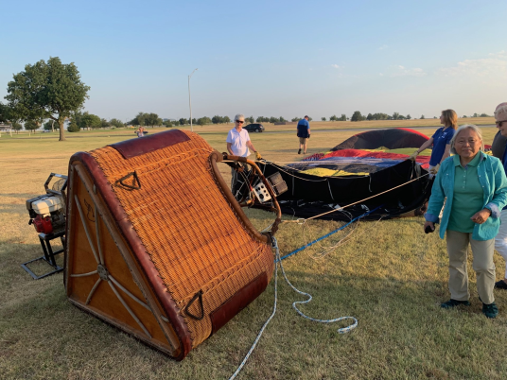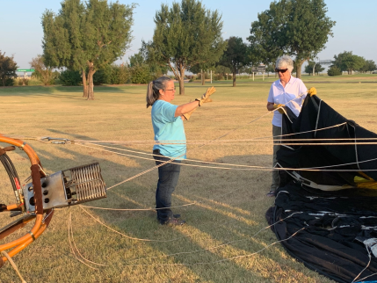

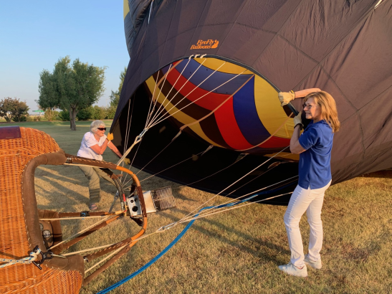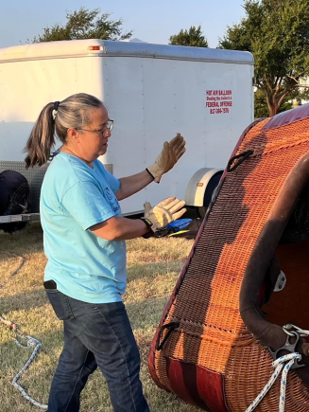

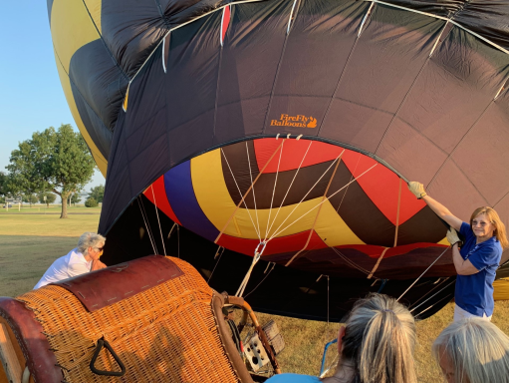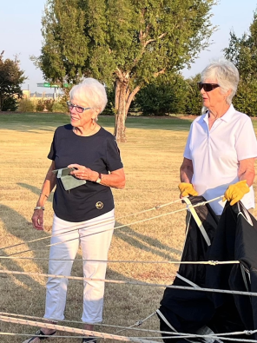

Future Events:

Air Derby
Co-ed Race! Check it out!!
The ARC Air Derby is a VFR flight flown during daylight hours on a single day this Fall. The objectives are for each team to design a route that conforms to the ARC Air Derby Rules, estimate the time it will take them to fly that route, and then fly it as close to their estimated time as possible. The ARC Air Derby will conclude with a virtual Awards Banquet where prizes will be awarded for the closest time estimates for each leg and the entire route. The 2023 ARC Air Derby is open to all light aircraft that can compete within these rules. Routes may be designed and flown in the U.S. as well as other countries. Registration is limited to 99 Teams.
Registration for the 2023 ARC Air Derby opens Saturday, July 15, 2023, and closes Tuesday September 26, 2023. The Derby event must be completed on any day between Friday, September 29, 2023, and Monday, October 9, 2023. For more information and rules, visit https://derby.airraceclassic.org/.

Fall Mid-Atlantic Section Meeting
.
The plans are pretty well finalized for our section meeting. See the minutes of our August meeting to get the schedule

Please register for the meeting or any part of the meeting as soon as possible. You should have gotten an email from Governor@mid-atlantic99s.org on August 21 with a registration link. Check for it or go to the link here:

https://docs.google.com/forms/d/e/1FAIpQLScebbipMniXgKthGAu2SFldZ3cfcpKGK0wjYqHsO30Cpm3hEw/viewform

It is especially important that we register ASAP since two things have to be done in advance: getting name tags for Udvar-Hazy and getting clearance to go to TRACON.

International meeting in Jordan

Jennifer Zinn is going. She says: “ I love to travel and this is a good opportunity to do so and meet other women pilots. I have not been to this area yet! I have no idea on any of it as far as being the rep for our division.. someone else said that apparently since I'm the only one planning on going. Not sure what you are looking at for that or what other kind of specifics you are looking for? I'm currently working and traveling while exploring Asia for the foreseeable future and am currently in Vietnam”

ProJet Aviation Expo November 3.

We have been at ProJet Aviation Expo in Leesburg for several years and love the networking. We always meet people at other tables and engage students in conversations about their aviation dreams.

Please consider signing up to help us at our table. November 3 is a Friday. We are there all morning and until shortly after lunch.

A NEW WAY FOR CHAPTER CHAIRS and VICE-CHAIRS TO COMMUNICATE WITH EACH OTHER

Starting in October, Headquarters will be hosting bi-monthly Zoom calls exclusively for Chapter Chairs and Vice-Chairs. With the help of Sutter Buttes Chapter Chair Mary Wick and Vice-Chair Lorin Ponton, along with IBOD Director Janet Patton, these bi-monthly calls will serve as a platform for collaborative discussions on matters pertinent to our chapters, fostering an environment of shared learning and support.

Scholarship

First Wings Applications Available
The Amelia Earhart Memorial Scholarship Fund First Wings Awards are semiannual awards of up to $6,000 based on completion of specific training milestones. They are available to Student Pilot Members of The 99s who meet eligibility requirements. To be eligible, applicants must hold a student pilot certificate (or provide evidence that they meet their country's flight training requirement), have been an official Student Pilot member three months prior to the application deadline, have logged five hours in the six months prior to the application deadline and show financial need.
The Fall 2023 First Wings deadline is October 1. The instructions and application are available on The 99s website.

Accomplishments of our members

Samantha Stahl earned her Commercial on August 7 at Leesburg

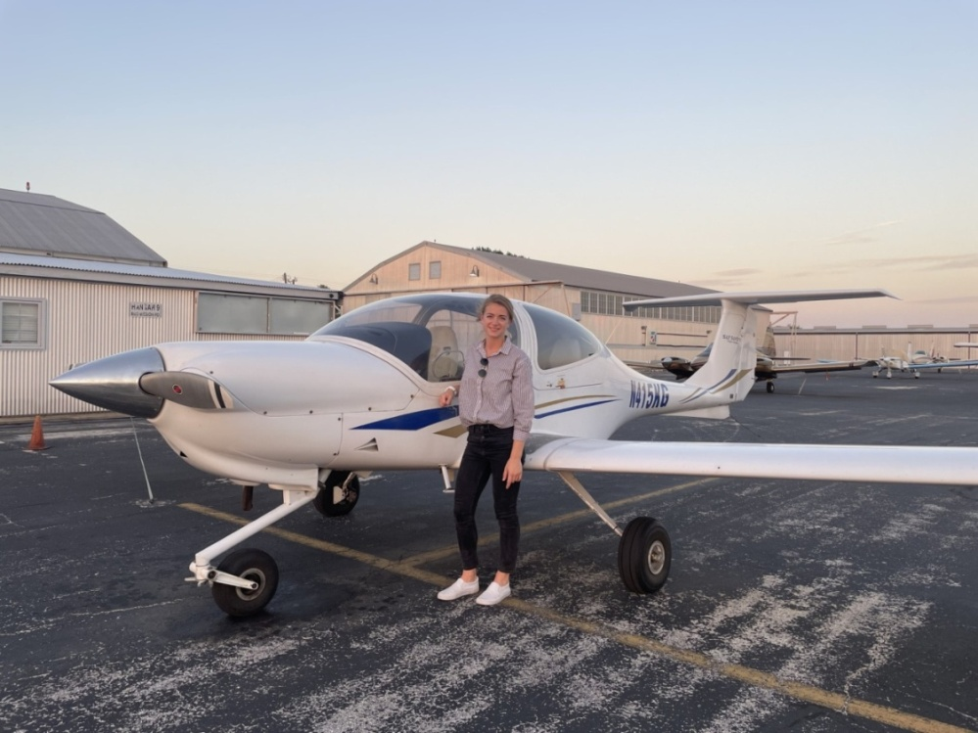

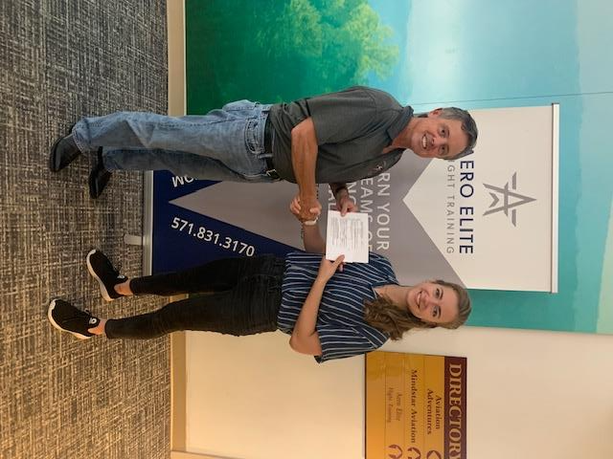

Samantha with Chris Frasse
Things to watch, read or listen to

Webinar - Stories from the Air, Flying for LightHawk
08/15/2023
Wednesday, September 13, 8:00 pm Eastern
SIGN UP TODAY!
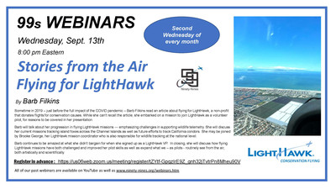
Stories from the Air
Flying for LightHawk
By Barb Filkins
Sometime in 2019 – just before the full impact of the COVID pandemic – Barb Filkins read an article about flying for LightHawk, a non-profit that donates flights for conservation causes. While she can't recall the article, she embarked on a mission to join LightHawk as a volunteer pilot, for reasons to be covered in her presentation.
Barb will talk about her progression in flying LightHawk missions --- emphasizing challenges in supporting wildlife telemetry. She will discuss her current missions tracking island foxes across the Channel Islands as well as future efforts to track California condors. She may be joined by Brooke George, her LightHawk mission coordinator who is also responsible for wildlife tracking at the national level.
Barb continues to be amazed at what she didn't bargain for when she signed up as a LightHawk Volunteer Pilot. In closing, she will discuss how flying LightHawk missions have both challenged and improved her pilot skills, as well as expand what we --- as pilots - routinely see from the air, both artistically and scientifically.
Register in advance
Our past webinars are available on YouTube and at www.ninety-nines.org/webinars.htm

Laura Savino has a YouTube channel on Aviation Safety.
https://www.youtube.com/@JetBossLauraSavino

I must recommend this channel HIGHLY. I have seen one “episode” on the dangers of Lithium Ion battery fires in flight and it is frighteningly important to know what she says there.

Aviatrix Book Club choice for September
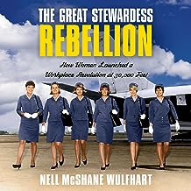

The empowering true story of a group of spirited stewardesses who “stood up to huge corporations and won, creating momentous change for all working women.” (Gloria Steinem, co-founder of Ms. magazine) It was the Golden Age of Travel, and everyone wanted in. As flying boomed in the 1960s, women from across the United States applied for jobs as stewardesses. They were drawn to the promise of glamorous jet-setting, the chance to see the world, and an alternative to traditional occupations like homemaking, nursing, and teaching. nBut as the number of “stews” grew, so did their suspicion that the job was not as picture-perfect as the ads would have them believe. “Sky girls” had to adhere to strict weight limits at all times; gain a few extra pounds and they’d be suspended from work. They couldn’t marry or have children; their makeup, hair, and teeth had to be just so. Girdles were mandatory while stewardesses were on the clock. And, most important, stewardesses had to resign at 32. Eventually the stewardesses began to push back and it’s thanks to their trailblazing efforts in part that working women have gotten closer to workplace equality today. Nell McShane Wulfhart crafts a rousing narrative of female empowerment, the paradigm-shifting ’60s and ’70s, the labor movement, and the cadre of gutsy women who fought for their rights—and won.

Our Newest Members:

Kayleigh Isaacs

Kayleigh joined in June and came to our August meeting in Warrenton. She lives in Fredericksburg and flies out of Culpeper where she is a student pilot making rapid progress. She is finishing an associates degree and plans to transfer to a four-year university next. Here she is at our August meeting.

She says: “I’m currently a student pilot out at Culpepper. I started flying in May, I’ve got roughly 33 hours, and I am preparing for my check ride! My goal is to be an aerospace engineer and my dream is to be an astronaut! Becoming a pilot is also a goal of mine that will help build up my career. It’s a lot of work, but I truly do love it. Aviation is a newer hobby of mine, as I am a space nerd at heart, but I have loved learning everything over the past year or so and can’t wait to learn more!”

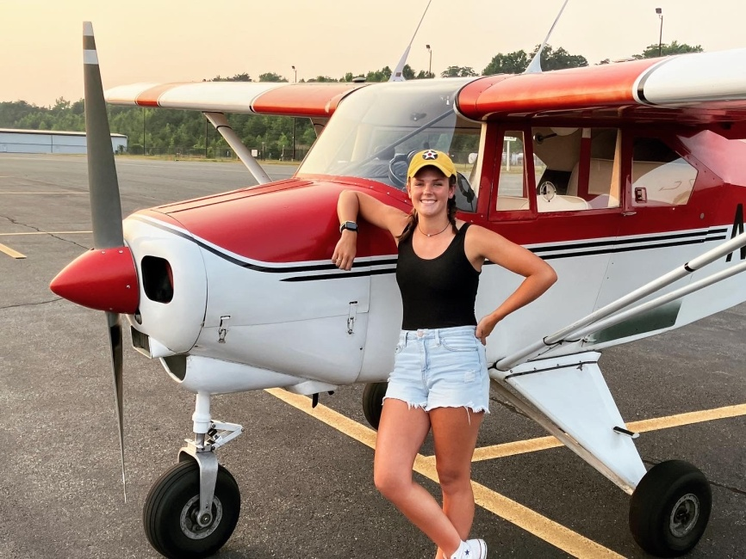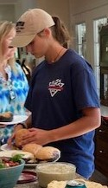

Samantha Lawrence

Our newest member lives in Reston and joined in late July. She says:
I started flying in the summer of 2003 out of KFWQ. I left for school (ERAU) in the fall and then came back the following summer to finish my license. I did a tail wheel endorsement in 2008.
I’ve been in-and-out of currency since 2010 but am getting current again with the intent to remain so going forward.

. 