

Old Dominion Chapter
SKYLINES

January 2024

Chair: Laura Savino
Vice-Chair: Mary McCutcheon
Secretary: Jessica Citrin
Treasurer: Barbara Gruber
Amelia Earhart Scholarship: Cynthia Axell
Aerospace Education: Debbie Gallaway
Membership: Sue Passmore
Newsletter: Mary McCutcheon
Webmasters: Jessica Citrin and
Stephanie Kight

Next Meeting

February 5 (Monday) at the Caboose Tavern.
520 Mill Street, NE. Vienna.

There is a loft where we will have a big table.
6 to 6:30 PM for dinner and 7 PM for the meeting.

The Holiday Party

Peggy and Rick hosted the holiday party this year and it was very festive.

I think about 11 ninety-nines were there and five forty-nine and a halves.
The food was scrumptious and the atmosphere warm.
The gift exchange was fun with the hottest item a lego airplane or something I didn’t get a close look at.

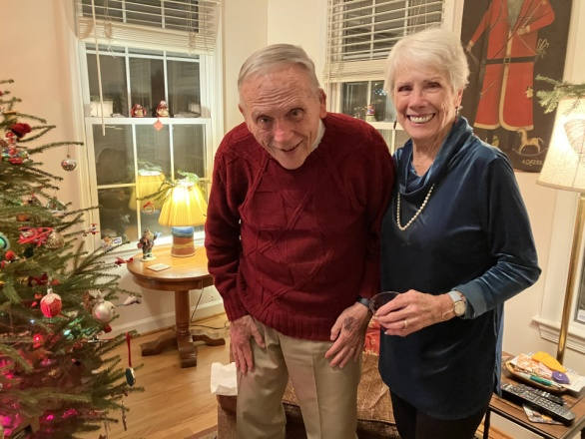

Rick Koehnke and Peggy Doyle Eric and Melissa Plumer

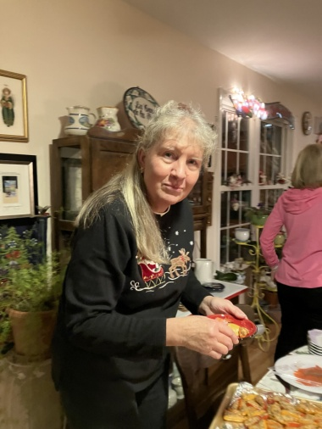

Bill Cain, Eric Plumer, Josh Rust, Morgen Reeb
Rick Koehnke, Dave Passmore

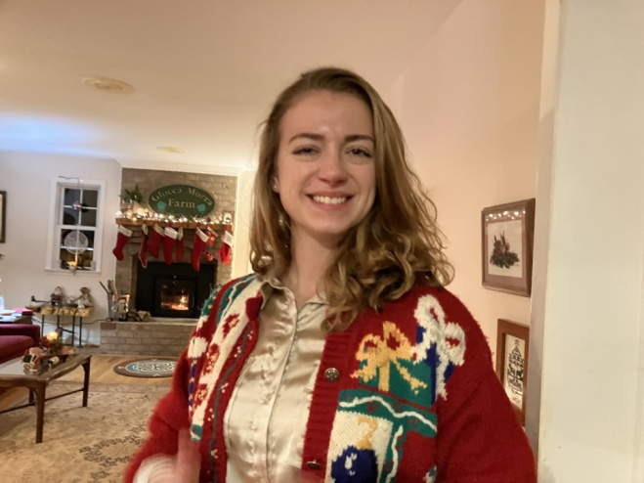
Hannah Rust’s brother, Josh Samantha Stahl

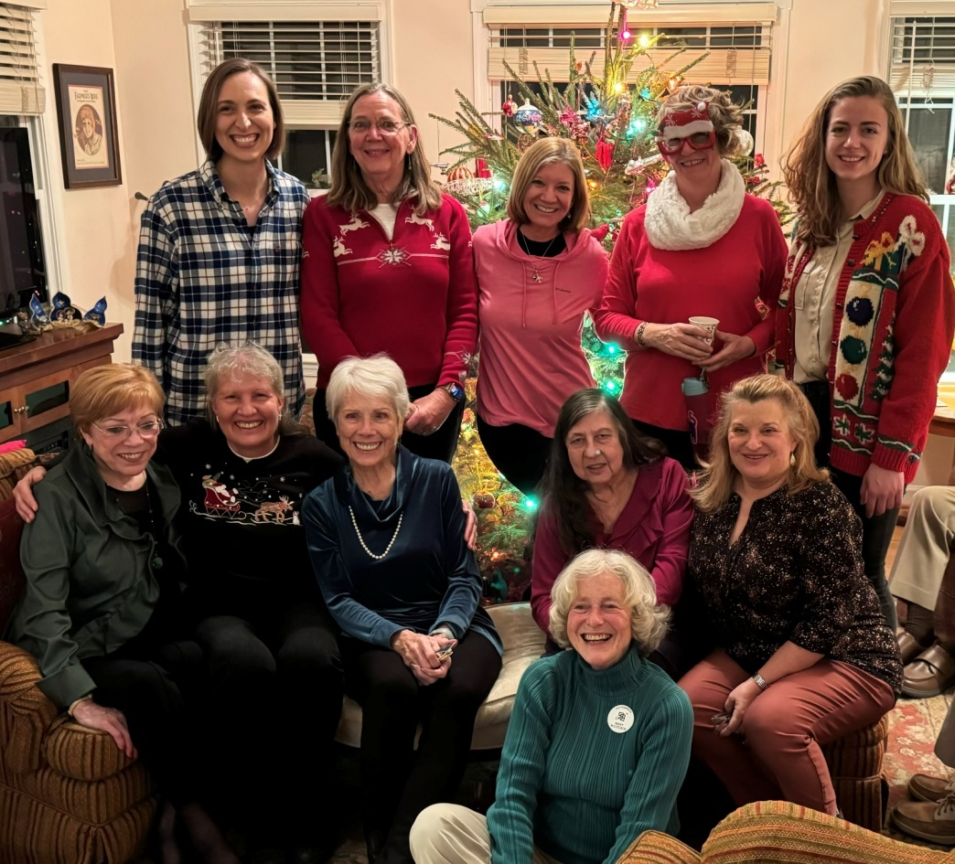
Back row: Hannah Rust, Sue Passmore, Laura Savino, Janet Davidson, Samantha Stahl
Front Row: RJ McGlasson, Morgen Reeb, Peggy Doyle, Barb Wilper, Melissa Plumer
Floor: Mary McCutcheon

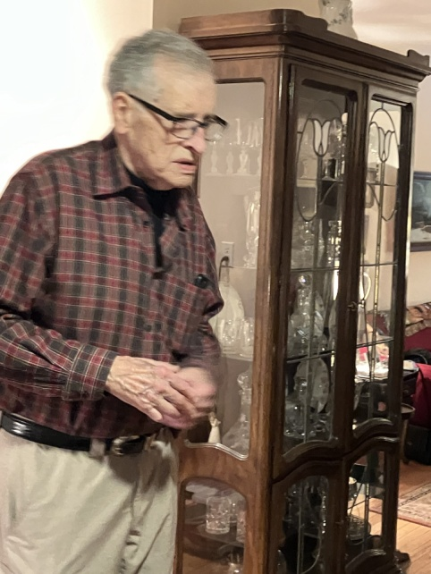 We were happy that Linda Cain’s husband, Bill, came. Linda was a very active 99 until her death 18 months ago. She and Bill were part of the core group of 99s and 49 ½ s for many years.
SPECIAL SCHOLARSHIP EDITION

This is the 2024 SCHOLARSHIP edition of the Skylines Newsletter
I am overwhelmed by the number of scholarships out there and the number of resources for learning about them. I am also SO sorry that some of the deadlines have passed or are so soon (like January 15) that it will be too late to apply.

Some of the links on this list will direct you to specific scholarships and others take you to a clearing house of additional lists. As such, you will find that there is a lot of redundancy: the cumulative lists will duplicate one another and include individual scholarships.

One of the best resources, I learned, is our own member, Janet Davidson, who has been keeping a list of these opportunities on a frequently updated facebook page and a web page. Please check these out to be very impressed:

Janet Davidson’s facebook page and website:

AVIATION SCHOLARSHIPS
(11) Facebook

FLIGHT SCHOLARSHIPS INFO
Flight Scholarships Home

Dare to be different

Debi Dreyfuss “Dare to be Different” Award application is due January 31, 2024.

The Award is available to any Mid-Atlantic Section Member, and offered by our Washington DC member Debi Dreyfuss (CFII, ATP, former Chapter Chair, Former Section Governor)

This is NOT the standard type of application where you write essays, compile letters of support and tally budgets, etc. —this is a chance to be creative in expressing your aviation goals and endeavors (what you are doing and what you will use the funds for). No rules on format—just ‘Dare to be Different’.

The guidelines are simple:

1. Applicant must be a 99 or student pilot member in the Mid-Atlantic Section (Student pilots will need a student pilot certificate).

2. Goals must be aviation oriented and related to flying..

3. The award goes to the most unusual/ expressive submission conveying aviation aspirations/ goals. It must be clever.

The award is for $1,500 if fewer than 5 entries are submitted, and $3,000 if 5 or more entries are submitted (this is to be spent however you would like to support your aviation endeavors, and the funds are available quickly, i.e., by late Feb/ March).

Visit our website: WashDC99s for past winners. We ask that the winner of the current year serve as part of the evaluation committee for the following year.

Please send the submission to
Pat Manos Kraemer at pat@flymall.org or 21520 Blunt Rd; Germantown, MD 20876-4402 and I will forward it to the judges.

Please let me know if you need additional information.

My best wishes to you and yours for a productive, joyful 2024 filled with lots of air hours.

Pat
~~
Pat Manos Kraemer
Kraemer Aviation Services
Chair, Scholarship, WashDC99s
FAA Safety Team Representative
301-758-2720
pat@flymall.org

Mid Atlantic Scholarship

Name of Scholarship: Mid Atlantic Section Scholarship
Amount of Scholarship: Up to $5,000.00
Application Receipt Deadline: February 28, 2024
Announcement Date: April 15, 2024
Description: Mid Atlantic Section of the 99s is committed to supporting and promoting woman pilots in the pursuit of aeronautical skills, both professionally and recreationally.
Eligibility: -
- Applicant must be a current member (in good standing) of Mid-Atlantic section of The Ninety-Nines, Inc.
- Scholarship must be used for training within one year.
- Applicant must already have a private pilot’s license
Purpose:
to add ratings, regain currency, increase proficiency, certificate or endorsement by participating in a defined training activity, e.g. instrument training, multi-engine training, CFI, CFII, seaplane, tailwheel, aerobatics, commercial rating, etc.
APPLICATION
Please submit the following three required application components in a single email to Mary McCutcheon, mmccutch@gmu.edu with attachments that may be in PDF or Word formats. Have your name on each file heading.
A. An essay limited to a single page describing:
- Applicant’s career and/or personal objectives in obtaining the scholarship?
- Way the scholarship will be used to advance those goals.
- Challenges faced without the scholarship
- Pertinent aviation related activities (including employment and recreation), qualifications and other experiences that pertain to these goals
- Future plans to contribute to the Ninety-nines and to the aviation community
B. Budget
Itemization of the total cost of the flight training requested and the plan for payment of the additional expenses not included in the application budget. Make it clear that there are sufficient funds from other sources to complete the training or course of study within one year. Financial need is not a requirement, but is an evaluation factor (tie-breaker).
C. Letter of recommendation
The recommendation must come from applicant’s chapter chair, flight instructor or other qualified individual to verify member's activity level, participation in chapter activities, goals, and aviation experience.
Optional Attachments: Any supporting documentation you deem important, such as:
A. Evidence of passing written or practical test, if applicable.
B. Current flight medical/BFR or other pertinent training
C. Last page or more of logbook
D. Additional letters of recommendation
Other Information:
- Scholarship will be awarded based on qualifications of applicant.
- Scholarship funds will be disbursed directly to the appropriate training organization.
- Invoices shall be submitted to Treasurer of the Mid Atlantic Scholarship of The 99s.
- The Mid Atlantic Section of The Ninety-Nines Scholarship Committee may request additional information or documentation.
-Judges are independent members of the aviation community who are not members of the Mid-Atlantic Section.
-For further questions contact Mary McCutcheon, mmccutch@gmu.edu or phone 703-217-8850

WOMEN IN AVIATION INTERNATIONAL
Apply Now - Women in Aviation International (wai.org)

AOPA
Aviation Scholarships - AOPA

FAA web site
Aviation Scholarships | Federal Aviation Administration (faa.gov)

FLYING MAGAZINE
12 Aviation Scholarships To Start Your Flying Career - FLYING Magazine

WOMEN IN CORPORATE AVIATION
Scholarship - Women in Corporate Aviation (wca-intl.org)

GLOBAL AIR
Aviation Scholarships | Globalair.com

Virginia Department of Aviation Scholarships for High School Seniors

Willard G. Plenti Scholarship
Willard G (virginia.gov)

John R. Lillard Scholarship
23-24-john-r-lillard-scholarship.pdf (virginia.gov)

Kenneth R. Scott Scholarship
23-24-kenneth-r-scott-scholarship.pdf (virginia.gov)
Accomplishments of our Members

Jenny Reeb

(from Morgen Reeb)
´Happy New Year! It’s all official, Jenny has her Airbus 320 type rating and has fully completed her check out. She finished her IOE (initial operating experience) on December 31st and has been released to the line. She is currently sitting reserve in Miami for Frontier Airline. She is based in Miami for January and February. She will be based in Orlando starting in March.”


Hannah Rust

Hannah is happy to report receiving two scholarships:

1. Wings for Amy.

Captain Amy Parsons earned her Private Pilot Certificate in 21 days and went on, with her husband Wayne, to have many adventurous flights both becoming Captains for United. Amy, Wayne and Laura Savino were all United pilots together. Hannah says:

“In Amy’s name, I have been given a flight training scholarship to complete my instrument rating! Thank you for investing in my future as a professional pilot, Captain Wayne. What a gift to honor Amy’s pioneering spirit and lasting legacy. Thank you, Laura for your constant belief in me. You have been instrumental in my aviation journey and have paved the way for my generation to follow. I am constantly amazed at how the aviation community truly becomes family.”

2. She has also been awarded the Women in Aviation scholarship that is provided by Boeing. This will be formally announced at the WAI conference in March

