

Old Dominion Chapter
SKYLINES
October 2024

Chair: Cynthia Axell and
Mary McCutcheon
Vice-Chair: Nancy Schuster
Secretary: Mary McCutcheon
Treasurer: Barb Gruber
Amelia Earhart Scholarship:
Cynthia Axell
Membership: Sue Passmore
Newsletter: Mary McCutcheon
Webmaster: Stephanie Kight

PEGGY DOYLE MEMORIAL

Peggy Doyle’s death on September 14 sent us into a state of shock and grief. Right after a summer full of activities including our annual Ocracoke weekend, a trip to Vancouver for the international Convention, and a cruise up to Alaska, her illness and death were totally unexpected.
R. J. McGlasson delivered a lovely eulogy at the Section meeting. I will try to encapsulate her words here adding some bits from her obituary.
There were many facets to Peggy’s life.
First, she was a passionate aviator who flew in any aviation event. She won a scholarship from the 99s in 1991 allowing her to get her CFII which she has kept active all these years. She spent 25 years promoting the Amelia Earhart Memorial Scholarship fund, and, of course, has been very active in the 99s, founding, along with several other women, the Old Dominion Chapter.
Many of us have gone to her parties both at the Gloca Mora Farm she and Rick had out in Fauquier County and at their house in Warrenton. Her Christmas parties were legendary.
She was always full of life and was a loyal friend as well as a warrior when she needed to be.
She loved her family and her many animals. Her husband, Col. Richard Koehnke, was a fun-loving 49 ½ who had a career as an Air Force pilot. She is survived also by a sister and brother and three children: Jerry Whitehouse II and his wife Tammy, Brian Whitehouse and his wife Krystal, Beth Whitehouse and her husband Chris Siebert. She also has six grandchildren: Jerry III, Russell, Ben, Colleen, Patrick and Richard as well as four great grandchildren: Bridget, Elliot, Lilah and Jerry IV.
She and Rick had horses and dogs, and Peggy also loved gardening.
R.J. concluded “It is the friends you meet on your path that make the journey worth while” And Peggy was one of those friends who had an impact on many many others.

The OktoberFest Themed Celebration of Life will be October 26 from 1 to 5 . It will be at Peggy and Rick’s house, 80 Menlough Drive, Warrenton.

Beer, other beverages, and knockwurst will be provided but side dishes, desserts and anything appropriate to the German theme are welcome if you care to contribute.

Please RSVP to R.J. McGlasson letting her know if you plan to bring something.

Her email is rjmcglasson@gmail.com and her phone number is 703-407-2764.

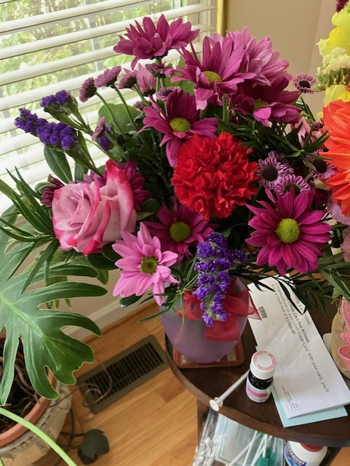
The flower arrangement that R.J. sent to Peggy

Here are miscellaneous picture of Peggy over the past 4 years

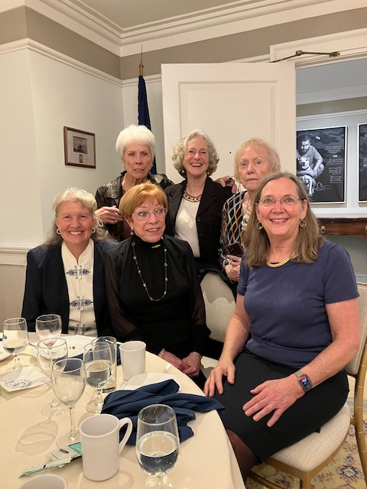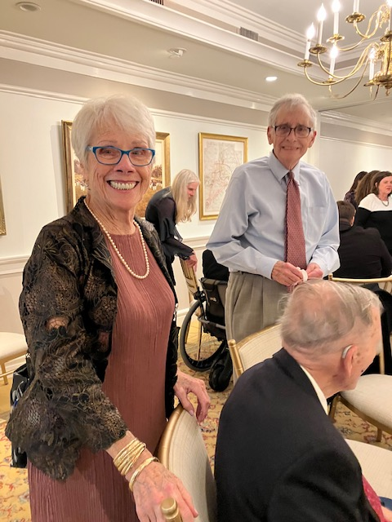

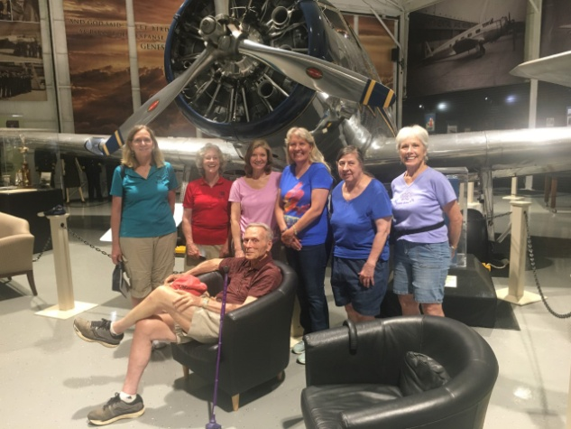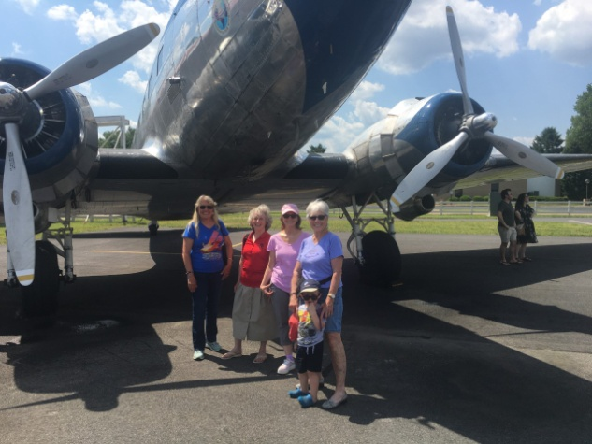

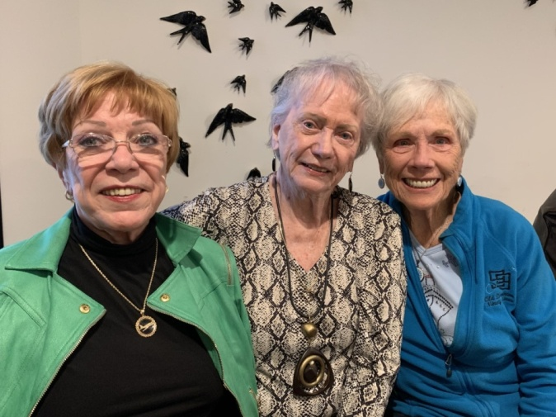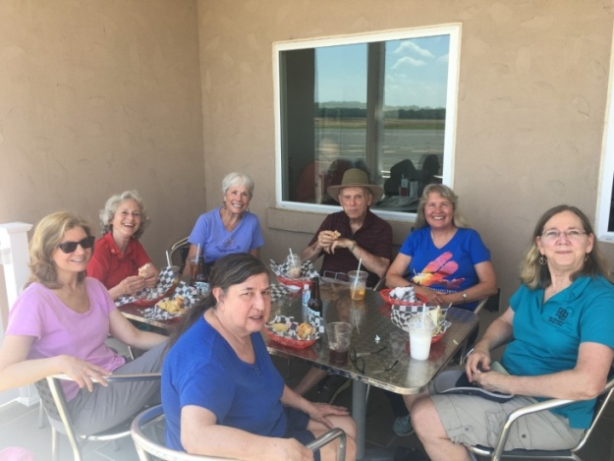

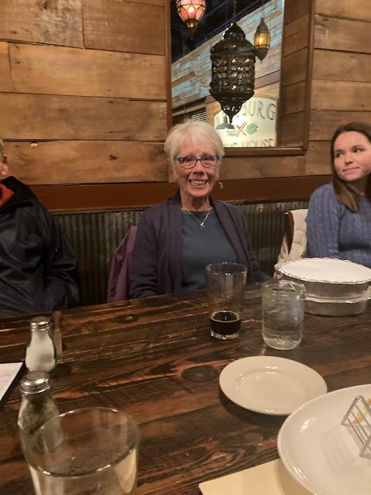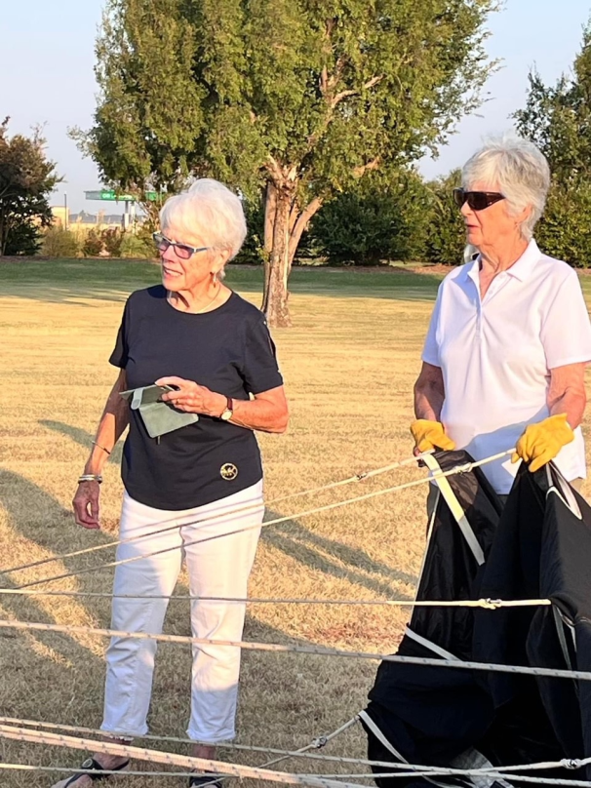

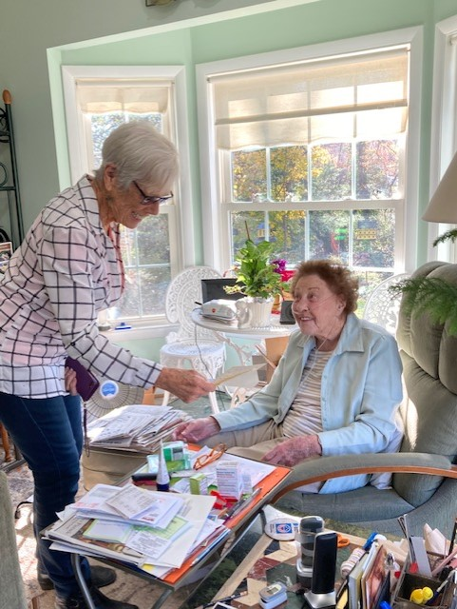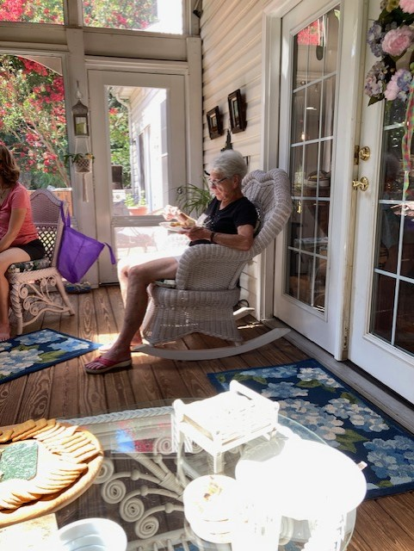
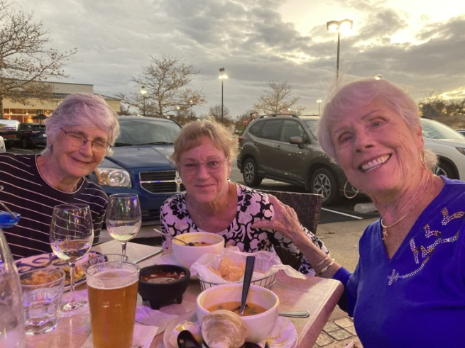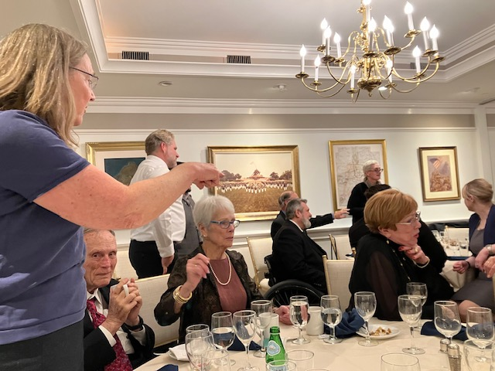

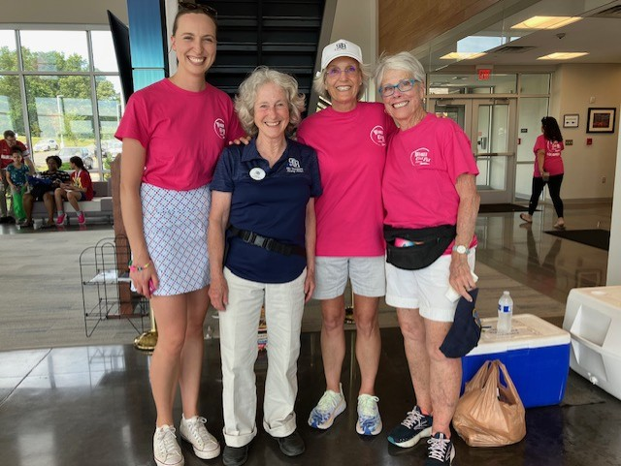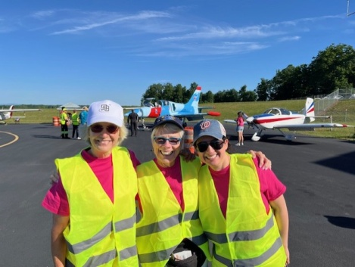

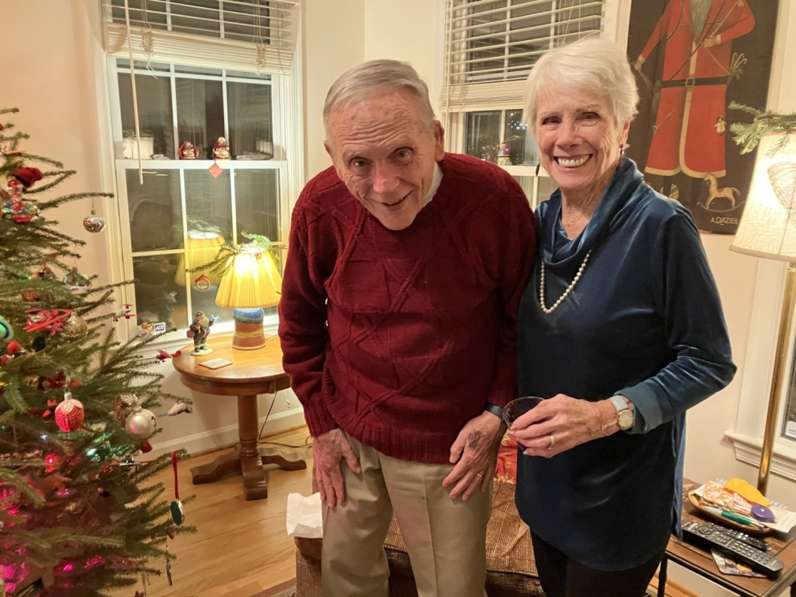
Peggy at Ocracoke over the years:

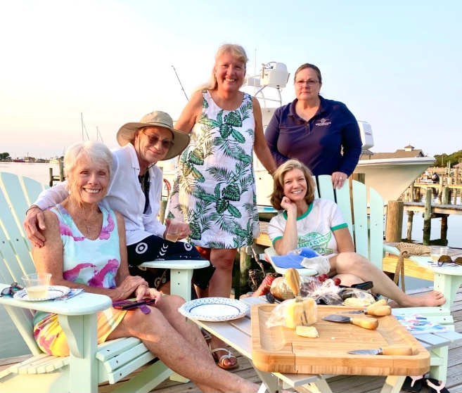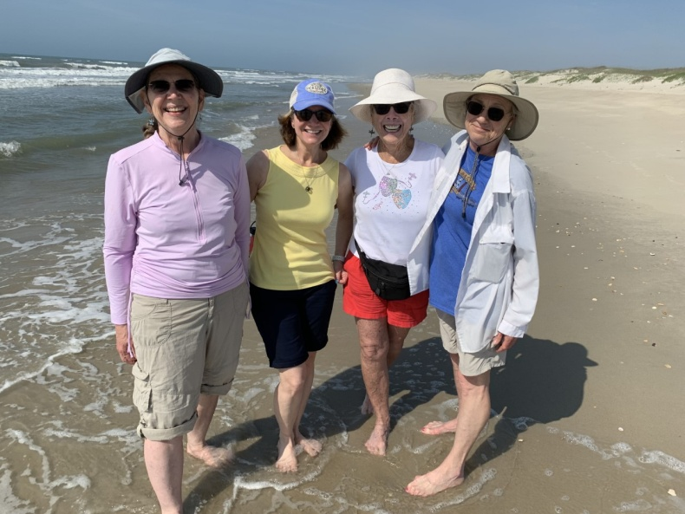

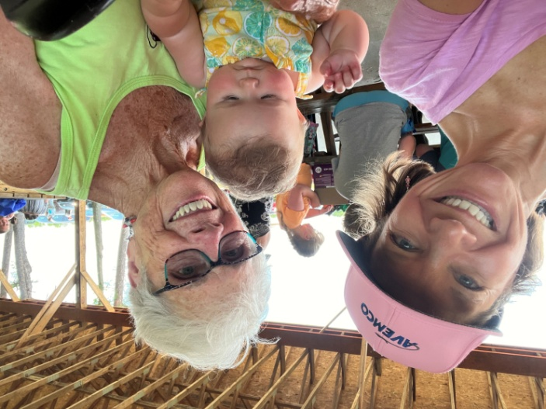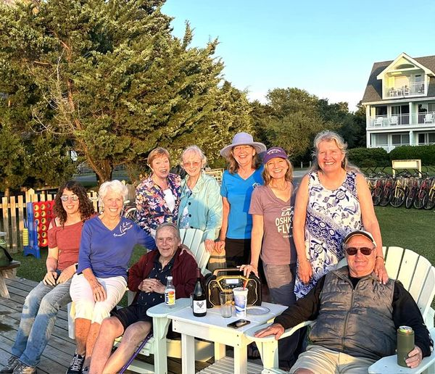

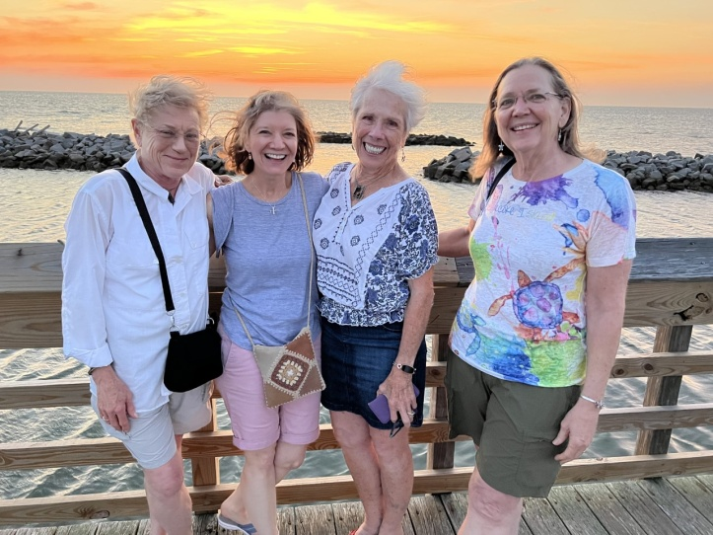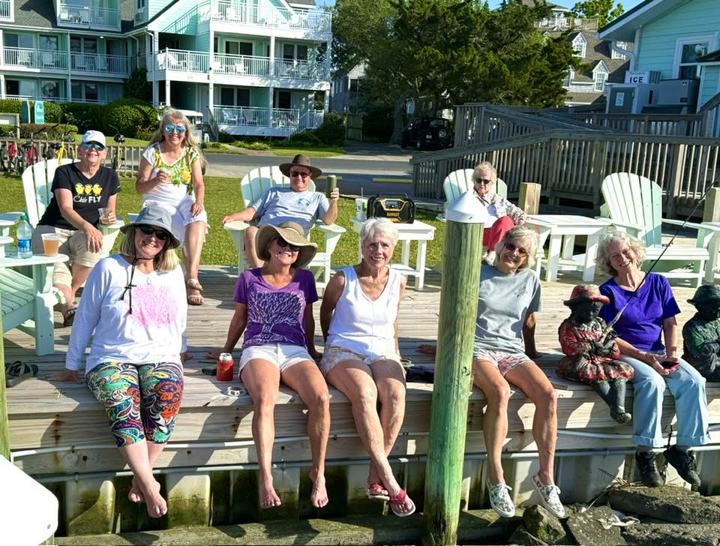
NEXT CHAPTER MEETING

We will be meeting for an informal brunch/ coffee klatch on October 19 (a Saturday) at 11 at a coffee and pastry place in Gainesville.

Tous Les Jours
7380 ATLAS WALK Way, Gainesville, VA 20155

HANGAR TALK BY CYNTHIA AXELL

I’ve always said the hardest part about being a pilot isn’t the flying, or knowing the regs, or the systems, or the limits. It’s the people. Managing people is the most difficult part of any job. And professional pilots deal with a lot of people.
Which leads me to ask: how do you, as a pilot, manage your flight deck? If you are not yet an airline pilot, but aspire to be, what do you imagine the atmosphere on an airline flight deck is like?
Do you imagine an autocratic Captain, barking orders? Making decisions while the lowly First Officer sits on her hands and waits to do what’s directed? The kinda guy who says, “When I say jump, you’re only response shall be, ‘how high?’”
Before the 1980’s, that actually was a fair description of ‘leadership’. But accidents and investigations led us to a new way of doing things. We now have CRM… crew resources management.
The Captain is now required, legally, to avail herself of all possible resources throughout the flight. For routine decision making (What fuel load do we want? What flaps and power setting should we use for takeoff? How long can we hold? What shall our bingo fuel be? How is that alternate holding up?) the two pilots consult with one another, using outside information as needed. It’s very democratic. When the Captain asks your opinion, she doesn’t lead you to her desired answer… doesn’t say, for example, “Gee, I think Des Moines looks good for our alternate, what do you think?” No. The Captain says something non-committal, like, “What are your thoughts for an alternate?” She makes you truly think. Your answer is your own. It carries weight and is seriously considered.
And when things get interesting, in non-routine situations, this also means expanding the consulting to include others: Dispatch, Maintenance, ATC, the flight attendants… even with the manufacturer, if need be.
There is rarely a time when there isn’t the time to consult and collaborate.
Okay, fine, you say. I’ll collaborate. I’ll consult.
Okay, now mentally put yourself in the right seat. On this particular flight, the PIC, or the Captain, is One Of Those. Insecure. Anxious. Irritable. When you advocate a course of action you know SOP recommends, maybe even mandates, he barks at you—“I’m the Captain!” or maybe, “You’re usurping my authority!” Maybe he belittles you and mutters something about minorities. You are squelched at every turn. Your input is not solicited, and when you give it anyway, it’s ignored. You are there because, he says, ‘you took the place of a qualified male.’ When you fly, his hand is reaching for the flap or gear lever as if to hint, ‘it’s time’, when you are flying perfectly fine, thank you very much, and weren’t ready yet to configure. He second guesses your every flying move, and the flying itself becomes a chore. It’s no longer as fun.
And then, it happens. He’s flying an approach to minimums. He’s unstable, fast and high at every point. And you find yourself afraid to say so. You’re spending a lot of mental B B’s trying to figure out how to point it out without damaging his ego, but you can’t. You resign yourself to the standard callouts, and so at 1000’, you say, “Airspeed” or “flaps to go”. And at 500’, you say the mandatory, “Unstable. Go around.”
And he doesn’t.
What do you do?
Yeah, these things happen. All too often. You became afraid to advocate because you were shut down. Every. Single. Time.
You will have to come up with your own personal limits for how far you’ll let someone go. You will have to decide how you’d react in a situation like this… and you will inevitably run into a situation like this. You can refuse to fly with the guy next time, but for now, you’re stuck. And you have an airplane with passengers who don’t care how you get them safely there, just do it. And YOU are the check, the balance. You must decide, preferably ahead of time, how you will react when the other pilot ignores SOP and puts you, the airplane, the passengers, in a bad place.
This is the topic of our next Hangar Talk. Oh, and let me point out the obvious: adhering to SOP carries no legal or professional jeopardy.

SECTION MEETING OCTOBER 4 and 5

The section meeting was hosted by the D.C. chapter and consisted of Friday events and the Saturday meeting.
The tour of the Glenn L. Martin Wind Tunnel had to be replaced by a talk at the College Park Airport about the wind tunnel research. I do not think any members of our chapter went.
After that several people met at the NTSB headquarters in D.C. for a fabulous tour. We saw crumpled “black” boxes (which are actually orange), mangled metal and many remains of unfortunate accidents. We learned about all the research they do to investigate accidents with the ultimate goal of reducing the likelihood that they will occur and read the transcripts of the landing in the Hudson by “Sully” Sullenberger .

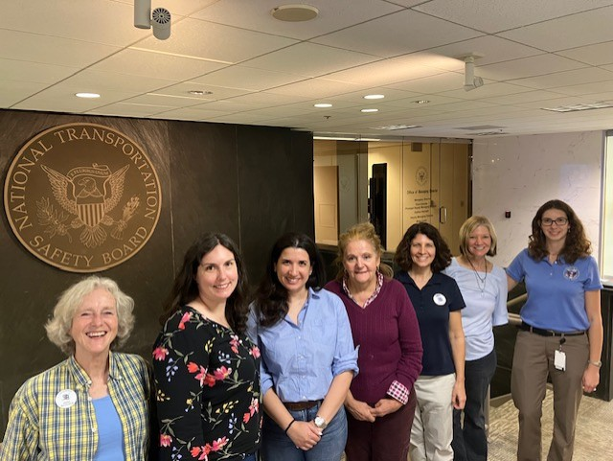
Mary McC, Eva Thierry, Yvy Von Helde, Lucia Mencia, Kathleen O’Neill, Laura Savino, Olivia Fowler

The Business Meeting was followed by two presentations by military aviators on the stresses and joys of serving in the military and balancing work and family.

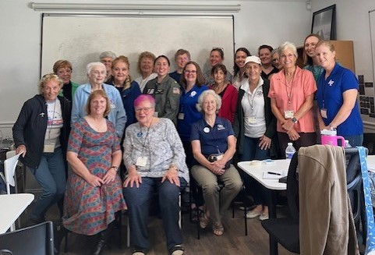

​

Dorothy Swain Lewis (Dot)’s Funeral

Dot Lewis was a WASP who died in 2013. Her inurnment funeral was held at Arlington Cemetery on September 30 and a reception followed in the Women In Military Service for America Museum.

Dorothy Swain Lewis - Wikipedia

She was not a 99 but many of her friends were and a few came to the service.
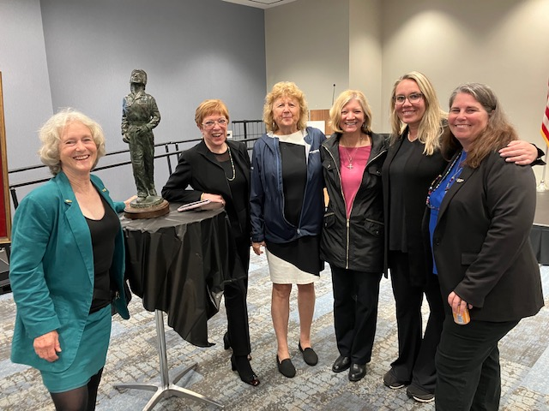
Mary McC RJ McGlasson Mary Wunder Laura Savino Caroline Jensen Kate Landeck.
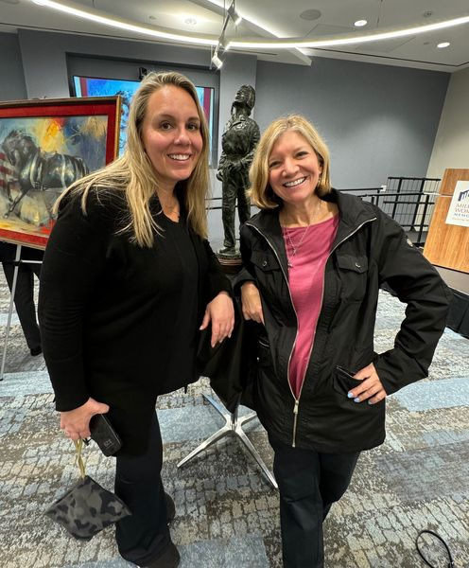

Caroline “Blaze” Jensen and Laura Savino standing in front of one of the sculptures that Dot did

Meet Caroline “Blaze” Jensen, first qualified female pilot in the T-7A Red Hawk - The Aviation Geek Club

November 8 ProJet Aviation Expo
Change in Location. Still ProJet though
ProJet Aviation | Aviation Expo

NEW LOCATION!!
Rider Jet Center (KHGR)
18421 Henson Blvd.
Hagerstown, MD 21742

We are signed up for ProJet again this year. As always we want volunteers to hang out at our table.
We are happy to note that two of the keynote speakers are women: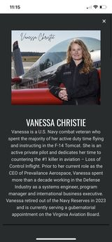 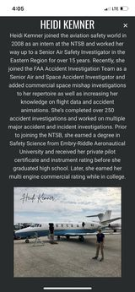

Accomplishments of our members

Mia Anderson wins
Primary Glider National Championship

Here’s what she says:
I can’t express how grateful I am for opportunities like this. The flying is so incredibly fun and exciting but the thing that will keep bringing me back is the people. Thank you to everyone who supported me throughout this journey! I appreciate every single one of you

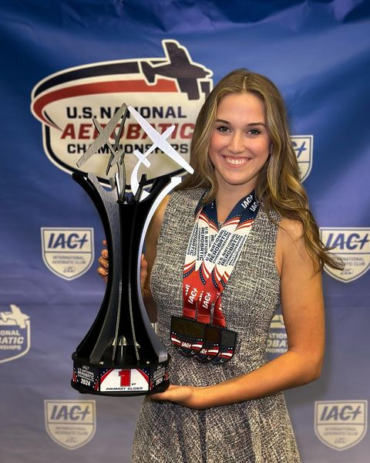

Jenny Reeb surpasses 1500 hours in AirBus

