

Old Dominion Chapter
SKYLINES

March 2024

Chair: Laura Savino
Vice-Chair: Mary McCutcheon
Secretary: Jessica Citrin
Treasurer: Barbara Gruber
Amelia Earhart Scholarship: Cynthia Axell
Aerospace Education: Debbie Gallaway
Membership: Sue Passmore
Newsletter: Mary McCutcheon
Webmasters: Jessica Citrin and
Stephanie Kight

Next Meeting

The March meeting will be on March 11 at the On The Border Mexican Cantina, 11880 Spectrum Ctr, Reston, VA 20190.

Jessica has reserved a big table for us and she’ll be getting there around 6:30. If you want dinner, get there around then too. The meeting will begin at 7:30

Our Chapter Election
We are holding an election for our new officers this month.

As of this time, we have ZERO volunteers to run for chair and vice chair. We have a treasurer, Barb Gruber, who has agreed to continue in this capacity and we have a brand new member, Grace Ailana Robertson, who has agreed to replace Jessica as Secretary. These are the positions subject to election. Our by-laws prohibit the chair and vice-chair from hanging on for more than two consecutive terms, though they can trade back and forth. Our by-laws also require that any elected officer must been a member for at least a year. These two details should either be ignored (probably not a great option), complied with, or eliminated through by-laws revision. This is something we will discuss at our meeting on Monday. It would be great if we could recruit people for these elected positions.
International Ninety-nines election
See your Ninety-Nines magazine to learn about the slate of officers and other elected officials. The official ballot will be sent to you either electronically or in the mail. The dates during which you can cast your ballot are March 15 through April 30 at midnight.

Did you NOT receive your magazine? Do you get it electronically? If neither of these, contact someone who can give you hers. The information is neither on the on the Ninety-nines website nor on the little Straight and Level supplement.

February Meeting
We planned to have our meeting at a funky brewery in Vienna that promised a private loft and a good menu. When we got there, though, the kitchen was closed and so we had to make a quick decision to go a half mile away to the Vienna Inn. This turned out to be OK.

Four new members showed up, Grace Ailana Robertson, Jennifer Weller, Nancy Schuster, and Yvy Von Helde.

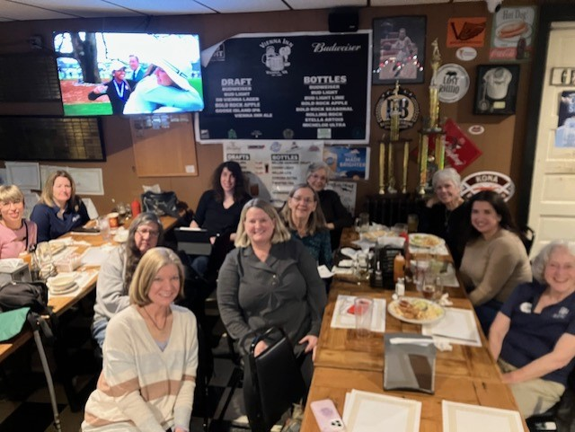
From left to right: Grace Robertson, Jennifer Weller, Barb Wilper, Laura Savino, Jessica Citrin, Nancy Schuster, Sue Passmore, Cynthia Axell Peggy Doyle, Yvy Von Helde, Mary McCutcheon
Scholarship News

First Wings Scholarship for Student Pilots
FOR STUDENT PILOT MEMBERS
First Wings applications are due April 1st & Oct 1st annually
Applicants must be Student Pilot Members for 3 months prior to the First Wings submission deadline and have logged 5 hours flight time within the preceding 6 months. Award is up to $6,000 for specific milestones as they are achieved.
First Wings Award

I am so sorry that of all the scholarships I listed last month, I neglected to mention the ninety-nines own First Wings Scholarship. I actually thought all 99s scholarships had deadlines of Jan 1 and it turns out that First Wings applications are due April and then again in October. You should have received an email from Cynthia Axell telling you about it. Contact Cynthia for questions and more information:

h20av8tricks@aol.com

707-481-0650

Mid-Atlantic Scholarship report

We received 5 applications by the February 28th deadline, and there are four people on the reviewing committee followed by three final judges. At this point in the process we are reviewing the applications for completeness to see which ones can be forwarded to the judges.

Udvar-Hazy Air and Space Family Day
Saturday March 9 from 10 to 2
Soar Together at Air and Space Family Day: Firsts in Flight | National Air and Space Museum

We were disappointed not to have been offered a table at Udvar-Hazy’s Family Day, but at least Laura Savino will have a table for her book and to engage visitors in conversation about her career.
We should try to get there anyhow just to see what is going on and maybe to put in a 99s plug for future events

Mid Atlantic Spring Section meeting
Hosted by the Mountaineer Chapter

The Mid-Atlantic Spring Section Meeting April 26 & 27, 2024
The Mountaineer 99s, assisted by the Sugarloaf 99s, are excited to be hosting the Mid-Atlantic Spring Section Meeting at Eastern WV Regional Airport / Shepherd Field (KMRB) in wild and wonderful Martinsburg, West Virginia.
Home of the Air National Guard 167th Airlift Wing, the airport boasts an 8815' x 175' runway, two flight schools, corporate and charter operations, an aviation museum and library, and a wonderful restaurant with views of the airport.
Our meeting will be held at the West Complex at 226 Pilot Way; Martinsburg, WV 25405.
Registration: Please register using our Sugarloaf Store Link. Please be sure to note your chapter in the comments section when checking out.
Arriving aircraft will park at the FBO and be transported by volunteer 99s and 49.5's.

Date | Time | Activity | Location
Friday, April 26 | 3-6 | Pickups for fly-ins | KMRB West Ramp
 | 6-9 | NoHost dinner | Venue TBD
Saturday, April 27 | 9-12 | Meeting | MRB West
 | Lunch | Speaker Eileen Isola | MRB West
 | 1-2 | Swap meet and visit to KMRB library and displays | KMRB West  KMRB FBO
 | 2-4 | Tour of Antietam Battlefield | Antietam, MD
 | 2- whenever | Antietam winery | Antietam, MD

Questions? Contact Mountaineer Chapter Chair Cindy Gresham

Ocracoke Trip Is planned for the weekend after memorial day weekend. May 31–June 3, 2024 Ocracoke Weekend. Contact the Ocracoke Harbor Inn to make reservations, (252) 928-5731. Contact RJ McGlasson for details (703)-407-2764.

Women can Fly Dates

Shannon May 18, 10-2
Shannon Airport | Women Can Fly

Want to volunteer as a pilot or on the ground?

Shannon Airport
Kristen Curtas Barnum
(540) 642-4396
kcurtas@shannonezf.com

Warrenton. June 8, 9-4
Warrenton-Fauquier Airport | Women Can Fly

Want to volunteer as a pilot or on the ground?

Warrenton-Faquier Airport
Sarah Patten
(856) 889-1566
sarah.patten@gmail.com

Dan McGlasson’s full military Burial and Memorial

On January 26, R.J. McGlasson’s 49½, Dan McGlasson was honored at a service in the historic Old Post Chapel at Ft. Myer followed by a burial in Arlington Cemetery. RJ hosted a beautiful Cajun food buffet lunch at the Army Navy Club downtown. Here are some pictures from the lunch

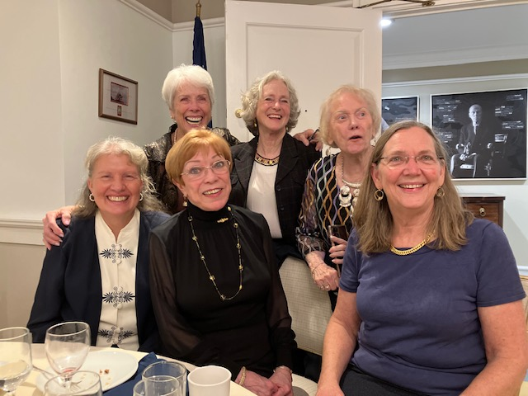
Morgen Reeb, Peggy Doyle, RJ McGlasson, Mary McCutcheon,
Marti Constantino, Sue Passmore

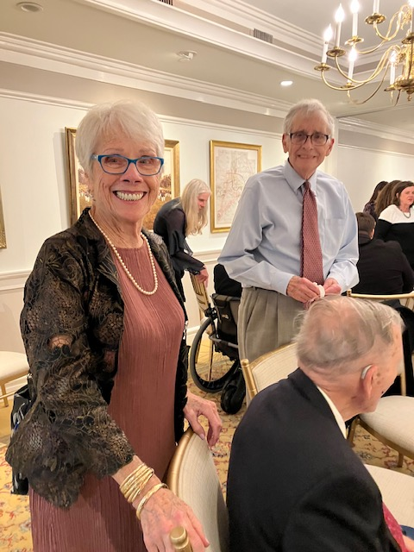
Peggy Doyle and Bill Cain

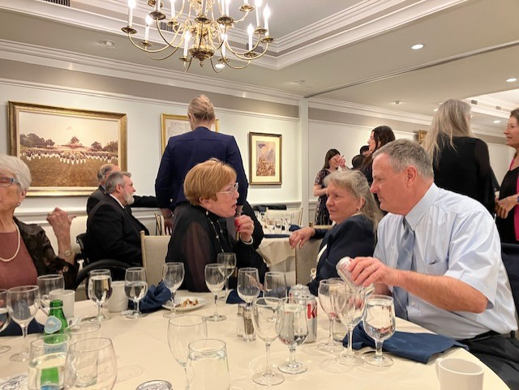
RJ McGlasson, Morgen and Frank Reeb

New Members

Nancy Schuster is a captain with flying the B-737 for SW Airlines based out of BWI. She lives around Leesburg/ Ashburn.

She joined the 99s in 1994 when she was flying for the Coast Guard in Honolulu.

She got her private license in 1990 and climbed one ladder after another.

Grace Robertson is a student pilot whose grandmother was a proud 99. Grace has offered to be our secretary.

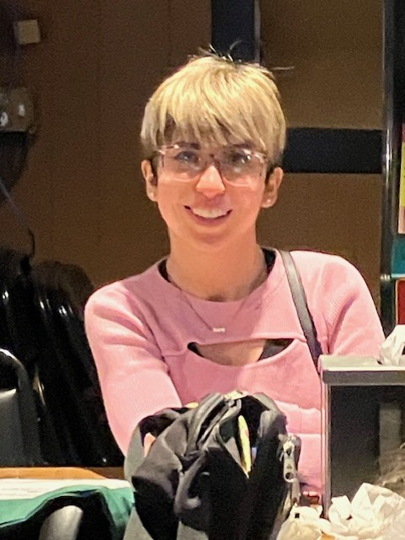

Jennifer Weller

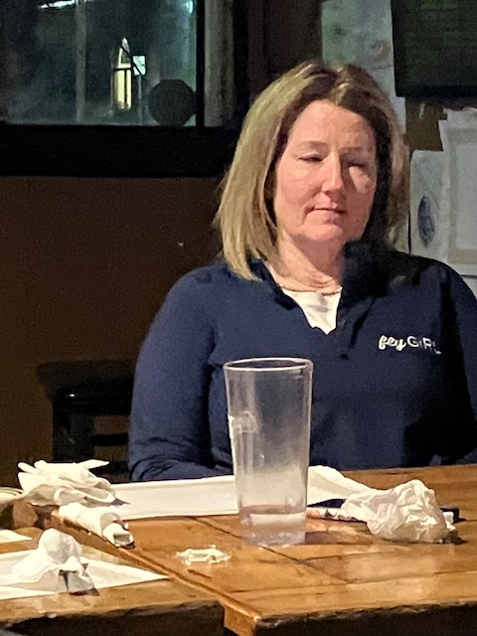

Yvy Von Helde is a flight attendant and student pilot moving forward toward getting a private pilot’s license.



Alison Melissa Northern just passed her instrument check ride

Anna Dare Lofdahl earned her private pilots license recently from Aviation Adventures in Winchester and is working full time toward her Instrument rating. She spends weekends working for Aviation Adventures so she is immersed in flying 24/7


Accomplishments of our Members

Jenny Reeb got her A320 type rating and fully completed her check out. She finished her IOE (Initial Operating Experience) and is currently sitting reserve in Miami for Frontier Airlines.

Hannah Rust earned an additional scholarship on top of the aforementioned one provided by Wayne Parsons. She is now working on her instrument rating.

Nicole Tait earned her B-777 rating at the end of January

Alison Melissa Northern just passed her instrument check ride

Colleen Whitehouse is having quality time with her Grandmother,
Peggy Doyle (lifted from Facebook)

