

Old Dominion Chapter
SKYLINES

April 2024

Chair: Laura Savino
Vice-Chair: Mary McCutcheon
Secretary: Jessica Citrin
Treasurer: Barbara Gruber
Amelia Earhart Scholarship: Cynthia Axell

Membership: Sue Passmore
Newsletter: Mary McCutcheon
Webmasters:
Jessica Citrin and Frankie Velasquez

NEXT MEETING

Monday, April 15 at 6 if you want to eat. 7 for the meeting
Lake Manassas/ Gainesville Wegman’s Upstairs
8297 Stonewall Shops Square, Gainesville
We will get our dinners from the Food Bars downstairs and carry them up.
These food bars close at 7 but the supermarket stays open till 11.

MEMBERS TAKING OFF

At our meeting we will be saying very sad farewells to three members

Jessica Citrin is moving to Seattle where Amazon made her an offer she couldn’t refuse. She’ll be back from time to time though, and has promised to make time for us.

Grace Robertson, who just joined a couple of months ago as a student pilot, loved being in our chapter even for a short time. She has moved to Sedona, Arizona to work in mental health care. AND she wants us all to know that we are welcome to stay with her when and if we fly to Sedona (one of the most awesome airports I ever visited)

Barbara Wilper has been a member of the 99s since 1977 starting out in St. Louis and then coming to Old Dominion. She has been our treasurer as long as I can remember keeping us in the black. She’s moving to Champaign-Urbana, Illinois close to her daughter.

ELECTIONS
Chapter elections.

Our chapter elections are taking place right now. Please get your ballots in to Jessica Citrin. She sent us the ballot as an email attachment. Send your votes to her either by email (jessicacitrin@outlook.com) or to her new address in Seattle
1600 2nd Ave 3809, Seattle, WA, 98101.
We all wish there were more people willing to run.

For chair, Cynthia Axell and Mary McCutcheon will serve together
For Vice-chair, we have Nancy Schuster
For Secretary, Mary McCutcheon
For Treasurer, Barb Gruber

Section elections.

Here is what Lin Caywood says:

Our Board is also elected every other year, and this is the year. Laura Savino is leading the effort with the other chapter chairs to present a slate for election on or before this meeting. Contact Laura at bigplanet747@gmail.com if you have an interest in serving as an officer or director.

International elections.

Check your email for the ballot and submit your ballot by by May 1.

PAST EVENTS

Our Chapter meeting on March 11
We had a good meeting at a Mexican Restaurant in Reston. Jessica has sent you the minutes. Here are some pictures.

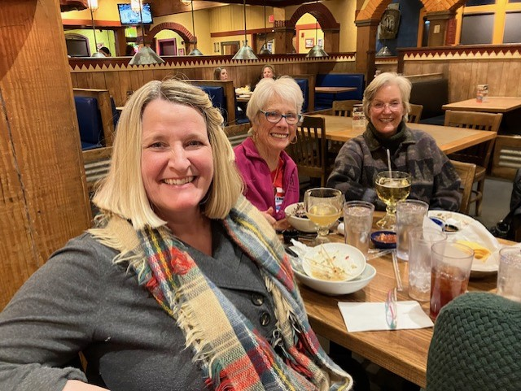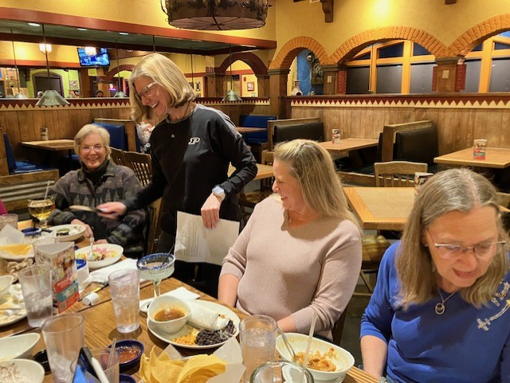
Nancy Schuster, Peggy Doyle, Cynthia Axell, Cynthia Axell, Laura Savino, ‘
Nicole Tait, Sue Passmore

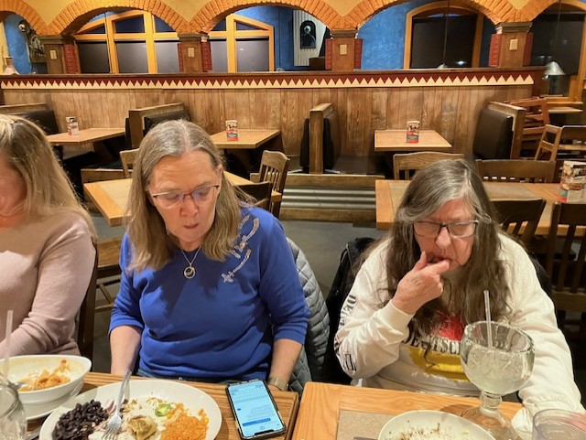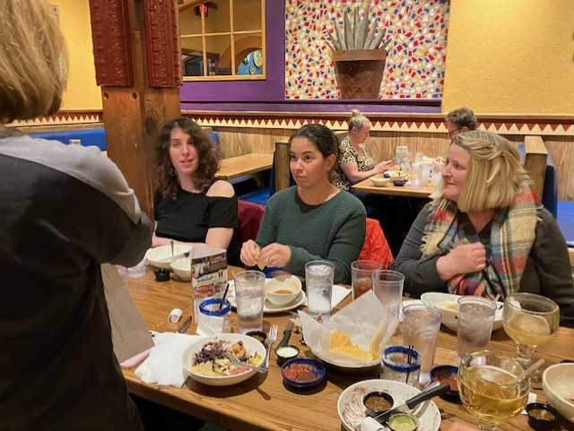
Sue Passmore, Barb Wilper, Jessica Citrin, Frankie Velasquez,
Nancy Schuster

WAI Conference March 21-23

There were several chapter members at WAI, the most prominent being the WAI director, Stephanie Kenyon. Unfortunately I only have a picture from the WAI webpage

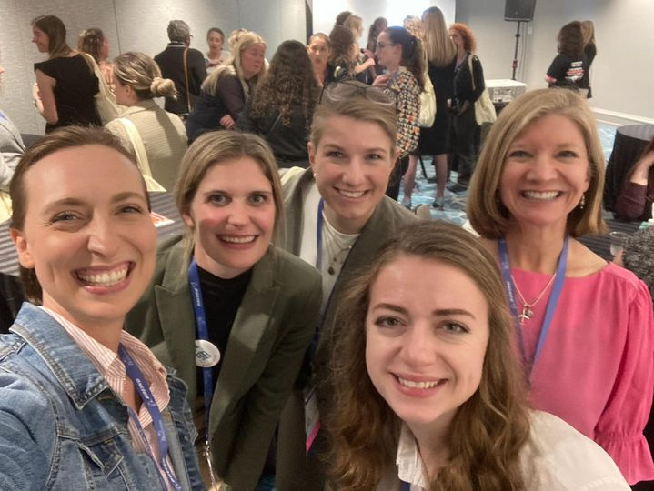
Hannah Rust, Stephanie Kight, Laura Schevenius, Stephanie Kenyon
Samantha Stahl, Laura Savino

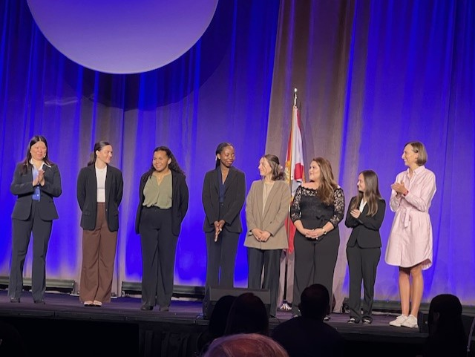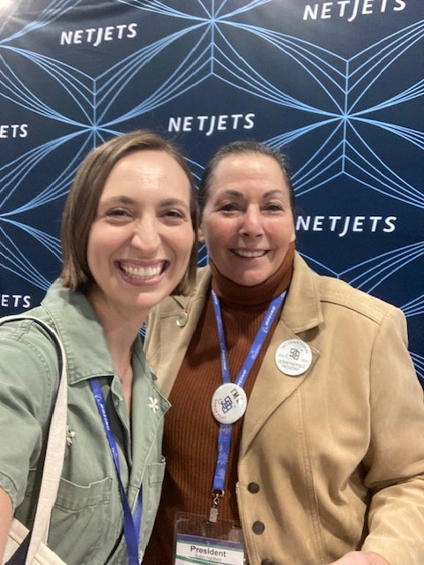
Hannah Rust at right receiving Hannah Rust renewing her
Boeing Flight Training scholarship friendship with Robin Hadfield

Breakfast at the Stone Gables Bed and Breakfast April 11

Frankie Velasquez let a few of us come to try out breakfast at the B&B that she and her husband, Travis, manage. The breakfast was spectacular featuring “Frances’ Famous French Toast”. Then we toured the place and found it utterly charming. A few of us were tempted to jump into a bed and stow away. The location is rural with a stream and a pond right there. In case you need to recommend a place for guests or for a wedding here is the link.
Stone Gables Bed & Breakfast (stonegables-bb.com)

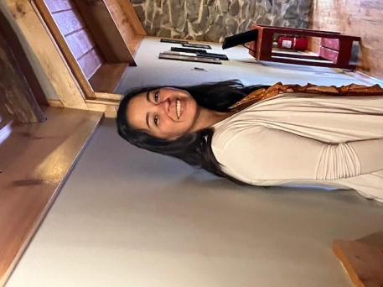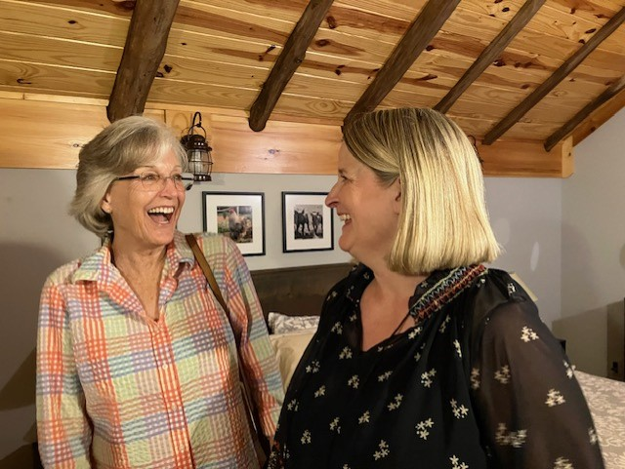
Frankie Velasquez Cynthia Axell and Nancy Schuster

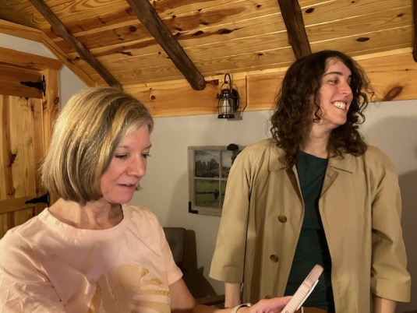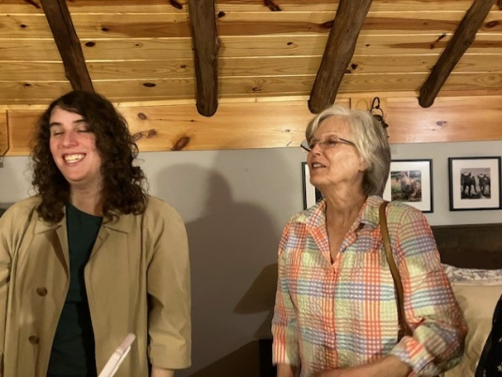
Laura Savino and Jessica Citrin Jessica Citrin and Cynthia Axell

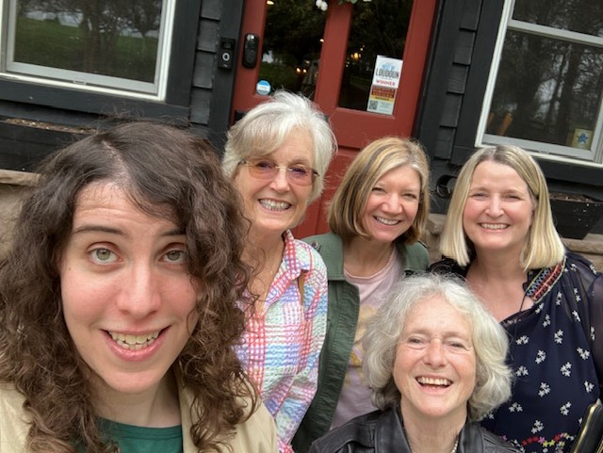
Jessica Citrin, Cynthia Axell, Laura Savino, Mary McCutcheon and Nancy Schuster

UPCOMING EVENTS

April 17 8-9 PM Jerrie Mock Commemoration

Jerrie Mock: Charting New Horizons in Aviation History for the Next Generation | National Air and Space Museum

Smithsonian event to celebrate the 60th anniversary of Jerrie Mock’s solo flight around the world. Free with registration.

Smithsonian Event | Smithsonian Institution

April 26-27 Mid Atlantic Section Meeting

The Mountaineer Section with Sugarloaf will host the meeting at Martinsburg Airport. Be sure to register. It is $55. Use the link below for the sugarloaf store.
Join Us At The Mid-Atlantic Spring Section Meeting April 26 & 27, 2024 (sugarloaf99s.blogspot.com)
https://sugarloaf99s.blogspot.com/p/sugarloaf-store.html.

May 1 5 – 8 PM BEVERLEY SHARP LAUNCH OF DIVERSITY AWARD
Air Bus Experience Center
1101 Pennsylvania Ave NW

Beverley was the President of the 99s. She lived in Reston with her pilot husband. It was Bev who persuaded me to join. She was a force. Sadly, Bev died in 2006. She is now being remembered for what she did for the 99s. Her husband remarried ANOTHER 99, Holly Brenneman. He couldn’t get enough of being a 49 ½. So being a 49 ½ twice might make him a 99!

The event costs $500 for non 99s but only $99 for us
https://wdcnn.betterworld.org/events/beverly-sharp-diversity-award-sp
www.DC99s.com

May 18. Lake Anna Splash In

From Janet Davidson

I think spring is finally here and it's time to start thinking about the summer flying season and splash-ins. As always we will be kicking off the splash-in season with food, fun and flying on May 18th at Lake Anna, thanks once again to Bob and Penny. They will graciously open up their home and outstanding lake location for another spectacular event.

Lake Anna Splash-in
N38-04.590 W077-48.740
Unicom 123.45
This is a social gathering with food, fun, friendship and flying.
RSVP by May 8th to Bob and Penny, 703-785-1505 or n75196@aol.com
If you can’t fly in, drive in 120 Old Mill Court Mineral, Va
The nearest full service airport KLKU Louisa, 12 miles away.
Bumpass 7W4 has no services and is 10 miles away.

May 30, 2024 8PM Conversation with Tammie Jo Shutts

Navy Pilot, Tammie Jo Shults, is the guest speaker at Udvar Hazy
Tickets are free but you have to sign up. Either In person and online.

AIRANDSPACE.SI.EDU
“Adventure is Worthwhile": A Conversation with Pilot Tammie Jo Shults

May 31-June 3 Ocracoke Weekend

It may be too late to get a room at the inn at Ocracoke, but maybe there are other places to stay. Fly or drive down. Bicycle everywhere on the island. Enjoy the seafood and the beach.

June 8 Women Can Fly at Warrenton

There will also be a Women Can Fly Event at Shannon (EZF) May 18, but the one we help sponsor is at Warrenton (HWY). Volunteer in many capacities.
Warrenton-Fauquier Airport | Women Can Fly

June 15 Innovations in Flight

This is a big event at Udvar-Hazy/ Dulles
Get your tickets beginning May 14
Innovations in Flight | National Air and Space Museum

June 18 – 21 Air Race Classic

I don’t think it is too late to sign up to volunteer at one of the stops. I’m going to Newark, Ohio.
Welcome to The Air Race Classic (Air Race Classic, Inc.)

June 29-30 Aerobatics Competition

James Polk Eastern Region Aerobatics Competition at Warrenton
BE THERE to cheer on Mia Anderson and Kat Emery.
- 2024-06-29 James K. Polk Open Invitational Midland, VA (Northeast). Directed by Adam Cope, Chapter 11

July 3-7 Ninety-nines International Meeting in Vancouver

Join 99s | Conference (The Ninety-Nines, Inc.)

July 22-28 Oshkosh

There will be a 99s house and Laura Savino will be there

MEMBER NEWS

Michele Bell

Maryland Wing, Civil Air Patrol
·
Maryland Wing, Apollo I Senior Squadron (MD-085) welcomes Capt. Michele Bell as its new commander. She takes the reins from Capt. Dustin Winter as he assumes other leadership roles within the Wing.
Capt. Bell has been part of #CivilAirPatrol since January 2014 and has filled many roles over the years to include Finance Officer, Operations Branch Director, Planning Section Chief, Incident Commander, Volunteer University Instructor, and Deputy Squadron Commander.
Bell was raised in a household focused on volunteerism where the four simple words “How can I help?” were imparted in daily activities; and continues this mantra as an adult. She often highlights that “If you have some time or talent to give to someone else, you do it - because it's the right thing to do “.
Capt. Bel also enjoys seeing the faces of #civilairpatrolcadets when they have their chance to succeed, whether it's their orientation flights or participation at a search and rescue exercise.
In her spare time Michele is an avid aviator (owns/pilots a Cessna 177B Cardinal), a volunteer at the Kennedy Center for the Performing Arts, and enjoys spending time with her cat, Turbo.

Yvy Von Helde

Congratulations to Yvy, who passed her private pilot checkride on March 22nd. Plus, she took her first passenger, her boyfriend, for a flight!

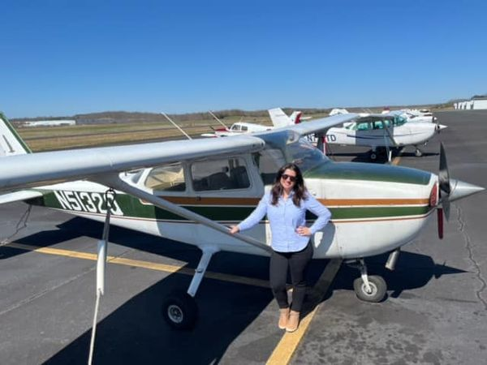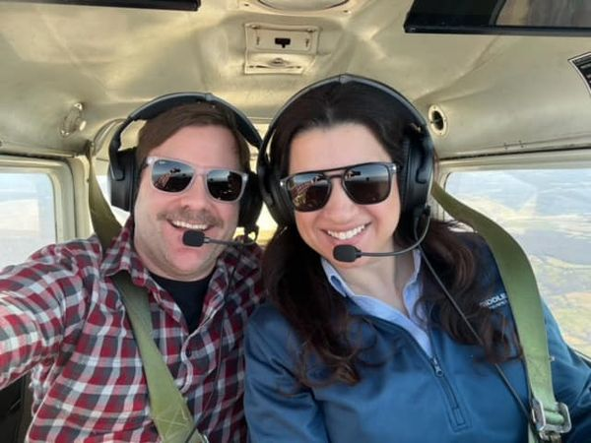

Mia Anderson

Mia won first Runner Up in the Miss Teen Volunteer America Pageant,
Congratulations to Mia! She received 2nd place overall in the primary category of the Estrella Classic, an aerobatic glider competition in Maricopa, Arizona! Watch her videos on her FB page… they are amazing! (20+) Facebook
She also volunteers at Hillsboro School

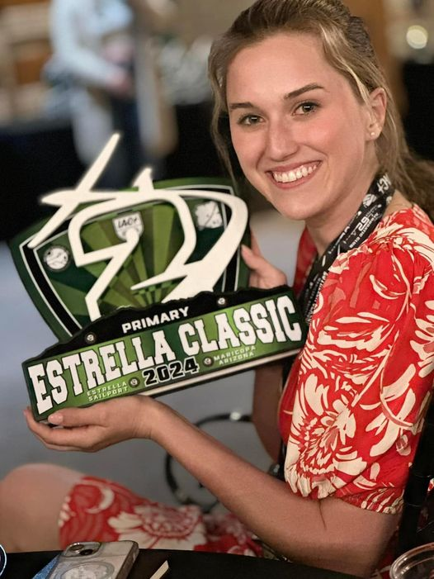

Laura Savino and Kat Emery

Wild coincidence. They ran into one another at Dulles.

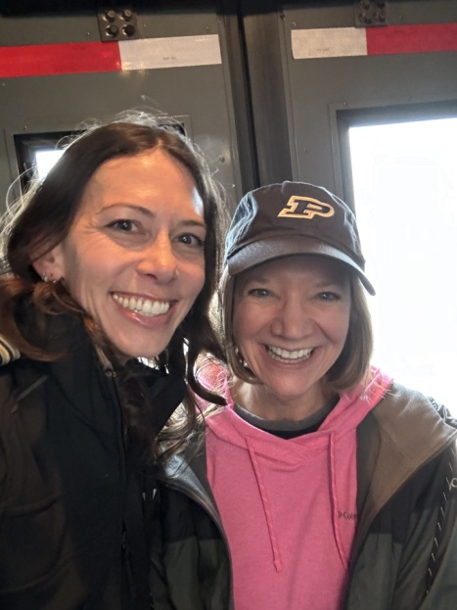

Nancy Schuster

Was the Captain of an all-woman crew. Here they are:

