

Old Dominion Chapter
SKYLINES
May 2024

Chair: Laura Savino
Vice-Chair: Mary McCutcheon
Secretary: Jessica Citrin
Treasurer: Barbara Gruber
Amelia Earhart Scholarship: Cynthia Axell

Membership: Sue Passmore
Newsletter: Mary McCutcheon
Webmasters:
Jessica Citrin and Frankie Velasquez

NEXT MEETING
Monday May 13, 6 for dinner 7 for the meeting

Logan's Roadhouse
7731 Donegan Drive
Manassas, VA, 20110

ELECTIONS
Section election was a non-election. No new slate of officers was put up so, the current board has been retained for another year.

International Elections The deadline was May 1 for casting a ballot. No results have been announced yet

PAST EVENTS
Our April Chapter Meeting
We met on April 15 at the Wegman’s in Gainesville.
Here are some pictures:

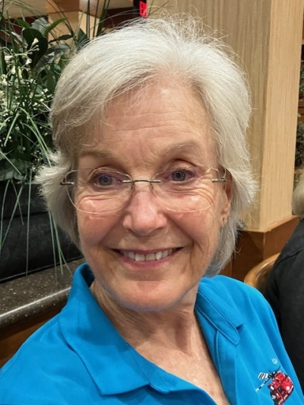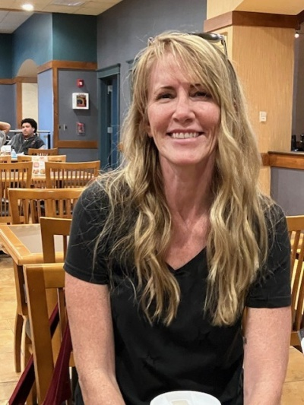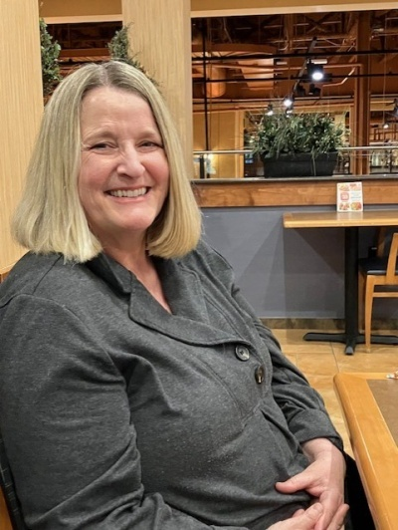
Cynthia Axell Jennifer Zinn Nancy Schuster

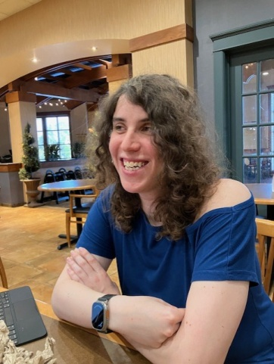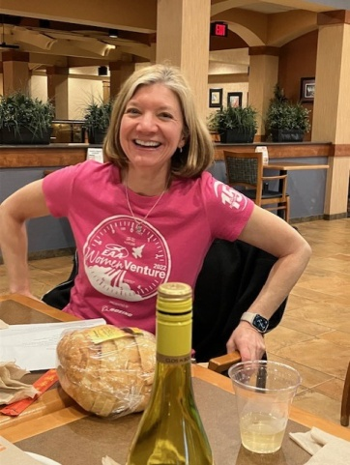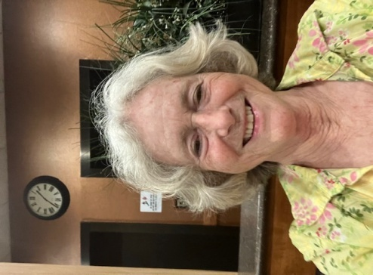
Jessica Citrin Laura Savino Mary McCutcheon

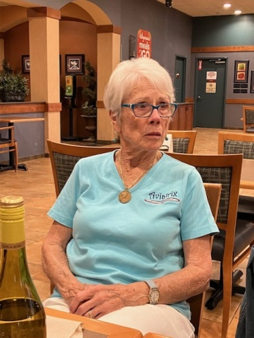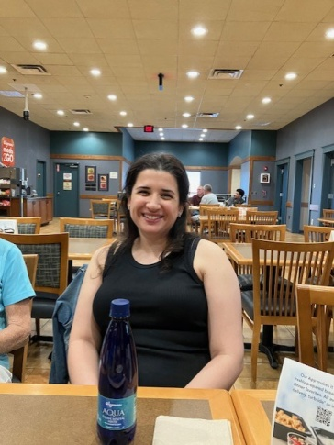
Peggy Doyle Yvy Von Helde

The Section Meeting was held at Martinsburg Airport on April 27. The weather was atrocious but at least one person flew in. The Mountaineer Chapter hosted with assistance from Sugarloaf.

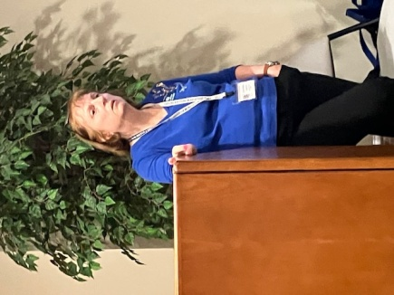
Lin Caywood conducting the meeting

The high point of the meeting was the keynote address by Eileen Isola about her astonishing flying career and her overcoming the kind of medical conditions that would have discouraged anyone else. Her book is Called Fight And Flight. It hasn’t been released yet
About the Book (eileeni.com)

Here is a YouTube about this extraordinary woman
#125 Eileen Isola, Decorated Air Force combat pilot, author, change maker (youtube.com)

Here she is speaking to us:

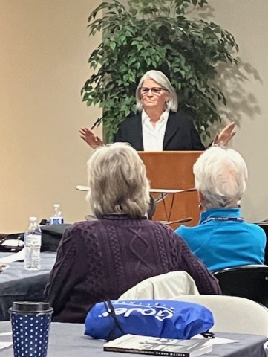

Here is a picture of the whole group (with my dogs, Presto and Bonanza)

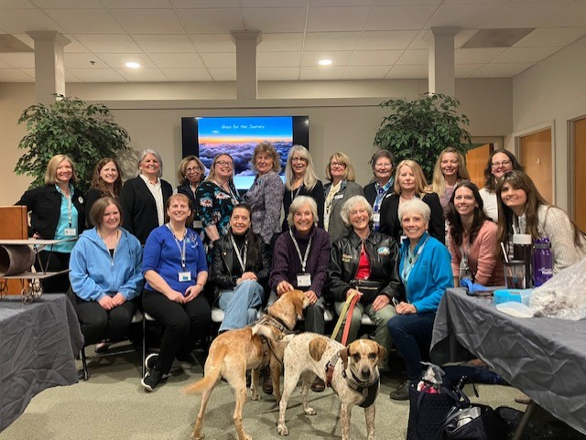

And here is a picture of our chapter

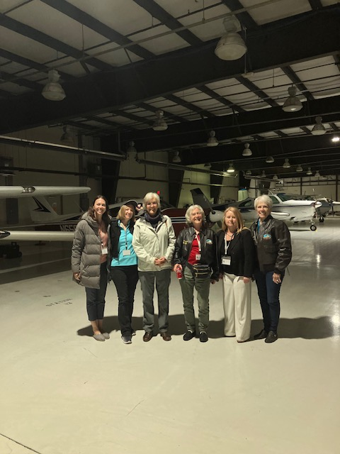
Kat Emery Laura Savino Cynthia Axell Mary McCutcheon Jeannine Bouvier and Peggy Doyle

Jerrie Mock Celebration
A good group of 99s showed up to at the downtown Air and Space Museum to celebrate the 60th anniversary of the completion of Jerrie Mock’s round-the-world flight on April 17.
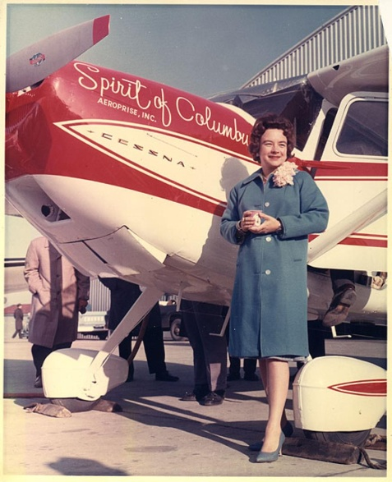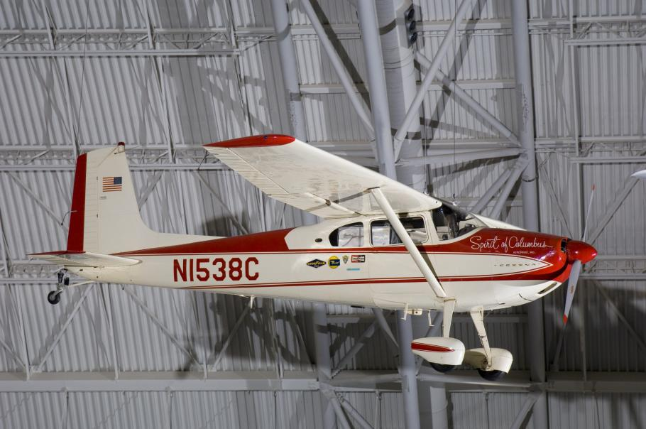

May 1 Beverley Sharp Aviation Diversity Award and Scholarship fundraiser
The D.C. Chapter hosted a kick-off event and fundraiser to acknowledge Beverley Sharp’s contribution to the 99s. Sue Passmore was there. Here is a picture of the 99s in attendance:

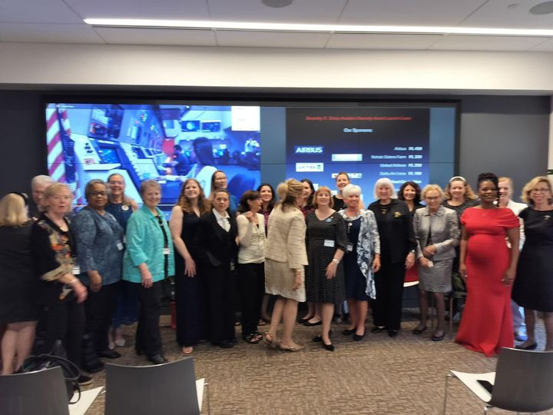

UPCOMING EVENTS

May 18. Lake Anna Splash In
This is a social gathering with food, fun, friendship and flying.
RSVP by May 8th to Bob and Penny, 703-785-1505 or n75196@aol.com
If you can’t fly in, drive in 120 Old Mill Court Mineral, Va
The nearest full service airport KLKU Louisa, 12 miles away.
(Janet Davidson is our contact person)

May 30, 2024 8PM
Conversation with Tammie Jo Shults

Navy Pilot, Tammie Jo Shults, is the guest speaker at Udvar Hazy
Tickets are free but you have to sign up. Either In person and online.

“Adventure is Worthwhile": A Conversation with Pilot Tammie Jo Shults | National Air and Space Museum (si.edu)

May 31-June 3 Ocracoke Weekend
A group of chapter members are going to Ocracoke at the end of the month.

May 18 Women Can Fly at Shannon

Shannon Airport | Women Can Fly
Volunteer | Women Can Fly

June 8 Women Can Fly at Warrenton

Warrenton-Fauquier Airport | Women Can Fly
Volunteer | Women Can Fly

June 15 Innovations in Flight
This is a big event at Udvar-Hazy/ Dulles
Get your tickets beginning May 14
Our chapter is considering setting up an activity there. If you want to participate, let Laura or Cynthia know
Innovations in Flight | National Air and Space Museum

June 18 – 21 Air Race Classic
I don’t think it is too late to sign up to volunteer at one of the stops. I’m going to Newark, Ohio where I will be a fuel log lady
Welcome to The Air Race Classic (Air Race Classic, Inc.)

June 29-30 Aerobatics Competition

James Polk Eastern Region Aerobatics Competition at Warrenton
BE THERE to cheer on Mia Anderson and Kat Emery.

July 3-7 Ninety-nines International Meeting in Vancouver

Join 99s | Conference (The Ninety-Nines, Inc.)

July 22-28 Oshkosh

There will be a 99s house and Laura Savino will be there

Scholarships

First Wings

From Cynthia:

Just a friendly reminder that Student Pilots can apply for the First Wings Award in both October and April 1st. They must be Student Pilot Members of the 99’s for three months prior to the First Wings submission deadline, have logged five hours flight time within the preceding six months and show financial need. The First Wings award is up to $6,000.00 for specific milestones as they are achieved. It is never too early to start thinking about applying! If you need any help or have questions, please contact Cynthia Axell at 707-481-0650.

SeaPlane Scholarships Available for 2025
Women Making a Splash
Scholarship - Seaplane Foundation

Here is a picture of the 2023 winners.

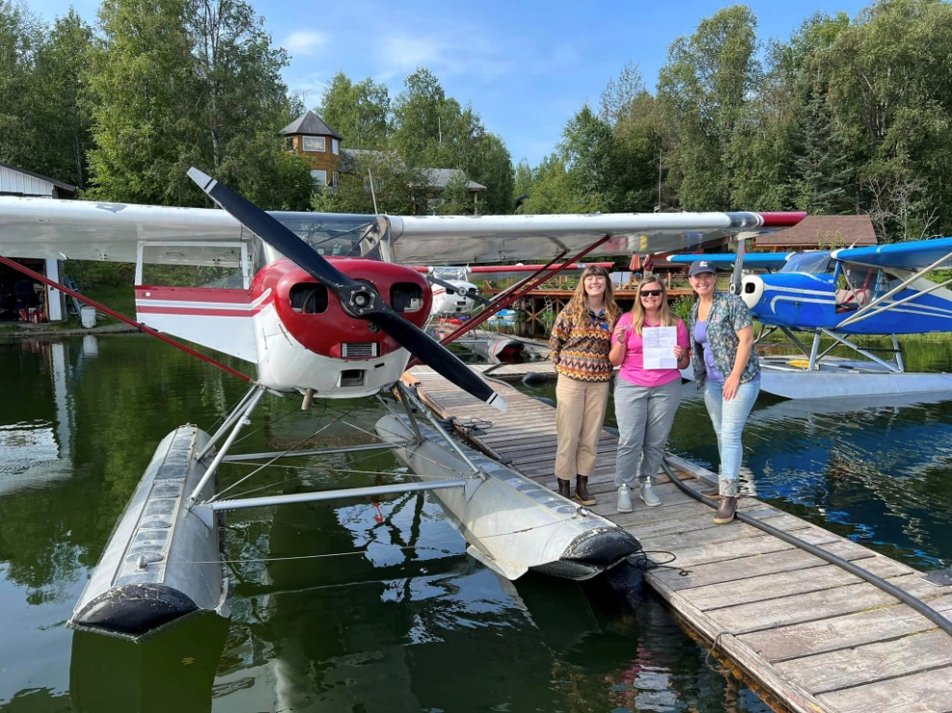

MEMBER NEWS

Barbara Gruber is now director of Education and Public Outreach for the National Radio and Telescope Observatory. She lives in Charlottesville three days a week.
National Radio Astronomy Observatory – Revealing the Hidden Universe (nrao.edu)

There are public tours on Saturdays that WE SHOULD DEFINITELY SIGN UP FOR. VLA stands for Very Large Array!!!

VLA Saturday – Public Guided Tours – National Radio Astronomy Observatory (nrao.edu)

Stephanie Kight Featured Aero Elite Flight Instructor. And now she’s applying for airlines jobs

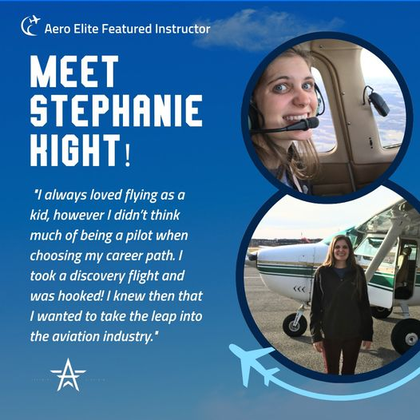

Samantha Stahl

Earned her CFI in March. Here is her checkride photo, a picture of her at WAI with Stephanie Kight and Hannah Rust

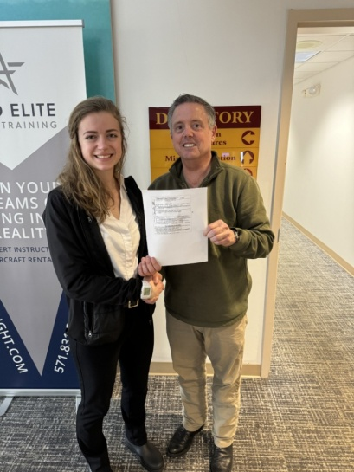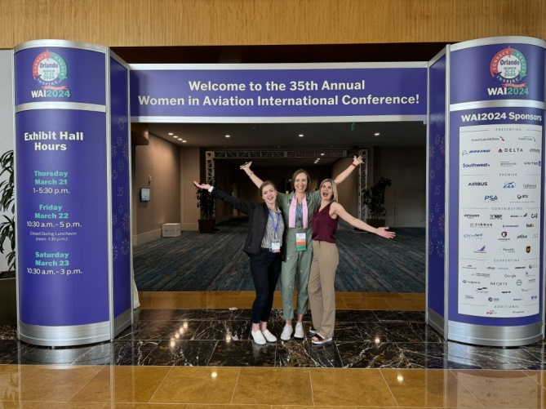

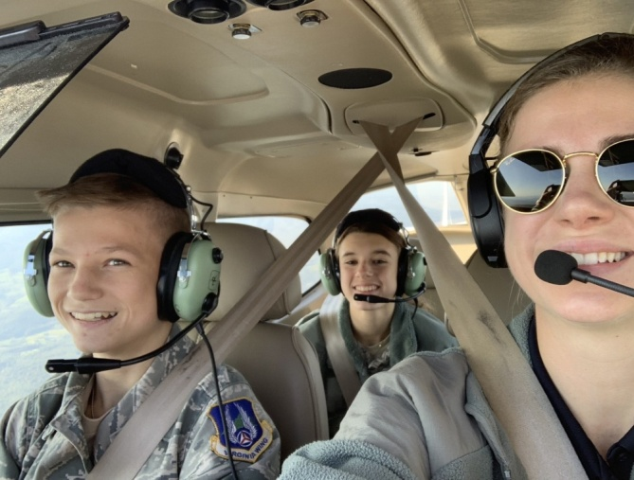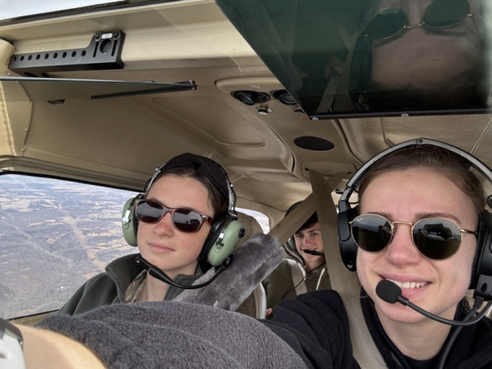

Samantha doing youth flights

Mia Anderson has been honored as a mentor for young pilots

Teen pilot mentor inspires the next generation — General Aviation News

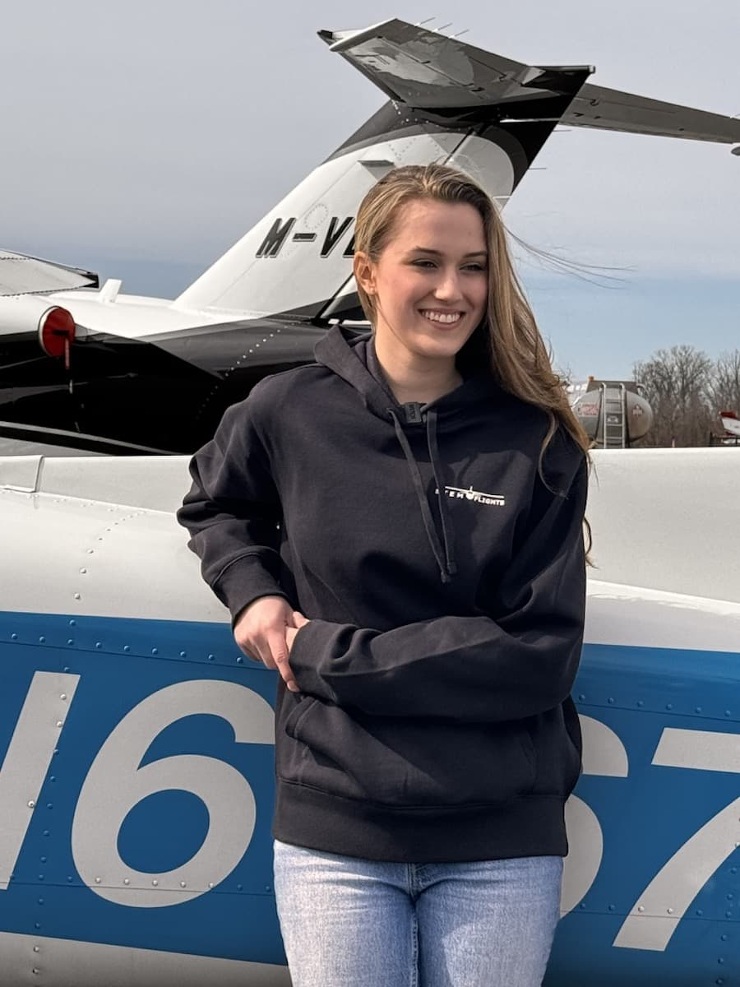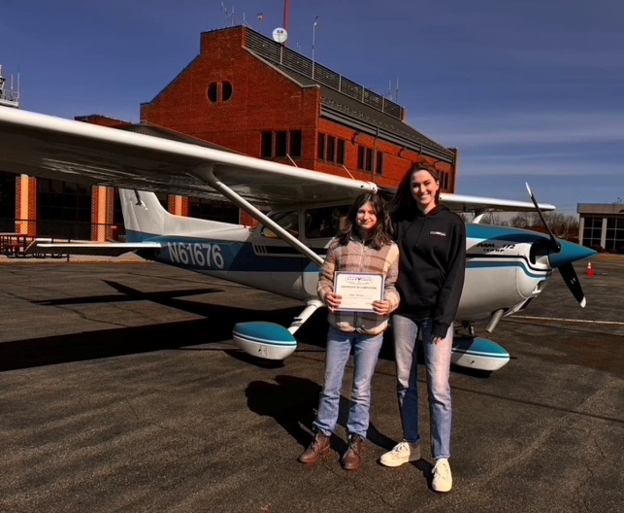

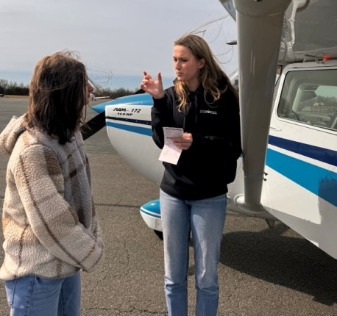

Janet Davidson just got back from a career development expo at Harvard sponsored by Women in Aviation International. She maintains a website of scholarship opportunities and learned about the very generous scholarships available through this program. Another chapter member, Stephanie Kenyon, oversees this program

https://www.wai.org/news/wai-harvard-university-2024#%23

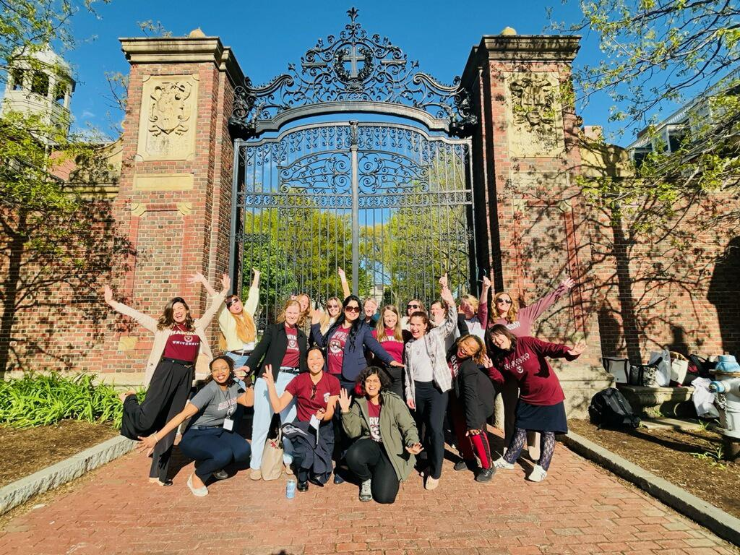

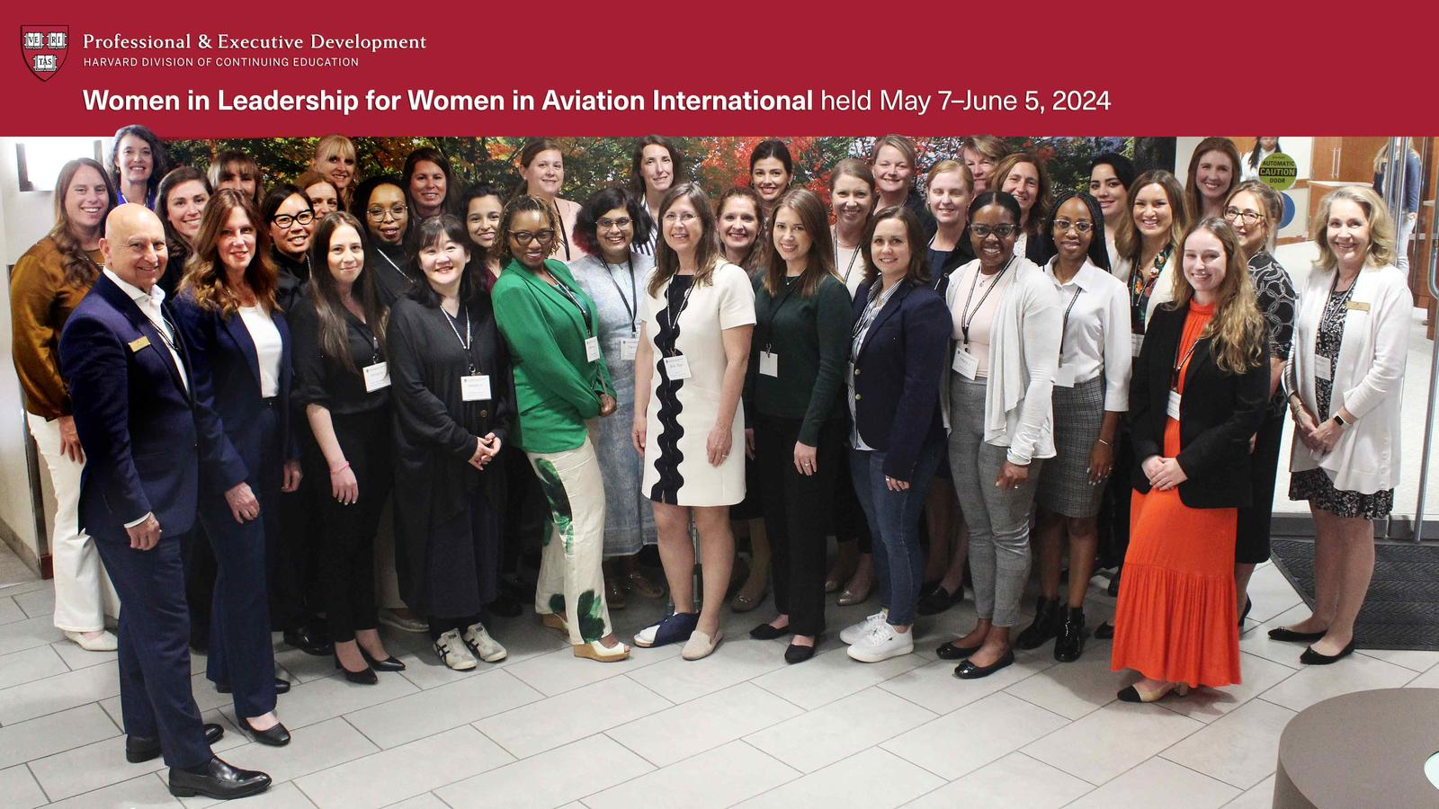

Jessica Citrin

Made it safely to Seattle where she has an apartment with a view.

On the way she almost got launched by Old Faithful, having to drive through Wyoming to avoid a blizzard in Colorado

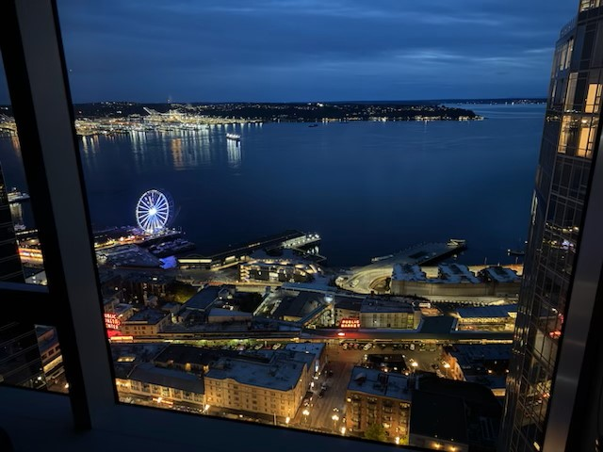

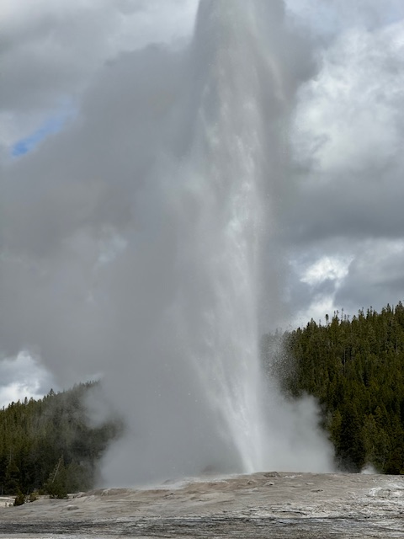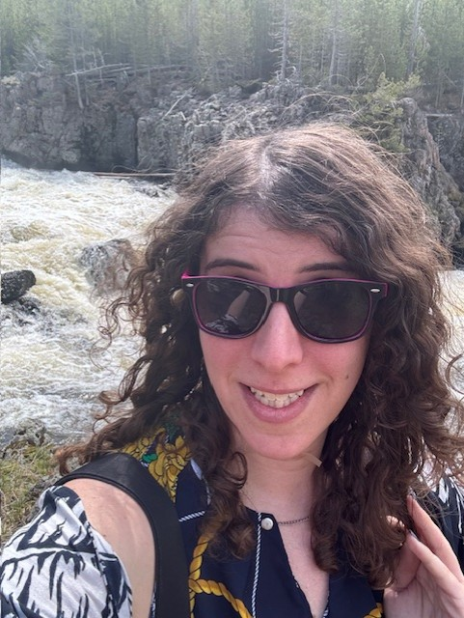

Barb Wilper

Has also made it to her new home, in Champaign or Urbana Illinois. She is half-way between the Chicago Chapter and the St. Louis Chapter. She may stick with St. Louis since that was her original chapter from back in the late 70s. She reports that she is, at present, surrounded by boxes.

New Members
(more on them next month)

Indya Bird

Gabrielle Hall

Other News:

The Air and Space Museum Archives has accessioned the papers of Gene Nora Jessen. Gene Nora was a recruit for the Mercury 13 astronaut program, one of the “Three Musketeers” and a pioneer in aviation. She lives in Boise, Idaho now. I was her chauffeur at the Air Race Classic Terminus in 2017. She told me many stories.

https://sova.si.edu/record/nasm.2023.0052

