

Old Dominion Chapter
SKYLINES
June 2024

Chair: Cynthia Axell and Mary McCutcheon
Vice-Chair: Nancy Schuster
Secretary: Mary McCutcheon
Treasurer: Barb Gruber
Amelia Earhart Scholarship: Cynthia Axell

Membership: Sue Passmore
Newsletter: Mary McCutcheon
Webmaster: Stephanie Kight

NEXT MEETING

Monday June 10, 6 for dinner 7 for the meeting

Lezzet, 13850 Braddock Rd in Centreville.

Cynthia says: It’s a reasonably priced Turkish restaurant, and if no one wants to eat there, there’s a couple of restaurants nearby (Glory Days, etcetera) Please RSVP to Cynthia no later than the 9th so we can tell the restaurant what to expect.

H20av8tricks@aol.com

Stay tuned for an agenda but be prepared to talk about preflighting and lessons learned.

Here is what Cynthia and Sue are suggesting for the meeting as well as future programs.

From Cynthia: This meeting will be another opportunity to proffer your thoughts on how to make this chapter more relevant and exciting. As part of that initiative, we will be introducing “Hangar Talk” during our meetings, where we share stories related to the topic of the month. The idea is to learn from others’ mistakes so we don’t make them ourselves. This month’s theme is Preflight. If you’ve had a “I learned from that” moment and are willing to share, please bring your story!

Sue Passmore also came up with some things we can discuss:

1) Get a Safety Briefing from a FAAST instructor. To facilitate, she suggested perhaps designating a Safety Committee chair?
2) Aviation movie at Sue’s house during inclement months. Suggestions for movies welcome.
3) Create or join aviation education events. The Girl Scouts have a Scout Day program.
4) Create a knowledge base of local CFI/CFII’s for our group. Who’s good? Who’s great? Who’s not? What was your general take on aircraft readiness/maintenance/documentation?
5) Take cookies to the FAA Towers in our area. (Perhaps we could get a controller to come speak at one of our meetings.)
6) Have a Poker Run. It’s a fundraising/flying event that requires 5 airports and LOTS of volunteers.

This is truly your chapter. If there are ideas you’d like to see implemented, please bring them to the next meeting, or reach out to either Cynthia, Nancy or Mary. We love ideas!

ELECTIONS

The international Election results are in:

President: Robin Hadfield: First Canadian Chapter, East Canada Section
Vice President: Minnetta Gardinier: Iowa Chapter, North Central Section
Secretary: Debi Dreyfuss: Washington DC Chapter, Mid-Atlantic Section
Treasurer: Aileen Coverdell: Mid-Columbia Chapter, Northwest Section
Director: Mary Build: Katahdin Wings Chapter, New England Section
Director: Pat Chan: Bay Cities Chapter, Southwest Section

Nominating Committee:
Jill Oakes: Manitoba Chapter, West Canada Section
Kaylee Jeffries: Dallas Chapter, South Central Section
Kathy Lester-Ross: Wisconsin Chapter, North Central Section

Amelia Earhart Memorial Scholarship Fund:
Tina Hartlaub: Wisconsin Chapter, North Central Section

Ninety-Nines Endowment Fund:
Virginia Harmer: San Gabriel Valley Chapter, Southwest Section
Stephenie Roberts: Texas Dogwood Chapter, South Central Section

Ninety-Nines Museum of Women Pilots:
Isabelle Kearney: Oklahoma Chapter, South Central Section

Amelia Earhart Birthplace Museum:
Joyce Parker: Northeast Kansas Chapter, South Central Section
Mandi Hill: Memphis Chapter, Southeast Section
Joan Widener: Air Capital Chapter, South Central Section
PAST EVENTS

Our May Chapter Meeting
We met on May 13 at Logan’s Roadhouse (see the minutes which I sent out on May 18)

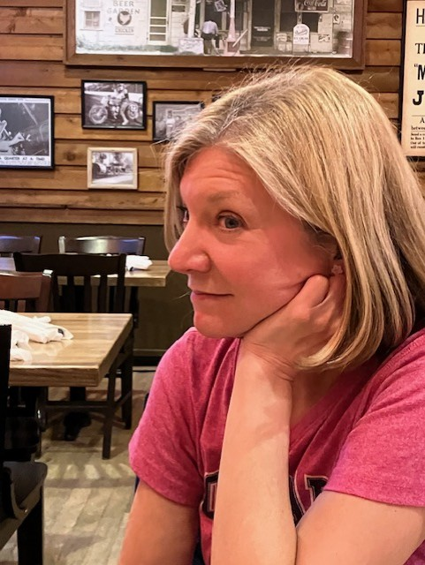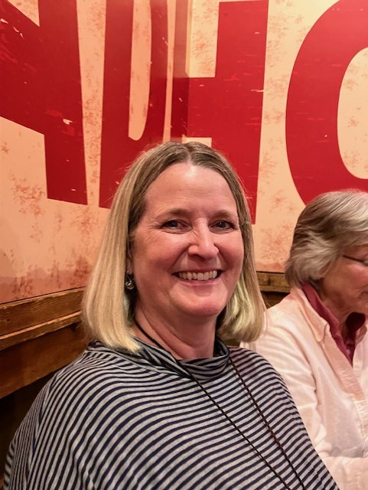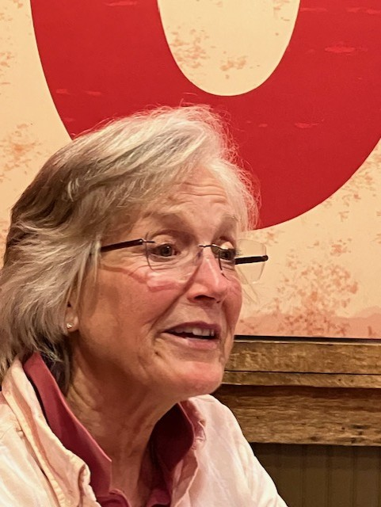

Laura Savino Nancy Schuster Cynthia Axell

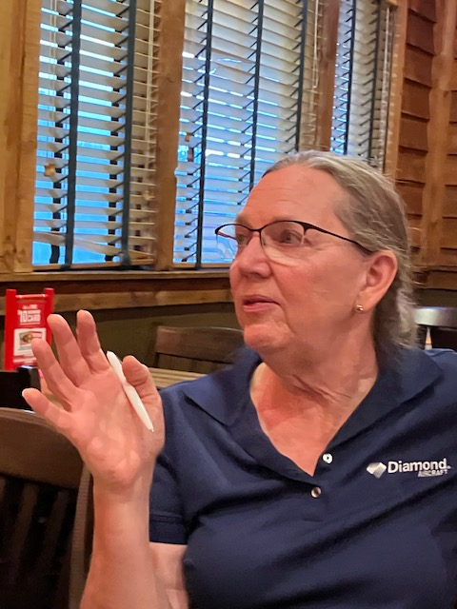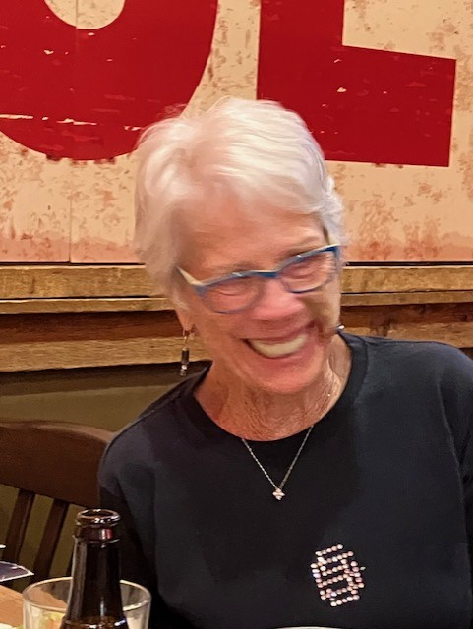
:
Sue Passmore Peggy Doyle

May 18 Women Can Fly at Shannon

Because of horrible weather with low ceilings and low visibility, this event was canceled. Those who went reported meeting some interested families with young girls who may attend the Women Can Fly event on Saturday at Warrenton.

Conversation with Tammie Jo Shults

Tammie Jo Shults was the Captain of a Southwest Airlines flight in which debris from an engine fan blade flew into a window and smashed it. One passenger was killed and pressure was lost. She safely landed the plane

“Adventure is Worthwhile": A Conversation with Pilot Tammie Jo Shults | National Air and Space Museum (si.edu)

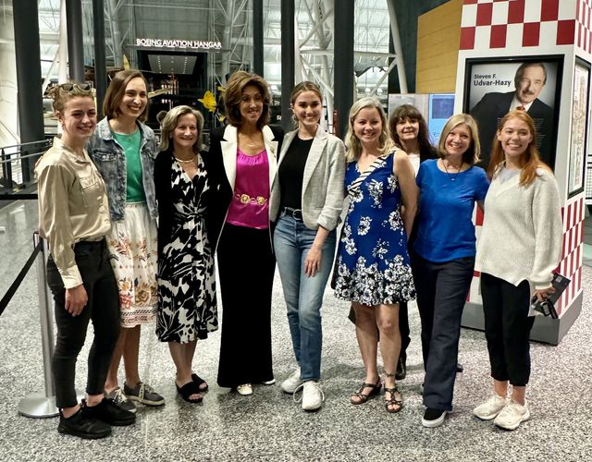

May 31-June 3 Ocracoke Weekend

The legendary Ocracoke Weekend has been going on for many decades. This year was the best attended yet. With perfect weather, two planeloads and several carloads arrived to spend an idyllic weekend.
If you are inspired to come next year, it is best to make a reservation early: Ocracoke Harbor Inn - Lodging in the Heart of Ocracoke Village
There are many other places to stay, but being together is especially fun.

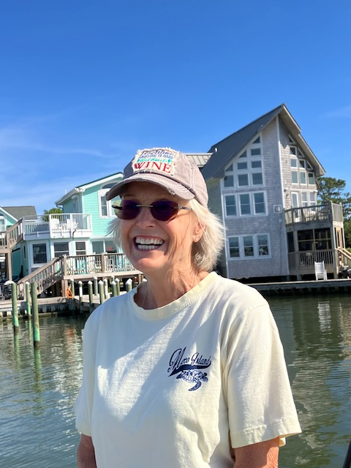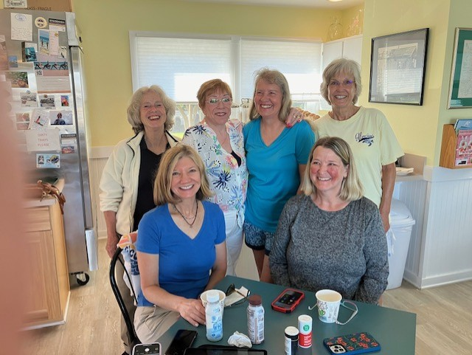
Cynthia Axell Mary McC Laura Savino MJ McGlasson Morgen Reeb

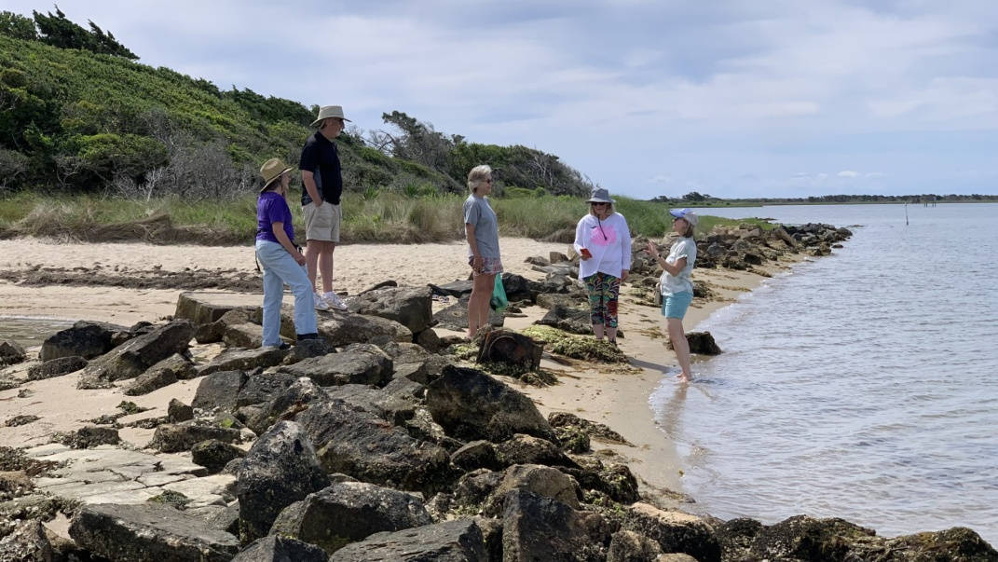

Mary McC Dave Passmore Cynthia Axell Nancy Schuster Laura Savino

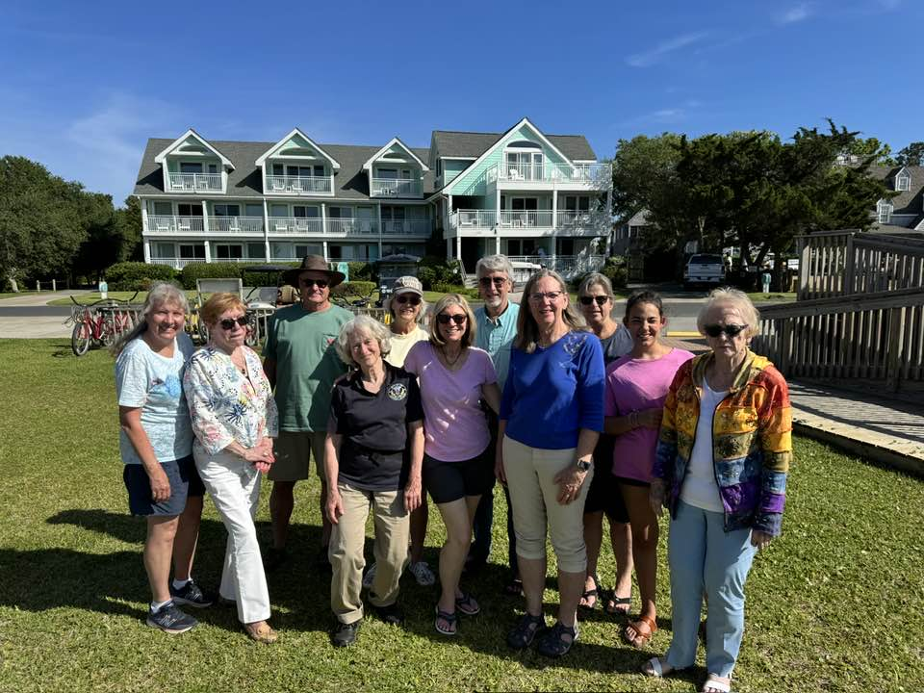
Back Row: Frank Reeb Cynthia Axell Dave Passmore Patty and Grace
Front Row: Morgen Reeb RJ McGlasson Mary McC Laura Savino
Sue Passmore Marti Constantino

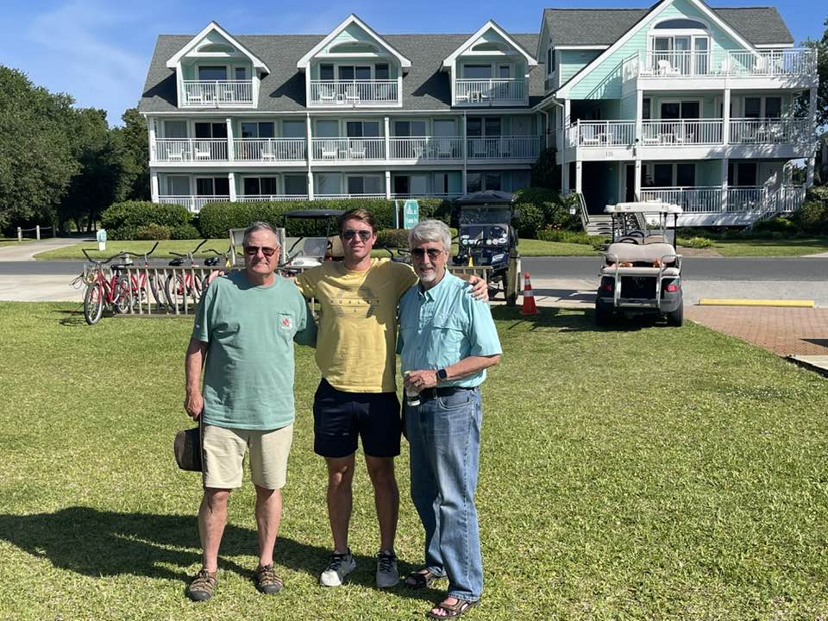
Frank Reeb Ryan Reeb and Dave Passmore

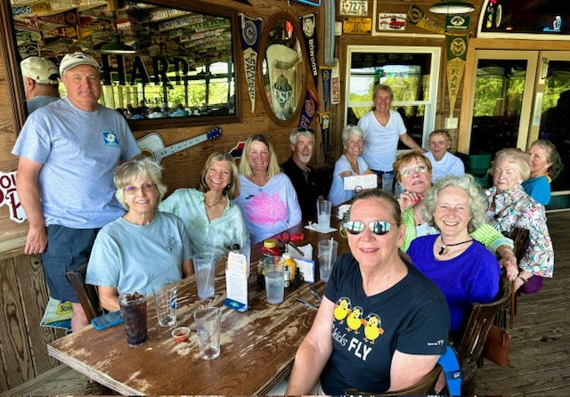
Sanding: Frank Reeb and Morgen Reeb
Back side of table: Cynthia Axell Laura Savino Nancy Schuster Dave Passmore
Peggy Doyle Rick Koehnke
Front side of table: Sue Passmore Mary McC RJ McGlasson Marti Constantino
Beth Whitehouse
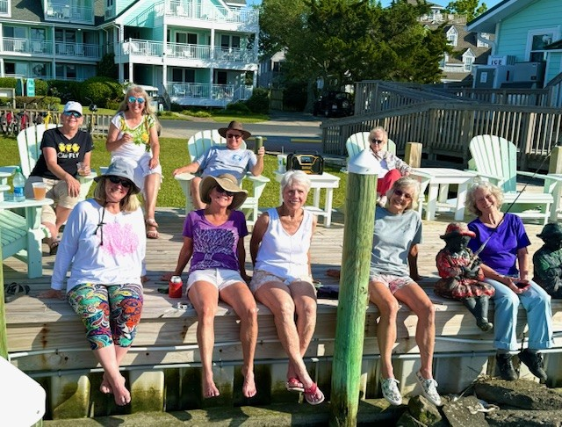

In chairs: Sue Passmore Morgen Reeb Frank Reeb Marti Constantino
On the dock: Nancy Schuster Beth Whitehouse Peggy Doyle Cynthia Axell Mary McC
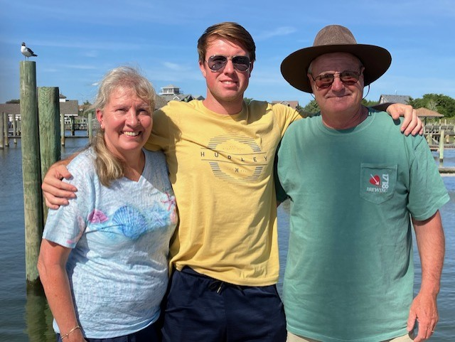
Morgen Reeb Ryan Reeb Frank Reeb

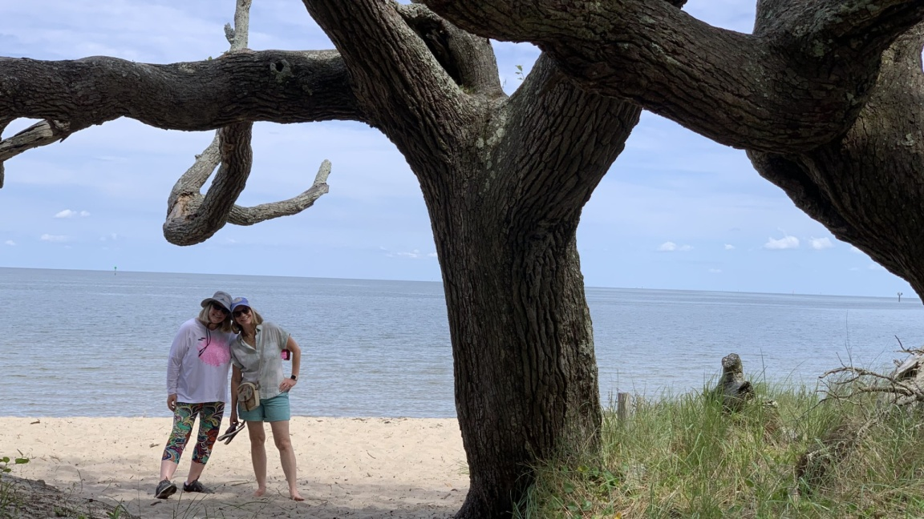
Nancy Schuster and Laura Savino
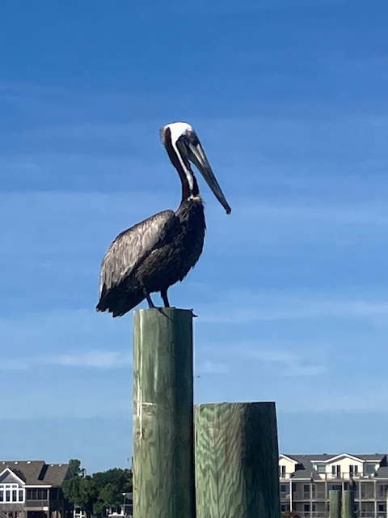

Silent Witness

UPCOMING EVENTS

June 8 Women Can Fly at Warrenton

Warrenton-Fauquier Airport | Women Can Fly
Volunteer | Women Can Fly

June 12. Laura in a Webinar

99s Webinar: A Conversation with Captain Laura Savino Wednesday, June 12, 2024, at 8:00 pm Eastern Following the popularity of her previous webinar, Inside the Tenerife Crash, please join us for a conversation on June 12th with Captain Laura Savino (Jet Boss). She will speak about her journey as a commercial pilot with Eastern, Pan Am, and United. Laura is an advocate for helping newer pilots find their place in aviation, so questions will be very welcome! REGISTER IN ADVANCE by clicking on the next block of text. Registration will pop up.

Welcome! You are invited to join a meeting: Jet Boss Laura Savino. After registering, you will receive a confirmation email about joining the meeting.
us06web.zoom.us

June 15 Innovations in Flight
This is a big event at Udvar-Hazy/ Dulles
Get your tickets beginning May 14
Once again, the Innovations in Flight at Udvar-Hazy takes place between 10:00 am to 3:00 pm on June 15th. Free tickets require sign-up on their website. Sue and Dave are flying the Epic 1000 in as a static display, as is Peggy Doyle in her club Cessna 182. Laura Savino will be signing her book. Stop and say hi!

Innovations in Flight | National Air and Space Museum

June 29-30 Aerobatics Competition

James Polk Eastern Region Aerobatics Competition at Warrenton
BE THERE to cheer on Mia Anderson and Kat Emery.

July 3-7 Ninety-nines International Meeting in Vancouver

The 99’s International Conference and Career Expo is from July 3-7 in Vancouver, British Columbia. Credentialing is required for the July 6 annual business meeting and is done online using the email address you have on file with the 99’s. There will be voting on bylaw changes, and all that neat information is available on the Ninety-Nines official website. Check it out.

Join 99s | Conference (The Ninety-Nines, Inc.)

July 22-28 Oshkosh

There will be a 99s house and Laura Savino will be there
If you are going to Oshkosh between July 22-28,, they are still looking for volunteers. RJ, Peggy and Laura will be there, and maybe others I have not heard from. If you are going, please reach out so we can put y’all in touch!

November 8 ProJet Aviation Expo

We are signed up for ProJet again this year and are happy to note that two of the keynote speakers are women:
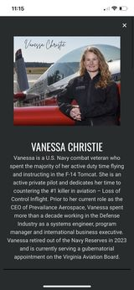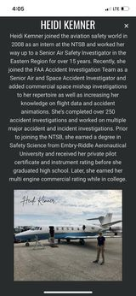
Scholarships

First Wings

From Cynthia:

We didn’t have a single applicant for First Wings in the Spring of 2024. Sad face emoji. New deadline is October 1st (must be a member not July 1, 2024)

please contact Cynthia Axell at 707-481-0650 or H20av8tricks@aol.com

MEMBER NEWS

Alison Northern

Passed both her Commercial ASEL checkride AND her CFI checkride recently. She is now working on her commercial multi-engine add-on and is scheduled to take that checkride on June 12.

Michele Bell

Here’s a picture of Michele with the Maryland Wing Civil Air Patrol

