

Old Dominion Chapter
SKYLINES
August 2024

Chair: Cynthia Axell and Mary McCutcheon
Vice-Chair: Nancy Schuster
Secretary: Mary McCutcheon
Treasurer: Barb Gruber

Amelia Earhart Scholarship: Cynthia Axell
Membership: Sue Passmore
Newsletter: Mary McCutcheon
Webmaster: Stephanie Kight

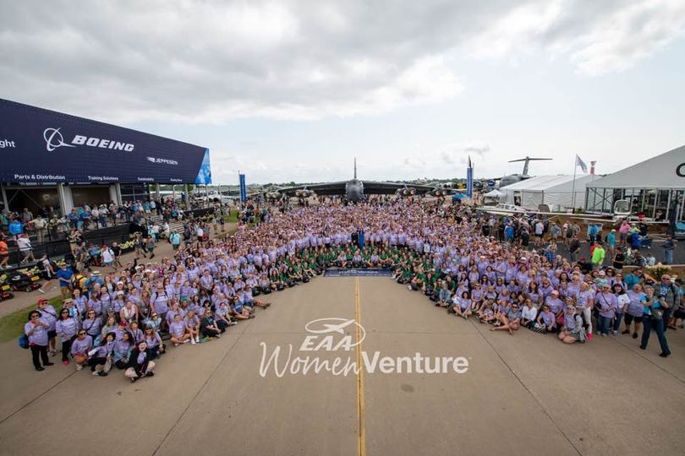

Women At Oshkosh 2024

NEXT MEETING

Our next meeting will be August 15 in Conference Room 1
In the Main Terminal of Manassas Regional Airport. This is an upstairs room.

At 6 the business portion begins and we can eat our dinner
At 7 the regular meeting begins
At 7:30 the speaker, Forrest Jones, from FAAST will speak on the WINGS program with personal stories

Here is what Cynthia says:

As we discussed during the last meeting, the first half hour will be the yawn-inducing discussion of chapter matters by officers, and is entirely skippable. If any business needs general participatory discussion, we will bring it forward to the general meeting, of course. You are always welcome to arrive at 6:00 if you want to witness the goings on of chapter business… not trying to discourage that. Just want to keep the interest levels up.

Then we will have Forrest Jones, a FAAST team member, discuss the advantages of the FAA’s FAAST and WINGS program. He will also discuss a topic near and dear to his heart, the actual subject matter of which will we all learn together at the presentation. Not trying to be coy, but I left it up to him.

As this is not a restaurant, if you desire sustenance, bring it. We aren’t budgeted for catering… my apologies. That may be something we bring up in the business portion of the meeting.

Pay your Chapter Dues

See if you can scan this somehow and use it to pay dues. $25. Goes to Barb Gruber.



PAST EVENTS

Women Can Fly. June 8
Here is Sue’s report which she submitted to GrassRoots column in the 99 News and will be in the Sepember-October Magazine:
The Old Dominion chapter co-hosted a Women Can Fly event at Warrenton (KHWY) airport on Saturday, June 8. The event is co-sponsored by the Virginia Department of Aviation, the Warrenton airport manager, David Huss, and The Ninety-Nines. It was a beautiful day to introduce women and girls to aviation..
The statistics for the day:
222 people attended the pre-flight briefings
239 people flew with us.
25 pilots volunteered to fly the participants
58 people constructed cell phone stands with aircraft building techniques at Women Can Build
Sarah Patten, an Old Dominion member and air traffic controller at Potomac Approach, has planned and coordinated this event for the last seven years. Over the last seven years, 1,457 people attended the preflight briefings and 1,329 people flew with us. These are phenomenal numbers and we know that some of our current members started their aviation journey here.
Besides Sarah, our volunteers included Cynthia Axell, Peg Doyle, Mary McCutcheon, Melissa Plumer, Hannah Rust, Yvy Von Helde and her 49 ½ Chris, and Jenn Weller. They spent all day on the ramp, and they were tired and sunburned but they had lots of fun and generated tons of smiles.
“First impressions are so important! As I think back to my first flight, I was awakened to a dream that I didn’t realize could become a reality. The Women Can Fly event has been that positive first impression of aviation for so many young women, girls & families over the years. It not only offers a flight experience, it introduces those attending to the supportive and dynamic industry that we all love. Seeing the transformation in the young girls who attend is inspiring — their confidence soars throughout the day. Sarah’s consistent leadership and collaboration with an extraordinary team of volunteers has created an incredible opportunity to make the gift of flight accessible to all.” - Hannah Rust
Sarah is planning to host the event again next year, which will be her 8th year of coordinating and planning the super day for our aspiring aviatrixes.
And here are some pictures:

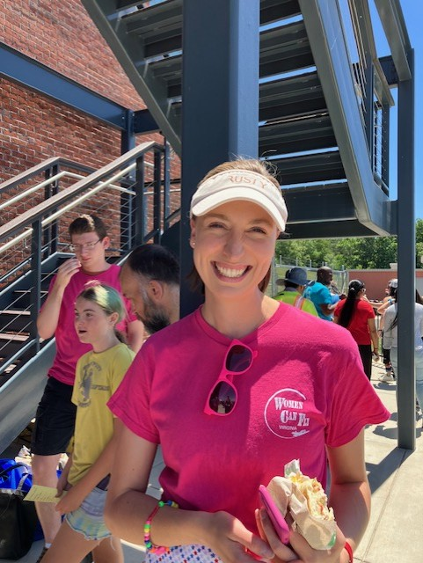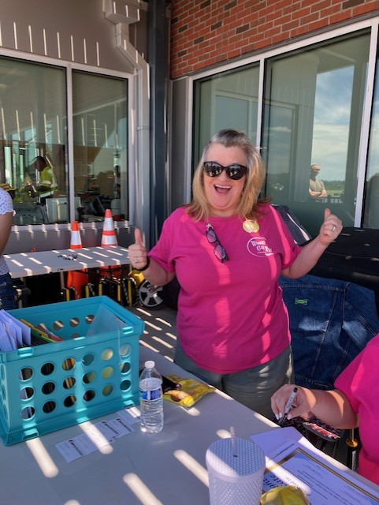
Hannah Rust Melissa Plumer

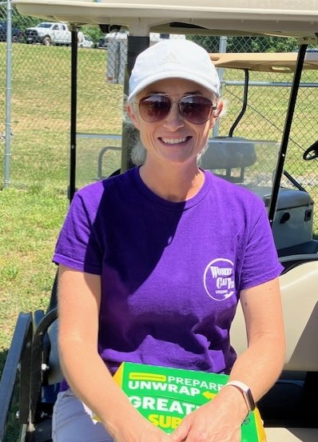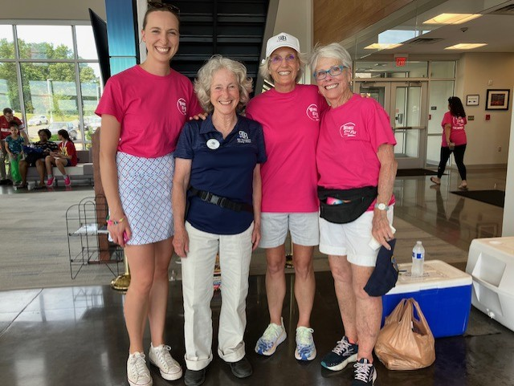
Sarah Patten Hannah Rust, Mary McC, Cynthia Axell, Peggy Doyle

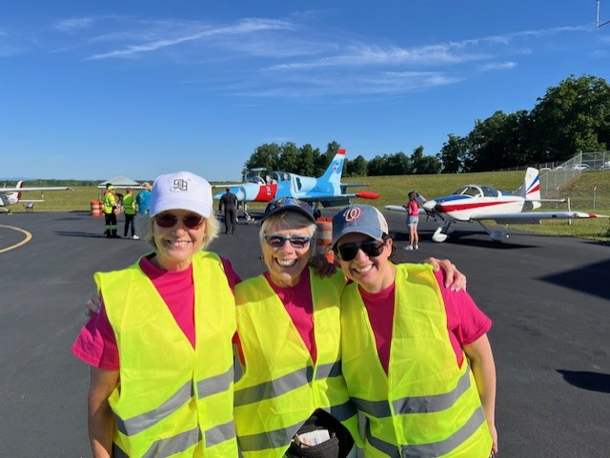
Cynthia Axell, Peggy Doyle, Yvy VonHelde

Old Dominion Chapter Meeting. June 10

We met at Lezzet Restaurant in Centreville. This picture was taken moments before we trashed the place, breaking china and causing mayhem. The waiter took this picture.

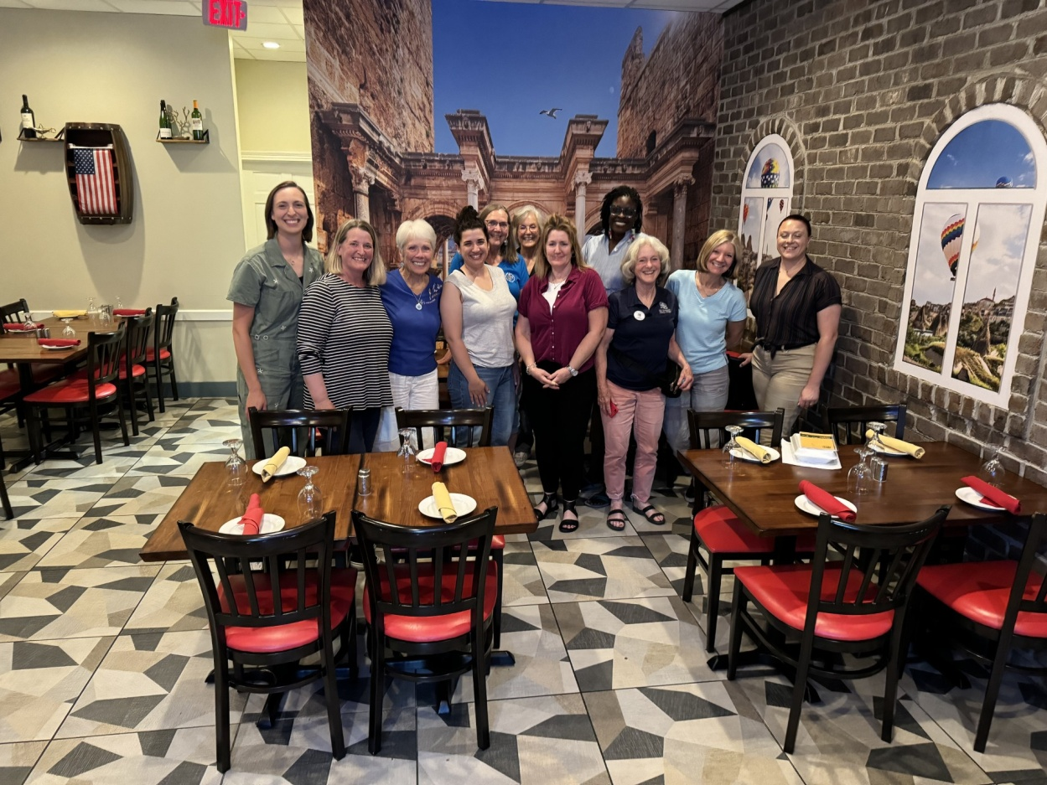

Hannah Rust, Nancy Schuster, Peggy Doyle, Yvy VonHelde, Sue Passmore, Cynthia Axell,
Alison Northern, Tayo Black, Mary McC, Laura Savino, Jenn Weller

June 15 Innovations in Flight

This was a big festival of aviation at Dulles. Laura Savino, Sue Passmore, and Melissa Plumber were there. 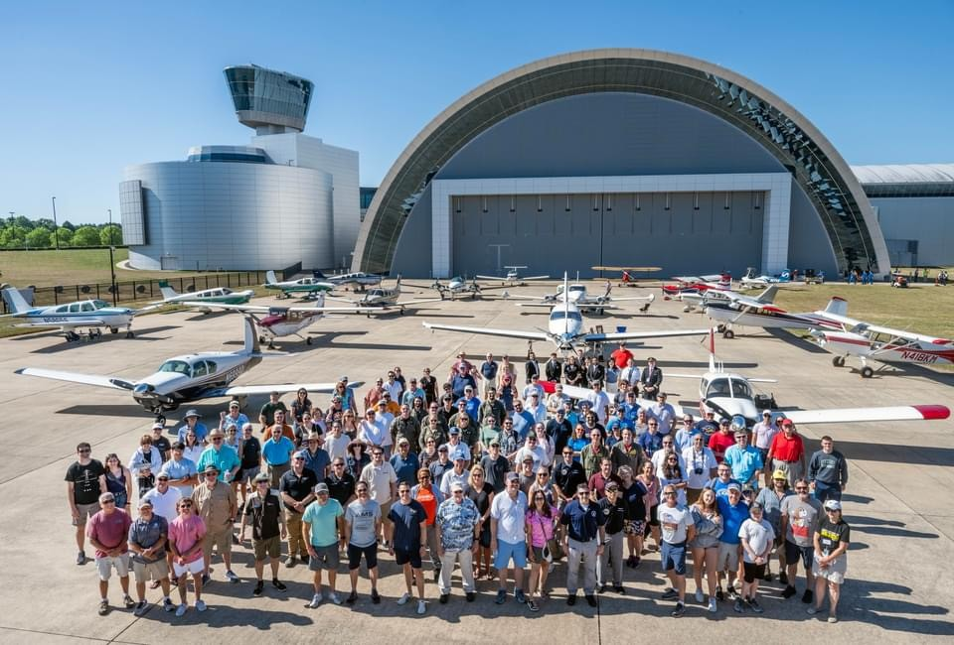

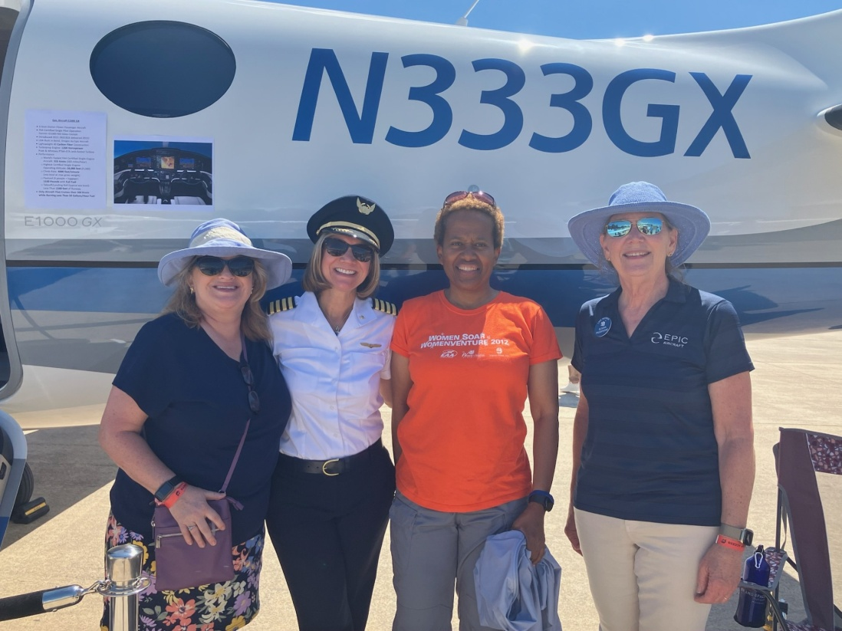

Melissa Plumer, Laura Savino, Suzanne Collins (Hampton Rds), Sue Passmore
June 17-21 Air Race Classic

There were no Old Dominion members competing but 9 mid Atlantic Section members races and they cleaned up!

Debi Dreyfuss and Joy Halcott (DC3-1) won first prize
Alicia Sikes and Nancy Rohr (Over the Moon) won 3rd
Lin Caywood and Susan Beall (Freakin Awesome) won 4th
Mary Wunder and Jo Alcorn (Flying Curly Girls) won 16th
Jeanne Willerth and Emmy Dillon (former Old Dominion member) (SHEnanigans) won 20th
I highly recommend looking at this map to show the progress. You might have to register as an ARC user, but it is free and worth it just to see this addictive map

https://airraceclassic2024.maprogress.com

Mary McCutcheon volunteered to head up the fuel slip/ fuel log crew at Newark, Ohio. Wendy Hollinger, whom we met at the Jerrie Mock round-the-world flight presentation at the Air and Space Museum, was the stop chair and organized everything superbly.

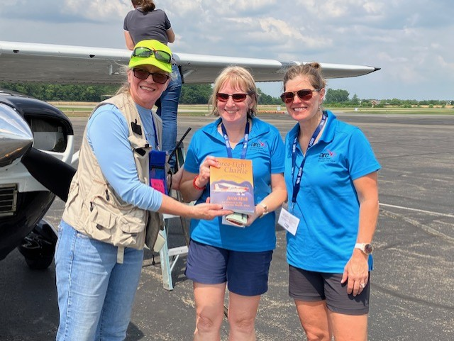

Lin Caywood and Susan Beall were the first to arrive at Newark (the 3rd stop) so Wendy presented them a copy of her book, Three Eight Charlie

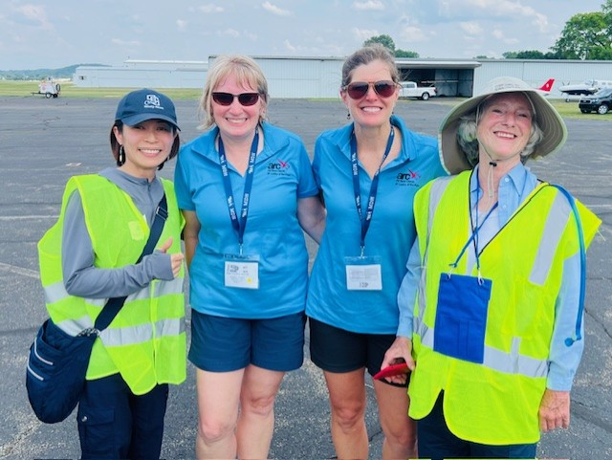
Jun Oikawa, Lin Caywood, Susan Beall And Mary McC

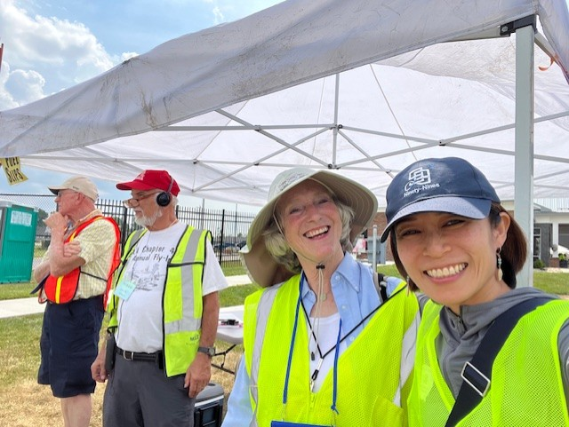

Mary McC and Jun Oikawa
July 3-7 Ninety-nines International Meeting in Vancouver

Judy Shaw, RJ, Sue, Peggy, Rick and Dave and Barb Gruber were all there.
Barb Gruber won a service award (see Member accomplishments below)

July 22-28 Oshkosh

Tayo Black flew to Oshkosh in a Cirrus, Sue and Dave, Mia Anderson, Melissa Plumer were there, Laura gave her Block-buster Tenerife talk,

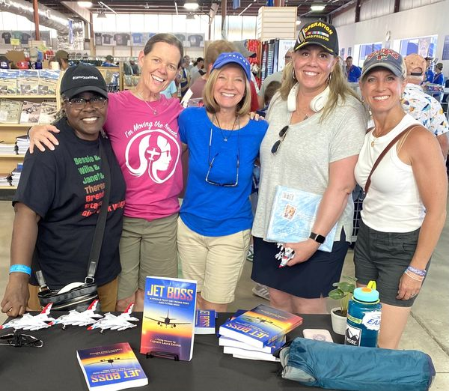
Girl pilot power!
Theresa Claiborne, first black female Air Force pilot & fellow UAL captain - Donna Miller, AA captain - Laura Savino, ret UAL captain and author of JET BOSS - Caroline 'Blaze' Jensen, Air Force Thunderbird pilot - Heather 'Lucky' Penny, F-16 hero pilot on 9/11.
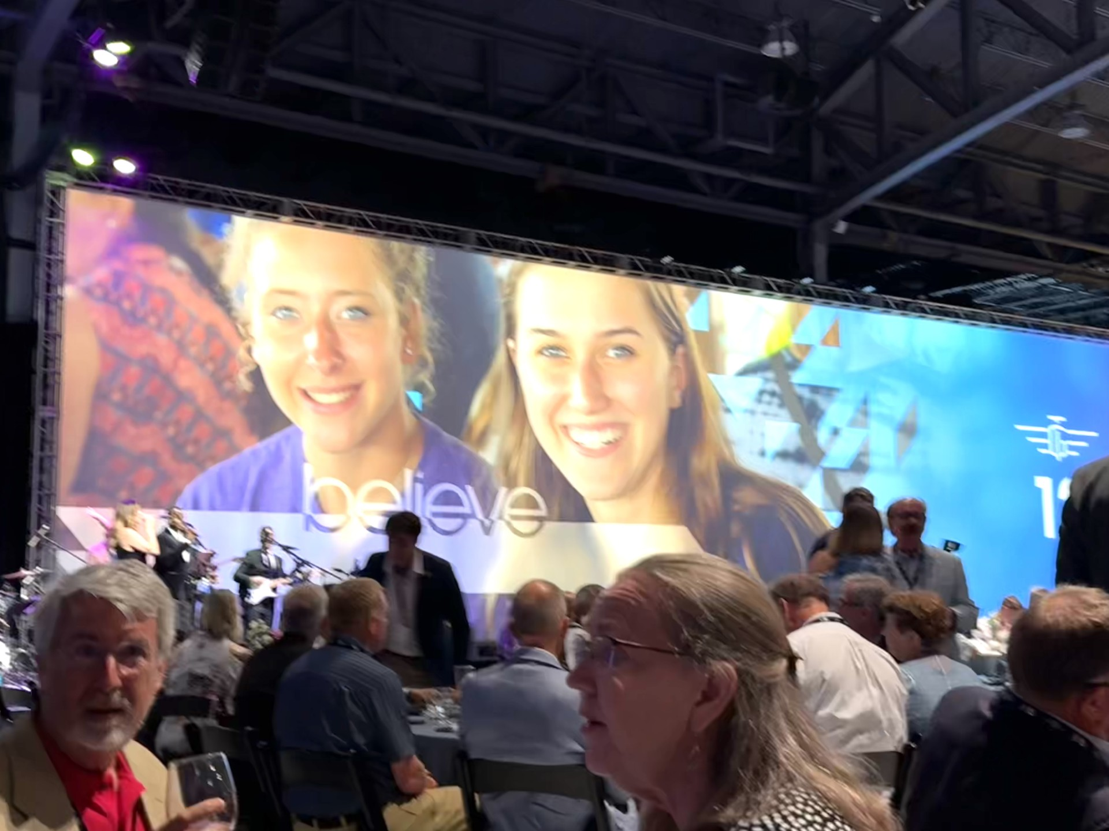
Here is Mia’s picture on the screen at the Young Eagles Fund Raiser dinner Sue and Dave Passmore in the foreground

Mia got to fly with Titan Aerobatic team.

FUTURE EVENTS

September 14. Let’s Fly Now at Easton Airport

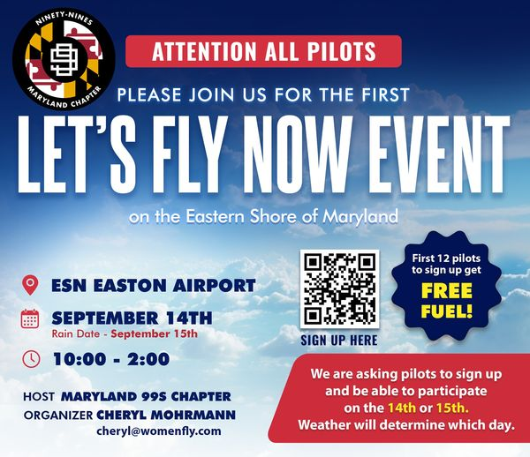

WAI Girls in Aviation September 24

November 8 ProJet Aviation Expo
Change in Location. Still ProJet though
ProJet Aviation | Aviation Expo

NEW LOCATION!!
Rider Jet Center (KHGR)
18421 Henson Blvd.
Hagerstown, MD 21742

We are signed up for ProJet again this year. As always we want volunteers to hang out at our table.
We are happy to note that two of the keynote speakers are women:
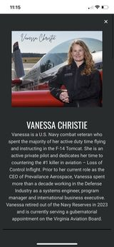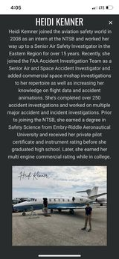

MEMBER NEWS

Frankie Velazquez earned her Instrument Rating

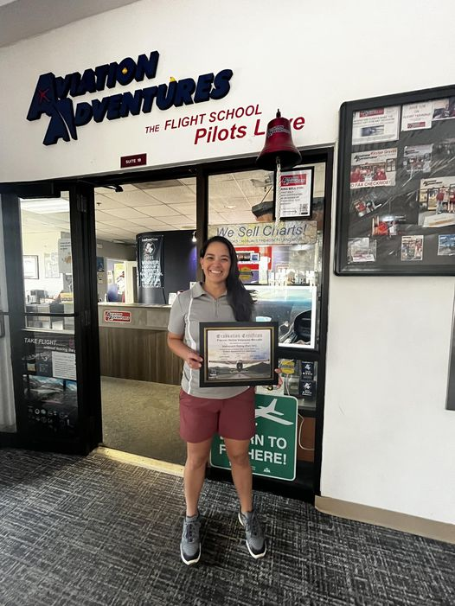

Hannah Rust Also earned her Instrument Rating

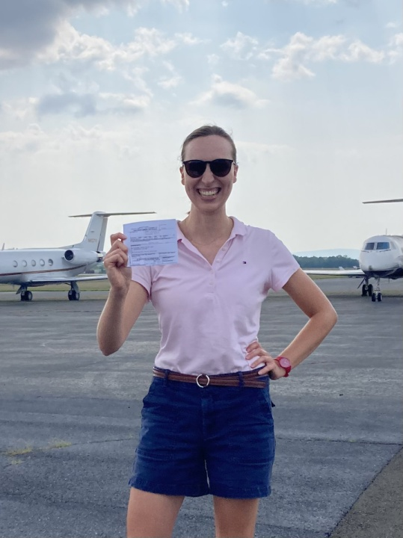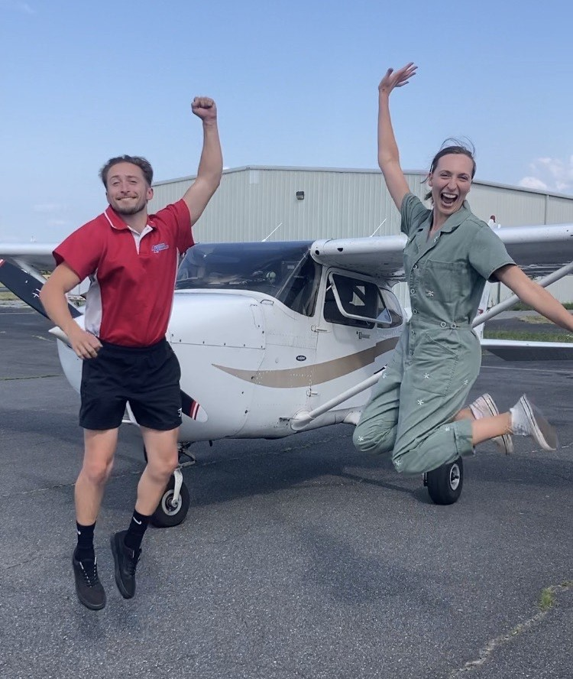
Logan Campbell with Hannah

Barb Gruber won an Award at the International Convenstion for her educational and public outreach contributions to aviation.

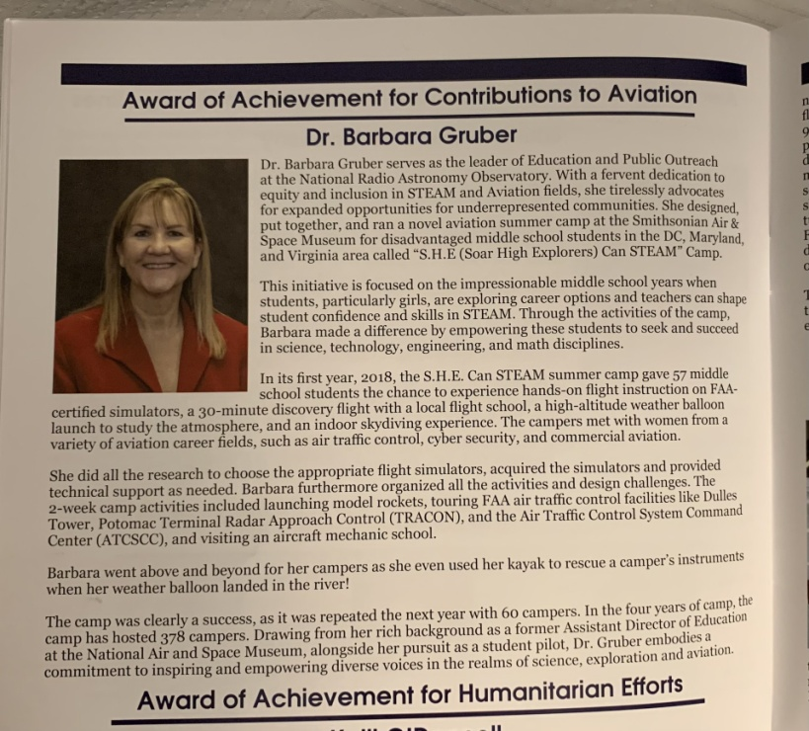

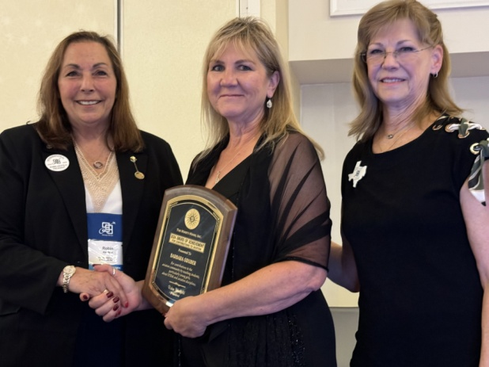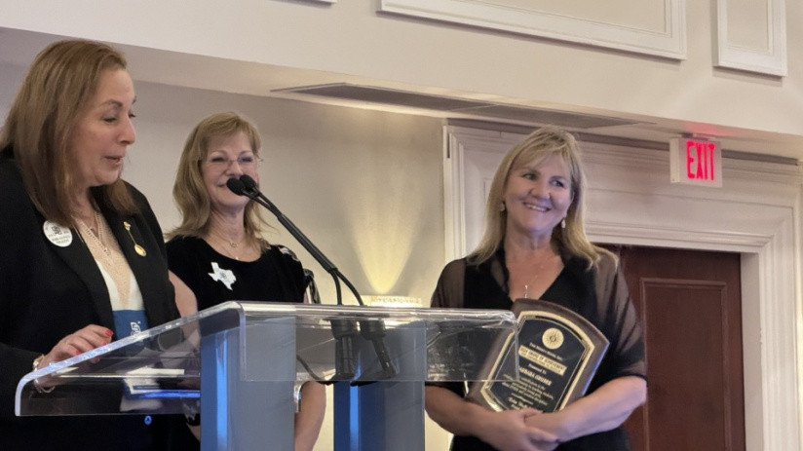

New Member:

Alana Bicoy.

Alana lives in Oakton and flies out of Leesburg, but goes back to Florida again this fall for her second year at Embry Riddle. Currently she is working towards Commercial at Leesburg,

