

Old Dominion Chapter
SKYLINES
August 2024

Chair: Cynthia Axell and
Mary McCutcheon
Vice-Chair: Nancy Schuster
Secretary: Mary McCutcheon
Treasurer: Barb Gruber

Amelia Earhart Scholarship:
Cynthia Axell
Membership: Sue Passmore
Newsletter: Mary McCutcheon
Webmaster: Stephanie Kight

HISTORY TIDBIT
I have a document that R.J. gave me for archival keeping, that begins with page 2. It is the minutes of a very early meeting of the 99s which lists 92 charter members and calls itself the “97 club”. STRANGE.

NEXT CHAPTER MEETING
The September meeting has been canceled. We will announce an October meeting soon.

NEXT SECTION MEETING

October 4 and 5 will be the fall section meeting hosted by the D.C. Chapter.

Pre-register at www.dc99s.com

This looks like a fabulous meeting.
Here is the agenda:

Friday October 4, 2024

10 Am – Noon. Tour of Glenn L. Martin Wind Tunnel. This is near the College
Park Airport, at University of Maryland, Wind Tunnel Building # 081, Paint Branch Drive, College Park, MD. Why are airplanes designed as they are? This special tour is in a state of the art low speed wind tunnel and has been actively involved in aerodynamic research and development of airplanes and wing designs. A fascinating tour explaining how fuselage, helicopters, conventional airplanes, UALs, wings are designed. Cutting edge design of airplanes to make them lighter, more buoyant, more efficient. The Wright Brothers had very primitive wind designs. This is a very interesting tour. Only for those who pre-register.

1:30 – 3:00 PM. Tour of National Transportation Safety Board at 490 L'Enfant Plaza, SW, Washington, DC 20594. A fascinating tour explaining how they investigate aviation accidents. Many accidents have been investigated, including US Airways Flight 1549, “the Miracle on the Hudson”. Explanation of some of the historic aviation accidents. Only for those who pre-register.
​​

Saturday Oct 5, 2024
Business Meeting:
9AM to Noon. Montgomery County Airpark – Gaithersburg Airport KGAI
Business meeting will be held at (first floor) Main Conference Room – Washington International Flight Academy (WIFA), Montgomery County Airpark (Gaithersburg, KGAI) 7940 Airpark Rd, Hangar C, Gaithersburg, MD 20879. There is parking available. You do not need a PIN to fly into KGAI.
This space is handicapped accessible.
​
Speaker: to be announced soon!
​
Lunch:
Noon to 1:00 PM by Café Sophie
Lunch will be provided by Café Sophie, which is a delightful European style café with a Scandinavian influence at Montgomery County Airport (KGAI). Tom, a Co-Founder, is a foodie from Bergen, Norway.
A few family members serve as hostesses. Also at main building of KGAI, (Second floor) 7940 Airpark Rd, Gaithersburg, MD.
​
August meeting

We had a good meeting on August 15 at Manassas Regional Airport in the terminal building meeting room.

The big attraction was a talk by Forrest Jones who is a member of the FAA safety team. He spoke about “lessons learned” and gave a gripping story about a mistake made in his plane’s annual that nearly cost him and his family and their dog’s lives. The land gear did not engage and the manual override was obstructed. He and his son and his wife (simultaneously dealing with a baby’s projectile diarrhea) all worked together for free the manual override. Meanwhile, the tower was alerted to a possible emergency, his wife took off her blouse to get rid of the diarrhea, and when they landed safely, they were naturally met by a cluster of concerned people. Lesson learned? After every annual check EVERYTHING thoroughly.

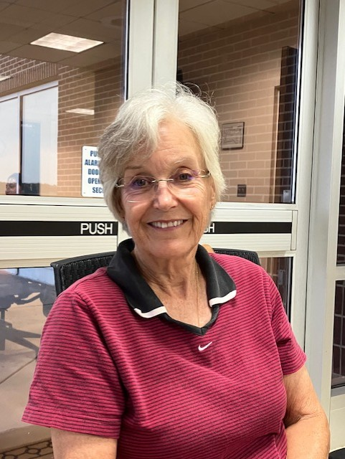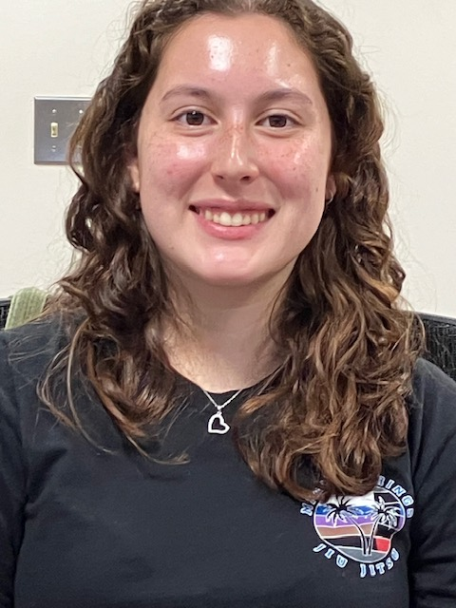
Cynthia Axell Alana Bicoy
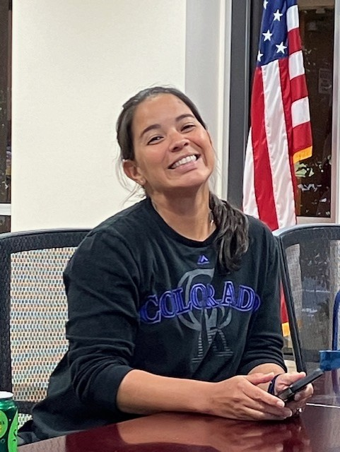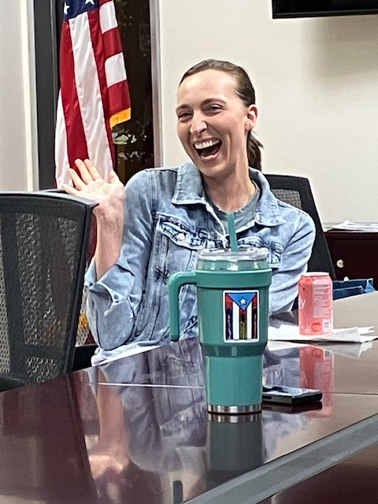
Frankie Velazquez Hannah Rust

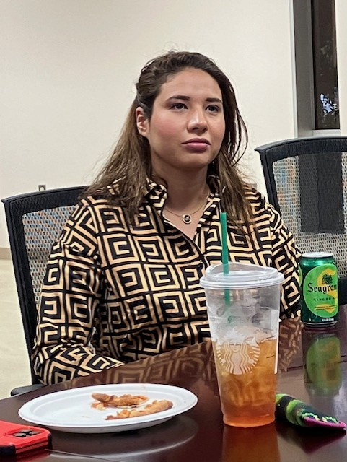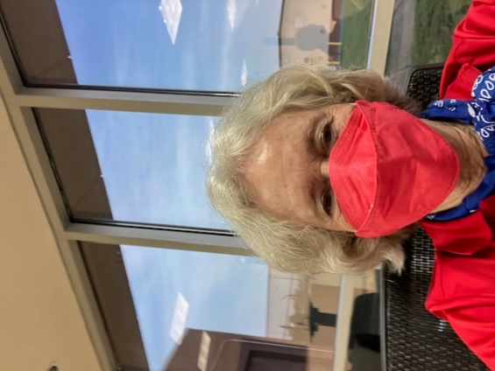
May El Zablawy Mary McCutcheon
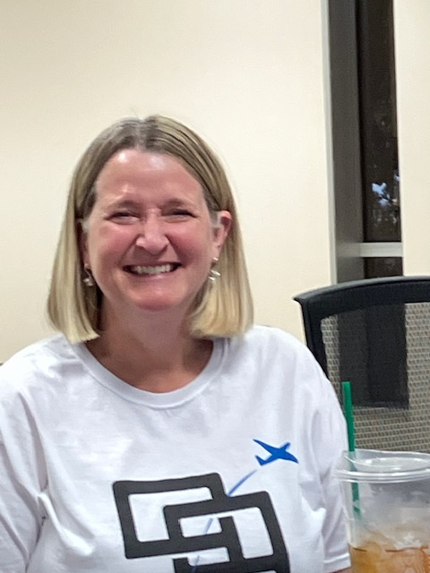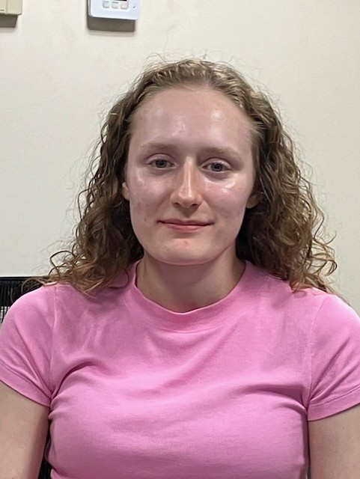
Nancy Schuster Priscilla Raila

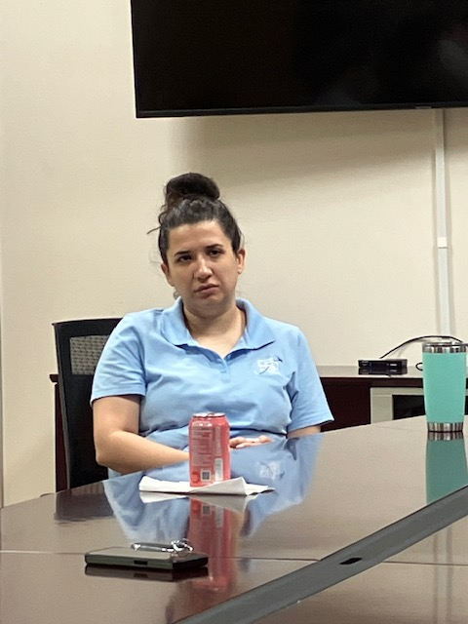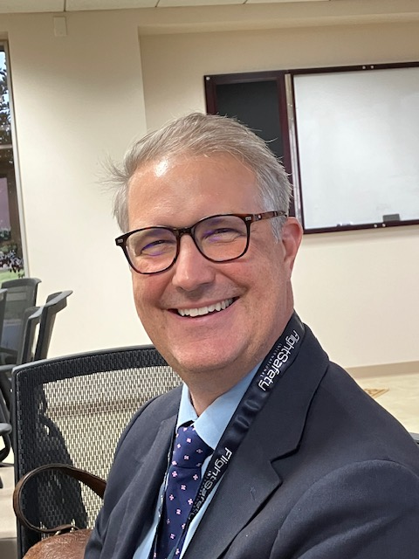

Yvy Von Helde Forrest Jones

FUTURE EVENTS

Let’s Fly Now September 14

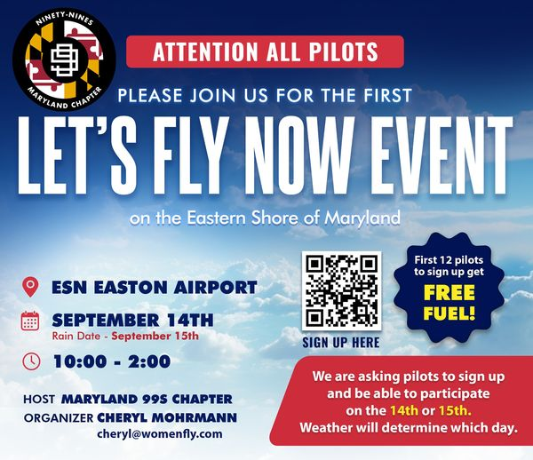

UDVAR HAZY TALK: September 19 8PM
The Path to Equality for Women Military Aviators

At the Steven F. Udvar-Hazy Center
and Live on YouTube
The U.S. military began training women as pilots and other aviators in 1973. But they didn’t achieve full equality until 1993, when they gained the right to fly combat aircraft.
Join us for The Path to Equality for Women Military Aviators on September 19 as authors Beverly Weintraub and Eileen Bjorkman discuss the challenges faced by America's pioneering women military aviators and their fight to open doors for future generations.
Registration is required for in person attendance and encouraged for online viewing.

Register for In Person |  | Register for Online

Udvar Hazy Talk: Women Take Flight: Stories of Air and Sea from the U.S. Coast Guard
October 10 at 8 pm
At the Steven F. Udvar-Hazy Center
and Live on YouTube
For over 100 years, the United States Coast Guard has used aviation as a means to save those in peril and protect the U.S. from maritime threats.
Join us for Women Take Flight: Stories of Air and Sea from the U.S. Coast Guard on October 10 as Cmdr. Jeanine Menze, Lt. Cmdr. Chanel Lee, and Lt. Cmdr. La'Shanda R. Holmes (Ret.), some of the first Black women to serve as Coast Guard pilots, discuss the victories and challenges of flying rescue and maritime enforcement missions for the military.
Register for In Person |  | Register for Online

November 8 ProJet Aviation Expo
Change in Location. Still ProJet though
ProJet Aviation | Aviation Expo

NEW LOCATION!!
Rider Jet Center (KHGR)
18421 Henson Blvd.
Hagerstown, MD 21742

We are signed up for ProJet again this year. As always we want volunteers to hang out at our table.
We are happy to note that two of the keynote speakers are women: