

Old Dominion Chapter
SKYLINES
January 2025

Chair: Cynthia Axell and
Mary McCutcheon
Vice-Chair: Nancy Schuster
Secretary: Mary McCutcheon
Treasurer: Barb Gruber
Amelia Earhart Scholarship:
Cynthia Axell
Membership: Sue Passmore
Newsletter: Mary McCutcheon
Webmaster: Stephanie Kight

NEXT MEETING
Our Next meeting will be January 13 at Lezzet Restaurant
13850 Braddock Rd #E, Centreville, VA 20121

Come at 6 for dinner and informal talk.
After dinner we have two parts to the program:

- Our speaker will be R.J. McGlasson who will speak about the India Conclave she went to in late November.

- And the business we hope to accomplish is the review of the chapter applicants for the Amelia Earhart Scholarship which are due January 1. We need to decide whether to push the applications up to the section level.

POLICY ON POSTING PHOTOS IN THE NEWSLETTER

I have been posting photos in the newsletter oblivious to the possibility that people might object. Please let me know if you prefer not to have your picture put in the newsletter and let me know if we are at a meeting or an event or a party that you would like me not to take your picture. I apologize for putting in unauthorized pictures. Often, I lift pictures from Facebook too. Let me know if this is not what you want too.

MID-ATLANTIC SCHOLARSHIP

Consider applying for the Mid-Atlantic scholarship for ratings and certifications above the level of PPL. Due date is February 28. I posted the application in a recent email. If you want me to resend this or you didn’t get it in the first place, let me know: mmccutch@gmu.edu

CHAPTER MEETING ON NOVEMBER 21

We met at the Pimmit Branch of the Fairfax County Libraries on November 21.
We shared food we brought in and heard an excellent presentation by Maria Esparaguerra from the Maryland Chapter. She spoke on mentoring in aviation and how important it is for pilots at all stages of their training and careers to have a circle of supporters. The Ninety-nines of course provides the framework for this support. In the discussion we agreed that we could make an effort to “be there” for each other.

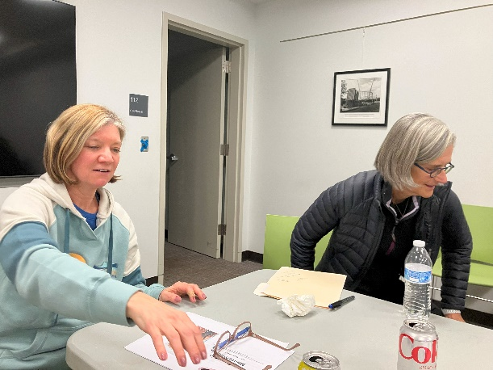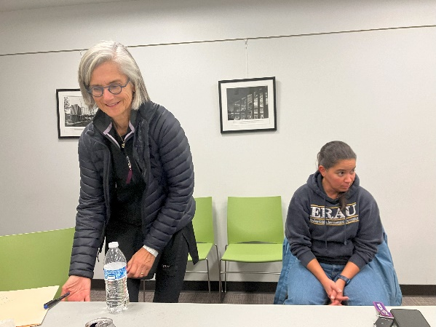
Laura Savino and Maria Esparraguera Frankie Velasquez and Maria E.

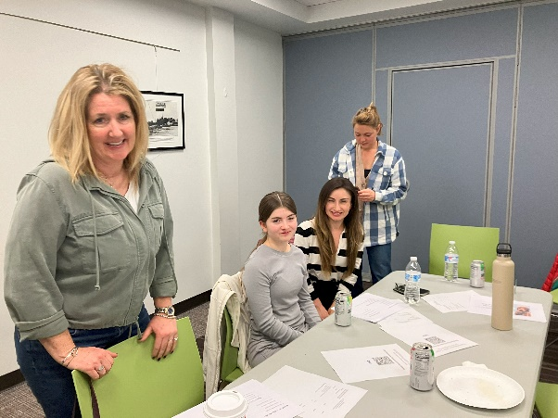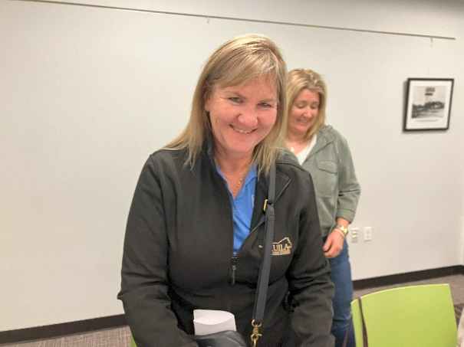

Emma, Tatiana, Olessiya, Nancy Nancy Schuster and Barb Gruber

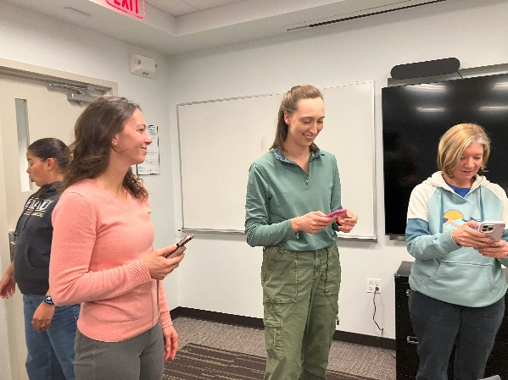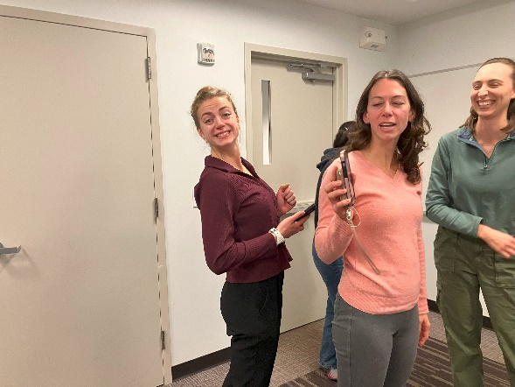
Frankie, Kat, Hannah, Laura Samantha, Kat, Hannah

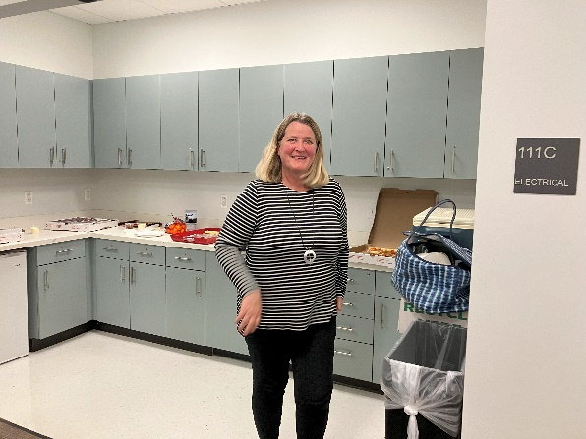
Nancy Schuster

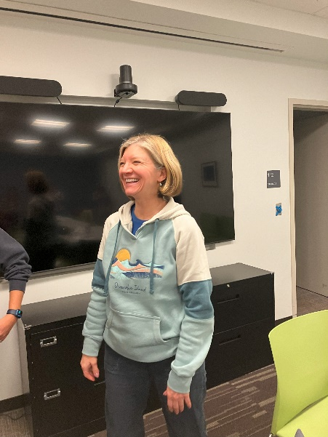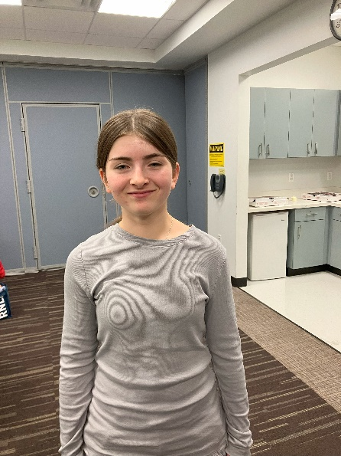
Laura Savino Olessiya Russell

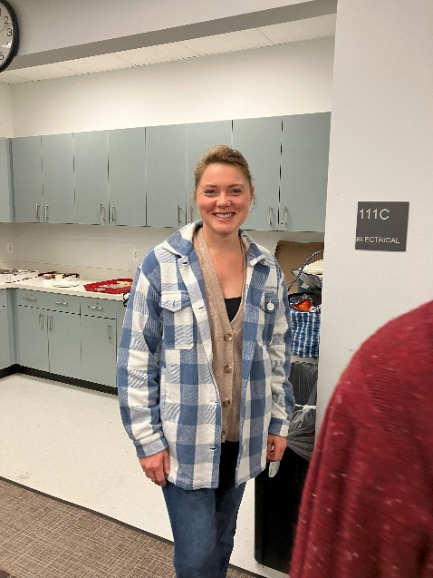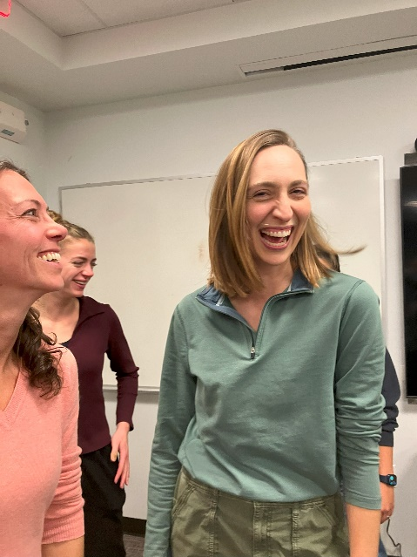
Emma Summers Kat Emery and Hannah Rust

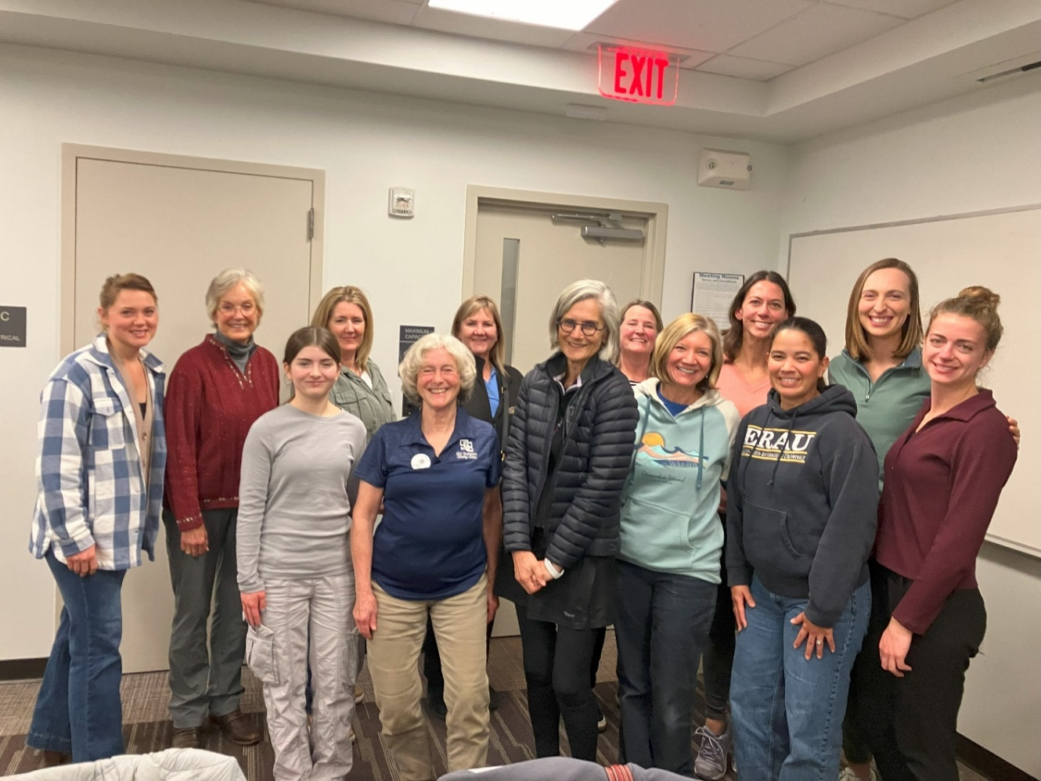
Emma Summers, Cynthia Axell, Olessiya Russell, Nancy Schuster, Mary McC,
Barb Gruber, Maria Esparraguera, Jenn Weller, Laura Savino, Kat Emery, Frankie Velasquez, Hannah Rust, Samantha Stahl

HOLIDAY PARTY AT SUE’S HOUSE

The Holiday party at Sue Passmore’s house on December 8 was a hit. The food was fabulous and the gifts were unforgettable. Next year, we might see some recycled ones.

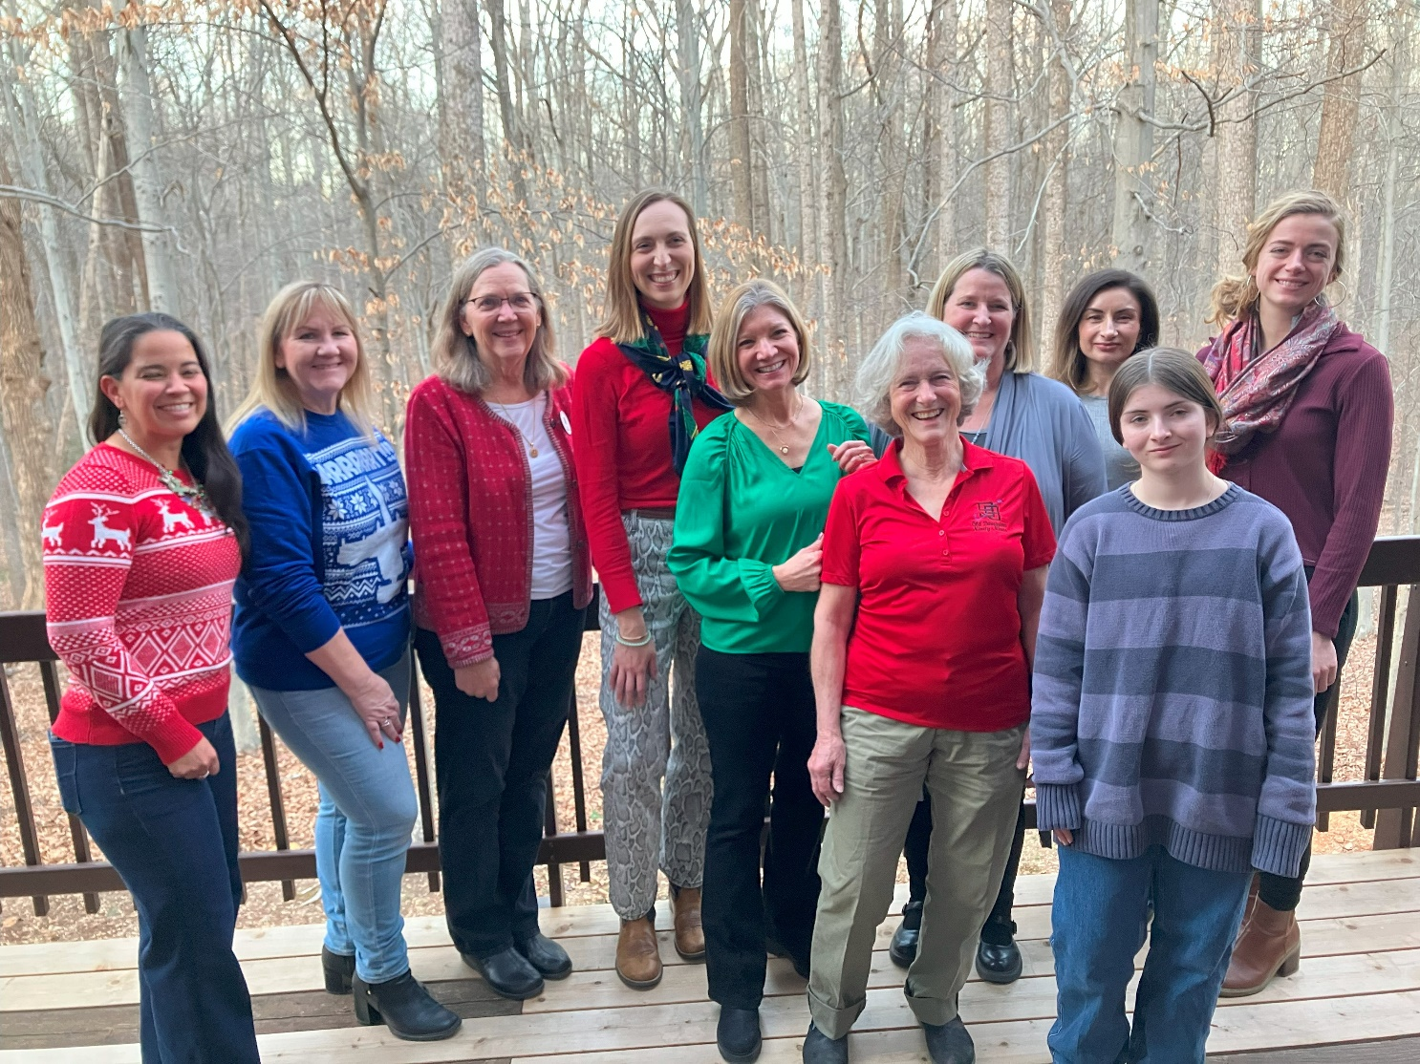
Frankie Velasquez, Barb Gruber, Sue Passmore, Hannah Rust, Laura Savino, Mary McC, Nancy Schuster, Tatiana Russell, Olessiya Russell, Samantha Stahl
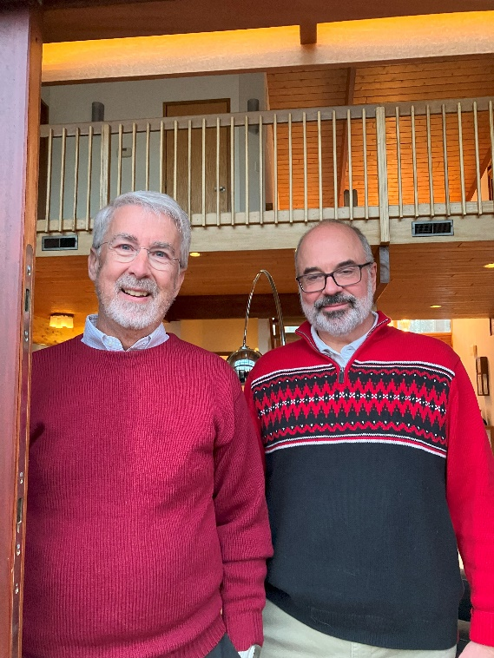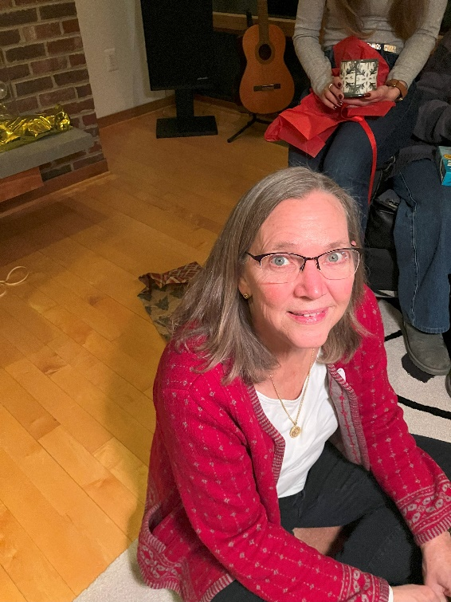
Dave Passmore and Dave Gruber Sue Passmore

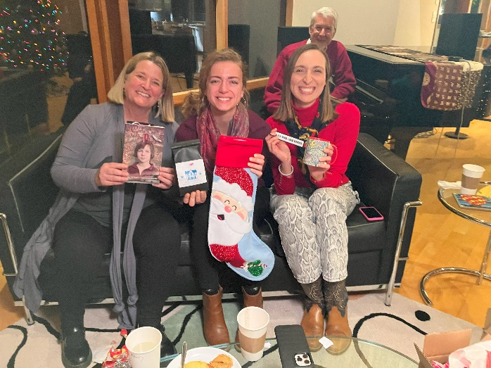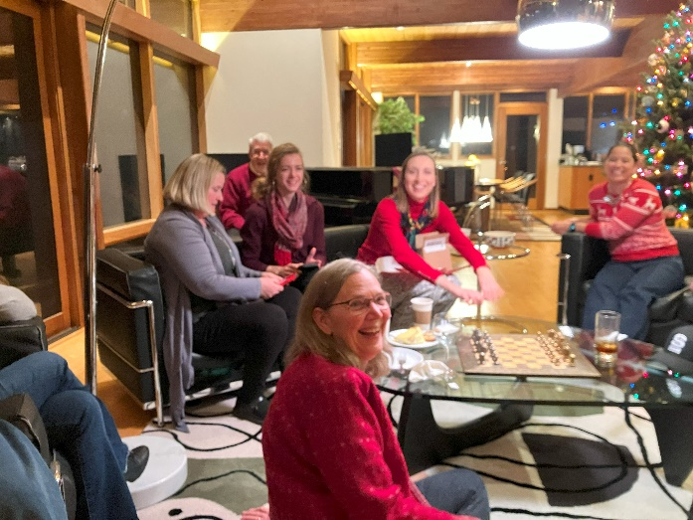
Nancy, Samantha and Hannah

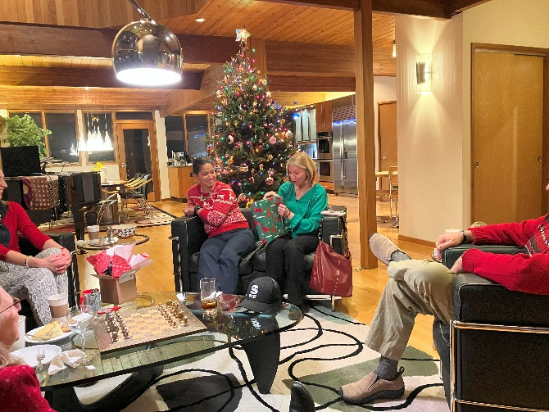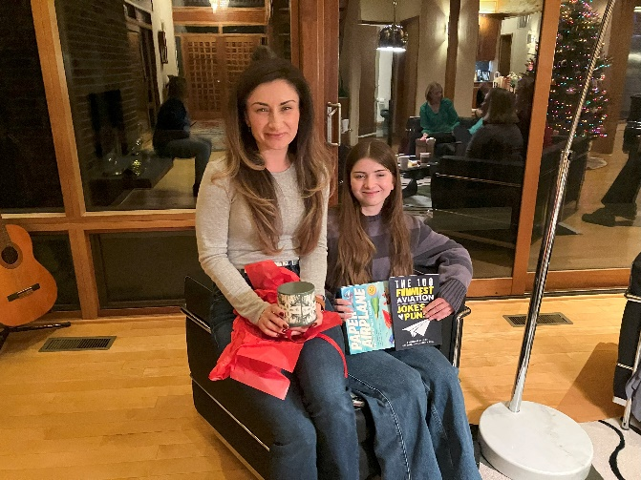
Tatiana and Olessiya Russell

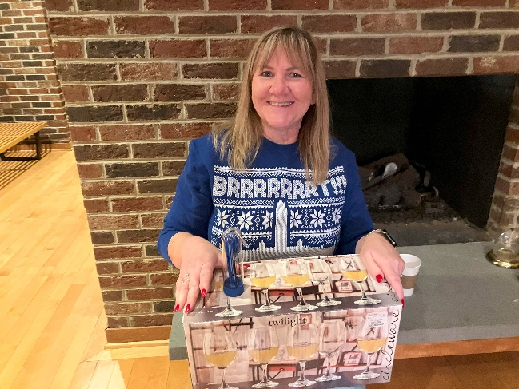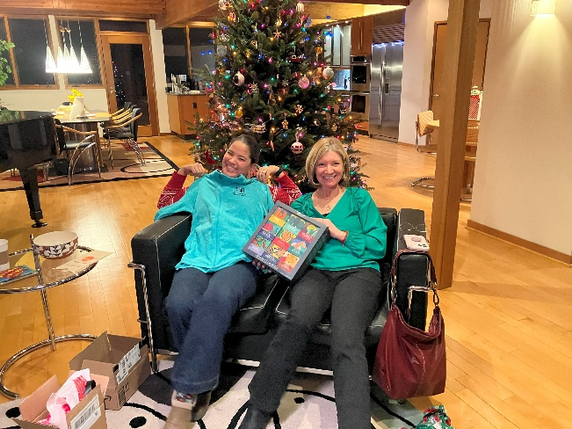
Barb Gruber Frankie and Laura

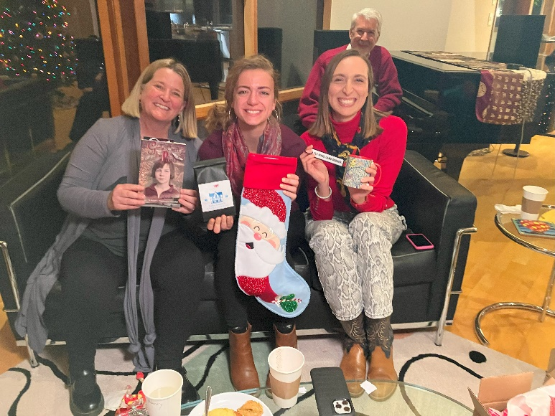
Nancy, Samantha and Hannah

SEUK KIM FUNERAL

Though this was not a Ninety-nines event, a lot of us knew Seuk and/or did Pilots N Paws rescues. The Funeral was in Fairfax on December 5. It was very moving. Laura Savino, Mary McC, and Gail Keys were there.

