

Old Dominion Chapter
SKYLINES
February 2025

Chair: Cynthia Axell
Vice-Chair: Nancy Schuster
Secretary: Mary McCutcheon
Treasurer: Barb Gruber
AE Scholarship: Cynthia Axell
Membership: Sue Passmore
Newsletter: Mary McCutcheon
Webmaster: Frankie Velasquez

NEXT MEETING
Our Next meeting will be on February 20 from 6 to 9
We shall meet at the Leesburg Executive Airport
1001 Sycolin Rd SE, Leesburg, VA 20175.
Nancy has reserved the conference room.
We are allowed to bring in food and drinks, so feel free to pack some snacks.
And the presentation for the meeting will be Laura Savino speaking on the Tenerife accident

January Chapter Meeting
On January 13, we met at the Lezzet Restaurant in Centreville (see minutes)

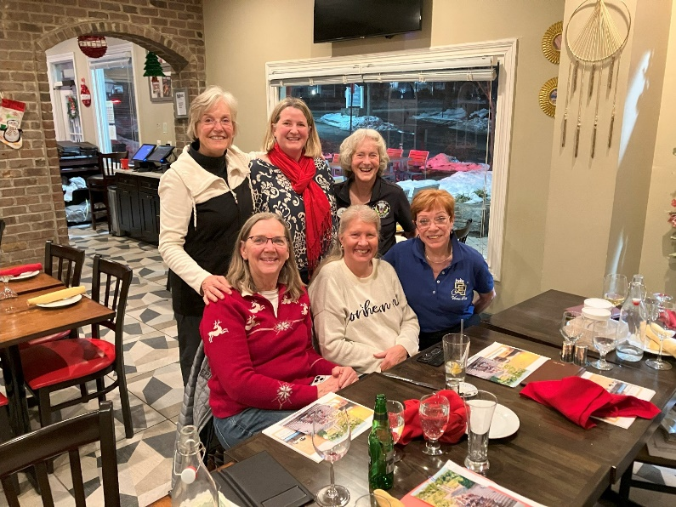
Cynthia Axell, Sue Passmore, Nancy Schuster, Morgen Reeb, Mary McC, RJ McGlasson
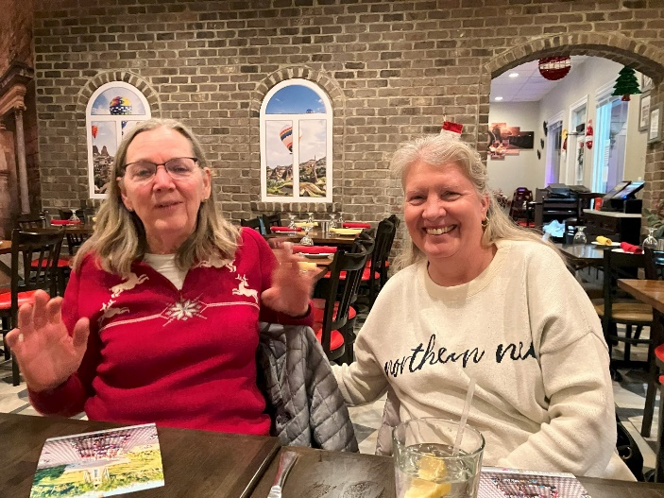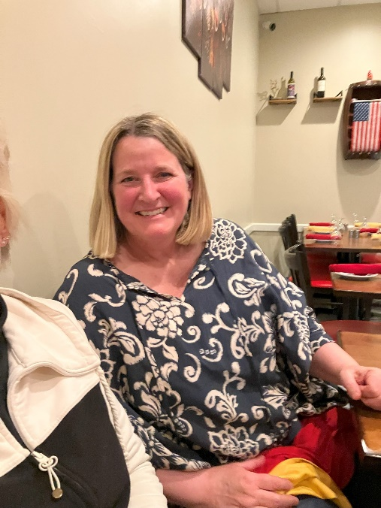
Sue Passmore and Morgen Reeb Nancy Schuster

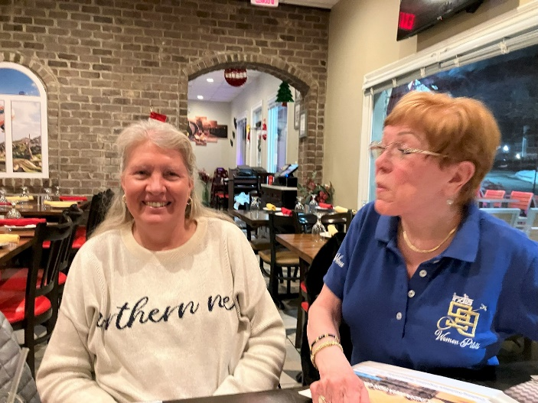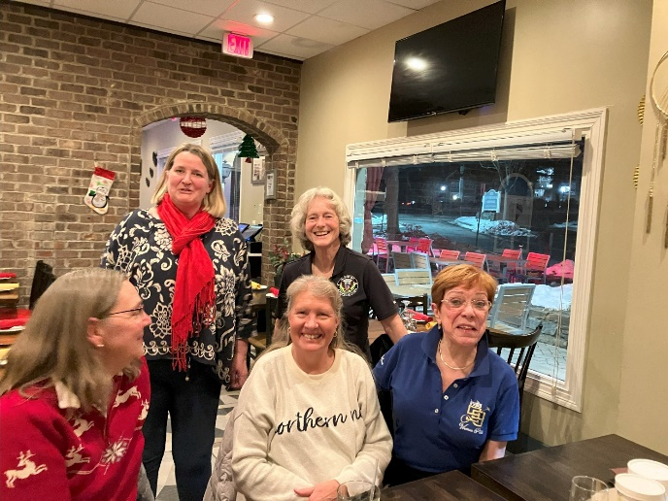
Morgen Reeb and RJ McGlasson RJ, Mary, Morgen, Nancy and Sue

R.J. McGlasson gave a great presentation on the India Conclave in December. The chapter there really went all out to give their visitors as good a time as possible. There was terrible pollution, several people got sick and RJ hurt her leg. But the whole experience was memorable. Here are some of her pictures:

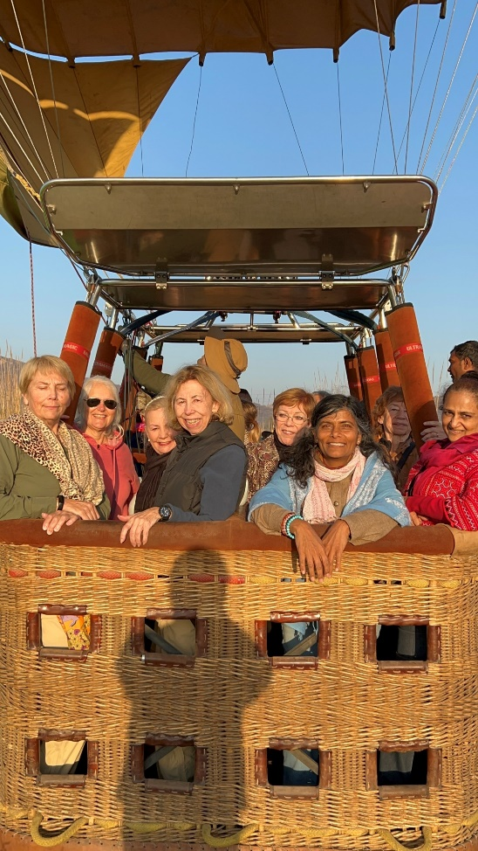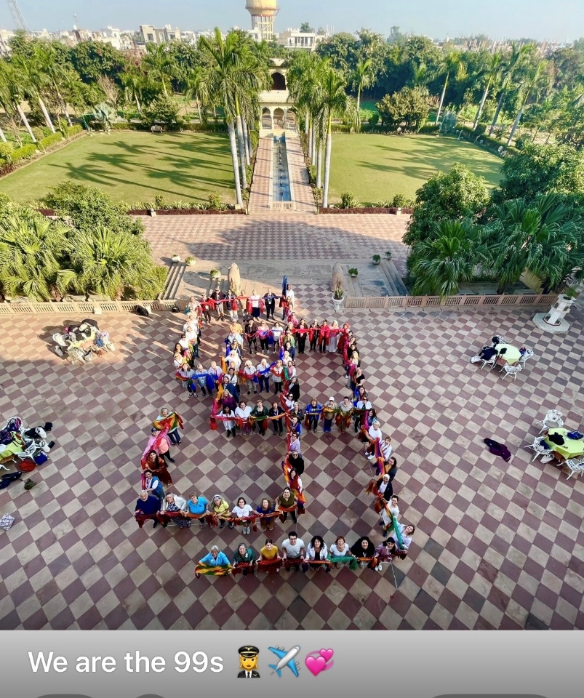



MID-ATLANTIC SCHOLARSHIP

The deadline for the Mid-Atlantic Scholarship is February 28. Check guidelines in an earlier email. Contact me if you want me to resend:
mmccutch@gmu.edu

WASP EXHIBIT AT AIR FORCE MUSEUM

The Air Force Museum in Dayton is proud to have a new and big exhibit on the WASP. Here is the big announcement:

https://www.nationalmuseum.af.mil/Upcoming/Press-Room/News/Article-Display/Article/4065522/national-museum-of-the-us-air-force-opens-refreshed-and-expanded-exhibit-honori/

Retirement of Major General Jeannine Leavitt, First female fighter pilot

https://www.msn.com/en-us/news/us/u-s-air-force-1st-female-fighter-pilot/vi-AA1uCZr2?ocid=socialshare

MEMBERS ACCOMPLISHMENTS

Alana Bicoy has earned three certificates/ ratings in about 4 months: Commercial (in earlier newsletter), CFI, and CFII. This is amazing.
She is in Florida now but will be back for the summer.

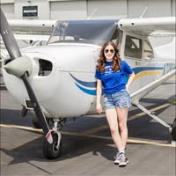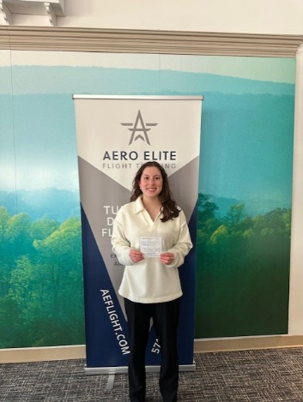
CFI

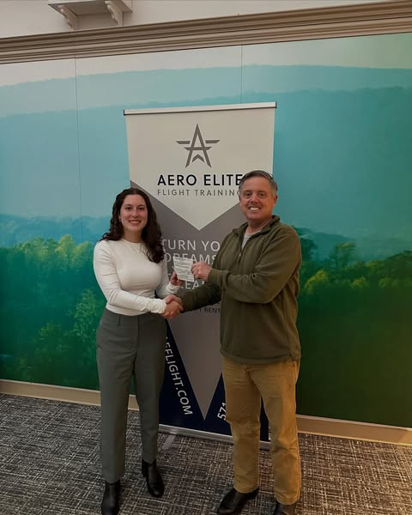
CFII

