

Old Dominion Chapter
SKYLINES
March 2025

Chair: Cynthia Axell
Vice-Chair: Nancy Schuster
Secretary: Mary McCutcheon
Treasurer: Barb Gruber
AE Scholarship: Cynthia Axell
Membership: Sue Passmore
Newsletter: Mary McCutcheon
Webmaster: Frankie Velasquez

Chapter Meeting

March 31 6 to 8:30
McLean Governmental Center, 1437 Balls Hill Rd. McLean, VA.
You can bring food (potluck or whatever you want) and there is AV equipment.

Kat Emery will be our speaker.
Our hangar talk will be about WIND. See the talking points later in the newsletter under the heading “HANGAR TALK”
We also have a new sign-up system thanks to Nancy:

Old Dominion 99’s March Meeting
signupgenius.com

Mid-Atlantic Section meeting

April 25 and 26th

Hosted by the Delaware Chapter at Delaware State University, Dover, Delaware
Contact: Rachel Anderson
This just in from Polly Steenhagen and Rachel Anderson:
You can register now at delaware99s.org
And get additional information on https: mid-atlantic99s.org.
Want MERCH? Go to https://forms.office.com/r/PysXfFk0Fm

POSSIBLE TRIP TO THE DRONE FARM IN WATERFORD

Laura Savino got this message from XElevate where we went for a field trip a few years ago.

The owner of XElevate, Andrew Biechlin, has invited our chapter to come out for a tour and for a one day hands-on drone lesson.
I know we tried this a few years ago, and inclement weather kept our drones on the ground. We have been invited back.

Past meeting. February 20

We had a terrific meeting in the meeting room at Leesburg Airport
After a potluck dinner, we conducted a little bit of business and we had some hangar talk about communications and mis-communications

Then Laura Savino gave a spell-binding account of the Tenerife disaster.

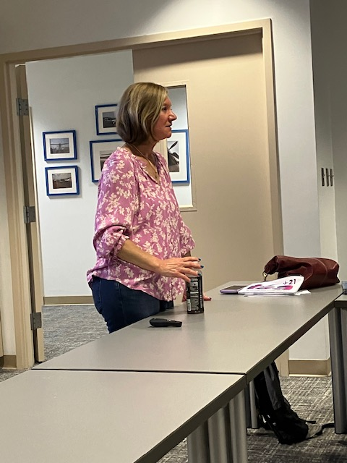
Laura Savino

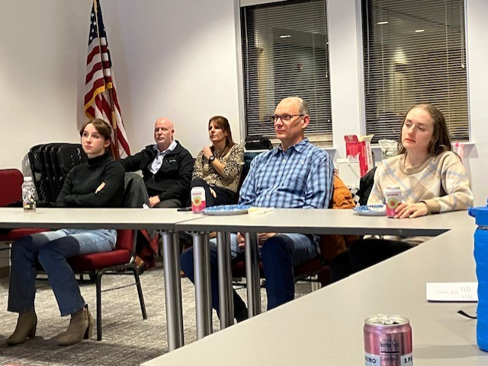
Maya Schweigert, Maya’s parents, Tony Raila, Priscilla Raila

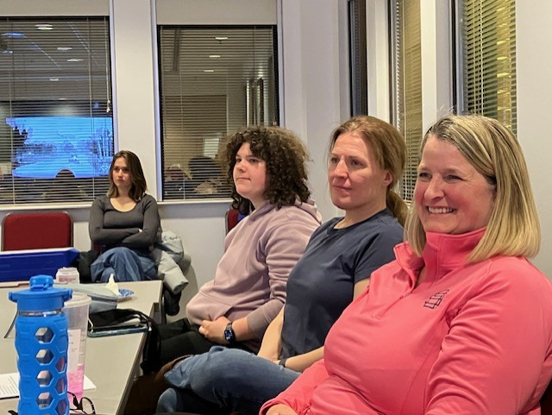
Mia Anderson, J.P. Kane, J.P.’s mother, Nancy Schuster

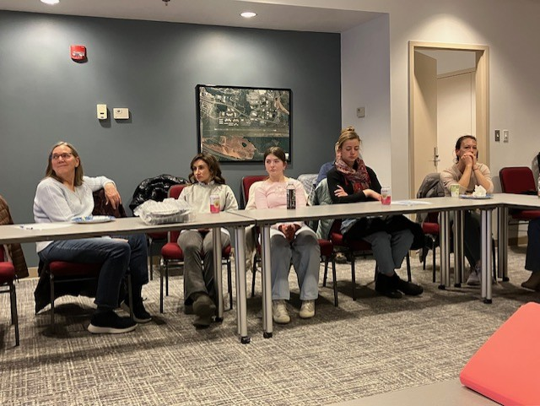
Sue Passmore, Tatania and Olesiya Russell, Sam Stahl, Kat Emery

INTERNATIONAL ELECTION SLATE

The only contested position is Director: we can vote for up to two and there are three candidates. Other positions are not contested. I am including the campaign pitches for the director position only.
The voting deadline is May 1, 2025 at 11:59 pm GMT +00:00, UTC.
The Ninety-Nines, Inc. is using an online election system to tabulate votes. You have been assigned a unique access key which can only be used to vote once, and your voting choices will remain anonymous. Do not forward this email. Do not reply to this email to vote, as your vote will not be registered.
To vote, visit:
https://secure.electionbuddy.com/XNDH-MJLM-HG5S-TBSS/
CANDIDATES FOR DIRECTOR – VOTE FOR UP TO TWO

A1 Madeleine Monaco Chicago Area Chapter, North Central Section

My long participation in almost every area of the Ninety-Nines activities has allowed me to learn and grow and I would like to continue to serve as Director. I have a BA in Applied Behavioral Science from National Louis University. I have been CEO of a medium sized labor union IBEW 1220, Radio and Television Broadcast Engineers and developed many innovative projects for that body, negotiating contracts, conducting arbitration and grievance processes, and leading organizing campaigns. I have been a CFI since 1982 and co-founded the pilots association at Palwaukee Airport. I have been a member of CAP, EAA, Illinois Aviation Forum, Illinois Aviation Hall of Fame, and Illinois Aviation Museum. Serving in the past as an Alderman and an Airport Commission Member for the City of Prospect Heights, co-owner of Chicago Executive Airport, has enhanced my role as an airport activist. I believe that members benefit more from an organization by participating. After winning an AE Scholarship I worked to pay back to AEMSF as a Trustee. My philosophy and goals are personified by a welcoming attitude. An encouragement to all woman pilots to join, get active and find that their passion and sense of purpose will be rewarded by their involvement in aviation and the 99s. My goal as Director would be to keep working to assure that every woman pilot knows about the 99s and considers joining in our valuable work – supporting women who fly.

A2 Carol Voss Emerald Angels of the Gulf Coast Chapter, Southeast Section

I am honored to submit my candidacy for the International Director position. My affiliation as a student pilot with the 99s began in 1988, when we were not able to join as 99s, but only participate as a “66” of a local chapter. Since then, I have been an active member of four Chapters, and now a proud Life Member. Currently I serve as Chapter Chair, Membership Chair and on Southeast Section’s Ways & Means Committee. Within my Chapter, I have held all officer positions, Section Meeting Chair, volunteered at the AirVenture 99s tent and the 99s House at Sun ‘n Fun, chaired our booth at the AOPA fly-in and have promoted the 99s at countless other aviation events. As a Director for two different Sections I served as the Awards Committee Chair. I have been an officer in my local EAA chapters, a member of AOPA, WAI, AWAM, volunteered for the Air Race Classic, and have been a Pylon Judge for the National Air Race Championships in Reno. There are so many reasons to be involved with the 99s, but the highlights for me have been the lasting friendships and introducing new pilots to the amazing 99s. Over the years, I have experienced so many improvements in our organization and look forward to working on our International Board in whatever capacity I can contribute and support. I would be
honored to use my executive business experience and skills to serve as your International Director.

A3 Dina Dawod African Section

As Vice Governor of the African Section of the Ninety-Nines, I bring extensive experience and a deep passion for empowering women in aviation. I am a Commercial Pilot flying for a private airline in Egypt, with a proven track record of leadership and advocacy. With Africa having less than 1% of women as pilots, I have dedicated my career to advancing opportunities for women in our industry. My contributions to the Ninety-Nines include raising awareness of the organization across Africa through participation in international aviation conferences as a panel speaker in countries such as Dubai,Rwanda, Ethiopia, Malawi, Jordan, and Egypt. I have spearheaded outreach programs, including recent partnerships with AFRAA and EgyptAir, to inspire the next generation of female aviators. These initiatives reflect my commitment to expanding the presence and influence of the Ninety-Nines globally. My philosophy aligns with the core values of the Ninety-Nines: fostering camaraderie, mentorship, and support for women in aviation. My goals as International Director are to increase global membership, particularly in underrepresented regions like Africa, by creating pathways for mentorship and education, enhancing visibility through strategic partnerships, and building a robust network of collaboration among members worldwide. Together, we can continue the Ninety-Nines’ legacy of excellence and inclusion. I am honored to seek your support for this position and remain committed to advancing our shared mission of empowering women pilots across the globe.

AVIATION EXPO

We have participated in the ProJet Aviation Expo in Leesburg for years. It is always on a Friday in November and busloads of high school aviation students come to see what careers might be in store for them. Then last year the Expo moved to Rider Aviation in Hagerstown. It may be there every other year or every year. I don’t know. It was a long drive to get there and members of the Mountaineer chapter are located there already. Now we should decide whether or not to continue to do this. To do it only if it is in Leesburg. Or to encourage the Mountaineers to take it on.

MID-ATLANTIC SCHOLARSHIP

We had seven applications for the Mid-Atlantic Scholarship this year. The results will be announced VERY SOON

CALL FOR NOMINATIONS FOR CHAPTER POSITIONS

Pretty soon we’ll have our chapter elections again and as always we are searching for people interested in serving in any of our elected positions: Chair, vice-chair, Secretary and Treasurer. The chair must be replaced every two years. Other positions might be kept for more terms, but some circulation is always desirable.

Hangar Talk by Cynthia Axell

Wind. Pilots alternatively love, and hate, wind. When it’s blowing steady down the runway, grass strip or narrow river we intend to take off and land on, it’s our best friend. When it’s a gusty crosswind, or a tailwind on a one-way in, one-way out landing area, it’s like the friend that not only ghosted us, but turned against us: a challenging change of events we have to deal with.
Just taxiing out in high winds can be a challenge. In most GA aircraft, you’ll steer with rudder as usual but find you’re using quite a bit to keep on that taxi line. You don’t need to think much on what rudder to use—just keep the nose pointing straight. The nose will want to weathervane into the wind (thanks to that nice rudder back there). It will become instinctual to put in the proper control input to keep the airplane pointed where you want it. As for the wings, you absolutely must put the yoke, or stick, towards the wind. That dumps the lift on that upwind wing. Pulling the stick aft at the same time for any tailwind component will keep your trusty steed from trying to leap skyward.
You’ll notice, as you taxi, that the control input you are using to stay on track are what we call ‘crossed controls’. Wing down, opposite (or top) rudder. These are exactly the same inputs you’ll use on takeoff, landing and rollout. Otherwise known as a slip, or sideslip, this is the most common method used in crosswind conditions. After you lift off with those crossed controls, just ease them out to neutral to bring the aircraft back into trim. You’ll then fly out in a crab to track runway centerline.
For landing in a sideslip, you’ll find you touch down on the upwind wheel first. Then the downwind wheel, then the nose to help tracking. Keep those crossed controls in and don’t let them slide to neutral… you’ll know immediately if you got lazy and did this. As we say in aviation, it’s self-correcting. (Meaning the feedback you get tells you immediately you goofed.)
The other method is landing in a crab, where the nose remains pointed into the wind, the ground track is down the runway centerline, and you land essentially sideways. It requires quick action upon ground contact with both rudder and ailerons to de-crab, spoil the lift and keep the airplane on centerline. This maneuver can put tremendous initial side loads on the landing gear. One reason to land in a crab? The wind is so high that the sideslip (wing-down top-rudder method) risks dragging a wing tip on the ground. This is an issue in low wing, low engine aircraft (like the Boeing 737 with split scimitar wingtips and an engine that sits uncomfortably close to the ground.)
A final landing method is to conduct the entire final in a crab, then de-crab (wing down, top rudder sideslip) in the flare. This is what most airliners do. Why not fly the entire final in a sideslip you ask? Because airliners have spoilers, large panels on the upper side of the wing, to help in turns. When the yoke is turned ten degrees or more (as in a sideslip), those panels raise. They don’t just help turn, they create a tremendous amount of drag. Many airliners don’t have enough excess power to counteract that drag (especially when coupled with the drag of landing flaps.)
But happily, GA aircraft can fly in a slip all day long and still have excess power. You don’t have to go from a crab to a sideslip in the flare if you don’t want. But it’s a good skill to learn and practice, when you’re ready.
By the way, since we mentioned flaps… you might consider not using full flaps in a heavy or gusty crosswind condition. Those big old barn doors out there will only make things more challenging for you.
Very rarely, the winds are so strong, pilots will fly final in a crab on the upwind side of centerline (but still over the runway) because, during the decrab maneuver, the airplane slides toward centerline. Again, this is usually done in very high winds at or near the demonstrated crosswind limit, and when the aircraft design is conducive to a wingtip strike—wherein the pilot simply cannot input enough aileron to stop the sideward drift.
One thing we know about slips? They are an excellent way to dump lift. Which means, of course, that when you sideslip with a hefty crosswind on short final, you might need more power than normal to keep from descending too fast. Just keep that in mind—you might not want to chop the throttles to idle.
In gusts, on final, it is also an excellent protective measure to carry a few knots of extra speed. Why? Because when that gust dies on you, you’ll lose the lift it gave you and oh, boy, howdy---here comes a sink rate you didn’t count on. With those few extra knots, you can trade airspeed for ‘altitude’ and slow the descent by raising the nose just a smidge. How much airspeed to carry is a good question. At the airlines, we use half the headwind and all of the gust. For example, say you have a headwind component that’s 12 knots with a gust of 25. Half the headwind is 6, and the gust is 13 (25 gust factor minus 12 knot headwind). So, you’ll add 19 knots. That’s just one method, but it’s a good one.
One final note: the most dangerous crosswind in the pattern is the overshooting crosswind on final. Imagine this: you are on downwind. In order to track your desired pattern, you find you are crabbing significantly into the wind, nose pointing away from the runway. That’s your big clue an overshooting crosswind is happening. When you fly your base, the wind will push you towards the runway. Like most of us, you might misjudge when to turn final and turn too late. Turning at your normal point won’t work, because the wind is pushing you. You will find yourself steepening your turn to capture final. Here’s the danger: sometimes, pilots will add some rudder to swing that nose towards the runway when they see they are overshooting final. Now, they are in the dreaded skid. This can lead to an approach turn or skidded turn stall. Skidded turn stalls happen at a higher airspeed and often without a stall warning. They are not your usual vanilla stalls. They are often a violent upset that rolls you inverted. So… please don’t use rudder to fix a bad overshoot. Just use ailerons, and if necessary, go around!

NEW MEMBER

SHELBY CLARK

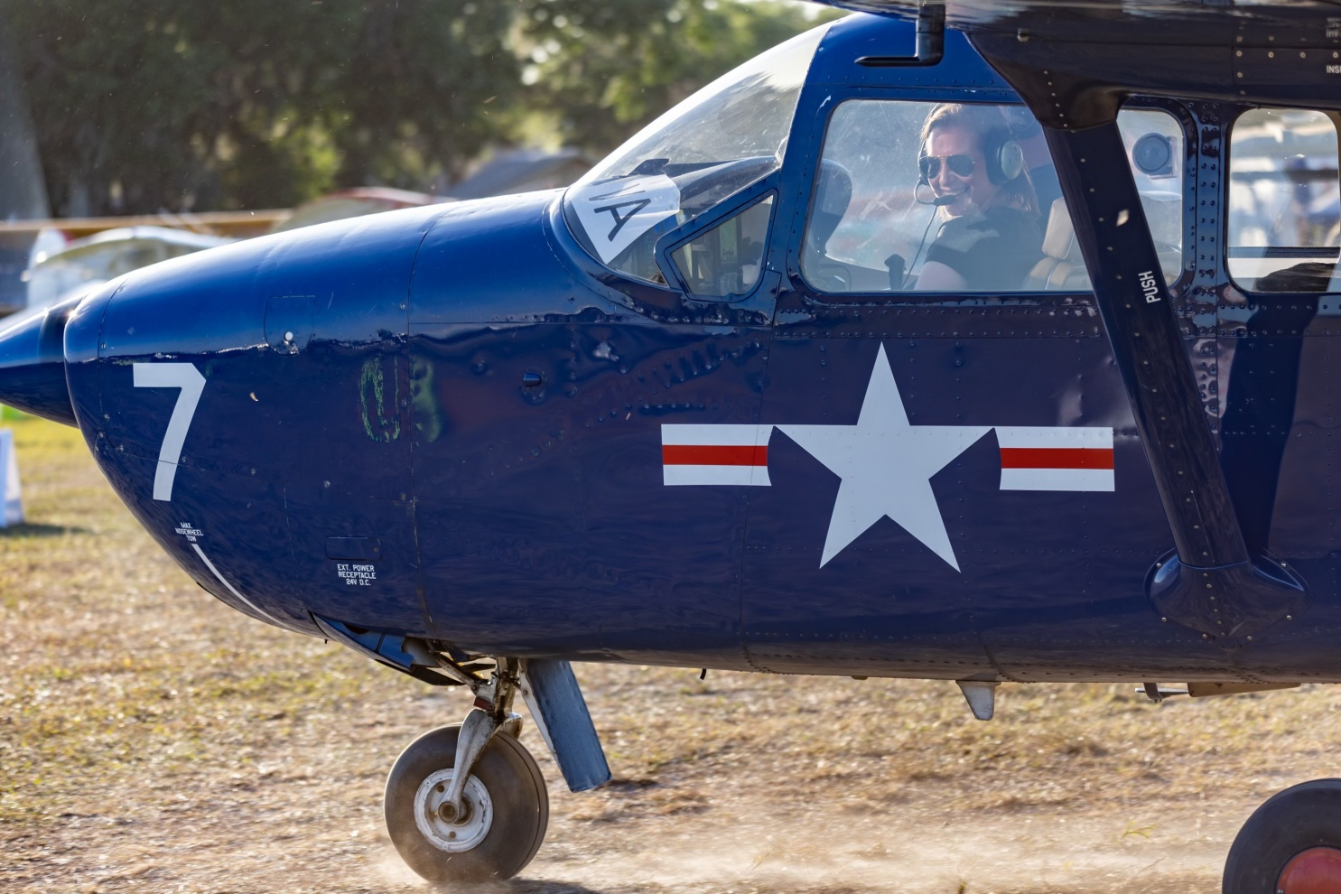

I'm a 3rd generation pilot who is currently working as a CFI, CFII, MEI out of KJYO with Aviation Adventures. I grew up around airplanes and first became interested in flying as a teenager at aviation camp but then got away from it to travel and work in Foreign Affairs as a contractor with the Air Force. In 2021, I decided to start flying with the intent of flying for fun on the weekends and here we are. I've also enjoyed helping to restore old airplanes at a nearby grass strip. I'm hoping to continue to further my aviation knowledge with tailwheel, aerobatics, and seaplane in the future.

