

Old Dominion Chapter
SKYLINES
May 2025

Chair: Cynthia Axell
Vice-Chair: Nancy Schuster
Secretary: Mary McCutcheon
Treasurer: Barb Gruber
AE Scholarship: Cynthia Axell
Membership: Sue Passmore
Newsletter: Mary McCutcheon
Webmaster: Frankie Velazquez

Next Meeting
Monday, June 9 6 PM Leesburg Airport conference room
Sue Passmore will speak on writing strong scholarship applications
Bring what you want to eat or to share
There is a “sign-up genius” you can use to commit to a food.

March Chapter Meeting
March 31 6 to 8:30
McLean Governmental Center, 1437 Balls Hill Rd. McLean, VA.

Kat Emery was our speaker
The talk was fascinating. Seven months pregnant, she survived a crash landing while flying with one of her students. The engine failure was due to bubbles of water in the fuel.

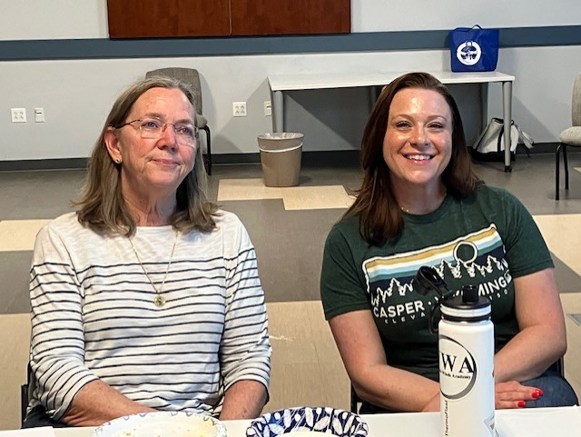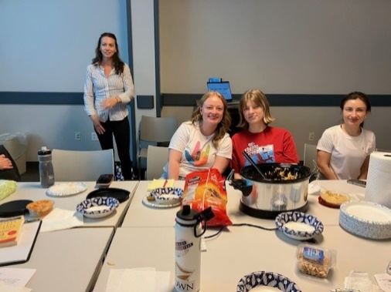
Sue Passmore and Alison Northern Kat Emery, Madison Donnewirht, Chris Schwartz and Tatiana Russell
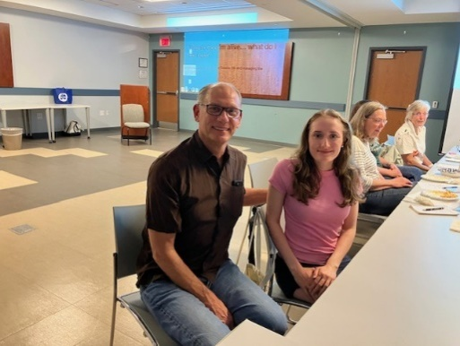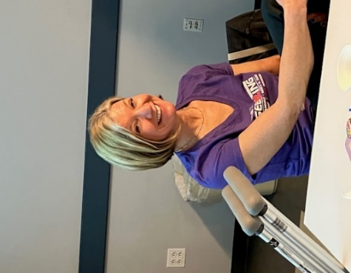
Tony Raila and Priscilla Raila Laura Savino

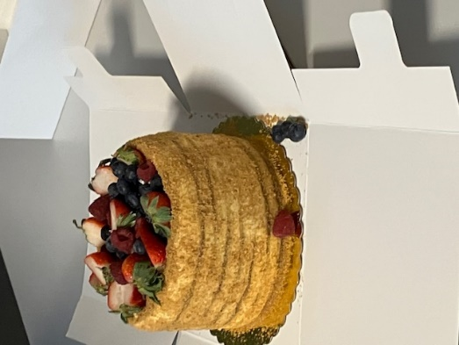
Fabulous cake brought by Olessiya and Tatiana

May Chapter Meeting
We met on May 12 at Manassas Regional Airport conference room. Frankie Velazquez spoke on the importance of pre-flight weather briefing and she emphasized how temperature, wind, icing, precipitation and visibility can impact airplane performance, pilot competence, and passenger experience.

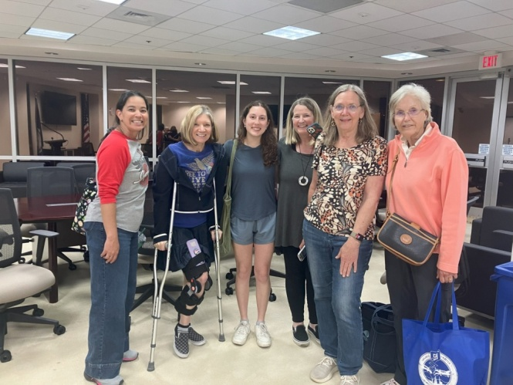
Frankie, Laura, Alana Bicoy, Nancy, Sue, Cynthia

Mid-Atlantic Section meeting

April 25 and 26th

Hosted by the Delaware Chapter at Delaware State University, Dover, Delaware

The only member of our chapter who attended was Sue Passmore

XElevate Field Trip
On May 10, a few of us went to XElevate in Waterford to see the drones in operation. We toured the place and “played” with drones and a small light remote operated plane equipped with a camera. Wearing virtual reality goggles was fabulous.

We were greeted by the owners and staff, Andy Biechlin, Alissa Biechlin, and Marcy Eisenberg

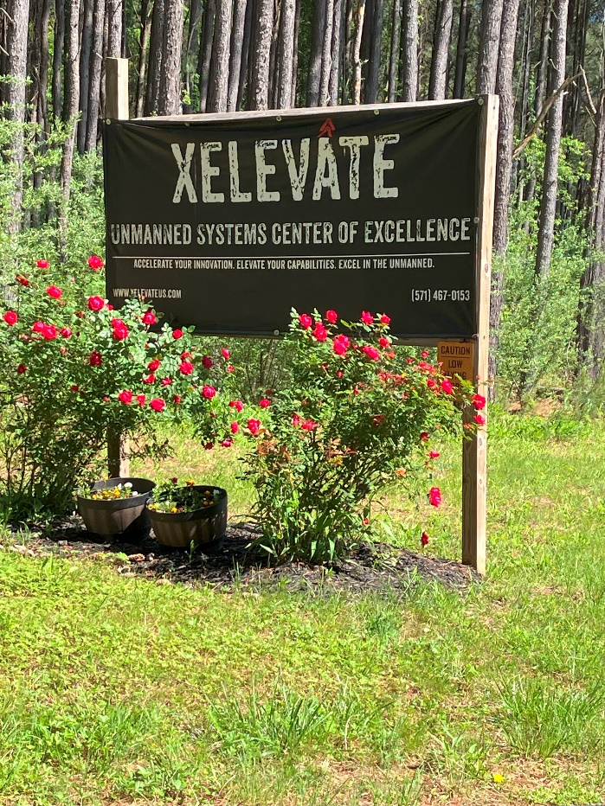

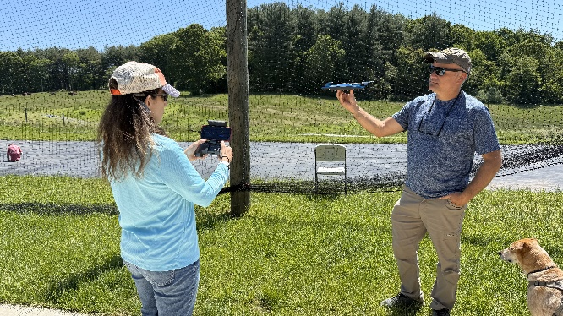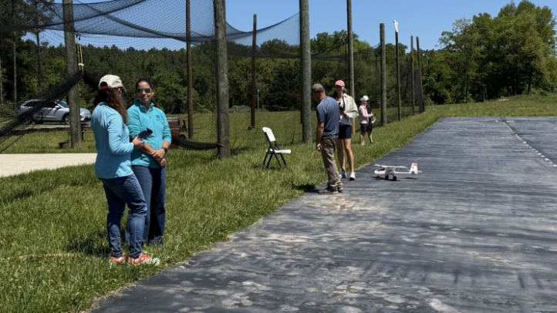
Marcy Eisenberg and Andy Biechlin View of the runway

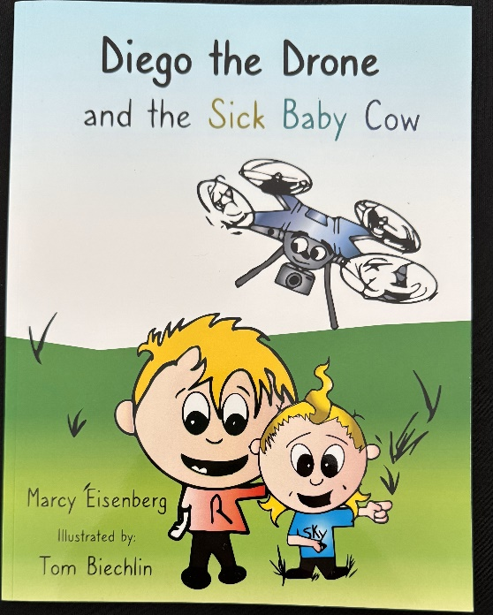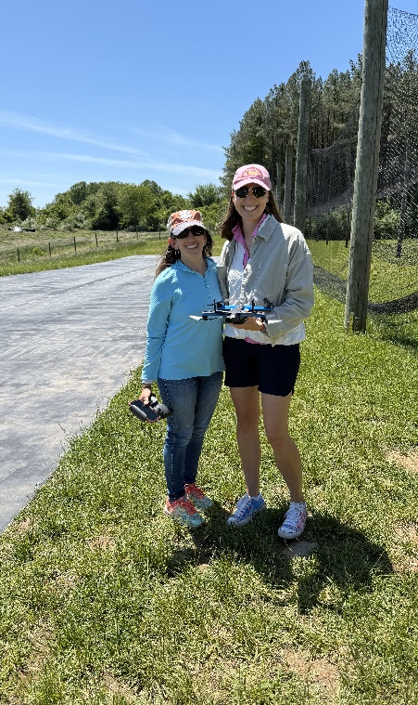
Children’s book Marcy Eisenberg and Hannah Rust

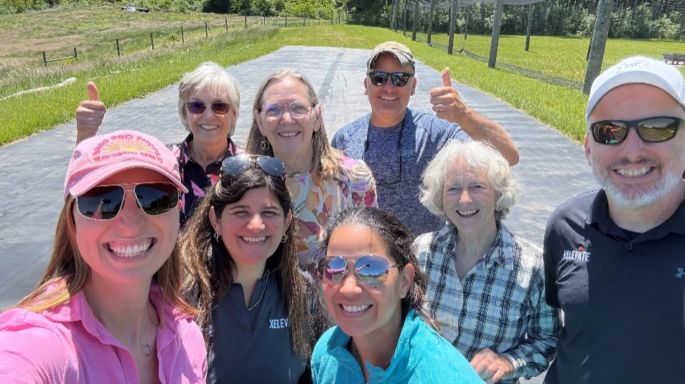
Hannah, Cynthia, Alissa, Sue, Frankie, Andy, Mary and Michael

Memorial Day Laying of WASP wreaths
Some of us met at the Arlington Cemetery on Saturday, May 24 to put flowers on the graves of WASP. Erin Miller, whose grandmother was Elaine Harmon and who wrote the book Final Flight Final Fight.
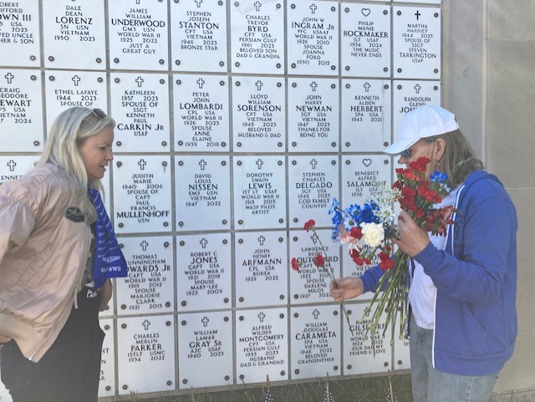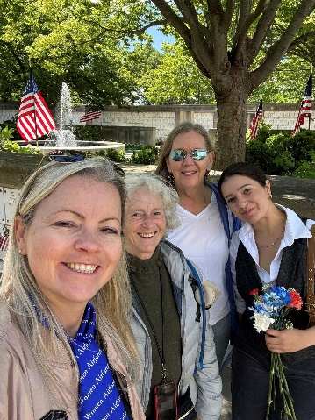
Erin and Sue at Dorothy Swain Lewis grave Erin, Mary, Sue and Hailey Gilson

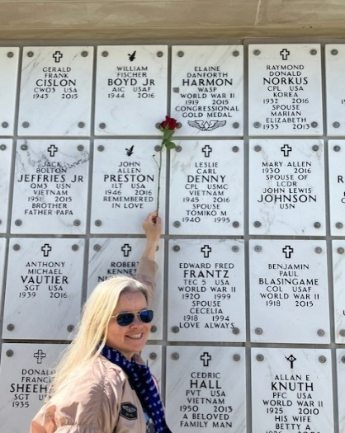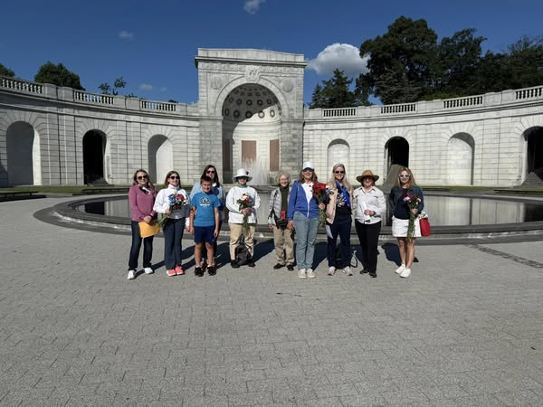
Erin and Elaine Harmon’s grave The whole team

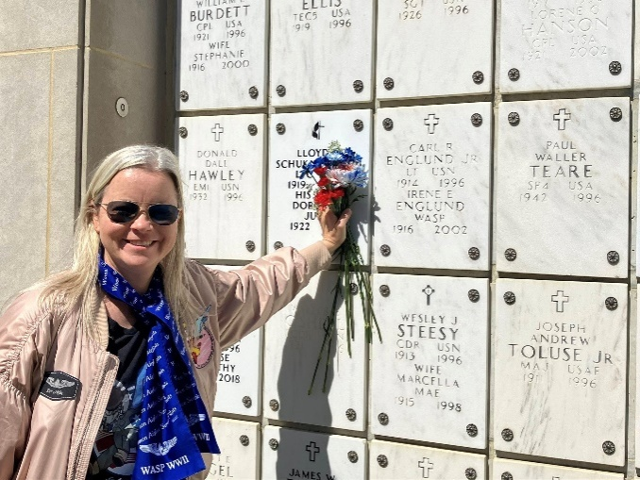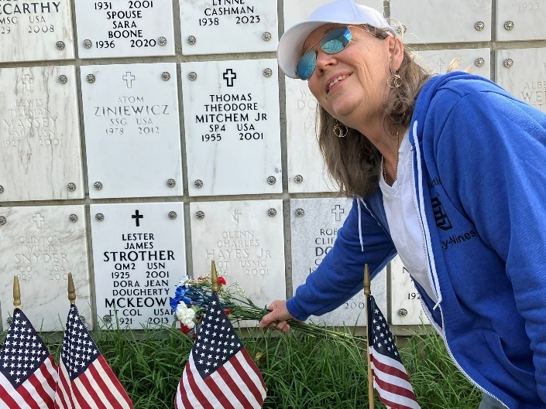
Erin and Irene Englund’s grave the pilot who flew the B29 to show the boys she could do it
AirlineRadioShow Podcast May 31
Laura Savino will be interviewed on a live podcast at 1 PM on Saturday May 31. The podcast is AirlineRadioShow.com and the topic is how to get hired by the airlines. There will be a Q & A so hearing it live will give you the opportunity to ask a question. Streaming it later is probably also an option.

Women Can Fly June 7
This will be at Warrenton as always.
There may be vacancies for volunteers either on the ground or as pilots.
Questions? Contact Sarah Patten.
Sarah.Patten@gmail.com

0 a.m. - 4:00 p.m.

MID-ATLANTIC SCHOLARSHIP
The winner of the Mid-Atlantic Scholarship was Samantha Stahl.

FIRST WINGS SCHOLARSHIP
One of the winners was Olessiya Russell

NAME TAGS
Cynthia is exploring name tags for those of us who want them. The vendor, Anastasia McCune, is in the Coloradochapter. Here’s what she says:

You have a choice of a pin backing ($11 each), or a magnetic backing ($12.50).
There is also room to add an office if you need to - for instance, Chair, Vice Chair, Secretary, etc.

There is a fillable PDF which I can’t fix to this newsletter.
But Contact me and I’ll forward it to you (mmccutch@gmu.edu) or Contact the vendor in the Colorado Chapter: badges@colorado99s.org
GreenBank tour
Barb Gruber might set us up with a tour of GreenBank, but to give you some exciting ideas, here are some options we have already:







(20+) SETI Tour | Facebook
MEMBERS IN THE NEWS:

Gail Keys with her sea plane

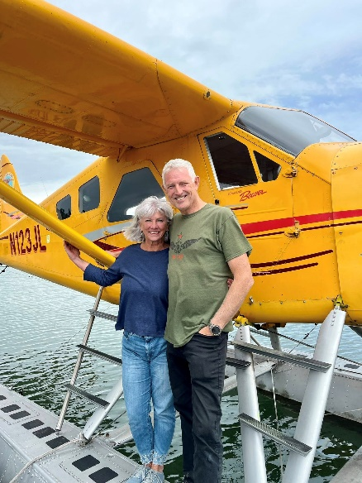

Mia Anderson has launched a new organization with a facebook page. Here’s what she says:

I just launched a new Facebook group called Air Ambition Aviators — a community built to connect aviators of all levels. Whether you're learning to fly, looking for mentorship, or have experience to share, you're welcome here!
Ask questions
Share your journey
Learn from others
Celebrate your wins
We would love to have you!

(20+) Air Ambition Aviators | Facebook

airambition.org

Mia also came in second in the recent

U.S. National Aerobatic Championships Estrella Classic:

You must see the camera view of her controlling the glider:

oerSponsdttfh 0ht1Mh3l4th25ai5 :i33112750ahlya110i8 04hMP5g ·

Alana Bicoy has a BAE systems internship flying a GulfStream G550
and is going to Sweden

R.J. McGlasson is moving June 11 to:
Village At Orchard Ridge
400 Clocktower Ridge Drive #236
Winchester, VA 22603

Colleen Whitehouse is looking good
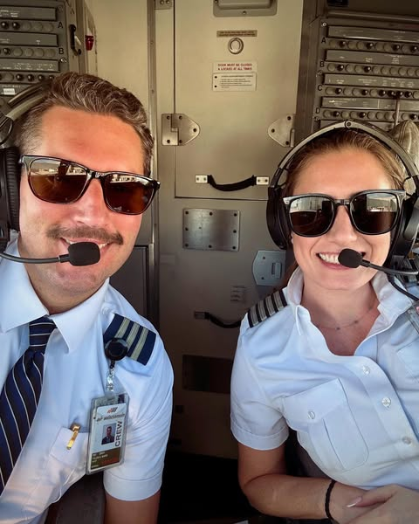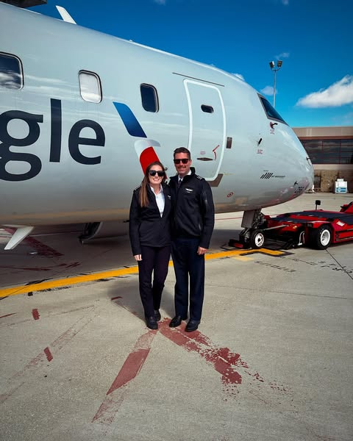
Olessiya Russell Won First Wings Scholarship

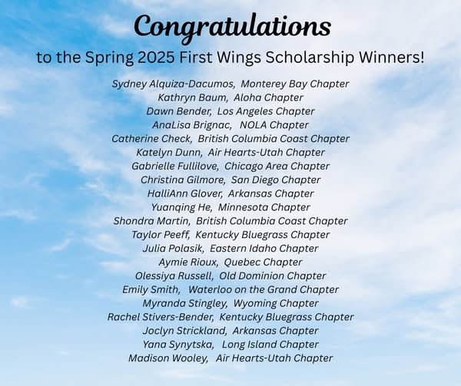

Samantha Stahl won Mid-Atlantic scholarship

New members:

Priscilla Raila. A Student pilot who has come to several meetings already

Samantha Henry

I’m a Chief Warrant Officer 2 in the United States Army Reserve! I fly the CH-47F. I’m a Woodbridge resident, wife, and mom of 2!

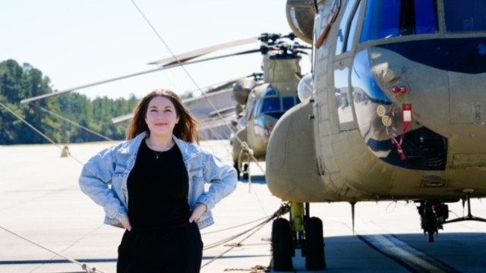

Charlotte Young

