

Old Dominion Chapter
SKYLINES
July-August 2025

Chair: Cynthia Axell
Vice-Chair: Nancy Schuster
Secretary: Mary McCutcheon
Treasurer: Barb Gruber
AE Scholarship: Cynthia Axell
Membership: Sue Passmore
Newsletter: Mary McCutcheon
Webmaster: Frankie Velasquez

Next Meeting
August 20 6 to 8
At the Ciao Osteria
14115 St. Germain Drive
Centreville, VA
The meeting goal will be to review what we have and what we need (material as well as skill and experience) for painting two compass roses this fall: Culpeper and Winchester.

PAST NEWS
Last Meeting
Our last meeting was June 9 in Leesburg
The highlight of the meeting was a talk by Sue Passmore on scholarship applications.
She talked specifically about the AE scholarship program but her advice would apply to just about any scholarship or any application at all: follow the directions, include what is relevant, turn in all materials on time, be neat, don’t make any dumb mistakes.
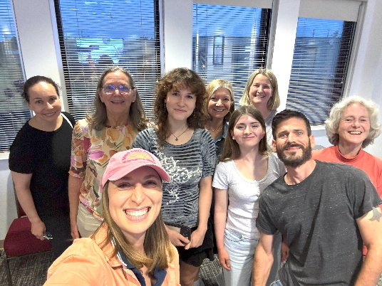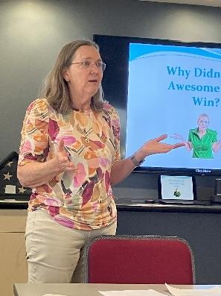
MSM, Richard Russell, Nancy Schuster, Olessiya Russell, Sue Speaking
Laura Savino, Katya Zubareva, Hannah Rust, Sue, Tatiana Magruder
Ocracoke
The trip to Ocracoke attracted a good bunch of 99s at the end of May.

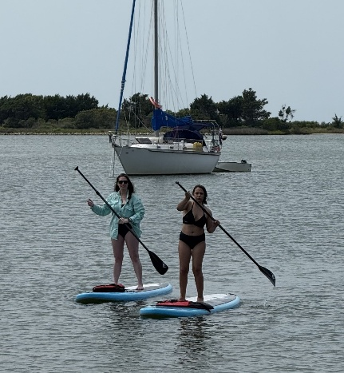
Frank and Morgen Reeb, Sue Passmore, Colleen Whitehouse and Grace Goodin
Marty Constantino, R.J. McGlasson

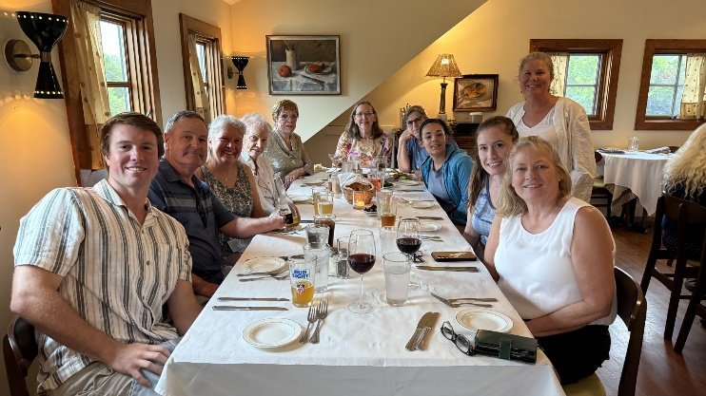

Ryan, Frank and Morgen Reeb, Marti Constantino, R.J. McGlasson, Sue Passmore, Patty Goodin, Grace Goodin, Colleen Whitehouse, Beth Whitehouse, Krystal Whitehouse

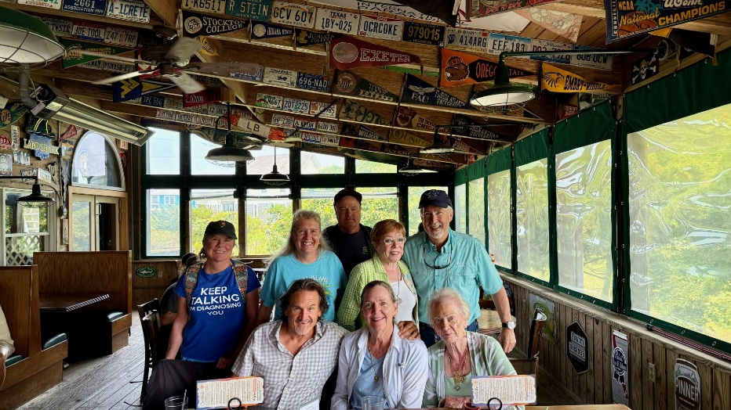

Back row: Beth Whitehouse, Morgen Reeb, Frank Reeb, R.J. McGlasson, Dave Passmore. Front: Alex (friend of Dave’s), Sue Passmore, Marti Constantino

Women Can Fly

The weather was perfect for Women Can Fly/ Warrenton this year.
Thanks go, again, to Sarah Patten for pulling it all together but also to the volunteers who did traffic management, registration, flying, preflight briefings, and Women Can Build.

From Sarah Patten:
Here are the numbers:
220 people attended our preflight briefings
51 people made cell phone stands at Women Can Build
24 pilots came out to fly
196 people got to fly with us
And over the 8 years, we've now had 1677 people attend our preflight briefings, and we have safely flown 1525 people!
Thank you to all the volunteers.
One extra cool thing happened. Alana Bicoy was able to meet Bob, EAA 186 member and retired Delta captain, who gave her her first airplane ride and started her aviation journey. Alana has 1 more year left at Embry-Riddle and she has a cool internship flying a Gulfstream and will be heading to Sweden this week!
This event is one of those that changes lives.

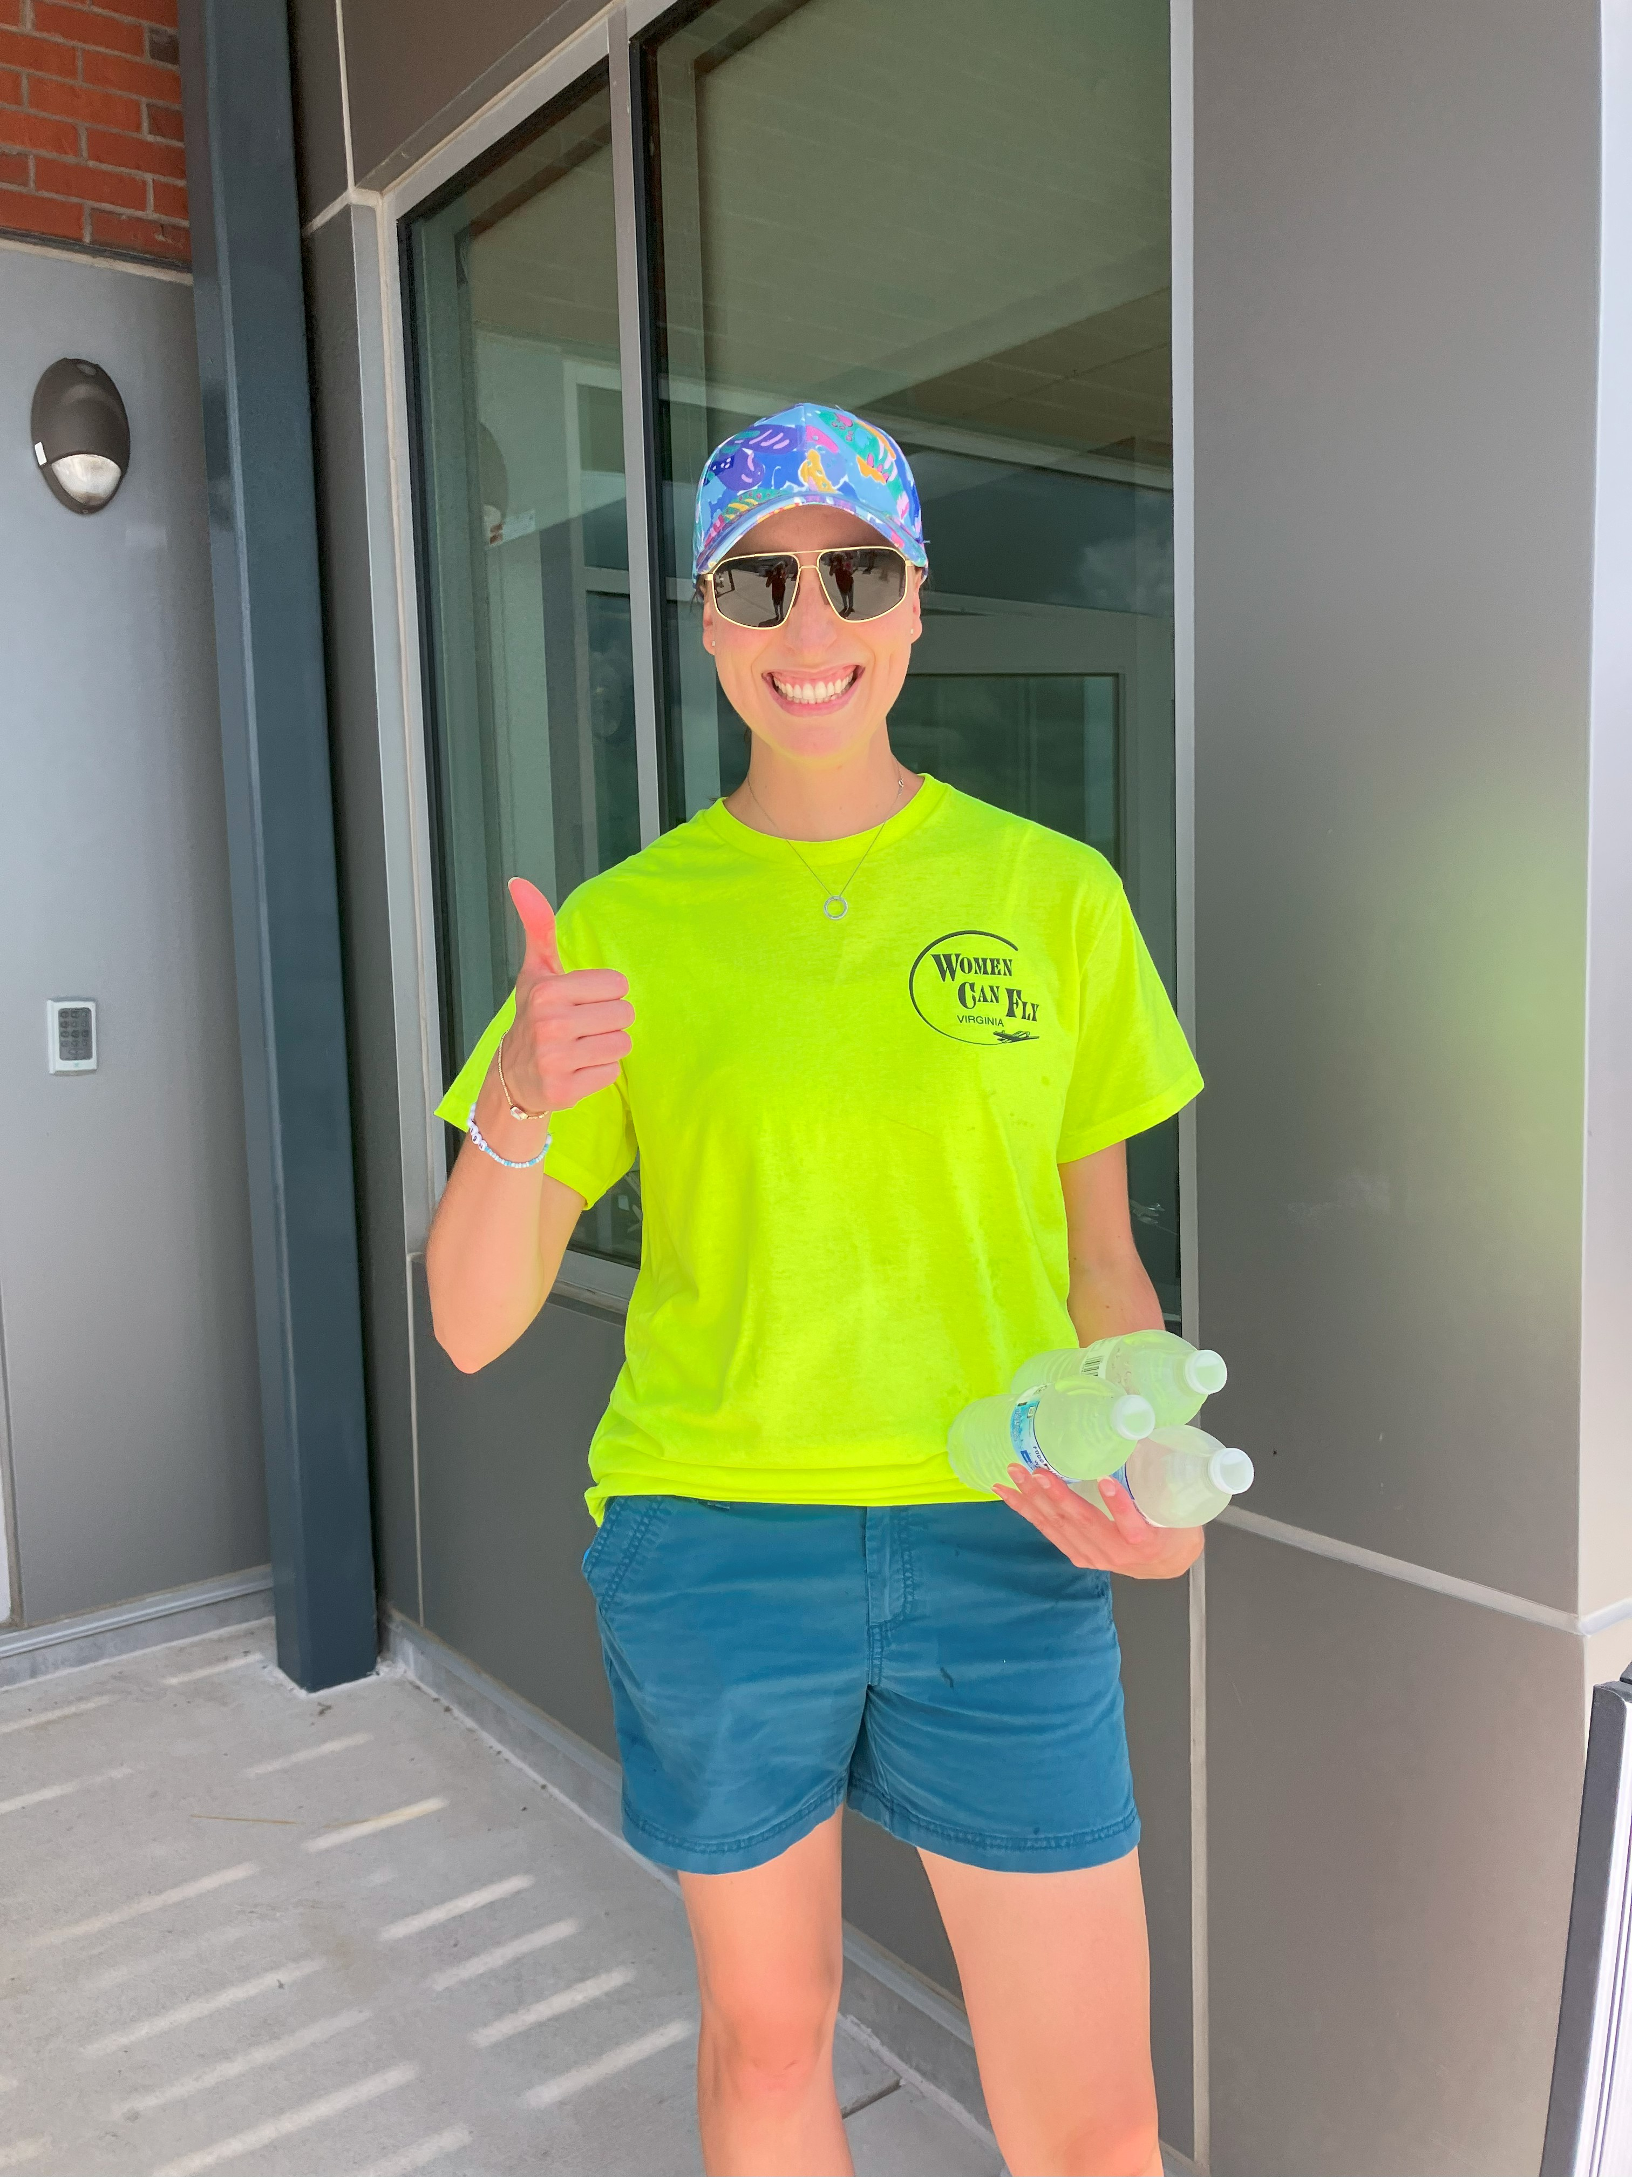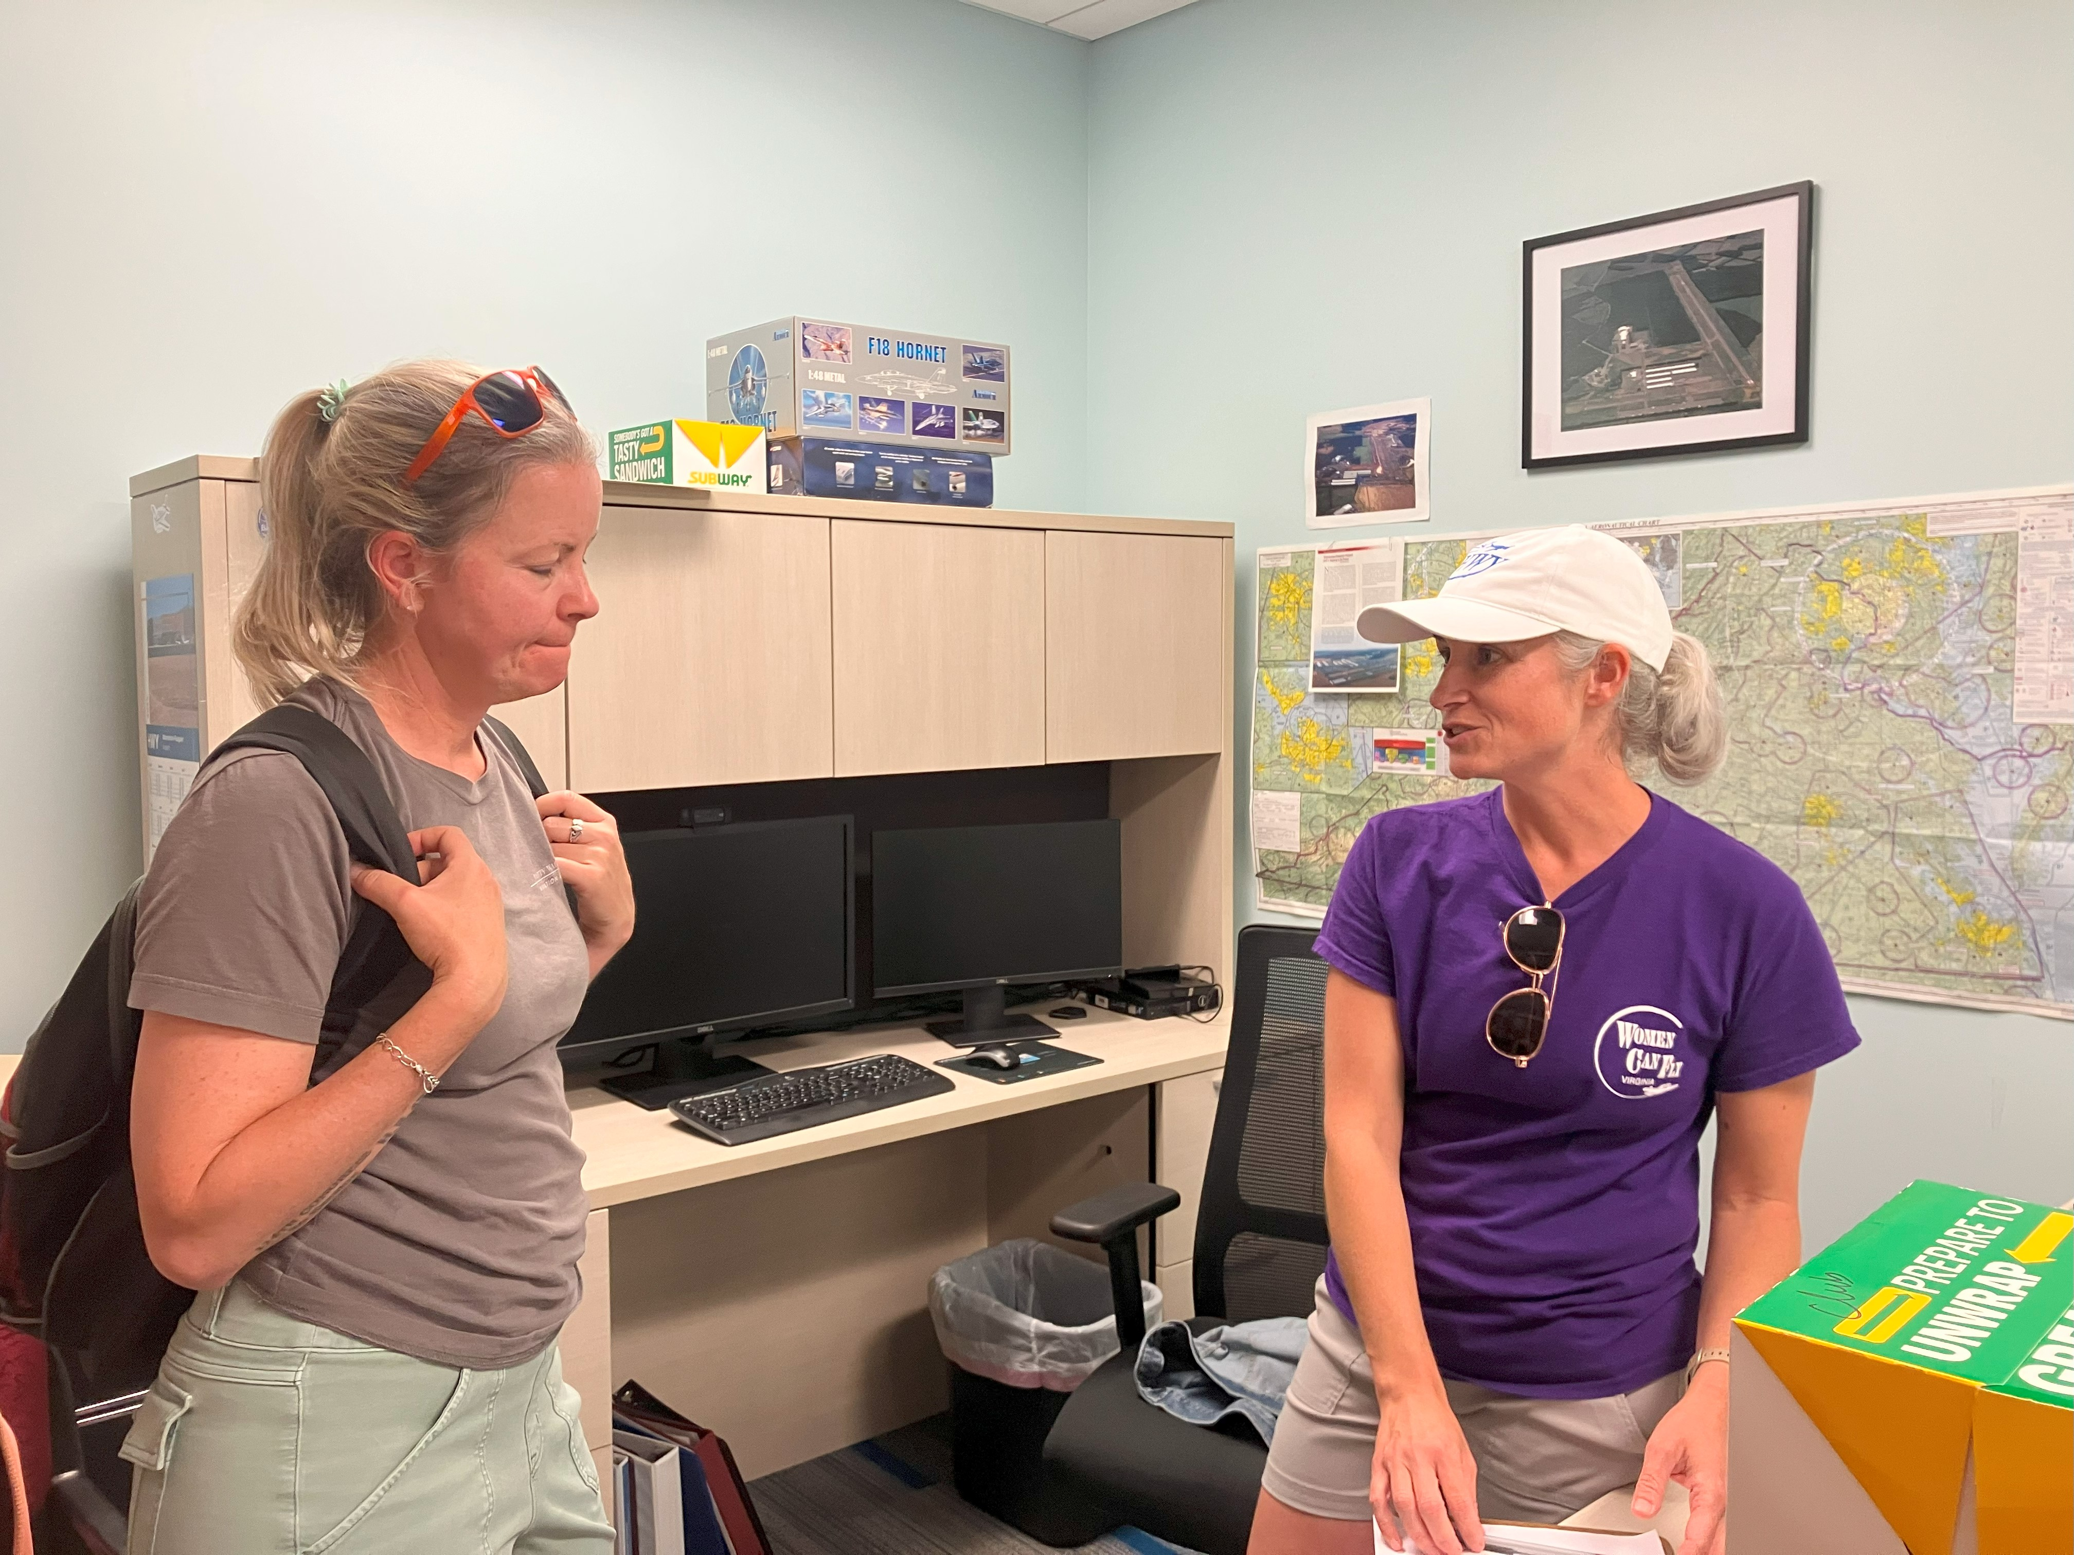
Hannah Rust Erin Miller and Sarah Patten

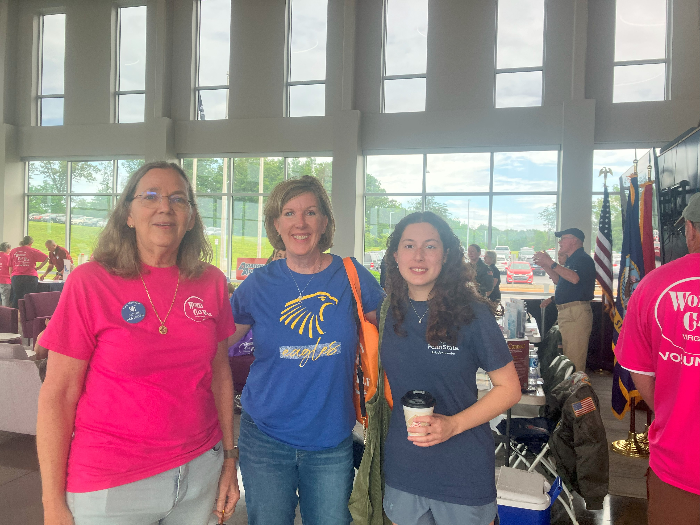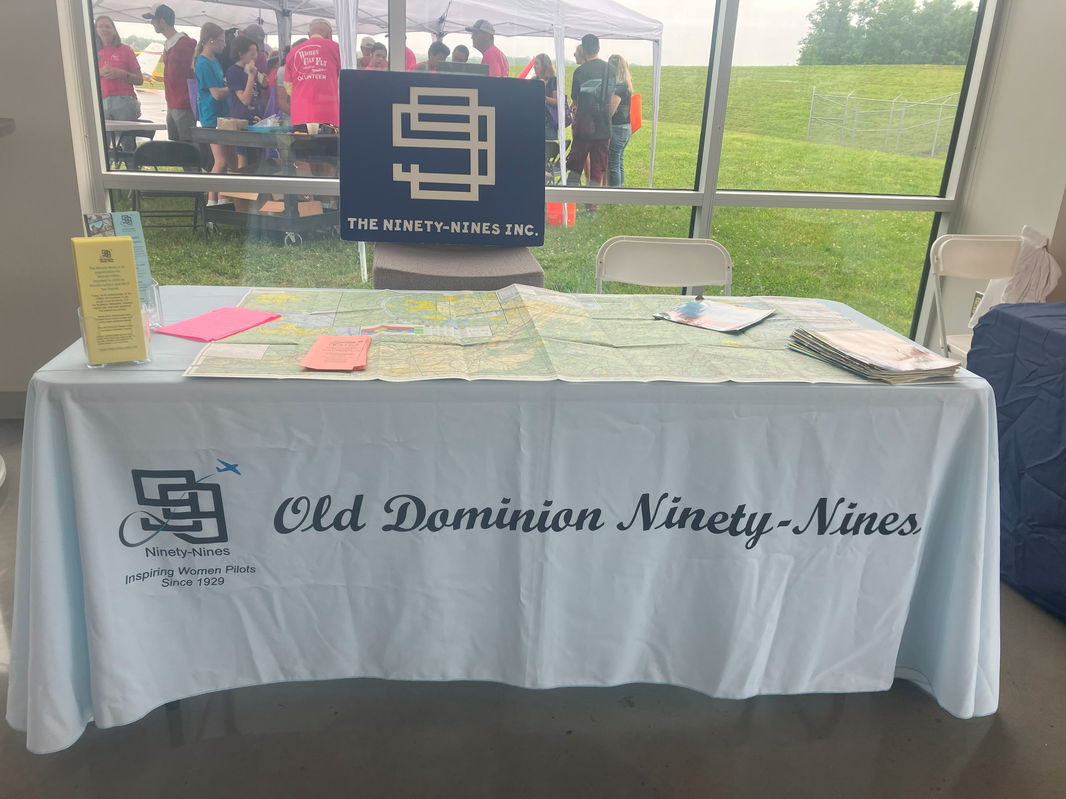

Sue Passmore, Doreen Bicoy, Alana Bicoy Our table attracted a bunch of visitors

Udvar Hazy Tour

Sue Passmore conducted a tour of Udvar Hazy for a group of us 99s. Members of our chapter were joined by Nancy Schuster’s husband, Laura Savino’s son, Liz Booker who started the Aviatrix Book Club, and Erin Miller. We saw a large part of the museum and heard from Sue a lot of back stories that made the tour way better than we could have done on our own.

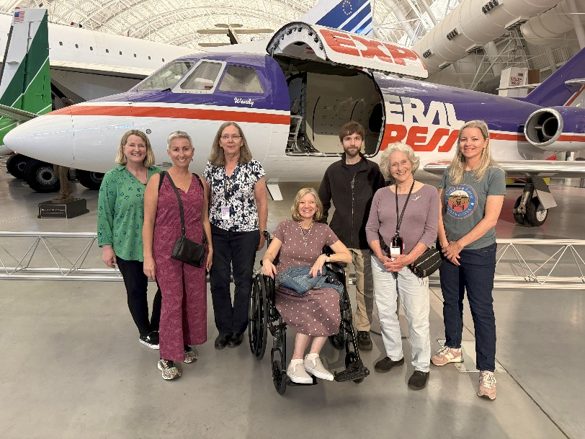
Nancy Schuster, Liz Booker, Sue Passmore, Laura Savino and her son, Nicholas, Mary McCutcheon, Erin Miller

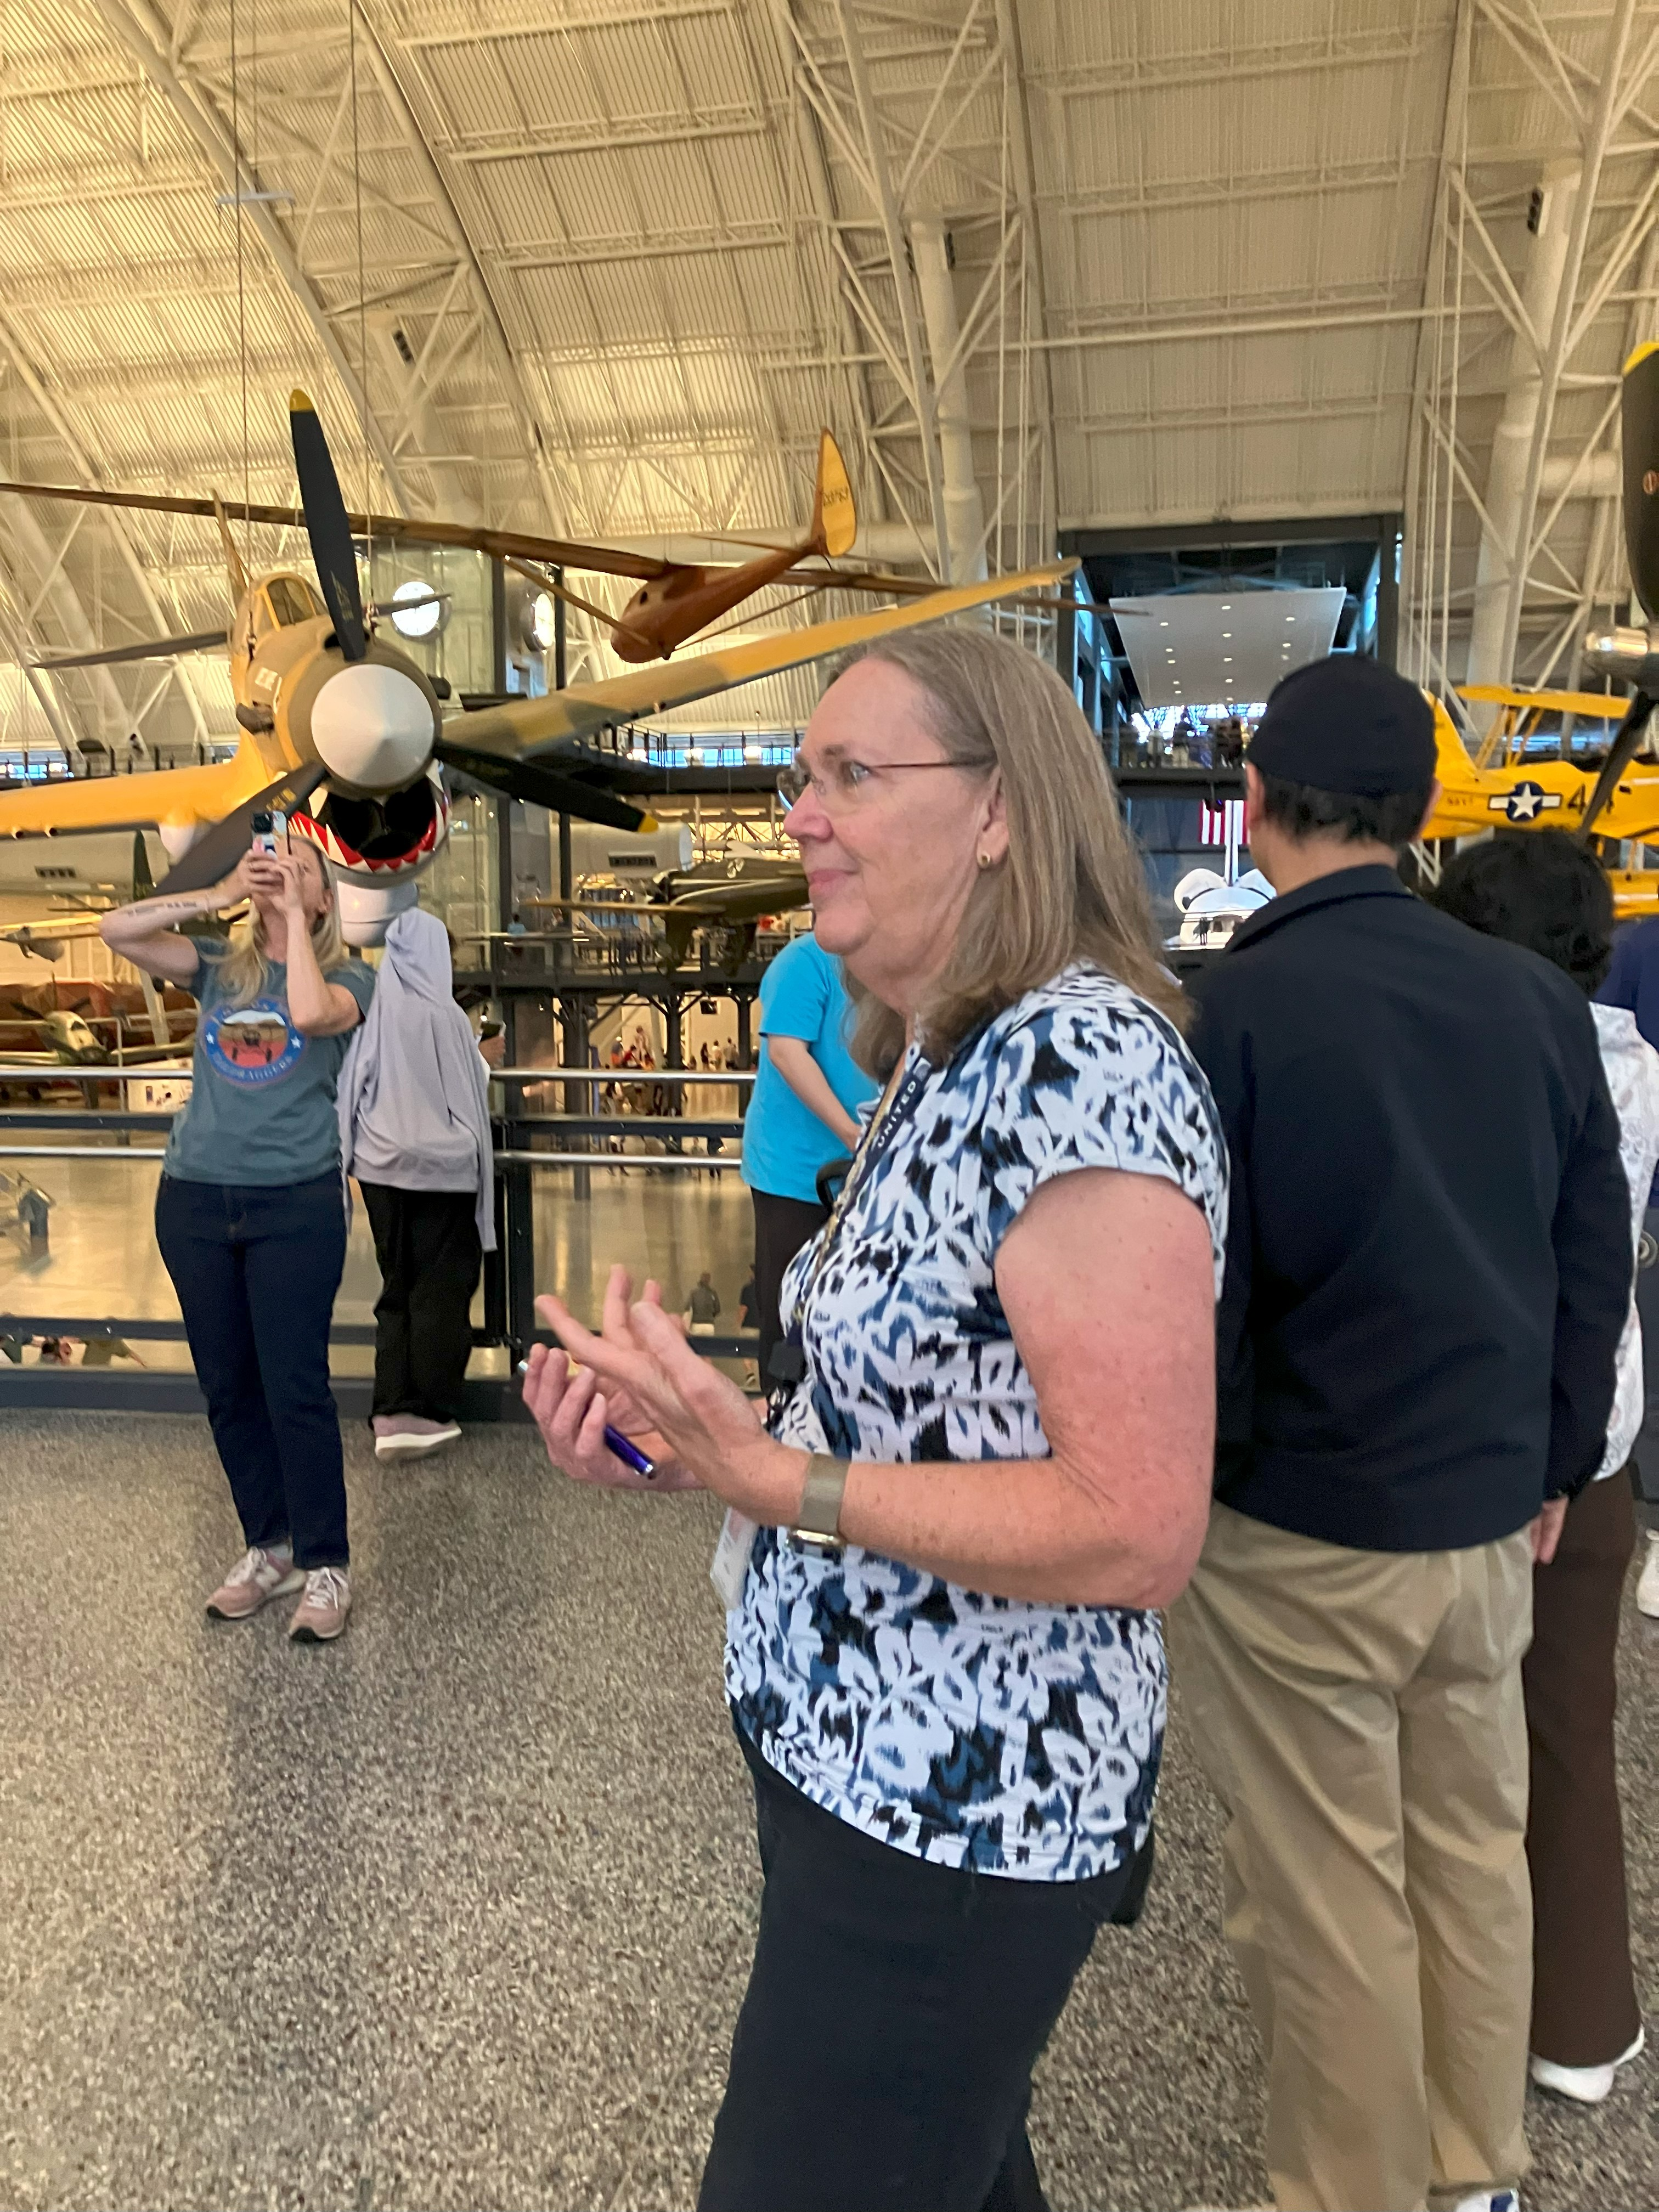

Sue Passmore giving the tour

International Meeting at Burlington, VT

Several Members went to Burlington. Sue and Dave gave Laura and R.J. a trip there and back on their Epic
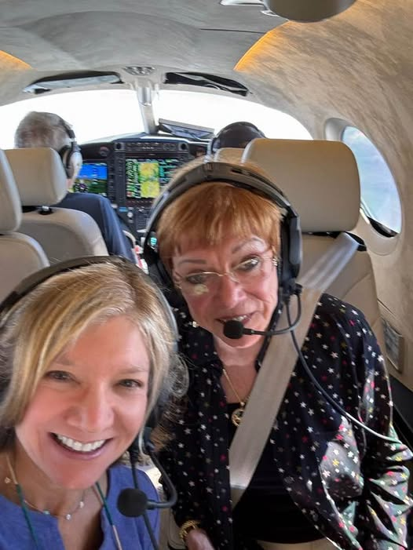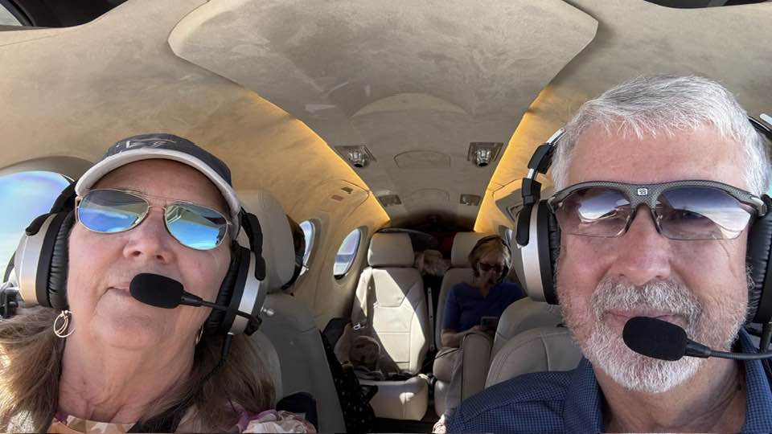
Laura Savino and R.J. McGlasson Sue and Dave Passmore

The meeting in Burlington in July was especially significant because Peggy Doyle was celebrated and memorialized at the dinner. Rick and her children were presented with an award.
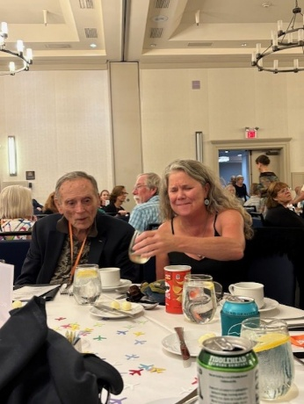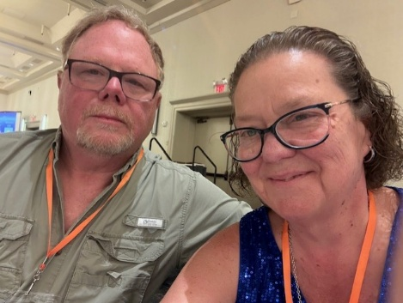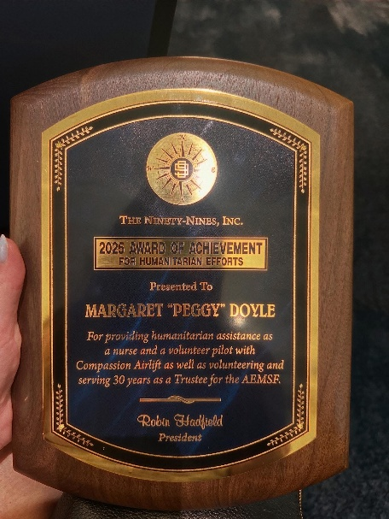

Rick Koehnke Jerry and Tammy Whitehouse Peggy’s award

Oshkosh

Our chapter was well represented at Oshkosh this year. Laura Savino gave a couple of major talks, Barb Gruber won the NCASE Mervin K. Strickler Jr Aerospace Education Leadership award (see news from our members) Mia Anderson was honored for being EAA through and through.
Here is a picture of her at the gala:

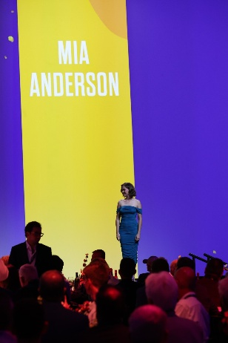

Back in 2022, a plane was built over the course of the one week at Oshkosh, known as the “one week wonder” Sue Passmore and Mia Anderson were part of the team. The plane is now at the Udvar Hazy Museum.

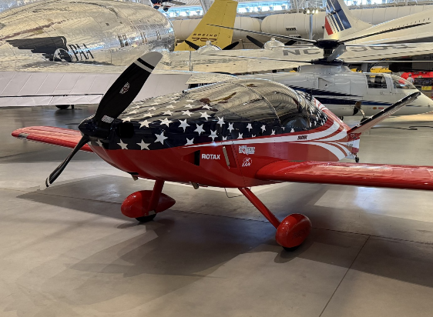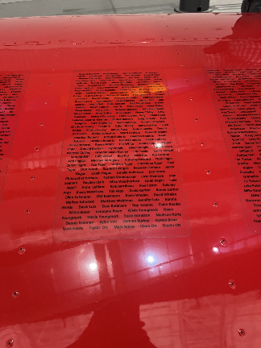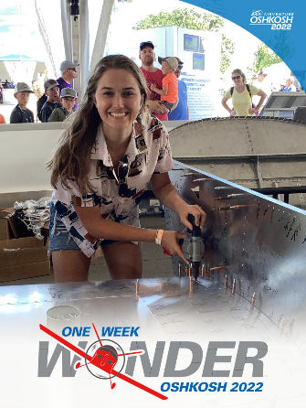
One Week Wonder at Udvar-Hazy Participants Mia in 2022

THE FUTURE
Air Marking Gigs
Culpeper
Our date to paint Culpeper is the weekend of September 12 through 14. I think it is a two day job. The old rose (which we had painted) has been eradicated, and the survey has been completed now and we are ready to estimate paint needs and line up volunteers. Any one??? Culpeper’s 25th airfest will be at the end of September.

Winchester
This will be the next on our agenda later in the fall.

Fall Section Meeting –
note deadline for hotel reservations at discounted rate

The meeting will be at Lambertville House 1812 Room, on aturday, October 4th
- price and details to follow. Amy promises by MONDAY or so she will know more and we will have a way to register by then.

Options to fly in:
Trenton-Mercer (KTTN) and shuttle or ride-share.
Doylestown (KDYL) and take a ride-share.

We have hotel blocks at 2 hotels:
1. The Marriott Courtyard in Ewing, NJ across the street from the Trenton, NJ Airport.
360 Scotch Road Ewing, NJ 08628
Call 609-771-8100 for reservations and mention the 99s to get discount
Prices are $169 for a double and $189 for Queen rooms plus taxes and fees.
Block will be held until September 3, 2025
There is a shuttle to get you from the airport to the hotel across a busy road.
You will have to make ground arrangements to get to the Saturday meeting.

Lambertville House in Lambertville, NJ at the site of the meeting.
32 Bridge Street/ Lambertville, NJ 08530
Call 609-397-0200 (Ninety-Nines Code WPC)
Block will be held until 8/19/2025
Prices vary depending on room: Queen starts at $390 and King starts at $415 plus taxes and fees
Most rooms have jetted tubs, fireplaces, and come with a food voucher and onsite parking
Recommended if spending the weekend and want to walk or bike through the town and nature trails.

Hope to see you there,
Amy Urbine / Eastern PA chapter/ 610-701-1979
SCHOLARSHIP
WAI Scholarship

WAI2026 Scholarships Open
Deadline to submit is October 15, 2025

July 15, 2025 — The 2026 Women in Aviation International (WAI) scholarship program is officially open, and members can review dozens of scholarships at www.wai.org/scholarships. Currently, there are over 50 scholarships valued at more than $200,000 offered for flight training, engineering, maintenance, dispatch, and career advancement for individuals of all ages and stages of their aviation and aerospace career journey. This 2026 scholarship cycle includes several new scholarships to further members’ learning in flight training and dispatch. Applicants are encouraged to check for new scholarships often and may apply for up to three scholarships per year.
“WAI believes in shaping the future of our industry by investing in the people who will meet the needs of our current and future global workforce demands,” says WAI CEO Lynda Coffman. “The support of our annual scholarship program is one of the major benefits of being a WAI member, and we appreciate the generosity of our scholarship funders.”
The total amount of scholarships awarded by WAI funders since 1995 is more than $15 million.
Recipients will be awarded during the 37th Annual Women in Aviation International Conference in Dallas, Texas, from March 19-21, 2026. To qualify for a scholarship, the applicant must be a current WAI member through March 30, 2026, or join as a new member by October 1, 2025. Applications must be submitted to WAI by October 15, 2025, and winners will be notified by December 15, 2025. Details of each scholarship, application requirements, FAQs, plus tips for submitting a winning application can be found at www.wai.org/scholarships. Apply here

NEWS FROM OUR MEMBERS

Ilana Bicoy says:

I recently had an incredible experience as a corporate flight intern with BAE Systems. Throughout my internship, I gained valuable insight into the behind-the-scenes operations of corporate aviation and what it takes to be a professional corporate pilot. I was fortunate to spend seven days jump-seating in a Gulfstream G550 including a trip to Sweden where I had the opportunity to observe and learn about international flight procedures firsthand.

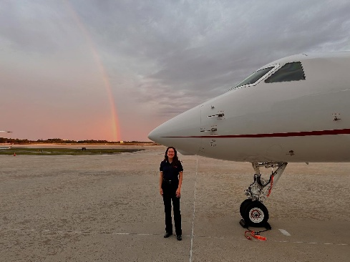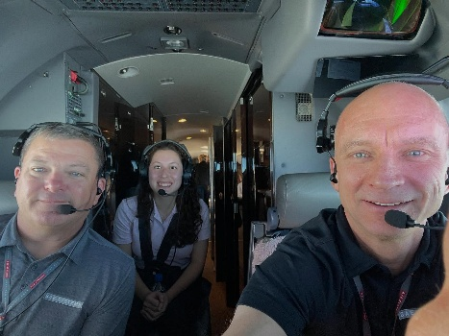

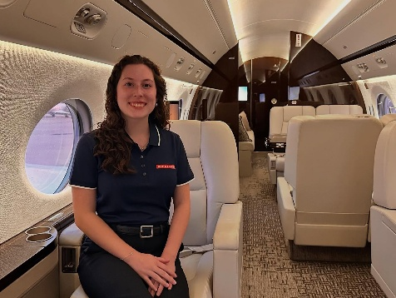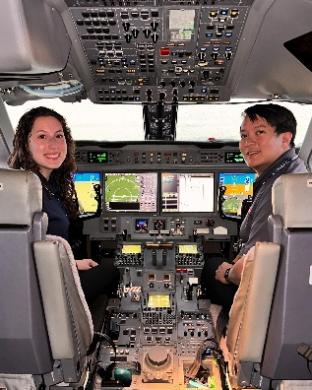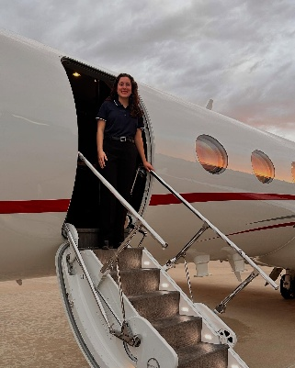

Cynthia Axell
Has finished her grueling training in Oklahoma City and is now at last a fully qualified aviation inspector for the FAA. She is currently working on some interesting investigations.

Morgen Reeb and Jenny Reeb
Morgen took Jenny Reeb to Paris for Take your Daughter to Work Day.

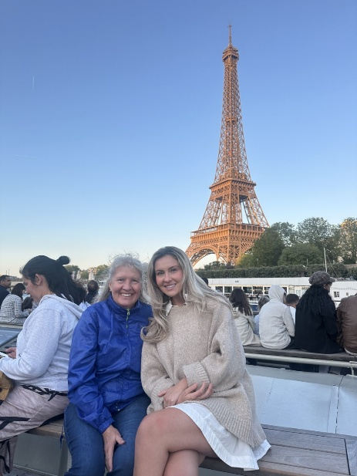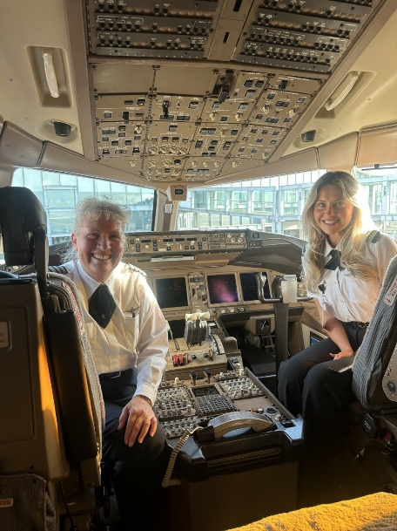

She retires from American Airlines in mid September. RJ McGlasson and Marti Constantino are going on one of her last flights to and from Barcelona. Mary McCutcheon is going on her last flight on September 17 from Milan. Expecting a hoedown on board and a HOSEdown after landing at JFK.

Yvy Von Helde
Passed her CFI on august 7 and is working toward the CFII now
She is a student at ATP in Manassas

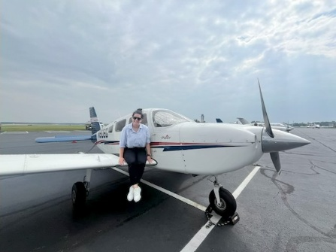

Barb Gruber
Won the NCASE Mervin K. Strickler Jr Aerospace Education Leadership award presented to her at Oshkosh

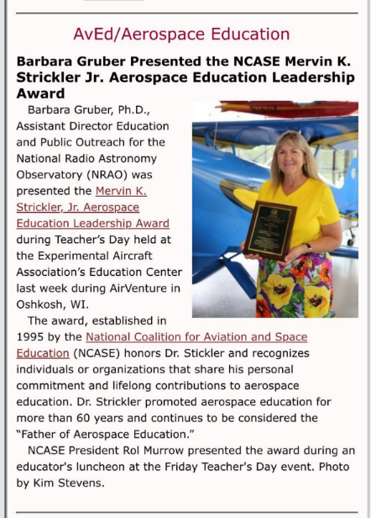

Laura Savino’s youtube interview is excellent
Flying Through Limits: A Story of Grit, Growth, and Guts

Mia Anderson

There is a book of essays written by young people about getting good things done. Mia has a chapter. I have just ordered it.

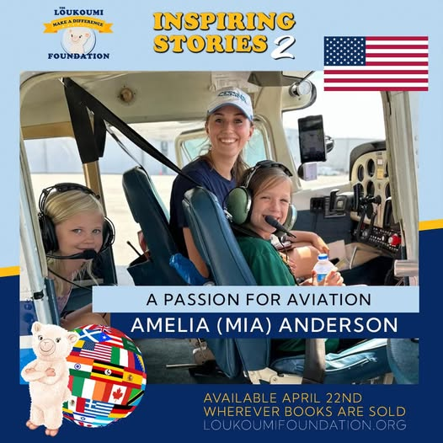

NEW MEMBERS

Suzette Rash
Rebecca Akhigbe
Ekaterina Zubareva
Charlotte Young

