

Old Dominion Chapter
SKYLINES
October 2025

Chair: Cynthia Axell
Vice-Chair: Nancy Schuster
Secretary: Mary McCutcheon
Treasurer: Barb Gruber
AE Scholarship: Cynthia Axell
Membership: Sue Passmore
Newsletter: Mary McCutcheon
Webmaster: Frankie Velazquez

Next Meeting

Our next meeting will be October 30 at Jarern Thai Cuisine, 14245 Centreville Square, Centreville, VA 20121 starting at 6 pm. Reservation is under 99's. We have no speaker but Cynthia proposes a resumption of our hangar talks. Here is what she suggests we discuss:

Preparation requires rumination.

When you are flying in those quiet moments enjoying the stillness of the night sky, or watching the majesty of a sunrise over the ocean, or marveling at the golden aspens blanketing the mountains below you, do yourself a favor: savor the moment. Then ask yourself, “What if?”

What if the engine quit, right now? What if the fire warning light and horn came on? What if I lost all cabin pressurization? What would I do?

These are situations that require fairly quick action. Having played them through in your head might help you get past the denial stage (this can’t be happening… to me!) and into the triage stage.

A pilot who hasn’t considered all the many steps involved in, say, a ditching in the ocean at night, greets the moment unprepared. And when you are unprepared, you forget things. Not everything is on the checklist… like taking that emergency flashlight and mirror from your bag.

You can also ask yourself less calamitous questions, such as, “What am I missing?” “What should I be doing now?” “How can I prepare for what’s to come?”

A pilot who isn’t monitoring the weather at their destination is caught by surprise by the closing dew point spread or the fog that follows. They are completely unprepared when the airport goes below approach minimums.

I encourage you to engage in mental exercises during those hours of quietude. Challenge yourself to think outside the box.

I have included the other pilot in some of my exercises, asking, “What would you do if so and so happened, right now?” Their answers can be instructive. They can also be alarming. You learn a lot by asking questions, if you do it in a friendly, conversational way. Questions can feel challenging and sometimes threatening. But if you have a great rapport with the other pilot, and trust one another, probing around the what-if scenarios can be engaging for both. It certainly can keep you awake.

And remember: Fly the airplane. Silence the Warning. Confirm the emergency. Then, pull out the checklist.

Hope to see you there!

Cynthia Axell
Chair, Old Dominion Ninety-Nines
Last Meeting
We met on August 20 at Ciao Osteria in Centreville. The main agenda item was to discuss what we would need to do to prepare for painting the compass rose at Culpeper.

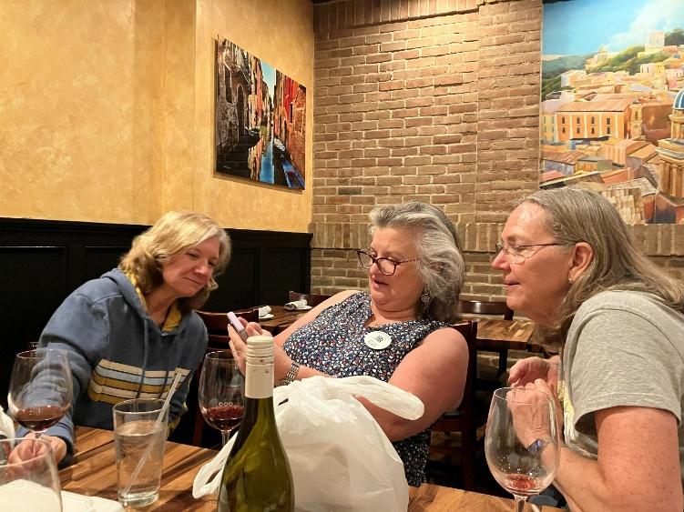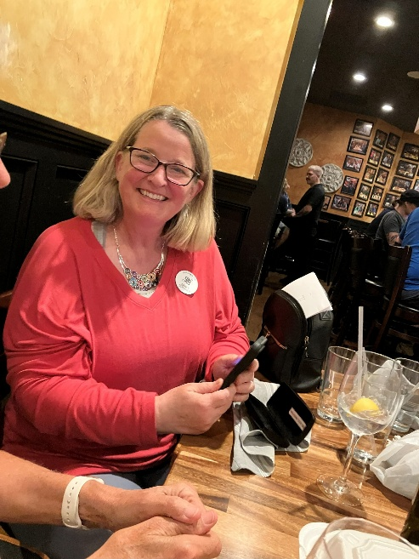
Laura, Melissa and Sue Nancy
Air Marking

The Saturday after our August meeting Barb Gruber opened up her hangar at Culpeper so we could assess our supplies and our additional needs. Mary brought a tent, a 99s template, a line marker, miles of tape, and a large instruction book she had been keeping since Judy Shaw left.

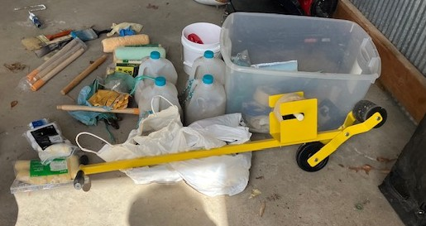
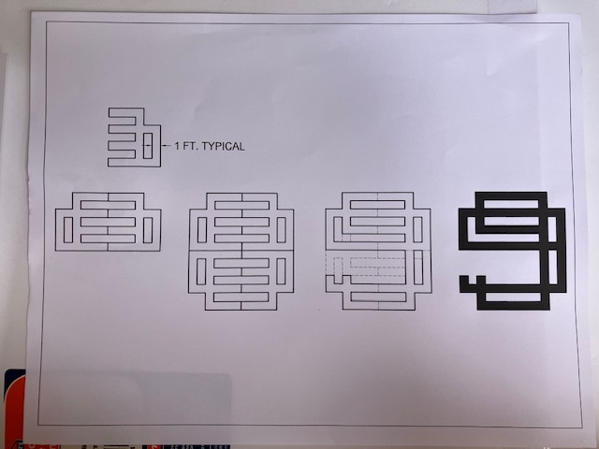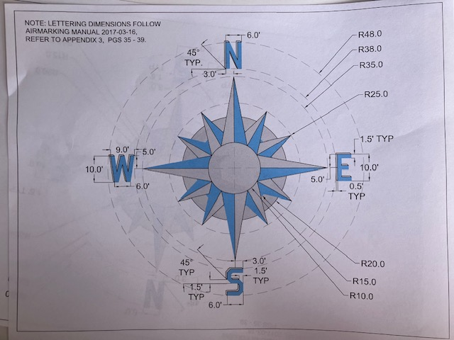

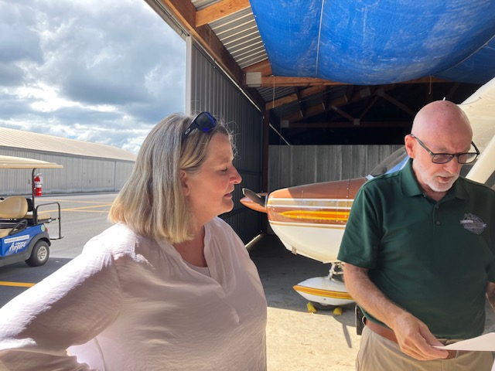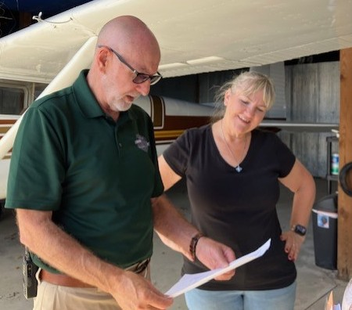

Nancy and Chris Godart Chris Godart and Barb

The chalking and painting took place on September 12 and 13th. Cynthia coordinated the effort. The airport supplied paint and some supplies as well as a lunch.
Here are pictures of the team during and after the job.

Our next gig is supposed to be Winchester

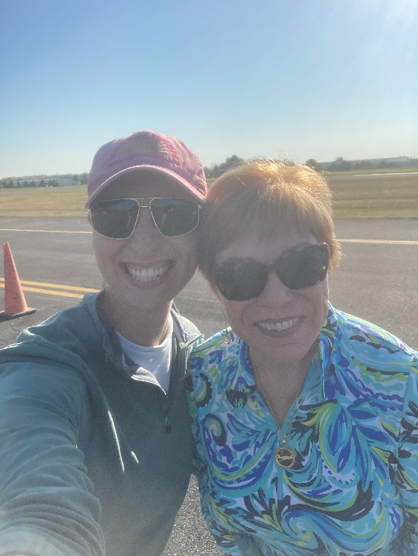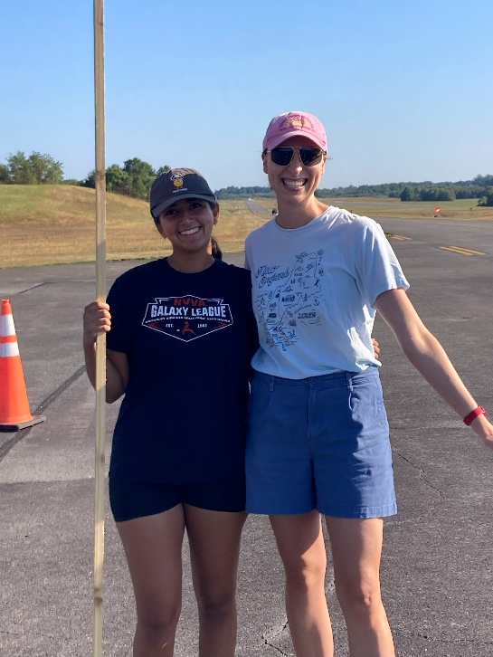

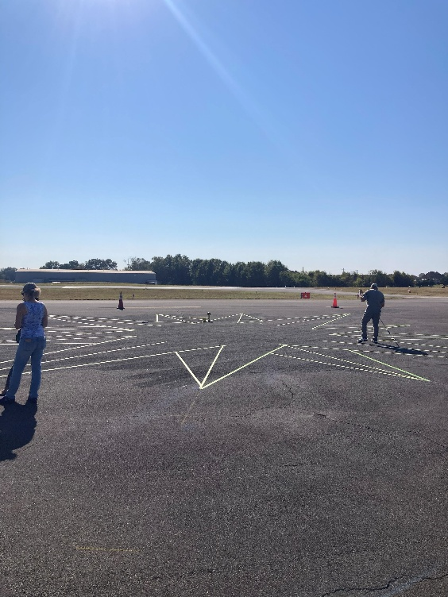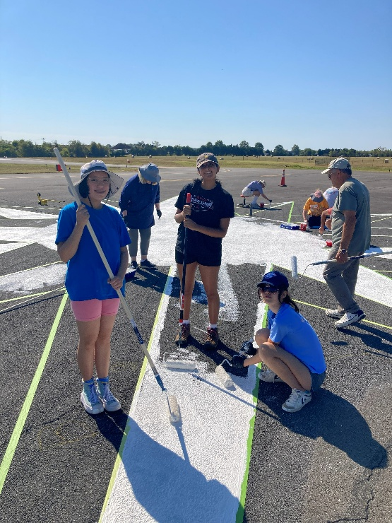
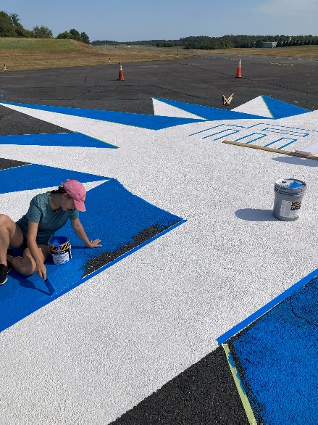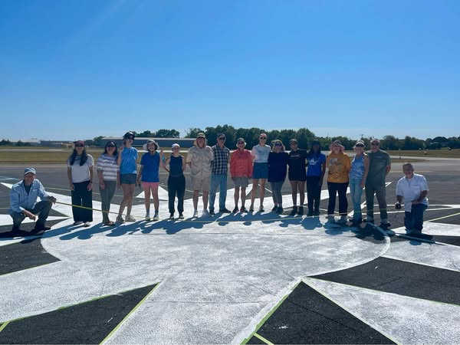

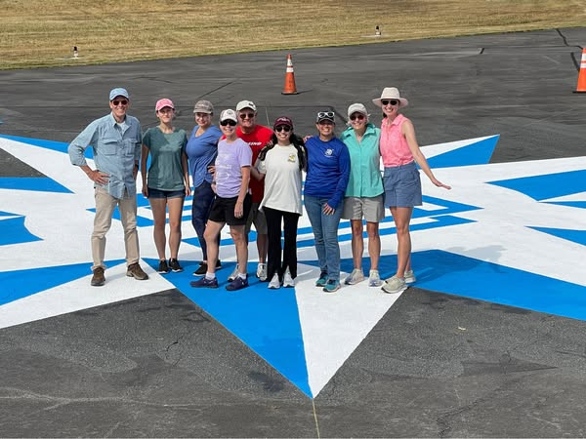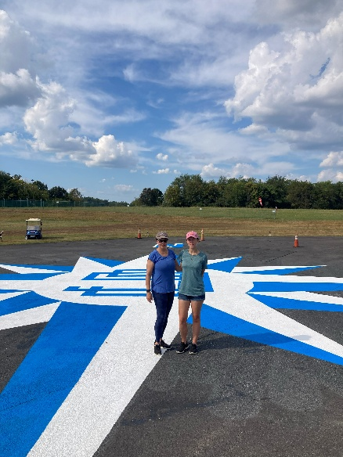

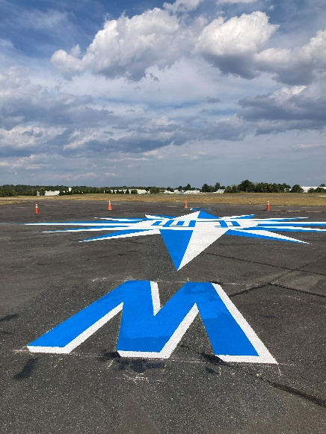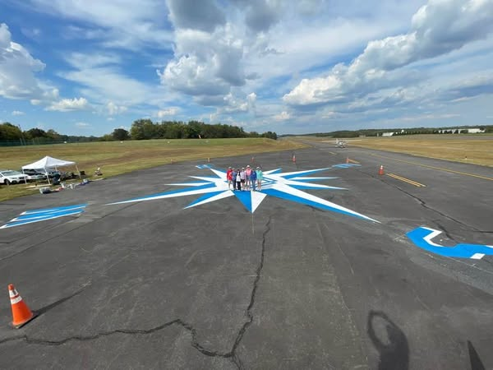

Fall Section Meeting –

Laura Savino attended the fall section meeting in Lambertville, NJ.
Minutes will be produced eventually. My sources of information about the meeting are Mary Wunder and Laura. I gather there was significant discussion about the cost of registering for these meetings and whether there are ways to make them more affordable.
It also became clear that our chapter is the only one that has its own treasury with any revenue. Whether our chapter needs to continue to charge “dues” or even keep a bank account for “voluntary donations” might be a topic for discussion.

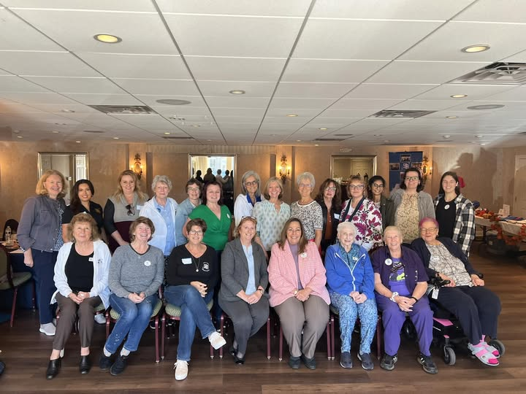

Culpeper Air Fest

The compass rose job was to timed to prepare the Culpeper airport for its Air Fest 2025 event. Whether any of the pilots used the rose for its intended purpose is beside the point. It looked fabulous and the airport staff was immensely proud.

So a few Old Dominion 99s went to see the show: Sue and Dave Passmore, Mary McCutcheon, Nancy Schuster, Cynthia Axell, and Laura Savino. Many fans of our chapter were also there including Chuck Tippett and Erin Miller as well as the airport staff who love us. The show was great. Here are some pictures.

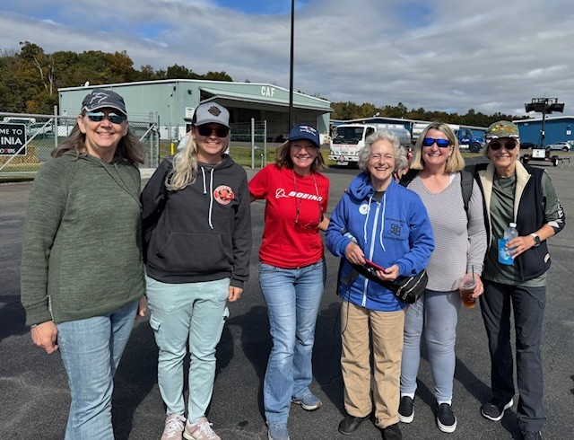
Sue, Erin, Laura, Mary, Nancy, Cynthia
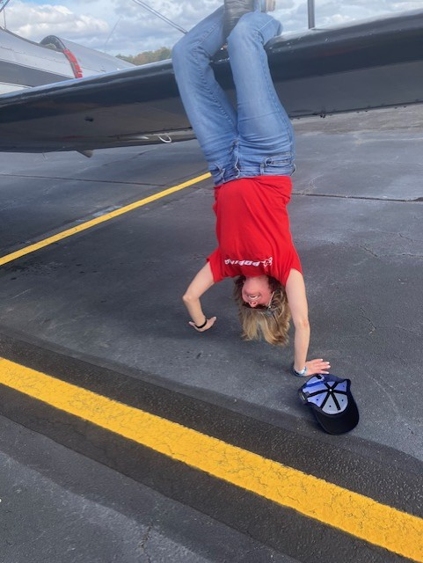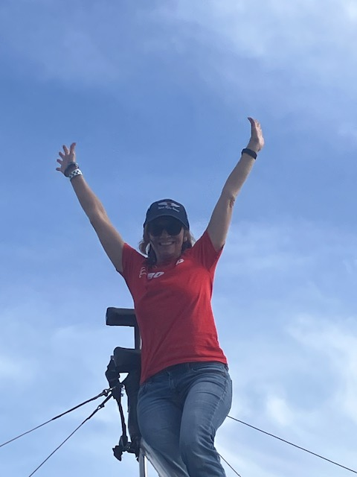
Laura practicing wing-walk stunts

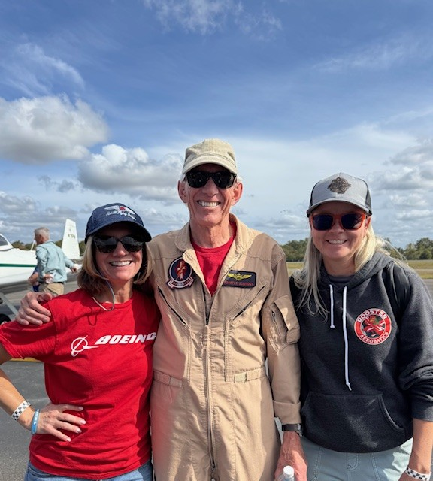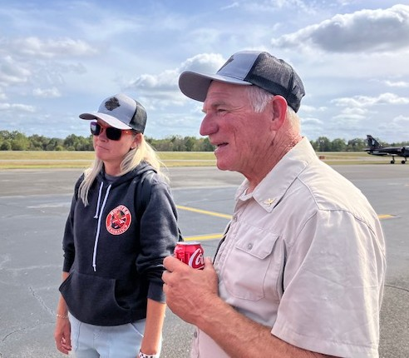

Laura, “Rooster”, and Erin Erin and Chuck Tippett

Member highlights

Mia Anderson
Mia entered the International Aerobatics Club National Competition September 28 to October 3 in Salina, Kansas. She competed in both primary power (getting 5th place) and Sportsman Glider (winning first place)
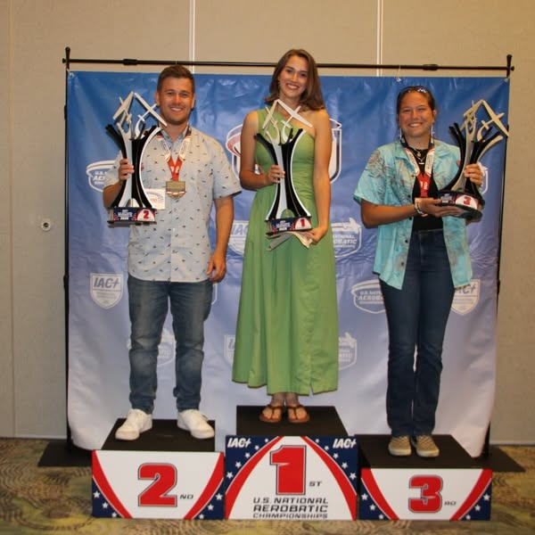
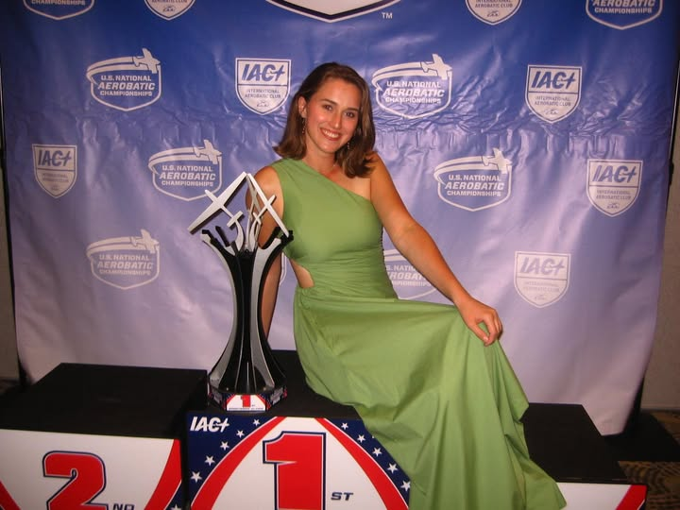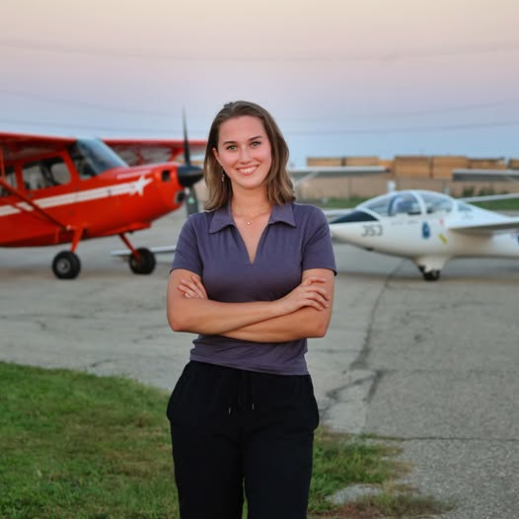

Frankie Velazquez was honored at the 5th Annual Latinas in Aviation Global Festival at College Park Aviation Museum and the Field of Firsts Foundation.
September 27 College Park, MD

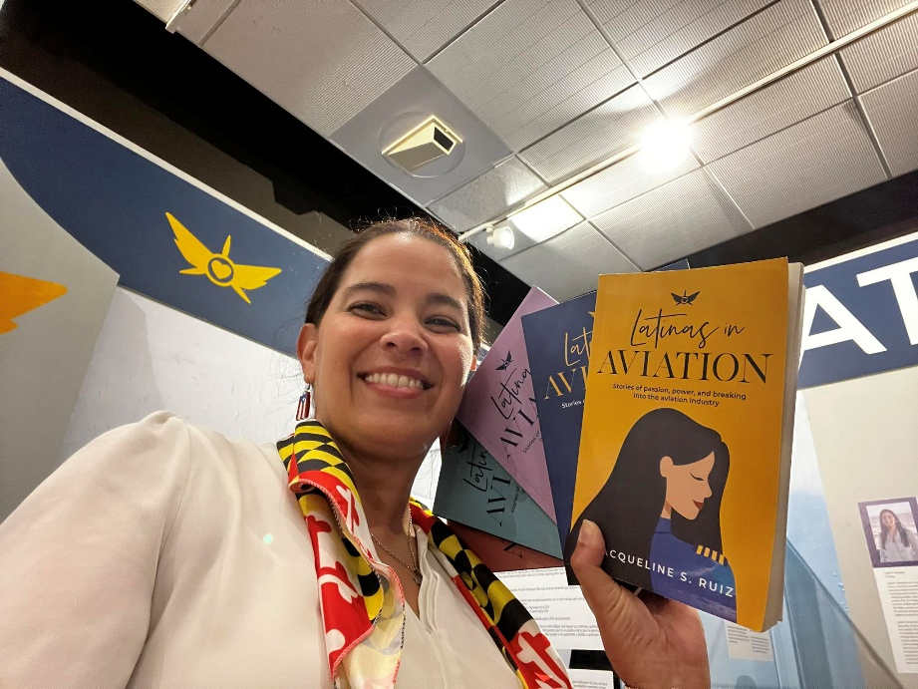

Barb Gruber (known as ThunderBarb)

got the thrill of a lifetime getting to go with the Thunderbirds. They wanted to honor her for her for her work at the Greenbank telescope and for her ongoing commitment to aviation and space science education

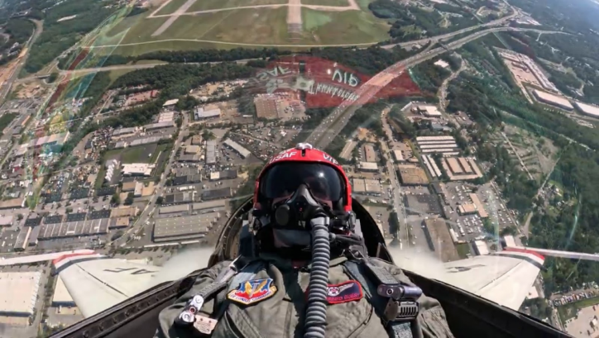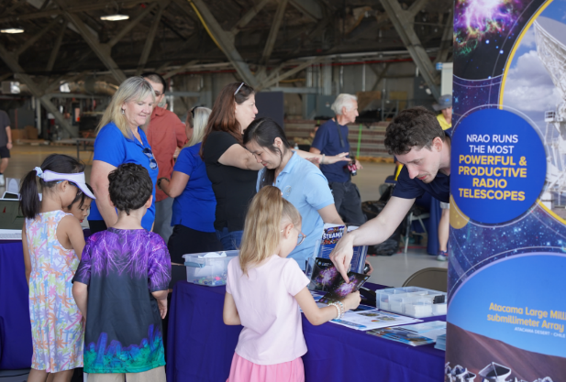

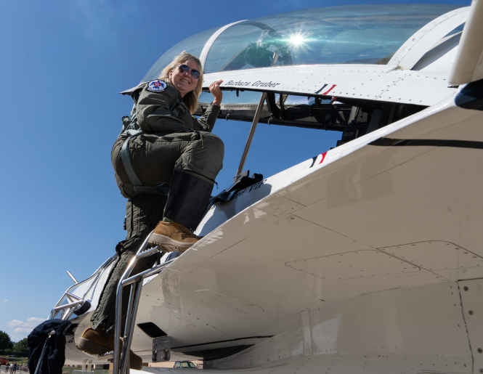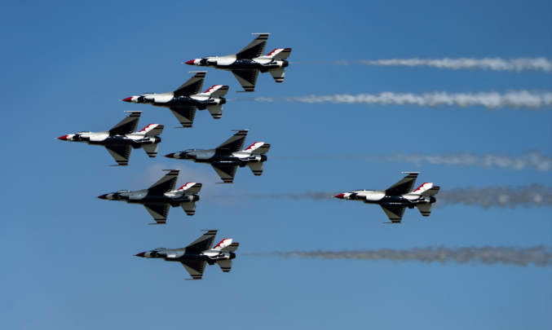

Morgen Reeb’s Retirement Flight

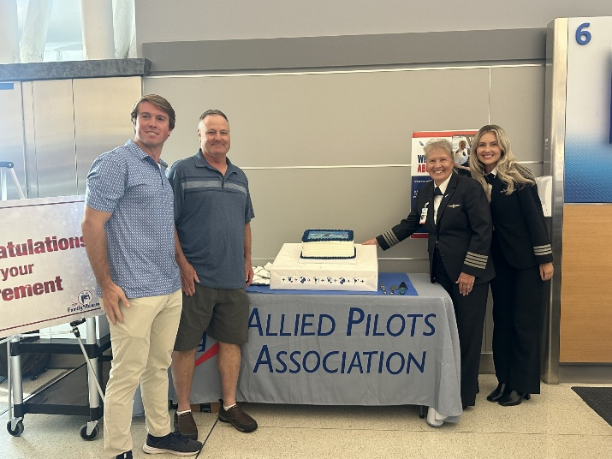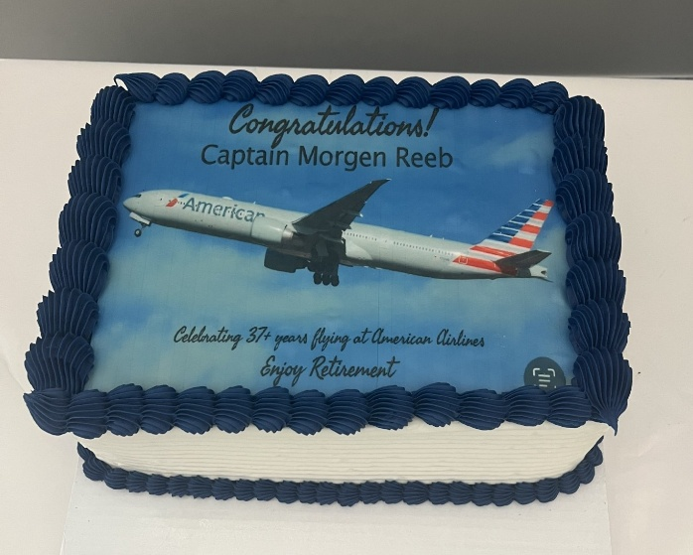
Before departing JFK on September 15. Ryan, Frank, Morgen and Jenny cut their cake.

Then the family had a day and a night to enjoy Milan before the final flight on September 17. Mary McCutcheon decided to go for the fun of it. Passengers were welcomed with a sign telling them the significance of the flight. I got on board and met the four pilots, all of whom were women. Morgen gave her spiel about keeping seatbelts fastened in case of unexpected tubulence and added that this was her retirement flight. Those who understood English clapped. The flight attendants passed around a “card” which was actually a booklet so each passenger could write something. When it came to me, I photographed Ryan’s entry. When we landed at JFK, we were met with the water cannon. It was fun to sit at a window seat getting blasted with the firehose. Then when it was time to get off, I gave Morgen the card Cynthia had picked out for her. Totally great time.

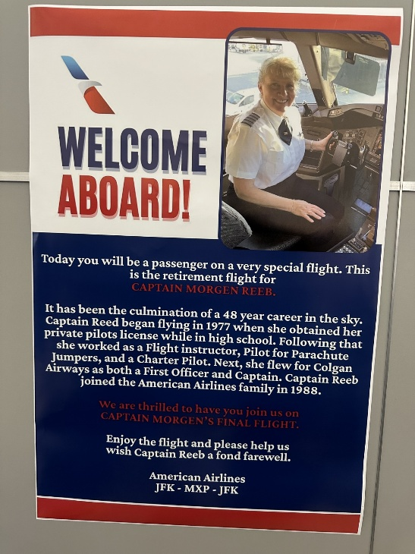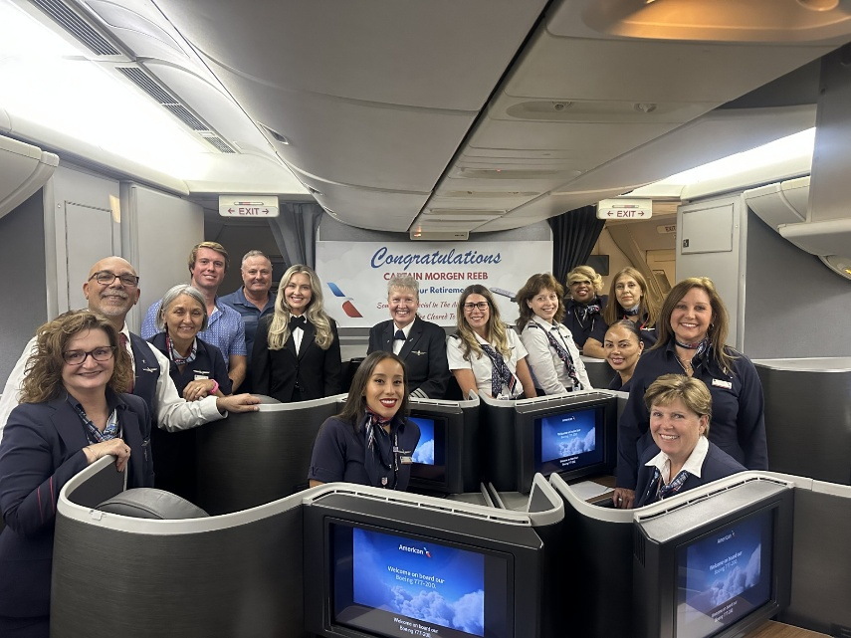

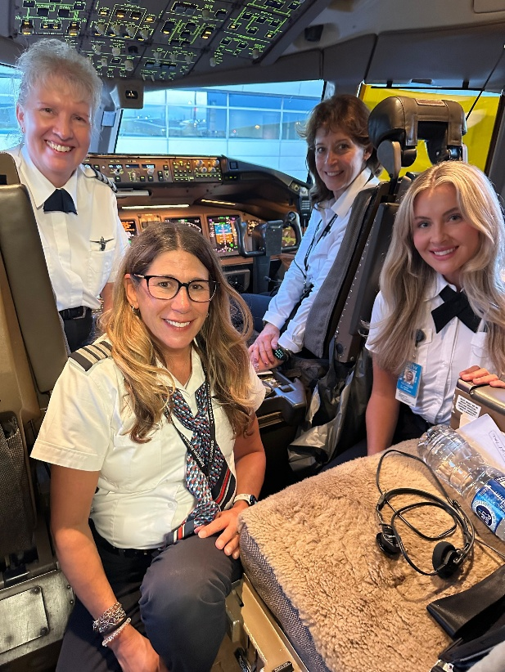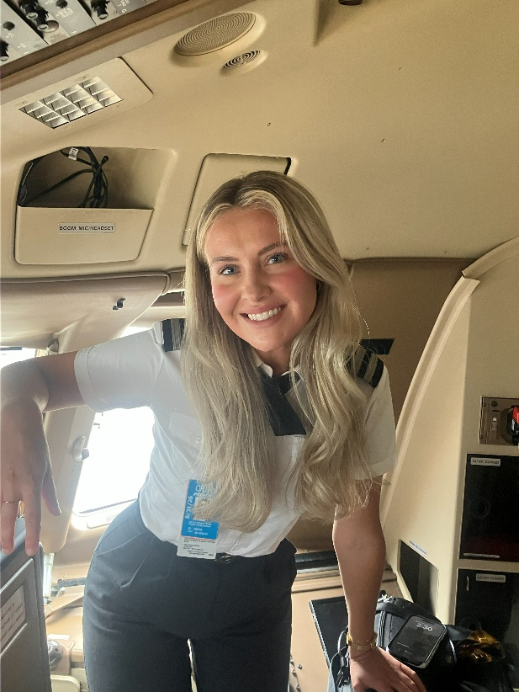
Jenny Reeb was part of the crew
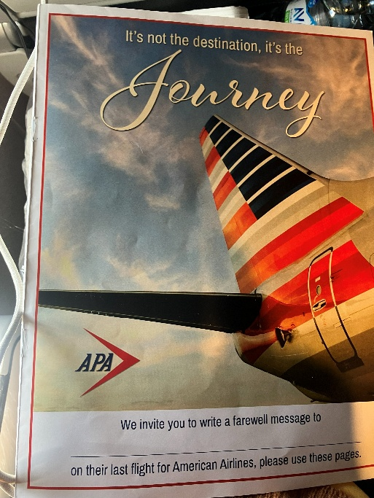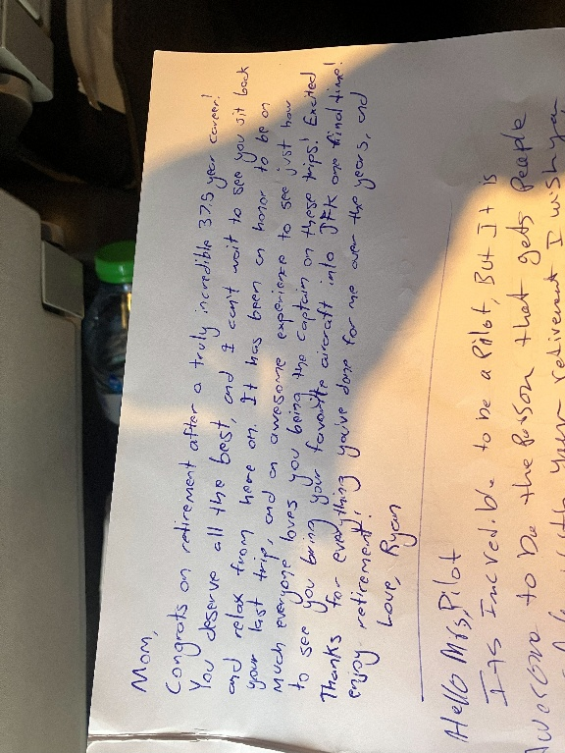
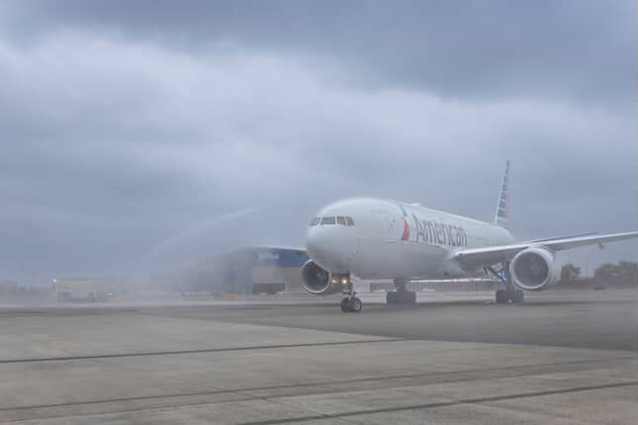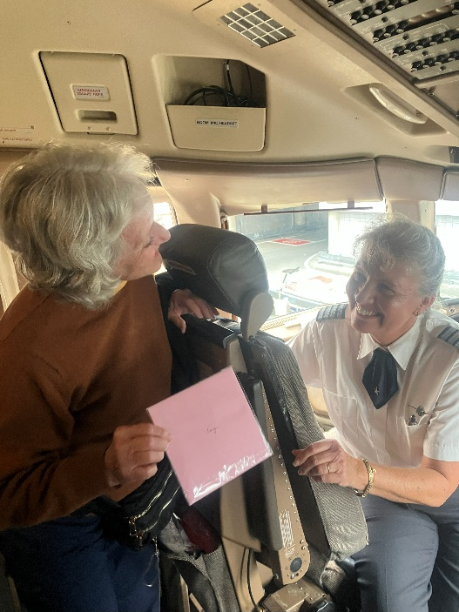

Morgen and Jenny Reeb

Not long after retirement, the newly minted lady of leisure took another flight with her daughter, Jenny, to Orlando

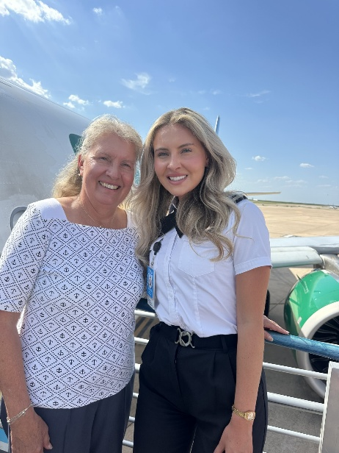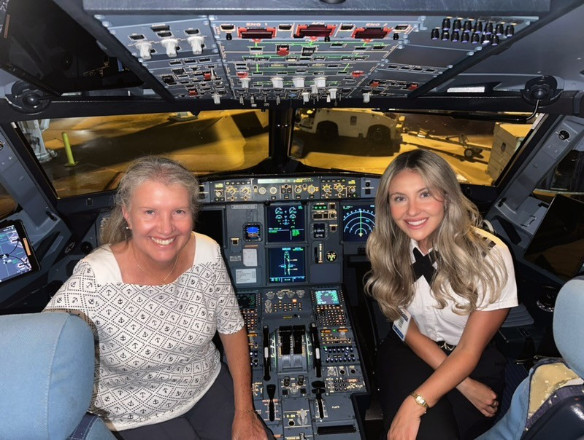

Morgen Reeb, Laura Savino, Jenny Reeb and Nancy Shuster at ISA-21 in Iceland

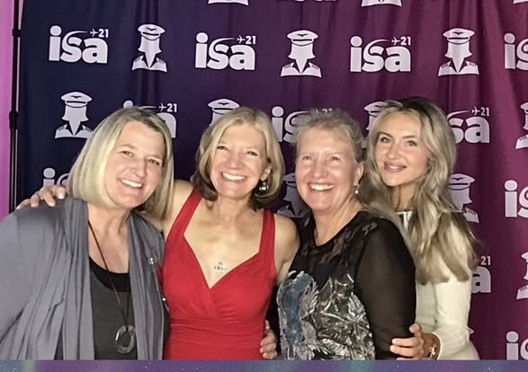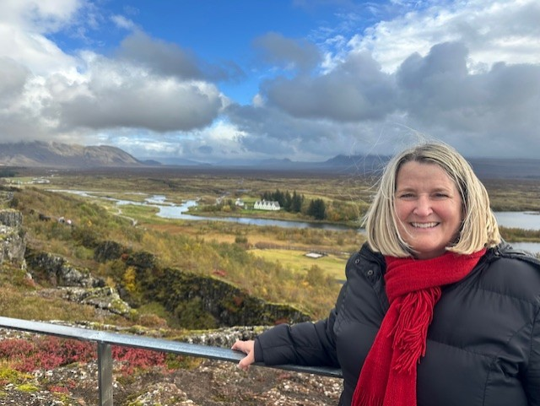
Nancy, Laura, Morgen, Jenny Nancy Schuster



