

Old Dominion Chapter
SKYLINES
December 2025

Chair: Cynthia Axell
Vice-Chair: Nancy Schuster
Secretary: Mary McCutcheon
Treasurer: Barb Gruber
AE Scholarship: Cynthia Axell
Membership: Sue Passmore
Newsletter: Mary McCutcheon
Webmaster: Frankie Velazquez

HOLIDAY PARTY

DECEMBER 19
At Cynthia Axell’s house 53 Menlough Drive, in Warrenton
Come around 5 and bring a pot luck dish and a gift.
Bring a husband or significant other.
Even an insignificant other will be welcome.
No one is coordinating the potluck so you never know what you’re going to get.
And your gift should not be addressed to anyone in particular, and should disguise your identity too.
If you bring a guest, bring another gift too.
Make your gift not too expensive but ideally desirable to a pilot. We’re going to play our game of Yankee auction.

RSVP. To Cynthia at h20av8tricks@aol.com

OCTOBER MEETING

The October meeting was held at Jarern Thai Cuisine, 14245 Centreville Square, Centreville, VA 20121. Frankie Velazquez, Sue Passmore, Olessiya Russell, Barb Gruber, Rebecca Akhigbe,Laura Savino, Allison Northern, and Nancy Schuster were there.

Here is a picture:

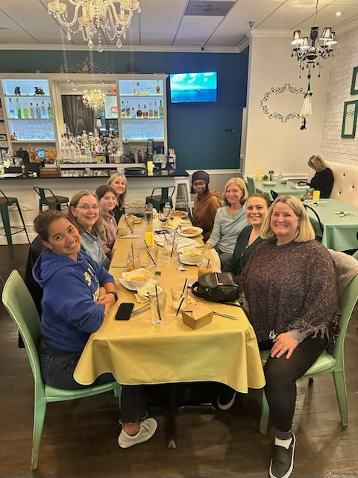
SCHOLARSHIP NEWS

Ekaterina Zubareva won the Amelia Earhart first wings scholarship
Here is some background on this winner:

She joined the Civil Air Patrol and has already been promoted twice —

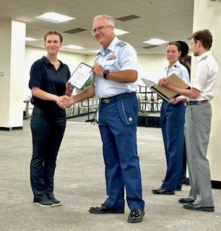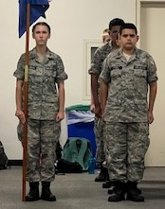

First to Cadet Airman in July, and then to Cadet Airman

Over the summer, she interned with Bravo Flight Training in Frederick, gaining valuable hands-on experience with aircraft mechanics and earning AMT logged hours. She plans to continue this internship during the school year for high school credit.

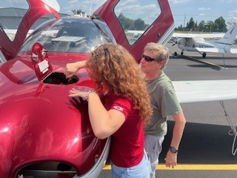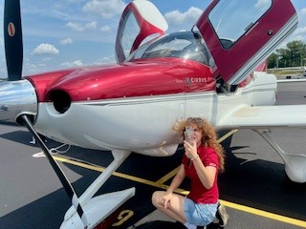

Samantha Stahl

Samantha won the Mid-Atlantic Scholarship to complete the ATP/CTP course. She has done this and is due to take the written exam soon. She has been flying Boeing 767 and 757 simulators with a lot of training.

Here’s a photo

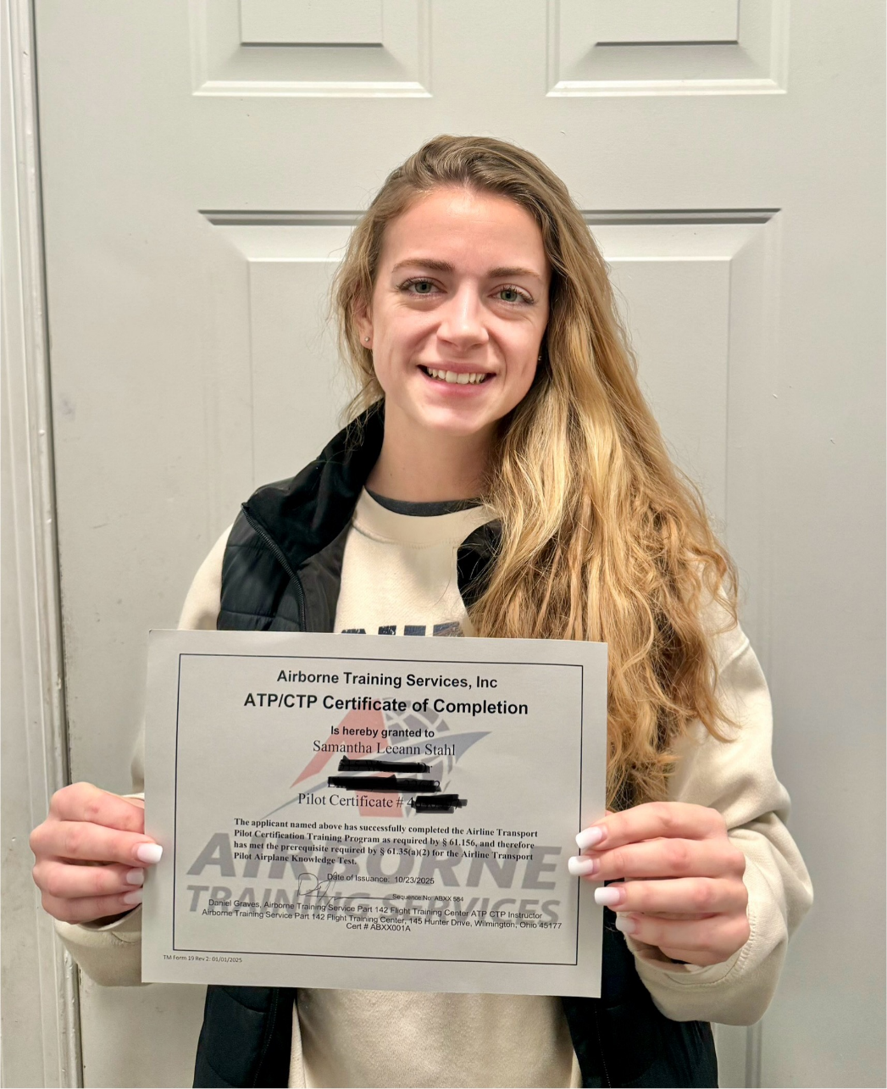

SCHOLARSHIPS FOR NEXT YEAR

AE Scholarship Application Deadline is January 1st

SCHOLARSHIP DESCRIPTIONS
There are five separate Amelia Earhart Memorial Scholarship applications in order to accommodate the most common types of requests. The applicant should use the application form most appropriate to her circumstances and goal.

Flight Training Scholarship
Up to $20,000 to complete an additional pilot certificate or rating or pilot training course. Examples: Multi-engine rating, commercial certificate, King Air competency or qualification training or Boeing 737 type rating.

Academic Scholarship
Up to $10,000 scholarship towards one year of a college degree in aviation or aerospace. Students may re-apply for continuing support through graduation. Examples: Associate's, Bachelor's, Master's, or Doctoral degree in fields such as aerospace engineering, aviation business management, air traffic management, or professional pilot. Note: Flight training may be included if integral to curriculum.

Technical Training Scholarship
Up to $20,000 scholarship to complete an aviation or aerospace technical training or certification course. or flight training course that does not result in a pilot certificate/rating but results in completion of verified course requirements. Examples: ATP CTP, Airframe and/or Powerplant Mechanic certificate, Dispatcher certificate, Air Traffic Control training program, government or manufacturer's safety training, specialized training or certification course, mountain flying course, or specialized seaplane training course. Note: Excludes any flight training and any technical training that is part of a college degree program.

Vicki Cruse Memorial Scholarship for Emergency Maneuver Training
Fully paid scholarship to provide emergency maneuver and spin training in addition to an introduction to aerobatics. In memory of 99 Vicki Cruse, an internationally known aerobatic pilot, this scholarship is available to any licensed pilot member of The 99s without regard to existing ratings, financial need or length of membership. Complete details about the training can be found in the application package.

Kitty Houghton Memorial Scholarship
This International scholarship in memory of Kitty Houghton, is offered specifically to encourage women pilots in emerging economy countries to pursue a career in aviation benefiting their home country.

Hillsboro Charter Academy Flight Funday Fest

Our chapter members have been involved in Hillsboro Academy’s annual event for several years. It is such a joy to share the gift of aviation with the next generation! The event was on November 6.

Laura Savino, Mia Anderson and Hannah Rust were there this year. Maybe there were others from our chapter too.

Hannah sent some great pictures of her teaching navigation, reading charts and flight planning. She says “I loved seeing the excitement & sparks of curiosity as students opened their charts and started searching for different nav aids, obstacle altitudes and waypoints enroute. The Virginia Department of Aviation have been incredible to work with, donating over 150 charts so that every student can continue planning their future flight adventures!”

Laura arranged a sky-writing air show on the spur of the moment which was spell-binding for the kids.

And Mia is also featured in some good pictures as she told the kids about aerobatic flying.

Apollo 13 astronaut Fred Haise was also there telling stories and answering questions.

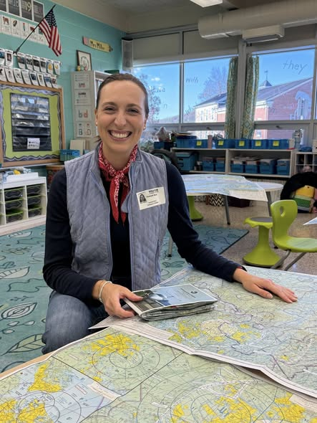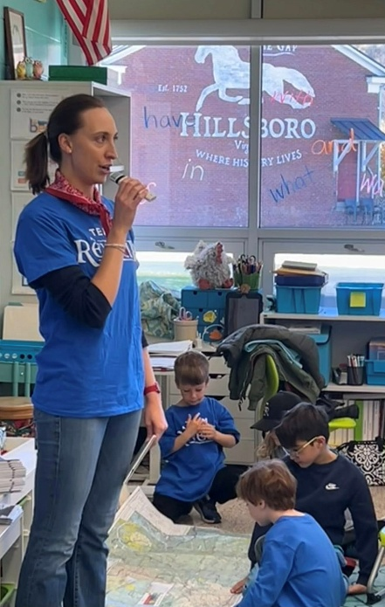

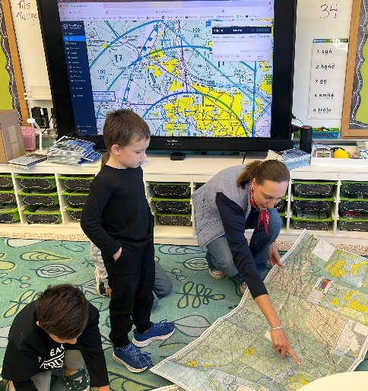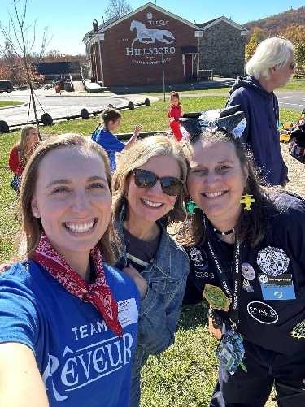

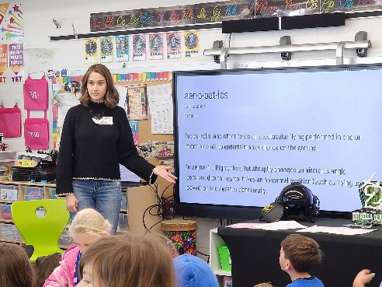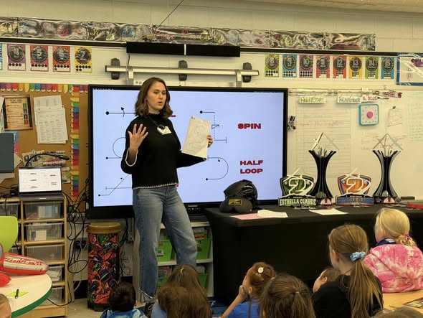

COOL TELESCOPE NEWS

This comes from Barb Gruber, who is an educational outreach member of the GreenBank space telescope team.
From Barb Gruber:

Heads up, astronomy fans! You can spot the NSF Very Large Array in the brand-new Apple TV series ‘Pluribus.’ Our giant dishes aren’t just background scenery, but actually play into - and kick off - the show’s main storyline! #Pluribus #VeryLargeArray

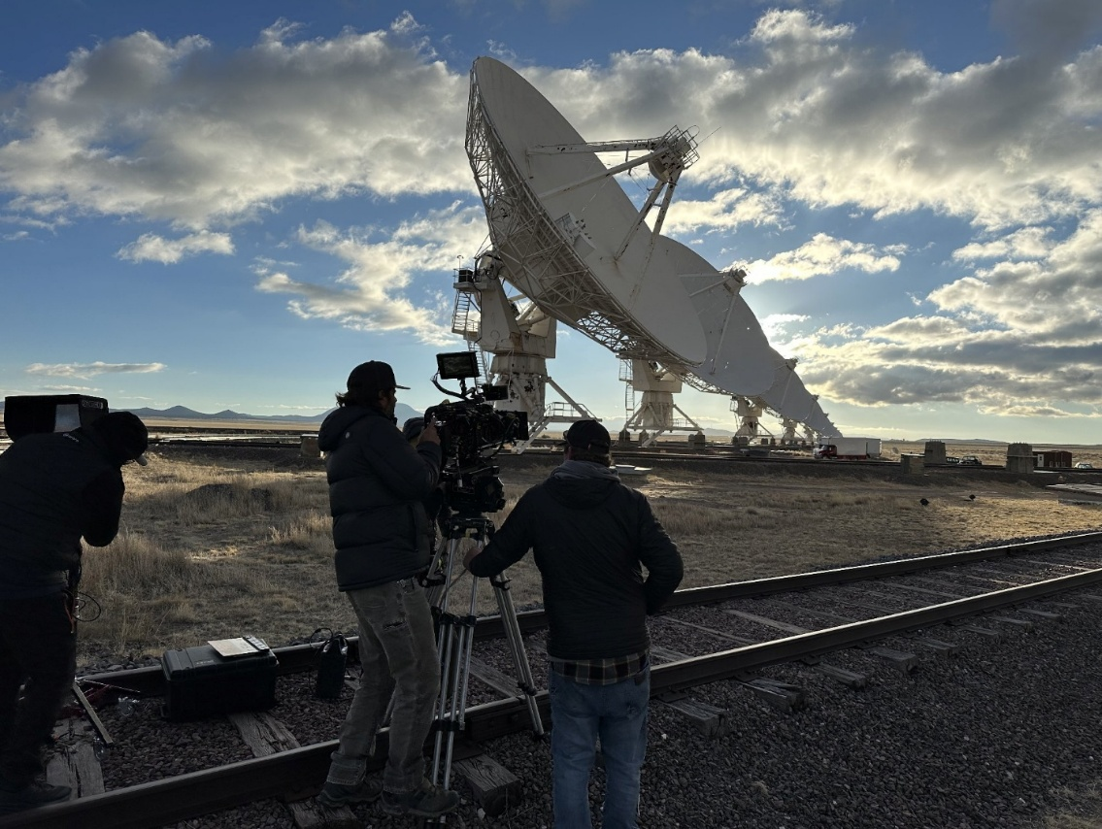

MIA ANDERSON IN THE NEWS

(lifted unapologetically from FACEBOOK)
I Took to the skies at the first ever Nancy Lynn Aerobatic Open and came home with 1st place in Powered Primary! I also somehow walked away with the Grass Roots achievement and the American Champion Aircraft flight medal
I was honored to fly in an event that celebrates Nancy Lynn’s incredible legacy and the spirit of aerobatics.

Leesburg native Amelia Anderson was flying gliders and planes before she could drive a car, starting out at age 13. Six years later, she’s now competing in national aerobatic competitions – and winning.
Known to her friends as Mia, Anderson said aviation is in her blood.
“My dad's a pilot for Southwest Airlines. My mom's a flight attendant for Southwest. My grandmother and her twin sister were also flight attendants for Southwest. … And I have two great-grandfathers that were also private pilots. So, when they say aviation's in the DNA, it's true,” she said.
Anderson’s journey started when her father set up a discovery flight with The Experimental Aircraft Association’s Young Eagles program, an organization that helps children and teens discover aviation through a free flight.

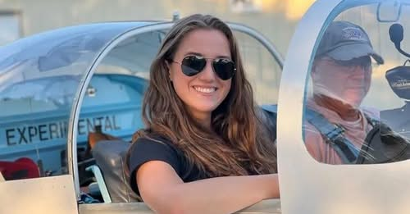

loudounnow.com
Loudoun Pilot Makes Waves in National Aerobatic Scene

NEW MEMBERS

SANYA BHALLA

Hello! My name is Sanya Bhalla, and I am a student pilot and junior in high school! I am working to get my Private Pilot's License (PPL) and am currently completing ground school. I am so excited to join the Ninety-Nine's chapter and build a community of support around me!

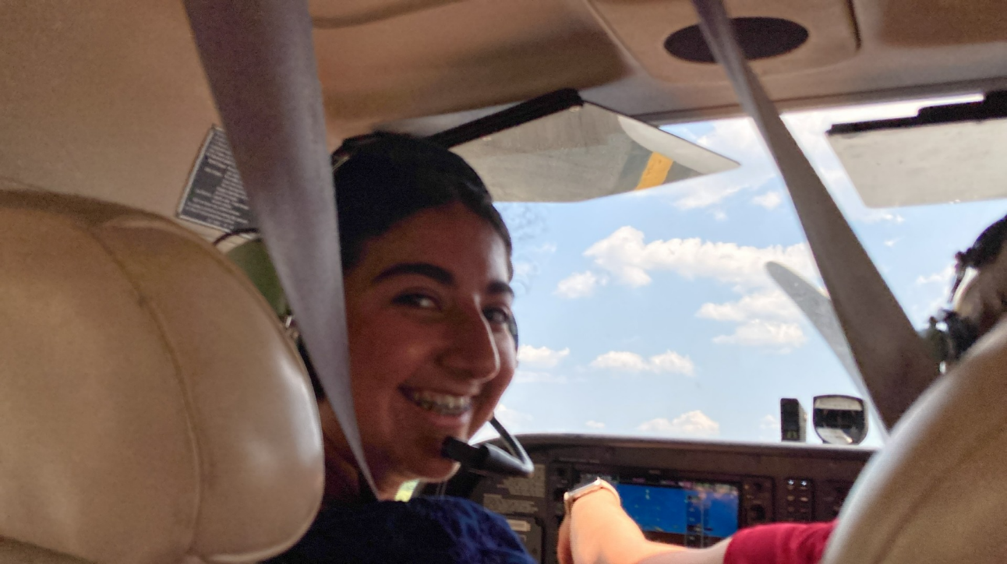

In Addition we have Charlotte Granahan, Suzette Rash, Marian Schultz and Charlotte Young. Maybe we’ll have their stories in the next newsletter

