

Old Dominion Chapter
SKYLINES
January 2026

Chair: Cynthia Axell
Vice-Chair: Nancy Schuster
Secretary: Mary McCutcheon
Treasurer: Barb Gruber
AE Scholarship: Cynthia Axell
Membership: Sue Passmore
Newsletter: Mary McCutcheon
Webmaster: Frankie Velazquez

NEXT MEETING

DATE: January 27
LOCATION: Conference room upstairs in Leesburg Airport terminal
TIME: Come around 6 and bring something to share and eat
SPEAKER: This is the talk we’ve been waiting for: Mia Anderson will tell us about her aerobatic flying experiences. She may tell us both about glider aerobatics as well as powered aerobatics. Wait and see.

TASTE OF WHAT IS TO COME:

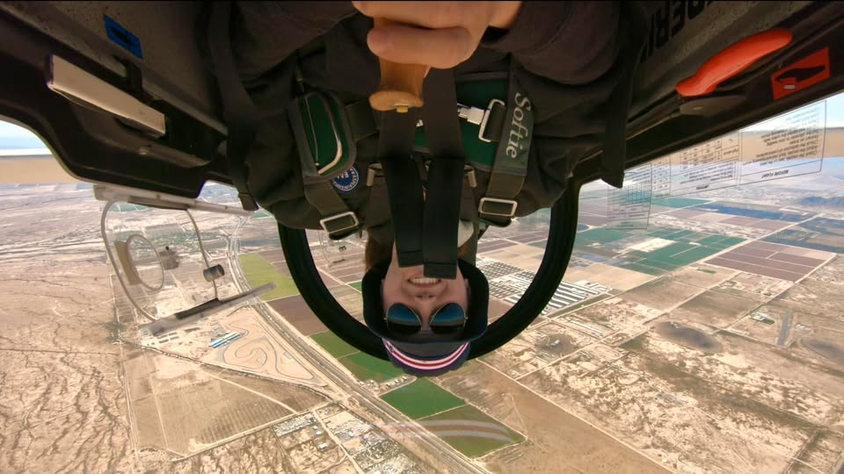

HOLIDAY PARTY

We had a dynamite great time at Cynthia’s house for our holiday party on DECEMBER 19

Here are some pictures of the scene:

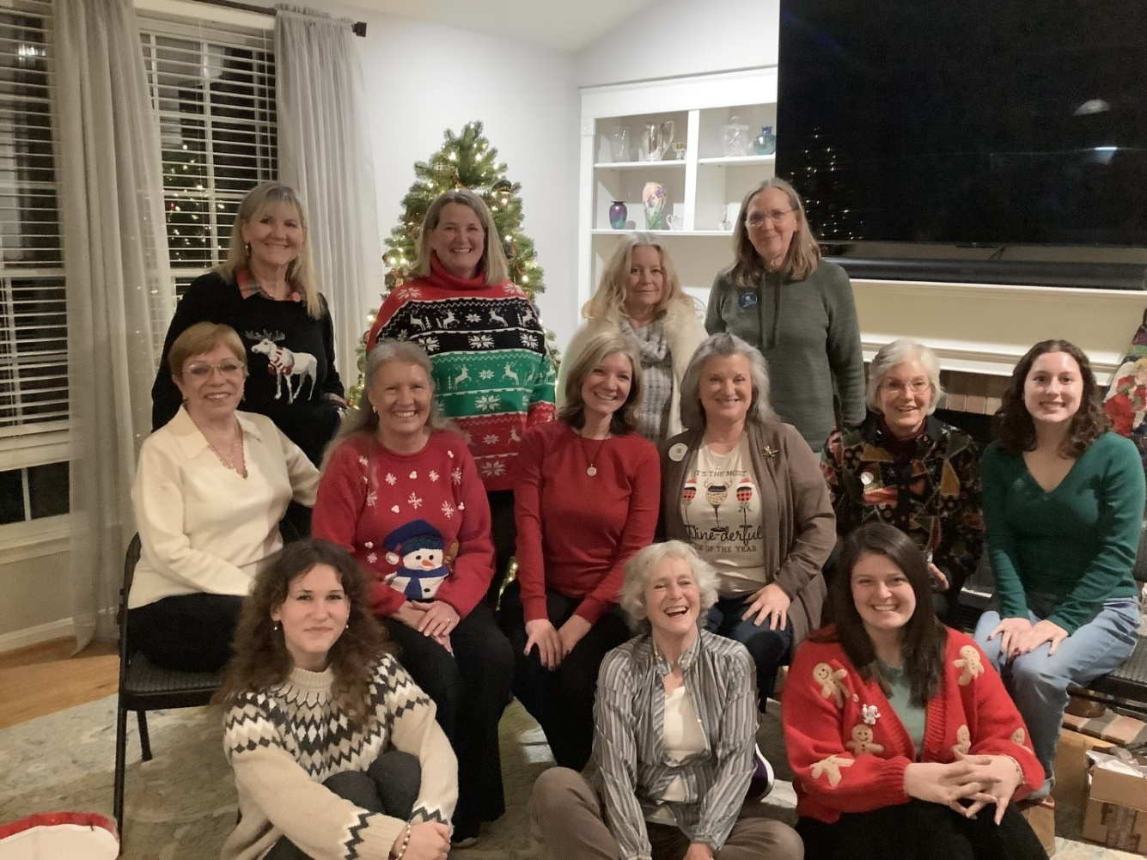
Back row: Barb Gruber, Nancy Schuster; Jeannine Bouvier, Sue Passmore
Middle Row: RJ McGlasson, Morgen Reeb, Laura Savino, Melissa Plumer, Cynthia Axell, Alana Bicoy. Front Row: Katya Zubareva, Mary McCutcheon, Charlotte Granahan

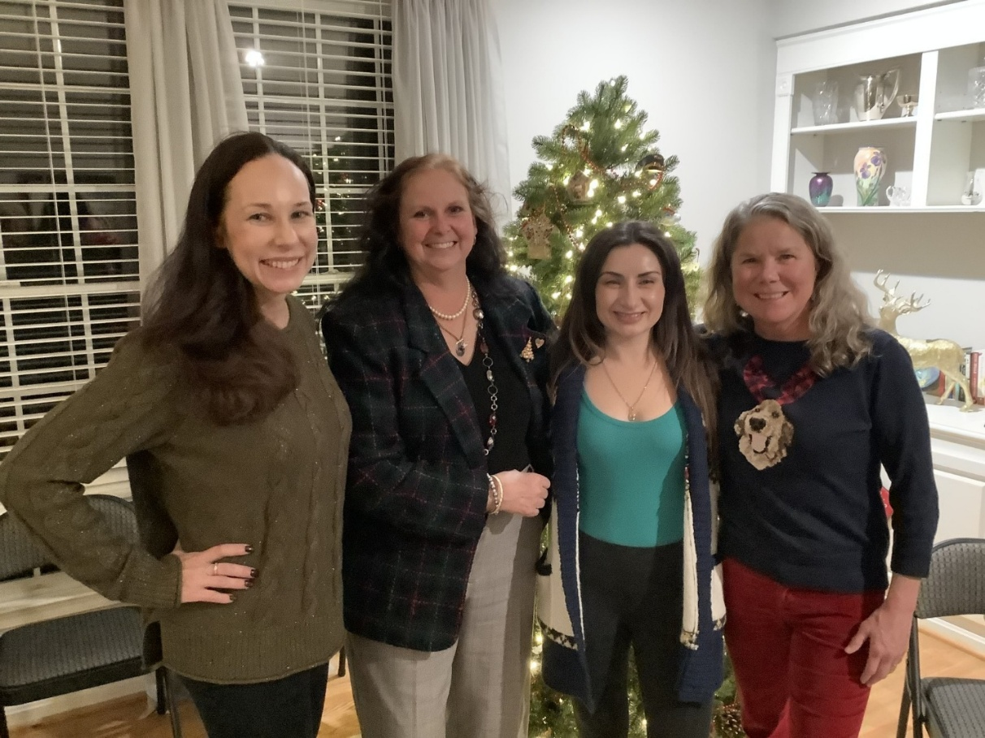
Tatiana Zubareva, Kimberly Granahan, Tatiana Russell, Beth Whitehouse

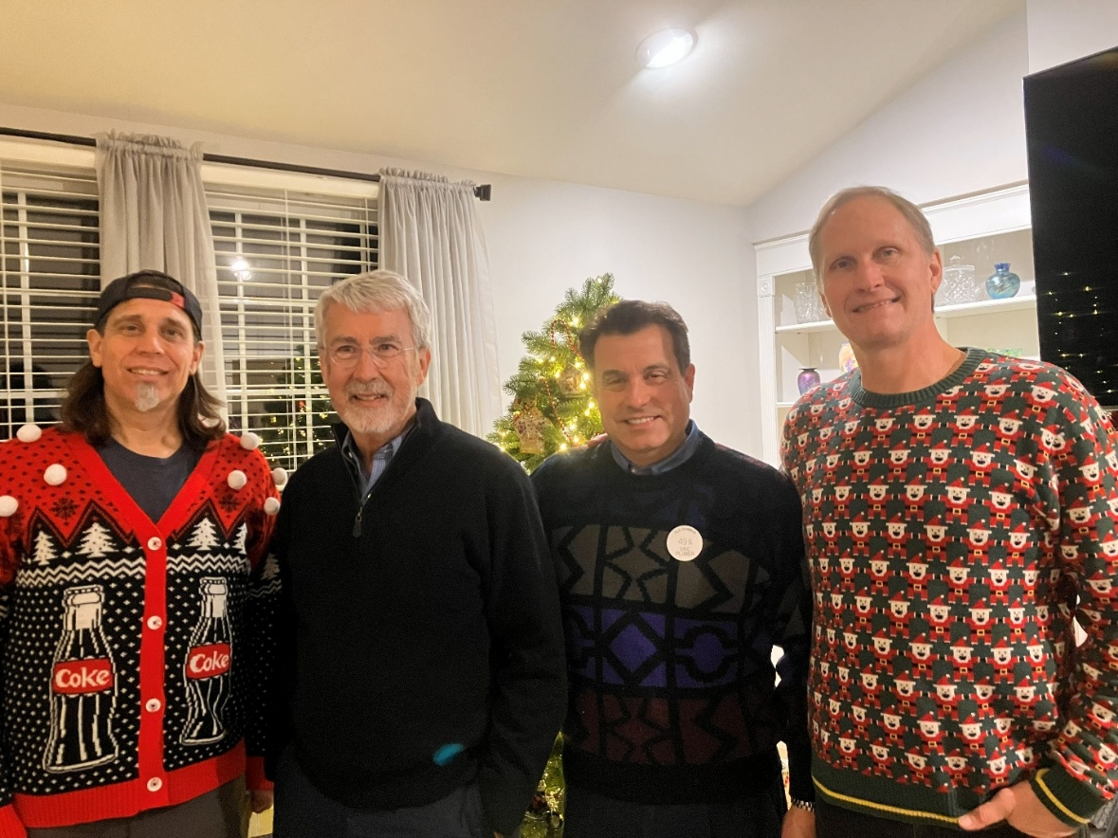
Mike Schuster, Dave Passmore, Eric Plumer, Chris Siebert
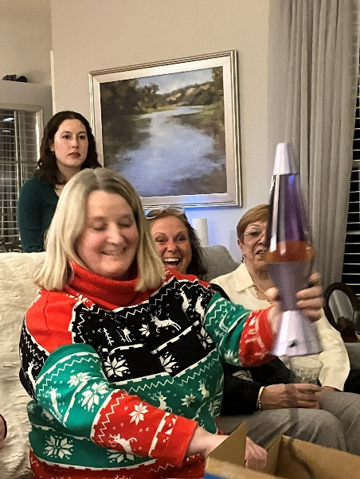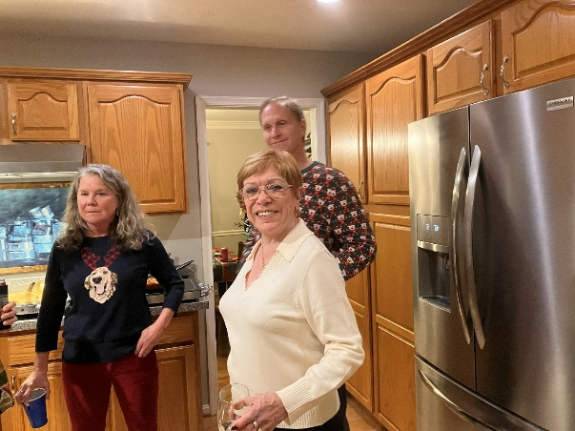
Alana, Nancy, Kimberly and RJ Beth, RJ and Chris
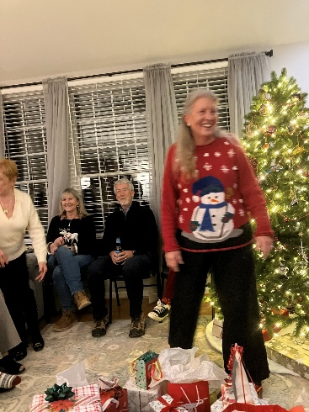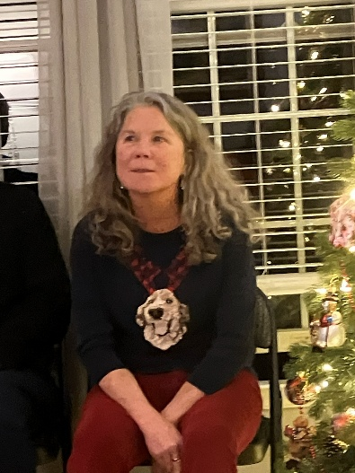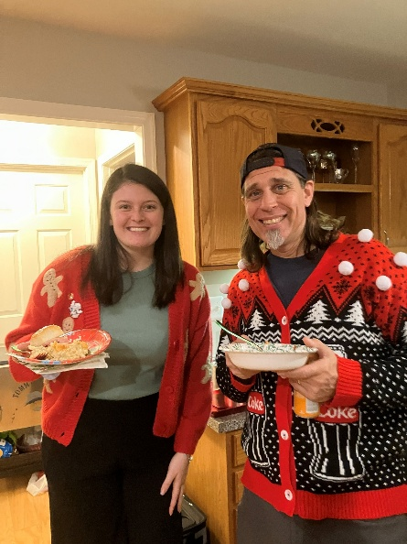
Barb, Dave, Morgen Beth Whitehouse Charlotte and Mike

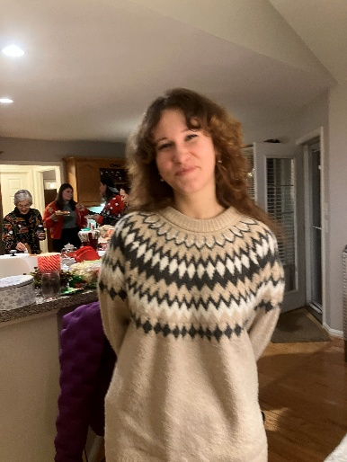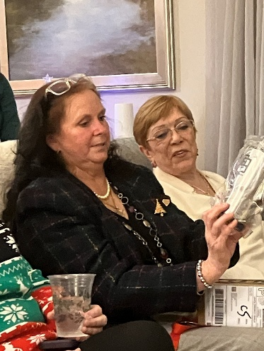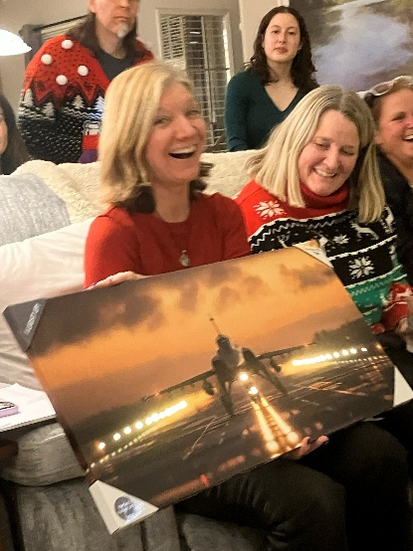
Katya Zubareva Kimberly and RJ Laura, Alana and Nancy
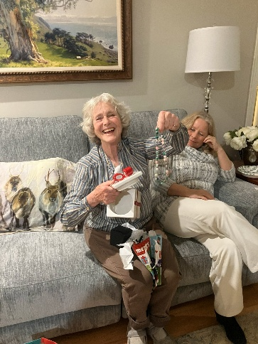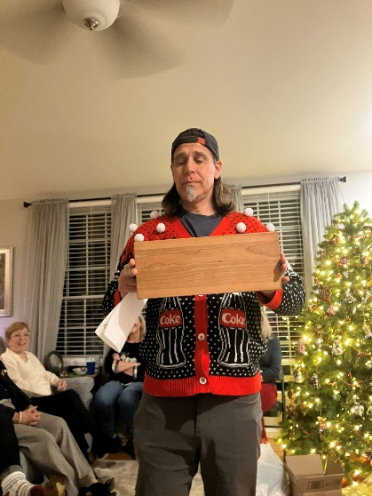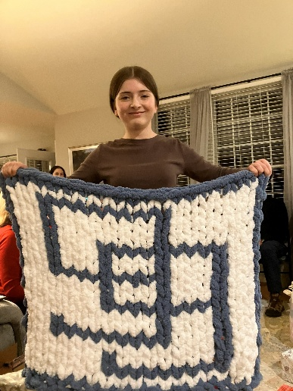
Mary McC Mike Schuster Olessiya with the blanket
Knitted by Barb Gruber

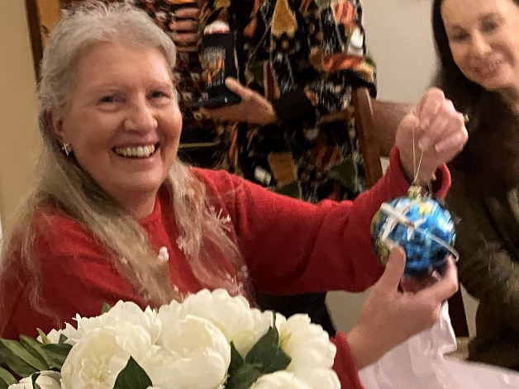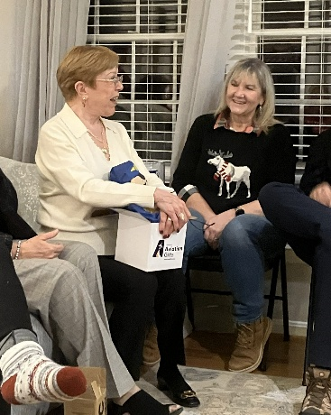
Morgen Reeb and the ornament RJ and Barb

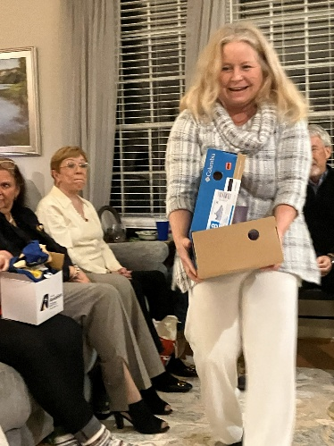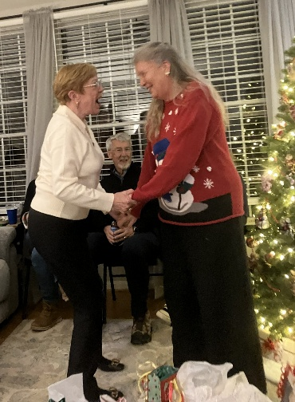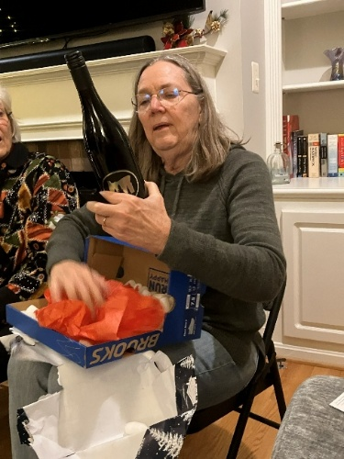
Jeannine Bouvier RJ and Morgen Sue and the bottle of Oregon wine
SCHOLARSHIP NEWS

Mid-Atlantic Section of The Ninety-Nines Scholarship Application

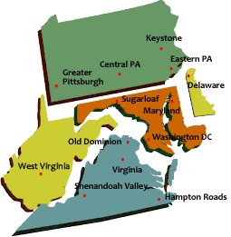

Name of Scholarship: Mid Atlantic Section Scholarship
Amount of Scholarship: Up to $5,000.00
Application Receipt Deadline: February 28, 2026
Announcement Date: April 15, 2026

Description: Mid Atlantic Section of the 99s is committed to supporting and promoting woman pilots in the continued pursuit of aeronautical skills, both professionally and recreationally.
Eligibility:
- Applicant must be a member of the Mid Atlantic Section of The Ninety-Nines.
- Applicant must be a current member (in good standing) of The Ninety-Nines, Inc.
- Scholarship must be used for training within one year.
- Applicant must already have a private pilot’s license

Purpose:
to add ratings, regain currency, increase proficiency, certificate or endorsement by participating in a defined training activity, e.g. instrument training, multi-engine training, CFI, CFII, seaplane, tailwheel, aerobatics, commercial rating, etc.

APPLICATION
Please submit the following three required application components in a single email to Mary McCutcheon, mmccutch@gmu.edu with attachments that may be in PDF or Word formats. Have your name on each file heading.

A. An essay of no more than 400 words describing:
- Applicant’s career and/or personal objectives in obtaining the scholarship?
- Way the scholarship will be used to advance those goals.
- Challenges faced without the scholarship
- Pertinent aviation related activities (including employment and recreation), qualifications and other experiences that pertain to these goals
- Future plans to contribute to the Ninety-nines and to the aviation community
B. Budget
Itemization of the total cost of the flight training requested and the plan for payment of the additional expenses not included in the application budget. Make it clear that there are sufficient funds from other sources to complete the training or course of study within one year. Financial need is not a requirement but will be considered in the evaluation.
C. Letter of recommendation
The recommendation must come from applicant’s chapter chair, flight instructor or other qualified individual to verify member's activity level, participation in chapter activities, goals, and aviation experience.

Optional Attachments: Any supporting documentation you deem important, such as:
A. Evidence of passing written or practical test, if applicable.
B. Current flight medical/BFR or other pertinent training
C. Last page or more of logbook
D. Additional letters of recommendation
Other Information:
- Scholarship will be awarded based on qualifications of applicant.
- Scholarship funds will be disbursed directly to the appropriate training FBO or training organization.
- Invoices shall be submitted to the Treasurer of the Mid Atlantic of The Ninety-Nines (Mary Wunder).
- The Mid Atlantic Section of The Ninety-Nines Scholarship Committee may request additional information or documentation.
-Judges are independent members of the aviation community who are not members of the Mid-Atlantic Section.
-For further questions contact Mary McCutcheon, mmccutch@gmu.edu or
phone 703-217-8850

MORE ON SCHOLARSHIPS

This is a good source of information on scholarships
https://www.facebook.com/profile.php?id=100064286845299

And here is a synthesis of the information
Flight Scholarships Home

THE 1979 SLIDE SHOW MADE FOR THE
50TH ANNIVERSARY OF THE 99S

A few years ago, when we were having zoom meetings, I think I showed the slides made for the 1979 50th anniversary of the founding of the 99s. There is a script with the slides which I put into a power point show. RJ had kept these slides for 45 years, and now they’re here in my house. I’d really like to mount this all on youtube so the slides self-propel and a voice gives the narrative. So is there a volunteer who might like to be this voice? Must have a melodic and authoritative yet bemused tone. Any volunteers?

Here are two examples of slides:

Early wingwalkers Louise Thaden mid-air refueling
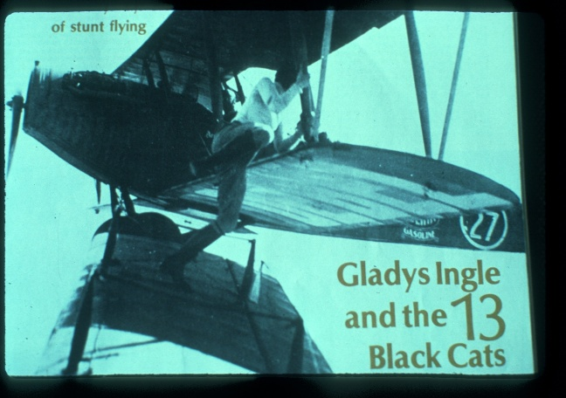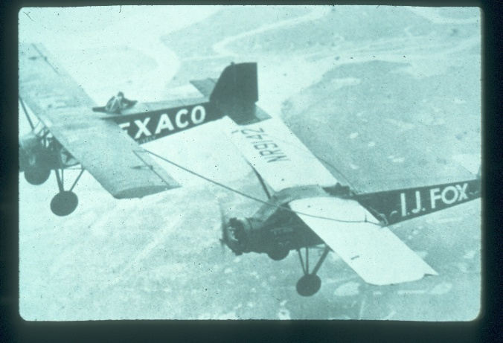

KAT EMERY STRANDED IN PUERTO RICO

Kat and her family decided to take a very short vacation in Puerto Rico. They were having a great time when, on January 3 the U.S. staged the capture of Maduro in Venezuela. The entire airspace due north of Venezuela was included in a massive flight restriction.
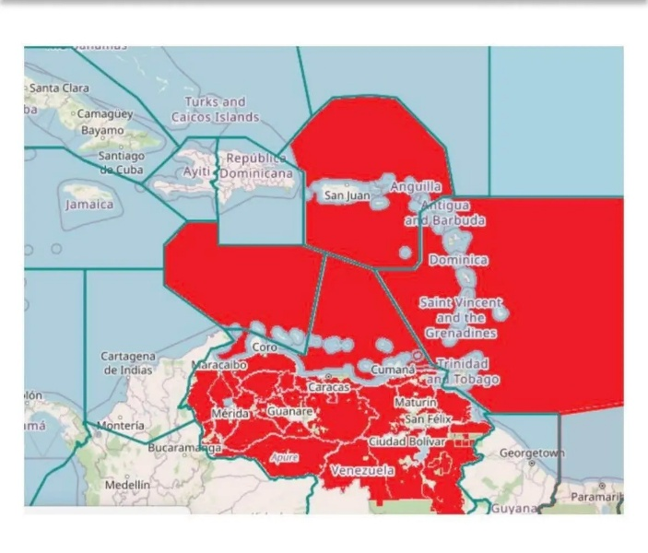
Kat was supposed to be home by the 5th for work at Mesa, but couldn’t bet out of Puerto Rico. The whole system was backed up for days and Kat and her family were “forced” to extend their vacation. Luckily they found housing probably because incoming tourists were also prevented from arriving. In the end she and her family made it home and Mesa had to reschedule its staff. Here she is looking doubly happy to be on the way home:.

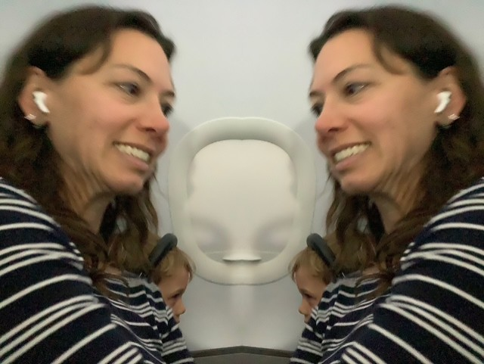

A PODCAST FOR WOMEN IN AVIATION

Fly Girls’ Guide to Aviation Careers is weekly show where real stories from across the aviation industry take flight.
Hosted by René Banglesdorf, this podcast goes beyond the cockpit to spotlight women who are shaping the skies—pilots, mechanics, air traffic controllers, business leaders, safety experts, engineers, and more. Each episode offers a front-row seat to their personal journeys, career pivots, and powerful lessons learned along the way.
Whether you’re dreaming of your first solo, transitioning careers, or already soaring, this podcast is your invitation to explore what’s possible in aviation. Hear from women who lead charter ops, manage rocket launches, give seaplane instruction, shape national policy, and support entire flight departments—all while sharing actionable insights, leadership tips, and a love of flight that transcends job titles. (this the blurb from the website)

https://weareflygirls.com/podcast

AN OUTING IDEA JANUARY 31 AND
A THEATRICAL EVENT

Dear Virginia and DC Area Ninety-Nines Representatives,

My name is Dallyn Bayles. I’m a professor of theatre at Southern Virginia University in Buena Vista, Virginia (www.svu.edu). I’m contacting you to see if it’s possible to schedule a representative from the Ninety-Nines organization to come meet with my cast who will be presenting the world premiere of an inspiring new musical production titled FLY that’s based on the events of the 1929 Women’s Air Derby.

I’d love for them to share a little about the history of the organization, its founding members and other participants who participated in the air derby (the seven pilots portrayed in the musical are Louise Thaden, Marvel Crosson, Amelia Earhart, “Pancho” Barnes, Ruth Elder, Bobbi Trout, and Claire Fahy), and anything else they feel would be inspiring to know about the organization and its connection to the1929 Women’s Air Derby.

Our schedule is fairly open to whenever it would be best for you between now and when we open on Feb 13th. We invite you to come to our beautiful campus, or we could come to you, if that’s best. Our cast will be in the Washington, DC, area on Saturday, Jan 31st, to visit the National Air and Space Museum near Dulles that morning. Meeting with someone that afternoon would also be great.

Of course, we'd also love to invite you to come see our production of FLY, which runs Feb 13-14 and 19-21, if you’re interested and available. For more information, please visit bit.ly/svufly.

NEW MEMBERS

Charlotte Granahan

“I recently switched to the Old Dominion 99s chapter. I have been with the Shenandoah chapter as I have been going to school in Harrisonburg, VA, but recently moved back to my parent's house in Northern VA while I am looking for a job.
A little about me: I come from an aviation family as my grandfather was a WWII instructor, and my father is a private pilot. In early 2019, I started taking flight lessons with my brother and sister out of KHWY.
My sister and I earned our private pilot licenses in 2019, and my brother earned his in 2021. At that point, I decided I wanted to be a professional pilot and fly corporate, cargo, or airlines. I went on to attend the US Air Force Academy Preparatory School in Colorado Springs in 2020 and graduated in May 2021 when I was nominated and received an appointment to the US Air Force Academy. I attended from June 2021-October 2021,when I decided to voluntarily disenroll. I transferred to James Madison University in January 2022 to continue my efforts toward an engineering degree and graduated from JMU in May 2025 with my engineering B.S. degree and minors in mathematics and honors.
Over the summer I worked toward my instrument flight rating and took my IFR checkride in October for the first time and passed with flying colors. I am currently working toward earning hours for my Commercial and CFI licenses and trying to find an engineering or aviation job.”

Charlotte Granahan
703-350-9261

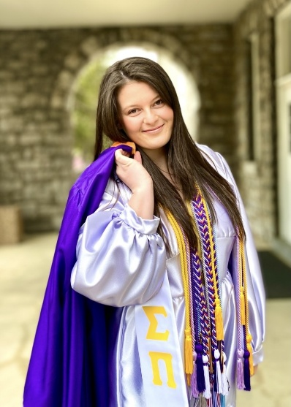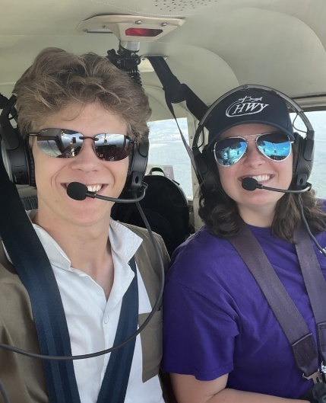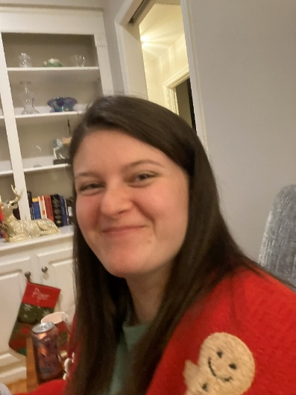

Marian Schultz

is a professional musician who has taught music in the Fairfax County schools and also sings in choirs. I had the pleasure of going to a Christmas Eve service at the Universalist Church in Washington and I heard her sing.

She is a student pilot taking lessons at Aviation Adventures in Manassas.

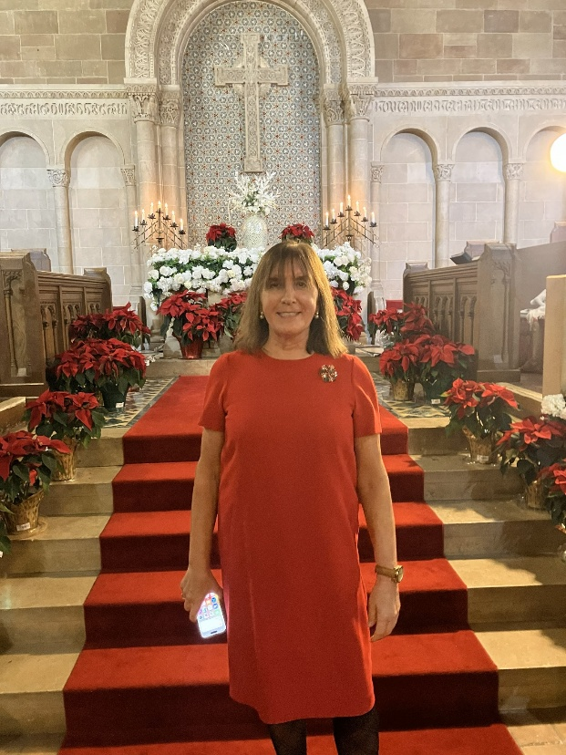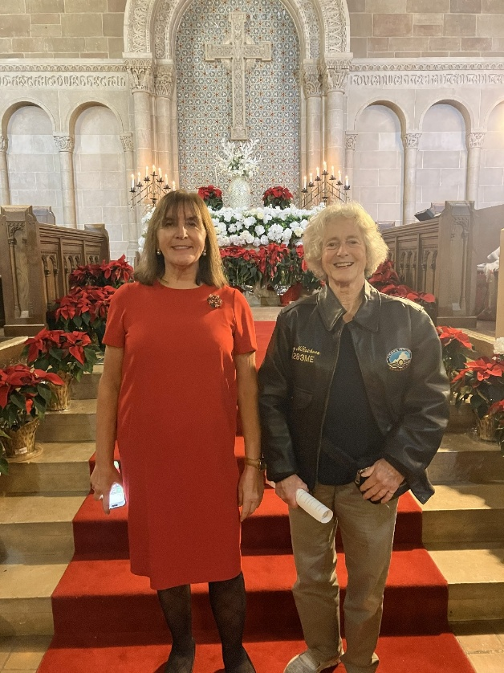

Marian Schultz Marian and Mary McCutcheon

