

Old Dominion Chapter
SKYLINES
March 2026

Chair: Cynthia Axell
Vice-Chair: Nancy Schuster
Secretary: Mary McCutcheon
Treasurer: Barb Gruber
AE Scholarship: Cynthia Axell
Membership: Sue Passmore
Newsletter: Mary McCutcheon
Webmaster: Frankie Velazquez

NEXT MEETING

We have not set a next meeting date yet

CHAPTER ELECTIONS

Its time to elect our new officers for this next year. Cynthia has done a superb job as chair and Nancy has done a superb job as vice chair. Cynthia is stepping down and Nancy has volunteered to run for chair.

The election will be done by a google link (Sue is researching how to get it done). You will receive your ballot very soon and we ask that you fill it out and follow the directions for submitting it. Even though each office position is unopposed, you are invited to write in an alternative.

The slate of candidates is:
Chair: Nancy Schuster
Vice chair: Laura Savino
Secretary: Mary McCutcheon
Treasurer: Barb Gruber

MID-ATLANTIC SECTION ELECTIONS

Ballots for the Mid-Atlantic Section election should be distributed very soon. Keep your eye on your inbox. Your ballot will be due mid April. Follow the directions.

INTERNATIONAL ELECTIONS

Vote now in the international elections too. Go to you members only page of the ninety-nines web site and go to annual elections. There are bios of the candidates. Some of our members may be able to give personal testimonies if you ask around. Annual Election (The Ninety-Nines, Inc.)

MID ATLANTIC SECTION MEETING

May 1, 2026 - Meeting
Mid-Atlantic Section Spring Meeting

Where: Hartford County Airport, Churchville, Maryland
When: Friday, May 1, 2026
through Sunday, May 3, 2026
Mid-Atlantic Section
Hosted by the Maryland Chapter
Contact: Naomi Koehler
Board Rep: Pat Chan

From Maria Esparraguera:

We're excited to share the registration link for our Spring Section Meeting—please feel free to pass it along to anyone who might be interested!

99s Mid-Atlantic Spring Section Registration

There are two attendance options : Please note there is an option to attend only the business meeting in person or virtually. The business meeting runs from 9:00 AM to 12:00 PM on Saturday. We ask that everyone register in advance so we can plan accordingly.

Hotel Accommodations We have not arranged a room block this year, but several hotels are available nearby in Aberdeen, approximately four miles from 0W3. Here are current rates from TripAdvisor:

Hotel | Rate
Red Roof Inn | $81/night
Courtyard by Marriott | $101/night
Comfort Inn & Suites | $145/night
Days Inn | $145/night
Hilton Garden Inn | $247/night
Hampton Inn | $253/night
Fairfield by Marriott | $314/night

Friday Afternoon – Drone Research Center Tour (3:00 PM) The day before the meeting, we have an exciting opportunity: a tour of the Survice Drone Research Center at Harford County Airport. Survice specializes in eVTOL vehicles and autonomous technologies, operates FAA COA-certified Group 3 VTOL flight ops across 120 acres up to 400 ft altitude, and features cutting-edge visualization and live flight testing. This is a fascinating visit—but space is limited to 15 participants, so please register early if you'd like to attend!

Saturday Afternoon – Special Presentation Following the morning business meeting, Melissa Torres, a Designated Pilot Examiner (DPE) based out of Frederick, will be joining us. She'd love to answer your questions about checkrides and professional pilot career paths—a wonderful opportunity not to be missed!

If you have any questions, please don't hesitate to reach out to our Chapter Chair, Naomi Koehler, at nlkoehler@outlook.com, or to me directly. We hope to see you there!

Maria Esparraguera
Maryland 99s Chapter Secretary
PAST MEETINGS

February 12
We met at a Thai Restaurant in Centreville and heard
a presentation by Leslie Melanson followed the meeting. She spoke about her career path and her work as an FAA aviation safety inspector for Part 91 and Part 135 GA aviation.

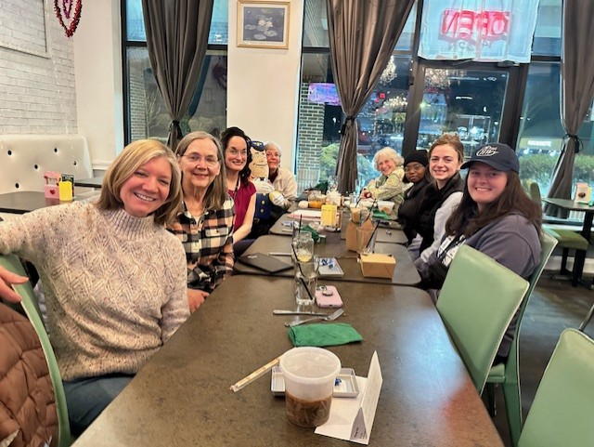
Laura Savino, Sue Passmore, Leslie Melanson, Otto Pilot, Cynthia Axell, Mary McCutcheon, Rebecca Akhigbe, Samantha Stahl, Charlotte Granahan

March Meeting Wednesday March 4
We met at Leesburg Airport upstairs conference room where the roof leaked constantly. We had a potluck dinner, a short business meeting, and then Mia Anderson gave a spellbinding talk about doing aerobatic maneuvers in a glider. She has competed many times and usually does really well.

Now Mia is off to Pensacola to begin her Southwest streamlined training program called Destination 225. (get it? 225 is the heading for southwest)

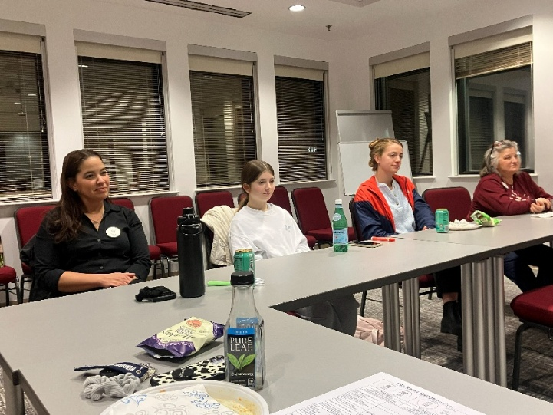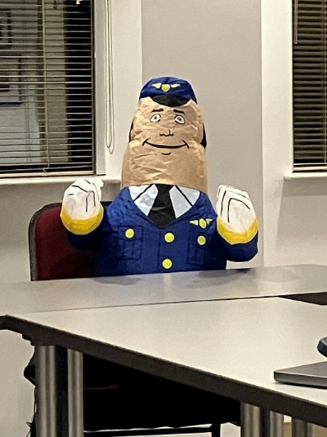
Frankie Velazquez, Olessiya Russell, Otto Pilot
Samantha Stahl, Melissa Plumer

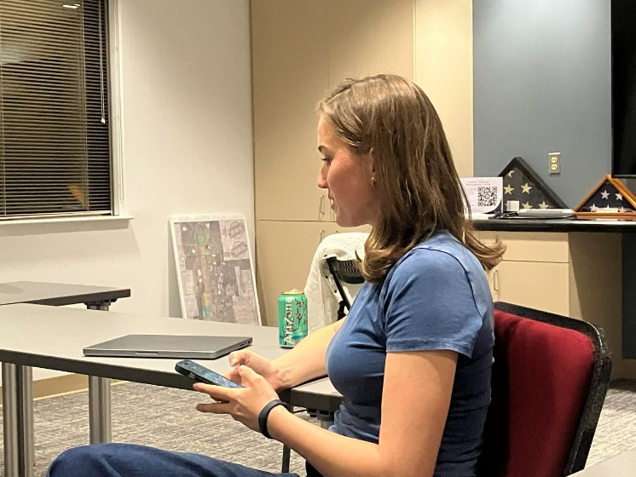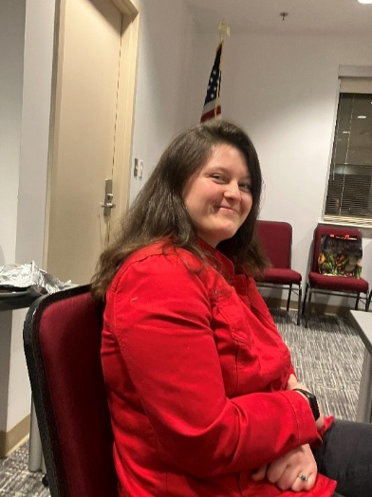
Mia Anderson Charlotte Granahan

The FLY Performance in Buena Vista
The drama department at Southern Virginia University performed a new musical called FLY. This play depicts the 1929 “Powder Puff Derby” air race.
They contacted our chapter to see if we wanted to meet them at Udvar Hazy. Laura Savino went and was impressed with how curious they were about women in aviation and they invited her to go to the play and say a few words about flying.

Laura, Cynthia, Nancy, Morgen, R.J. and Sue all went for opening night and met the playwright and director and cast. They had a blast.

So I went for the final show and also was treated like a VIP. The show is fabulous with excellent music and a good plot. They took some poetic license with the plot, but that is to be expected.

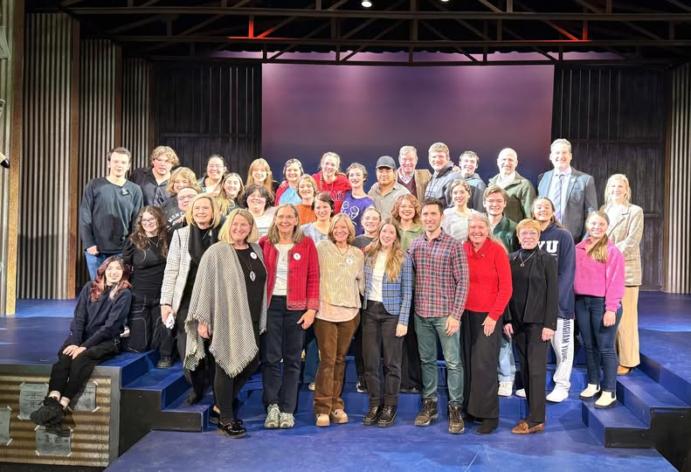
The 99s are in the front row for opening night

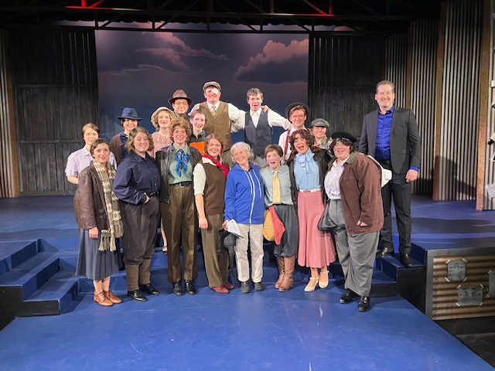
The cast and Mary McCutcheon on closing night

VIRGINIA AERONAUTICAL HISTORICAL SOCIETY MEETING MAY 2
Sarah Patten forwarded this to us from Rick Genaille on behalf of the VAHS

I am pleased and excited to announce that the Virginia Aeronautical Historical Society (VAHS) will hold an annual meeting on Saturday May 2 from 11:00 a.m. to 5:00 p.m. at Horsefeathers Airport (53VA), 9669 Green Road, Midland, VA. Horsefeathers is a sod strip located in beautiful Virginia countryside reminiscent of the early days of aviation.
All 99s members and their families are invited to attend. Admission is free. You are welcome to spend as much time as you like at the event.
Attractions and Entertainment:
- VAHS archives and Hall of Fame displays
- VAHS HoF Fame guest speakers
- Vintage aircraft static displays
- Airplane rides
- Tethered balloon rides
- RC aircraft demos
- Moon bounce and hay wagon rides
- Irish dancers
- Live music
Food and Beverages:
- Food trucks
- Wine and beer bar
Fund Raisers:
- Silent/live auctions
- Raffles
Please mark your calendars and plan to enjoy the day and support the VAHS. I look forward to seeing you at Horsefeathers! More information to follow as we get closer to the event date.
Richard (Dick) Genaille
Chairman, VAHS Board of Directors

CHALLENGE AIR FOR KIDS
Challenge Air for Kids and Friends

Kari Anderson is promoting this event where we might volunteer either as pilots or as whatever else is needed. It is April 11 at Frederick. Check out these sites and think about it. Already a few 99s are committed to being there.

Frederick, MD- Saturday April 11th, 2026
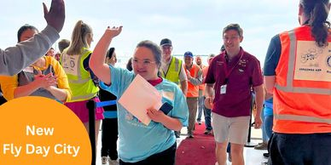
AOPA National Aviation Community Center, 296 Buchmeier Road
Frederick, Maryland 21701

VOLUNTEER
Pilots
Frederick Volunteer Enrollment

CYNTHIA’S HANGAR TALK FROM MARCH

Night Flying

On clear nights, the stars twinkle brightly overhead. If your timing is right, you might see SpaceX launch in a fiery arc, and then minutes later, return the booster in a spectacular feat of precision rocketry. Falling stars and meteors streak across the Milky Way. The sun reflects off the space station as it zooms past. You recognize constellations. On a full moon night, the landscape is silvery, dotted by the black velvet of lakes. Some reflect the moon back at you. Cities and towns sparkle.
Radios are fairly quiet. You can get a direct routing from coast to coast. Requested altitudes are almost always available.
Night flying can be so zen.
Until it isn’t.
I’m thinking of JFK Jr. But first, some factoids about the peculiar challenges of night flight.
Your eyes can take about 30 minutes to adapt to darkness. Each decade of age adds about 39 seconds to that adaptation time. Vitamin A is needed for producing rhodopsin, the pigment need for low-light vision. Any deficiency in Vitamin A can impair your adaptation, as can other conditions: glaucoma, cataracts, even LASIK or PRK surgery. Having your cockpit lights turned on too bright, a too-bright iPad, getting flashed by someone else’s taxi or strobe lights --- all these can delay your dark adaptation. This is why, as a courtesy, pilots turn off their taxi lights when approaching another aircraft nose to nose, and why strobes aren’t turned on until taking the runway.
Even fully adapted, your eyes can fool you at night. Try staring at a light on a starless night for 10 seconds or more. It will appear to move, or wander, even dance erratically. This is autokinesis, a visual illusion that occurs in dark, featureless environments (perhaps over the ocean on an overcast night). This phenomenon is potentially dangerous for pilots and boaters, as it can be mistaken for actual motion, leading to disorientation or improper navigation.
Have you ever experienced the black hole effect? Land at an airport with few surrounding lights, and you might feel higher than you actually are. I experienced this in the Coast Guard doing night landings on a cutter with overcast skies. With only a white stern light to focus on, I would’ve flown right into the water had the radar altimeter not accurately indicated my dangerously low altitude. It was a sobering realization how my eyes fooled me.
I’ve also experienced a false horizon, where the curving lights of the shoreline off my left looked like the horizon, and made me want to bank to make things appear “level”.
I’ve also gotten vertigo more than once, usually at night or in IMC. Hovering a helicopter over a black ocean, spotlights on, the rotor wash picks up seawater and the vortices whirl it around in a vertigo-inducing display.
And for the funny story – we were launched to check out a boat fire reported by a commercial airliner passing over the ocean. We flew in the reported direction, and sure enough, saw a bright orange flame. We flew for quite some time and the flame didn’t appear to get any closer. Imagine the hilarity when we realized it was the brilliant orange autumn moon, low in the sky, occasionally peeking through the dark clouds.
Then there’s unlit terrain. Beware during VFR approaches into an airport at night. Dark, unpopulated hills around airports have snared more than one pilot who descended “early”. If you are unfamiliar with an airport you are operating into at night, do due diligence on surrounding terrain and obstacles. If you can fly an instrument approach, fly it. If winds force you to circle to land, do not make the mistake of thinking a descent to FAF altitude is safe when not on the lateral approach path. It is not. Published circling minimums are always higher. Maintain at least the Minimum Safe Altitude (MSA) or Minimum Vectoring Altitude (MVA) until established on the final approach segment. Use that PAPI/VASI.
Here’s an excerpt from AOPA on visual illusions. “According to the Aeronautical Information Manual, illusions that lead to spatial disorientation are one of the leading factors in fatal accidents. The graveyard spiral is a likely scenario in this accident. An observed loss of altitude during a coordinated constant-rate turn that has ceased stimulating the motion-sensing system can create the illusion of being in a descent with the wings level. The disoriented pilot will pull back on the controls, tightening the spiral and increasing the loss of altitude. Once the fluid in the semicircular canals of the inner ear has stabilized, the sensation is generally of being in level unaccelerated flight. When another control input is made, unless the pilot correctly interprets and follows the flight instruments, it is likely that the aircraft will be placed in an unusual attitude.
A very strong disorienting sensation can be induced by putting the aircraft into a prolonged constant-rate turn, allowing the sensation-sensing organs to stabilize, and then abruptly turning the head. This might occur where the pilot bends down to look at a chart, reach for something on the floor, or to change fuel tanks if the switch is poorly located.”
Back to JFK, Jr. During the last part of his night flight, he was forced to fly over water. Pilots flying at the same time reported poor visibility in haze. The horizon was not visible, and the lights of the coastline disappeared to his left in haze. JFK Jr was not yet instrument-rated, although he was training for this rating. Again, here’s what AOPA had to say: “The flight proceeded normally until the descent, when it appears that Kennedy disengaged the autopilot. That was precisely the time, in retrospect, to leave it on. The stable platform of level flight becomes more treacherous when the aircraft is climbing or descending. The fluids in the inner ear move in multiple directions, and the final radar plot shows a classic disorientation spiral where the aircraft descended and climbed, made several turns, and then the pilot – when level – was tricked by his senses into rolling the aircraft into a gentle bank. As the nose pitched down and the airspeed increased, the pilot, sensing he was level, pulled back rather than rolling wings level. This further increased the bank angle, which caused the nose to drop farther and G forces to build. The only salvation is to believe the flight instruments and ignore your senses. It is counterintuitive and essential.
When you fly at night, trust your instruments. Be conservative. Remember, the only weather “report” that matters is the one you see outside your window. If the weather is worse than forecast and not what you expected, seriously rethink your plans. And if you have an autopilot or wing leveler, use it if you start to feel disoriented. Either one can save your life.

NEWS FROM OUR MEMBERS
Laura Savino in Atlanta with her United Maternity Uniform
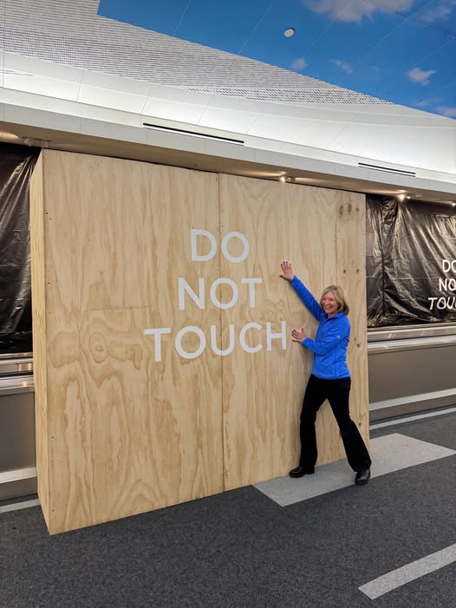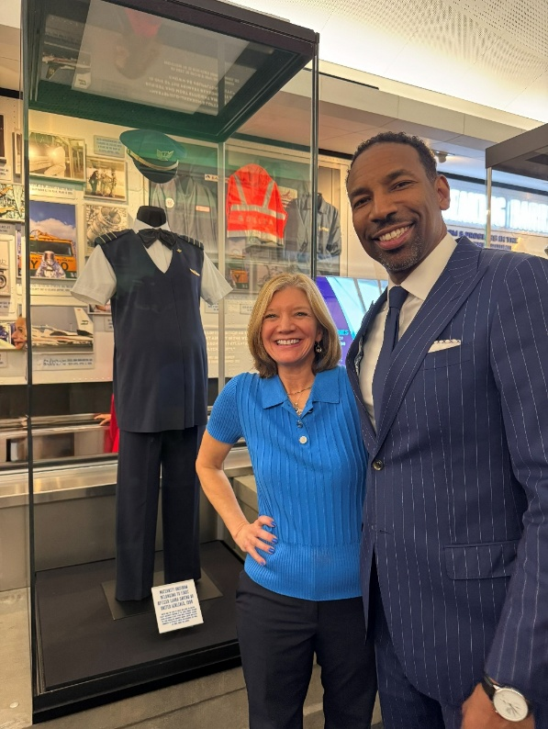
She says:
Today I was honored by the mayor of Atlanta, Andre Dickens, with the unveiling of my maternity uniform from the 90’s at ATL (Hartsfield-Jackson International Airport), as part of the Blue Skies: Breaking Barriers permanent exhibit.
This display is about the original airline pilot maternity uniform (not about me) and the barriers that finally came down for minority pilots.

AND HERE IS LAURA
Signing books with the brilliant International Space Station astronaut Cady Coleman and the amazing Tracey Curtis Taylor, who circumnavigated the globe in a 1942 biplane Stearman.
#WomeninAviation #WAI2026
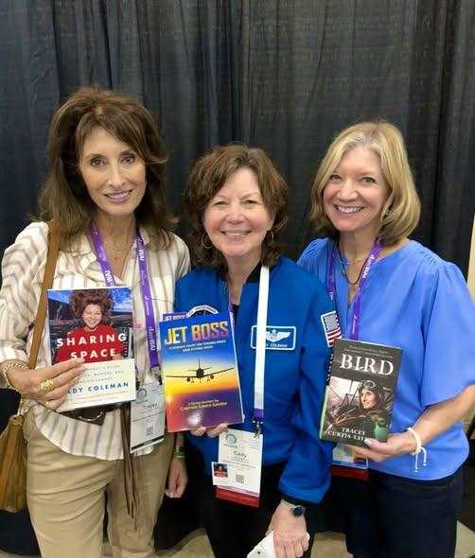

Samantha Stahl says
“I did well on my Envoy interview and was offered the job! I am grateful for all the support from the 99s, and could not have gotten this far without all the amazing help.”

Here she is at Envoy headquarters in Dallas where they conducted her interview on 3/10/2026.
