

Old Dominion Chapter
SKYLINES
June 2026

Chair: Nancy Schuster
Vice-Chair: Laura Savino
Secretary: Mary McCutcheon
Treasurer: Barb Gruber
AE Scholarship: Cynthia Axell
Membership: Sue Passmore
Newsletter: Mary McCutcheon
Webmaster: Frankie Velazquez

NEXT MEETING
We have not set a date for our next meeting yet

UPCOMING EVENTS
WOMEN CAN FLY
Saturday, June 6. Contact Sarah Patten (sarah.patten@gmail.com) if you want to volunteer. Otherwise, just come and enjoy the day and hang out at the 99s table.

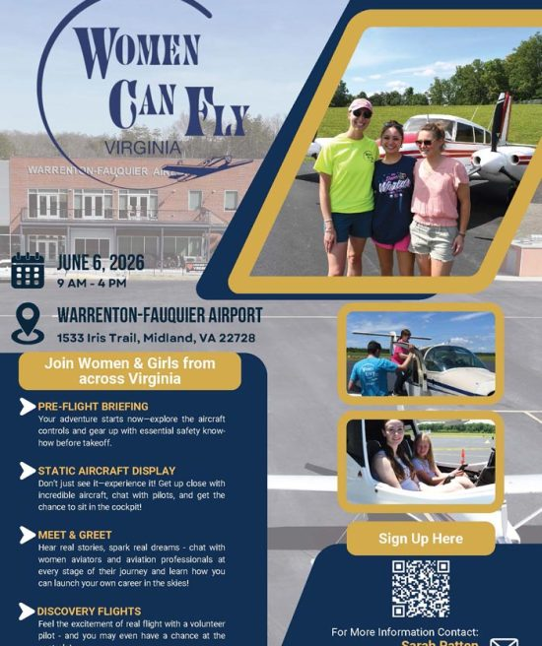
GAIL KEYS’ RETIREMENT PARTY
Gail has just retired from United.
Her retirement party is also on June 6, but it is close to Warrenton, so if you go to Women Can Fly, you can swing by the party afterwards

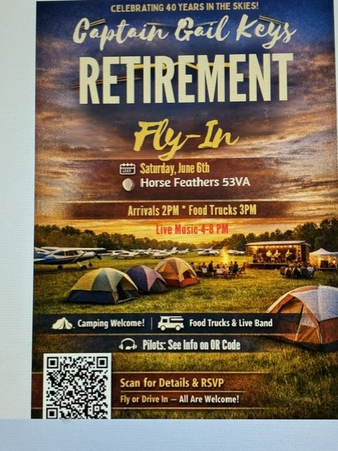

9669 Green Rd., Midland, VA
Horse Feathers is 6 miles south of Warrenton and 4½ miles (10 minutes by car) northwest of the Warrenton-Fauquier Airport.

Look for the big gate sign:
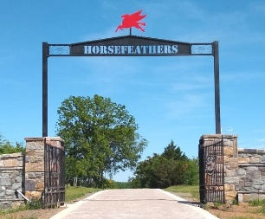

CHAPTER ELECTIONS

In a landslide, the following people were elected as officers in our chapter:
Chair: Nancy Schuster
Vice chair: Laura Savino
Secretary: Mary McCutcheon
Treasurer: Barb Gruber

RECENT CHAPTER MEETINGS
APRIL 30
On April 30 we met at Firebirds Wood Fired Grill in Gainesville. We talked about the Virginia Aviation History event at Horsefeathers, the possible attendance by members of the FLY cast, scholarship winners and we voted to support the Virginia Aviation Historical Society with a donation of $250.

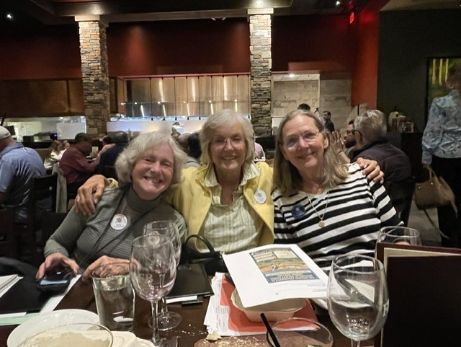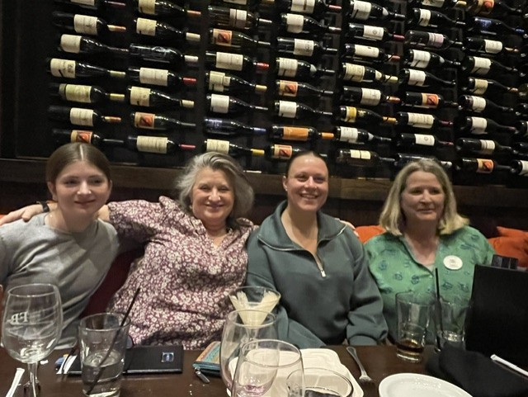
Mary, Cynthia, Sue Olessiya, Melissa, Allison, Nancy

MAY 14
We met at Logan’s Roadhouse in Manassas. There was discussion of the successful Virginia Aviation Historical Society event at Horsefeathers on May 2 and the need to donate money to Women Can Fly. The featured speaker was Mary Ann Shaffer. From Nancy’s minutes, “She was the first woman chief pilot for KIAD base and system wide for United. While doing that she also became engineer, a lawyer and ran her own law firm. She is now involved in safety for United.”
MID-ATLANTIC SECTION MEETING

On May 2,the Mid-Atlantic Section Meeting took place in Harford County Maryland. Mary McCutcheon went. The main news was the passing of the Governor’s title from Lin Caywood to Maria Esparraguera. Mary announced that the winner of the Mid-Atlantic Scholarship was Tina Richardson from the Sugarloaf chapter. Tina described how she is going to get her instrument rating and will devote her flying to her charity of supplying service animals with needed equipment.

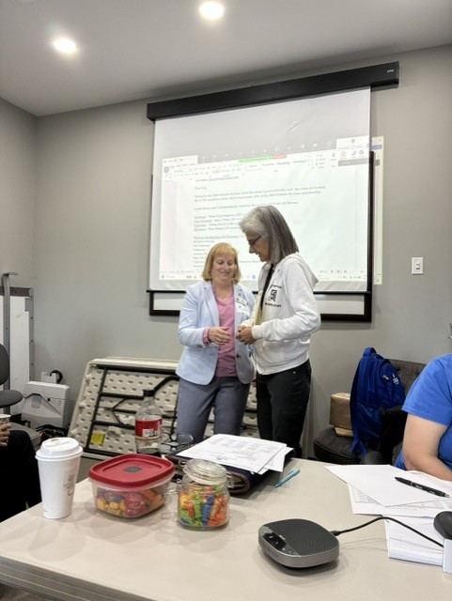
Lin Caywood and Maria Esparaguerra

CHALLENGE AIR

Thanks largely to Kari Anderson (the mother of our illustrious member, Mia), Challenge Air came to Frederick. This event exposes children with special needs to aviation. In past years, it has been held in other parts of the country, so we are glad to have it here in the mid-Atlantic.
Our chapter provided a few volunteers, and Lin Caywood was one of the pilots.

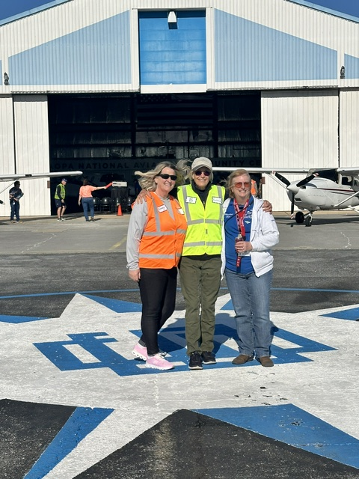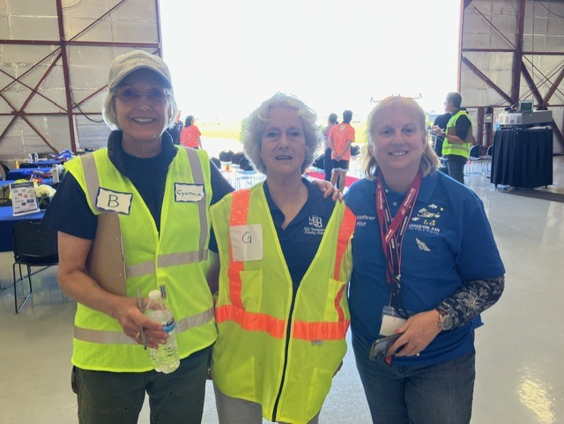
Nancy, Cyntia and Lin Cynthia, Mary and Lin

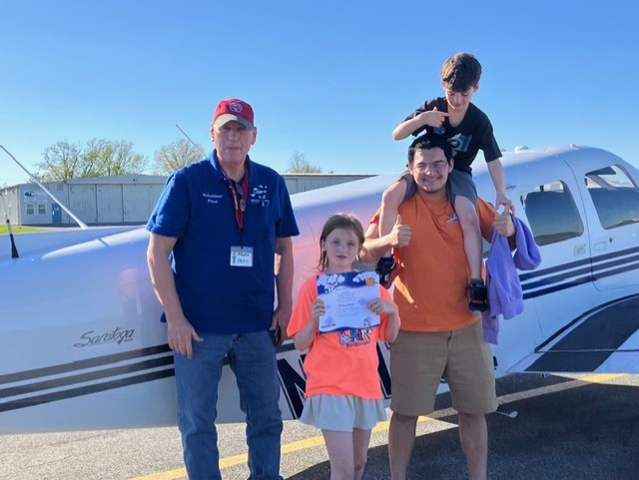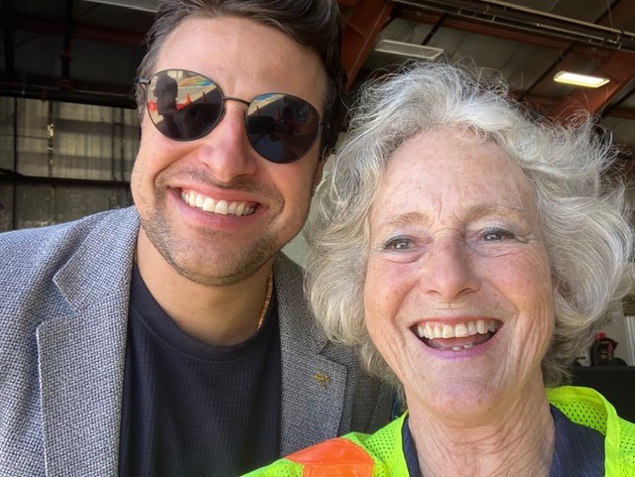
A happy family Jo O from Channel 4 news and Mary

Virginia Aeronautical Historical Society (VAHS) 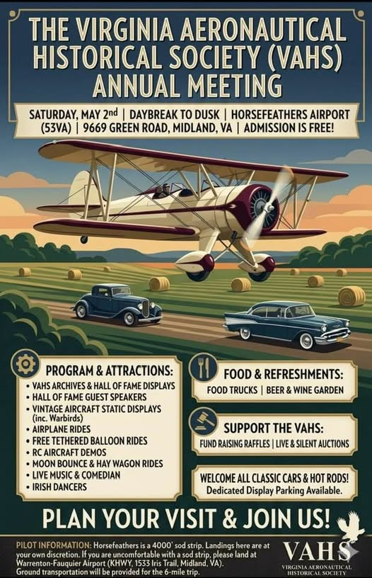

Chuck Tippett hosted a celebration of Virginia Aviation History at his Horsefeather’s airport on May 2. There was all kinds of entertainment and food and flights in stearmans. Many of our members went and expected to be joined by the cast of the play FLY. Only one cast member, Avery, and her parents were able to come, but they had a fabulous time.

Here are some pictures:
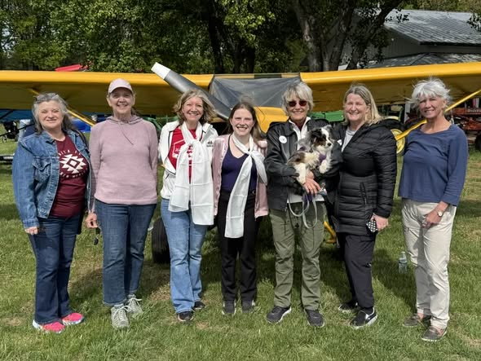
Melissa, Sue, Laura, Avery, Cynthia and Piper, Nancy, Gail
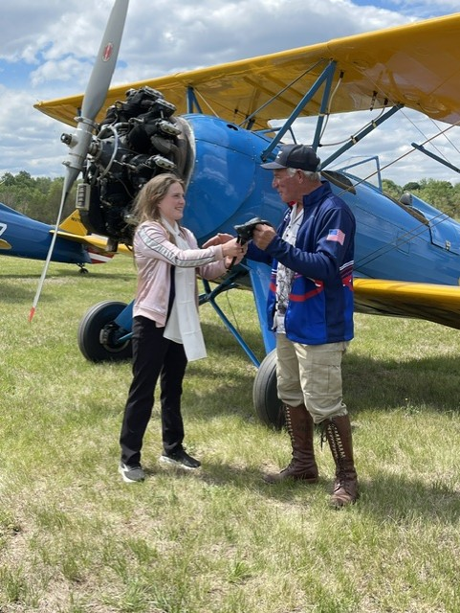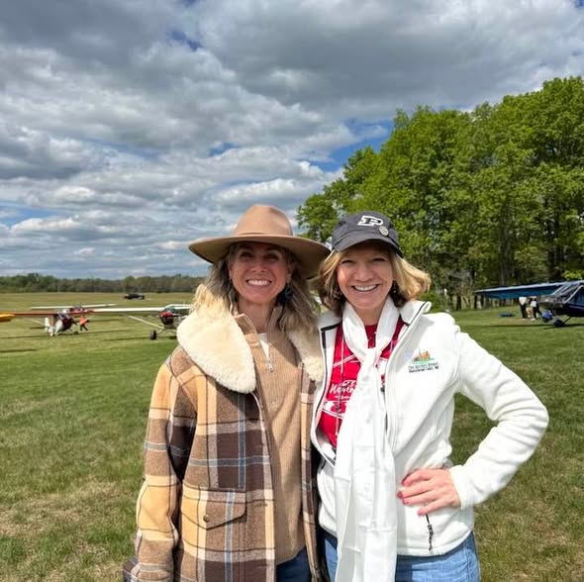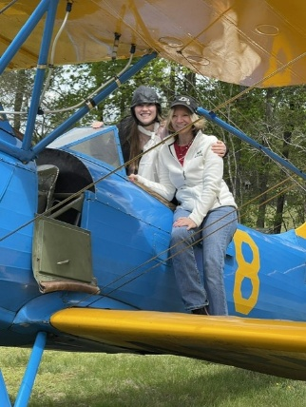
Avery and Chuck Heather Penney and Laura Avery; and Laura

SCHOLARSHIP WINNERS

The Amelia Earhart Vicki Cruz Scholarship was awarded to Charlotte Granahan
Katya Zubareva won an AE First Wings scholarship (given to Olessiya Russell last year)
Tina Richardson (from the Sugarloaf chapter) won the Mid-Atlantic Scholarship

AVIATRIX FILM FESTIVAL

A Ninety-nine from the Chicago Chapter is a filmmaker and started an Aviatrix Film Festival. Her name is Susan Roe Musacchio, and she is the daughter of Bobbi Roe who founded the Aviatrix Publishing Company, Published the 99 News and was a founding board member of Women in Aviation International. Bobbi Roe died in 2021 and now her daughter is picking up the family tradition.
The festival is called The Bessie Coleman Aviation Film Festival.



The first screening was May 2 at a runway near Chicago. I had lunch with her a few weeks ago and am going to see if I can get ahold of these films to show here for our chapter.

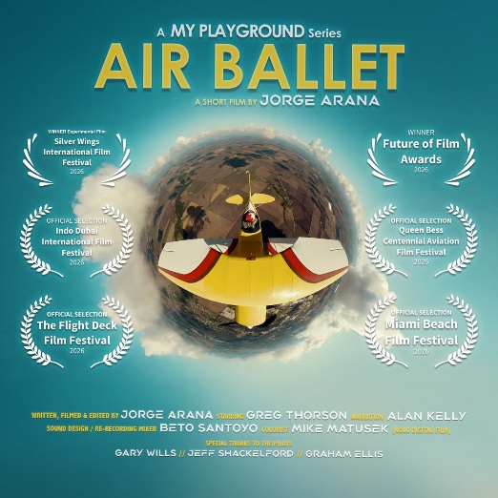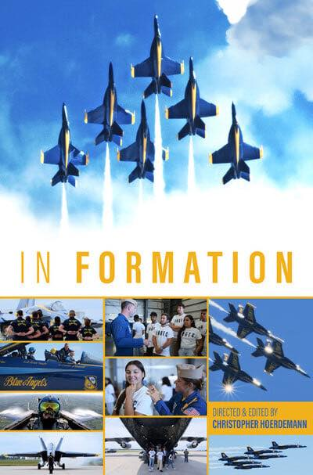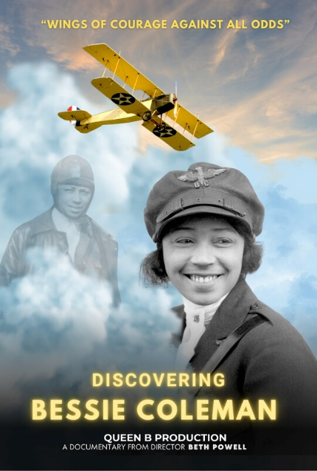

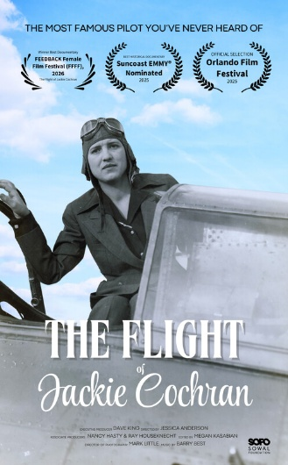

NEWS FROM OUR MEMBERS

Samantha Stahl was accepted as an Envoy pilot. Envoy is a subsidiary of American Airlines. Here she is with her fellow new recruits:

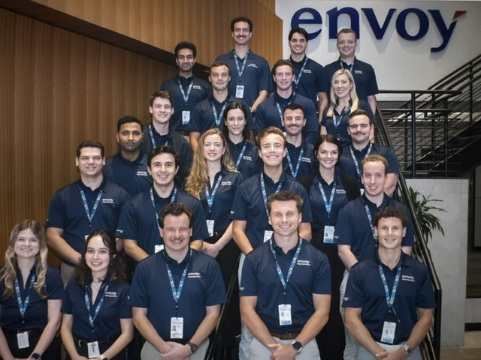

Katya Zubareva is going to start in the fall at Capitol Technology University in Laurel, MD

Olessiya Russell is going to start at the University of North Dakota

Laura Savino is qualified to fly a Kingair B200 after training in Arizona
She has has been hanging out with a lot of awesome people lately 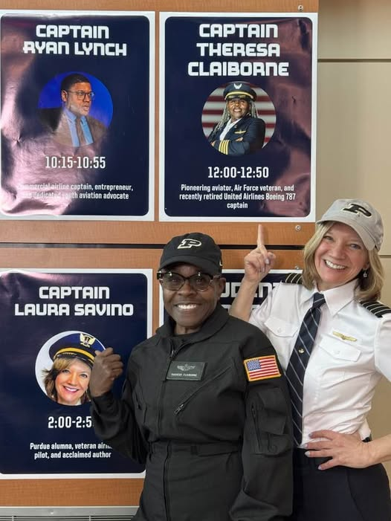 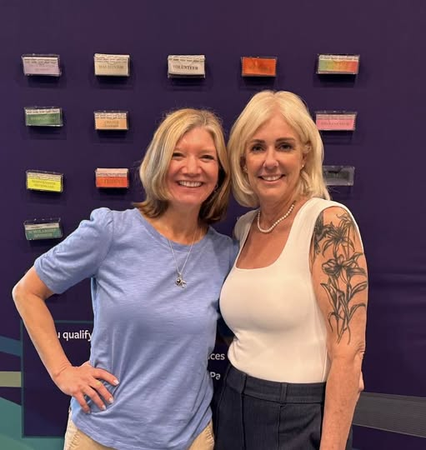
Laura with Theresa Claiborne Laura with NTSB chair Jennifer Homendy

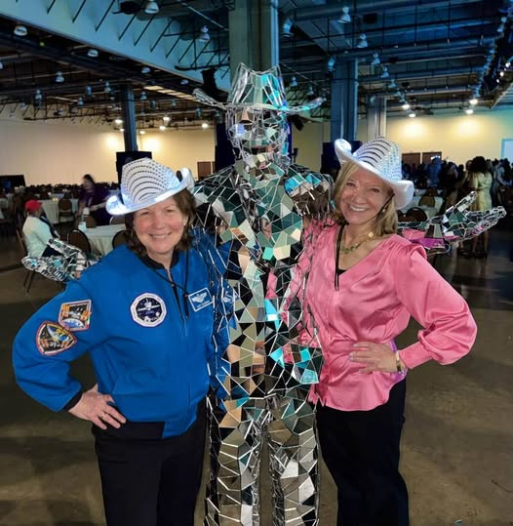
Laura with astronaut Cady Coleman

Mary McCutcheon will be volunteering the Air Race Classic at the third stop, Spartanburg Downtown in Spartanburg, South Carolina. The Race starts on June 23 and ends on the 26th. Come down to see what happens. No one from our chapter is flying but several members of the Mid-Atlantic Section will compete.

Sue Passmore wrote an excellent story about our chapter trip to see the play FLY in the latest 99 News.

NEW MEMBER
Heather (“Lucky”) Penney
We are extremely proud that Heather Penney has joined our chapter. She is a true American Hero who was dispatched the morning of September 11, 2001 to intercept the plane that Air Traffic Control knew was aiming to attach some target in Washington. The World Trade Center buildings and the Pentagon had already been struck and United Airlines Flight 93 was still “out there”. Here are just a couple of interviews that you will find chilling and inspiring.
Extended interview: F-16 pilots recall mission to intercept Flight 93 on Sept. 11, 2001 - YouTube
Heather "Lucky" Penney: The Official Licensing Website of Heather Penney

The Unthinkable 9/11 Suicide Mission to Bring Down Flight 93 | Heather Penney

