

Old Dominion Chapter
SKYLINES
July 2026

Chair: Nancy Schuster
Vice-Chair: Laura Savino
Secretary: Mary McCutcheon
Treasurer: Barb Gruber
AE Scholarship: Cynthia Axell
Membership: Sue Passmore
Newsletter: Mary McCutcheon
Webmaster: Frankie Velazquez

NEXT MEETING
We have not set a date for our next meeting yet
One thought is to go see the newly opened halls at downtown Air and Space
Here is Laura showing the compass rose in honor of the 99s

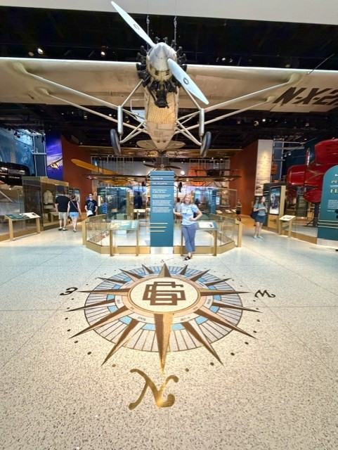

PAST EVENTS
WOMEN CAN FLY
Warrenton hosted the annual Women Can Fly event on Saturday, June 6. As always, Sarah Patten made it run as smoothly as possible given the very late start. A T-6 made an emergency landing right before 10 AM and slid almost, but not quite, off the end of the runway. The pilot was fine but the plane was in bad shape. Then it took hours to remove the wreckage sufficiently to allow a completely clear runway. STILL, a growing crowd of expectant passengers waited patiently.
A lot of us Old Dominion 99s were there to serve in various capacities.
Here are statistics provided by Sarah:
225 people attended our preflight briefings
45 people made cell phone stands at Women Can Build
34 pilots came out to fly in 28 airplanes
11 static display aircraft joined in the fun
212 people got to fly with us
Sarah goes on: “I know some of you are curious about our total stats over the years. This was year nine for me; in the past nine years we've held the event, we've now had 1902 people attend our preflight briefings, and we have safely flown 1737 people”.

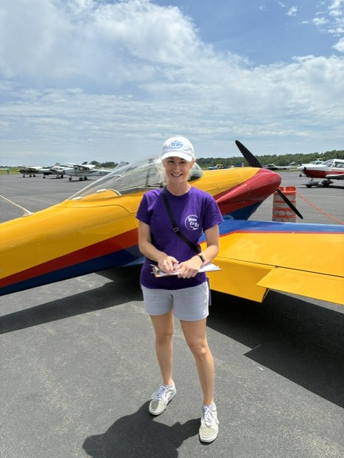

Sarah Patten

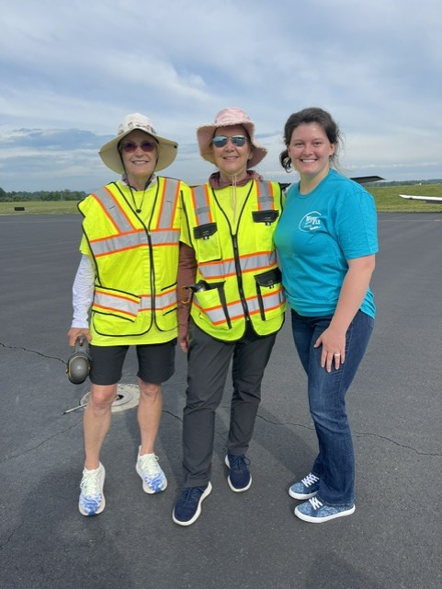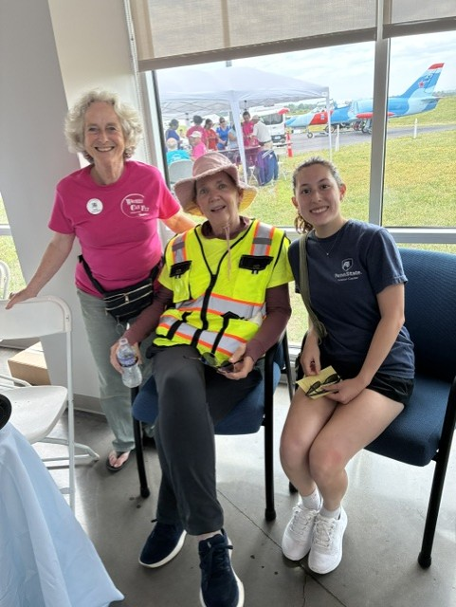
Cynthia, Sue, Charlotte Granahan Mary McC, Sue Passmore and Alana Bicoy

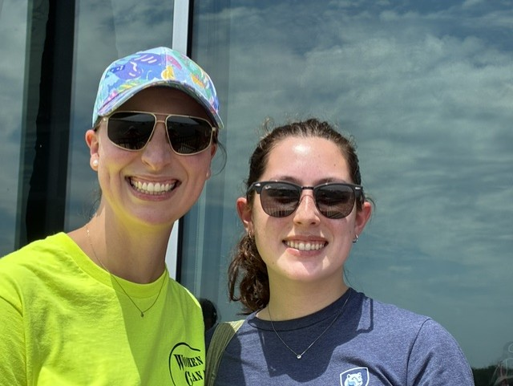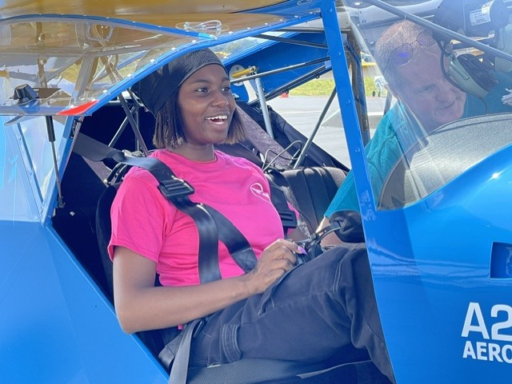
Hannah Rust and Alana Bicoy Rebecca Akhigbe

Laura Savino, Sierra, Heather Penney
Elliana Taddeo and Mary McCutcheon

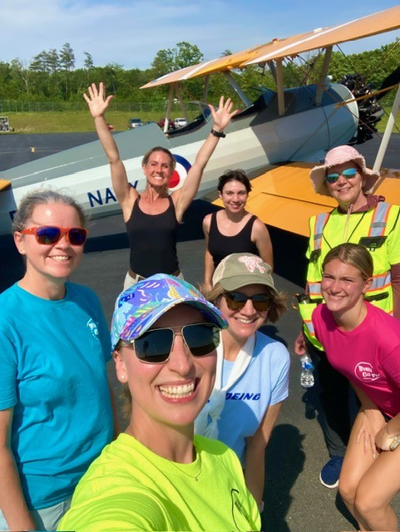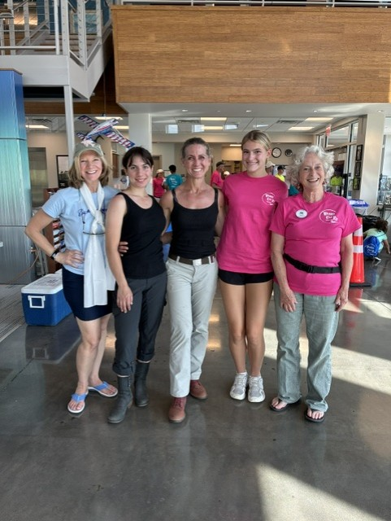

Erin Miller, Heather Penney, Sierra,
Sue Passmore, Hannah Rust, Laura Savino,
Elliana Taddeo

GAIL KEYS’ RETIREMENT PARTY

Also on June 6 was Gail Keys’ retirement party from United. Chuck Tippett, who owns both the Flying Circus and Horsefeathers landing strip, hosted an extravaganza for her retirement party. A lot of our volunteers went on after Women Can Fly to Horsefeathers not far away.

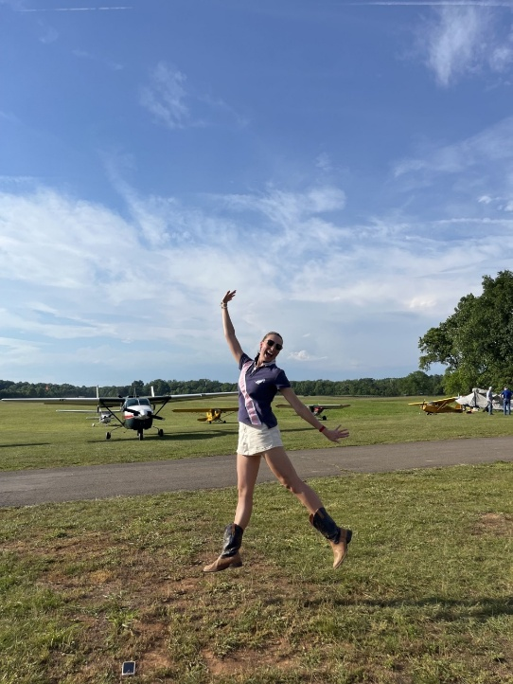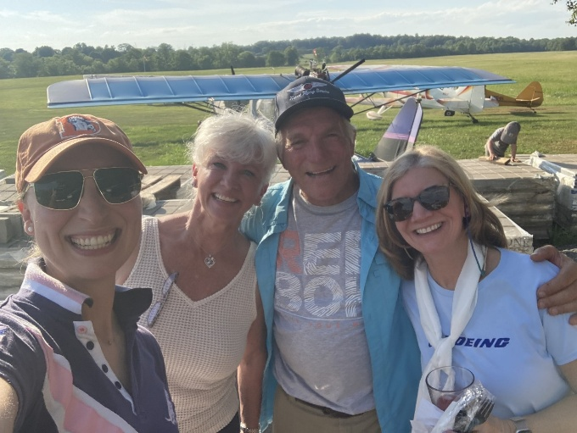
Hannah Rust Hannah, Gail, Chuck and Laura

Our new member, Heather Penney was there with her Stearman as well. Her daughter, a flight student of Chuck’s, had just had her first solo earlier that day, so it was a double celebration.

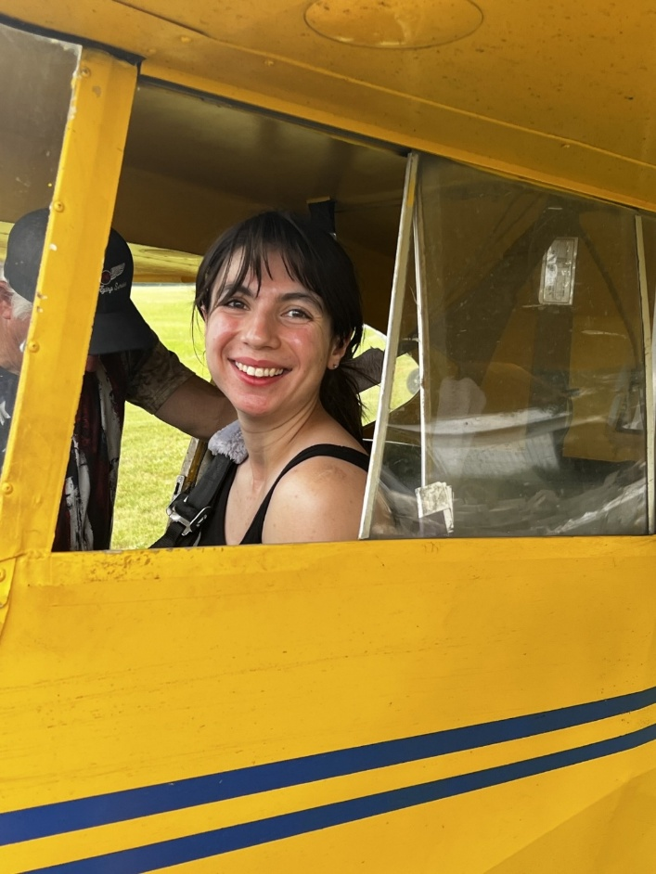
Here is Heather’s daughter Sierra

OCRACOKE
Another beautiful weekend at Ocracoke this year. Here are pictures of the participants: Cynthia Axell, RJ McGlasson, Morgen Reeb, Sue Passmore and Terry Donner, a friend of Morgen’s

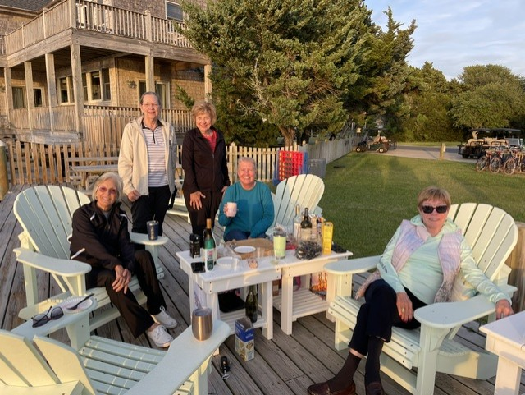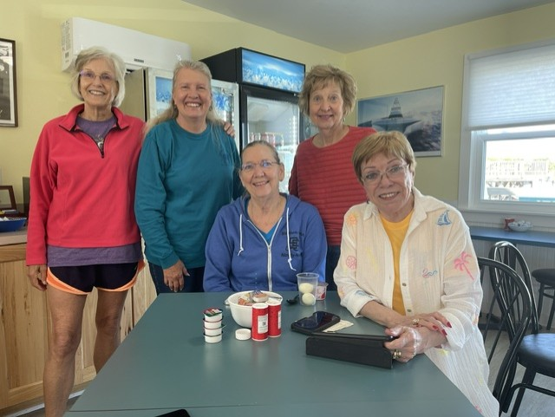

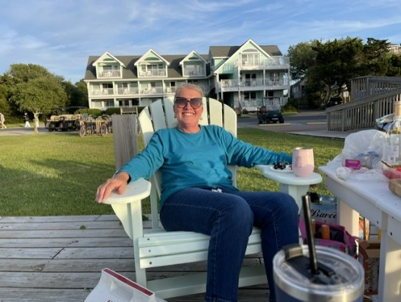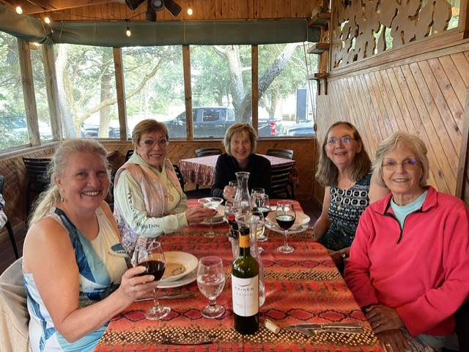
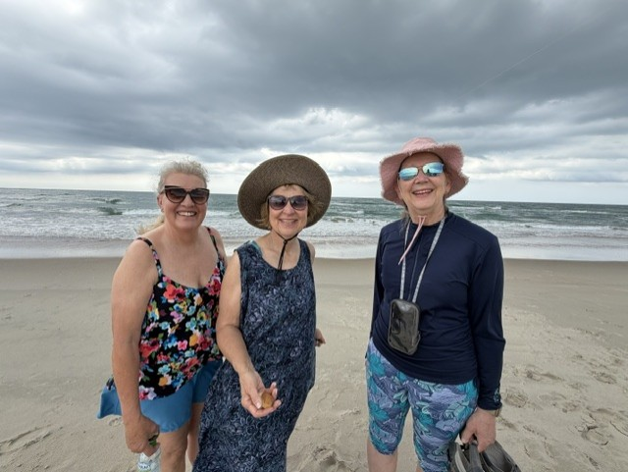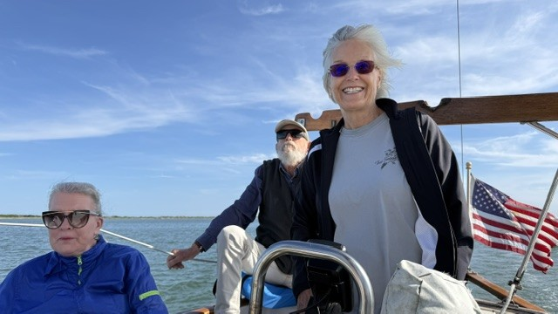
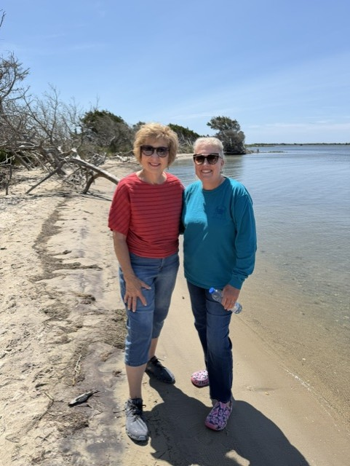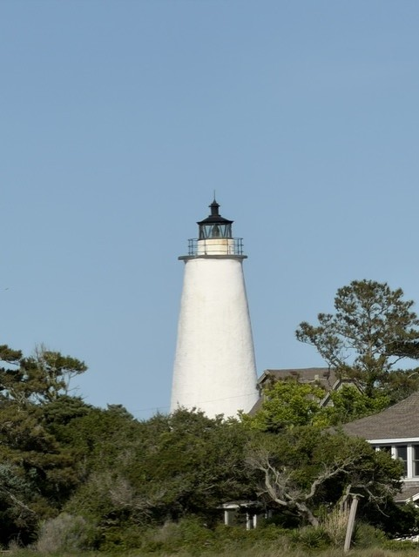

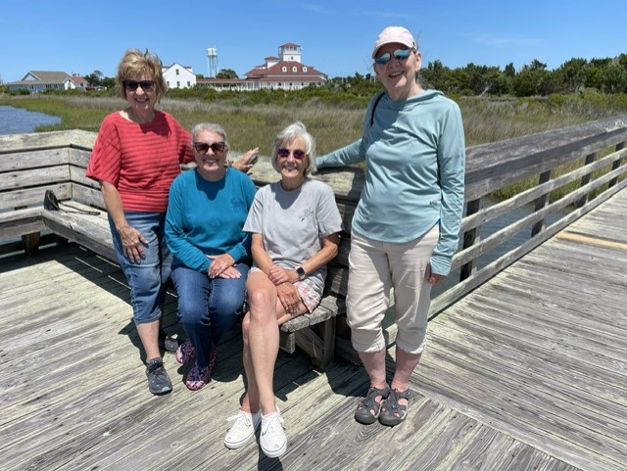
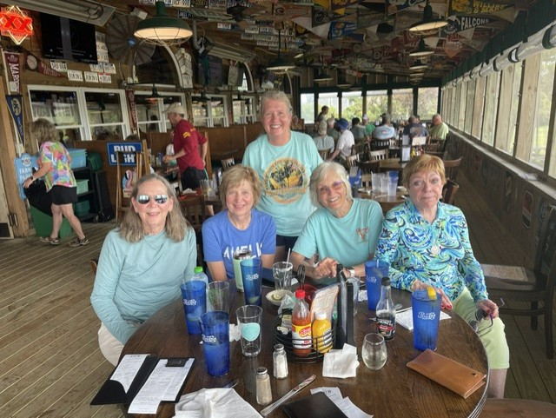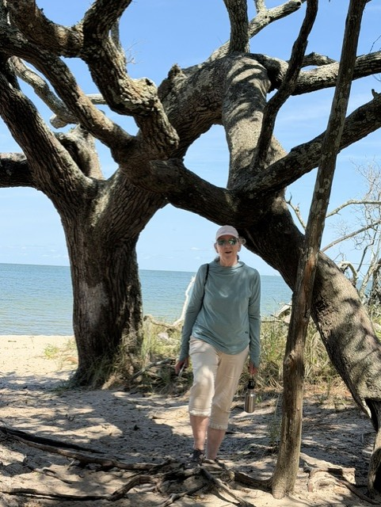
INNOVATIONS IN FLIGHT

June 13

This annual event at Dulles/Udvar-Hazy attracts pilots with planes they like showing off as well as families who want to wander around and maybe get some inside experience. This year, two of our members, Laura Savino and Heather Penney went: Laura in a Cirrus and Heather in her Stearman.
Here is a group picture with Laura in the green shirt and Heather to her left (our right).

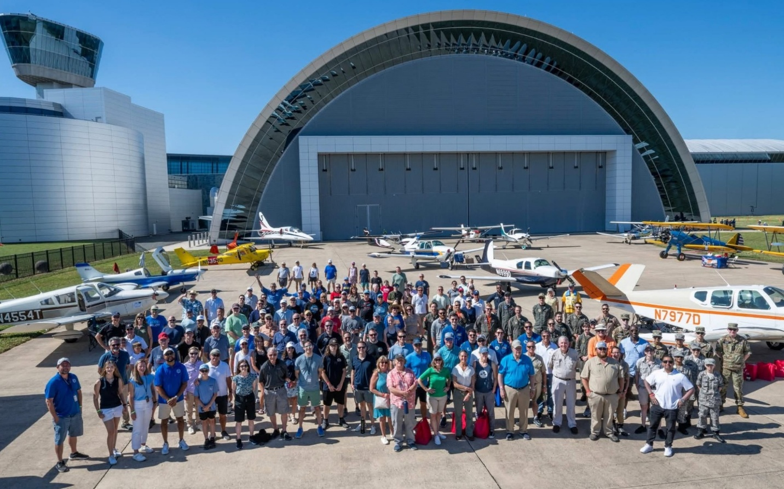

THE AIR RACE CLASSIC
June 23 through June 26

This year’s Air Race Classic, the successor to the legendary Powder Puff Derby of 1929, started in Alton Illinois and finished in Mount Vernon, Illinois going about 2500 miles to stops in Kentucky, South Carolina, Georgia, Alabama, Mississippi, Arkansas, Kansas and Wisconsin. I (Mary McCutcheon) have volunteered for several years in various capacities and this year I went to Spartanburg, South Carolina to join fellow 99s, Maria Lamia, Liana Hart, Kat Evans, Staci Jones, Chris Jones, Lorna Mack and others who also volunteered.
It was the 99s new treasurer, Maria Lamia who masterminded the stop and tried to make it the best on the route. We lost out to the Arkansas stop, but we provided ice cold wet cloths for hot racers, lots of refreshments including fresh locally grown peaches, an ice cream truck, a face, arm and leg painting tent, an airplane balloon making craftsman, and, best of all, a very experienced racer from nearby Brevard, North Carolina, Anne Honer, who has raced I think more than 12 times. She held court in the FBO where the racers came for refreshments, to use the bathroom and to get some air conditioning.
No one had problems at Spartanburg, but more than half of the teams who signed up, were disqualified, scratched, or otherwise failed to make it to the finish line.
It is worth noting that our Mid Atlantic Section was well represented and that Alicia Sikes (Eastern Pennsylvania) and Nancy Rohr (Delaware), won first place with their team “Over the Moon”. Debi Dreyfuss (D.C.) and Joy Halcott (Maryland) placed third with their team “DC3-1”. Jojo Shisler (Keystone), and Mary Wunder (Eastern Pennsylvania) also finished respectably. Lin Caywood’s team had to quit due to engine problems, but she is a veteran of many races.
If you have 5 minutes, please go to this news coverage of the Spartanburg stop. You’ll see Alicia Sikes and a brief cameo appearance of me, Mary, sitting at the welcome table (WOOHOO)

49th Air Race Classic makes pit stop in Spartanburg

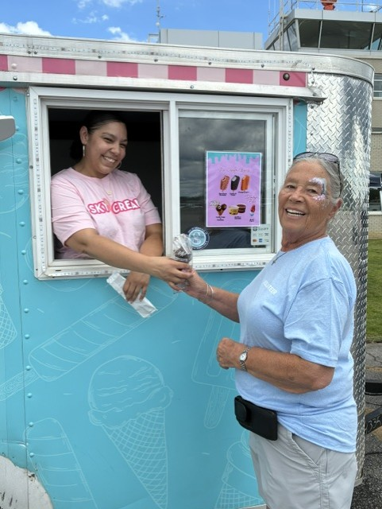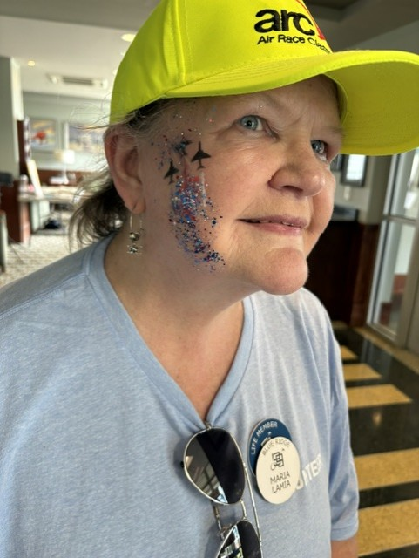
The most popular attraction at Spartanburg: An Ice Cream truck

Stop Chair, Maria Lamia, with her face paint of jets and contrails

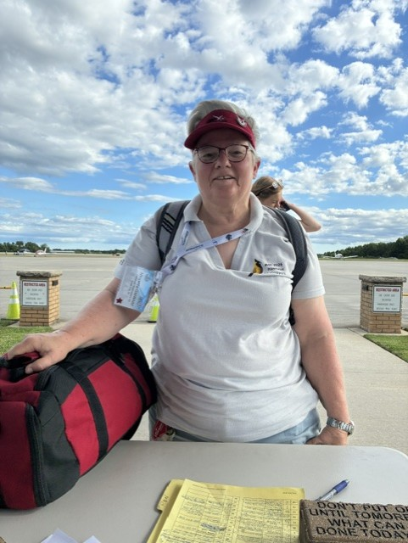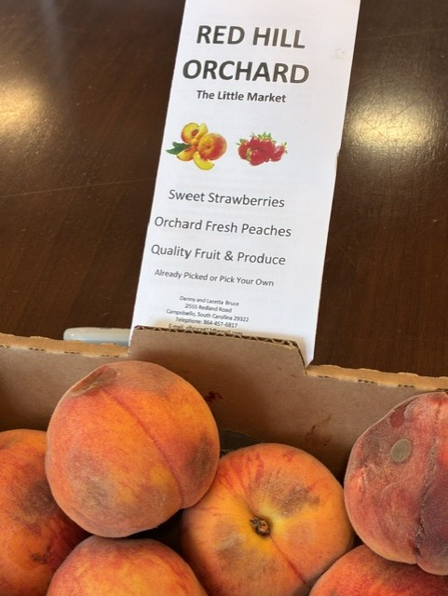
Minetta Gardenier arriving Local South Carolina Peaches
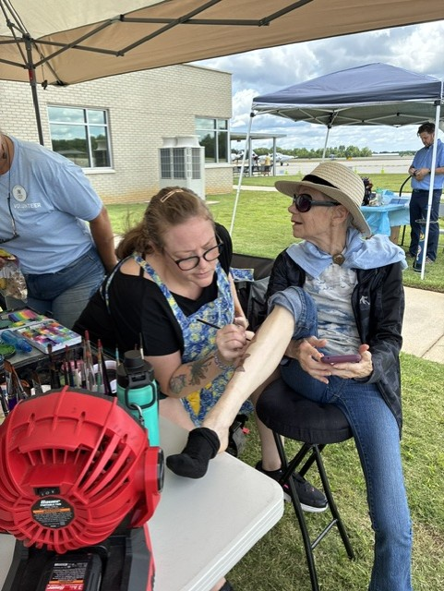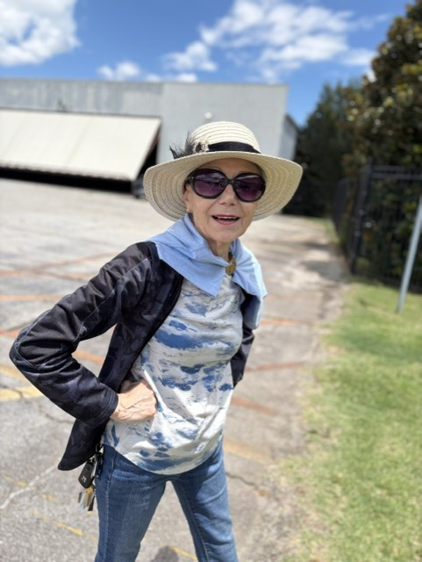
Lorna Mack getting her leg painted Lorna Mack provided ground transport

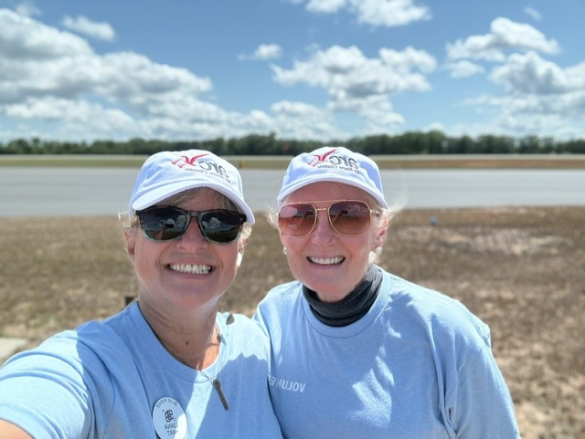
Liana Hart and Kat Evans, the timers
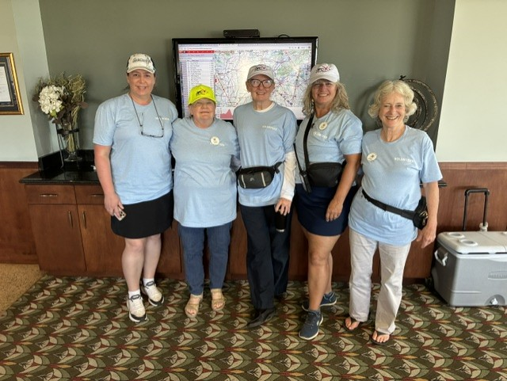
All the volunteers including Mary McCutcheon

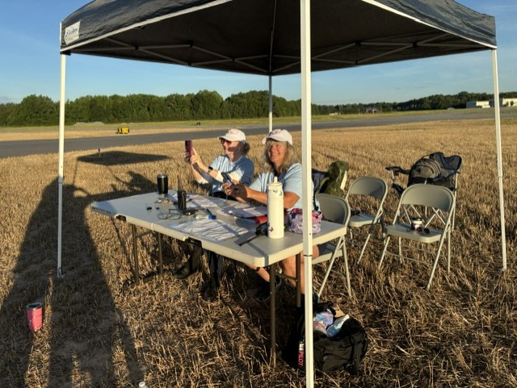
The tireless timers: Kat Evans and Liana Hart

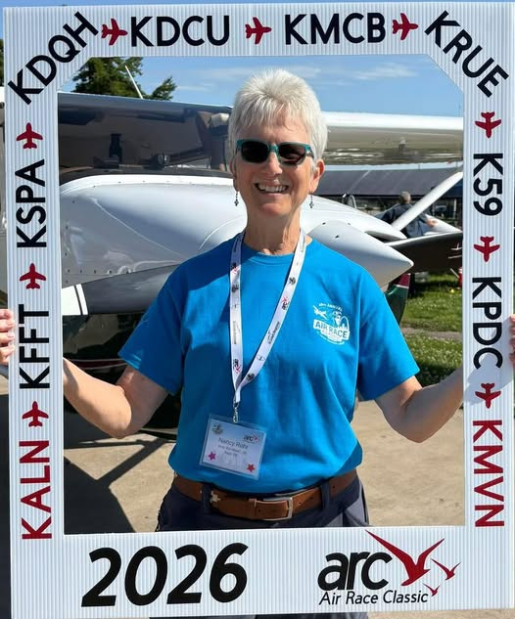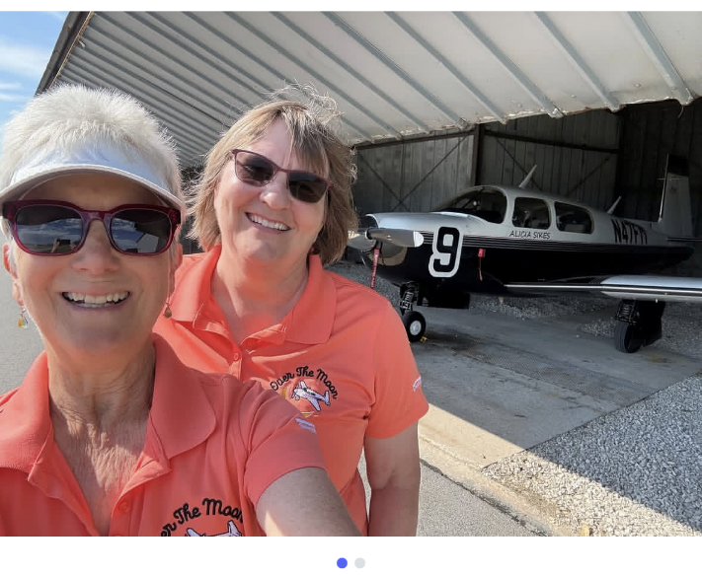

Nancy Rohr after the race Nancy Rohr and Alicia Sikes

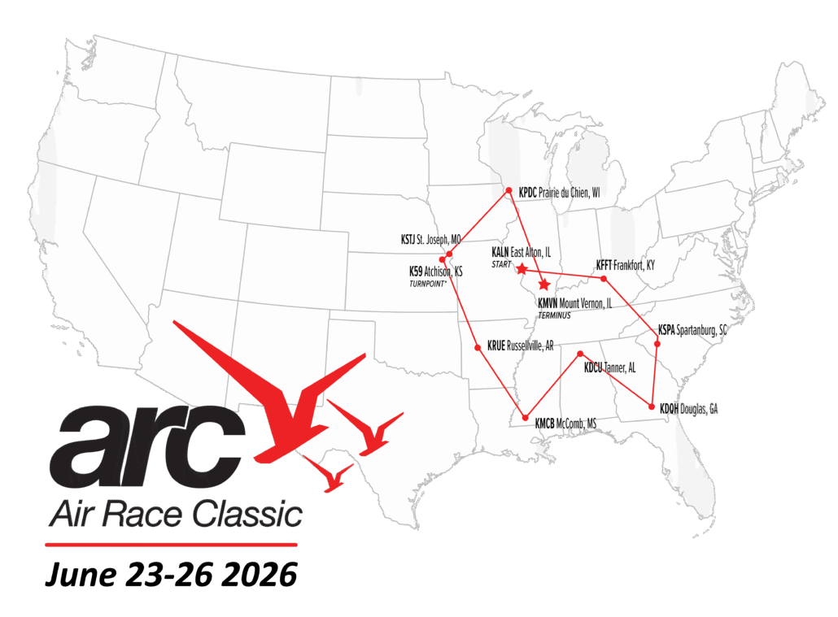

NEW MEMBER
We are happy to welcome a new member, Aimee Ou. She came around to our table at Women Can Fly and decided to join.

MEMBER NEWS

Jenny Reeb
has been hired by Delta Airlines! She starts school in Atlanta, Georgia on August 4th. She doesn’t know what airplane she’ll be on yet.
Mia Anderson
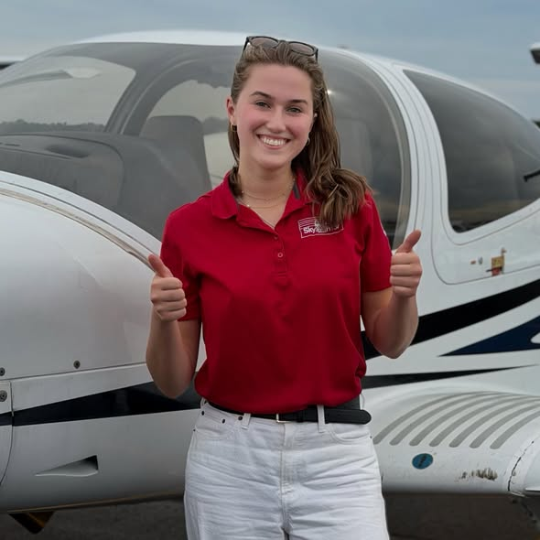
Earned her Instrument Rating
Olessiya Russell

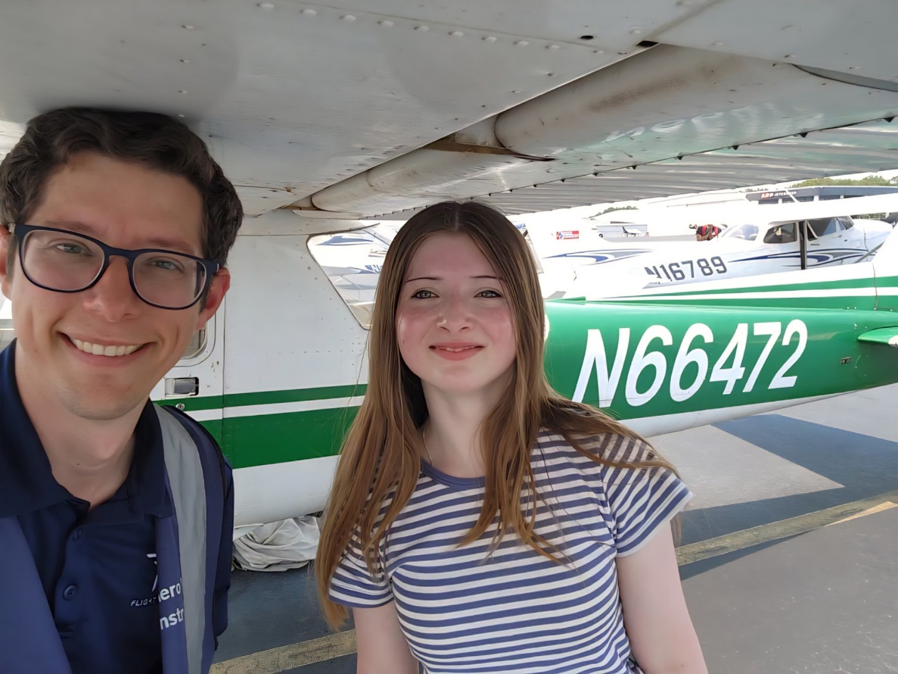
Earned her Private

Charlotte Granahan

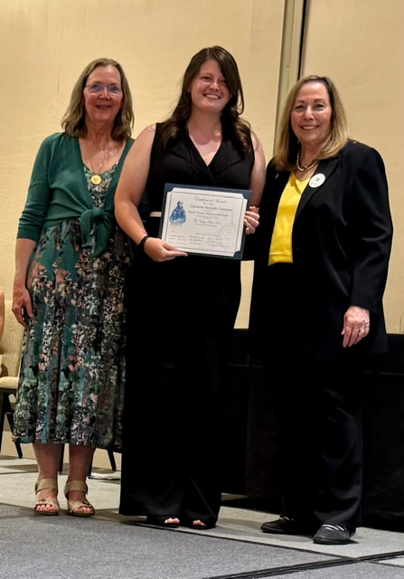
At the International Convention getting an award representing the Vicky Cruz AE scholarship

Laura Savino
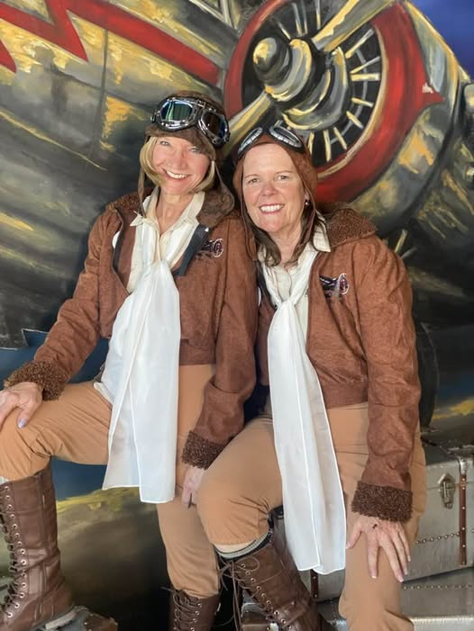
Laura and Donna Miller dressed up like early air racers for the 1940’s ball in Boulder, Colorado

