

Old Dominion Chapter
SKYLINES
August/September 2026

Chair: Nancy Schuster
Vice-Chair: Laura Savino
Secretary: Mary McCutcheon
Treasurer: Barb Gruber
AE Scholarship: Cynthia Axell
Membership: Sue Passmore
Newsletter: Mary McCutcheon
Webmaster: Frankie Velazquez

Here are the contents of this newsletter in case you want to skip sections:
I. Next meeting
2. Hangar Talk --page 2
3. Tour of the Tracon and Center facilities at Vint Hill --page 5
4. Obituary and Memorial Flying Circus event for Chuck Tippett—page 7
5. Obituary for one of our members: Judy Bergman—page 8
6. Girls In Aviation upcoming events – page 8
7. Compass Rose at Winchester—page 9
8. WASP news and internet links for WASP things – page 9
9. Forest of Friendship – page 10
10. First Wings Scholarship deadline – page 10
11. News from our members – page 11
10. Returning member – page 11
.
NEXT MEETING
Monday August 31 at 6:30 PM
upstairs meeting room of Leesburg Terminal
Agenda includes Hangar talk on Preflight tips, Compass Rose plans, Girls In Aviation Participation, and other business that may arise.
Bring something to share for our snack if you have the inclination

HANGAR TALK By Cynthia Axell

There’s so much to talk about when you consider the preflight inspection. We were all taught how to conduct a preflight during early training by our flight instructors. Depending on the technical expertise of your instructor, their interest level and their professionalism, you may have come away from training with a very different level of understanding than your peers. On one hand, I’ve seen instructors wait inside the FBO while their brand-new students do the walk around, then rush to launch with no follow up, no oversight, no way to ensure nothing was overlooked. I’ve also watched instructors carefully go over the aircraft every time with the student, checklist in hand—thorough, professional and unhurried.
The variety of approaches are endless, but what is troubling are professional pilots (or aspiring professionals) who are shockingly casual about the preflight, only giving the aircraft the most perfunctory look over, rushing through it as if the inspection isn’t vital. What is equally troublesome is that, if systems knowledge is lacking, the pilot might see something on preflight but not recognize its significance to safety of flight. It’s probably not a shock to hear that faulty preflight inspections and skipped checklists are directly responsible for several major commercial and general aviation disasters.
Mistakes made during preflight don’t just affect low time general aviation pilots. Commercial airliners have been brought down by lapses in rigor during the walkaround. (I cringe when I see airline pilots doing a walkaround looking at their phone.) What items are easy to miss at any time but especially at night? Tape over static ports, put there by maintenance prior to a cleaning. Think Aeroperú Flight 603 (1996): During a late-night flight, the flight instruments on a Boeing 757 provided contradictory speed and altitude data. Confused by the indications, the pilots inadvertently flew the aircraft into the Pacific Ocean, killing all 70 people on board. Investigators discovered that a maintenance worker had taped over the static ports during cleaning, and the flight crew missed the clear tape during their night-time preflight walk-around.
Insects like to build nests inside pitot tubes (admittedly hard to detect on commercial aircraft, but anytime a plane sits idle for weeks, this must be ruled out.) It happened to Birgenair Flight 301 (1996): Just months before the Aeroperú crash, a Boeing 757 crashed into the Caribbean Sea shortly after take-off from Puerto Plata. The captain's airspeed indicator read incorrectly, and lack of instrument cross checks for verification led to an aerodynamic stall. Prior to the flight, the aircraft sat on the tarmac for 25 days without its pitot tube covers installed, allowing black mud dauber wasps to build a nest inside the pitot tube. This blockage was not caught by the flight crew before departure.
Pressure to launch, especially if one pilots an expensive jet for the privileged few, can cause one to rush through the motions of a preflight. Consider the 2014 Bedford Gulfstream IV Crash: A private luxury jet carrying seven people crashed during an aborted takeoff at Laurence G. Hanscom Field. The crew omitted their mandatory preflight flight control check. As a result, they failed to realize that the mechanical gust lock—a device that locks control surfaces in place while parked—was still engaged, making it impossible to rotate and lift off.
And then there’s complacency and an acceptance of a deviation from normalcy. The thought process works like this: it worked before and no one got hurt--so whatever ‘it’ is becomes accepted practice. Take Bering Air Commuter Crash (Reported 2026): A scheduled flight operating in Alaska crashed due to a pattern of systemic weight management oversight (undersight is more like it). The NTSB Investigation Report revealed that the pilots routinely accepted underreported weight manifests during preflight setup, causing the aircraft to operate well outside its legal and safe takeoff weight limits.
The National Transportation Safety Board (NTSB) attributes, on average, dozens of accidents each year specifically to "inadequate preflight inspection". According to the FAA Safety Database, the most common omissions include:
Fuel Contamination: Failing to sample the fuel for water or dirt.
Unsecured Caps and Hatches: Leaving oil fillers, fuel caps, or baggage doors unlatched.
Forgotten Hardware: Leaving wheel chocks, intake plugs, or control locks attached.
And now for one of my own experiences (and there are several to choose from, unfortunately).
As a flight instructor for the US Navy in the T-34C, I was preflighting an aircraft with my 1LT Marine student pilot in preparation for an advanced instrument training flight. As I checked the tail for freedom of movement, I heard a hollow thunk. It didn’t happen again, but I also suspected the elevator wasn’t moving its full range of motion. I asked the student to check the elevator to verify my suspicion. After moving the elevator up and down, he declared it normal. Hmm. Once in the run-up area, I did the flight control check (at that time, only the pilot in the forward seat did the control check.) I noticed the control stick did not hit my five-point release harness when pulled full back (as it usually did.) I asked the student to do a control check and tell me if he noticed anything different. He was satisfied all was well after his check. Hmmm. Well, as you can guess, it didn’t sit right with me. So, I told him I was gonna call line maintenance over to check it out. The line mechanic knew me, as I was also a post-maintenance functional check pilot and flew a lot of test flights. He took my concern seriously. He looked in the aft tail inspection port while I pulled the stick back and came back to me shaking his head. “You’re right, it’s not going full throw. Don’t know why. Why don’t you get another bird while we take a look at this one.” That saved my life.
Post-flight, I was summoned to the hangar by maintenance oversight (and a civilian employee of Beechcraft). The tailcone of my aircraft was pulled off, revealing the problem: the elevator bellcrank counterweight had come unattached and was lying over the pitch change horn. The supervisor said if we’d taken off, the elevator would have jammed and we would’ve never made it back. They’d found the weld points missing from the factory, and a quick check with the heavy maintainers revealed that checking for those weld points wasn’t on the overhaul checklist. So, as every aircraft taxied in post-flight, maintenance checked the tail. Between the aircraft in Pensacola, Corpus Christi, Patuxent River and B’ville, five aircraft had already been found missing the welds. One had the counterweight nearly completely backed out, one flight away from disaster. Yikes. I wrote a change that was accepted to the flight manual that both pilots would check all flight controls during walkaround and during the run-up control check. Just common sense, right? Students can’t be expected to know what feels normal. An instructor should definitely know.
My takeaway from this experience? If you are a student, ask your instructor to accompany you on your preflights and check your work. This isn’t just for flight control issues, it applies to all systems. Try to know your aircraft. As for flight controls, try to learn how it feels. What’s normal. What’s not. Exercise the flight controls manually as you do the walk around, checking for freedom of full range of motion. Listen for anything out of the ordinary. When you do the control check, be sensitive to any limit in the motion, any binding or resistance. And when you feel something isn’t right, LISTEN to your gut! Get it checked out. Don’t worry about what other people will think or say, or worry about maintaining the schedule, or keeping on the grumpy maintainers’ good side, the instructors next flight or your loss of slot time. It is your life. Nothing is more important than that.

TOUR OF COMMAND CENTER

On August 19th we took a tour of the Command Center and TRACON at Vint Hill.
Laura Savino, Mary McCutcheon, Charlotte Granahan and her brother Doug, and Alison Northern all came. While we were there, Sarah Patten showed up too.
We had a slide show and introductory lecture and then adjourned to the big dark room with all the monitors. Then we went into the TRACON facility and saw their bank of training monitors.

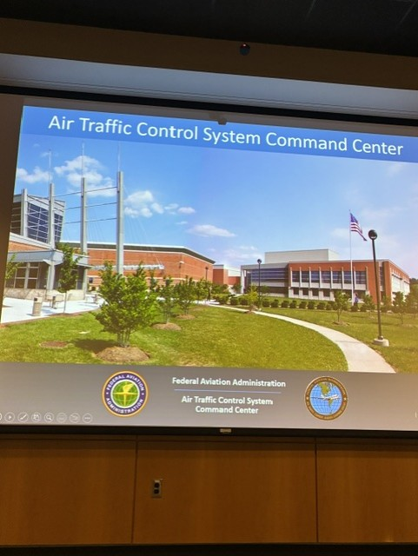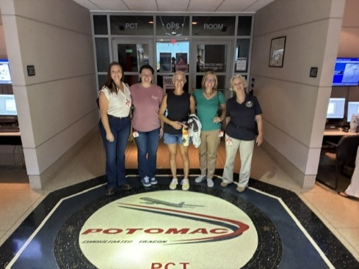
Alison Northern, Charlotte Granahan, Laura Savino and Mary McCutcheon
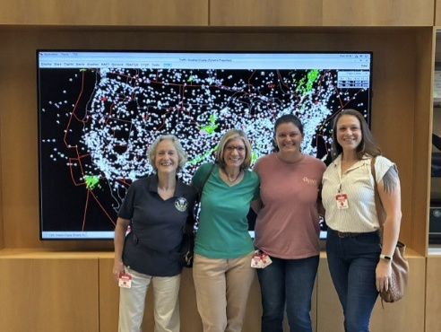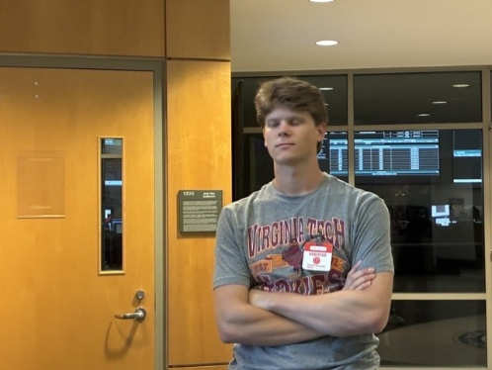
Mary Laura Charlotte Alison Doug Grahahan
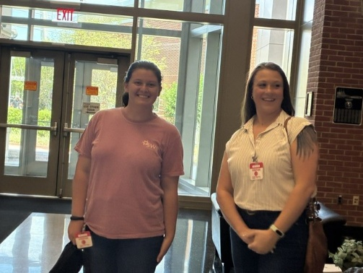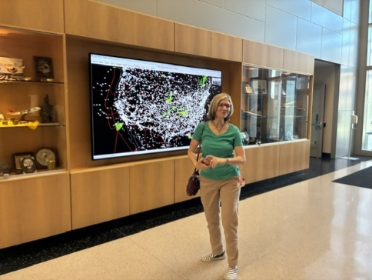
Charlotte and Alison Laura Savino

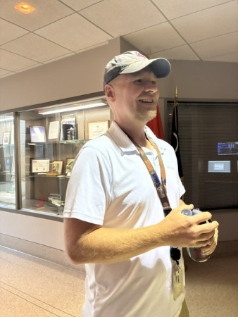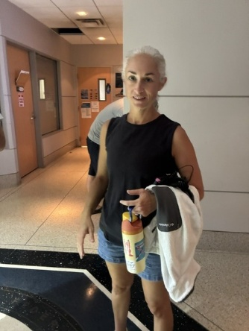
Chris Martz, our TRACON guide Sarah Patten

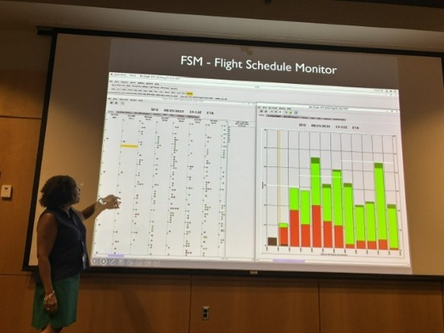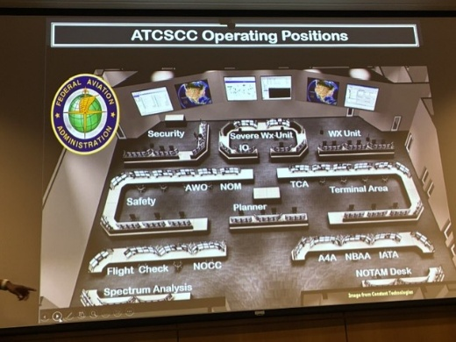
Danielle Perry showing us a traffic flow example The layout of the control center

CHUCK TIPPETT OBITUARY AND FLYING CIRCUS MEMORIAL

Chuck Tippett ran the Flying Circus. He has been a great friend of the 99s and a great supporter of Women Can Fly. He hosted Gail Keys’ retirement party and many other events at his Horsefeathers Airstrip in Warrenton.
His sudden death on August 3 sent shock waves through the aviation community. He died while swimming with his family at his place in Coles Point, VA. He was only 65 years old.
Here are some pictures of Chuck

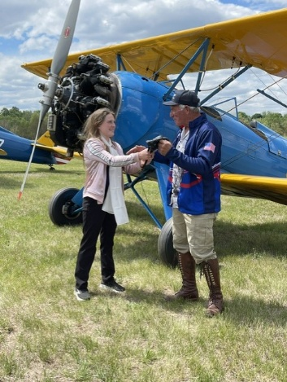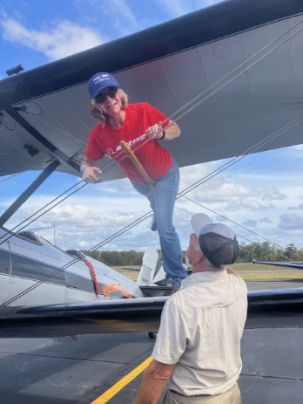
Chuck giving a ride to one of the Fly! Actresses Chuck teaching Laura how to wingwalk

Chuck’s wife, Vicki, predeceased him. They had been married 35 years and she was the love of his life. They had three children, Chuck, Chip and Victoria and seven grandchildren. Any memorial tributes should be made in his and her memories to:
FCPS Transitions Program
c/o Special Education Office
430 E. Shirley Avenue, Building B
Warrenton, VA 20186

On August 9, the Flying Circus held a memorial with a missing man formation with the Stearman fleet.

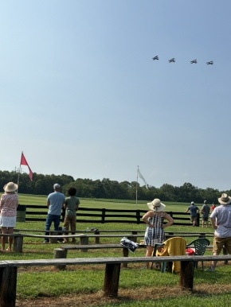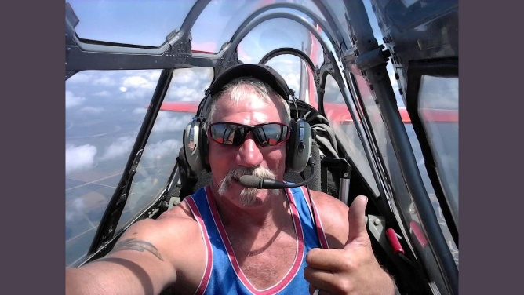
JUDY SUE BERGMAN, LIFE MEMBER OF THE 99s IN THE OLD DOMINION CHAPTER, DIED FEBRUARY 22, 2025
Judith Sue Bergman, born on January 12, 1942, in Hot Springs, Arkansas, passed away peacefully at home in Warrenton, Virginia surrounded by her children.
Judy was preceded in death by her husband of 59 years, Kenneth R. Bergman.
She and Ken lived in Annandale where they raised 6 children. Once the kids had become self-sufficient, she got her flying license and joined the Old Dominion Chapter of the 99s. According to an obituary she entered an air race with a friend ‘in which they finished dead last but were awarded the “Meathead Award,” which was a year's supply of steaks.’ According to this obituary, she also was an Angel Flight pilot and flew around the country with her husband in her little plane.
She is interred or inurned at Arlington Cemetery.

GIRLS IN AVIATION COLLEGE PARK AND DCA
Women in Aviation International is organizing several events in our region to encourage girls to pursue aviation. We have been involved in ones at College Park in the past and now we have a chance to get involved some more.
We can host a booth or get involved in other ways. Check out the links below for more information.
The event at Winchester is September 19, at College Park is October 10 and at Washington National (DCA) on October 14.

City: Winchester, VA
Date of Event: September 19, 2026
Location: Winchester Regional Airport, 491 Airport Rd, Winchester, VA 22602
Contact: Carley Walker Phone: 703-851-7952 Email: carley@stemflights.org
Website: https://www.winchesteraviation.org/events
Reservations are required. Register HERE!

City: College Park, MD
Date of Event: October 10, 2026
Location: College Park Airport, 1909 Corporal Frank Scott Dr, College Park, MD 20740
Contact: Landon Aud Holloway Phone: 540-471-7747 Email: Landonkaud@gmail.com
Website: https://www.wai-crc.com/

City: Arlington, VA
Date of Event: October 14, 2026
Location: DCA Signature, 1 Aviation Cir, Arlington, VA 22202
Contact: Landon Aud Holloway Phone: 540-471-7747 Email: Landonkaud@gmail.com
Website: https://www.wai-crc.com/

COMPASS ROSE AT WINCHESTER
At the Winchester Girls in Aviation Day, they (or maybe WE) will recruit girls to help with the Compass Rose painting at Winchester. The date for the compass rose painting will be sometime in October assuming that the preliminary survey and purchase of paint can happen before hand. Cynthia has a lot of the other supplies such as the template and a lot of tape and string dispensers.

WASP NEWS

The news has been full of stories about the last surviving WASP, Nell Stevenson Bright. She was featured on the cover of the Ninety-Nines Magazine this summer. Well, our 99s adjacent friend, Albert Lewis, whose mother, Dottie Swain, was a WASP and a good friend of Nell’s went to visit Nell in Salt Lake City. At 105, she is doing extremely well – living in a retirement home with minimal need for any help.

There are many internet links to WASP stories especially now that the baby boom children and passionate grandchildren are taking on the narratives. The April issue of the Atlantic had a story about the WASP that I cannot link to this newsletter. If you can read it with your own subscription, it is worth it. This is a link you will be able to click on, though.

https://www.yahoo.com/lifestyle/articles/6-untold-stories-female-pilots-185032039.html
A new biographical documentary about Jackie Cochran is now ready to see. I contacted the filmmaker and she will need to set up a viewing until after the film festivals are finished:
https://www.jackiecochranfilm.com/

We might wait till we can stream it.

FOREST OF FRIENDSHIP



This year the Forst of Friendship is inducting four of our Old Dominion members: Cynthia Axell, Laura Savino, Morgen Reeb, and R.J. McGlasson. The ceremony will take place September 11 and 12 in Atchison, Kansas. The theme of this year’s event marking the 50th anniversary of the Forest of Friendship is “World Friendship Through Flight”.

FIRST WINGS SCHOLARSHIP DEADLINE

FOR STUDENT PILOT MEMBERS
First Wings applications are due April 1st & Oct 1st annually
Applicants must be Student Pilot Members for 3 months prior to the First Wings submission deadline and have logged 5 hours flight time within the preceding 6 months. Award is up to $6,000 for specific milestones as they are achieved.
First Wings Award Instructions are available here

NEWS FROM OUR MEMBERS

SAM STAHL
“I finished my Envoy training and earned my ATP and type rating in the ERJ 170/175. I passed my IOE line check and am now a line pilot on reserve at ORD. I can’t believe I get to fly jets!”

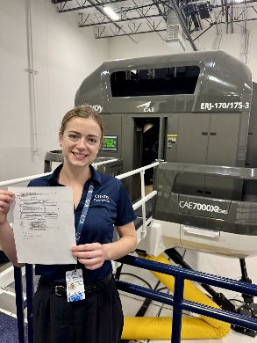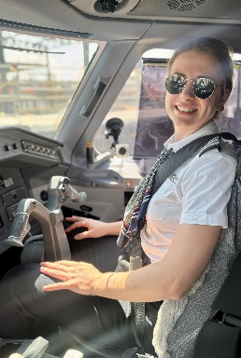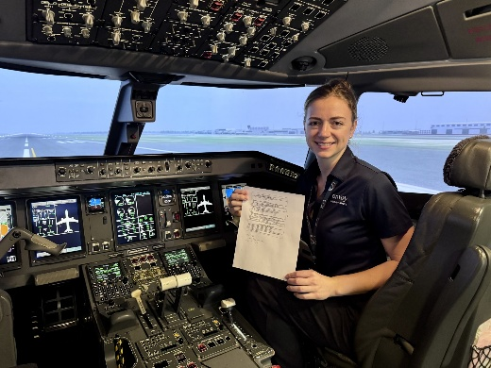
Pictures are after passing my type ride in the sim, and then in the jet on IOE.

MIA ANDERSON
Earned her Commercial

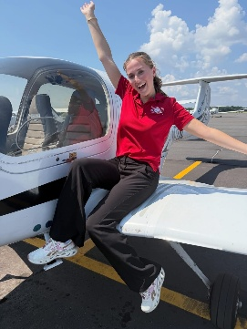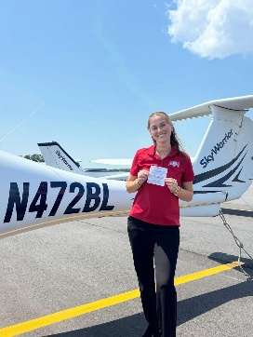

RETURN MEMBER

Christa Houser has come back from Germany. She had been a member since 2008 but let the membership lapse while she was away. She now lives in Vienna. Welcome back

